Step 3 — K-fold cross-validation backtesting
K-fold cross-validation cycles the test window across the full dataset, so performance is assessed across multiple independent periods rather than just one.
The standard K-fold procedure cannot be applied directly in a financial series, shuffling observations in a random way would allow future returns to leak into the training set, a fundamental error in backtesting (Bailey et al., 2014). Instead, a walk-forward variant is used: the training window always ends before the test window begins. With K = 5 folds across the full two-year dataset (January 2024 to December 2025), each fold spans roughly 100 trading days. An embargo buffer of five days is applied at each boundary to prevent autocorrelation from contaminating the split (López de Prado, 2018).
Results across folds
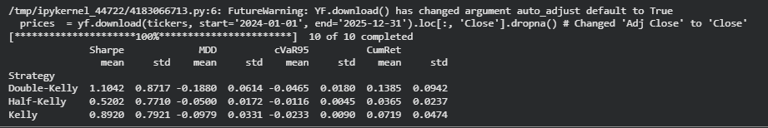
The mean Sharpe ratios follow the expected ordering: Double-Kelly leads at 1.10, full Kelly at 0.89, and Half-Kelly at 0.52. On return alone, doubling the allocation appears to pay off. The risk picture complicates that reading considerably. Double-Kelly's fold-to-fold standard deviation of 0.87 is nearly as large as its mean Sharpe ratio, which means the strategy's performance was highly inconsistent across periods. The mean maximum drawdown of −18.8% and a daily cVaR of −4.65% on the worst 5% of trading days confirm the tail exposure that comes with leverage. Half-Kelly shows the tightest risk figures across all four measures and the most stable behaviour fold-to-fold.
This pattern is consistent with what the literature predicts. Thorp (2006) noted that practitioners tend to favour half-Kelly because Kelly's theoretical growth guarantees depend on knowing the true parameters exactly, which is never possible in practice. MacLean, Thorp, and Ziemba (2011) document that even small errors in the estimated mean return cause leveraged strategies to underperform, and the fold-to-fold variance in the Double-Kelly results here reflects precisely that sensitivity.

Step 4b Improvements using clustering: Hierarchical Risk Parity
Why mean-variance optimisation breaks down out-of-sample
Michaud (1989) described this as "error maximisation": the optimiser treats sampling variation as genuine signal, overweighting assets with historically high returns that may simply have been lucky. DeMiguel, Garlappi, and Uppal (2009) tested this across 14 empirical datasets and found that the naive equal-weight portfolio outperformed unconstrained Markowitz out-of-sample in the majority of cases. The culprit is estimation error compounding through the matrix inversion.
Merton (1980) showed that estimating the mean return of a single asset to within one standard error requires roughly (σ/μ)² observations. For an equity with annualised volatility of 20% and expected excess return of 5%, that is over 1,600 trading days, more than six years of data. Our in-sample period covers roughly 440 trading days across 10 assets, so the mean return estimates feeding into the Kelly optimiser carry non-trivial uncertainty throughout.
How HRP works
Hierarchical Risk Parity, introduced by López de Prado (2016), sidesteps expected return estimation entirely. The method has three stages. First, a distance matrix is derived from the correlation matrix using d(i,j) = √(½(1 − ρᵢⱼ)). Hierarchical agglomerative clustering (Ward, 1963) is then applied to produce a dendrogram showing which assets are most similar. Second, the covariance matrix is reordered so that assets close together in the dendrogram sit adjacent to one another, concentrating intra-cluster relationships near the diagonal. Third, weights are assigned through recursive bisection: the asset set is repeatedly split into two sub-clusters, with weight allocated to each sub-cluster inversely proportional to its variance contribution. The result is a portfolio where no single cluster disproportionately drives total variance.
In-sample weights
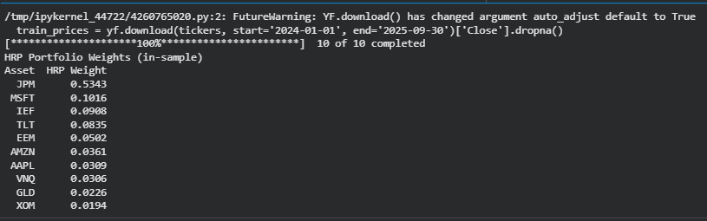
JPMorgan's is notable with 53.4% allocation so when one asset or cluster shows sufficiently low variance relative to the rest of the universe during the training period, the recursive bisection can concentrate weight there.
Out-of-sample comparison
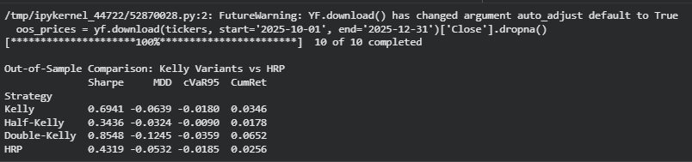
Out-of-sample, full Kelly produces the best Sharpe ratio at 0.69, with HRP at 0.43. A 53% allocation to a single stock means the portfolio's return profile in Q4 2025 was driven almost entirely by JPM's performance rather than genuine diversification across the asset universe.
That said, HRP produces a lower maximum drawdown than full Kelly (−5.3% vs −6.4%) and comparable tail risk, which is consistent with López de Prado's (2016) finding that HRP tends to outperform on drawdown metrics even when Sharpe ratios are close.

STEP 5: Quick Comparison of Methodologies

Tool | Core Merit | Major Drawback
Hierarchical Risk Parity (HRP) | Highly robust; doesn’t invert covariance matrices; creates stable, well-diversified risk clusters. | Completely ignores expected returns; will not explicitly maximize growth.
Constrained Kelly (or Half-Kelly) | Maximizes long-term compounding growth; constraints/halving protect against extreme drawdowns. | Highly sensitive to input errors (garbage in, garbage out); can still be highly volatile.
Double-Kelly | Maximizes aggressive growth and explicitly utilizes leverage to boost returns. | Extremely high risk of catastrophic loss; hyper-sensitive to estimation errors.

Establish Baseline Using HRP
Start with HRP - group assets using their correlations before anything else. Then shift money around until each group bears the same amount of risk weight. Not total value, just risk. That balance matters more than size. The method skips guessing which asset wins. Instead, it spreads exposure like water filling uneven terrain. Each part ends up pushing equally on the whole structure. Risk becomes uniform across clusters. Allocation follows that rule strictly. Nothing extra goes to familiar names or recent gains. Equal pressure keeps things stable when markets twist sideways.
Because it creates a base of varied investments, steady enough to handle guesswork flaws while steering clear of risky clusters in any single area.
Apply Controlled Risk Using Half Kelly Strategy
Action: Overlay a Constrained or Half-Kelly framework onto the stable baseline.
Here is why: starting carefully helps shift returns toward stronger growth. Limits on positions or skipping short trades - these act like brakes when forecasts get shaky. Cutting allocations in half also softens the blow if guesses miss their mark. Relying fully on aggressive math can backfire fast; small changes twist outcomes wildly.
Optionally Use Double Kelly Strategy with Caution
Action: Reserve Double-Kelly strictly for high-conviction, tactical adjustments.
Here’s the thing. Double-Kelly piles on exposure, cranks up danger. So, it fits only when markets aren’t swinging wildly. Forecasts must scream upside - way above normal. On top of that, the person using it needs nerves built for chaos. Otherwise, better left alone.
The Bottom Line
Starting slow keeps your base solid, so mistakes early won’t wreck what comes next. Instead of rushing in, you first guard against loss - HRP puts safety first. Then, growth enters - but only within tight limits, like Constrained Kelly shows. After that settles, bolder moves appear, guided by Double-Kelly's sharper edge. Through each shift, protection stays just as strong as ambition. The result? Money lasts longer, while gains climb smarter.

