How to Read Apache Kylin from Apache Flink using Scala

Date: August 2016
Update: Nov 2016
Author: Ramón Portolés, Alberto Linkedin

Intro
There are several Attempts to use this in Scala and JDBC Attempt1 Attempt2 Attempt3 Attempt4 … but none works ...

Problem 1: There aren’t any doc about connect Kylin with Flink
Problem 2: We will try use CreateInput and JDBCInputFormat in batch mode and access via JDBC to Kylin. But isn’t implemented in Scala is only in Java MailList

Then , We will go step by step solving problems

Pre-requisites
- We need an instance of Kylin, with a cube: Quick Start with Sample Cube, will be enough
You can check:

- Scala and Apache Flink Installed
- IntelliJ Installed and configured for Scala / Flink (See Flink IDE setup guide )

Used Software:
- Apache Flink v1.2-SNAPSHOT
- Apache Kylin v1.5.2
(In Nov 2016, only works with 1.5.4 or more by dependences with Calcite, I Tested with v1.6.0)
- IntelliJ v2016.2
- Scala v2.11

Starting point:
This can be out initial skeleton:
import org.apache.flink.api.scala._
val env = ExecutionEnvironment.getExecutionEnvironment
val inputFormat = JDBCInputFormat.buildJDBCInputFormat()
.setDrivername("org.apache.kylin.jdbc.Driver")
.setDBUrl("jdbc:kylin://172.17.0.2:7070/learn_kylin")
.setUsername("ADMIN")
.setPassword("KYLIN")
.setQuery("select count(distinct seller_id) as sellers from kylin_sales group by part_dt order by part_dt")
.finish()
val dataset =env.createInput(inputFormat)
The first error is:
We add to Scala: import org.apache.flink.api.java.io.jdbc.JDBCInputFormat

Next error is
We can solve dependencies (mvn repository: jdbc)
Add this to your pom.xml:
<dependency>
<groupId>org.apache.flink</groupId>
<artifactId>flink-jdbc</artifactId>
<version>${flink.version}</version>
</dependency>

Solve dependencies of row
Similar to previous point we need solve dependencies of Row Class (mvn repository: Table):
- In POM.XML
<dependency>
<groupId>org.apache.flink</groupId>
<artifactId>flink-table_2.10</artifactId>
<version>${flink.version}</version>
</dependency>
- In Scala:
import org.apache.flink.api.table.Row

Solve RowTypeInfo property (and their new dependencies)
This is the new error to solve
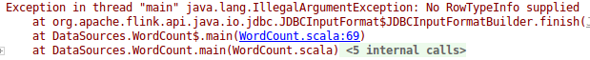
- If we check the code of JDBCInputFormat.java, we can see this new property (and mandatory) added on Apr 2016 by FLINK-3750 Manual JDBCInputFormat v1.2 in Java

Add the new Property: setRowTypeInfo
val inputFormat = JDBCInputFormat.buildJDBCInputFormat()
.setDrivername("org.apache.kylin.jdbc.Driver")
.setDBUrl("jdbc:kylin://172.17.0.2:7070/learn_kylin")
.setUsername("ADMIN")
.setPassword("KYLIN")
.setQuery("select count(distinct seller_id) as sellers from kylin_sales group by part_dt order by part_dt")
.setRowTypeInfo(DB_ROWTYPE)
.finish()

- ¿How can configure this property in Scala? In Attempt4 , there is an incorrect solution
We can check the types using the intellisense: 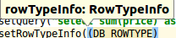
Then we will need add more dependences :(
Add to scala:
import org.apache.flink.api.table.typeutils.RowTypeInfo
import org.apache.flink.api.common.typeinfo.{BasicTypeInfo, TypeInformation}

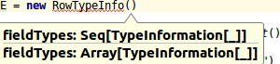
We need create a Array or Seq of TypeInformation[]
My solution:
var stringColum: TypeInformation[String] = createTypeInformation[String]
val DB_ROWTYPE = new RowTypeInfo(Seq(stringColum))

Solve Class Not Found
We need find the kylin-jdbc-x.x.x.jar and expose to flink
- We need to find the JAR Class for the JDBC Connector
From Kylin Download Choose Binary and the correct version of Kylin and HBase
Download & Unpack: in ./lib:
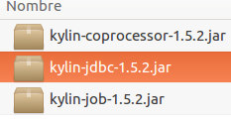

- Make this JAR accessible to Flink
If you execute like service you need put this JAR in you Java ClassPATH using your .bashrc
Check the actual value:
Check the permission for this file (Must be accessible for you):

If you are executing from IDE, you need add your ClassPath manually:
On IntelliJ: > > >
The result, will be similar to: 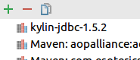

Solve Couldn’t access resultSet
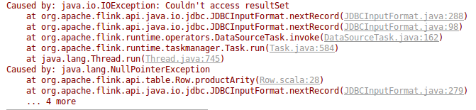
Is related with Flink 4108 (MailList) and Timo Walther make a PR
If you are <= Flink 1.2 you will need apply this path and make clean install

Solve the casting
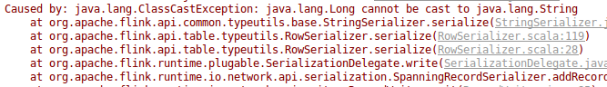
In the error msg you have the problem and solution …. nice ;) ¡¡

The result
The out must be similar to this, print the result of query by standard output:
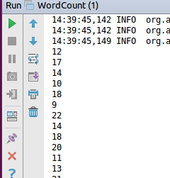

Now more complex
We can try with multi-colum and multi-type query:
select part_dt, sum(price) as total_selled, count(distinct seller_id) as sellers
from kylin_sales
group by part_dt
order by part_dt

We will need changes in DB_ROWTYPE:
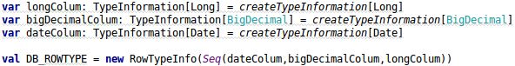
And import lib of Java, to work with Data type of Java

The new Result will be: 
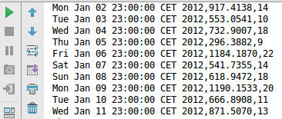

Error: Reused Connection
Check if your HBase and Kylin is working
Also you can use Kylin UI for it

Error: java.lang.AbstractMethodError: ….Avatica Connection
See Kylin 1898,
It is a problem with kylin-jdbc-1.x.x. JAR, you need use Calcite 1.8 or more → use Kylin 1.5.4 or more

ERROR: can't expand macros compiled by previous versions of scala
Is a problem with versions of scala, check in with scala -version your actual version and choose your correct POM
Perhaps you will need a IntelliJ > File > Invalidates Cache > Invalidate and Restart

Final Words
Now we can read Kylin’s data from Apache Flink, great News ¡¡
We solved all integration problems, and tested with different types of data (Long, BigDecimal and Dates)
Today (12 Oct 2016) Flink 1.2-SnapShot, you need download, apply path, compile and make install …. but in new releases will not necessary

For any suggestions, feel free to contact me
Thanks, Alberto

