How to use Hue with Kylin

Date: August 2016
Author: Ramón Portolés, Alberto Linkedin

Intro
In Hue-2745 v3.10, add jdbc support like Phoenix, Kylin, Redshift, Solr Parallel SQL, …
However, there isn’t any manual to use with Kylin :(

Pre-requisites
Build a cube sample of Kylin with Quick Start with Sample Cube,

You can check:

Used Software:
- Apache Hue v3.10.0
- Apache Kylin v1.5.2

Install Apache Hue
If you have Hue installed, you can skip this step
To install Hue on Ubuntu 16.04 LTS. The official Instructions didn’t work but this works fine:
There isn’t any binary package, thus pre-requisites must be installed and compile with the command make
Sudo apt-get install --fix-missing -q -y \
git \
ant \
gcc \
g++ \
libkrb5-dev \
libmysqlclient-dev \
libssl-dev \
libsasl2-dev \
libsasl2-modules-gssapi-mit \
libsqlite3-dev \
libtidy-0.99-0 \
libxml2-dev \
libxslt-dev \
libffi-dev \
make \
maven \
libldap2-dev \
python-dev \
python-setuptools \
libgmp3-dev \
libz-dev

Download and Compile:
git clone https://github.com/cloudera/hue.git
cd hue
make apps

Start and connect to Hue:
build/env/bin/hue runserver_plus localhost:8888
  - runserver_plus: is like runserver with debugger
  - localIP: Port, usually Hue uses 8888

The output must be similar to:
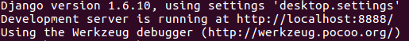

Connect using your browser: http://localhost:8888

Important: The first time that you connect to hue, you set Login / Pass for admin
We will use Hue / Hue as login / pass

Issue 1: Could not create home directory

It is a permission problem of your current user, you can use: sudo to start Hue

Issue 2: Could not connect to …

If Hue’s code had been downloaded from Git, Hive connection is active but not configured → skip this message

Issue 3: Address already in use
The port is in use or you have a Hive process running already.
You can use ps -ef | grep hue, to find the PID and kill

Configure Apache Hue for Kylin
The purpose is to add a snipped in a notebook with Kylin queries

References:
- Custom SQL Databases
- Manual: Kylin JDBC Driver
- GitHub: Kylin JDBC Driver

Register JDBC Driver

- To find the JAR Class for the JDBC Connector
From Kylin Download, Choose Binary and the correct version of Kylin and HBase
Download & Unpack: in ./lib:
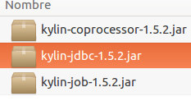

- Place this JAR in Java ClassPATH using .bashrc

check the actual value:

check the permission for this file (must be accessible to you):

- Add this new interface to Hue.ini
Where is the hue.ini ?
- If the code is downloaded from Git : UnzipPath/desktop/conf/pseudo-distributed.ini
(I shared my INI file in GitHub)
- If you are using Cloudera: you must use Advanced Configuration Snippet
- Other: find your actual hue.ini

Add these lines in [[interpreters]]
[[[kylin]]]
name=kylin JDBC
interface=jdbc
options='{"url": "jdbc:kylin://172.17.0.2:7070/learn_kylin","driver": "org.apache.kylin.jdbc.Driver", "user": "ADMIN", "password": "KYLIN"}'

- Try to Start Hue and connect, just like in ‘Error: Reference source not found’

TIP: One JDBC Source for each project is need

Register without a password, It can do use this other format:
options='{"url": "jdbc:kylin://172.17.0.2:7070/learn_kylin","driver": "org.apache.kylin.jdbc.Driver"}'

And when you open the Notebook, Hue prompts this:


Issue 1: Hue can’t Start
If you see this when you connect to Hue ( http://localhost:8888 ):
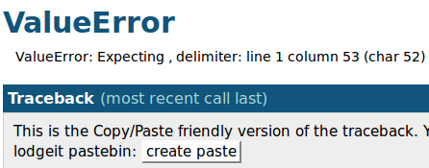
Go to the last line:
And launch Python Interpreter (see console icon on the right):
In this case: I’ve forgotten to close “ after learn_kylin

Issue 2: Password Prompting
In Hue 3.11 there is a bug: Hue 4716
In Hue 3.10 with Kylin, I didn’t have any problem :)

Test query Example
Add Kylin JDBC as source in the Kylin’s notebook:
> > >

Write a query, like this:
select part_dt, sum(price) as total_selled, count(distinct seller_id) as sellers from kylin_sales group by part_dt order by part_dt

And Execute with:
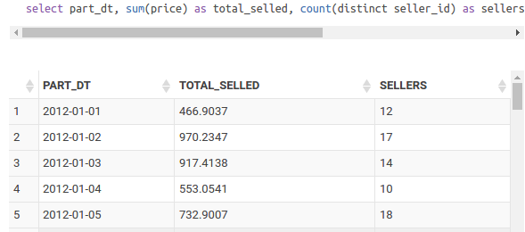

Congratulations !!! you are connected to Hue with Kylin

Issue 1: No suitable driver found for jdbc:kylin

There is a bug (not solved since 27 Aug. 2016, nor in 3.10 and 3.11), but the solution is very easy (Thanks to Shahab Tajik)
You only need to change 3 lines in <HuePath>/desktop/libs/librdbms/src/librdbms/jdbc.py

Limits
In Hue 3.10 and 3.11
- Auto-complete doesn’t work on JDBC interfaces
- Max 1.000 records. There is a limitation on JDBC interfaces, because Hue does not support result pagination Hue 3419
- Obviously: It’s read-only

Future Work

Dashboards
There is an amazing feature of Hue: Searh Dasboards / Dynamic Dashboards (you can ‘play’ with this Demo On-line) … But this only works with SolR
There is a Jira to solve this: Hue 3228 is in RoadMap for 4.1. Check Hue MailList and add Dashboards to JDBC connections

Chart & Dynamic Filter
Nowadays, it isn’t compatible, you only can work with Grid
I think the problem is that Hue doesn’t know how to read Kylin Metadata Hue 4011


DB Query
> , is not yet supported with JDBC
Now it only supports Django Databases

For any suggestions, feel free to contact me
Thanks,
Alberto.

