Example of Tuning Cube I
Date: Dicember 2016
Author: Ramón Portolés, Alberto Linkedin
Thanks to ShaoFeng Shi for help

We can try to optimize a very simple Cube, with 1 Dim and 1 Fact table (Date Dimension)
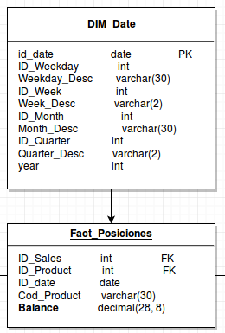
Our Base line is:
- One Measure: Balance, we calculate always Max, Min and Count
- All Dim_date (10 items) will be used as dimensions
- Input is a Hive CSV external table
- Output is a Cube in HBase with out compression
With this configuration, the results are: 13 min to build a cube of 20 Mb (Cube_01)

Cube_02
Our first improve will be use Joint and hierarchy on Dimensions to reduce the carnality
We can put together all ID and Text of: Month, Week, Weekday and Quarter
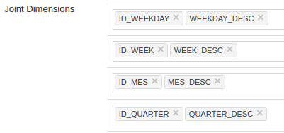
Define Id_date and year like Hierarchy
The size down to 0.72 and time to 5 min

Kylin 2149, ideally, we can define define also these Hierarchies:
- Id_weekday > Id_date
- Id_Month > Id_date
- Id_Quarter > Id_date
- Id_week > Id_date
But for now, isn’t possible use Joint and hierarchy together in one Dim :(

Cube_03
Now we can try compress HBase Cube with Snappy:

Cube_04
Now we can try compress HBase Cube with gzip:

The results of compression output are:
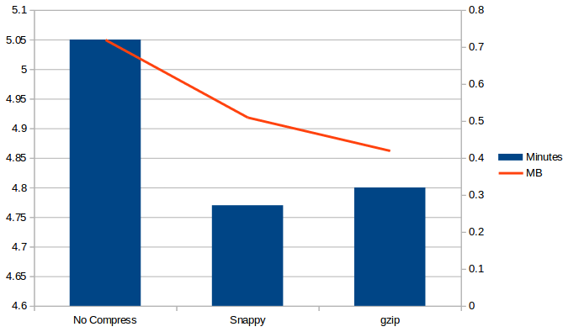
The difference between Snappy and gzip in time is very few 1% but in size is 18%

Cube_05
Now the time distribution is like this:
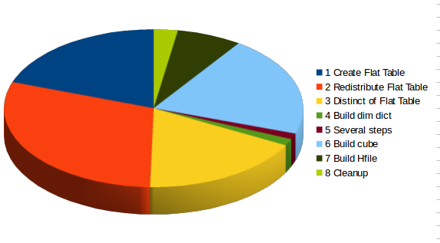

We can group detailed times in groups by concepts :
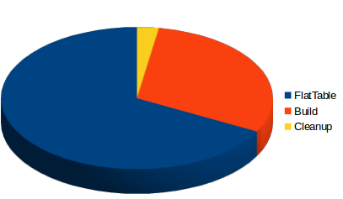
We can see the 67 % is used to build / process flat table respect 30% to build cube
We are losing a lot of time in first steps !!

We can try to use ORC Format and compression on Hive (Snappy):
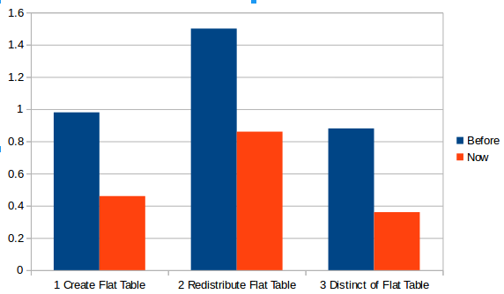
The time in three first steps (Flat Table) has been improved to the half :)

Cube_06: Fail
If we see the distribution of rows
Fact Table | 3.900.00 rows
Dim Date | 2.100 rows

And see the query to build the flat table: (The idea is)
SELECT
,DIM_DATE.X
,DIM_DATE.y
,FACT_POSICIONES.BALANCE
FROM FACT_POSICIONES INNER JOIN DIM_DATE
ON ID_FECHA = .ID_FECHA
WHERE (ID_DATE >= '2016-12-08' AND ID_DATE < '2016-12-23')

The problem is, Hive in only using 1 Map to create Flat Table. Then lets go to change this undesirable behavior. Our solution is partition DIM and FACT by same columns
- Option 1: Use id_date as partition column on Hive table. This have a big problem: the Hive metastore is meant for few hundred of partitions not thousand (Hive 9452 there is an idea to solve this isn’t in progress)
- Option 2:Generate a new column for this purpose like monthslot.
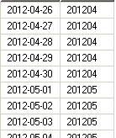
The same column will be add to dim and fact tables
Now the data model need be cached, add this new condition to join
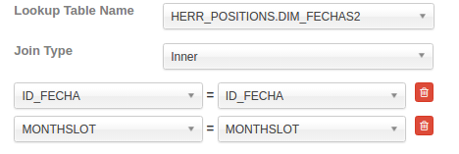
The new query to generate flat table will be similar to:
SELECT
FROM FACT_POSICIONES INNER JOIN DIM_DATE
ON ID_FECHA = .ID_FECHA AND MONTHSLOT=MONTHSLOT
And launch the build of new cube with this data model
But The performance has worsened :( . I tried several test without solution
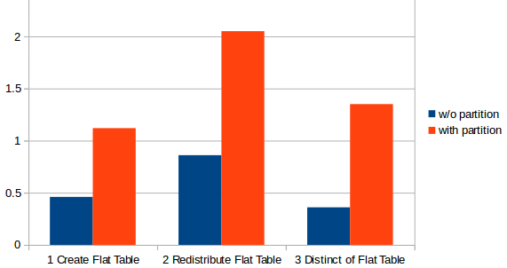
The problem is didn’t use partitions to generate several Mappers
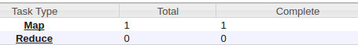

The Final results
