Example of Tuning Cube II
Date: Dicember 2016
Author: Ramón Portolés, Alberto Linkedin

Tuning of M-R Map-Reduce
After tuning of cube: (See KylinPerformance_I)
- Hive Input tables compressed
- HBase Output compressed
- Apply techniques of reduction of cardinality (Joint, Derived, Hierarchy and Mandatory)
- Personalize Dim encoder for each Dim and Choose best order of Dim in Row Key

Now we have three types of cubes:
- Cubes with low cardinality in their dimensions
- Cubes with high cardinality in their dimensions
- The third type, ultra high cardinality (UHC) which is outside the scope of this article

Cubes with low cardinality Dimensions:
In our example:
- Fact table 4Millons of rows
- Dim1 2K & Dim2 12K of rows

Out Time Chart must be similar to this:
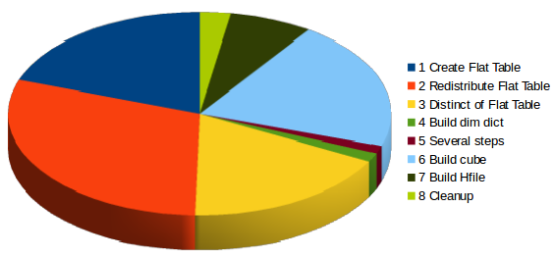

If we make a group by concept:
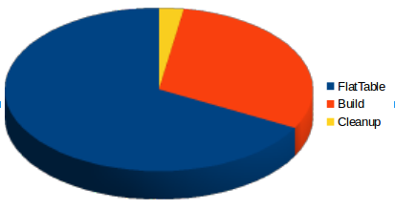
We can see the 67% of time is used on Flat Table (Steps 1,2,3)

Attempt 1:
How can try to reduce the time in these steps?
You can see the SQL Hive of these steps on > 
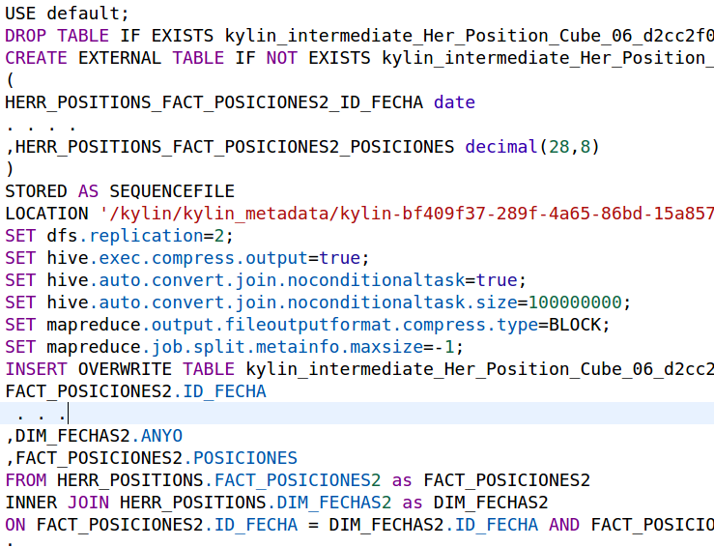
We can see:
- Uses external Tables of Hive
- Uses Sequencefile as storage format
We can try to use other columnar formats
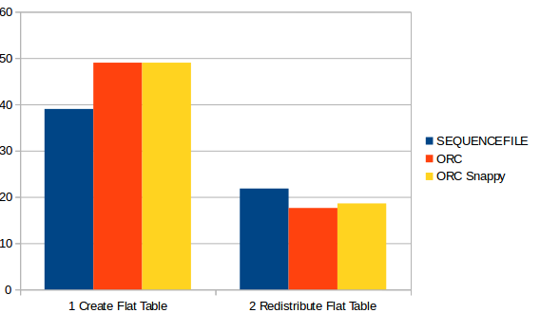
- ORC
- ORC compressed with Snappy
But the result are worst than Sequence file …
See comments about this from Shaofengshi in MailList

Attempt2:
The second strep (redistribute Flat Hive table)
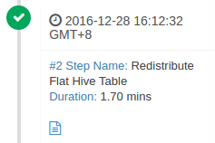

Is a simple row count:
We can think in some approx: If we don’t need accurate, we can make a count of fact table → this can be performed in parallel with Step 1 (and 99% of times will be accurate)
See comments about this from Shaofengshi in MailList , In future version (Kylin 2265 v2.0) this steps will implemented using Hive table statistics

Cubes with high cardinality Dimensions:
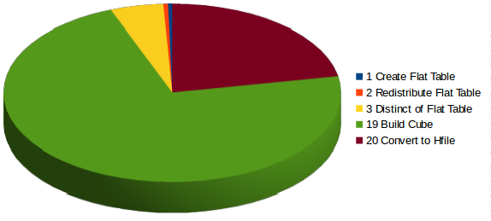
In this case the 72% of time is used to Build Cube
This step is a MapReduce task, you can see the Sql Hive of these steps on >

Attempt1:
How can improve the performance of Map – Reduce? The easy Way is increase the numbers of mappers and reduces (= Increase parallelism).
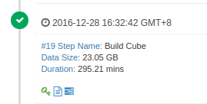
NOTE: YARN / MapReduce have a lot parameters to configure and adapt to your system, we only will be focus on small part of them
(In my system I can assign to YARN Resources: 12 – 14 GB and 8 cores)
- yarn.nodemanager.resource.memory-mb = 15 GB
- yarn.scheduler.maximum-allocation-mb = 8 GB
- yarn.nodemanager.resource.cpu-vcores = 8 cores
With this config our max teorical grade of paralelist is 8 , but this have a problem: “Timed out after 3600 secs”

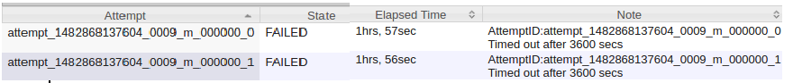
The parameter mapreduce.task.timeout (1 hour by default) define max time that Application Master (AM) can happen with out ACK of Yarn Container. Once past this time, AM kill the container and retry the same 4 times (with same result)
Where is the problem? Our problem is that I starter 4 mappers, but each mapper need more than 4 GB to finish
- The solution 1: add more RAM to YARN
- The solution 2: add more Reduce the number to vCores
- The solution 3: You can play with max RAM to YARN by node (yarn.nodemanager.resource.memory-mb) and min RAM to container (yarn.scheduler.minimum-allocation-mb). If you increase minimum RAM per container, YARN will reduce the numbers of maps in

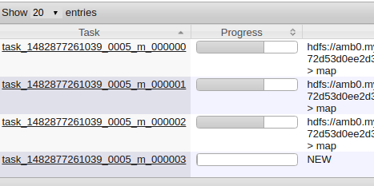
In three cases the result are the same: reduce the level of parallelism ==>
- Now we only start 3 mappers at same time, the fourth must be wait to free slot
- The three first mappers spread the ram, then they will have enough ram to finish the task

During a normal “Build Cube” step you must see similars messages on YARN log:
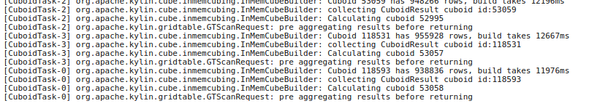
If you don’t see periodically, perhaps you have a bottleneck in memory

Attempt2:
We can try to use differences aggregations groups to improve the query performance of some Dim very important or with high cardinality.
In our case we define 3 Aggregations Groups:
- “Normal cube”
- Cube with Date Dim and Currency (as mandatory)
- Cube with Date Dim and Carteras_Desc (as mandatory)
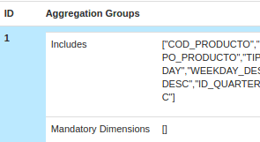
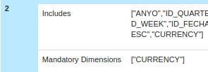
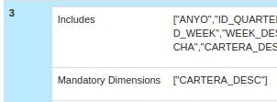

Compare without / with AGGs:
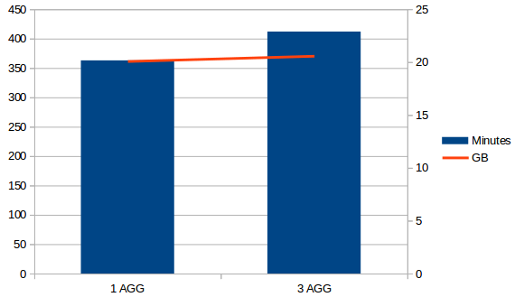
Now we uses 3% more of time to build the cube and 0.6% of space, but queries by currency or Carteras_Desc will be very faster

