Use Qlik with Apache Kylin
Date: September 2016
Author: Ramón Portolés, Alberto Linkedin

Intro
It’s a new player in the BI tools world, with a high growth from 2013
On-line demos
Nowadays has connectors for Hadoop Databases: Hive and Impala
But doesn’t have Kylin connector

Used Software
- Kylin v1.5.2
- Kylin ODBC v1.5
- Qlik Descktop v3.0.2.0

Pre-requisites
- We need an instance of Kylin, with a cube: Quick Start with Sample Cube, will be enough

You can check:

- Download Install and configure Kylin ODBC Driver
  - Install Kylin ODBC
  - Add DNS System in Windows
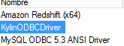
  - And configure: User-name /Password: ADMIN / KYLIN
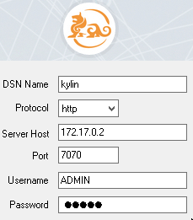
  - Click Connect and Choose the project

Click on “Done”

Install Qlik:
Requires: (System Requeriments)
- Windows 7 SP1 (64 bit) or 8.1 (64 bits)
Be careful with 64 bits and SP1, its mandatory
I tested on Windows 2012 and didn’t Work
- Framework .Net 4.5.2
- 1.5 GB of free Disk Space
Note: The Language of Qlik Desktop is the same as your S.O. (you can change)
My apologies for some pictures in Spanish language ;)

We launch the process as Admin:
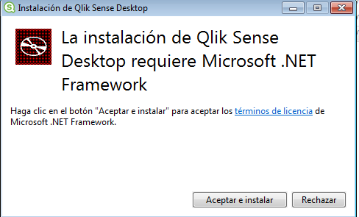

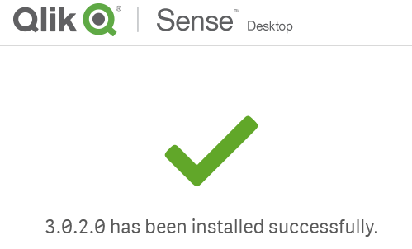

Issue 1: The Burn engine cannot run with an MBA under the .NET 4
(The Qlik Forum and msg txt wrongly suggests its about .NET problem)
In log you will see:
: Error 0x81f403e8: The Burn engine cannot run with an MBA under the .NET 4 CLR on Windows 7 RTM with .NET 4.5.2 (or greater) installed.
[0070:0A8C][2016-09-09T22:34:33]i000: Loading prerequisite bootstrapper application because managed host could not be loaded, error: 0x81f403e8.
[0070:0BC0][2016-09-09T22:34:33]i000: Setting numeric variable 'WixStdBALanguageId' to value 3082

Solution: Qlik requires SP1 of Windows 7 to install ( this info Isn’t in the official System Requeriments)
Download & Install SP1 64 bits

Issue2: Microsoft .Net framework is required for Qlik Sense desktop setup
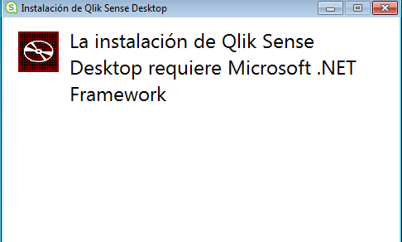
And you don’t have a button “Accept and install”
I tried Qlik Community 1 and Qlik Community 2 , but didn’t work
Solution: I deleted in windows registry all references to Qlik

Create New App
Open Qlik Desktop
Create New App, With name Kylin 

Now, the complex is import your Kylin data into Qlik
I documented the fails, because I think are also important

Attempt 1: To add Data (fail)
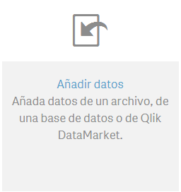> > > 
The login and password can be empty

We can see the Kylin’s tables:
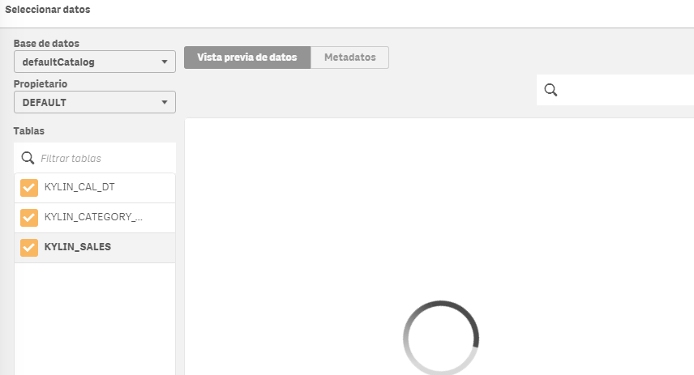
Problem: The load never finish (I Waited 20 minutes)
See ‘Issue 1: Qlik Metadata’

Attempt 2: Add Data (fail)
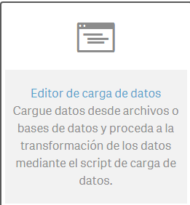> > > >
The login and password can be empty
An click on:
Problem: The load never finish
See ‘Issue 1: Qlik Metadata’

Attempt 3: Add Data (successful)
We need configure our own data loader using a script
We change some configuration in parameters from connector created in “Attempt 2: Add Data (fail)”
We will need activate debug mode:
And test default script with , you can see an execution step by step

List of changes:
- Change format to Dates to YYYY-MM-DD
- Add Connection String: You can add directly with
- Load columns & data from tables

First, we test query using Kylin UI:
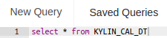
The result is: (731 rows)
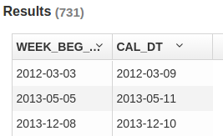
(Note: We can use to copy the name of columns)
The result must be similar to this: (See “script_data_1.txt”, on gitHub)
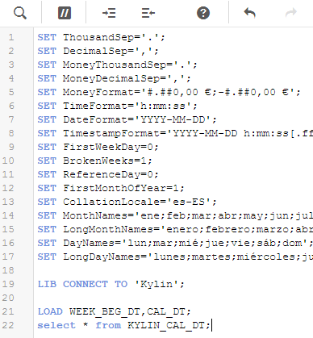
We can test the import:
Save Script:
Out of debug mode: 
Now, “Load data” button must be enabled:

The Output must be similar to: (check the row count is the same like Kylin UI)
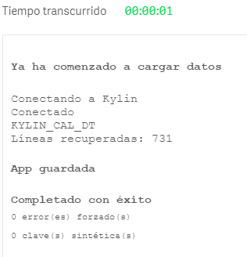
To Import other table (fact table) you only need add
LOAD PART_DT,LEAF_CATEG_ID,LSTG_SITE_ID,LSTG_FORMAT_NAME,PRICE,
SELLER_ID,MIN_PRICE_,MAX_PRICE_,COUNT__, COUNT_DISTINCT_SELLER_ID_,
COUNT_DISTINCT_LSTG_FORMAT_NAME_;
select * from KYLIN_SALES;

We can put “alias” to data easy:
[CAL_DT]:
LOAD WEEK_BEG_DT,CAL_DT;
select * from KYLIN_CAL_DT;

In my Hard: a Laptop with HBase, Kylin, Hive .. In a Docker Container and Qlik in a Virtual Box, the performance to ingest data has been good, only 2 sec for 3 Tables and 10K Rows
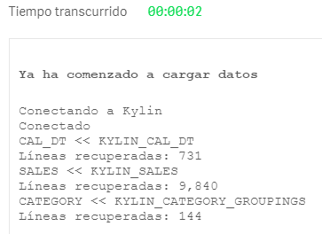
We can see all ingested tables in “data manager”: >
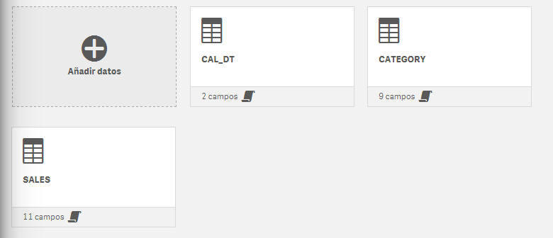

NOTE that: If you try to see data of one table: Click in one, you can’t see data (below)
“Data tables defined in the load script are not managed in Data manager”
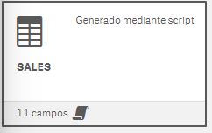


Issue 1: Qlik Metadata
The log of ODBC kylin are in:
When use Attempt 1 and 2, we can see errors: SQLGetInfoW
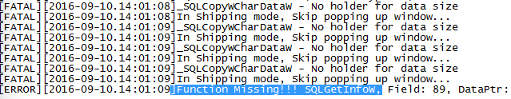

Define Table associations
(Managing data associations)
You can see you actual table associations in:
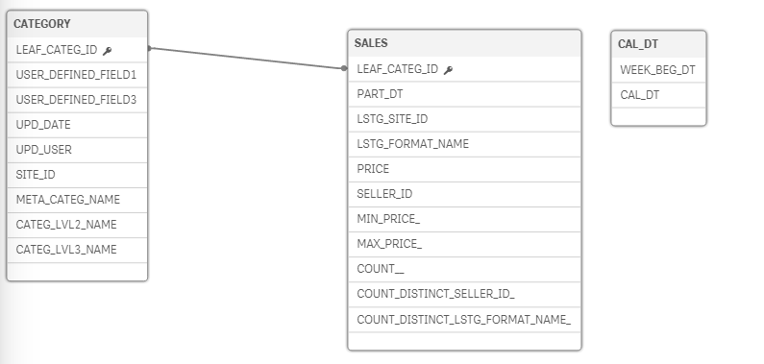
But this association isn’t correct, you can see the corrects in Kylin UI > Model designer > Data Model:
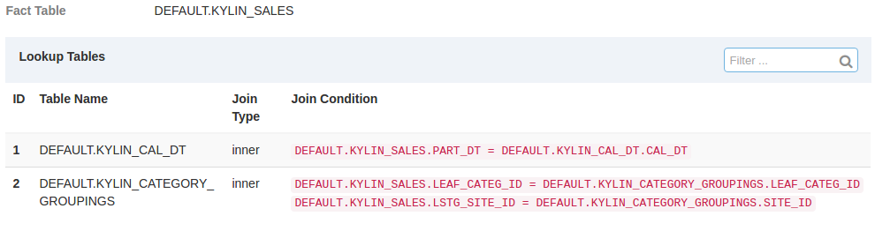
How can I change? :
In “data manager”: > >
In true, you can’t change because
“Data tables defined in the load script are not managed in Data manager”

Create dataSheets
There is only way to add data from load script into a sheet:
In “data manager”: > > > Edit Sheet
You can see all Columns in: , you can classifies like Dim or measures with Right click
Also, you can define a Hierarchy in Dim:
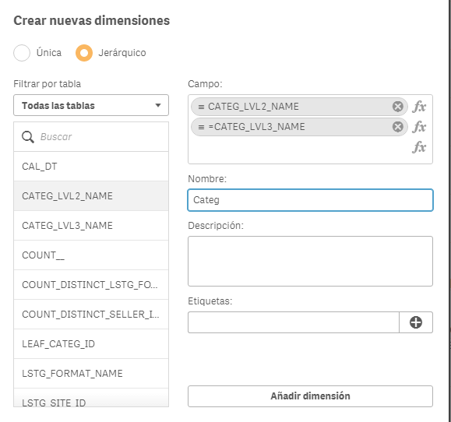
First, add graphic elements from : (Drag and drop)
Second: Add Dim and Measures (Drag and drop)
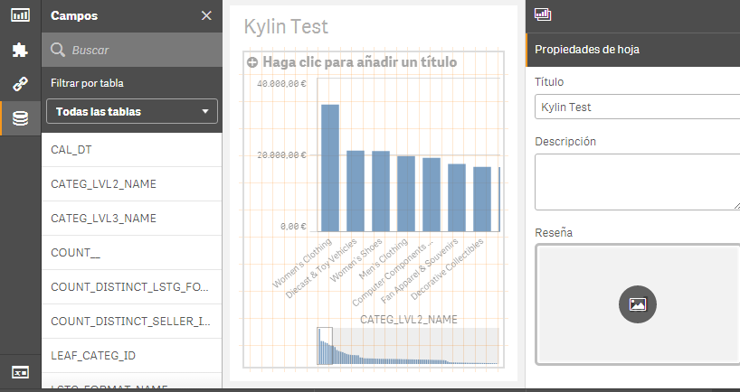
You can View the result from main menu:
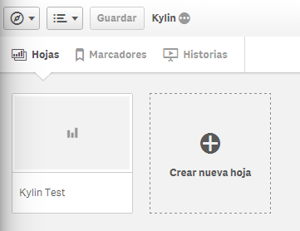

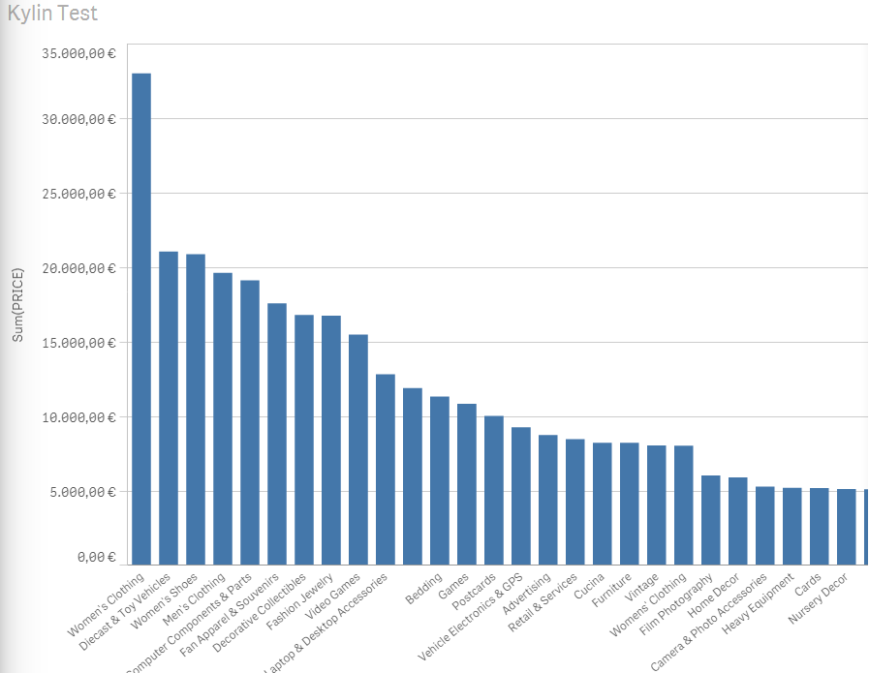

Future Work
- Load data using “load script” is a workaround to read data from Apache Kylin, but like data isnt’t controlled by Data Manager you can’t use the preview of data (manual reference) (Qlik Community)
- Same problem with “associations”, you can’t manage/change because this data aren’t managed by Data Manager
This problems means, if your automatic associations aren’t correct, the data results will be false

For any suggestions, feel free to contact me
Thanks, Alberto

