Use SQuirreL with Apache Kylin
Date: October 2016
Updated : Dicember 2016
Author: Ramón Portolés, Alberto Linkedin

Intro
SquirreL SQL is a multi platform Universal SQL Client (GNU License)
You can use it to access HBase + Phoenix and Hive

Used Software
- Kylin v1.5.2 & ODBC 1.5
Update Dic 2016: Kylin 1.6.0 & ODBC 1.6.0 Work OK
- SquirreL SQL v3.7.1

Pre-requisites
- We need to find the JAR Class for the JDBC Connector
From Kylin Download, Choose Binary and the correct version of Kylin and HBase
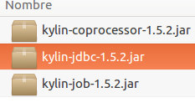
Download & Unpack: in ./lib:

- We need an instance of Kylin, with a cube: Quick Start with Sample Cube, will be enough
You can check:

- Dowload and install SquirreL, you will need Java

Add Kylin Driver
On left menu: > > >
And locale your JAR:
Configure this parameters:
- Put a name:
- Example URL
jdbc:kylin://172.17.0.2:7070/learn_kylin
- Put Class Name:
TIP: If auto complete not work, type you: org.apache.kylin.jdbc.Driver
Check in your Driver List:

Add Aliases
On left menu: > : (Login pass by default: ADMIN / KYLIN)
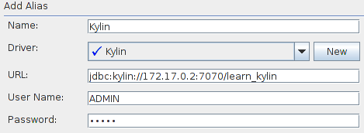
And automatically launch conection:
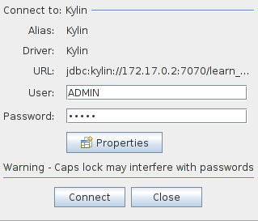

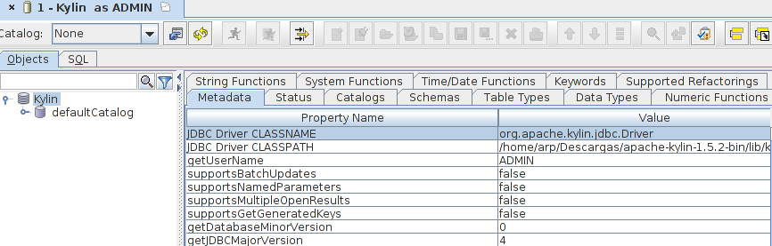
Connect and Execute
The startup window when you are connect:

Choose Tab: and write your querie (whe use Kylin’s example cube):
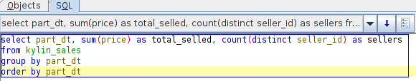
select part_dt, sum(price) as total_selled, count(distinct seller_id) as sellers from kylin_sales group by part_dt
order by part_dt

Execute With:
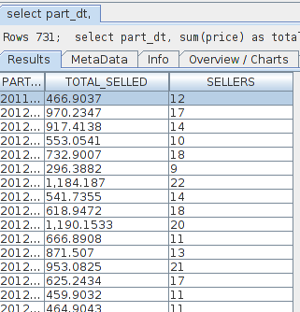
And it’s works, OK 

Extra: Some tips:
SquirreL isn’t the most stable SQL Client, but its very flexible and get you a lot of info
I use it for PoC and try to solve / check connectivity problems

List of Tables:
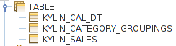

List of Columns of table:
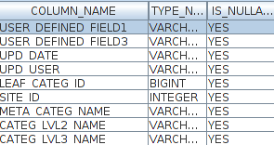

List of column of Querie:
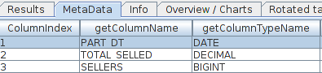

Export the result of queries:
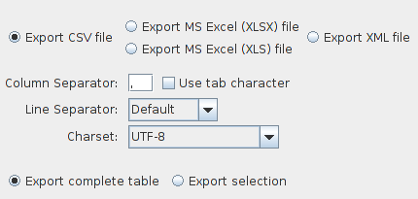

Info about time query execution:
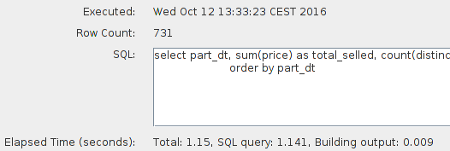

For any suggestions, feel free to contact me
Thanks, Alberto

