Use Apache Kylin With Caravel

Date: August 2016
Author: Ramón Portolés, Alberto Linkedin

Intro
Caravel is a UI for data exploration:

- Developed by Airbnb
- Originally intended for Druid, to support other databases uses SQLAlchemy
- Some Picture examples: 1 2
Forked by Rocky Qi (https://github.com/rocky1001/caravel) to support Kylin
pykylin: Wu Xiang makes an interface (python → Kylin), using SQLAlchemy
PyHive: Dropbox makes an interface (python → Hive), using SQLAlchemy

Also there is connectors for: Teradata, SQL Server, MySQL, Google SQL, PostgreSQL, Sybase, Firebird, Oracle, ...

References:
- Open source data visualization tools (For Apache Kylin) Description
- OLAP + open source data visualization tools -For Apache Kylin

Used Software
- Kylin: 1.5.2
- Caravel Kylin 0.9.0
- pykylin
- python 3

Pre-requisites
- We need an instance of Kylin, with a cube: Quick Start with Sample Cube, will be enough

You can check:
- Also need Python 3.x
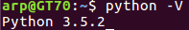

NOTE For Ubuntu systems:
which python
ls -la /usr/bin/python
sudo rm /usr/bin/python
sudo ln -s /usr/bin/python3 /usr/bin/python
Before:
After:

- Check pre-requirites of Caravel for your S.O
Debian / Ubuntu:
sudo apt-get install build-essential libssl-dev libffi-dev python-dev python-pip

Fedora / RedHat (You will need add EPEL7)
sudo yum upgrade python-setuptools
sudo yum install gcc libffi-devel python-devel python-pip python-wheel openssl-devel

Install Caravel
- Download & install Caravel
mkdir caravel
cd caravel
wget https://github.com/rocky1001/caravel/archive/master.zip
unzip master.zip
cd caravel-master
pip install . #installing Kilin Caravel (Note the dot at the end)
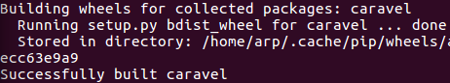

- Initialize Caravel:
Execute this commands:

fabmanager create-admin --app caravel # Create admin user
caravel db upgrade # Initialize the metadata database
caravel init # Create default roles and permissions
caravel load_examples # Load some data to play with

My Config: ADMIN / KYLIN
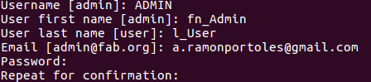
- Start Caravel web server on port 8088
sudo env "PATH=$PATH" caravel runserver -d -p 8088 #ubuntu
sudo caravel runserver -d -p 8088 #centos
Connecto to: http://localhost:8088/login/

Issue1: Error PIP: No module named ‘pip’
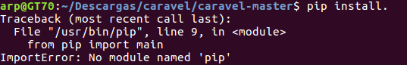
If you are in Ubuntu you need install pip3:
sudo apt-get -y install python3-pip
pip3 #check install
pip3 install . # remember the dot at the end

Issue2: Segment Violation
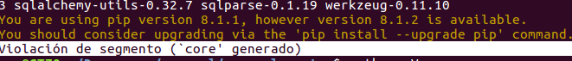
In my Ubuntu 16.04 I solved upgrade pip package:
pip install --upgrade pip
pip -V #pip 8.1.3

Issue3: Can’t find fabmanager
In my Ubuntu: pip install all dependencies of Carabel, but didn’t do in my actual path
To solve:
sudo find / -name fabmanager* #To find the actual path of file
#In my case: /home/arp/.local/bin/fabmanager
export PATH=$PATH:/home/arp/.local/bin/ #You can put in you .bashrc
fabmanager –help # To check the command

Issue4: Connection is use
If you see this:
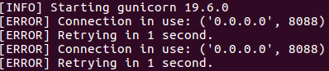
Solution:
lsof -i:8088 #To find the PID which use the port 8088
kill xxx
lsof -i:8088 #to re-check

Issue5:Address already in use
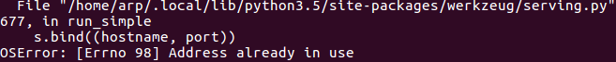
Solution:
ps -fA | grep python #to find PIDs
sudo kill xxx
ps -fA | grep python #to re-check

Issue6: ERROR:flask_appbuilder.base:Add Permission on Menu Error
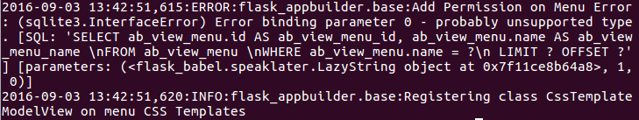

Issue7: Failed Building Wheel for cryptography
Failed Builing Wheel for pandas
SOL:
apt-get remove python-cff -y
pip install --upgrade setuptools
pip install --upgrade cryptography

Test of Caravel:
Connect to http://localhost:8088/login/ (KYLIN /ADMIN)
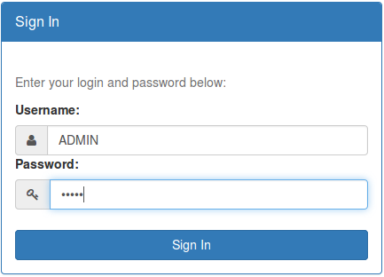
>

Issue1: The load of Web page show this:

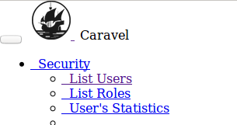
- Install npm pakage, (for ubuntu):
sudo apt-get update
sudo apt-get install nodejs
sudo apt-get install npm
npm #check npm is in you path
- Build & configure npm pakages of Caravel
cd caravel-master/caravel/assets
npm install
npm run prod
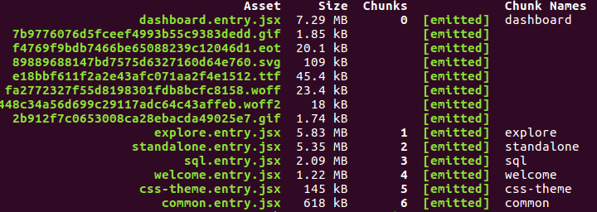

Issue2: Error on “npm run prod”
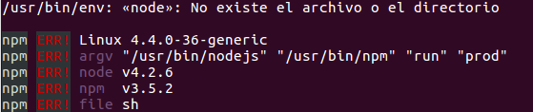
Is an error in Ubuntu Path: Link, to solve:
sudo ln -s /usr/bin/nodejs /usr/bin/node

Issue3: Error in /caravel-select2.js
Is a Bug detected in Airbnb Carbel (2016/Jul/15) , still unresolved in Kylin Caravel (Sep 2016)
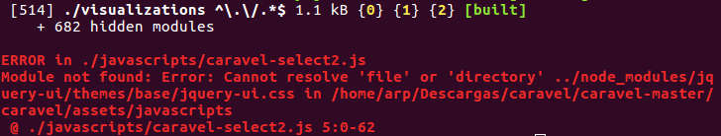
To solve:
rm -rf /node_modules/jquery-ui
npm i jquery-ui@1.10.5 --save
npm run prod #now must be work fine :)

Create Connection

Fallo
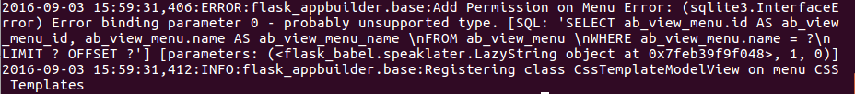

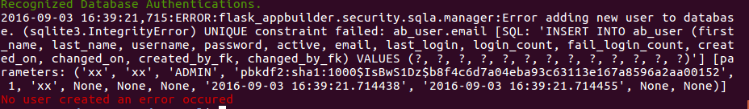

Other TIPs:

How-to: List Admin user
fabmanager list-users --app caravel
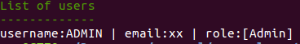

How to: Unistall Caravel
sudo pip uninstall caravel
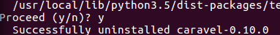

How-to: check if XX pkg has been install by user or root
If executable.py is on /usr/local/bin or /user/local/lib/python ==> has been installed by root
If executable is on /home/arp/.local/lib/python3/site-packages ==> has been installed by user

How to unistall all Caravel dependencies:
sudo pip uninstall -y cryptography
sudo pip uninstall -y flask-appbuilder
sudo pip uninstall -y flask-cache
sudo pip uninstall -y flask-migrate
sudo pip uninstall -y flask-script
sudo pip uninstall -y flask-testing
sudo pip uninstall -y flask-sqlalchemy
sudo pip uninstall -y humanize
sudo pip uninstall -y gunicorn
sudo pip uninstall -y markdown
sudo pip uninstall -y pandas
sudo pip uninstall -y parsedatetime
sudo pip uninstall -y pydruid
sudo pip uninstall -y python-dateutil
sudo pip uninstall -y requests
sudo pip uninstall -y simplejson
sudo pip uninstall -y six
sudo pip uninstall -y sqlalchemy
sudo pip uninstall -y sqlalchemy-utils
sudo pip uninstall -y sqlparse
sudo pip uninstall -y werkzeug
sudo pip uninstall -y Flask-Cors
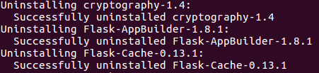

How-to: Find metadata DB
- Open: ./caravel/config.py
- Find Line:

How-to: Metadata DB Problems
If you Initialize Caravel Several times, you will see this errors
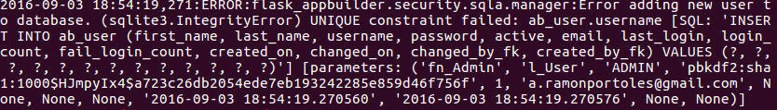
We can’t insert Duplicate registers
My solution is: Delete metadata DB (See ‘How-to: Find metadata DB’, to find) and init this DB

Final test:
1º On Ubuntu: I tested branch = 0.9 and branch= “caravel-kylin”
The ERROR msg of SQL duplicate … SQL error column …. SQL error cast ==> Disappear :)
But some pages of UI didn’t work: See video 1

2º On Ubuntu: I tested Airbnb Caravel
Worked fine: See video 2

3º On Centos: Tested branch = 0.9

