How to use Hue with Sisense

Date: August 2016
Author: Ramón Portolés, Alberto Linkedin

Intro
Sisense, It’s a BI software (similar to Tableau), on-line demo and Video Examples
Reference

Used Software:
- Apache Kylin v1.5.2
- Sisense v6.4.1
- Kylin ODBC Driver v1.5

Pre-requisites
- We need an instance of Kylin, with a cube: Quick Start with Sample Cube, will be enough

You can check:

- Download Install and configure Kylin ODBC Driver
  - Install Kylin ODBC
  - Add DNS System in Windows
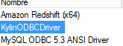
  - And configure: User-name /Password: ADMIN / KYLIN
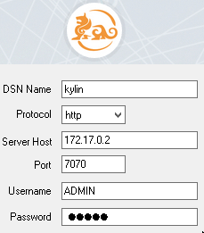
  - Click Connect and Choose the project

Click on “Done”

Create New DashBoard
- Create new dashboard
 >  > 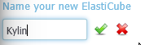

- Add external data-source
 > > > > >

- Add tables:

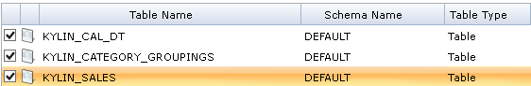
Nowadays, There is a small issue with get metadata: MailList
We can solve this with >
and re-write the select without “[DEFAULT]”

- a

