Providing Guidance to Software Developers on Selecting Usability Methods through Usability Planner
Xavier Ferre¹, Nigel Bevan²

1 Universidad Politecnica de Madrid  Campus de Montegancedo  28660 - Boadilla del Monte (Madrid)  Spain  xavier.ferre@upm.es | ² Professional Usability Services  12 King Edwards Gardens  London W3 9RG  UK  mail@nigelbevan.com
Abstract. There is a growing interest in the software development world about adequately managing the usability of the software products produced. HCI (Human-Computer Interaction) literature offers a variety of usability techniques to apply in the development of interactive systems. Software developers with a software engineering background encounter a high difficulty in interpreting, selecting, and integrating these usability methods in the overall software development process. Usability planner offers guidance on usability method selection by providing a categorization of techniques by the software process stage where they are applicable, and filtering the variety of techniques for each stage according to project and organizational constraints.
Keywords: usability-software engineering integration, usability techniques in the software development process, UCD method selection
- Introduction
Software development organizations need to cater for a variety of quality attributes in the software products they build. Among them, usability has been receiving a greater deal of attention in the last decade.
The growing emphasis on usability may be related to the increasingly wide use of systems by the general public, and the need to deal with the user experience in consumer products. But there is also a wider acceptance of usability techniques in companies developing software systems as a way to obtain higher quality systems, and of UCD (User Centered Design) as the approach to build systems with a high usability level. As a result, more and more companies have started paying attention to the usability of their products, raising their awareness about usability and UCD, and investing resources in introducing usability practices in their day to day practice [15].
When faced with the need to increase the usability level of their products, software development teams and organizations face some obstacles that hinder the integration of usability practices into their development processes. In the first place, there is a terminology breach and a disparity in the concepts handled between SE (software engineering) and HCI (Human-Computer Interaction) [4], in particular in terms of software process descriptions. For example, the term ‘method’ is used with slightly different meanings in HCI and SE. A method in HCI can be applied in conjunction with other methods to fulfil the objectives of a particular activity in an UCD process. For example, brainstorming is a method that can be applied for understanding the context of use, and it can be combined with other methods like field observations. On the other hand, a ‘method’ in SE implies “a notation (or set of notations) supported by a process which guides the application of the notations” [7], suggesting a more organized set of activities, and typically at a higher level than HCI methods. We can say that the term ‘technique’ in SE is typically used to refer to a similar level of detail as HCI methods, according to its usage in the SWEBOK (Software Engineering Body of Knowledge)[7]. We will use in this paper the term ‘method’ in the HCI/UCD sense.
Additionally, there is a great variety of existing usability techniques to be considered. For example, [3] identified 95 different techniques described in six different books. It is not surprising that UCD structure and techniques are not very well known and difficult to master for common developers and small and medium-sized development teams [11].
Usability Net [13] offers a good overview of UCD for a software developer. It presents an organized view of usability practices, but it does not offer specific guidance in the process of selecting usability methods appropriate for a particular context.
ISO documentation provides some guidance for the problem of usability method selection. In the first place, ISO PAS (Publicly Available Specification) 18152:2003 [8] offers a process framework that would allow a software engineer to understand the basics of the UCD overall process approach. It can serve for understanding the advice contained in the ISO TR (Technical Report) 16982 [9], which specifically addresses the issue of UCD method selection. ISO TR 16982 offers recommendations on categories of methods to be applied considering specific project, user, task and product characteristics, along with the availability of usability expertise. Nevertheless, these ISO documents are not straightforward to use in a practical situation, they are quite academic, as the Special Interest Group in Software Testing from the British Computer Society [1] highlights.
Usability Planner is an online tool [14] that has been conceived for offering advice on usability method selection through a highly practical approach. It is based on the recommendations present in ISO TR 16982, supplemented with the author’s experience in usability integration in software engineering development processes. In order to help in the choice of the stages where usability methods are to be planned, the base practices in ISO PAS 18152 are linked to each stage offered in the tool.
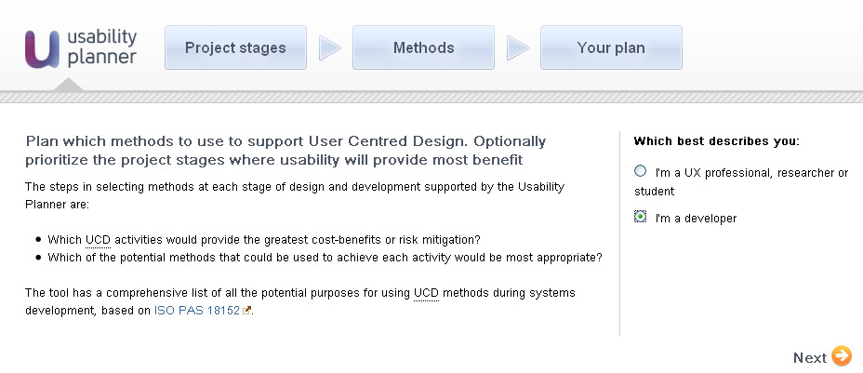
The tool offers two versions (see Fig. 1): A version addressed to users belonging to the HCI field, aimed to help them to introduce new techniques they are not that familiar with; and a version addressed to software developers, which offers a set of stages based in a SE software process view. We will focus on the latter version in this paper.
Fig. 1. Home page of the Usability Planner tool.
We consider that the version addressed to software developers can be also valuable to students with a SE background following an introductory HCI course.
- Software Development Process Stages
Software development processes vary from organization to organization, and even from one software development team to another. Nevertheless, for offering advice on usability techniques to be applied, we have to resort to a generic iterative software process, so that the description of software process stages is easily recognizable for a software engineer. Even if an organization or team uses a specific terminology in terms of stages, such specific terminology should be easily fitted into the generic stages used in Usability Planner.
We have chosen a basic set of four stages, to make them generic enough to be fitted into more fine-grained processes. The following set of four stages and their description to the tool user are based on the RUP (Rational Unified Process) phases, adapted from the RUP description in [10] and [5]:
- Inception: During inception, you establish the business rationale for the project and decide on the scope of the project. This is when you get the commitment from the project sponsor to go further. Therefore, the focus is on handling the risks related to the business case: Is this project financially worthy? Is it feasible?
- Elaboration: In elaboration, you collect more detailed requirements, do more extensive design and you establish the baseline software architecture. The main focus is on the technical risks, exploring the main technical decisions, and maybe revisiting the scope again, as the requirements become better understood.
- Construction: During construction, you carry out the mass of work for detailed design and implementation activities. The focus is on the "logistical" risks; on making every design decision taken previously fit into the built system. The result of this stage is something that can be installed at the end’s user workplace, which can be part of the system or the whole system.
- Deployment: In the deployment stage, you handle the risks associated with the logistics of deploying the product to its user base, and it also includes monitoring the use of the system when already installed. It can include activities like beta testing, performance tuning, and user training.

The user will be asked for which of these stages he or she plans to introduce usability methods in the software process (see Fig. 2). The advice on the particular methods suggested will be structured according to the stages selected.
- Constraints to Produce the Recommended Usability Plan
Usability Planner offers its guidance on usability technique selection particularized to the specific constraints of a particular project and organization.
The constraints considered are based in ISO TR 16982, with some rephrasing after iteratively evaluating low-level prototypes of Usability Planner with usability professionals.
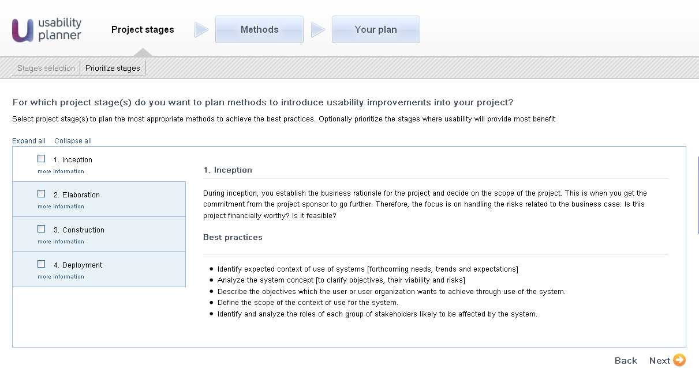
Fig. 2. Selection of process stages where to introduce usability techniques.

The tool gives real-time feedback to the user on the prioritized list of usability methods recommended according to the particular constraints selected. Some methods are taken out of the list when certain constraints are set, while others just change their degree of appropriateness, illustrated by stars besides each method (see Fig. 3).

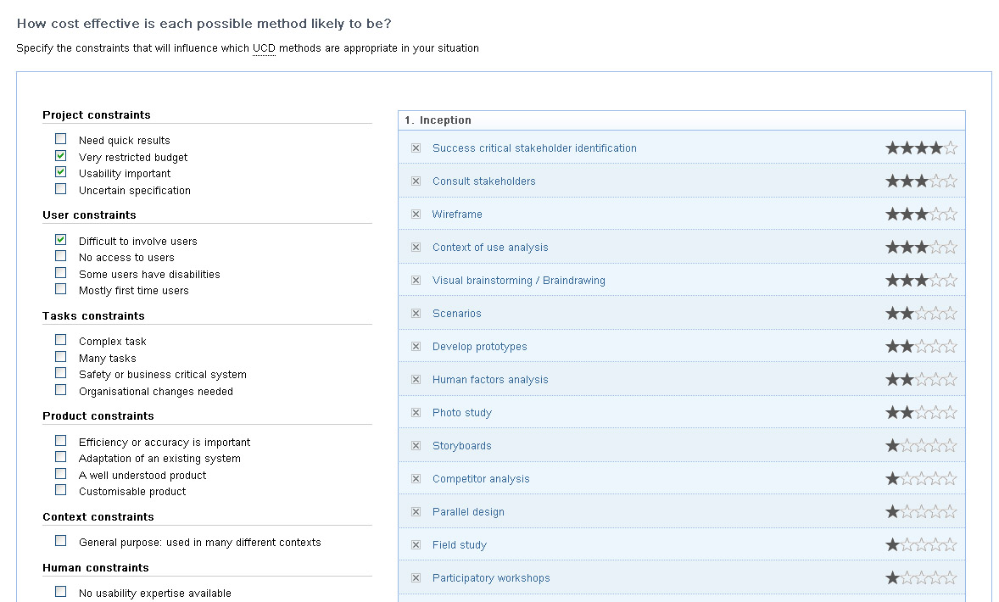
Fig. 3. Setting constraints to produce a specific recommendation of methods.

The user may get a description of any particular method clicking on its name (see Fig. 4). Where available, a link to the preview of the Usability Body of Knowledge [12] is also provided to offer additional information. If the user decides not to apply several methods there is the possibility of deleting them, so that the final plan only contains the methods the user has chosen from the selection of methods recommended by Usability Planner.

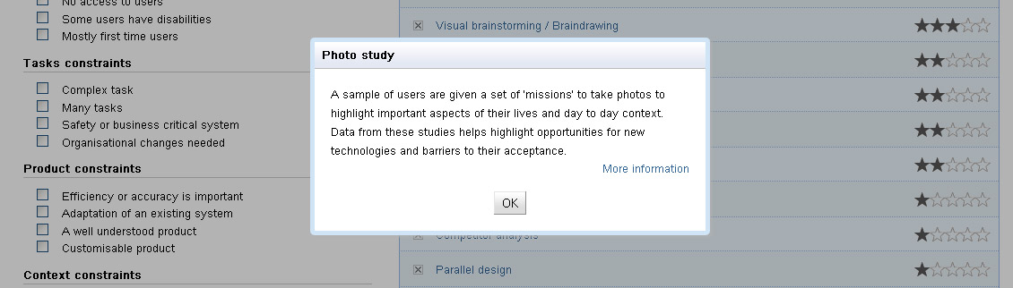
Fig. 4. Description of the Photo study method.
The final usability plan presents the list of methods suggested - and not deleted by the user - organized according to the considered project stages (see Fig. 5).
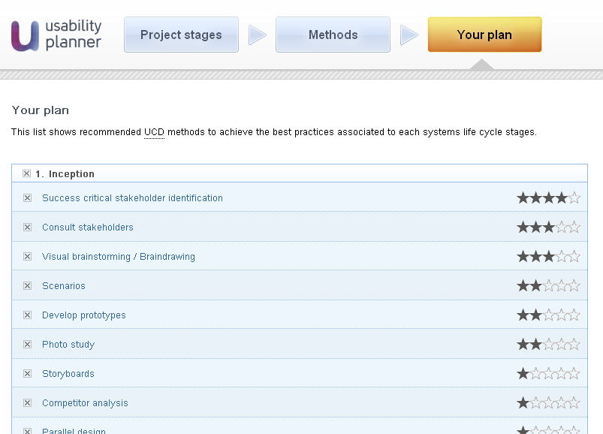
Fig. 5. Usability plan gathering the recommendations of the tool.
- Evaluation
Previous versions of the tool (with only the version for users coming from an HCI background) have been tested in different venues, including the NordiCHI 2010 conference [2]. The feedback gathered has been positive in terms of the tool usefulness, and it has allowed for a refinement of the tool up to the current version.
The possibility of adapting the set of weights used by the tool to the particularities and experience of a given company or usability expert were highlighted as a positive feature of the tool.
The tool has been offered to students following an elective Interaction Design course, part of a SE Master degree. One of the objectives of the course is that the student is able to map usability activities and techniques to software engineering practices from a software development process perspective. For this purpose the students have been asked in a first phase to select usability methods to apply in a concrete practical project they will work into, by means of a bibliographical research. In a second phase they have been requested to re-evaluate their decision on method selection after applying them, and they have been offered the possibility of using Usability Planner as a source for this latter assignment.
The feedback from the nine students who have chosen to use the tool highlights its usefulness for the purpose of selecting UCD methods. They have also pointed out possible improvements for usage in a learning environment, like the possibility of giving more prominence to certain methods that should be chosen in almost every class project. Additionally, some misunderstandings with the meaning of the star ranking will have to be considered for the design of the next version of the tool.
As mentioned above, we consider that the tool may be of interest to a wide range of possible users, including software developers with interest in usability and UCD; HCI students; and junior usability professionals. Even senior usability professionals may have interest in the tool as a support to push the adoption of usability practices into organizations. Nevertheless, further evaluation is needed to get evidence of the tool utility for different groups of users.
- Conclusions
Usability Planner is offered freely as a web tool to anyone needing support in the decision of which usability methods to apply in the development of interactive systems, according to the particular constraints for the project or organization. The code will be offered as an open source license (GNU General Public License, version 3 [6]), to ease the possible extension of its functionality and to favour its use.
While the tool initially embodies the knowledge of the authors, this will be refined by iterative evaluation. The content is customizable so that expert HCI consultants may employ their expertise modifying the criteria for method selection present in the tool to match their own situation.
The preliminary evaluation of the tool has offered promising results about its usefulness.

The next steps for improving the tool in future versions include:
- Offering the possibility of saving the current project to allow sending a usability plan to colleagues, or to re-evaluate selection decisions in another session.
- Refining the set of methods and criteria, and the internal weighting, to improve the quality of the recommendation, comparing the output of the tool to recommendations by usability professionals.
- More formal evaluation of the usefulness and usability of the tool for the intended users, in particular for practitioners with a software engineering background.
- Including an easily understandable way of grouping particular methods to be applied in a stage according to UCD terminology, to allow easier communication between software engineers and usability professionals.

References
- BCS SIGiST: Usability Guidelines www.testingstandards.co.uk/usability_guidelines.htm (2006)
- Ferre, X., Bevan, N. & Escobar, T.A.: UCD Method Selection with Usability Planner. Proceedings of NordiCHI 2010 (2010)
- Ferre, X., Juristo, N., Moreno, A.M.: "Framework for Integrating Usability Practices into the Software Process". Lecture Notes in Computer Science. 6th Int. Conf. on Product Focused Process Improvement (PROFES 2005), vol. 3574, pp. 202-215 (2005)
- Ferre, X., Juristo, N. & Moreno, A.M.: Obstacles for the Integration of HCI Practices into Software Engineering Development Processes. In C. Ghaoui, ed., Encyclopedia of Human-Computer Interaction. Idea Group Reference, 2006, pp. 422-428.
- Fowler, M., Scott, K.: UML distilled 2nd. Ed. Addison-Wesley, Boston (2000)
- GNU. General Public License version 3 http://www.gnu.org/licenses/gpl.html (2007)
- IEEE Computer Society Professional Practices Committee. "Guide to the Software Engineering Body of Knowledge - 2004 Version". IEEE Computer Society, Los Alamitos (CA), USA, 2004.
- ISO/PAS 18152: A specification for the process assessment of human-system issues. ISO, Geneva (2003)
- ISO/TR 16982: Usability methods supporting human-centred design. ISO, Geneva (2002)
- Kroll, P., Kruchten, P.: The Rational Unified Process Made Easy. A Practitioner’s Guide to the RUP. Addison-Wesley, Boston (2003)
- Seffah, A. and Metzker, E.: The obstacles and myths of usability and software engineering. Communications of the ACM. Vol. 47, 12, pp. 71-76 (2004)
- Usability Body of Knowledge (preview) http://www.usabilitybok.org/ (2010)
- Usability Net: Tools and Methods http://usabilitynet.org/tools.htm (2006)
- Usability Planner tool http://usabilityplanner.org/ (2011)
- Venturi, G., Troost, J., Jokela, T.: People, Organizations, and Processes: An Inquiry into the Adoption of User-Centered Design in Industry. International Journal of Human-Computer Interaction, 21(2), 219-238 (2006)

