## Rafting Site - Planning Document

### Logo

(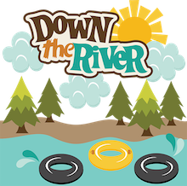.)

### Color Palette

- **primary-color**: #264653

- **secondary-color**: #2a9d8f

- **accent1-color**: #e9c46a

- **accent2-color**: #f4a261

### Typography

- **heading-font**: Merriweather

- **text-font**: Roboto

### Color Palette URL (Coolors.co)

https://coolors.co/264653-2a9d8f-e9c46a-f4a261