4. Results
Following the protocol outlined in section 3.2, we evolved 100 networks for each of the seven variants of the model. For all networks, we set network size to 2000 nodes; ; and . These choices are discussed in the appendix.

4.1. Goodness-of-fit of the power-law model
For each network evolved we computed two best-fit power-law models, one for and the other forhere is the in-degree the minimizes the Kolmogorov-Smirnov distance between the fitted function and the data over . On each of these models , we ran a goodness-of-fit test as described in section 3.2. This resulted in two distributions of p-values for our control group, plus two more for each of our six treatment groups. Table 3 and 4 report descriptive statistics for these distributions.
Table 1: Testing for goodness-of-fit of power-law models to in-degree distributions of interaction networks in online communities, with no onboarding (control group) and with onboarding. The parameter nu1 approximates "effectiveness" of onboarding, i.e. the ability of moderators to move newcomers to reach out to the community. The parameter nu2 represents community responsiveness, i.e. the probability that the newcomer's efforts in approaching a community member will be reciprocated. Power-law models are estimated over all nodes with degree k>=1
Table 2: Testing for goodness-of-fit of power-law models to in-degree distributions of interaction networks in online communities, with no onboarding (control group) and with onboarding. The parameter nu1 approximates "effectiveness" of onboarding, i.e. the ability of moderators to move newcomers to reach out to the community. The parameter nu2 represents community responsiveness, i.e. the probability that the newcomer's efforts in approaching a community member will be reciprocated. Power-law models are estimated over all nodes with degree k>=1
Table 3: Testing for goodness-of-fit of power-law models to in-degree distributions of interaction networks in online communities, with no onboarding (control group) and with onboarding. The parameter nu1 approximates "effectiveness" of onboarding, i.e. the ability of moderators to move newcomers to reach out to the community. The parameter nu2 represents community responsiveness, i.e. the probability that the newcomer's efforts in approaching a community member will be reciprocated. Power-law models are estimated over all nodes with degree k > kmin, where kmin is the value of k that minimizes the Kolmogorov-Smirnov distance between the fitted power-law model and the generated data.
Table 4: Testing for goodness-of-fit of power-law models to in-degree distributions of interaction networks in online communities, with no onboarding (control group) and with onboarding. The parameter nu1 approximates "effectiveness" of onboarding, i.e. the ability of moderators to move newcomers to reach out to the community. The parameter nu2 represents community responsiveness, i.e. the probability that the newcomer's efforts in approaching a community member will be reciprocated. Power-law models are estimated over all nodes with degree k > kmin, where kmin is the value of k that minimizes the Kolmogorov-Smirnov distance between the fitted power-law model and the generated data.
From tables 3 to 6, we conclude that onboarding seems to have some effect on the goodness-of-fit of the generated data to their respective best-fit power-law models when . The effect goes in the direction of reducing the p-values, and therefore increasing the probability that the power-law model will not be a good approximation of the interaction network's in-degree distribution. On the other hand, there does not seem to be a significant effect on the in-degree distribution's tail; whether onboarding is present or not, we cannot reject Hypothesis 2 for the great majority of the interaction networks generated when. We confirmed this result, which is in accordance with the theory, by regression analysis, detailed in the appendix.
It is worth it to examine in more detail the behaviour of the in-degree distributions of our simulated interaction networks over the whole support . Preliminary visual inspection of Illustration 1 reveals that the plotted in-degree distributions look remarkably similar to those of the real-world online communities mentioned in section 3.1.
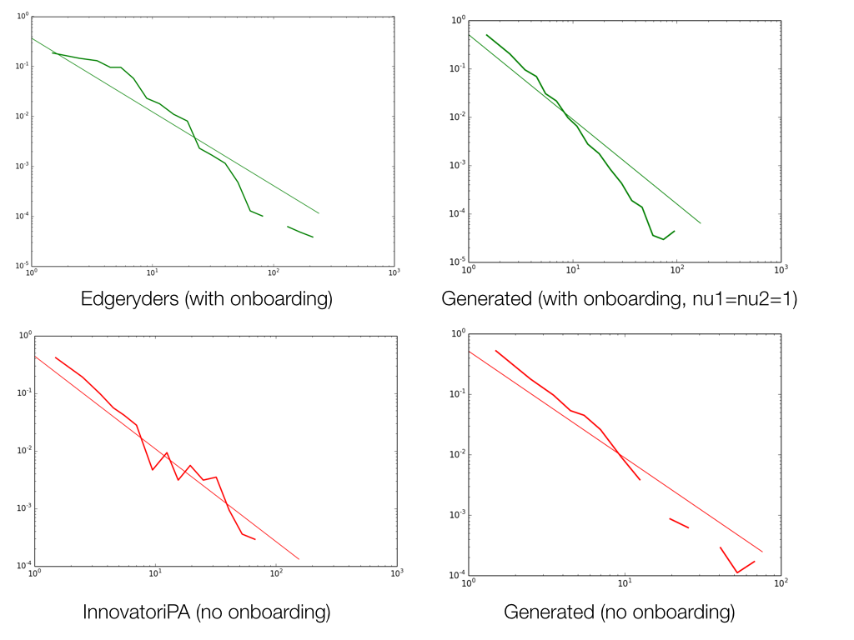Illustration 1: Probability density functions of the interaction networks across four online communities, with onboarding (top) and without (bottom). The in-degree distributions on the left refer to real-world online communities; the ones on the right to simulated ones. We picked a network at random out of the we 100 simulated with no onboarding, and another one from the 100 we simulated with “perfect” onboarding, i.e. .

Visual inspection of the actual graph, however, reveal a fundamental dissimilarity: interaction networks from real-worls online communities display a clearly visible community structure, whereas those from our simulation do not.
On closer examination, turns out to play a greater role than in driving the model. In illustration 2 we show the cumulate density function of the p-values in the control and treatment groups; in the latter, we plot a curve for each value of , independently of the value of .
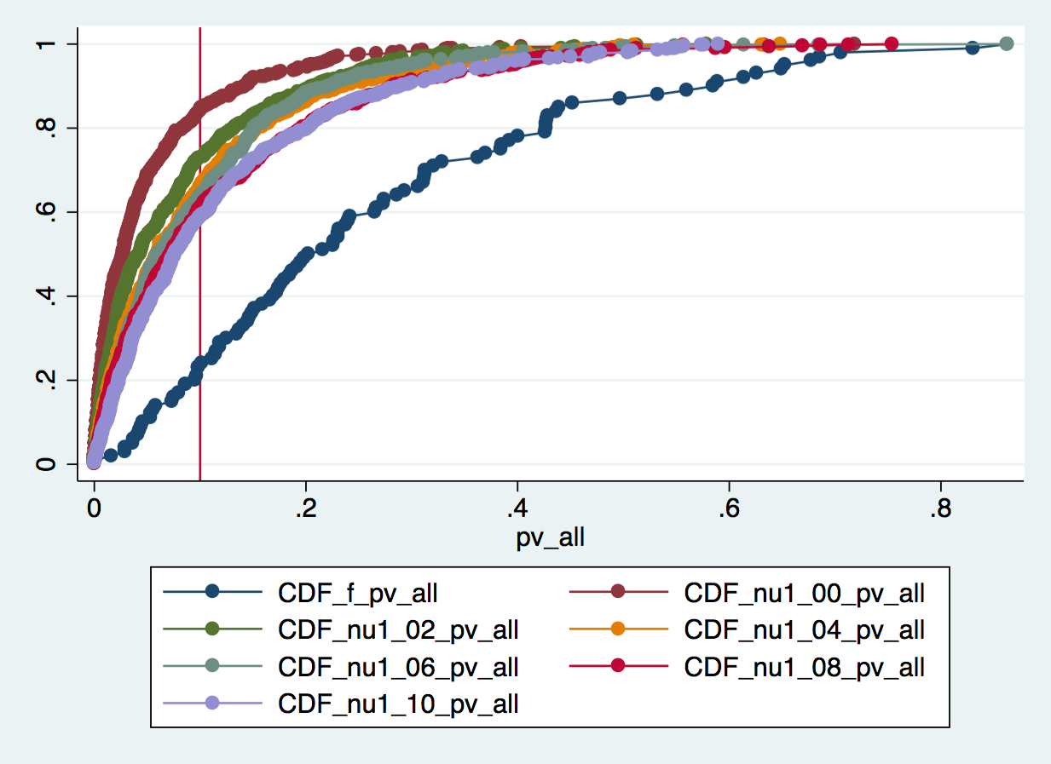Illustration 2: Cumulate Density Functions of p-values without onboarding (dark blue) and with onboarding. A curve is plotted for each value of from 0.0 to 1.0.
20% of the networks evolved without onboarding (dark blue) have degree distributions that test negatively for Hypothesis 1. When onboarding is introduced, that percentage rises to between 50 and 90%. The percentage of rejections declines as the onboarding effectiveness parameter grows.
Illustration 3 repeats the same operations as illustration 2, but this time, in the treatment group, we plot a curve for each value of , independently of the value of .
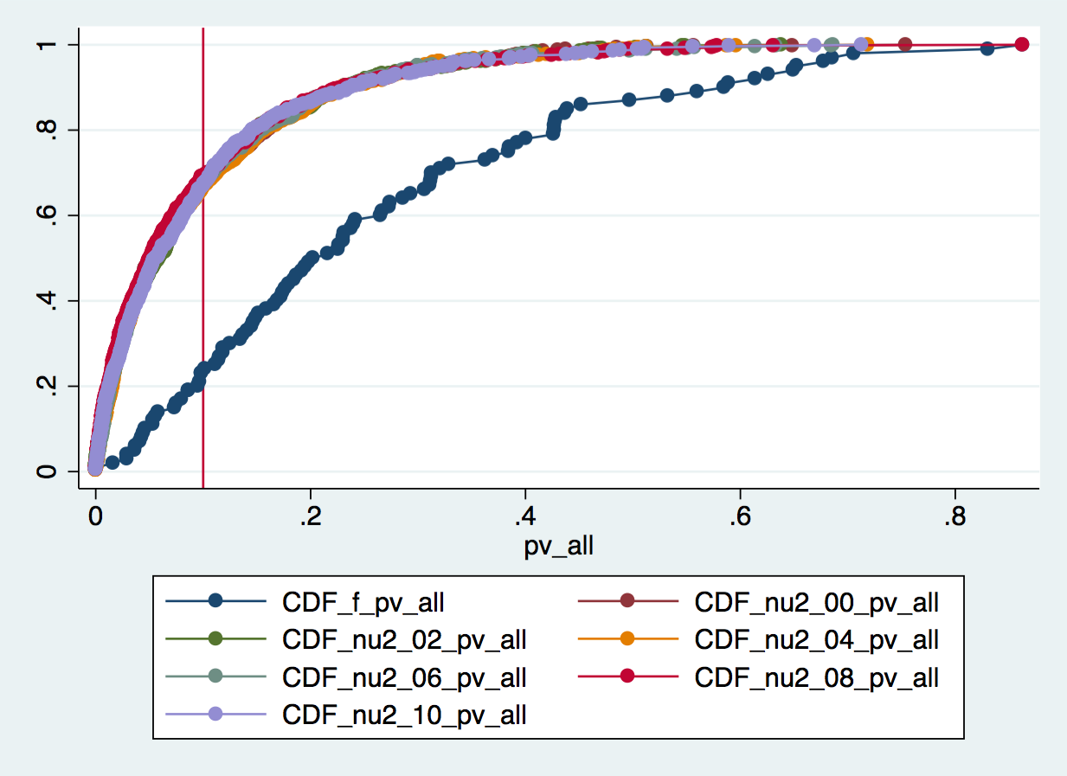Illustration 3: Cumulate Density Functions of p-values without onboarding (dark blue) and with onboarding. A curve is plotted for each value of from 0.0 to 1.0.
Illustration 4: Cumulate Density Functions of p-values without onboarding (dark blue) and with onboarding. A curve is plotted for each value of from 0.0 to 1.0.
The difference between control and treatment groups remains clearly marked, but variations in the community responsiveness parameter seem to make no further difference to the probability of rejecting Hypothesis 1 in any given run of our simulation model.
We confirm the impression from visual inspection by regression analysis. First, for each value assigned to we build a dummy variable that takes value 1 when the simulated interaction network was generated by a model where takes that particular value, and 0 otherwise. We next do the same for . Next, we run a regression with the p-value of the best-fitting power-law model for as the dependent variable. As regressors, we use all the dummy variables, as well as their interaction terms. We use and as baselines. We obtain the following results:
- All coefficients on dummy variables representing different values of , except the one representing , are positive and statistically significant at the 0.05 confidence level.
- All coefficients on dummy variables representing different values of are non-significant.
- All coefficients on interaction terms between the two groups of dummy variables are non-significant.
Finally, we use F-tests to test for joint significance of all dummy variables representing different values of and all interaction terms respectively. In neither test can we reject the null hypothesis that the coefficients on, respectively, the dummy variables representing different values of and those representing the interaction terms between and are jointly equal to zero.
We conclude that:
- When onboarding policies are in place in an online community, they degrade the goodness-of-fit of the in-degree distribution of its interaction network to the power-law model. This effect is due to non-power -law behavior of low-connectivity nodes, whereas the distribution's tail maintains its power-law shape. This is hardly surprising; adding onboarding to on online community implies adding a second mechanism to allocate new edges in its interaction network, besides the “endogenous” one of preferential attachment. The edges driven by onboarding all target newcomers into the community – thus, by construction, zero-in-degree nodes. Such behavior at the micro level leaves its signature in the “head” of the in-degree distribution.
- When onboarding policies are in place, a greater onboarding effectiveness corresponds to a greater goodness-of-fit of the interaction network's in-degree distribution to the power-law model. Again, this is not surprising: by construction, effective onboarding leads to generating extra edges, the targets of which are allocated by preferential attachment; these extra edges “pull back” the degree distribution towards its power law shape.
- When onboarding policies are in place, a greater community responsiveness has no effect on the goodness-of-fit of the interaction network's in-degree distribution to the power-law model. This is somewhat counterintuitive: a greater community responsiveness means extra edges are generated, the sources of which are not allocated by preferential attachment, and we would have expected them to further pull the in-degree distribution away from the power-law model.

4.2. Lower bounds
Our results show a limited, albeit statistically significant, effect of onboarding on the value of , the value of that minimizes the Kolmogorov-Smirnov distance between the data generated by the computer simulation and the best-fit power-law model. Illustration 5 plots the cumulate density function of networks in the control group (dark blue) and the treatment group – in the latter, we plot a curve for each value of , independently of the value of . tends to be higher in the networks that received the onboarding treatment; about 60% of in-degree distributions in the control group fit the power-law model best for , against 30-40% in the treatment groups.
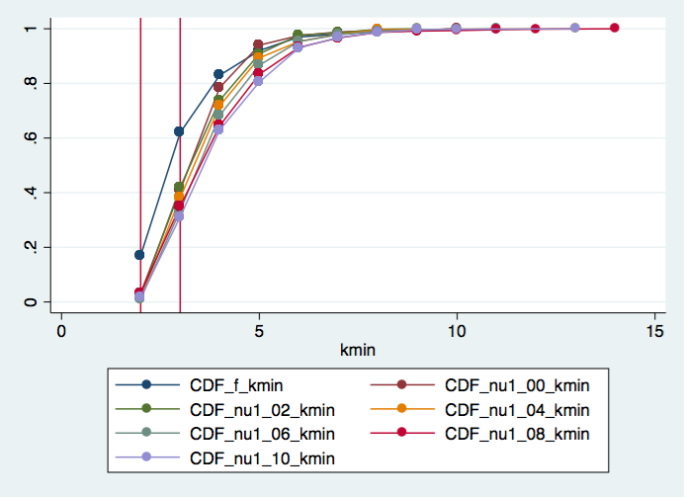Illustration 5: Cumulate Density Functions of the degrees at which networks exhibit power law behaviour. Over 60% of the networks evolved without onboarding (dark blue) approximate power-law models best when such power-law models are fitted with lower bound 3 or lower. When onboarding is introduced, that percentage decreases to between 30 and 40%.
Table 6 illustrates, for each batch of 100 networks in the treatment (each batch characterized by its own value pair), the average value of and the results of a t-test on the null hypothesis that vs the alternate hypothesis that .

Table 5: Values of in the control group and in the treatment group. The treatment group batches are divided by values of and .

4.3 Exponent
When considering only the tails of the in-degree distributions (), we find that introducing onboarding has a positive and significant on the value of the exponent. This is consistent with the theoretical results by Dorogovtsev and Mendes [16], who proved that introducing a fraction of non-preferential attachment edges in evolving networks with preferential attachment does not suppress power-law behaviour in its degree distribution, but only increases the scaling exponent thereof. Table 7 summarizes the results of t-tests on the null hypothesis that against the alternative hypothesis that , where is the scaling exponent.
[insert t-test table here]
Mimicking the procedure followed in section 4.1 for p-values, we performed regression analysis using the value of the power-law model's exponent as the dependent variable, with the dummy variables representing different values of and , as well as all their pairwise interactions, as independent variables. We found no evidence of any of them to be significantly different from zero. Next, we ran F-tests for joint significance of the groups of variables representing respectively, all different values of , all different values of , and all interaction terms. None of the three rejects the null hypothesis that the joint effect on the dependent variable of the group of independent variables being tested is null.

