Project 3 – Network Performance Measurement

CIIC 4070 – Computer Networks

Alberto I. Cruz Salamán

802-18-0591

Prof. Kejie Lu

Computer Science and Engineering

Table of Contents:

1. Introduction
2. Basics of iperf and jperf
3. Experiments using your own PC
4. Experiments to test a remote server
5. Conclusions
6. References
7. Introduction

This paper is a project for the CIIC 4070 course at UPRM. It will count as a partial exam in which the resulting product of the student’s investigative process showcases a developed result that encompasses the topics discussed in class. In it, the student is required to understand the usage of two different programs intended to measure network performance: iperf y jperf. Both will be used to measure the student’s computer connection with his modem and to measure the connection that it has with a remote server specified in the iperf/jperf sites and report the bandwidth and measurements obtained in each.

1. Basics of iperf and jperf

Iperf is a tool to measure the bandwidth, loss and other parameter of a specific IP network. It runs in a CLI (Command Line Interface) and supports analysis for the UDP and the TCP protocols. The latest released version is v3.1.3.

Jperf is a GUI interface executable for the Iperf tool. Coded in Java, it essentially reduces the complexity of writing the commands with several continuous flags and numbers and having to repeat the process in an “uncomfortable” development environment. Its latest version is the v2.0.2.

1. Experiments using your own PC

#################**TCP**#############################

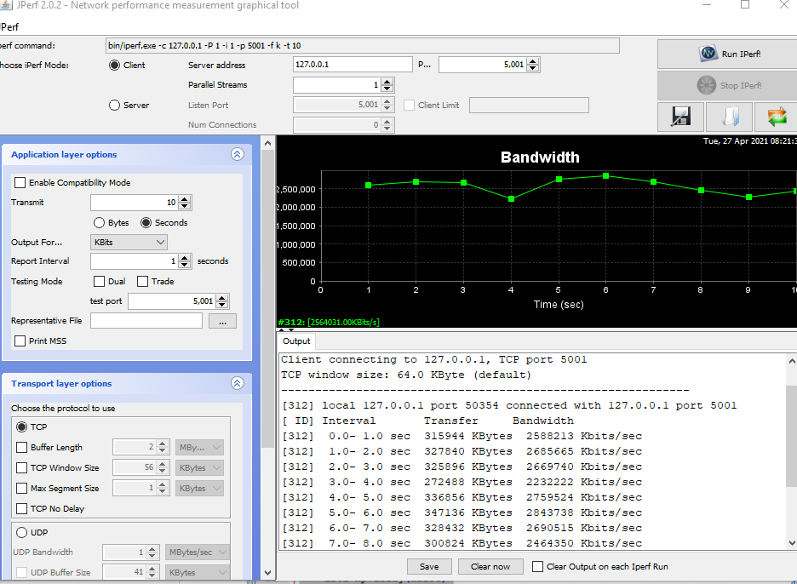

# SERVER

**iperf3.exe -s**

-----------------------------------------------------------

Server listening on 5201

-----------------------------------------------------------

Accepted connection from 127.0.0.1, port 50132

[ 5] local 127.0.0.1 port 5201 connected to 127.0.0.1 port 50133

[ ID] Interval Transfer Bandwidth

[ 5] 0.00-1.01 sec 456 MBytes 3.80 Gbits/sec

[ 5] 1.01-2.00 sec 480 MBytes 4.05 Gbits/sec

[ 5] 2.00-3.00 sec 539 MBytes 4.52 Gbits/sec

[ 5] 3.00-4.00 sec 491 MBytes 4.12 Gbits/sec

[ 5] 4.00-5.00 sec 452 MBytes 3.80 Gbits/sec

[ 5] 5.00-6.00 sec 528 MBytes 4.43 Gbits/sec

[ 5] 6.00-7.00 sec 657 MBytes 5.51 Gbits/sec

[ 5] 7.00-8.00 sec 388 MBytes 3.26 Gbits/sec

[ 5] 8.00-9.00 sec 397 MBytes 3.33 Gbits/sec

[ 5] 9.00-10.00 sec 606 MBytes 5.09 Gbits/sec

[ 5] 10.00-10.00 sec 0.00 Bytes 0.00 bits/sec

- - - - - - - - - - - - - - - - - - - - - - - - -

[ ID] Interval Transfer Bandwidth

[ 5] 0.00-10.00 sec 0.00 Bytes 0.00 bits/sec sender

[ 5] 0.00-10.00 sec 4.88 GBytes 4.19 Gbits/sec receiver

-----------------------------------------------------------

Server listening on 5201

-----------------------------------------------------------

# CLIENT

**iperf3.exe -c 127.0.0.1**

Connecting to host 127.0.0.1, port 5201

[ 4] local 127.0.0.1 port 50133 connected to 127.0.0.1 port 5201

[ ID] Interval Transfer Bandwidth

[ 4] 0.00-1.01 sec 457 MBytes 3.81 Gbits/sec

[ 4] 1.01-2.00 sec 480 MBytes 4.05 Gbits/sec

[ 4] 2.00-3.00 sec 539 MBytes 4.52 Gbits/sec

[ 4] 3.00-4.00 sec 491 MBytes 4.12 Gbits/sec

[ 4] 4.00-5.00 sec 452 MBytes 3.79 Gbits/sec

[ 4] 5.00-6.00 sec 528 MBytes 4.43 Gbits/sec

[ 4] 6.00-7.00 sec 657 MBytes 5.51 Gbits/sec

[ 4] 7.00-8.00 sec 388 MBytes 3.26 Gbits/sec

[ 4] 8.00-9.00 sec 396 MBytes 3.33 Gbits/sec

[ 4] 9.00-10.00 sec 606 MBytes 5.08 Gbits/sec

- - - - - - - - - - - - - - - - - - - - - - - - -

[ ID] Interval Transfer Bandwidth

[ 4] 0.00-10.00 sec 4.88 GBytes 4.19 Gbits/sec sender

[ 4] 0.00-10.00 sec 4.88 GBytes 4.19 Gbits/sec receiver

iperf Done.

#################**UDP**#############################

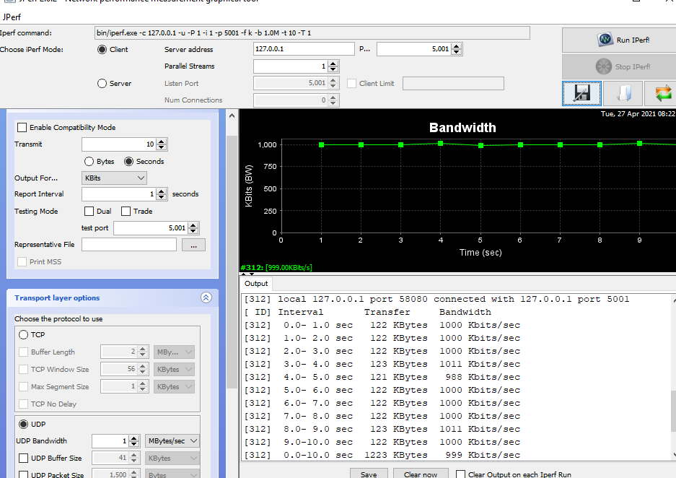

# SERVER

**iperf3.exe -s**

-----------------------------------------------------------

Server listening on 5201

-----------------------------------------------------------

Accepted connection from 127.0.0.1, port 50294

[ 5] local 127.0.0.1 port 5201 connected to 127.0.0.1 port 62702

[ ID] Interval Transfer Bandwidth Jitter Lost/Total Datagrams

[ 5] 0.00-1.00 sec 120 KBytes 979 Kbits/sec 0.125 ms 0/15 (0%)

[ 5] 1.00-2.00 sec 128 KBytes 1.05 Mbits/sec 0.221 ms 0/16 (0%)

[ 5] 2.00-3.01 sec 128 KBytes 1.04 Mbits/sec 0.267 ms 0/16 (0%)

[ 5] 3.01-4.01 sec 128 KBytes 1.05 Mbits/sec 0.294 ms 0/16 (0%)

[ 5] 4.01-5.01 sec 128 KBytes 1.05 Mbits/sec 0.358 ms 0/16 (0%)

[ 5] 5.01-6.01 sec 128 KBytes 1.05 Mbits/sec 0.428 ms 0/16 (0%)

[ 5] 6.01-7.00 sec 128 KBytes 1.05 Mbits/sec 0.468 ms 0/16 (0%)

[ 5] 7.00-8.01 sec 128 KBytes 1.05 Mbits/sec 0.473 ms 0/16 (0%)

[ 5] 8.01-9.00 sec 128 KBytes 1.05 Mbits/sec 0.542 ms 0/16 (0%)

[ 5] 9.00-10.00 sec 128 KBytes 1.05 Mbits/sec 0.413 ms 0/16 (0%)

[ 5] 10.00-10.00 sec 0.00 Bytes 0.00 bits/sec 0.413 ms 0/0 (0%)

- - - - - - - - - - - - - - - - - - - - - - - - -

[ ID] Interval Transfer Bandwidth Jitter Lost/Total Datagrams

[ 5] 0.00-10.00 sec 0.00 Bytes 0.00 bits/sec 0.413 ms 0/159 (0%)

-----------------------------------------------------------

Server listening on 5201

-----------------------------------------------------------

# CLIENT

**iperf3.exe -c 127.0.0.1 -u**

Connecting to host 127.0.0.1, port 5201

[ 4] local 127.0.0.1 port 62702 connected to 127.0.0.1 port 5201

[ ID] Interval Transfer Bandwidth Total Datagrams

[ 4] 0.00-1.00 sec 128 KBytes 1.04 Mbits/sec 16

[ 4] 1.00-2.00 sec 128 KBytes 1.05 Mbits/sec 16

[ 4] 2.00-3.01 sec 128 KBytes 1.04 Mbits/sec 16

[ 4] 3.01-4.00 sec 128 KBytes 1.05 Mbits/sec 16

[ 4] 4.00-5.01 sec 128 KBytes 1.05 Mbits/sec 16

[ 4] 5.01-6.01 sec 128 KBytes 1.05 Mbits/sec 16

[ 4] 6.01-7.00 sec 128 KBytes 1.05 Mbits/sec 16

[ 4] 7.00-8.00 sec 128 KBytes 1.05 Mbits/sec 16

[ 4] 8.00-9.00 sec 128 KBytes 1.05 Mbits/sec 16

[ 4] 9.00-10.00 sec 128 KBytes 1.05 Mbits/sec 16

- - - - - - - - - - - - - - - - - - - - - - - - -

[ ID] Interval Transfer Bandwidth Jitter Lost/Total Datagrams

[ 4] 0.00-10.00 sec 1.25 MBytes 1.05 Mbits/sec 0.413 ms 0/159 (0%)

[ 4] Sent 159 datagrams

iperf Done.

1. Experiments to test a remote server

**iperf3.exe -c iperf.biznetnetworks.com**

Connecting to host iperf.biznetnetworks.com, port 5201

[ 4] local 192.168.0.5 port 50323 connected to 117.102.109.186 port 5201

[ ID] Interval Transfer Bandwidth

[ 4] 0.00-1.01 sec 256 KBytes 2.09 Mbits/sec

[ 4] 1.01-2.01 sec 256 KBytes 2.09 Mbits/sec

[ 4] 2.01-3.01 sec 256 KBytes 2.10 Mbits/sec

[ 4] 3.01-4.00 sec 128 KBytes 1.06 Mbits/sec

[ 4] 4.00-5.01 sec 128 KBytes 1.04 Mbits/sec

[ 4] 5.01-6.01 sec 0.00 Bytes 0.00 bits/sec

[ 4] 6.01-7.01 sec 128 KBytes 1.04 Mbits/sec

[ 4] 7.01-8.01 sec 128 KBytes 1.05 Mbits/sec

[ 4] 8.01-9.00 sec 128 KBytes 1.06 Mbits/sec

[ 4] 9.00-10.00 sec 128 KBytes 1.05 Mbits/sec

- - - - - - - - - - - - - - - - - - - - - - - - -

[ ID] Interval Transfer Bandwidth

[ 4] 0.00-10.00 sec 1.50 MBytes 1.26 Mbits/sec sender

[ 4] 0.00-10.00 sec 1.31 MBytes 1.10 Mbits/sec receiver

iperf Done.

1. Conclusions

Through the project the student learned how to analyze the network performance and parameters with the CLI tool iperf and its GUI release jperf. The student gained insight on how to manipulate the variables to oversee tests in the TCP and UDP protocols and learned to acquire the throughput and bandwidth information from the tools.

1. References

A. Cruz, “CIIC4070-Project_3,” YouTube, 2021. [Online]. Available: https://youtu.be/E5i6mfqjEJE. [Accessed: 27-Apr-2021].

behfor, “[HOWTO] Test My Network Speed?! [iPerf &amp; JPerf],” YouTube, 12-Mar-2018. [Online]. Available: https://www.youtube.com/watch?v=3JQg76nqmps&amp;ab_channel=Behfor. [Accessed: 27-Apr-2021].

Esnet, “esnet/iperf,” GitHub. [Online]. Available: https://github.com/esnet/iperf. [Accessed: 27-Apr-2021].

Index of /pub/iperf/. [Online]. Available: https://downloads.es.net/pub/iperf/. [Accessed: 27-Apr-2021].

“JPerf / IPerf - A very simple example,” YouTube, 09-May-2018. [Online]. Available: https://www.youtube.com/watch?v=5PkxfzrNHFQ&amp;ab_channel=TimPetrosky. [Accessed: 27-Apr-2021].

myr4ik07, Peto, and R. McMahon, “Using iPerf to Test Network Speed and Bandwidth (Throughput),” Windows OS Hub, 15-Jul-2020. [Online]. Available: http://woshub.com/testing-network-bandwidth-using-iperf/. [Accessed: 27-Apr-2021].

P. Vouzis, “How to Use JPerf,” NetBeez, 06-May-2019. [Online]. Available: https://netbeez.net/blog/how-to-use-jperf/. [Accessed: 27-Apr-2021].

ricksite, “Windows 10 iPerf3 (Network Speed Test Software) Install and Demonstration,” YouTube, 10-Jan-2019. [Online]. Available: https://www.youtube.com/watch?v=GE3MsbTP_G4&amp;ab_channel=RickMakes. [Accessed: 27-Apr-2021].

V. GUEANT, “iPerf - The ultimate speed test tool for TCP, UDP and SCTPTest the limits of your network + Internet neutrality test,” iPerf.fr. [Online]. Available: https://iperf.fr/iperf-download.php#windows. [Accessed: 27-Apr-2021].

“xjperf,” Google. [Online]. Available: https://code.google.com/archive/p/xjperf/downloads. [Accessed: 27-Apr-2021].