Report 1 – Bandwidth and Capacity of Wireless Communication Systems

CIIC 4070 – Computer Networks

Alberto I. Cruz Salamán

802-18-0591

Prof. Kejie Lu

Computer Science and Engineering

Table of Contents:

1. Introduction
2. Basics
3. The Regulations
4. The standards
5. Starlink System
6. Conclusions
7. References
8. Introduction

This paper is a project for the CIIC 4070 course at UPRM. It will expand upon the research of the student surrounding the topics and questions prompted by the professor in regards of the Bandwidth and Capacity of Wireless Communication Systems. It will explain in detail the basics of all of it, the standards that are enforced in these systems with some of its regulations and a brief discussion of what is the Star Link system powered by SpaceX.

1. Basics

The three components to define the bandwidth of a given signal are the power spectral density, the power spectrum, and the frequency threshold. Likewise, the three components to define the bandwidth of a given wireless channel are the power spectrum density, the power spectrum, and the frequency threshold.

The Shannon capacity of a wireless channel is specified by the following equation:

***R*** *= Blog2(1+SNR) [bps]*

1. The Regulations

The maximum power fed into an antenna is 30 dBm. The EIRP is the Effective Isotropic Radiated Power. The dBi (decibel relative to isotrope) is the antenna gain. The only antennas that can reach the maximum of 30dBi are directional antennas and the prices for these components could go ranging from $125 to $300.

1. The standards

In chapter 17 it is specified that the maximal transmission power depends on the regulatory bodies.

Individuals claim that the same channel has a bandwidth of 18MHz as it is explained in chapter 17 where it is says that a 18MHz bandwidth is defined when the threshold is set to 0dBr. Other people claim that it is 22MHz bandwidth because it can be achieved with a threshold of -20dBr.

|  |  |  |
| --- | --- | --- |
| **Topic** | **Information** | **Comments** |
| Standards | -IEEE 802.11a  -IEEE 802.11b  -IEEE 802.11g  -IEEE 802.11n  -IEEE 802.11ac  -IEEE 802.11ax | -This standard sets the frequency that Wi-Fi works.  -This standard use more typical frequency and speed.  -Stands the maximum data rate and usage reliability.  -Supporting of multi-channel usage.  - Increase the data throughput for Wi-fi devices.  - Improvements in the ac standard. |
| Spectrum Band | -ELF  -THF  -ULF  -VLF  -SLF  -VHF  -(UHF)  -(SHF)  (-EHF)  -(LF)  -(MF)  - (HF) | -Extremely low frequency  -Tremendously high frequency  - Ultra low frequency  - Very low frequency  -Super low frequency  -Very high frequency  -Ultra high frequency  - Super high frequency  - Extremely high frequency  -Low frequency  - Medium frequency  - High frequency |
| Bandwidth | 20 MHz  40 MHz  60 MHz  80 MHz  160 MHz | N.A |
| **MTP** | **20dBm** | **(Maximal transmission power)** |
| Transmission Distance | Bluetooth:  Wi-fi:  InOcean:  Broadband: Narrow Band: | 10 m  100 m < 400 m  200m  1km  1km |

|  |  |
| --- | --- |
| **Bandwidth** | **Data rate** |
| 20-160MHz ->2.4-5GHz | 2.4Gbps |
| 20-160MHz -> 5 GHz | 1.73Gbps |
| 20-80MHz ->5GHz | 886.7 Mbps |
| 20-40MHz ->2.4-5GHz | 450 Mbps |
| 20 MHz -> 2.4 GHz | 54 Mbps |
| 20MHz -> 5GHz | 54 Mbps |
| 20MHz ->2.4GHz | 11 Mbps |
| 20MHz -> 2.4GHz | 2 Mbps |

|  |  |
| --- | --- |
| **Technology** | **Standard** |
| NFC | ISO/IEC 1800-3 |
| Bluetooth version 5.0 | IEEE 802.15.1 |
| Zigbee | IEEE 802.15.4 |
| Wi-fi 5 | IEEE 802.11ac |
| Wi-Gig | IEEE 802.11ad |

1. Starlink System

The Starlink is a satellite internet constellation being constructed by SpaceX providing satellite Internet access. The constellation will consist of thousands of mass-produced small satellites in low Earth orbit, working in combination with ground transceivers. The altitude for the Starlink satellite system is 550km.The frequency bands for each of its orbits are:

* 10.7–12.7 GHz
* 14–14.5 GHz
* 17.8–18.55 GHz
* 18.8–19.3 GHz
* 27.5–29.1 GHz
* 29.5–30 GHz

The bandwidths of said orbits are:

* 12-18GHz for Ku
* 26.5-40GHz for Ka
* 40-75GHz for V

According to a beta tester of the system power for a user terminal to work is around 100w. The maximal uplink for tracking, telemetry and control is 14 GHz and 47.45 GHz. The maximal downlink for tracking, telemetry and control is 12.25 GHz and 18.60 GHz. The latency exhibit in the user terminals goes between 18-19 milliseconds and the minimal downlink latency goes down to 18 milliseconds.

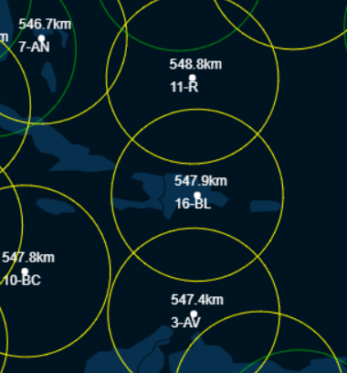

*Puerto Rico Under StarLink Satellite*

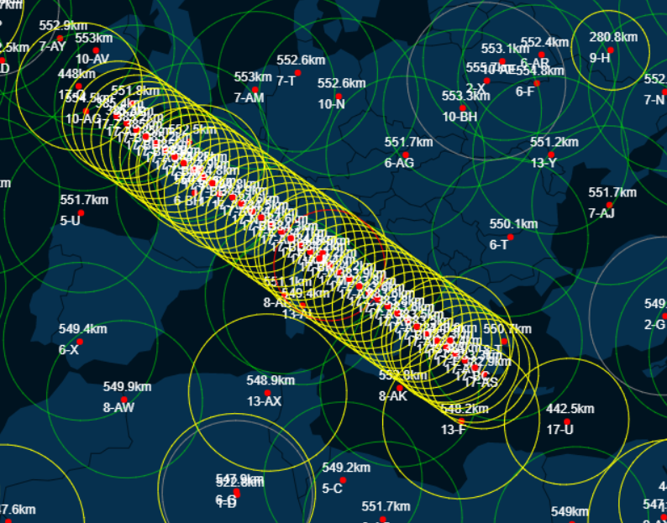

*17-xx satellites*

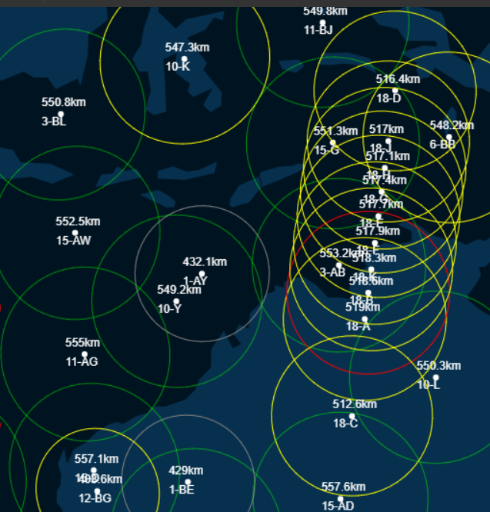

*18-xx satellites*

1. Conclusions

Throughout this investigative process the overall concept and purpose of the bandwidth and capacity of wireless communication systems was understood by the student. Knowledge of the specific in the signals and devices responsible with the delivery of information through the globe are clearer and well defined. As well as a new understanding of what the Star Link system is and where to look for its current location and status.

1. References

[1]"Shannon Capacity - an overview | ScienceDirect Topics", *Sciencedirect.com*, 2021. [Online]. Available: https://www.sciencedirect.com/topics/computer-science/shannon-capacity. [Accessed: 20- Feb- 2021].

[2]"Antenna Basics", *SimpleWiFi*, 2021. [Online]. Available: https://www.simplewifi.com/pages/antenna-basics. [Accessed: 20- Feb- 2021].

[3]"The Most Common Wi-Fi Standards and Types, Explained", *MUO*, 2021. [Online]. Available: https://www.makeuseof.com/tag/understanding-common-wifi-standards-technology-explained/#:~:text=Wireless%20standards%20are%20a%20set,Fi%20standard%20every%20few%20years. [Accessed: 21- Feb- 2021].

[4]"Radio spectrum", *En.wikipedia.org*, 2021. [Online]. Available: https://en.wikipedia.org/wiki/Radio_spectrum. [Accessed: 20- Feb- 2021].

[5]"Maximum Transmit Power - an overview | ScienceDirect Topics", *Sciencedirect.com*, 2021. [Online]. Available: https://www.sciencedirect.com/topics/engineering/maximum-transmit-power. [Accessed: 20- Feb- 2021].

[6]"Wireless Communication ＜Short-Range Wireless Communication＞ | Electronics Basics | ROHM", *Rohm.com*, 2021. [Online]. Available: https://www.rohm.com/electronics-basics/wireless/short-range-wireless-communication. [Accessed: 21- Feb- 2021].

[7]"Different Wi-Fi Protocols and Data Rates", *Intel*, 2021. [Online]. Available: https://www.intel.com/content/www/us/en/support/articles/000005725/wireless.html. [Accessed: 20- Feb- 2021].

[8]"Near Field Communication Technology Standards – NearFieldCommunication.org", *Nearfieldcommunication.org*, 2021. [Online]. Available: http://nearfieldcommunication.org/technology.html. [Accessed: 20- Feb- 2021].

[9]"IEEE 802.15.1", *Ieee802.org*, 2021. [Online]. Available: https://www.ieee802.org/15/pub/TG1.html. [Accessed: 21- Feb- 2021].

[10]"Home - Zigbee Alliance", *Zigbee Alliance*, 2021. [Online]. Available: https://zigbeealliance.org/. [Accessed: 21- Feb- 2021].

[11]"Wi-Fi CERTIFIED ac | Wi-Fi Alliance", *Wi-fi.org*, 2021. [Online]. Available: https://www.wi-fi.org/discover-wi-fi/wi-fi-certified-ac. [Accessed: 21- Feb- 2021].

[12]e. notes, "WiGig IEEE 802.11ad | 60 GHz Microwave Wi-Fi | Electronics Notes", *Electronics-notes.com*, 2021. [Online]. Available: https://www.electronics-notes.com/articles/connectivity/wifi-ieee-802-11/802-11ad-wigig-gigabit-microwave.php. [Accessed: 21- Feb- 2021].

[13]"Starlink's satellites will be orbiting at a much lower altitude, reducing the risks of space junk", *Phys.org*, 2021. [Online]. Available: https://phys.org/news/2019-05-starlink-satellites-orbiting-altitude-space.html. [Accessed: 21- Feb- 2021].

[14]"Starlink Compendium – ElonX.net", *ElonX.net*, 2021. [Online]. Available: https://www.elonx.net/starlink-compendium/#constellation. [Accessed: 21- Feb- 2021].

[15]J. Brodkin, "SpaceX Starlink users provide first impressions and unboxing pictures", *Ars Technica*, 2021. [Online]. Available: https://arstechnica.com/information-technology/2020/11/spacex-starlink-beta-tester-takes-user-terminal-into-forest-gets-120mbps/. [Accessed: 21- Feb- 2021].

[16]S. Vaughan-Nichols, "The Starlink internet beta has begun: Here's what to expect | ZDNet", *ZDNet*, 2021. [Online]. Available: https://www.zdnet.com/article/the-starlink-internet-beta-has-begun-heres-what-to-expect/#:~:text=In%20this%20early%20stage%2C%20Starlink,we%20enhance%20the%20Starlink%20system. [Accessed: 21- Feb- 2021].

[17]J. Koetsier, "Starlink Internet From Space: Faster Than 95% Of USA", *Forbes*, 2021. [Online]. Available: https://www.forbes.com/sites/johnkoetsier/2020/11/01/starlink-internet-from-space-faster-than-95-of-usa/?sh=3e874e301bb0. [Accessed: 21- Feb- 2021].

[18]"Starlink satellite tracker", *Starlink satellite tracker*, 2021. [Online]. Available: https://satellitemap.space/indexA.html. [Accessed: 21- Feb- 2021].

[19]*IEEE Standard for Information technology Telecommunications and information exchange between systems Local and metropolian area networks Specific requirements Part 11: Wireless LAN Medium Access Control (MAC) and Physical Layer (PHY) Specifications*. New York: IEEE Computer Society, 2016.

[20]"5 GHz airMAX 30 dBi RocketDish Antenna", *Ubiquiti Inc.*, 2021. [Online]. Available: https://store.ui.com/collections/operator-airmax-and-ltu/products/5ghz-rocketdish-30dbi-rocket-kit. [Accessed: 20- Feb- 2021].

[21]M. included), "MikroTik mANT30 Antenna 4.7-5Ghz 30dBi Dual-Pol 45deg Slant Dish with Precision Alignment Mount (RP-SMA patch cables included)", *Baltic Networks*, 2021. [Online]. Available: https://www.balticnetworks.com/mikrotik-mant30-antenna-4-7-5ghz-30dbi-dual-pol-45deg-slant-dish-with-precision-alignment-mount-rp-sma-patch-cables-included. [Accessed: 20- Feb- 2021].