Report 2 – Error Correction Codes and Error Detection Codes

CIIC 4070 – Computer Networks

Alberto I. Cruz Salamán

802-18-0591

Prof. Kejie Lu

Computer Science and Engineering

Table of Contents:

1. Introduction
2. The Basics
3. Error correction code
4. Error detection code
5. Codes in standards
6. Conclusions
7. References
8. Introduction

This paper is a project for the CIIC 4070 course at UPRM. It will expand upon the research of the student surrounding the topics and questions prompted by the professor in regards of the Error Correction Codes and Error Detection Codes, which were discussed in the class.

1. The Basics

* A valid codeword is a set of character in an error-correcting scheme that follows the established standards of transmission and contains no errors after being sent/received.
* The set of all valid codewords in an error correcting scheme is called the complete code (mapping).
* The hamming distance between two codewords is the resulting amount of “1” bits remaining after applying a XOR operation with both.
* The hamming distance of a complete code is the lowest hamming distance between two of the codewords that compose the scheme. (d)
* The error correction capabilities of a complete code can be acquired in the number of bits it can correct. A certain scheme can only correct ***(½ * complete code hamming distance – 1)*** bits in a codeword.
* The error detection capabilities of a complete code can be summarized as the quantity of bits that the scheme is able to detect as faulty to request a retransmission of them. A complete code can detect ***(complete code hamming distance – 1)*** bits in a codeword.

1. Error correction code



* LDPC coding (noisy channel->noiseless channels)

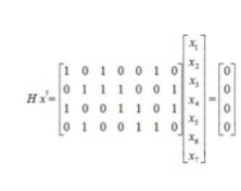

A low density matrix enters as it’s multiplied by the transpose of the output equation to acquire the parity bits that compose it.

* Polar Coding
* 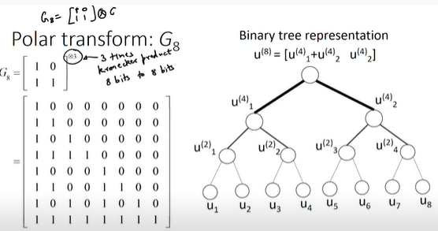

If represented as a tree the polar coding scheme allows for an abstraction of a transform matrix as a rising tree with an output of o=[i_1 xor i_2, i_2] vector.

1. Error detection code



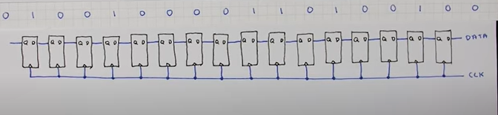

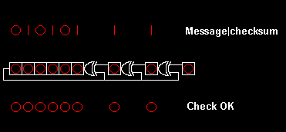

It uses a shift register in series to confirm the veracity of the message. If all bits are 0 there is no error, if not index will be shown in result.

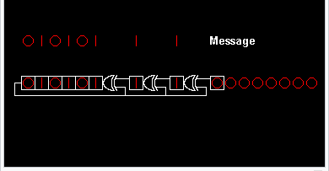

Using xors and latches the message is shifted and using a generator polynomial encrypted to the checksum

1. Codes in standards
   1. IEEE 802.11 Standard
2. CRC-32



1. CRC-16

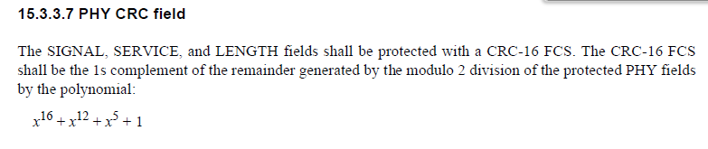

* 1. 5G NR Standard

LDPC codes are designed to efficiently support incremental redundancy (IR)HARQ. As will be described later, such IR-HARQ design of 5G LDPC codes effectively reduces the size of encoding and decoding graph when the operating code rate is high, which also helps the realization of high throughput

5G polar codes, as a coding scheme for control, are designed to perform well with short block length while addressing a latency issue of successive cancellation decoding.

Distributed CRC is utilized to avoid large latency periods that are present in LDPC and polar code generation.

1. Conclusions

To conclude this report the student understood the details and aspects of the datalink layer and the error detecting and correction schemes that exists in order to increase the reliability of the messages transmitted in the vast diversity of protocols that exist.

1. References

“Computation of cyclic redundancy checks,” Wikipedia, 28-Dec-2020. [Online]. Available: https://en.wikipedia.org/wiki/Computation_of_cyclic_redundancy_checks. [Accessed: 15-Mar-2021].

“Cyclic redundancy check,” Wikipedia, 11-Mar-2021. [Online]. Available: https://en.wikipedia.org/wiki/Cyclic_redundancy_check. [Accessed: 15-Mar-2021].

D. Terr, “Codeword,” from Wolfram MathWorld, 2021. [Online]. Available: https://mathworld.wolfram.com/Codeword.html. [Accessed: 15-Mar-2021].

Encoding LDPC codes in 5G. YouTube, 2019.

J. Bae, ahmed abotabl, and hsien-ping lin, An overview of channel coding for 5G NR cellular communications, 2019. [Online]. Available: https://www.cambridge.org/core/services/aop-cambridge-core/content/view/CF52C26874AF5E00883E00B6E1F907C7/S2048770319000106a.pdf/div-class-title-an-overview-of-channel-coding-for-5g-nr-cellular-communications-div.pdf. [Accessed: 2021].

S. Foroughi Follow, “LDPC Codes,” SlideShare, 20-May-2014. [Online]. Available: https://www.slideshare.net/s4h4rr/ldpc-codes-34889266. [Accessed: 15-Mar-2021].

YouTube, 2012.