Il 16/05/2019 12.26, Daubenschuez, Markus ha scritto:

Dear Pierluigi!

The sizes of the devices are:

C134R233 - 4 µm

C134R235 - 5 µm

C134R237 - 6 µm

 Here are the more accurate values, extracted from measurements in µm

4.47E+005.26E+006.26E+00

A good starting point would be a master thesis that I have here. Unfortunately the thesis is in German. If you want I can send it to you and tell you the important equations.

In our program we use this equivalent circuit model:

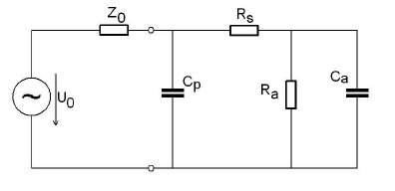

A – active  
S – mirror

P – Pad

The optical response is also described in chapter 7 of Rainers book. Here (7.4) is the important equation. Maybe Rainer has better references in mind.

I never tried to implement this small signal fitting of a VCSEL. What I did in the past, was a implementation for fitting RIN (relative intensity noise) data.

The equation is comparable to (7.4), but there you drive the VCSEL in cw mode. So you don’t have to care about parasitics.

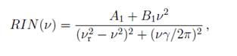

I think we did it in Matlab and in Origin.

Best regards,

Markus

**Von:** Pierluigi Debernardi [<mailto:pierluigi.debernardi@ieiit.cnr.it>]   
**Gesendet:** Donnerstag, 16. Mai 2019 10:11  
**An:** Daubenschuez, Markus [<markus.daubenschuez@philips.com>](mailto:markus.daubenschuez@philips.com)  
**Cc:** Alberto TIBALDI [<alberto.tibaldi@polito.it>](mailto:alberto.tibaldi@polito.it); [rainer.michalzik@uni-ulm.de](mailto:rainer.michalzik@uni-ulm.de)  
**Betreff:** Re: AW: AW: AW: AW: Update

Dear Markus,

thank you.

It would be helpful if you can put me in the condition to perform the fits you are talking about. Providing me with some formulas and explanations.

For S21 it's a single (parasitics) + double (optical) pole fitting.

I guess one has to start from S11, to extract the parasitics, and then fitting just the remaining optical part with S21.

If you can provide more info, and an example on the data you sent, that'll simplify a bit my life.

Thanks in advance

Pierluigi

Il 16/05/2019 09.56, Daubenschuez, Markus ha scritto:

Hello Pierluigi!

The S21 looks good. For the S11 data I’m not quite sure if they are correct. Here it’s not common to plot the |S11|^2

Normally we plot them in a Bode diagram:

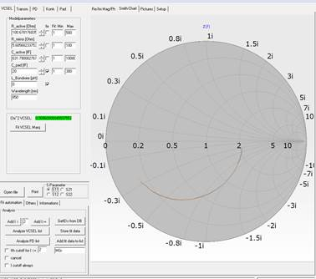

For phase and magnitude it would look like this:

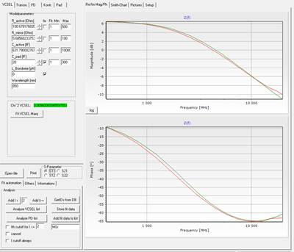

You are right. The S11 is the key element for the electrical parasitics. Here we do a fitting of the measured data with a simple equivalent circuit (R active zone, R mirror, C active zone and C bondpad). Normally the bondpad capacitance is a fixed value in the range of some 10 fF. In the case of this devices we have really large pads, do the value should be higher. The inductance is set to zero.

The reference impedance of the setup is 50Ohm.

For the S21 a fitting of modulation transfer function is done.

I hope this helps you.

Best regards,

Markus

**Von:** Pierluigi Debernardi [<mailto:pierluigi.debernardi@ieiit.cnr.it>]   
**Gesendet:** Donnerstag, 16. Mai 2019 08:21  
**An:** Daubenschuez, Markus [<markus.daubenschuez@philips.com>](mailto:markus.daubenschuez@philips.com)  
**Cc:** Alberto TIBALDI [<alberto.tibaldi@polito.it>](mailto:alberto.tibaldi@polito.it); [rainer.michalzik@uni-ulm.de](mailto:rainer.michalzik@uni-ulm.de)  
**Betreff:** Re: AW: AW: AW: Update

Dear Markus,

thanks to Alberto, who got specialized in loading your data (also in the special format s2p you sent, which I would not have been able to manage), I can show you what you sent, to know if all looks fine to you.

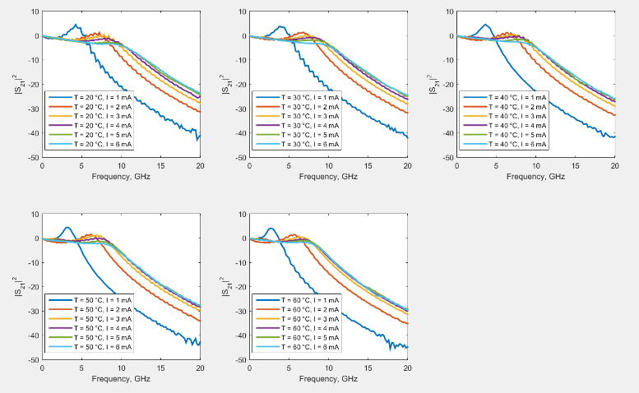

It's the first time for me to deal with this topic, so please let me know if this is exactly what I'll try to compute, i.e. the DeltaP_opt/DeltaI_drive.

At the VCSEL day I've heard a comment: to access the electrical parasitics, S11 is the parameter to look at:

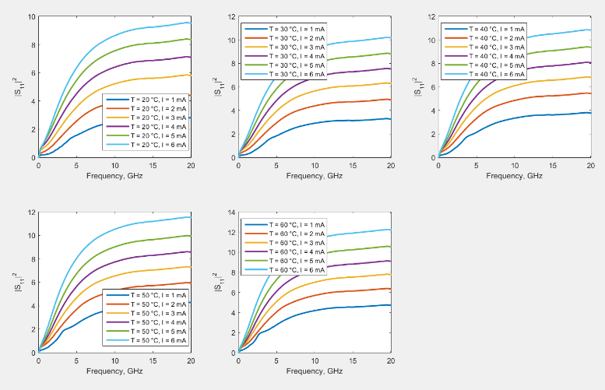

Is anybody of you aware of how to extract the parasitics from these curves? I guess one has to imply an equivalent circuit. Please send me some simple ideas.

Alberto extracted an equivalent input impedance, from which I can simply get S11, once I know the reference impedance. Is it 50 Ohm in this case?

Till soon

Pierluigi