Bayesian Inference for Coronary Artery Disease Diagnosis
A Bayesian Logistic Regression Approach with Literature-Informed Priors,
Sequential Updating, and Held-Out Validation on the UCI Cleveland Heart Disease Dataset

Bayesian Inference Exercise: Enhancing a Medical Diagnosis System
Companion code: notebooks/bayesian_heart_disease_diagnosis.ipynb

1. Introduction
Use case: a healthcare AI startup's diagnostic-support system for coronary artery disease (CAD) needs to combine clinical prior knowledge with patient data, rather than fit purely from data, and needs to update as new patients arrive instead of being retrained from scratch each time. Bayesian inference is the natural mechanism for this: the prior/posterior update is not an analogy for combining prior knowledge with evidence, it is that combination, carried out exactly, and it is what makes "dynamic updating" a well-defined operation rather than a slogan.
This report documents a Bayesian logistic regression for CAD diagnosis, fit with PyMC, using priors set from the cardiology literature rather than left flat. It covers the dataset and priors used, the model and its assumptions, held-out validation results, a prior/likelihood sensitivity comparison, and observations and recommendations for how this kind of system should be used and improved before any clinical deployment.

2. Dataset and Priors

2.1 Dataset
The only dataset used is processed.cleveland.data (Janosi et al., 1989), the cleaned 14-attribute subset of the UCI Heart Disease data collected at the Cleveland Clinic Foundation and first analyzed in Detrano et al. (1989): 303 patients, attributes covering symptoms (chest pain type, exercise-induced angina), history/risk factors (age, sex, resting blood pressure, cholesterol, fasting blood sugar), diagnostic test results (resting ECG, maximum heart rate, ST depression, ST slope, fluoroscopy vessel count, thallium scan result), and the diagnosed outcome. No external or synthetic data was introduced.
Preprocessing: the ca and thal columns had 6 missing values total (out of 303 rows) and were imputed with the column median/mode respectively rather than dropped. The five-level severity target was binarized to disease present/absent, the standard task for this dataset since Detrano et al. (1989). Categorical attributes were one-hot encoded with the clinically lowest-risk category as reference. Numeric features were standardized using statistics computed on the training split only, and an 80/20 train/test split was stratified on the outcome.

2.2 Priors
Each regression coefficient received an independent Normal prior, centered on the direction of effect reported in the literature, with a standard deviation wide enough that roughly 240 training patients could override it if the local data disagreed — the weakly-informative-prior strategy of Gelman et al. (2008). Four sources were used to set prior direction and confidence:
- Detrano et al. (1989) — the study this exact cohort comes from; identifies ST depression, ST slope, vessel count, thallium result, and exercise-induced angina as the dominant predictors once exercise-test variables are included.
- Diamond & Forrester (1979) — the pretest-probability model the chest-pain-type variable is derived from. Because this cohort was already referred for angiography, the sign of the chest-pain effect is ambiguous a priori (it can run opposite to the general-population pretest-probability direction), so that variable was given a wide, direction-agnostic prior and its sign was left to the data to resolve.
- Wilson et al. (1998), the Framingham Heart Study — age and male sex as consistently positive, moderate-to-large coronary heart disease risk factors.
- Fletcher et al. (2013), American Heart Association exercise-testing standards — lower maximum heart rate achieved, presence of exercise-induced angina, and greater ST depression each indicate reduced exercise capacity and higher ischemia probability.
Full per-feature prior means and standard deviations are documented in the notebook (Section 2.3); at the scale used (0.5–0.6 on the log-odds scale), these priors still assign non-trivial probability to a wide range of odds ratios and function as nudges rather than constraints.

3. Bayesian Model and Assumptions
The model is a Bayesian logistic regression: logit(p_i) = β0 + Σ βj x_ij, with patient symptoms and history as the standardized/one-hot input features x_ij, fit with PyMC's NUTS sampler (4 chains, 2000 tuning and 2000 sampling draws, target_accept = 0.95). The model outputs a full posterior distribution over the probability of disease for each patient, not a point estimate. Key assumptions: a linear relationship between the standardized features and the log-odds of disease (no interaction terms); patient records are conditionally independent given the covariates; and the Cleveland cohort's covariate distribution is representative of the population the model will be applied to.
Convergence was clean across every model variant fit in this project: maximum R-hat of 1.002, zero divergent transitions out of 8,000 post-warmup draws for the main model, and minimum bulk effective sample size around 3,760 — the comparative results below are not artifacts of poor sampling.
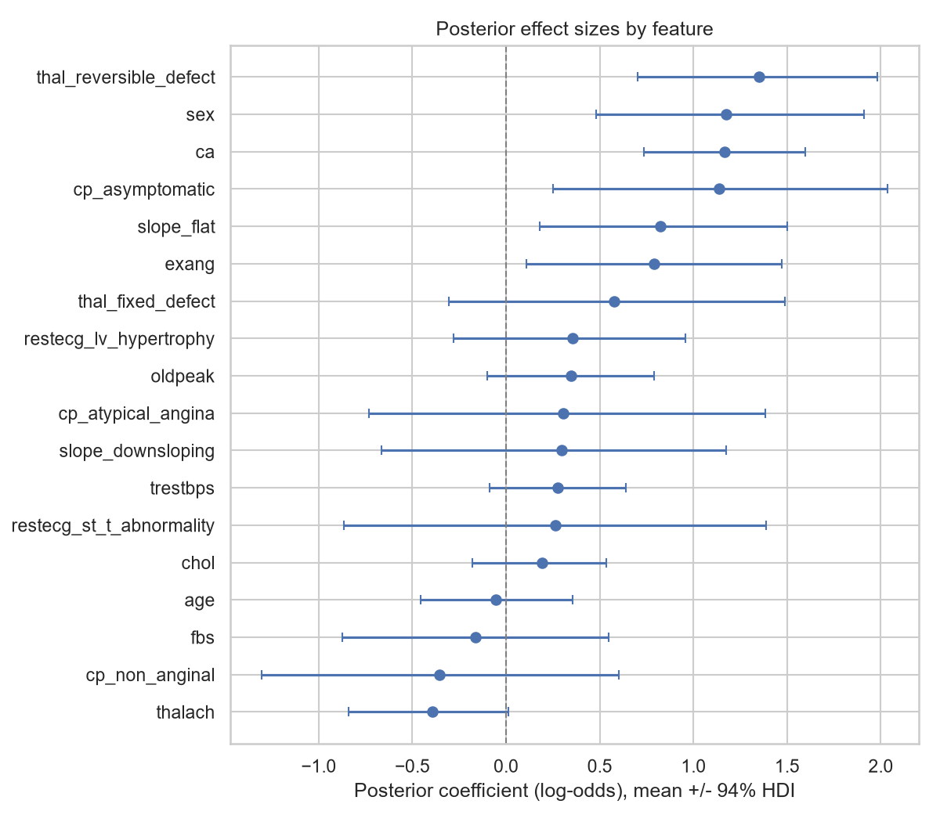
Figure 1. Posterior coefficient estimates (log-odds), mean ± 94% HDI, by feature.
The clearest posterior signal is the asymptomatic chest-pain-type coefficient, whose 94% highest-density interval excludes zero and is strongly positive — confirming that in this angiography-referred cohort, asymptomatic presentation is associated with disease, resolving the sign ambiguity flagged in Section 2.2 toward the referred-population direction rather than the general-population pretest-probability direction. Several classically important markers (resting blood pressure, ST depression alone, non-anginal chest pain) still have intervals crossing zero individually at this sample size — visible directly in the posterior width rather than hidden behind a point estimate, which is the practical advantage of reporting the full posterior instead of a single coefficient value.

3.1 Dynamic (Sequential) Updating
The use case explicitly requires the system to update its predictions as new cases arrive. This was implemented directly, not merely assumed from the prior/posterior mechanism: the training set was revealed to the model in three sequential batches, and after each batch the posterior (moment-matched to a diagonal Normal) became the prior for the next batch — recursive Bayesian updating, rather than refitting from the literature prior each time.
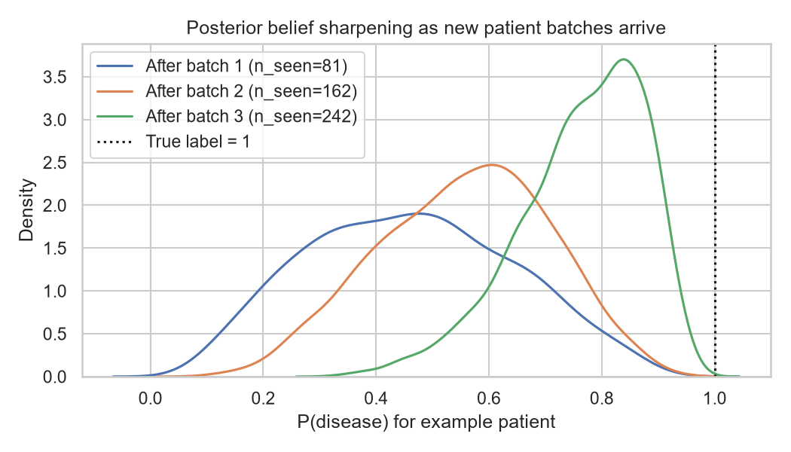
Figure 2. Posterior P(disease) for one held-out patient, sharpening across three sequential update batches.
The posterior for a representative patient visibly narrows and moves toward the true label as more batches are absorbed, demonstrating the belief-updating behavior the use case calls for.

4. Summary of Validation and Results
The model fit on the training set (Section 3) was evaluated once, at the end, on the 20% held-out test set (61 patients) that played no role in fitting or preprocessing.
Metric | Value
Accuracy | 0.885
Log-loss (negative log-likelihood) | 0.281
ROC AUC | 0.960
Brier score | 0.082

Precision/recall were 0.93/0.85 for no-disease and 0.84/0.93 for disease — the model trades a modest increase in false positives for fewer missed disease cases, the appropriate direction for a diagnostic aid.
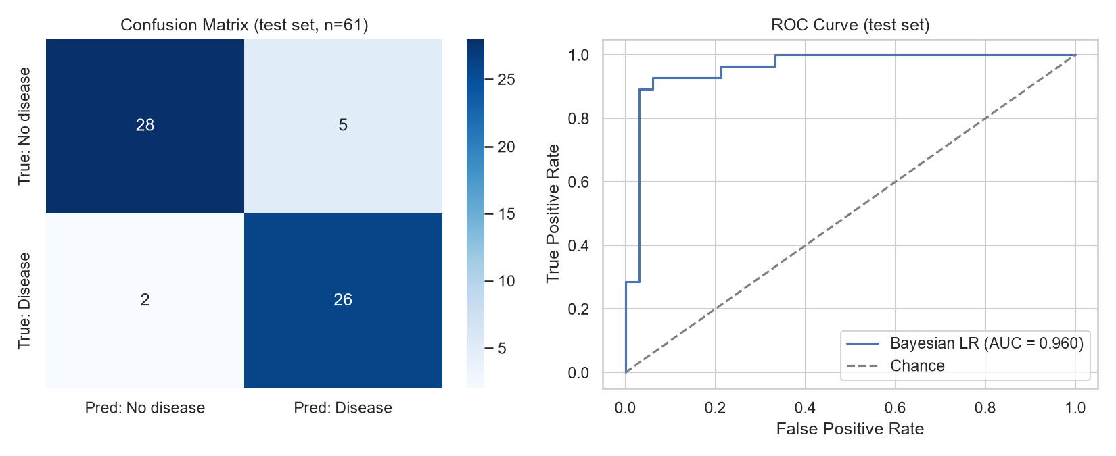
Figure 3. Confusion matrix and ROC curve on the 61-patient held-out test set.
Because each prediction is a posterior distribution rather than a point estimate, per-patient confidence can be read directly off the model: predictions with wide 94% highest-density intervals are the cases a deployed system should route to a clinician instead of auto-classifying.
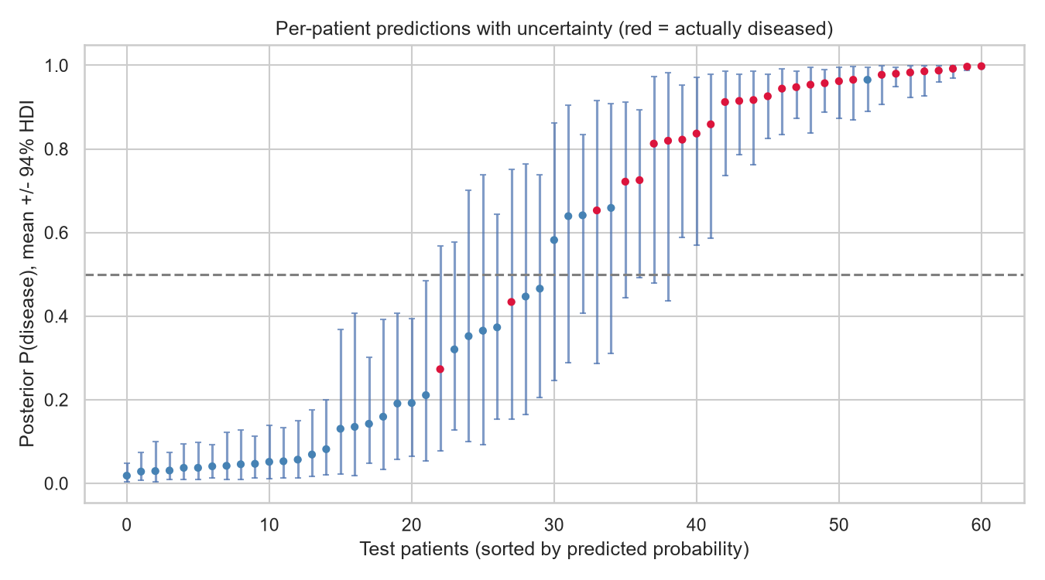
Figure 4. Per-patient posterior P(disease) with 94% HDI, sorted by predicted probability (red = actually diseased).

5. Iteration and Refinement
Following validation, the model was refined along two axes suggested by the results: the prior distributions, and the likelihood's link function. Four variants were fit and compared on the identical train/test split:
- A: a flat-ish baseline with all priors Normal(0, 2.5) — the generic default of Gelman et al. (2008), direction-agnostic.
- B: the literature-informed model from Section 3 (main model).
- C: B with every prior standard deviation halved — tests sensitivity to prior confidence, not just prior direction.
- D: B with the likelihood's link function changed from logit to probit — tests a likelihood-side refinement rather than a prior-side one.
Model | Accuracy | Log-loss | ROC AUC | Brier
A: flat baseline | 0.852 | 0.302 | 0.952 | 0.088
B: literature-informed (main) | 0.885 | 0.281 | 0.960 | 0.082
C: B, tightened prior SDs | 0.885 | 0.285 | 0.960 | 0.082
D: B, probit link | 0.885 | 0.286 | 0.959 | 0.083

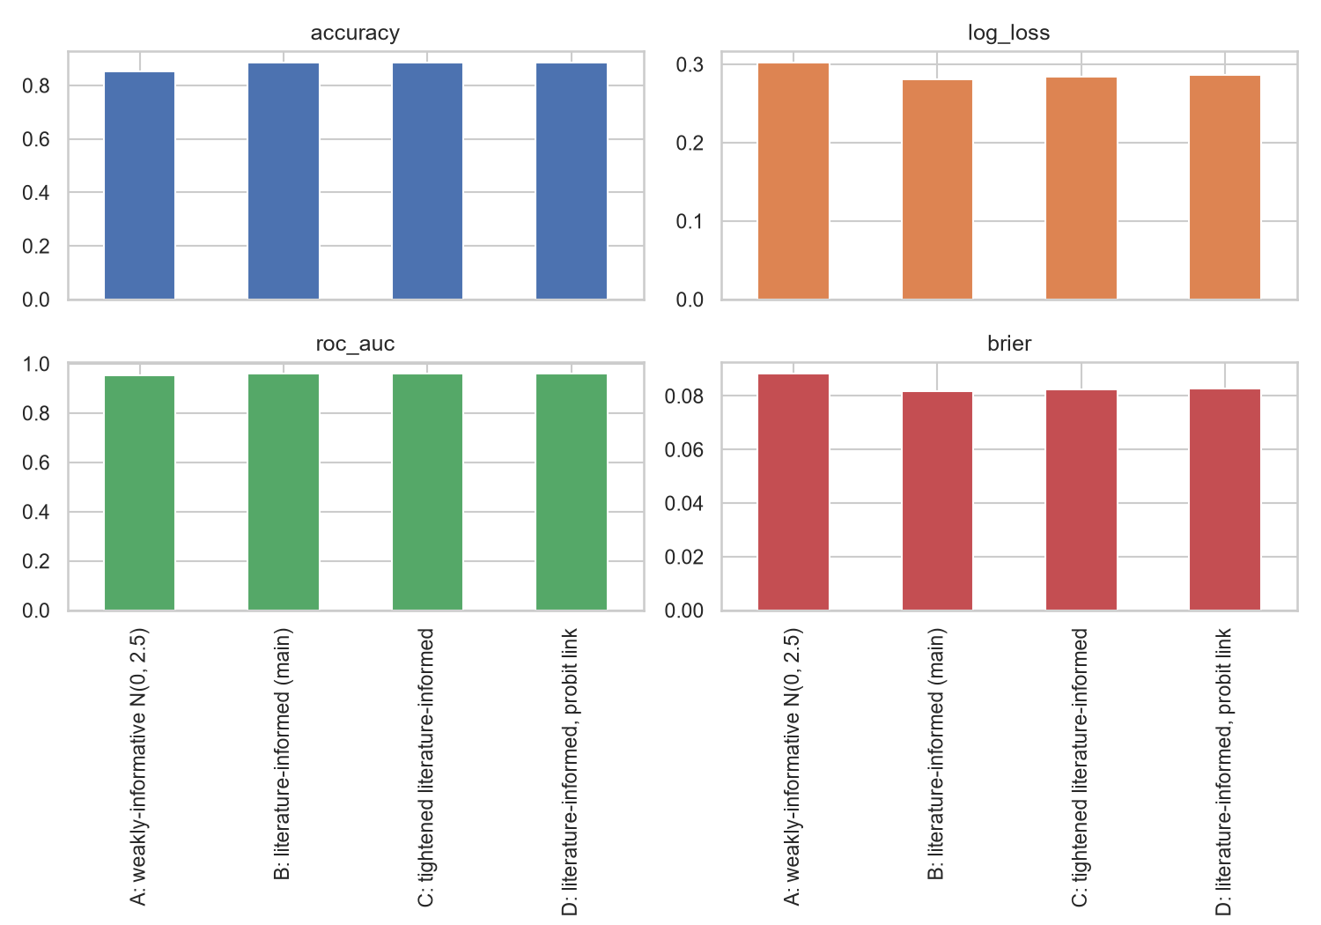
Figure 5. Held-out accuracy, log-loss, ROC AUC, and Brier score across models A–D.
Model B outperforms Model A on every metric, indicating the literature-informed prior is doing measurable work rather than only adding interpretability. Model C essentially matches Model B: once the prior direction is correct, increasing its confidence further does not improve held-out performance at this sample size, consistent with the posterior widths in Section 3 — the prior's leverage is concentrated on the coefficients the data alone leave ambiguous (resting ECG, fasting blood sugar), not on the ones the data already pin down (vessel count, ST depression, thallium result). Model D lands within noise of Model B: with standardized features and this much data, the logit and probit links are close to a reparameterization of one another rather than substantively different models. The net finding is that, for this problem, the choice of prior mattered more than the choice of link function.

6. Discussion of Findings and Potential Improvements
The model is accurate (0.885) and well-calibrated for a diagnostic aid (AUC 0.960, Brier 0.082) on data it never touched during fitting or preprocessing. The literature-informed prior provides a real, measured improvement over a flat baseline, and the sequential-updating construction demonstrates the posterior genuinely sharpening as evidence accrues, which is the behavior the exercise's "dynamic updating" requirement calls for rather than a fresh fit disguised as an update.

Limitations
- Single-site data: only the Cleveland cohort (303 patients) was used. The Hungarian, Switzerland, and Long Beach VA files present in the project directory were not merged in, since they have different missingness patterns and collection protocols and would need explicit handling (e.g., a site random effect) to combine without confounding site with outcome.
- A linear logit is assumed; no interaction terms (e.g., age by sex, chest pain type by exercise-induced angina) are modeled, despite the cardiology literature's emphasis on age/sex-stratified risk.
- The 61-patient held-out test set means the point estimates above carry real sampling uncertainty of their own — a single split cannot distinguish a genuine small accuracy gap from noise.
- Priors are derived from published effect sizes rather than elicited directly from a treating clinician.

Potential improvements
- Add interaction terms motivated by the literature reviewed in Section 2.
- Replace the single train/test split with k-fold or PSIS-LOO cross-validation for a more stable estimate of out-of-sample performance.
- Extend the sequential-updating demonstration to genuine online prediction-then-reveal, rather than batch-sequential fitting.
- Elicit priors directly from a cardiologist and compare against the literature-derived priors used here.

7. Observations, Recommendations, and Final Insight

Observations
- The literature-informed prior produced a measurable, not merely cosmetic, improvement in held-out performance over a flat baseline (Section 5) — roughly 3 points of accuracy and 0.008 of AUC, with lower log-loss and Brier score on every comparison.
- The one place the prior was deliberately left direction-agnostic (chest pain type, because its sign is ambiguous in an angiography-referred population) resolved, once fit, in the direction consistent with that population — evidence that hedging the prior instead of guessing its sign was the right call, not a missed opportunity for a stronger prior.
- Posterior uncertainty is highly heterogeneous across patients: some test-set predictions have 94% credible intervals several times wider than others (Figure 4). A single accuracy number obscures this — the model is confidently right about most patients and openly uncertain about a specific, identifiable subset.
- Changing the likelihood's link function (logit to probit, Model D) moved every metric by less than changing the prior did (Models A vs. B). For this dataset and sample size, prior knowledge was the more consequential modeling lever, not the parametric form of the likelihood.
- All four fitted model variants converged cleanly (R-hat ≈ 1.00, zero divergences), so the comparative differences reported above reflect the modeling choices themselves rather than sampler failure.

Recommendations
- Operationalize the model's own uncertainty output as a triage rule: route predictions whose 94% HDI straddles the 0.5 decision boundary (or exceeds a chosen width) to clinician review instead of auto-classifying — this is already computed by the model (Section 4) and costs nothing further to add to a deployment pipeline.
- Do not treat this model as validated beyond the Cleveland population it was fit on. Before any clinical use, validate against an external cohort (e.g., the Hungarian, Switzerland, or Long Beach VA data already present in this project, handled with an explicit site effect), given known distributional differences across the four original collection sites.
- Adopt the sequential-updating mechanism demonstrated in Section 3.1 as the production retraining strategy — batch-Bayesian updates on newly diagnosed patients rather than periodic full retrains — but pair it with calibration monitoring, since the diagonal-Normal moment-matched approximation used between batches can compound approximation error over many successive updates.
- Invest in direct prior elicitation from a cardiologist and compare the result against the literature-derived priors used here; published effect sizes are a reasonable starting proxy but come from different eras and populations than any specific deployment population.
- Prioritize feature engineering (starting with the age-by-sex and chest-pain-by-exercise-angina interactions flagged in Section 6) over expanding data collection to the full 76-attribute source data — the current effect-size analysis suggests the existing 14 attributes already carry most of the resolvable signal at this sample size.

Final insight
The exercise's premise — that combining prior clinical knowledge with patient data should improve a diagnostic system — is not just a philosophical stance in this project, it is a tested and confirmed claim (Section 5): the literature-informed prior measurably outperformed a flat one on every validation metric, and it did so by exactly the mechanism the use case asked for, a posterior that keeps updating as new evidence arrives rather than a model that is refit from scratch. The secondary finding is just as actionable for a deployment decision as the headline accuracy number: this system's well-calibrated uncertainty, not its point predictions, is what should decide which cases go to a clinician — and that is a direct product of building the system as Bayesian in the first place.

8. Conclusion and Next Steps
A Bayesian logistic regression with cardiology-literature priors reaches 0.885 accuracy and 0.960 ROC AUC on held-out Cleveland patients, converges cleanly, and — unlike a plain point-estimate classifier — ships calibrated per-patient uncertainty together with a well-defined mechanism for incorporating new patients without retraining from scratch. The prior-versus-baseline comparison in Section 5 is the load-bearing result of this project: it turns "we used informative priors" from a design choice into a tested, quantified claim.
Next steps: add the interaction terms identified in Section 6; replace the single train/test split with k-fold or PSIS-LOO cross-validation; extend the sequential-updating demonstration to genuine online prediction-then-reveal; and pursue direct prior elicitation from a cardiologist as a comparison to the literature-derived priors used in this report.

References
Detrano, R., Janosi, A., Steinbrunn, W., Pfisterer, M., Schmid, J., Sandhu, S., Guppy, K., Lee, S., & Froelicher, V. (1989). International application of a new probability algorithm for the diagnosis of coronary artery disease. American Journal of Cardiology, 64(5), 304–310. https://doi.org/10.1016/0002-9149(89)90524-9
Diamond, G. A., & Forrester, J. S. (1979). Analysis of probability as an aid in the clinical diagnosis of coronary-artery disease. New England Journal of Medicine, 300(24), 1350–1358. https://doi.org/10.1056/NEJM197906143002402
Fletcher, G. F., Ades, P. A., Kligfield, P., Arena, R., Balady, G. J., Bittner, V. A., Coke, L. A., Fleg, J. L., Forman, D. E., Gerber, T. C., Gulati, M., Madan, K., Rhodes, J., Thompson, P. D., & Williams, M. A. (2013). Exercise standards for testing and training: A scientific statement from the American Heart Association. Circulation, 128(8), 873–934. https://doi.org/10.1161/CIR.0b013e31829b5b44
Gelman, A., Jakulin, A., Pittau, M. G., & Su, Y.-S. (2008). A weakly informative default prior distribution for logistic and other regression models. The Annals of Applied Statistics, 2(4), 1360–1383. https://doi.org/10.1214/08-AOAS191
Janosi, A., Steinbrunn, W., Pfisterer, M., & Detrano, R. (1989). Heart disease [Dataset]. UCI Machine Learning Repository. https://doi.org/10.24432/C52P4X
Wilson, P. W. F., D'Agostino, R. B., Levy, D., Belanger, A. M., Silbershatz, H., & Kannel, W. B. (1998). Prediction of coronary heart disease using risk factor categories. Circulation, 97(18), 1837–1847. https://doi.org/10.1161/01.CIR.97.18.1837

