Module 4: 4-bit Quantum Adder
This notebook extends the full-adder design in the class notebook QC_Ekert_FA1bit_and_2bit_examp.ipynb to add two 4-bit binary numbers using Qiskit. It reuses the class notebook's carry, carry_rev, and sum functions.
Each input is an unsigned integer from 0 to 15, encoded as four binary bits. The output has five bits so that the final carry is retained: for example, 1111 + 1111 = 11110 (15 + 15 = 30).
The code requires qiskit, matplotlib, and pylatexenc (for the circuit drawing).
In [1]
from qiskit import QuantumCircuit
from qiskit.primitives import StatevectorSampler
from qiskit.visualization import plot_histogram
import matplotlib.pyplot as plt

Full-adder functions from the class notebook
These three gate sequences are reused unchanged.
In [2]
# Define functions for the ripple carry adder.
def sum(circ, cin, a, b):
circ.cx(a,b)
circ.cx(cin,b)
def carry(circ, cin, a, b, cout):
circ.ccx(a, b, cout)
circ.cx(a, b)
circ.ccx(cin, b, cout)
def carry_rev(circ, cin, a, b, cout):
circ.ccx(cin, b, cout)
circ.cx(a, b)
circ.ccx(a, b, cout)

Extending the design to four bits
The circuit uses 13 qubits. Each bit position has a carry qubit, an a qubit, and a b qubit. The b qubits become the four sum bits; qubit 12 holds the final carry.
Bit position | Carry input | Input A | Input B / sum
0 (least significant) | q0 | q1 | q2
1 | q3 | q4 | q5
2 | q6 | q7 | q8
3 (most significant) | q9 | q10 | q11

All carry qubits start at zero. The carry block runs through the four positions. At the most significant position, a CNOT undoes the change made by carry before sum writes the top sum bit. The circuit then runs carry_rev and sum backward through the lower positions, restoring intermediate carry qubits to zero.
The circuit measures q2, q5, q8, and q11 into classical bits 0 through 3, and q12 into bit 4. The displayed result is therefore carry s3 s2 s1 s0, read directly as a five-bit binary number.
In [3]
N_BITS = 4 # width of the adder
def c_q(i):
"""Qubit holding carry c_i."""
return 3 * i
def a_q(i):
"""Qubit holding a_i."""
return 3 * i + 1
def b_q(i):
"""Qubit holding b_i (overwritten with sum bit s_i)."""
return 3 * i + 2
def encode(circ, value, qubit_of, n):
"""Load an n-bit integer into a register with X gates (bit 0 = LSB)."""
for i in range(n):
if (value >> i) & 1:
circ.x(qubit_of(i))
def add_ripple_adder(circ, n):
"""Append the n-bit ripple-carry adder |a,b,0> -> |a,a+b> to circ."""
# 1) propagate carries upward
for i in range(n):
carry(circ, c_q(i), a_q(i), b_q(i), c_q(i + 1))
circ.barrier()
# 2) most significant bit: undo carry's CNOT, then compute its sum
circ.cx(a_q(n - 1), b_q(n - 1))
sum(circ, c_q(n - 1), a_q(n - 1), b_q(n - 1))
circ.barrier()
# 3) uncompute carries downward, writing each sum bit into b_i
for i in range(n - 2, -1, -1):
carry_rev(circ, c_q(i), a_q(i), b_q(i), c_q(i + 1))
sum(circ, c_q(i), a_q(i), b_q(i))
circ.barrier()
def build_adder(a, b):
"""Build the 4-bit adder for two integers in [0, 15]."""
n = N_BITS
if not (0 <= a < 2**n and 0 <= b < 2**n):
raise ValueError(
f"a and b must be in [0, {2**n - 1}] for an {n}-bit adder")
qc = QuantumCircuit(3 * n + 1, n + 1)
encode(qc, a, a_q, n)
encode(qc, b, b_q, n)
qc.barrier()
add_ripple_adder(qc, n)
# sum bit s_i -> clbit i, final carry -> clbit n, so the measured
# bitstring (printed MSB first) is the binary value of a + b
for i in range(n):
qc.measure(b_q(i), i)
qc.measure(c_q(n), n)
return qc
def run_counts(circuits, shots=1024):
"""Run circuits on the sampler; return a list of count dicts."""
if isinstance(circuits, QuantumCircuit):
circuits = [circuits]
job = StatevectorSampler().run(circuits, shots=shots)
return [res.data.c.get_counts() for res in job.result()]

The 4-bit circuit
Example inputs: 1011 (11) and 0110 (6). The expected output is 10001 (17).
In [4]
qc = build_adder(11, 6)
print(f"4-bit adder: {qc.num_qubits} qubits, {qc.num_clbits} output bits")
qc.draw("mpl", fold=22)
4-bit adder: 13 qubits, 5 output bits

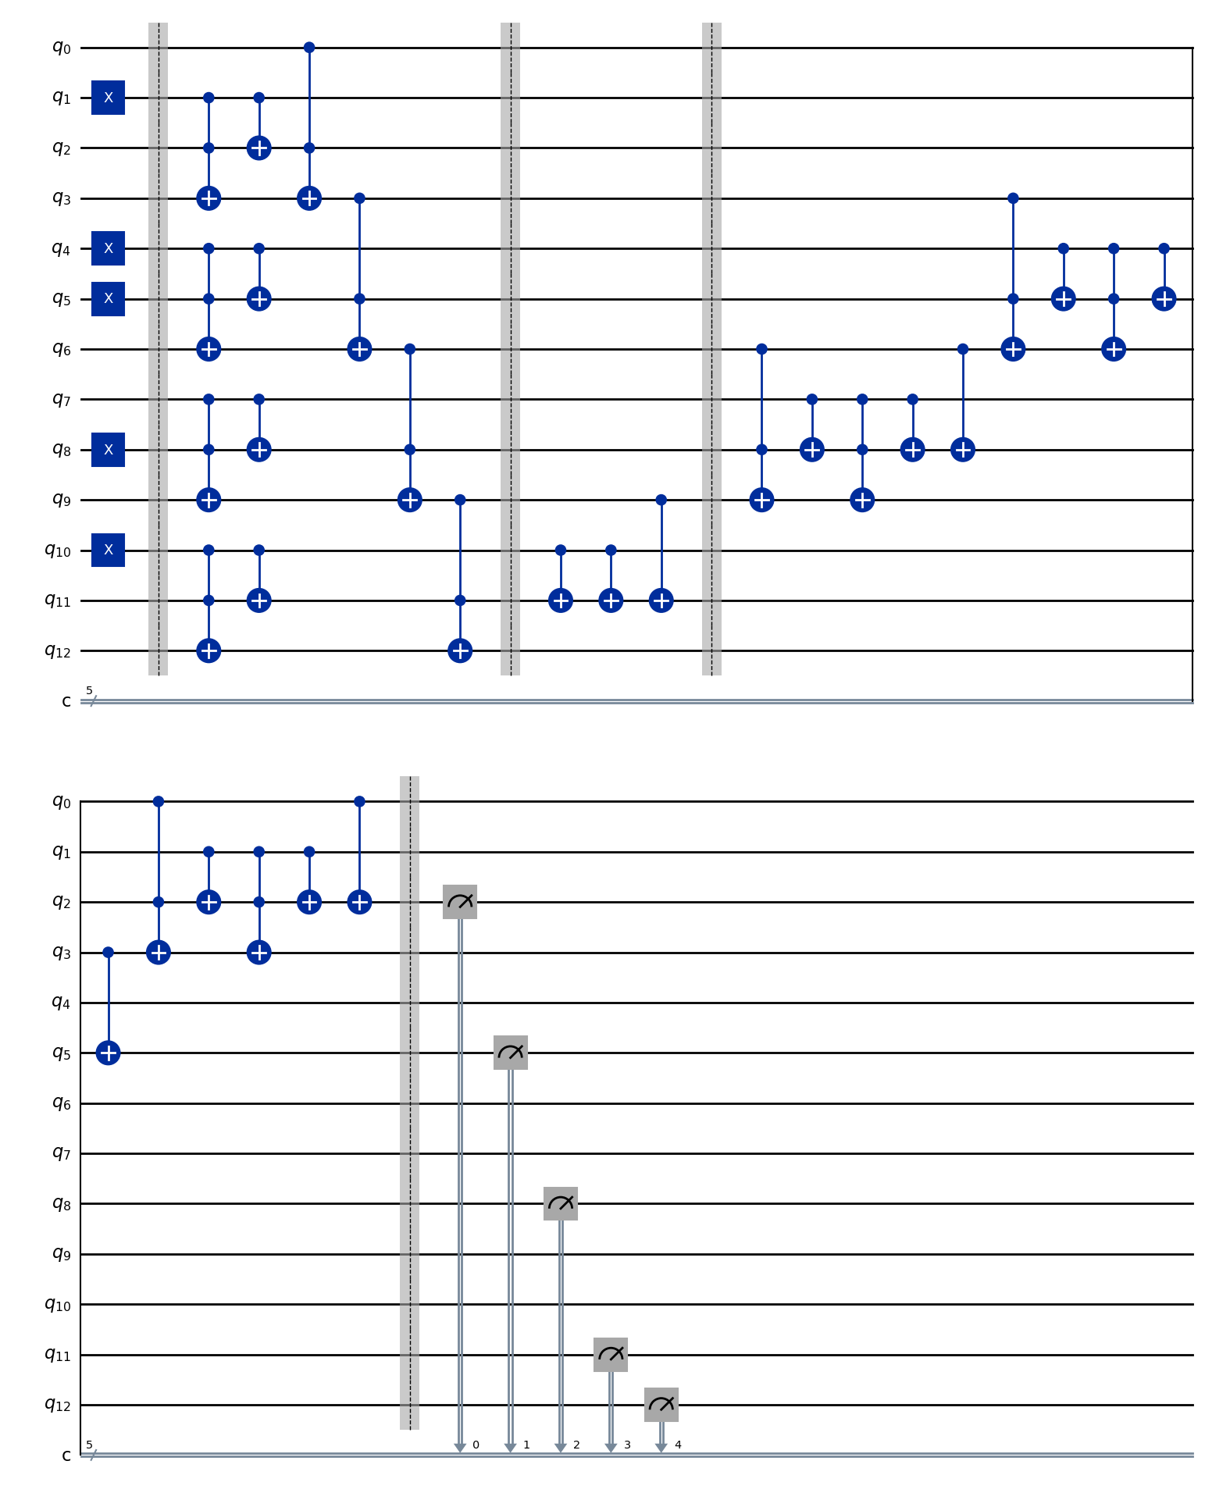
4-bit adder circuit for 1011 + 0110 (11 + 6).

Test cases and histograms
Each test below adds two four-bit binary inputs with the Qiskit circuit. Its own output lists the expected sum, measured sum, shot counts, and PASS or FAIL result, followed immediately by its histogram.
The eight cases cover zero, additions without carries, carry propagation, the final carry, and the largest four-bit inputs. Every circuit runs for 1024 shots using the ideal StatevectorSampler. The shared function below runs and checks one test at a time.
In [5]
SHOTS = 1024
def test_adder(a, b, label):
"""Run one 4-bit addition, print its result, and draw its histogram."""
counts = run_counts(build_adder(a, b), shots=SHOTS)[0]
expected = f"{a + b:05b}"
measured = max(counts, key=counts.get)
passed = counts == {expected: SHOTS}
status = "PASS" if passed else "FAIL"
print(f"Inputs: A = {a:04b} ({a}), B = {b:04b} ({b})")
print(f"Expected sum: {expected} ({a + b})")
print(f"Measured sum: {measured} ({int(measured, 2)})")
print(f"Counts: {counts}")
print(f"Result: {status}")
assert passed, f"Incorrect result for {a:04b} + {b:04b}: {counts}"
fig = plot_histogram(
counts,
title=f"{label}\n{a:04b} + {b:04b} = {expected}",
figsize=(6.4, 3.4),
)
fig.tight_layout()
plt.close(fig)
return fig

Test case 1: Zero inputs
Inputs: 0000 (0) and 0000 (0). Expected sum: 00000 (0).
In [6]
test_adder(0b0000, 0b0000, "Test case 1: Zero inputs")
Inputs: A = 0000 (0), B = 0000 (0)
Expected sum: 00000 (0)
Measured sum: 00000 (0)
Counts: {'00000': 1024}
Result: PASS
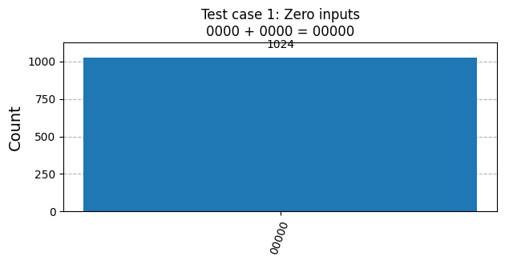

Test case 2: Carry through lower positions
Inputs: 0101 (5) and 0011 (3). Expected sum: 01000 (8).
In [7]
test_adder(0b0101, 0b0011, "Test case 2: Carry through lower positions")
Inputs: A = 0101 (5), B = 0011 (3)
Expected sum: 01000 (8)
Measured sum: 01000 (8)
Counts: {'01000': 1024}
Result: PASS
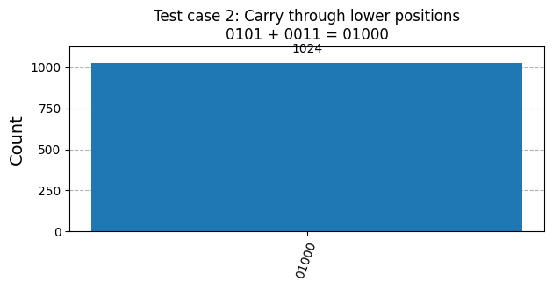

Test case 3: Addition without carries
Inputs: 1001 (9) and 0110 (6). Expected sum: 01111 (15).
In [8]
test_adder(0b1001, 0b0110, "Test case 3: Addition without carries")
Inputs: A = 1001 (9), B = 0110 (6)
Expected sum: 01111 (15)
Measured sum: 01111 (15)
Counts: {'01111': 1024}
Result: PASS
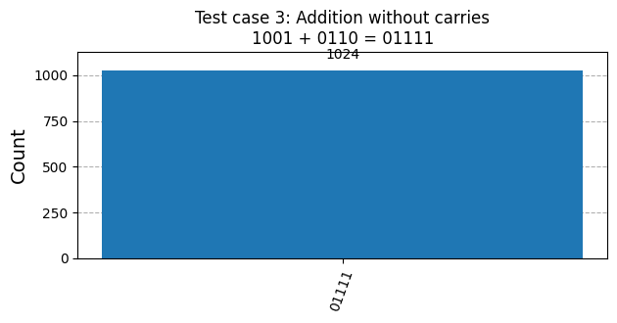

Test case 4: Another addition without carries
Inputs: 0111 (7) and 1000 (8). Expected sum: 01111 (15).
In [9]
test_adder(0b0111, 0b1000, "Test case 4: Another addition without carries")
Inputs: A = 0111 (7), B = 1000 (8)
Expected sum: 01111 (15)
Measured sum: 01111 (15)
Counts: {'01111': 1024}
Result: PASS
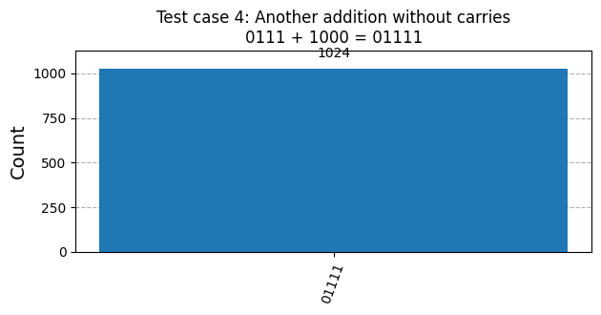

Test case 5: Carry through all four positions
Inputs: 0001 (1) and 1111 (15). Expected sum: 10000 (16).
In [10]
test_adder(0b0001, 0b1111, "Test case 5: Carry through all four positions")
Inputs: A = 0001 (1), B = 1111 (15)
Expected sum: 10000 (16)
Measured sum: 10000 (16)
Counts: {'10000': 1024}
Result: PASS
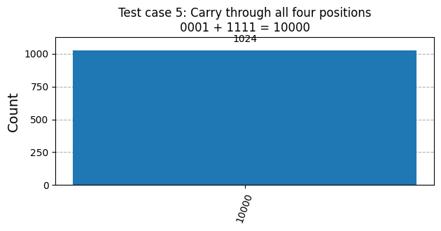

Test case 6: Final carry with a nonzero lower sum
Inputs: 1100 (12) and 1010 (10). Expected sum: 10110 (22).
In [11]
test_adder(0b1100, 0b1010, "Test case 6: Final carry with a nonzero lower sum")
Inputs: A = 1100 (12), B = 1010 (10)
Expected sum: 10110 (22)
Measured sum: 10110 (22)
Counts: {'10110': 1024}
Result: PASS
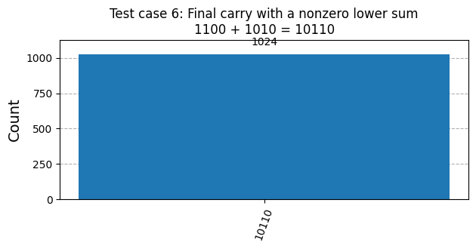

Test case 7: Largest four-bit inputs
Inputs: 1111 (15) and 1111 (15). Expected sum: 11110 (30).
In [12]
test_adder(0b1111, 0b1111, "Test case 7: Largest four-bit inputs")
Inputs: A = 1111 (15), B = 1111 (15)
Expected sum: 11110 (30)
Measured sum: 11110 (30)
Counts: {'11110': 1024}
Result: PASS
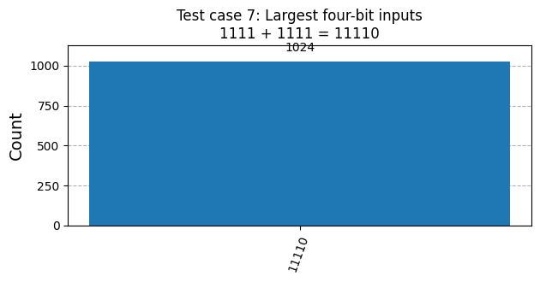

Test case 8: Carry from the most significant position
Inputs: 1000 (8) and 1000 (8). Expected sum: 10000 (16).
In [13]
test_adder(0b1000, 0b1000, "Test case 8: Carry from the most significant position")
Inputs: A = 1000 (8), B = 1000 (8)
Expected sum: 10000 (16)
Measured sum: 10000 (16)
Counts: {'10000': 1024}
Result: PASS
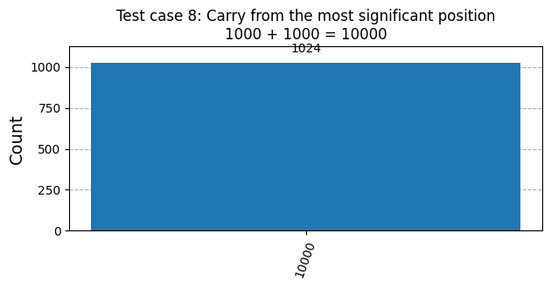

Observations
These observations refer to the eight individual test cases and their corresponding histograms.
- Zero inputs: 0000 + 0000 produced 00000 (0 + 0 = 0).
- Additions without carries: 1001 + 0110 (9 + 6) and 0111 + 1000 (7 + 8) both produced 01111 (15), as expected.
- Carry propagation: 0101 + 0011 produced 01000 (5 + 3 = 8), showing a carry through the lower bit positions. 0001 + 1111 produced 10000 (1 + 15 = 16), showing a carry through all four positions into the fifth output bit.
- Final carry and maximum inputs: 1100 + 1010 produced 10110 (12 + 10 = 22), 1000 + 1000 produced 10000 (8 + 8 = 16), and 1111 + 1111 produced 11110 (15 + 15 = 30). The leading 1 in these five-bit results shows that the circuit retained the final carry. The 15 + 15 case tests the largest possible pair of four-bit inputs.
- Agreement between expected and measured results: Every test printed PASS. In each of the eight histograms, all 1024 shots appeared at the expected binary sum, with no other outcome observed in the ideal simulation.

Summary
The implemented Qiskit circuit extends the class full-adder design to four bits using the same carry, carry_rev, and sum functions.
Part of the answer | Result shown in this notebook
Circuit size | 13 qubits and 5 classical output bits
Test cases | 8 additions using four-bit binary inputs
Cases demonstrated | Zero, no carry, carry propagation, final carry, and maximum inputs
Expected versus measured sums | All 8 results matched; every case printed PASS
Histogram results | 1024 counts at the expected sum in each case
Largest tested addition | 1111 + 1111 = 11110 (15 + 15 = 30)

The individual test outputs and histograms demonstrate correct addition for the eight tested input pairs. The fifth output bit preserves sums larger than 15, including the observed results 16, 22, and 30.

