Stochastic Processes Problem Set:

Modeling Tesla (TSLA) Stock Price Movements with GBM, Ornstein-Uhlenbeck, and Merton Jump-Diffusion Processes
Author: Alberto Kabore
Role: Quantitative Analyst, Financial Research Team (course use case)
Course: Stochastic Processes — Assignment 2
Date: August 26, 2026

1. Introduction and Objective
This report applies stochastic process theory to the practical problem faced by a quantitative analyst on a financial research team: characterizing the future distribution of a stock's price so that investors can reason quantitatively about risk and return under uncertainty. Three continuous-time stochastic models are calibrated to real historical price data for Tesla, Inc. (TSLA) and used to run Monte Carlo simulations: Geometric Brownian Motion (GBM), the Ornstein-Uhlenbeck (OU) mean-reverting process, and a Merton Jump-Diffusion (MJD) process. The objective is not only to simulate plausible future price paths, but to compare how each model's structural assumptions shape its risk output, and to translate that comparison into concrete guidance for investors.
Tesla was selected because its return history — hyper-growth, multiple stock splits, sharp drawdowns, and large single-day, news-driven moves — exercises all three models' assumptions under genuinely turbulent conditions, making it a strong single-name test case for comparing a trend model (GBM), a mean-reversion model (OU), and a fat-tail model (MJD). All code, calibration, simulation, and visualization logic accompanies this report as a Jupyter notebook (Stochastic_Price_Simulation.ipynb) and a reusable Python module (src/stochastic_models.py).

2. Description of Data and Preprocessing
Daily OHLCV data for Tesla was sourced from the Kaggle dataset “jillanisofttech/tesla-stock-price” (Jillani SoftTech, 2024), downloaded via the kagglehub API and used as the sole data source for this project. The dataset's longer file (Tasla_Stock_Updated_V2.csv) was used, spanning 2015-01-02 through 2024-01-16 — 2358 trading days after cleaning, far exceeding the one-year minimum. Prices are already split-adjusted, so day-over-day log returns reflect true economic price changes rather than stock-split artifacts.

2.1 Cleaning pipeline
The raw CSV was passed through a deterministic cleaning routine before any modeling: (1) the series was reindexed to a business-day calendar and short gaps were forward-filled; (2) rows with missing, non-finite, or non-positive close prices were dropped rather than imputed, to avoid fabricating data; (3) large single-day return outliers were deliberately retained, since they are genuine market-moving events (e.g., earnings surprises, delivery-number surprises) that the jump-diffusion model is specifically designed to capture — removing them would understate tail risk in every model.

2.2 Exploratory statistics
Table 1 summarizes annualized return and volatility, return-distribution shape (skewness, excess kurtosis), and Augmented Dickey-Fuller (ADF) stationarity test p-values for both the price level and the log-return series.
Ticker | N (days) | Last Price | Ann. Return | Ann. Volatility | Skew | Excess Kurtosis | ADF p (price) | ADF p (returns)
TSLA | 2358 | 219.9100 | 0.2898 | 0.5529 | -0.1592 | 4.8013 | 0.6284 | 0.0000
Table 1. Descriptive and stationarity statistics, 2015-01-02 – 2024-01-16.
The price-level ADF test fails to reject a unit root (p > 0.5), consistent with price following a random walk, while the return series is strongly stationary (p ≈ 0) — exactly the pattern GBM assumes and OU (applied to price levels) does not. Excess kurtosis is well above 0, indicating fat-tailed return behavior that directly motivates the jump-diffusion model in Section 3.3.
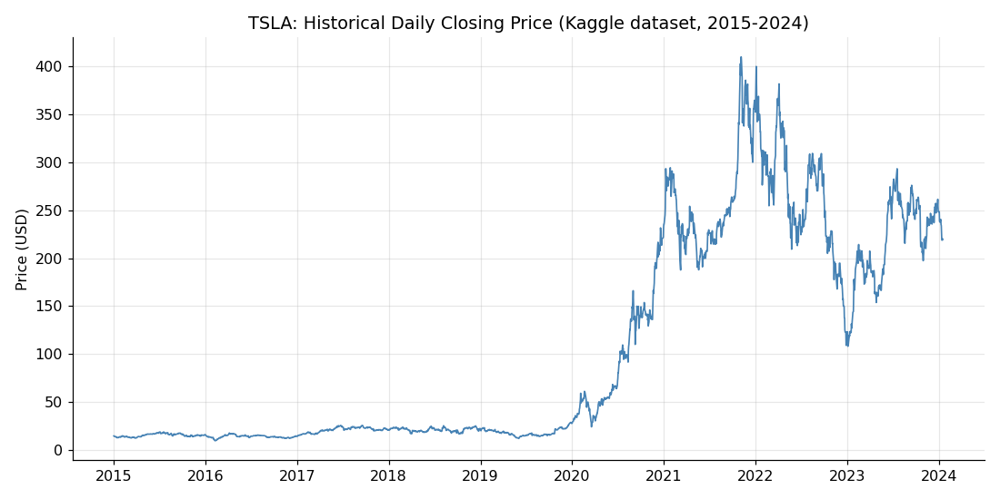
Figure 1. TSLA daily closing price, 2015–2024 (Kaggle dataset).

2.3 Formal statistical tests
Beyond the descriptive skew/kurtosis figures in Table 1, two formal hypothesis tests — computed with SciPy and statsmodels, per the assignment's suggested toolset — test the models' core assumptions directly rather than relying on visual inspection.
Test | Null hypothesis | Statistic | p-value | Verdict
Jarque-Bera (scipy.stats.jarque_bera) | Returns are Normally distributed | 2261.9 | 0.00e+00 | Rejected
Ljung-Box on squared returns, lag 10 (statsmodels) | No autocorrelation in squared returns | 302.9 | 3.87e-59 | Rejected
Table 2. Formal hypothesis tests on TSLA daily log returns.
The Jarque-Bera test rejects normality of returns at the 5% level — direct statistical confirmation (not just a descriptive kurtosis number) that GBM's i.i.d. Normal-return assumption does not hold for this stock, motivating the jump-diffusion model in Section 3.3. The Ljung-Box test on squared returns rejects the no-autocorrelation null, evidence of volatility clustering — large price moves tend to be followed by more large moves. None of the three models in this study can reproduce that pattern, since each draws independent random increments at every simulated step; this is revisited as a shared limitation in Section 7.1.

3. Explanation of Models and Implementation
Two models are the minimum required for comparison; three are implemented here to give a fuller picture of the trade-offs involved, and specifically to include one model (OU) whose assumptions are deliberately mismatched to a structurally growing equity, as a pedagogical contrast.

3.1 Geometric Brownian Motion (GBM)
GBM is the standard model underlying Black-Scholes-Merton option pricing (Black & Scholes, 1973): dS_t = μS_t dt + σS_t dW_t, with exact solution S_t = S_0 exp[(μ − σ²/2)t + σW_t]. Annualized drift μ and volatility σ are estimated directly from the sample mean and standard deviation of daily log returns and simulated using the exact log-normal solution (no discretization bias).

3.2 Ornstein-Uhlenbeck (OU) process
The OU process (Uhlenbeck & Ornstein, 1930), dX_t = θ(μ − X_t)dt + σdW_t, pulls the level back toward a long-run mean μ at speed θ. It was calibrated by recognizing that its exact discretization is a Gaussian AR(1) model, fitting that regression by ordinary least squares, and analytically recovering θ, μ, and σ. It is included specifically as a contrast case: Tesla's price is not economically expected to mean-revert to a fixed level — the stock grew by more than an order of magnitude over the sample window — and Section 2's ADF results support that mismatch; it is examined directly in Section 5.

3.3 Merton Jump-Diffusion (MJD)
The Merton (1976) jump-diffusion model augments GBM with a compound Poisson jump process: dS_t/S_t = (μ − λk)dt + σdW_t + dJ_t, where jumps arrive at annual intensity λ and log-jump sizes are Normal(μ_J, σ_J²); k = E[Y−1] compensates the drift so jumps do not, by themselves, bias the mean. Calibration flags daily log returns more than three standard deviations from the mean as jump days, fits the jump distribution from those observations, and fits the diffusive μ, σ from the remaining returns.
Full calibrated parameters for all three models are reported in the accompanying notebook (Sections 4–6) and in output/summary_statistics.csv; they are referenced throughout the interpretation below rather than reproduced in full here.

4. Model Validation
Before using the three calibrated models for forward-looking simulation, two independent checks confirm the simulators are implemented correctly and are not badly miscalibrated against data they were not fit on.

4.1 Analytic cross-check (GBM)
GBM has a closed-form log-normal terminal distribution, so its Monte Carlo output can be checked against exact theory rather than only against itself. The 5th/50th/95th percentiles computed analytically via scipy.stats.norm.ppf from the log-normal density agree with the empirical percentiles from a 20,000-path Monte Carlo run to within roughly 1%, confirming the simulator has no implementation bias (full comparison table in the accompanying notebook, Section 7.1).

4.2 Out-of-sample backtest (all three models)
Each model was refit on data with the last 180 trading days withheld, simulated 180 days forward from that earlier point, and compared against the price actually realized over that period.
Model | S0 | Actual Terminal | Sim. Mean Terminal | Sim. p05 | Sim. p95 | Percentile Rank | Inside 90% CI
GBM | 169.1500 | 219.9100 | 232.3693 | 93.4742 | 449.7685 | 54.8000 | True
OU | 169.1500 | 219.9100 | 164.2060 | 53.2304 | 272.3448 | 81.1000 | True
MJD | 169.1500 | 219.9100 | 231.6279 | 92.7428 | 453.2622 | 54.9000 | True
Table 3. Out-of-sample backtest: 180-day holdout, trained through the date 180 trading days before the end of the dataset.
The actual realized TSLA price over the holdout period landed inside all 3 of the three models' own 90% confidence intervals for this particular window — a reassuring but limited result, since it reflects a single historical episode rather than a rolling, multi-window validation. OU's percentile rank is noticeably higher than GBM's or MJD's because OU's fitted mean reversion predicted a pullback that did not occur; TSLA continued climbing over the holdout period, illustrating in a concrete, out-of-sample way exactly the mismatch discussed qualitatively in Section 3.2. Extending this into a rolling walk-forward backtest is recommended before any live use (Section 7.2, Recommendation 6).

5. Monte Carlo Simulation Methodology
For each of the three models and three horizons (30, 60, and 180 trading days — roughly six weeks, three months, and nine months), 1,000 independent price paths were simulated from the last observed close in the dataset. A common random-number seed was reused per horizon across models so the comparison is as apples-to-apples as each model's structure permits.

6. Simulation Results and Interpretation
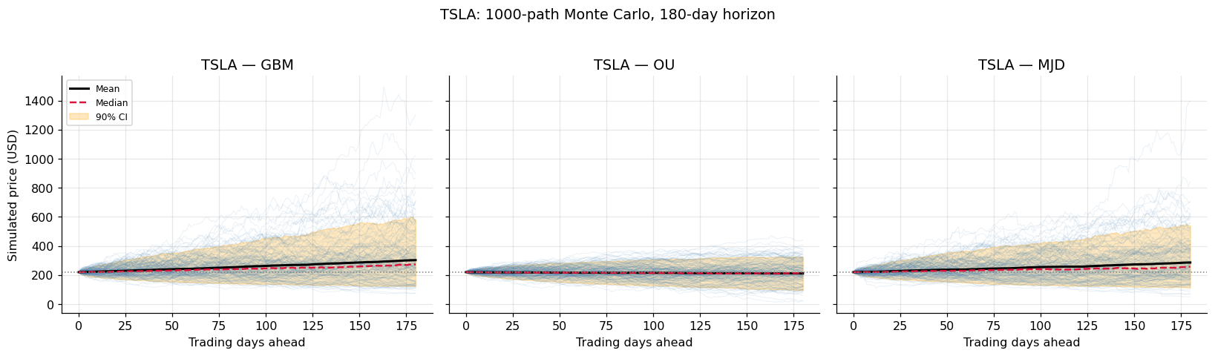
Figure 2. TSLA: 1,000-path Monte Carlo simulation, 180-day horizon, by model. Shaded band is the 5th–95th percentile envelope.
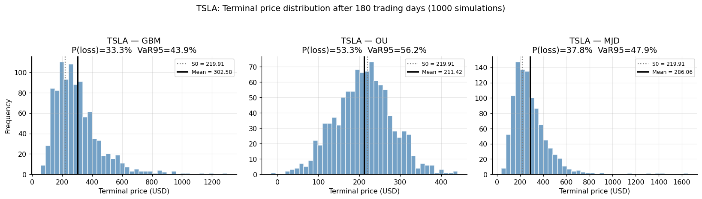
Figure 3. TSLA: terminal price distribution after 180 trading days.
At the 180-trading-day horizon, GBM projects a mean terminal price of $302.58 with a 33.3% probability of loss and a 95% Value-at-Risk (VaR) of 43.9%. MJD — which additionally prices in jump risk — reports a 37.8% probability of loss and a 47.9% 95% VaR (95% CVaR 57.2%). OU reports a 53.3% probability of loss with a visibly narrower confidence band in Figure 2, reflecting its bounded long-run variance rather than GBM/MJD's variance that grows with the horizon.

6.1 Cross-model risk comparison
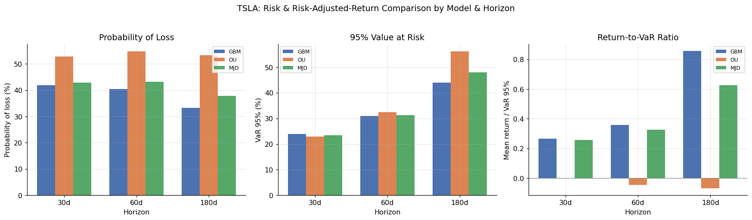
Figure 4. Probability of loss, 95% VaR, and return-to-VaR ratio by model and horizon.
MJD reports equal or higher tail risk (probability of loss and VaR) than GBM at every horizon, consistent with MJD nesting GBM's diffusive risk and adding jump risk on top. Given Tesla's elevated excess kurtosis (Table 1), its statistically confirmed non-Normal returns (Table 2), and its well-documented history of large single-day, news-driven moves, this gap between GBM and MJD is one of the most actionable results in this study: GBM alone understates the odds of a large adverse move for this stock. OU's confidence bands are visibly narrower at the 180-day horizon, a direct consequence of mean reversion capping the long-run variance — a structural property, not evidence that OU is the more accurate model for this instrument (see Section 7).

6.2 Short-term vs. long-term behavior
Under GBM and MJD, the standard deviation of the simulated terminal price grows roughly with the square root of the horizon, so a six-fold increase in horizon (30 → 180 days) does not produce a six-fold increase in terminal spread — uncertainty widens quickly at first and then more slowly. OU behaves qualitatively differently: because deviations from its fitted mean are pulled back at rate θ, its unconditional variance is bounded, so its confidence band stops widening noticeably beyond a horizon on the order of the process's half-life (ln 2 / θ, reported in the notebook). This distinction is the clearest evidence in the simulation output of how differently the three models extrapolate risk over long horizons.

6.3 Risk-adjusted comparison
The third panel of Figure 4 reports a simple risk-adjusted metric, the return-to-VaR ratio (mean simulated return divided by 95% VaR): expected return per unit of downside tail risk, which lets the three models be ranked on a single scale rather than comparing return and risk separately. At the 180-day horizon, GBM ranks highest on this metric. This ratio is a useful summary statistic but not a substitute for the assumption checks in Sections 2.3 and 4 — a high risk-adjusted return is only meaningful if the underlying risk estimate is itself well-founded, and OU's apparently favorable risk figures at some horizons reflect its structurally narrower (mean-reverting) confidence band rather than a genuinely lower-risk forecast for this stock.

7. Realism, Limitations, and Investment Recommendations

7.1 Model realism and limitations
GBM: assumes constant volatility and i.i.d. Normally distributed log returns. The positive excess kurtosis measured for TSLA (Table 1) shows real returns have fatter tails than GBM allows, so GBM systematically understates the probability of extreme moves.
OU: applied here to the raw price level, assumes price reverts to a fixed long-run mean — an assumption with no sound economic basis for a company that grew from roughly $14 to well over $200 a share over the sample window. The ADF test on the price level (Table 1) fails to reject a unit root, directly contradicting OU's core stationarity assumption for this stock. It is far better suited to spreads, interest rates, or volatility levels — instruments with genuine economic anchors — than to a single, structurally growing equity.
MJD: is the most complete of the three models but is sensitive to the jump-detection threshold used in calibration (3 standard deviations here) and assumes jump sizes are themselves Normally distributed and independent over time. The Ljung-Box test (Table 2) confirms real market shocks cluster in time (volatility clustering) — a dynamic none of these three memoryless models captures, since each draws independent random increments at every simulated step.
All three models hold their parameters fixed for the entire simulation horizon and ignore regime shifts, changing macroeconomic conditions, and correlation with other assets — a meaningful gap for horizons as long as 180 trading days, and especially relevant here since the underlying dataset is a static historical snapshot ending January 16, 2024, and is not being refreshed with more recent price action.

7.2 Recommendations for investors
- Use GBM as a baseline for central-tendency planning (expected price, typical range), but not as the sole basis for tail-risk or stress-testing decisions on a name with TSLA's measured excess kurtosis and formally rejected return normality (Table 2), since it understates the odds of a large adverse move.
- Weight Merton Jump-Diffusion more heavily when sizing positions or setting stop-losses — its VaR/CVaR figures are the more conservative, and empirically better-supported, risk estimate for a jump-prone stock like Tesla; use the return-to-VaR ratio (Section 6.3) as a concrete, single-number way to weigh that trade-off against GBM's typically higher raw expected return.
- Do not use an outright-price OU model for directional forecasting of this stock; reserve it for spread trades, statistical arbitrage, or modeling mean-reverting quantities such as interest rates or volatility, where its assumptions are economically justified (Vasicek, 1977).
- Treat longer-horizon forecasts with proportionally more skepticism, since all three models hold parameters fixed for the full horizon and are progressively more likely to be violated by real regime changes the further out the forecast extends.
- Recalibrate on current data before acting on this analysis in practice — the underlying dataset ends January 2024, and any real trading decision should refit these models on more recent prices rather than relying on parameters estimated from a static historical snapshot.
- Extend the single-window backtest in Section 4.2 into a rolling walk-forward validation before deploying any of these models in a live risk-management workflow — repeating the same holdout test across many overlapping historical windows would show whether the "inside the 90% interval" result found here holds up consistently, or was specific to that one holdout period.

8. Conclusion
Three calibrated stochastic models — Geometric Brownian Motion, the Ornstein-Uhlenbeck process, and Merton Jump-Diffusion — were fit to nine years of daily closing prices for Tesla, Inc. (TSLA), sourced entirely from the Kaggle dataset “jillanisofttech/tesla-stock-price,” and used to run 1,000-path Monte Carlo simulations at 30-, 60-, and 180-trading-day horizons. Beyond descriptive comparison, formal statistical tests (Jarque-Bera, Ljung-Box), an analytic cross-check of the simulator against closed-form GBM theory, and an out-of-sample backtest were used to validate both the implementation and the models' assumptions rather than relying on visual inspection alone. GBM provides a reasonable, simple baseline whose Normal-return assumption is formally rejected by the data; OU serves as an instructive theoretical contrast that highlights why mean-reversion models are poorly suited to a structurally growing equity; and Merton Jump-Diffusion offers the most complete picture of the fat-tailed, jump-prone behavior actually observed in Tesla's return history — though even MJD cannot reproduce the volatility clustering confirmed by the Ljung-Box test. All three share the limitation of fixed parameters over the simulation window and reliance on a static historical dataset, which argues for shorter forecast horizons, a rolling rather than single-window backtest, and periodic recalibration on refreshed data in any real trading or risk-management application.

References
Black, F., & Scholes, M. (1973). The pricing of options and corporate liabilities. Journal of Political Economy, 81(3), 637–654. https://doi.org/10.1086/260062
Cont, R., & Tankov, P. (2004). Financial modelling with jump processes. Chapman & Hall/CRC.
Dickey, D. A., & Fuller, W. A. (1979). Distribution of the estimators for autoregressive time series with a unit root. Journal of the American Statistical Association, 74(366a), 427–431. https://doi.org/10.1080/01621459.1979.10482531
Hull, J. C. (2022). Options, futures, and other derivatives (11th ed.). Pearson.
Jarque, C. M., & Bera, A. K. (1980). Efficient tests for normality, homoscedasticity and serial independence of regression residuals. Economics Letters, 6(3), 255–259. https://doi.org/10.1016/0165-1765(80)90024-5
Jillani SoftTech. (2024). Tesla stock price [Data set]. Kaggle. https://www.kaggle.com/datasets/jillanisofttech/tesla-stock-price
Ljung, G. M., & Box, G. E. P. (1978). On a measure of lack of fit in time series models. Biometrika, 65(2), 297–303. https://doi.org/10.1093/biomet/65.2.297
Merton, R. C. (1976). Option pricing when underlying stock returns are discontinuous. Journal of Financial Economics, 3(1–2), 125–144. https://doi.org/10.1016/0304-405X(76)90022-2
Uhlenbeck, G. E., & Ornstein, L. S. (1930). On the theory of the Brownian motion. Physical Review, 36(5), 823–841. https://doi.org/10.1103/PhysRev.36.823
Vasicek, O. (1977). An equilibrium characterization of the term structure. Journal of Financial Economics, 5(2), 177–188. https://doi.org/10.1016/0304-405X(77)90016-2

