3. Initial Model Development
Following the pattern in the notebook's Step 4, four models — a majority-class baseline, logistic regression (standardized features), a decision tree, and a random forest (300 trees) — were fit on a stratified 75/25 train/test split (results/split_assignment.csv, seed 42; n_train = 176,527, n_test = 58,843) and evaluated against three feature sets defined once in config.FEATURE_SETS: full (all 50 modeling features), no_derived (drops the six construction-derived features including URLSimilarityIndex), and url_only (the 18 lexical features readable from the URL string alone, before any page is fetched). Five-fold cross-validated F1 on the training set is reported alongside the held-out test metrics. Precision, recall, F1, and CV F1 are computed for phishing (label 0) as the positive class (config.POS_LABEL), not scikit-learn's default of legitimate (label 1); accuracy and ROC AUC are unaffected by that choice.

Feature set | Model | Accuracy | F1 (phishing) | ROC AUC | CV F1 (phishing, train)
full | Majority baseline | 0.5729 | 0.0000 | 0.5000 | —
full | Logistic regression | 0.9999 | 0.9999 | 1.0000 | 0.9998
full | Decision tree | 1.0000 | 1.0000 | 1.0000 | 1.0000
full | Random forest | 1.0000 | 1.0000 | 1.0000 | 1.0000
no_derived | Majority baseline | 0.5729 | 0.0000 | 0.5000 | —
no_derived | Logistic regression | 0.9993 | 0.9991 | 1.0000 | 0.9991
no_derived | Decision tree | 0.9990 | 0.9988 | 0.9990 | 0.9987
no_derived | Random forest | 0.9999 | 0.9998 | 1.0000 | 0.9998
url_only | Majority baseline | 0.5729 | 0.0000 | 0.5000 | —
url_only | Logistic regression | 0.9959 | 0.9952 | 0.9981 | 0.9954
url_only | Decision tree | 0.9972 | 0.9967 | 0.9967 | 0.9966
url_only | Random forest | 0.9973 | 0.9968 | 0.9981 | 0.9968

Observations:
- Accuracy moves from 1.0000 to 0.9999 to 0.9973 across full → no_derived → url_only — the flat ablation the leakage screen (Section 2) predicted: removing the derived and page-content features costs about a quarter of a percentage point, not a large gap.
- The majority baseline's phishing F1 is 0.0000 by construction: predicting "legitimate" for every URL never identifies a phishing URL, even though its accuracy (57.29%) matches the class balance.
- Precision, recall, F1, and CV F1 above are computed for phishing (label 0) as the positive class, not scikit-learn's default of legitimate (label 1); accuracy and ROC AUC are unaffected by that choice.
- Full metrics, per-model confusion matrices, and timestamps are in results/metrics_stratified_<feature_set>_<model>.json; the full table is results/initial_model_comparison.csv.
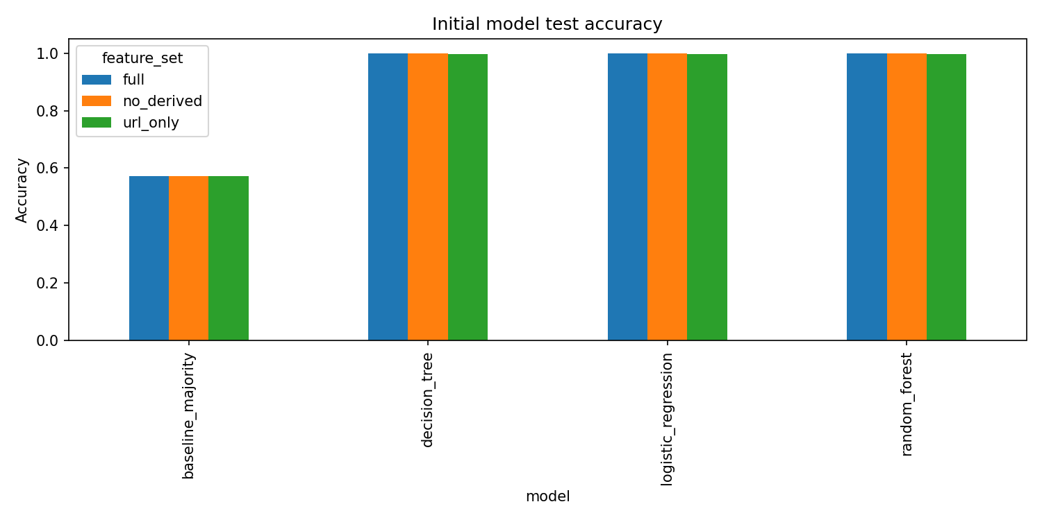
Figure 1
Held-out test accuracy by model and feature set.
Observations:
- The majority baseline (57.3% accuracy) is the floor every learned model is compared against; all three learned models exceed 99.7% accuracy in every feature configuration, regardless of feature set.
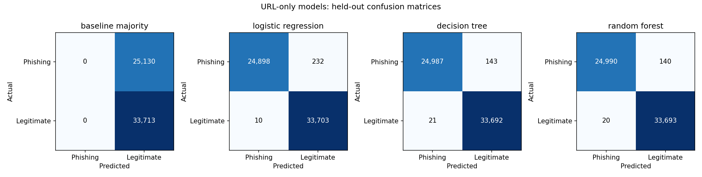
Figure 2
Held-out confusion matrices for the four url_only models (phishing vs. legitimate).
Observations:
- The url_only random forest — the strongest model that avoids both construction-derived and page-content features — reaches 99.92% phishing precision and 99.44% phishing recall on the held-out test set: 140 of 25,130 phishing URLs missed, 20 of 33,713 legitimate URLs misclassified.
- The majority baseline never predicts phishing at all (0 of 25,130 caught); each learned model closes nearly all of that gap using only URL-lexical features, available before any page is fetched.

