3. Initial Model Development
Following the pattern in the notebook's Step 4, four models — a majority-class baseline, logistic regression (standardized features), a decision tree, and a random forest (300 trees) — were fit on a stratified 75/25 train/test split (results/split_assignment.csv, seed 42; n_train = 176,527, n_test = 58,843) and evaluated against three feature sets defined once in config.FEATURE_SETS: full (all 50 modeling features), no_derived (drops the six construction-derived features including URLSimilarityIndex), and url_only (the 18 lexical features readable from the URL string alone, before any page is fetched). Five-fold cross-validated F1 on the training set is reported alongside the held-out test metrics. Precision, recall, F1, and CV F1 are computed for phishing (label 0) as the positive class (config.POS_LABEL), not scikit-learn's default of legitimate (label 1); accuracy and ROC AUC are unaffected by that choice.

Feature set | Model | Accuracy | F1 (phishing) | ROC AUC | CV F1 (phishing, train)
full | Majority baseline | 0.5729 | 0.0000 | 0.5000 | —
full | Logistic regression | 0.9999 | 0.9999 | 1.0000 | 0.9998
full | Decision tree | 1.0000 | 1.0000 | 1.0000 | 1.0000
full | Random forest | 1.0000 | 1.0000 | 1.0000 | 1.0000
no_derived | Majority baseline | 0.5729 | 0.0000 | 0.5000 | —
no_derived | Logistic regression | 0.9993 | 0.9991 | 1.0000 | 0.9991
no_derived | Decision tree | 0.9990 | 0.9988 | 0.9990 | 0.9987
no_derived | Random forest | 0.9999 | 0.9998 | 1.0000 | 0.9998
url_only | Majority baseline | 0.5729 | 0.0000 | 0.5000 | —
url_only | Logistic regression | 0.9959 | 0.9952 | 0.9981 | 0.9954
url_only | Decision tree | 0.9972 | 0.9967 | 0.9967 | 0.9966
url_only | Random forest | 0.9973 | 0.9968 | 0.9981 | 0.9968

The majority baseline's phishing F1 is 0.0000 by construction: predicting "legitimate" for every URL never identifies a phishing URL, so phishing precision, recall, and F1 are all zero even though accuracy is 57.29% — a reminder that accuracy alone is the wrong metric for this class balance. Full metrics, per-model confusion matrices, and timestamps are in results/metrics_stratified_<feature_set>_<model>.json; the comparison table with all four metrics per row is results/initial_model_comparison.csv.
The result is the flat ablation the leakage screen predicted: accuracy moves from 1.0000 to 0.9999 to 0.9973 across full → no_derived → url_only. Removing all six construction-derived features and all twenty-six page-content features — features unavailable at the moment a URL must actually be judged, before any page is fetched — costs about a quarter of a percentage point, not the large gap the single-feature screen alone would suggest. This benchmark cannot be repaired by dropping a named feature group; the classes differ systematically in shape (Section 2) rather than in one removable column.
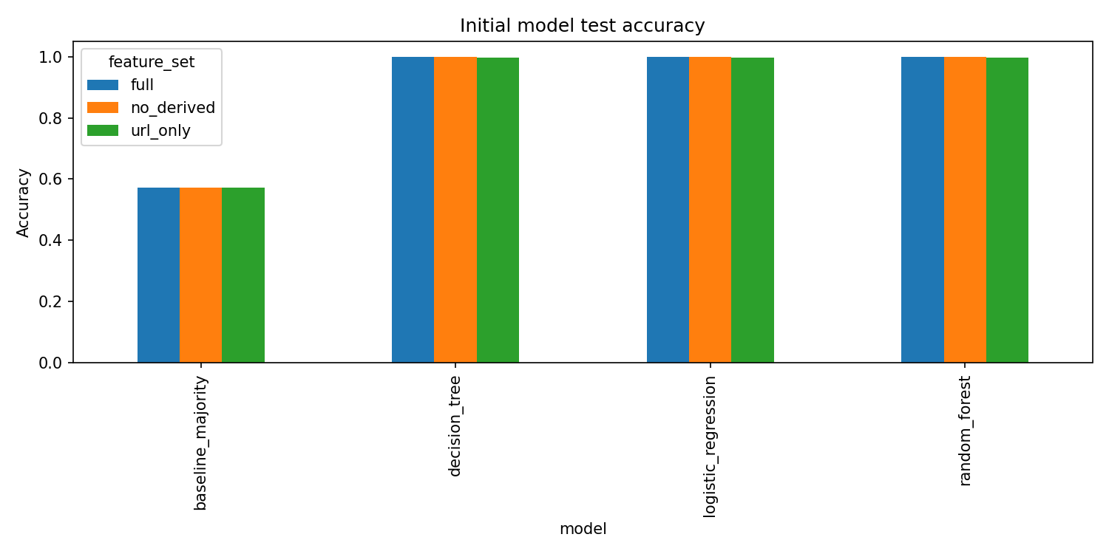
Figure 1
Held-out test accuracy by model and feature set. The majority baseline (57.3%) reflects the class balance; all three learned models exceed 99.7% accuracy in every feature configuration.
The url_only random forest is the strongest model that avoids both the construction-derived and page-content features: on the held-out test set it reaches 99.92% phishing precision and 99.44% phishing recall (140 phishing URLs missed out of 25,130; 20 legitimate URLs misclassified out of 33,713), as shown for all four url_only models in Figure 2.
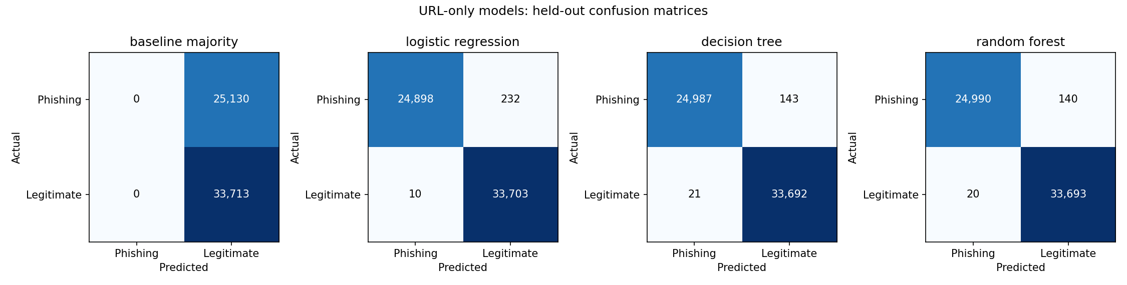
Figure 2
Held-out confusion matrices for the four url_only models (phishing vs. legitimate). The majority baseline never predicts phishing; the three learned models each miss fewer than 250 of the 25,130 held-out phishing URLs.

