Tuning, Evaluating, and Deploying a URL-Only Phishing Classifier: Deliverable 2

Group 5: [Team member names]
[Department, University]
PhDAI 732: [Course Name]
[Instructor Name]
September 27, 2026

Tuning, Evaluating, and Deploying a URL-Only Phishing Classifier
Deliverable 1 showed that near-perfect accuracy on the PhiUSIIL phishing dataset (Prasad & Chandra, 2024) comes largely from construction artifacts, and that the defensible estimate uses only the 18 lexical features readable from the URL string. This deliverable tunes that URL-only model, evaluates it once on the held-out test partition, and asks who bears its errors and how it would behave in production.

Hyperparameter Tuning
The course template tunes a matrix-factorization recommender on root mean squared error (RMSE). Our task is binary classification, so we applied the same procedure with scikit-learn's GridSearchCV (Pedregosa et al., 2011), scoring phishing-class F1 with seeded, stratified five-fold cross-validation (CV) on the URL-only training partition. We searched the three Deliverable 1 models and added histogram gradient boosting, 88 configurations and 440 fits in total. Every grid contained the untuned default, so each gain in Table 1 is measured on identical folds. Grid search suits grids this small; random or Bayesian search scales better as the number of hyperparameters grows (Bergstra & Bengio, 2012).
Gains were real but small. Logistic regression improved most (CV F1 .9954 to .9973), entirely through weaker regularization: F1 rose monotonically with C, so the lexical features are not overfitting at this sample size. Tree and forest gains were smaller than one fold-to-fold standard deviation (about .0003). Gradient boosting scored highest (.9975) and was selected as the final model before the test data were opened. Its chosen learning rate and iteration count sit at the grid edge, but the top eight configurations fall within .00003 of each other, a plateau rather than an unexplored optimum.
Table 1
Cross-Validated Phishing F1 Before and After Grid Search (URL-Only Features)
Model | Configs | Default F1 | Tuned F1 | Gain | Selected hyperparameters
Logistic regression | 12 | .9954 | .9973 | +.00183 | C=1000.0, class_weight=balanced
Decision tree | 24 | .9967 | .9967 | +.00003 | criterion=entropy, max_depth=30, min_samples_leaf=1
Random forest | 16 | .9968 | .9969 | +.00010 | max_depth=30, max_features=0.5, min_samples_leaf=1, n_estimators=300
Gradient boosting | 36 | .9970 | .9975 | +.00043 | l2_regularization=0.0, learning_rate=0.2, max_iter=600, max_leaf_nodes=31
Note. Mean over five stratified folds of the 176,527-URL training partition. The fold-to-fold standard deviation of F1 is about .0003 for every model.

Final Model Evaluation
Table 2 reports each tuned model on the 58,843 held-out URLs. The tuned gradient boosting model reached F1 = .9974, 95% bootstrap CI [.9970, .9978], with precision = .9997, recall = .9952, and a Matthews correlation coefficient of .9956. It missed 121 of 25,130 phishing URLs and flagged 7 of 33,713 legitimate ones (Figure 1), against 139 and 11 before tuning and 140 and 20 for the Deliverable 1 random forest. We weight precision, recall, and precision-recall area (PR AUC) above accuracy because the two errors carry different costs (Saito & Rehmsmeier, 2015; Chicco & Jurman, 2020). RMSE and mean absolute error (MAE) are defined for ratings, so we computed them on the predicted phishing probability: RMSE fell from .0488 to .0457 and MAE from .0049 to .0036.
Table 2
Tuned Models on the Held-Out Test Partition (URL-Only Features)
Model | Precision | Recall | F1 | PR AUC | RMSE | MAE | Missed | False alarms
Logistic regression | .9992 | .9939 | .9965 | .9987 | .0509 | .0058 | 154 | 19
Decision tree | .9992 | .9943 | .9967 | .9974 | .0515 | .0041 | 143 | 20
Random forest | .9993 | .9944 | .9968 | .9986 | .0487 | .0045 | 141 | 17
Gradient boosting | .9997 | .9952 | .9974 | .9985 | .0457 | .0036 | 121 | 7
Gradient boosting (default) | .9996 | .9945 | .9970 | .9988 | .0488 | .0049 | 139 | 11
Note. Phishing is the positive class. RMSE and MAE are computed on the predicted phishing probability. Missed counts phishing URLs predicted legitimate; false alarms counts legitimate URLs predicted phishing.
Figure 1
Confusion Matrix of the Tuned Gradient Boosting Model on the Test Partition
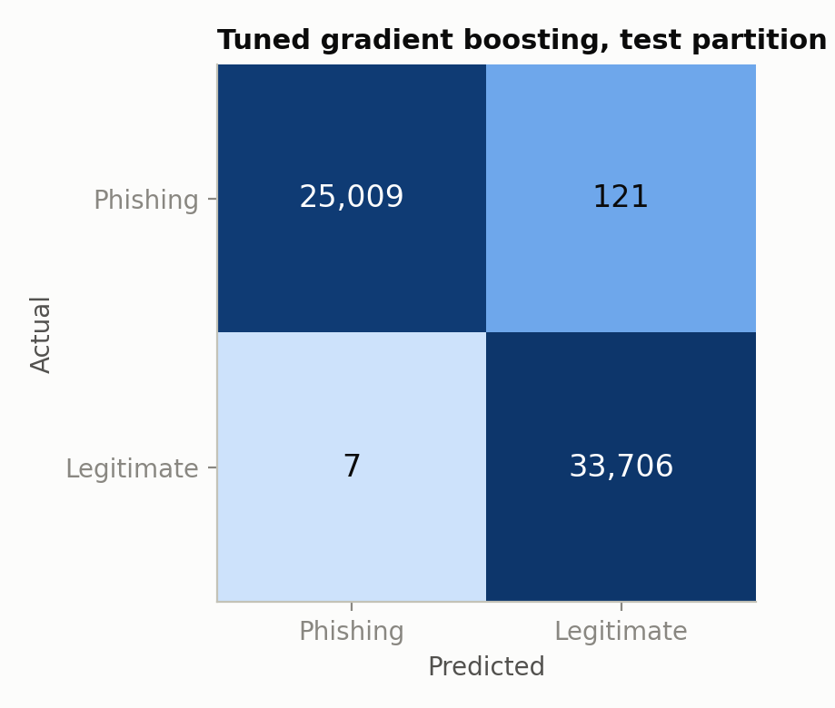
Note. Color uses a log scale so the error cells remain visible.
Two results qualify the headline. First, tuning traded a little ranking quality for decision quality: ROC AUC fell from .9984 to .9978 because the search optimized F1 at a 0.5 threshold. Second, the remaining errors are not borderline. The F1-optimal threshold learned on training folds was 0.500, and 110 of the 121 missed phishing URLs received a phishing probability below 0.1 (Figure 2). Spending a 0.1% false-alarm budget (threshold 0.231) recovers only 8 more phishing URLs for 16 more false alarms. Comparing predictions with actual labels shows why: the misses are short HTTPS homepages that impersonate brands, such as appleid-find.cloud, netflix-vn.com, and amazon5551.com. Lexically they look like the legitimate class, and none of the 18 counts encodes a brand name.
Figure 2
Predicted Phishing Probability for the Phishing URLs the Model Missed
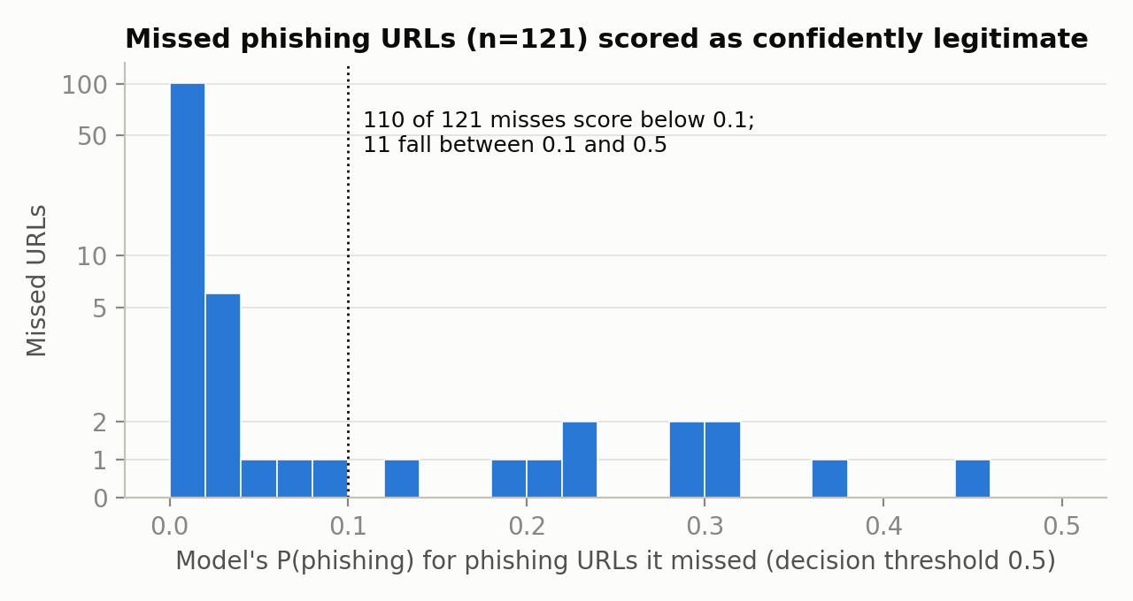
Note. Vertical axis is linear from 0 to 5 and logarithmic above.
Two checks support the result. Refit on a domain-grouped split, where no domain appears in both partitions, the model scored F1 = .9977, so it is not memorizing domains. On the full feature set, three of the four tuned models remain perfect, which confirms that the Deliverable 1 leakage finding survives tuning (Kapoor & Narayanan, 2023). The areas for improvement therefore lie in new information, such as brand-similarity and domain-registration features, not in further tuning.

Ethical Considerations
PhiUSIIL has no demographic attributes, but bias still enters through the kind of site owner behind a URL. The legitimate class consists of HTTPS homepages of established domains, while phishing URLs come from threat feeds (Prasad & Chandra, 2024), so the model partly learns the difference between two collection processes, a sampling bias common in security datasets (Arp et al., 2022). Its false alarms are uneven (Figure 3): 0.84% of legitimate .edu URLs (4 of 479) were flagged, against 0.006% for .com, because universities use long, multi-level addresses. For newer TLDs the rate cannot be measured at all: the test set holds 36, 112, and 7 legitimate .app, .io, and .dev URLs. And because every HTTP URL in the dataset is phishing, the model treats HTTP as proof of fraud and would block every legitimate HTTP-only site. A blocked site loses traffic and reputation, a harm that falls unevenly across groups (Mehrabi et al., 2021).
Figure 3
False-Alarm Rate on Legitimate URLs by Top-Level Domain
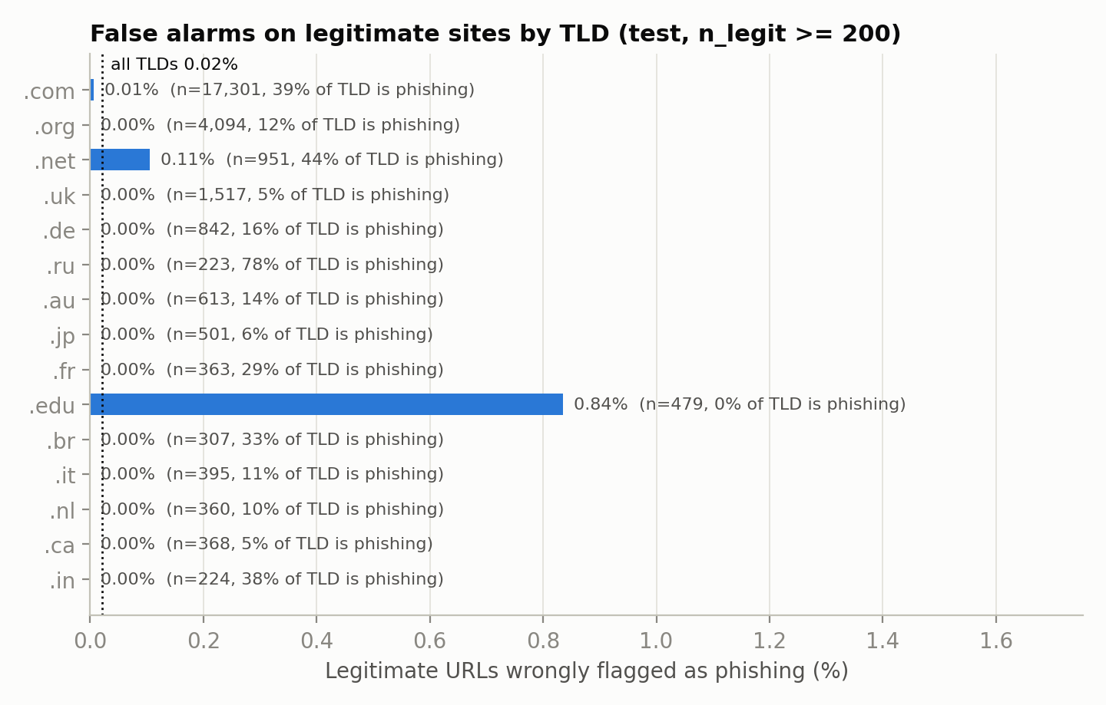
Note. Test partition, TLDs with at least 200 legitimate URLs. The dotted line is the overall rate.
Transparency is a partial safeguard. Four features (URLLength, LetterRatioInURL, DomainLength, IsHTTPS) carry most of the decision, which a flagged owner can be told, although the same list tells attackers what to imitate. Privacy risk is modest for URL-only screening, but a log of scored URLs is a browsing history and should be minimized and retained briefly. We would publish per-TLD error rates in a model card (Mitchell et al., 2019), add legitimate HTTP and new-TLD samples, drop or down-weight IsHTTPS, and give site owners an appeal path.

Real-World Application
The natural use is a pre-fetch screen. An email gateway, browser extension, or DNS resolver scores a URL before the page is requested, which is exactly the information setting the URL-only features simulate. Lexical models are fast and need no page download (Sahingoz et al., 2019), so a gradient boosting model over 18 numeric features can run inline at mail-server volume. It should not act alone. Blacklists catch known campaigns but lag new ones (Sheng et al., 2009), and our model has the opposite blind spot: clean-looking new domains. A layered design uses the classifier as the first stage and routes uncertain URLs to reputation and page-content checks.
Table 3
Expected Precision of the Final Model at Different Phishing Base Rates
Phishing share of traffic | Caught per million URLs | False alarms per million | Precision
42.7% | 425,012 | 119 | .9997
1.0% | 9,952 | 206 | .9798
0.1% | 995 | 207 | .8275
Note. Uses the test-set recall and false-alarm rate of the final model. The first row is the test partition's own class balance.
Table 3 shows the most important production adjustment. The test set is 43% phishing; live traffic is far cleaner. At one phishing URL per thousand, the same recall and false-alarm rate give a precision of about .83, so roughly one alert in six is false, a base-rate effect that benchmark evaluations routinely hide (Arp et al., 2022). Four modifications would make the system effective in production. First, set the operating point by cost: quarantine in a mail gateway can tolerate the budget threshold, while a browser interstitial needs the lower false-alarm default. Second, add features attackers cannot cheaply change, such as domain age, certificate transparency records, and edit distance to protected brand names, which targets the confident misses directly. Third, plan for drift. Phishing kits change within weeks, so score distributions and per-TLD false-alarm rates should be monitored, the model retrained on a rolling window, and each release validated on a time-ordered split (Gama et al., 2014). Fourth, deploy in shadow mode first, logging decisions without blocking, then enforce once live precision is measured.

Final Thoughts and Conclusion
- Tuning helped, but modestly. Grid search raised cross-validated F1 for every model. The tuned gradient boosting model improved test F1 from .9970 to .9974, cutting missed phishing URLs from 139 to 121 and false alarms from 11 to 7.
- The remaining errors are not a tuning problem. Of the 121 missed URLs, 110 were scored as confidently legitimate. They are brand impersonations on clean HTTPS homepages, which lexical counts cannot see, so further gains require new information rather than new hyperparameters.
- The dataset shapes the model as much as phishing does. HTTPS acts as a proxy for the label, legitimate .edu sites are flagged far more often than .com sites, and newer TLDs such as .app and .dev cannot be evaluated at all.
- Benchmark scores overstate field performance. At a realistic rate of one phishing URL per thousand, precision falls from .9997 to about .83, so evaluation must reflect deployment base rates.
- The Deliverable 1 argument holds end to end. The contribution of this project is the audit of where a near-perfect number comes from, not the number itself.
- A deployable system needs more than this model. It would use the fast URL screen as a first stage, add brand-similarity and domain-reputation features, monitor per-group error rates and drift, and retrain on a schedule.
- The work is reproducible. All code, the frozen split, search results, and figures are in the project repository (src/tuning.py, src/final_eval.py, and Sections 4 to 8 of the project notebook), and every number in this report is generated from those files.

References
Arp, D., Quiring, E., Pendlebury, F., Warnecke, A., Pierazzi, F., Wressnegger, C., Cavallaro, L., & Rieck, K. (2022). Dos and don'ts of machine learning in computer security. In Proceedings of the 31st USENIX Security Symposium. USENIX Association. https://www.usenix.org/conference/usenixsecurity22/presentation/arp
Bergstra, J., & Bengio, Y. (2012). Random search for hyper-parameter optimization. Journal of Machine Learning Research, 13, 281–305.
Chicco, D., & Jurman, G. (2020). The advantages of the Matthews correlation coefficient (MCC) over F1 score and accuracy in binary classification evaluation. BMC Genomics, 21, Article 6. https://doi.org/10.1186/s12864-019-6413-7
Gama, J., Žliobaitė, I., Bifet, A., Pechenizkiy, M., & Bouchachia, A. (2014). A survey on concept drift adaptation. ACM Computing Surveys, 46(4), Article 44. https://doi.org/10.1145/2523813
Kapoor, S., & Narayanan, A. (2023). Leakage and the reproducibility crisis in machine-learning-based science. Patterns, 4(9), Article 100804. https://doi.org/10.1016/j.patter.2023.100804
Mehrabi, N., Morstatter, F., Saxena, N., Lerman, K., & Galstyan, A. (2021). A survey on bias and fairness in machine learning. ACM Computing Surveys, 54(6), Article 115. https://doi.org/10.1145/3457607
Mitchell, M., Wu, S., Zaldivar, A., Barnes, P., Vasserman, L., Hutchinson, B., Spitzer, E., Raji, I. D., & Gebru, T. (2019). Model cards for model reporting. In Proceedings of the Conference on Fairness, Accountability, and Transparency (pp. 220–229). ACM. https://doi.org/10.1145/3287560.3287596
Pedregosa, F., Varoquaux, G., Gramfort, A., Michel, V., Thirion, B., Grisel, O., Blondel, M., Prettenhofer, P., Weiss, R., Dubourg, V., Vanderplas, J., Passos, A., Cournapeau, D., Brucher, M., Perrot, M., & Duchesnay, É. (2011). Scikit-learn: Machine learning in Python. Journal of Machine Learning Research, 12, 2825–2830.
Prasad, A., & Chandra, S. (2024). PhiUSIIL: A diverse security profile empowered phishing URL detection framework based on similarity index and incremental learning. Computers & Security, 136, Article 103545. https://doi.org/10.1016/j.cose.2023.103545
Sahingoz, O. K., Buber, E., Demir, O., & Diri, B. (2019). Machine learning based phishing detection from URLs. Expert Systems with Applications, 117, 345–357. https://doi.org/10.1016/j.eswa.2018.09.029
Saito, T., & Rehmsmeier, M. (2015). The precision-recall plot is more informative than the ROC plot when evaluating binary classifiers on imbalanced datasets. PLOS ONE, 10(3), Article e0118432. https://doi.org/10.1371/journal.pone.0118432
Sheng, S., Wardman, B., Warner, G., Cranor, L. F., Hong, J., & Zhang, C. (2009). An empirical analysis of phishing blacklists. In Proceedings of the Sixth Conference on Email and Anti-Spam (CEAS 2009).

Appendix
Team Contributions
Each member should confirm or edit their row before submission. Commit history in the project repository records who produced each artifact.
Team member | Role | Deliverable 2 contribution
[Name] | Lead / scaffold | Final assembly, editing to one voice, Conclusion
[Name] | Data steward | Frozen split verification, domain-grouped split
[Name] | Modeling | Grid search (src/tuning.py), final evaluation (src/final_eval.py)
[Name] | Evaluation / ethics | Metric justification, per-TLD error analysis, Ethics
[Name] | EDA / application | Figures, Real-World Application

