Dataset Preprocessing
Before beginning the exploratory analysis and model development, the PhiUSIIL Phishing URL dataset was reviewed and cleaned to make sure the team was working with consistent and reliable data. The original dataset contained 235,795 observations and 56 columns. These columns included information related to URLs, domains, webpage characteristics, and other features that can be useful for identifying phishing websites. As part of the preprocessing process, we checked the dataset for missing values, duplicate records, duplicate URLs, and inconsistencies in the target labels.
The cleaning process identified 425 duplicate URLs, which were removed before further analysis. There were no completely duplicated rows and no cases where the same URL had conflicting class labels. After removing the duplicate URLs, the cleaned dataset contained 235,370 observations while retaining all 56 columns. The cleaned data was also checked for missing values, and none were identified. As shown in Figure 1, the preprocessing output also produced a matching dataset fingerprint, which provided an additional check that the expected cleaned version of the dataset was being used by the group.

Figure 1
Data Cleaning and Preprocessing Summary
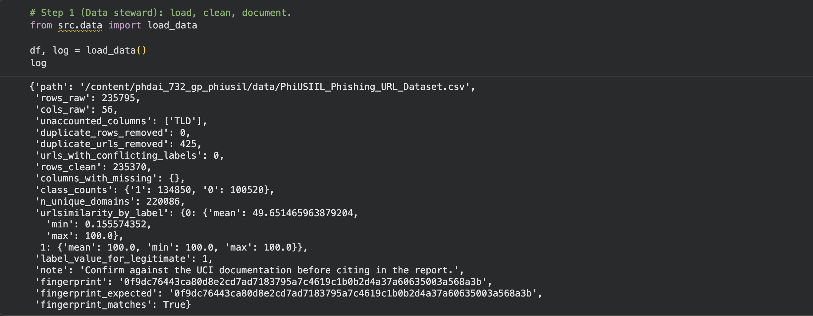
Note. The preprocessing workflow reduced the dataset from 235,795 to 235,370 observations after removing 425 duplicate URLs. No missing values or conflicting URL labels were identified.
The target variable, label, contained two values, 0 and 1. After preprocessing, class 1 contained 134,850 observations, representing 57.29% of the cleaned dataset, while class 0 contained 100,520 observations, representing 42.71%. Both classes therefore had a substantial number of observations available for analysis. A separate verification of the cleaned dataset also confirmed that there were no remaining duplicate rows or missing values. These checks were important because they helped establish a consistent dataset before the exploratory analysis and classification models were developed.
A leakage screening was also performed before modeling to determine whether individual features showed an unusually strong relationship with the target variable. Three features were flagged during this analysis. URLSimilarityIndex achieved approximately 99.67% single-feature accuracy, while NoOfExternalRef and LineOfCode achieved approximately 96.13% and 95.54%, respectively. These features were not automatically removed because high predictive accuracy by itself does not confirm that data leakage is present. Instead, they were flagged for additional consideration during feature selection and model evaluation. This allows the modeling team to examine whether model performance depends too heavily on features that may contain unusually strong information about the target.
Finally, consistent training and testing assignments were generated for the later stages of the project. The stratified split resulted in 176,527 observations for training and 58,843 observations for testing. A domain-grouped comparison split was also generated, containing 176,906 training observations and 58,464 testing observations. Preparing these splits in advance gives the team a consistent basis for exploratory analysis and model evaluation and helps prevent different members from unintentionally working with different versions or divisions of the dataset.

