Albert Kabore: Hyperparameter Tuning and Final Model Evaluation
View the charts: Open the [illustrated HTML draft](albert_tuning_and_evaluation.html) in a browser, or use Open Preview in your Markdown editor. The plain-text editor displays image links rather than charts. The [detailed notebook analysis](#detailed-notebook-analysis-and-visualizations) contains every V1–V17 visualization; the [Word copy](Albert_Tuning_and_Evaluation_Sections.docx) also embeds all 24 images.
This is the expanded master draft for Albert's Hyperparameter Tuning and Final Model Evaluation sections, including the complete notebook analysis and V1–V17 visualizations in the detailed appendix below. It intentionally exceeds the original half-page and one-page allocations so all supporting material is available for assembly. Table and figure numbers in the main sections stay as X; Eric numbers them at assembly. A formatted copy with the figures and tables embedded is in `Albert_Tuning_and_Evaluation_Sections.docx`.

Hyperparameter Tuning
We tuned SVD with Surprise's GridSearchCV using three-fold cross-validation (CV) on the 80,000-rating training partition only. This departs from the assignment's example code, which fits the search on the full dataset and so would let the test ratings both choose the hyperparameters and grade them. All three searches used the same three seeded folds, so their CV scores are directly comparable. On those folds, Surprise's default configuration scored a CV RMSE of 0.9534.
The assignment grid, run exactly as specified, crossed n_factors {50, 100}, n_epochs {20, 40}, and lr_all {0.002, 0.005}, leaving regularization at Surprise's default of 0.02. Table X summarizes it and the two searches that followed. Its 8 candidates improved on the defaults by only 0.0032, and in this grid each larger value (more factors, more epochs, a higher learning rate) raised mean CV RMSE (Figure X), which is consistent with overfitting while regularization stays at 0.02. Because that grid holds regularization fixed, an expanded grid of 54 candidates added reg_all {0.02, 0.05, 0.1} and widened the other axes. Its winner sat on the upper edge of all four axes, so a refined grid of 81 candidates extended each axis past that point. The refined search selected 200 factors, 80 epochs, a learning rate of 0.01, and regularization of 0.15 (CV RMSE 0.9294).
Regularization showed the largest sensitivity in both larger grids (Figures X and X). Averaged over the other settings, it moved CV RMSE by 0.0235 in the expanded grid, from 0.968 at 0.02 to 0.944 at 0.1, against 0.0059 for the learning rate. In the refined grid it moved CV RMSE by 0.0079, against 0.0011 or less for every other parameter. Its effect there was U-shaped (0.9323 at 0.1, 0.9309 at 0.15, 0.9388 at 0.2), and 0.15 was the best value in 24 of the 27 combinations of the other settings. This fits Bergstra and Bengio's (2012) observation that only a few hyperparameters usually matter for a given problem. The selected model still reaches three grid boundaries (the most factors, the most epochs, and the lowest learning rate), so we describe it as the best configuration tested, not a proven optimum. The surface is nearly flat near the top: the ten best refined candidates lie within 0.0008 of one another, and the three best differ only in factor count (0.9294 to 0.9297). Settings beyond the boundaries were not evaluated.
Table X
*Three Grid Searches on the Same Three Training Folds*
Search | Candidates | Values searched | Best CV RMSE (fold SD) | Best setting | Winner on grid edge
Assignment | 8 | n_factors {50, 100}; n_epochs {20, 40}; lr_all {0.002, 0.005}; reg_all 0.02 (fixed) | 0.9502 (0.0002) | 50, 20, 0.005 | n_factors (low), n_epochs (low), lr_all (high)
Expanded | 54 | n_factors {50, 100, 150}; n_epochs {20, 40}; lr_all {0.002, 0.005, 0.01}; reg_all {0.02, 0.05, 0.1} | 0.9306 (0.0006) | 150, 40, 0.01, 0.1 | All four (high)
Refined | 81 | n_factors {100, 150, 200}; n_epochs {40, 60, 80}; lr_all {0.01, 0.015, 0.02}; reg_all {0.1, 0.15, 0.2} | 0.9294 (0.0003) | 200, 80, 0.01, 0.15 | n_factors (high), n_epochs (high), lr_all (low)
*Note.* Scores are mean RMSE over three-fold CV on the 80,000-rating training partition; lower is better. Best settings are listed in the order n_factors, n_epochs, lr_all, reg_all. Surprise's default SVD (100, 20, 0.005, 0.02) scored 0.9534 on the same folds. The refined grid's result is the selected configuration. Values are from the tuning JSON and tuning_surface CSV files for each grid (tuning_assignment, tuning_expanded, tuning_refined).
Figure X
*Sensitivity of Cross-Validated RMSE to Each Hyperparameter in the Assignment Grid*
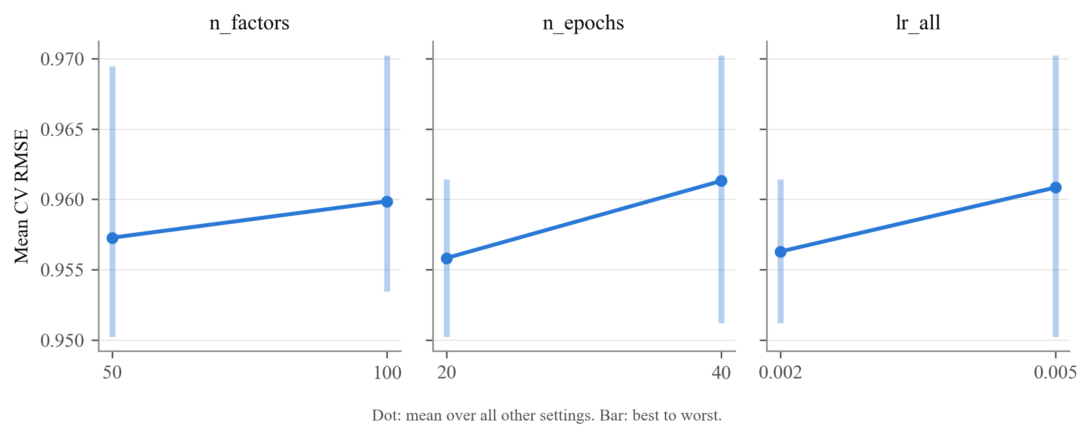
*Note.* Each panel shows mean three-fold CV RMSE on the training partition at each value of one hyperparameter, averaged over the other two (dot), with the range from best to worst candidate (bar). Regularization is fixed at Surprise's default of 0.02 in this grid. Every larger value raised mean CV RMSE: n_factors 0.9573 to 0.9599, n_epochs 0.9558 to 0.9613, lr_all 0.9563 to 0.9608. Lower is better. Values are from tuning_surface_assignment.csv.
Figure X
*Sensitivity of Cross-Validated RMSE to Each SVD Hyperparameter in the Expanded Grid*
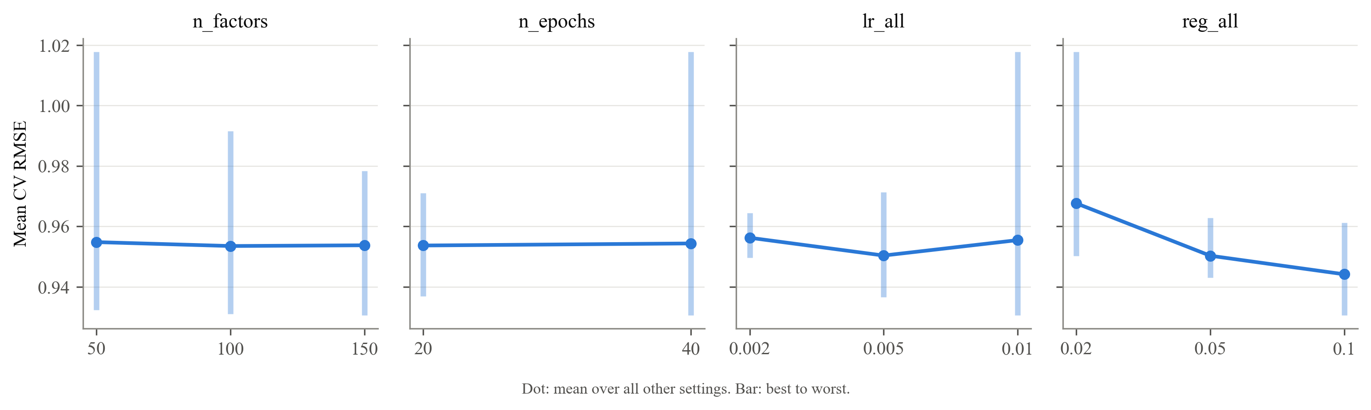
*Note.* Each panel shows mean three-fold CV RMSE on the training partition at each value of one hyperparameter, averaged over all settings of the other three (dot), with the range from best to worst candidate (bar). Only regularization (reg_all) shifts the mean noticeably across its values. Lower is better.
Figure X
*Sensitivity of Cross-Validated RMSE to Each SVD Hyperparameter in the Refined Grid*
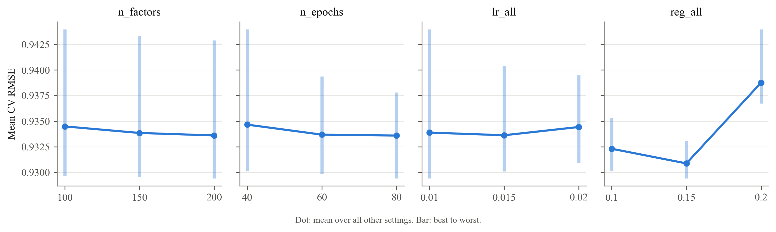
*Note.* Panels are read as in the expanded-grid figure. Regularization is again the only hyperparameter with a clear effect, and its minimum is inside the grid at 0.15 (mean CV RMSE 0.9309, against 0.9323 at 0.1 and 0.9388 at 0.2). The other three panels are nearly flat, so the three boundaries the selected model reaches (200 factors, 80 epochs, learning rate 0.01) matter little within the range tested. Lower is better. Values are from tuning_surface_refined.csv.

Final Model Evaluation
The tuned SVD was trained on the full training partition and scored once on the test set (Table X). Its test RMSE was 0.921 and its MAE 0.729, compared with 0.941 and 0.741 for the untuned SVD. That is a reduction of 0.0198 in RMSE (2.11%) and 0.0123 in MAE. The tuned SVD also improved on the bias-only baseline by 0.029 RMSE, an observed improvement over the bias-only baseline rather than an isolated estimate of the contribution of latent factors, since fitting and regularization also differ. The RMSE reduction is larger than the untuned SVD's fold-to-fold CV standard deviation of 0.0041. However, that standard deviation describes variation across training folds, not uncertainty in the difference between two models on one test set, so it is not a significance test for the improvement. Training RMSE was 0.791, a train-to-test gap of 0.131.
Table X
*Test-Set Rating Error and Ranking Quality by Model*
Model | RMSE | MAE | Precision@10 | Recall@10
Bias-only baseline | 0.950 | 0.752 | .596 | .249
Untuned SVD | 0.941 | 0.741 | .619 | .282
Tuned SVD | 0.921 | 0.729 | .596 | .261
*Note.* All models were fit on the 80,000-rating training partition and scored once on the 20,000-rating test set. Lower RMSE and MAE are better; higher precision and recall are better. Precision@10 and recall@10 rank only each user's held-out test ratings; a movie counts as recommended if it is in the user's top 10 with a predicted rating of at least 4, and as relevant if its true rating is at least 4 (942 users scored). Values are from final_evaluation.json, final_model_comparison.csv, and final_ranking_metrics.csv.
Predictions are compressed toward the mean (Figure X). Their standard deviation is 0.58, against 1.13 for the true ratings. Movies that users rated 1 were predicted at 2.77 on average, and movies rated 5 at 3.97, so the largest errors fall at the extremes of the scale. Errors are also larger where training evidence is thin (Figure X). RMSE was 0.965 for the lowest user-support group of test ratings (users with 11 to 59 training ratings), against 0.896 to 0.931 for the other quintiles, and 0.982 for the lowest movie-support group of test ratings (movies with 0 to 48 training ratings), against 0.881 to 0.924 for the rest. These patterns point to two areas for improvement. Estimates for sparsely rated users and movies need stronger shrinkage or supplementary information, and model selection should reward getting extreme ratings right, not only a lower average error.
Figure X
*Predicted Versus True Ratings for the Tuned SVD on the Test Set*
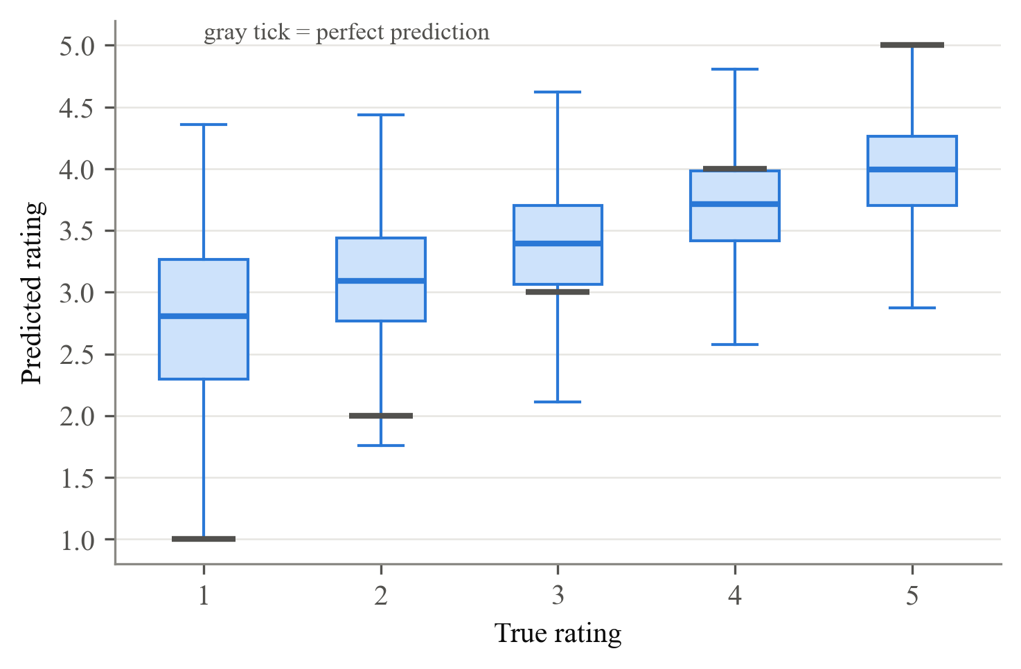
*Note.* Boxes show the distribution of the tuned SVD's predicted ratings for each true rating among the 20,000 test ratings; gray ticks mark a perfect prediction. Predictions for true 1s and 2s run high and predictions for true 5s run low, showing compression toward the mean rating of 3.53. Underlying values are in final_error_by_true_rating.csv.
Figure X
*Tuned SVD Test RMSE by Users' and Movies' Number of Training Ratings*
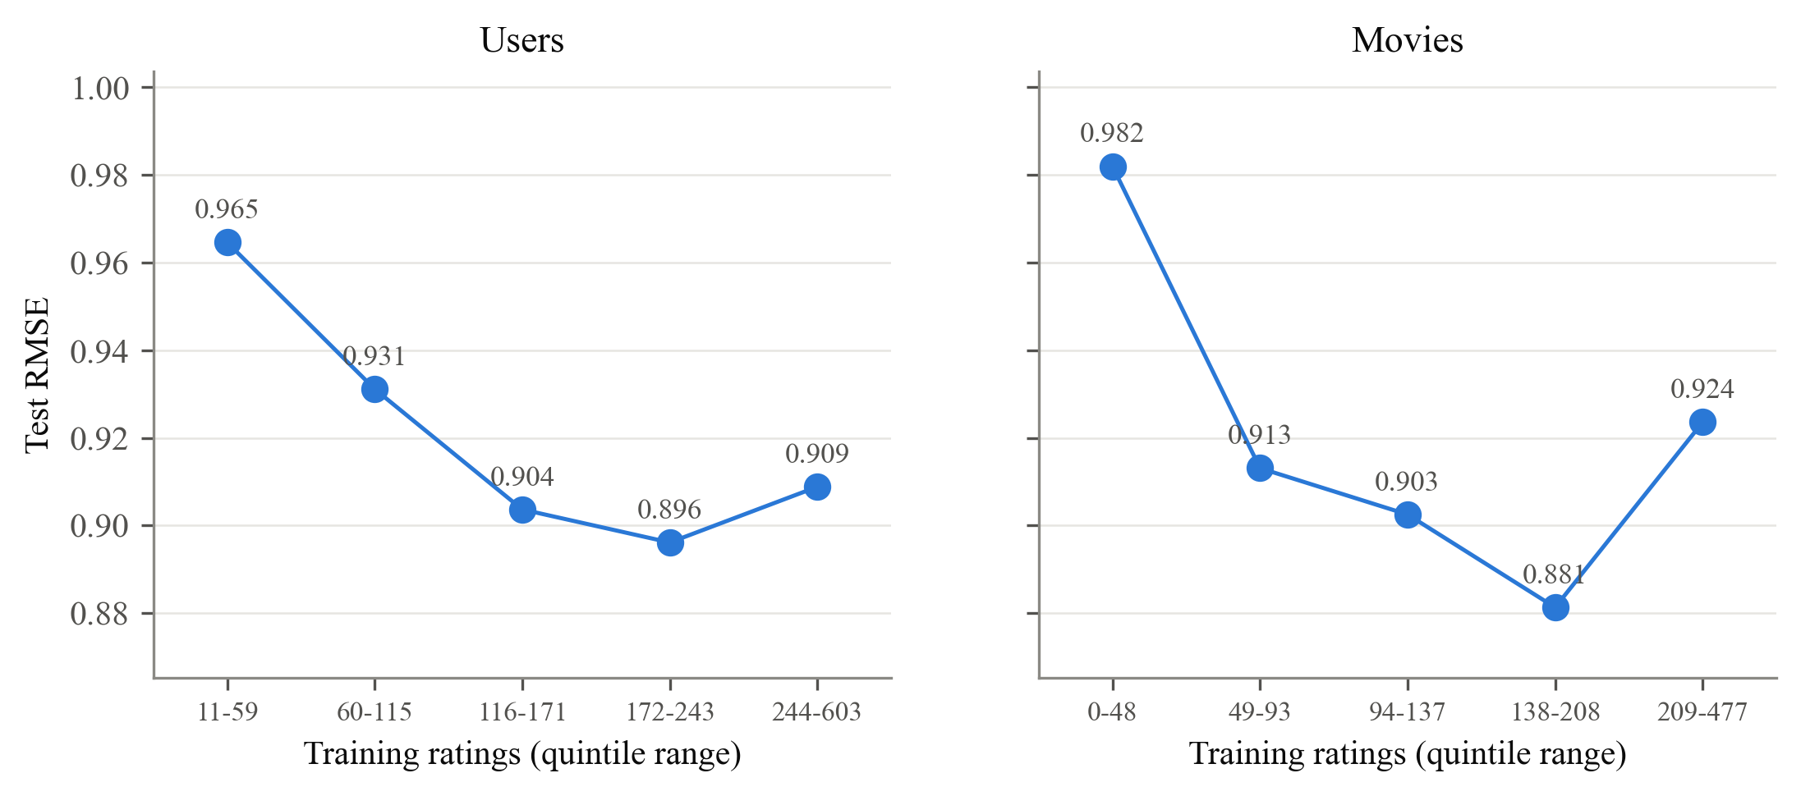
*Note.* Test ratings are divided into five equal-sized groups (quintiles) by how many training ratings the user (left) or the movie (right) has; the x-axis gives each quintile's range. Error is highest for the lightest users (0.965) and the least-rated movies (0.982). Values are from final_rmse_by_user_train_ratings.csv and final_rmse_by_item_train_ratings.csv.
Lower rating error did not produce better rankings. Selection optimized CV RMSE rather than precision or recall. Compressed predictions can leave relevant items below the predicted-rating cutoff of 4, reducing recall. Precision depends on which items cross that cutoff; users with no qualifying recommendations receive zero precision. These mechanisms may contribute to the decline, but their separate effects were not isolated experimentally. Both metrics are averaged over users, with zero recall assigned when a user has no relevant test items. Precision@10 fell from .619 for the untuned SVD to .596 for the tuned SVD, and recall@10 from .282 to .261 (Table X). These metrics use a restricted candidate set: for each user, only the movies that user rated in the test set are ranked. A movie counts as recommended if it is among the user's ten highest predictions and its predicted rating is at least 4, and as relevant if the user's true rating is at least 4. Because every candidate is a movie the user chose to watch and rate, these scores do not describe the full-catalog top-10 lists a deployed system would display, which here rank training-known movies the user has not rated in training, without applying the predicted-rating cutoff of 4. Training-unknown movies are excluded, and held-out rated movies may appear in those lists. Those full-catalog lists are where the tuned model's reliance on thin-evidence movies appears, as discussed in Ethical Considerations. Cremonesi et al. (2010) reported the same disconnect between rating error and top-N quality across algorithms; here it appears within a single algorithm under tuning.

Evaluation Validity
A random split lets the model train on ratings made after the ones it is tested on; 98.0% of test ratings involve a movie that also has later-dated training ratings. Table X and Figure X compare two chronological alternatives. Holding out each user's latest 20% of ratings raised the tuned SVD's RMSE to 0.972, and a single global cutoff date raised it to 1.021, 10.8% above the random split. Neither chronological split is a clean measure of this leakage, a known difficulty in choosing evaluation protocols for time-aware recommenders (Campos et al., 2014). The per-user split still trains on later ratings from other users, so 94.4% of its test ratings keep that future information about the movie. The global split removes it but assigns 85.2% of test ratings to users unseen in training (RMSE 1.028, against 0.979 for returning users), so it mainly measures cold-start performance. The tuned SVD's advantage over the bias-only baseline also shrinks from 0.029 on the random split to 0.009 on the global split, largely because latent factors cannot be learned for users with no training history. The random-split results are therefore best read as an optimistic estimate of deployed accuracy.
Table X
*Tuned SVD Test RMSE Under Three Train/Test Splits*
Split | Test RMSE | Test ratings with later training ratings of the same movie | Test ratings from users unseen in training
Random 80/20 (headline) | 0.921 | .980 | .000
Per-user chronological (latest 20% of each user) | 0.972 | .944 | .000
Global chronological (single cutoff date) | 1.021 | .000 | .852
*Note.* The tuned configuration was refit on each split's training ratings without re-tuning. The third column shows how much future information each split leaves in training; the fourth shows how much of the test set is cold start. On the global split, RMSE is 0.979 for returning users and 1.028 for new users. Values are from temporal_summary.json and temporal_comparison.csv.
Figure X
*Test RMSE of the Tuned SVD and the Bias-Only Baseline Under Three Train/Test Splits*
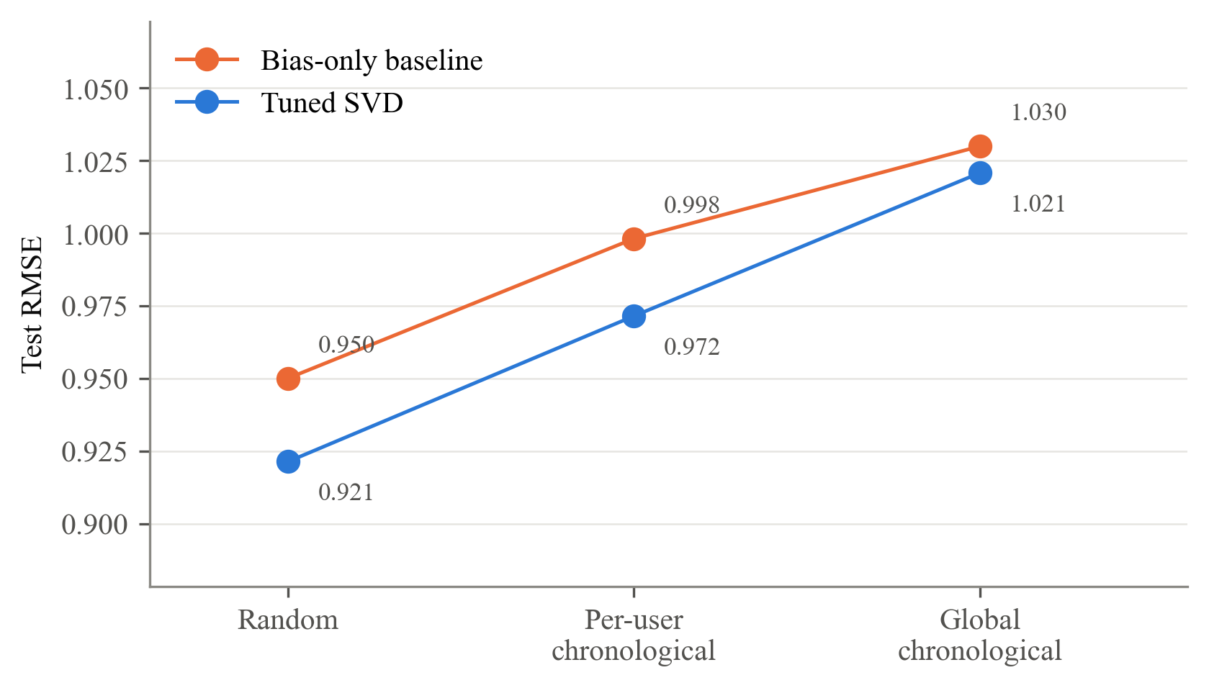
*Note.* Both models were refit on each split's training ratings with the same hyperparameters. RMSE rises for both as the split becomes more chronological, and the tuned SVD's advantage narrows from 0.029 (random) to 0.027 (per-user chronological) and 0.009 (global chronological). Values are from temporal_summary.json and temporal_comparison.csv.

References to Add
Bergstra, J., & Bengio, Y. (2012). Random search for hyper-parameter optimization. *Journal of Machine Learning Research, 13*, 281–305. https://jmlr.org/papers/v13/bergstra12a.html
Campos, P. G., Díez, F., & Cantador, I. (2014). Time-aware recommender systems: A comprehensive survey and analysis of existing evaluation protocols. *User Modeling and User-Adapted Interaction, 24*(1–2), 67–119. https://doi.org/10.1007/s11257-012-9136-x
Cremonesi, P., Koren, Y., & Turrin, R. (2010). Performance of recommender algorithms on top-N recommendation tasks. In *Proceedings of the Fourth ACM Conference on Recommender Systems* (pp. 39–46). ACM. https://doi.org/10.1145/1864708.1864721
Hug, N. (2020). Surprise: A Python library for recommender systems. *Journal of Open Source Software, 5*(52), Article 2174. https://doi.org/10.21105/joss.02174

Detailed Notebook Analysis and Visualizations
This expanded appendix includes every numbered visualization group (V1–V17) and the supporting analysis for Albert’s Hyperparameter Tuning and Final Model Evaluation sections. It is intentionally longer than the assignment’s short report allocation. Figure labels match the notebook; the six original report figures remain in the main sections above.
Tuning plots use the committed `tuning_surface_*.csv` files. Evaluation plots are rendered from the notebook’s model fits on the frozen splits and checked against the committed results. For V16, tuned catalog lists come directly from `final_top10_all_users.csv`, keeping exposure counts consistent with the report; the untuned lists are recomputed. Near-tied catalog scores can produce slightly different lists across numerical-library builds. Supplemental tables are saved beside the images. These exports do not replace the group’s authoritative `results/` files.

1. Hyperparameter tuning

1.1 Method, and one deliberate departure from the assignment's snippet
The assignment gives:
```python
from surprise.model_selection import GridSearchCV
param_grid = {'n_factors': [50, 100], 'n_epochs': [20, 40], 'lr_all': [0.002, 0.005]}
grid_search = GridSearchCV(SVD, param_grid, measures=['rmse'], cv=3)
grid_search.fit(data_surprise)
```
We use that grid and that call, with three changes, none of which alters the grid itself:
1. `fit` sees only the training partition. If `data_surprise` holds all 100,000 ratings, the test ratings help choose the hyperparameters and then grade them. Here `data_surprise` is built from the 80,000 training ratings only, and the test set is scored once, in Section 2.
2. Seeded folds. `cv=3` builds new, unseeded folds on every call. We pass `KFold(3, shuffle=True, random_state=42)`, so every search is scored on the same three folds and CV scores are comparable across grids.
3. MAE is recorded alongside RMSE, and SVD is seeded (`random_state=42`). The best configuration is still chosen by RMSE.

1.2 Assignment grid, exactly as specified (8 candidates)
Regularization is not in this grid, so it stays at Surprise's default of 0.02. Surprise's default SVD (100 factors, 20 epochs, learning rate 0.005, regularization 0.02) is one of the eight candidates, which gives the untuned CV score on the same folds.

Assignment candidates
n_factors | n_epochs | lr_all | cv_rmse | cv_rmse_sd | rank_test_rmse | cv_mae | std_test_mae | mean_fit_time
50 | 20 | 0.005 | 0.950223 | 0.000229155 | 1 | 0.750519 | 0.00141184 | 0.257717
50 | 40 | 0.002 | 0.951205 | 0.000241043 | 2 | 0.751959 | 0.00100299 | 0.497
100 | 20 | 0.005 | 0.953444 | 0.000203062 | 3 | 0.753572 | 0.0015192 | 0.47148
100 | 40 | 0.002 | 0.954332 | 0.000179918 | 4 | 0.754873 | 0.00130924 | 0.911299
50 | 20 | 0.002 | 0.958203 | 0.00112317 | 5 | 0.759736 | 0.000174016 | 0.280054
100 | 20 | 0.002 | 0.961416 | 0.000843338 | 6 | 0.762424 | 0.000291921 | 0.432289
50 | 40 | 0.005 | 0.969451 | 0.000704654 | 7 | 0.761017 | 0.000793875 | 0.510108
100 | 40 | 0.005 | 0.970244 | 0.000581956 | 8 | 0.764648 | 0.00119244 | 0.871865
V1. Assignment grid: all 8 candidates (orange = Surprise's defaults)
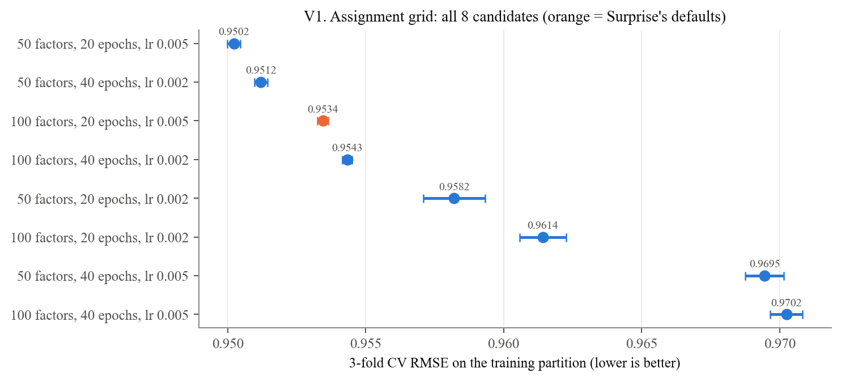
*V1.* The assignment grid's best candidate (50 factors, 20 epochs, lr 0.005) improves on the defaults by only 0.0032. Every candidate with the larger learning rate and 40 epochs is worse. Regularization is fixed at 0.02; these validation results are consistent with overfitting but do not establish its cause.
V2. Assignment grid sensitivity (dot = mean over the other settings, bar = best to worst)
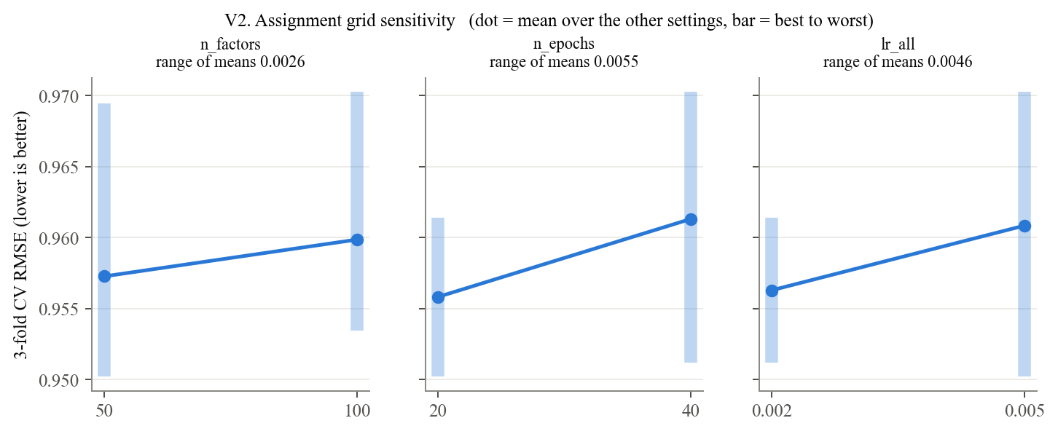

1.3 Expanded grid (54 candidates): adding regularization
The assignment's grid leaves `reg_all` fixed. On a matrix that is 93.7% empty, regularization is the hyperparameter most likely to matter, so the expanded grid adds it and widens the other axes.

Expanded search results
n_factors | n_epochs | lr_all | reg_all | cv_rmse | cv_rmse_sd | rank_test_rmse | cv_mae | std_test_mae | mean_fit_time
150 | 40 | 0.01 | 0.1 | 0.930595 | 0.000563676 | 1 | 0.736312 | 0.000883587 | 1.42319
100 | 40 | 0.01 | 0.1 | 0.931061 | 0.000599023 | 2 | 0.73648 | 0.000845534 | 1.08941
50 | 40 | 0.01 | 0.1 | 0.932377 | 8.78149e-05 | 3 | 0.736205 | 0.00087641 | 0.580412
150 | 40 | 0.005 | 0.1 | 0.936593 | 0.000695958 | 4 | 0.741728 | 0.0013916 | 1.92438
100 | 40 | 0.005 | 0.1 | 0.936707 | 0.000154092 | 5 | 0.741875 | 0.00121473 | 1.00549
150 | 20 | 0.01 | 0.1 | 0.936841 | 0.00081791 | 6 | 0.742008 | 0.00150455 | 0.708954
100 | 20 | 0.01 | 0.1 | 0.93704 | 0.000208897 | 7 | 0.742217 | 0.00128941 | 0.461312
50 | 40 | 0.005 | 0.1 | 0.938823 | 0.000491456 | 8 | 0.743167 | 0.00155658 | 0.567404
50 | 20 | 0.01 | 0.1 | 0.939243 | 0.000649585 | 9 | 0.743643 | 0.00166543 | 0.281823
50 | 20 | 0.01 | 0.05 | 0.942992 | 0.000162259 | 10 | 0.743142 | 0.00132365 | 0.281464
V3. Expanded grid sensitivity (dot = mean over the other settings, bar = best to worst)
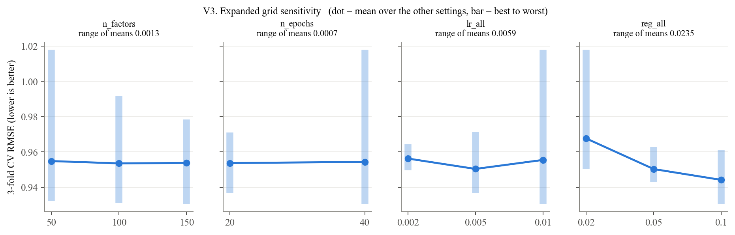
V4a. Best CV RMSE: reg_all x lr_all; V4b. Best CV RMSE: reg_all x n_epochs
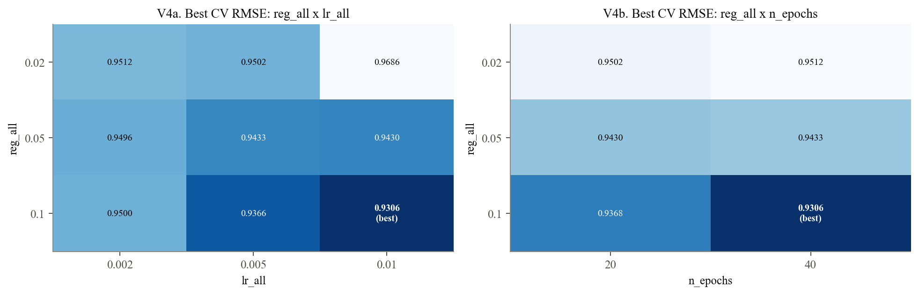
*V3 and V4.* Regularization dominates: its panel is the only one with a clear slope, and it moves mean CV RMSE by 0.0235 against 0.0059 for the learning rate. The heatmaps show the interaction. A large learning rate or more epochs helps only when regularization is strong, and the best cell sits in the corner (reg 0.1, lr 0.01, 40 epochs). A winner in a corner means the grid should be extended, which is what the refined grid does.

1.4 Refined grid (81 candidates): extending past the expanded winner

Refined search results
n_factors | n_epochs | lr_all | reg_all | cv_rmse | cv_rmse_sd | rank_test_rmse | cv_mae | std_test_mae | mean_fit_time
200 | 80 | 0.01 | 0.15 | 0.929409 | 0.000319162 | 1 | 0.73685 | 0.000781571 | 5.55582
150 | 80 | 0.01 | 0.15 | 0.929522 | 7.7993e-05 | 2 | 0.736844 | 0.000651601 | 3.98332
100 | 80 | 0.01 | 0.15 | 0.929663 | 0.000173329 | 3 | 0.736974 | 0.000774345 | 2.50609
200 | 60 | 0.01 | 0.15 | 0.929839 | 0.00030364 | 4 | 0.737339 | 0.000833925 | 4.77983
150 | 60 | 0.01 | 0.15 | 0.930015 | 0.000134525 | 5 | 0.737353 | 0.000730468 | 2.61455
200 | 60 | 0.015 | 0.15 | 0.9301 | 0.000251391 | 6 | 0.737383 | 0.000875657 | 5.55712
100 | 60 | 0.01 | 0.15 | 0.930152 | 0.00026158 | 7 | 0.737502 | 0.000797821 | 1.67278
200 | 40 | 0.01 | 0.1 | 0.930153 | 0.000240364 | 8 | 0.736159 | 0.00051772 | 2.79001
200 | 60 | 0.01 | 0.1 | 0.930161 | 0.000232659 | 9 | 0.735952 | 0.000492897 | 4.35167
150 | 60 | 0.015 | 0.15 | 0.93021 | 0.000195205 | 10 | 0.737376 | 0.00078059 | 2.95588
V5a. Refined grid sensitivity (dot = mean over the other settings, bar = best to worst)
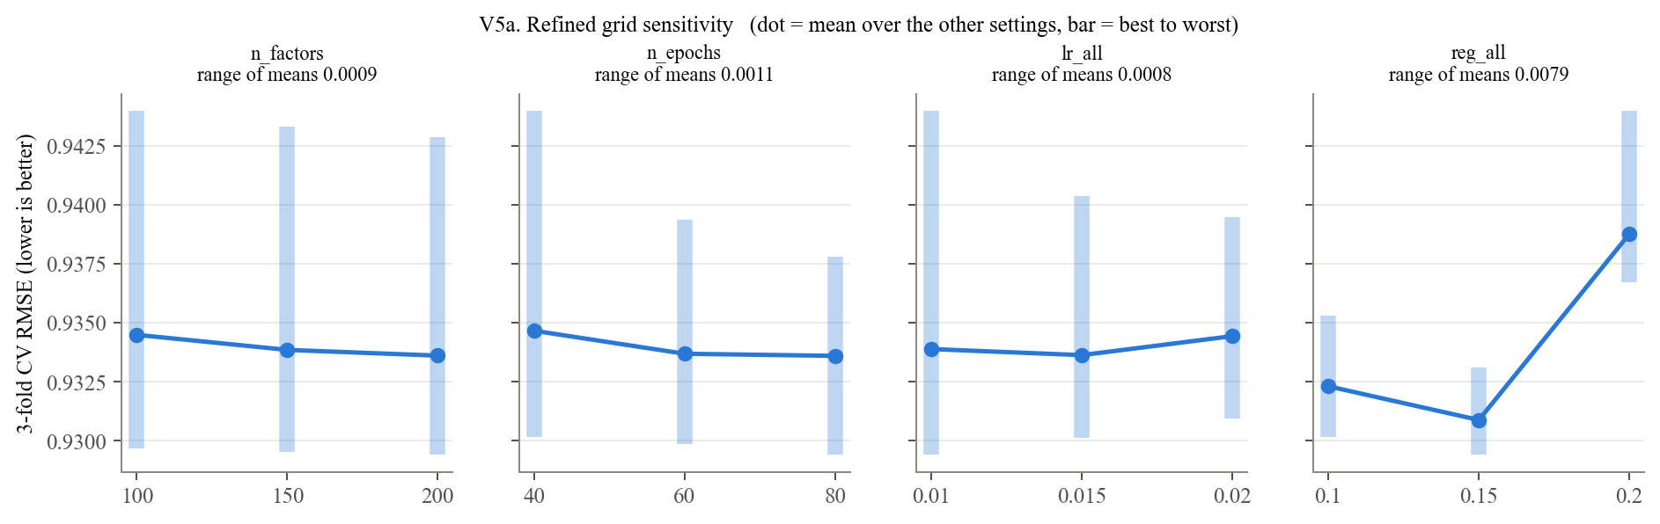
V5b. Best CV RMSE: reg_all x n_epochs; V5c. Best CV RMSE: reg_all x n_factors
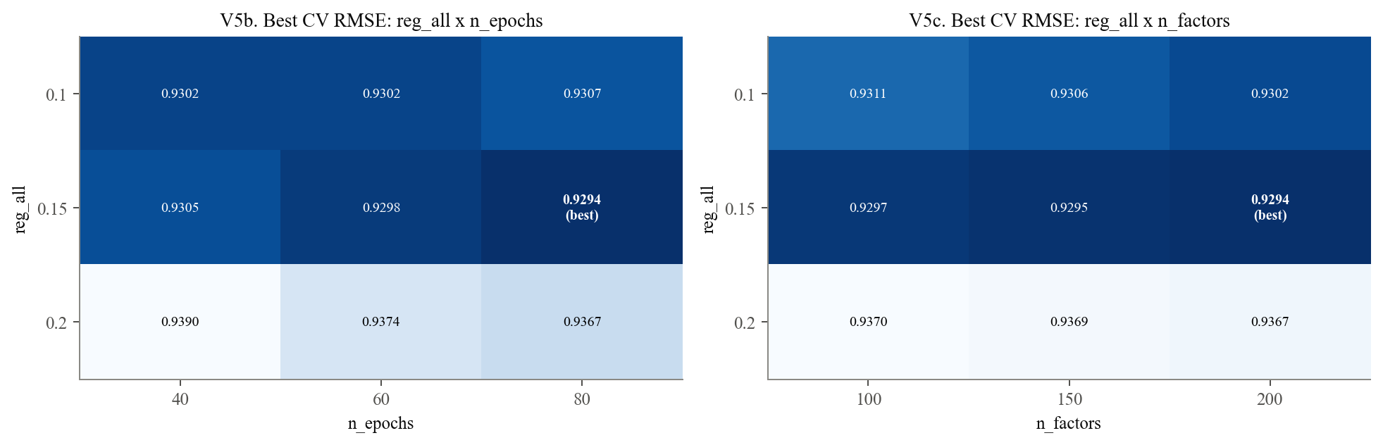
V6. Refined grid: 15 best candidates (orange = selected)
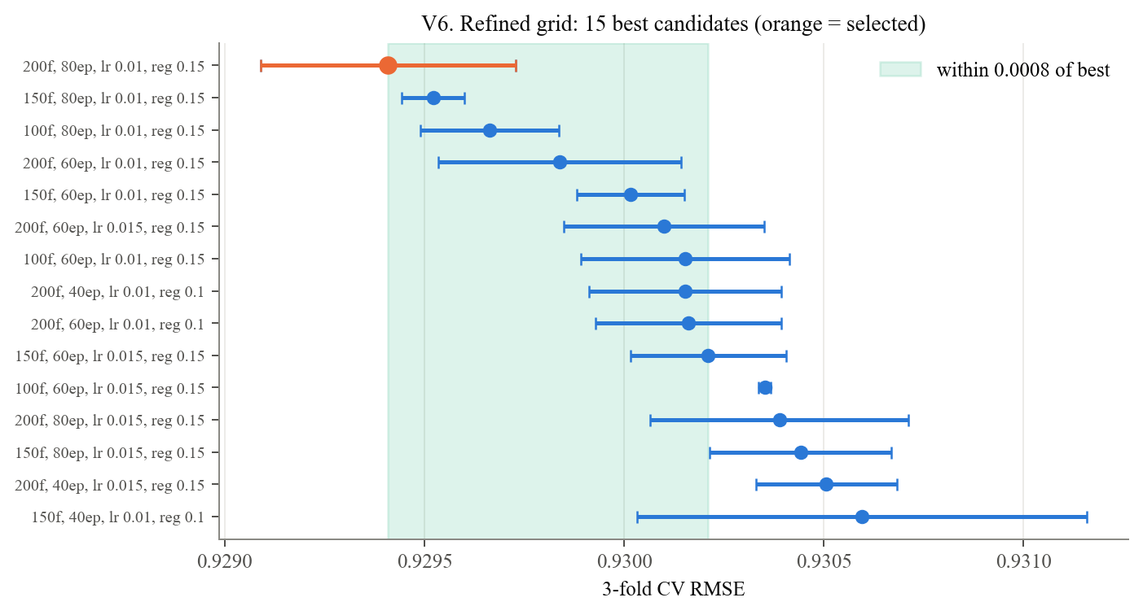
*V5 and V6.* Regularization still has the largest effect (0.0079, against 0.0011 or less for every other parameter), with 0.15 best in 24 of the 27 combinations of the other settings. The top candidates are nearly indistinguishable: the ten best lie within 0.0008, similar to their fold-to-fold SDs. The selected model still sits on three grid boundaries (200 factors, 80 epochs, lr 0.01). It is therefore the best configuration tested, not a proven optimum, settings beyond those boundaries were not evaluated.

Selection across all three searches
grid | candidates | best CV RMSE | best settings | on edge | most sensitive
assignment | 8 | 0.950223 | {'n_factors': 50, 'n_epochs': 20, 'lr_all': 0.005} | {'n_factors': 'lower', 'n_epochs': 'lower', 'lr_all': 'upper'} | n_epochs
expanded | 54 | 0.930595 | {'n_factors': 150, 'n_epochs': 40, 'lr_all': 0.01, 'reg_all': 0.1} | {'n_factors': 'upper', 'n_epochs': 'upper', 'lr_all': 'upper', 'reg_all': 'upper'} | reg_all
refined | 81 | 0.929409 | {'n_factors': 200, 'n_epochs': 80, 'lr_all': 0.01, 'reg_all': 0.15} | {'n_factors': 'upper', 'n_epochs': 'upper', 'lr_all': 'lower'} | reg_all
V7a. Every candidate (orange = best of each grid); V7b. Best CV RMSE after each search
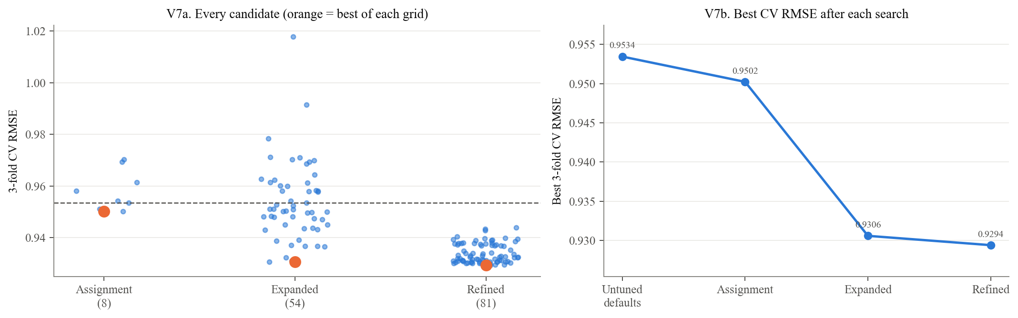
*V7.* The assignment grid barely moves the needle. Most of the observed gain (0.9534 to 0.9306) occurs in the expanded grid, which changes regularization and other axes, and refinement adds only 0.0012 more. These are 3-fold CV numbers; they must not be compared with the 5-fold CV column in the Model Selection table.

Detailed sensitivity and candidate checks
n_factors | n_epochs | lr_all | reg_all | cv_rmse | cv_rmse_sd | rank_test_rmse | cv_mae | std_test_mae | mean_fit_time
200 | 80 | 0.01 | 0.15 | 0.929409 | 0.000319162 | 1 | 0.73685 | 0.000781571 | 5.55582
150 | 80 | 0.01 | 0.15 | 0.929522 | 7.7993e-05 | 2 | 0.736844 | 0.000651601 | 3.98332
100 | 80 | 0.01 | 0.15 | 0.929663 | 0.000173329 | 3 | 0.736974 | 0.000774345 | 2.50609
Search | Candidates | Values searched | Best CV RMSE (fold SD) | Best setting | Winner on grid edge
Assignment | 8 | n_factors {50, 100}; n_epochs {20, 40}; lr_all {0.002, 0.005}; reg_all 0.02 (fixed) | 0.9502 (0.0002) | 50, 20, 0.005 | n_factors (low), n_epochs (low), lr_all (high)
Expanded | 54 | n_factors {50, 100, 150}; n_epochs {20, 40}; lr_all {0.002, 0.005, 0.01}; reg_all {0.02, 0.05, 0.1} | 0.9306 (0.0006) | 150, 40, 0.01, 0.1 | n_factors (high), n_epochs (high), lr_all (high), reg_all (high)
Refined | 81 | n_factors {100, 150, 200}; n_epochs {40, 60, 80}; lr_all {0.01, 0.015, 0.02}; reg_all {0.1, 0.15, 0.2} | 0.9294 (0.0003) | 200, 80, 0.01, 0.15 | n_factors (high), n_epochs (high), lr_all (low)
*1.6.* This cell reproduces the tuning statistics the report quotes: mean CV RMSE falls from 0.968 at regularization 0.02 to 0.944 at 0.1; 0.15 wins in 24 of 27 refined combinations; the three best refined candidates differ only in factor count. It also rebuilds the report's tuning table from the recomputed searches. The selected model is the best configuration tested: it still reaches three grid boundaries, and settings beyond them were not evaluated.

2. Final model evaluation

2.1 Tuned vs. untuned SVD on the held-out test set (RMSE and MAE)
Both SVDs and the bias-only baseline are fit on the full training partition and scored once on the 20,000 test ratings. The SVD-minus-baseline gap compares the fitted models; it does not isolate latent factors because fitting and regularization also differ.

Test and training error comparison
index | Test RMSE | Test MAE | Training RMSE | Train-to-test gap
Bias-only baseline | 0.950046 | 0.751633 | 0.921474 | 0.0285717
Untuned SVD | 0.941167 | 0.741349 | 0.684442 | 0.256725
Tuned SVD | 0.921334 | 0.729063 | 0.790539 | 0.130795
V8a. Test error by model; V8b. Size of each improvement; V8c. Training vs test RMSE
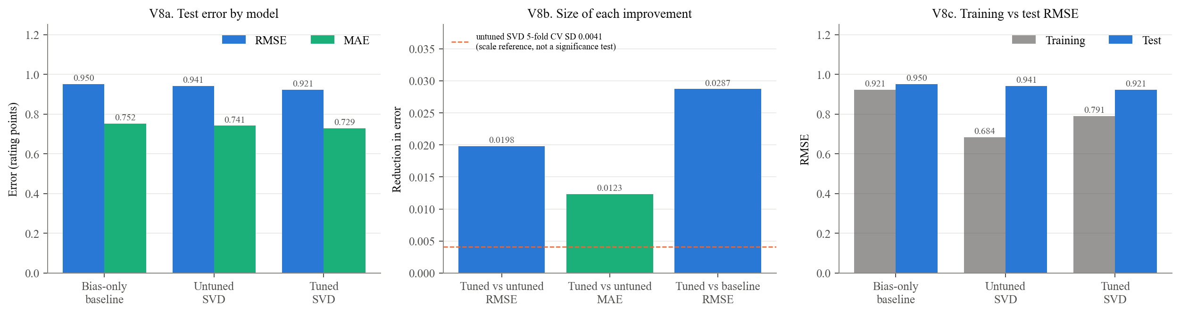
*V8.* Tuning lowered test RMSE from 0.941 to 0.921 (2.11%) and MAE from 0.741 to 0.729. The tuned SVD beats the bias-only baseline by 0.029, an observed improvement over the bias-only baseline; this comparison does not isolate the contribution of latent factors because fitting and regularization also differ.
Is the improvement meaningful? The 0.0198 reduction is larger than the untuned SVD's fold-to-fold CV standard deviation (0.0041). That comparison only gives a sense of scale. A CV standard deviation is not a significance test for a test-set improvement: it describes variation across training folds, not uncertainty in the difference between two models on one test set. V8c shows a train-to-test gap of 0.131 for the tuned SVD: it fits the training ratings much more closely than it generalizes.

2.2 Actual vs. predicted ratings

Prediction summary by actual rating
actual | mean predicted (untuned) | mean predicted (tuned) | n | mean signed error (tuned) | RMSE (tuned)
1 | 2.74978 | 2.77012 | 1253 | 1.77012 | 1.89632
2 | 3.07297 | 3.10068 | 2296 | 1.10068 | 1.21698
3 | 3.3577 | 3.36892 | 5507 | 0.368925 | 0.598083
4 | 3.69511 | 3.68483 | 6797 | -0.315165 | 0.53209
5 | 4.00193 | 3.9673 | 4147 | -1.0327 | 1.11726
V9a. Tuned SVD predictions by true rating; V9b. Where each true rating lands (row %)
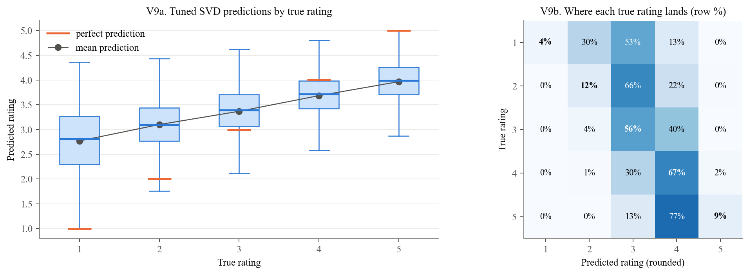
V10a. Predictions cluster between 3 and 4; V10b. Residual distribution on the test set
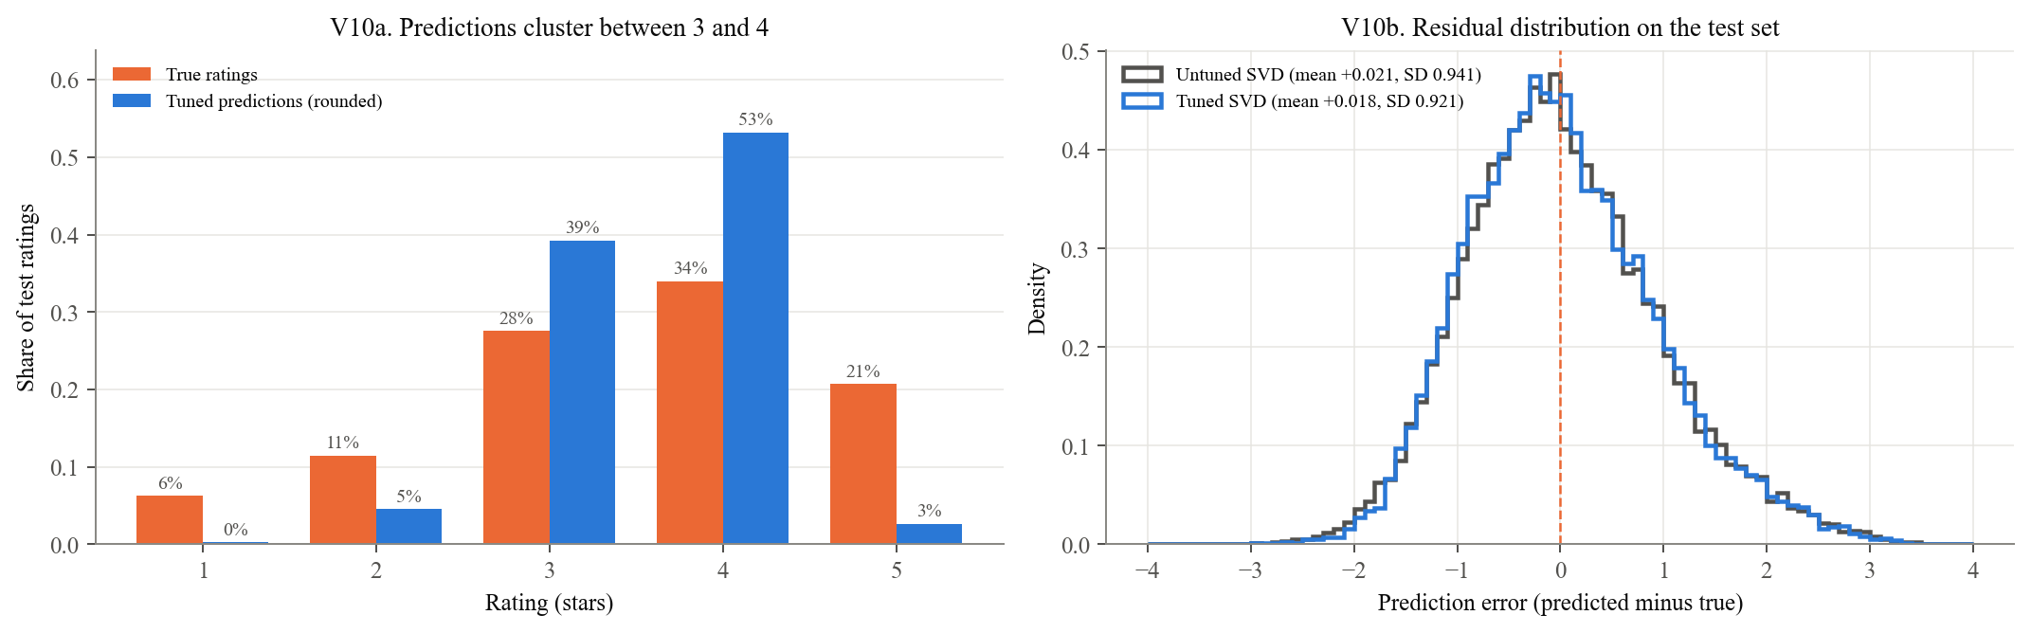
V11. Over-prediction of low ratings, under-prediction of high
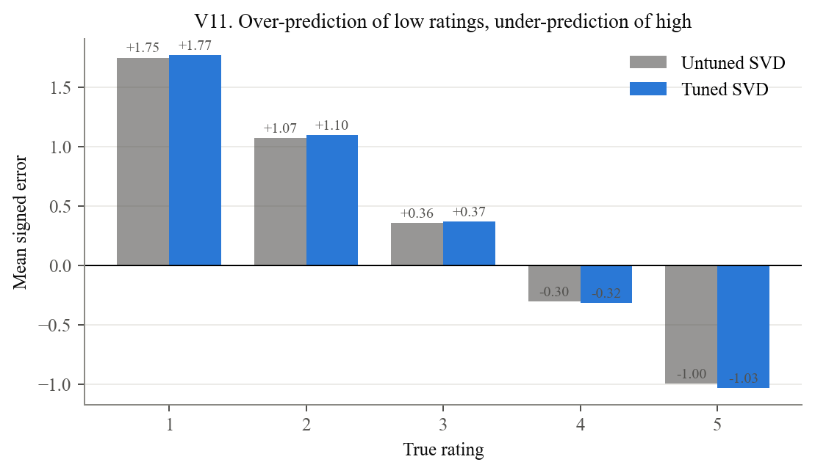
*V9 to V11.* Predictions are compressed toward the mean. Their SD is 0.58, against 1.13 for the true ratings. True 1s are predicted at 2.77 on average (+1.77) and true 5s at 3.97 (−1.03), so the largest errors sit at the extremes of the scale. V9b shows most true 1s and 2s land on a predicted 3. Middle ratings (3 and 4) are predicted well. This is typical of squared-error training with strong regularization: shrinking toward the mean lowers average error at the cost of extreme ratings.

2.3 Where errors are larger: users and movies with little training data

Error by training support
index | Untuned SVD | Tuned SVD | n
11-59 | 0.987359 | 0.964604 | 4076
60-115 | 0.952302 | 0.931129 | 3958
116-171 | 0.925755 | 0.903673 | 3969
172-243 | 0.913963 | 0.896136 | 4087
244-603 | 0.923878 | 0.908849 | 3910
index | Untuned SVD | Tuned SVD | n
0-48 | 1.00558 | 0.981991 | 4055
49-93 | 0.933244 | 0.913097 | 3990
94-137 | 0.916794 | 0.902524 | 3994
138-208 | 0.902589 | 0.881331 | 3985
209-477 | 0.943179 | 0.923586 | 3976
V12a. Users: RMSE by training volume; V12b. Movies: RMSE by training volume; V12c. Per-user RMSE (users with 5+ test ratings)
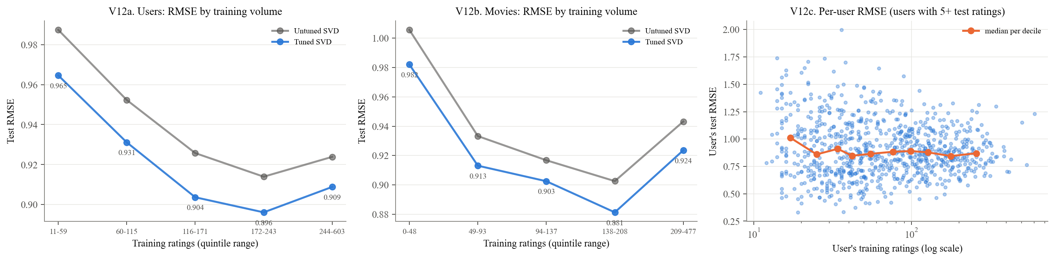
*V12.* Error is highest where evidence is thinnest. The lowest user-support group of test ratings (11 to 59 training ratings) has RMSE 0.965, against 0.896 to 0.931 for the other quintiles. The lowest movie-support group of test ratings has RMSE 0.982, against 0.881 to 0.924. V12c shows how widely individual users' RMSE varies at each activity level. Comparing the grey and blue lines in V12a and V12b shows whether tuning's gain was broad or concentrated in some groups.

2.4 Largest individual misses

Largest individual errors
user_id | title | actual | predicted | abs_err | item_train_ratings | user_train_ratings
405 | Another Stakeout (1993) | 5 | 1.25387 | 3.74613 | 15 | 603
270 | Jerry Maguire (1996) | 1 | 4.36058 | 3.36058 | 303 | 114
148 | Amadeus (1984) | 1 | 4.31873 | 3.31873 | 223 | 50
363 | World of Apu, The (Apur Sansar) (1959) | 1 | 4.31664 | 3.31664 | 5 | 243
159 | English Patient, The (1996) | 1 | 4.28129 | 3.28129 | 385 | 86
186 | Usual Suspects, The (1995) | 1 | 4.26507 | 3.26507 | 218 | 77
592 | Fantasia (1940) | 1 | 4.26001 | 3.26001 | 137 | 301
867 | Leaving Las Vegas (1995) | 1 | 4.25751 | 3.25751 | 235 | 79
72 | Empire Strikes Back, The (1980) | 1 | 4.25255 | 3.25255 | 290 | 112
887 | Little Princess, A (1995) | 1 | 4.2218 | 3.2218 | 30 | 137
310 | Tetsuo II: Body Hammer (1992) | 1 | 4.21956 | 3.21956 | 4 | 17
605 | Raising Arizona (1987) | 1 | 4.2047 | 3.2047 | 204 | 76
V13. The 12 largest test errors
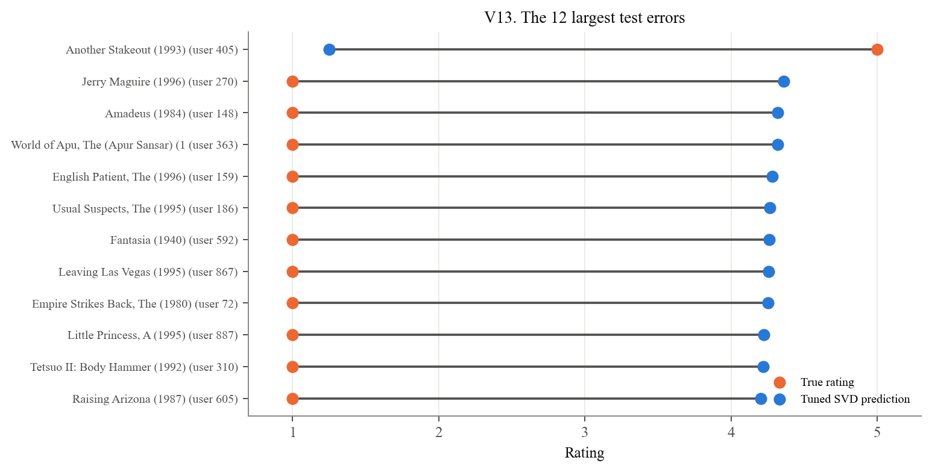
*V13.* In the committed run the largest misses include *Another Stakeout*, *Jerry Maguire*, *Amadeus*, *The World of Apu*, and *The English Patient* (`results/final_largest_errors.csv`). The table's training counts show whether each miss involves a thinly rated movie or a user departing sharply from a well-established consensus. The second case is the hardest for a model built on shared taste patterns, and these examples alone do not establish whether additional predictive signals are available.

2.5 Areas for improvement suggested by these errors
1. Thin evidence (V12): stronger shrinkage for users and movies with few ratings, for example a heavier movie-bias penalty (`reg_bi`), or side information (genre, demographics) to support sparse profiles.
2. Compression (V9 to V11): select models on metrics that reward getting extreme ratings and top items right, not RMSE alone.
3. Search boundaries (V6): extend beyond the three remaining edges, or use random search, which Bergstra and Bengio (2012) show is more efficient when only a few hyperparameters matter.

2.6 Ranking quality: precision@10 and recall@10
Protocol (candidate set = held-out rated items). For each user, only the movies that user rated *in the test set* are ranked.
- A movie is recommended if it is among the user's 10 highest predictions and its predicted rating is at least 4.
- It is relevant if the user's true rating is at least 4.
Precision@10 is the share of recommended movies that are relevant; recall@10 is the share of relevant movies that were recommended. This follows Surprise's FAQ definition.

Ranking metrics and list-length comparisons
index | precision@10 | recall@10 | users
Bias-only baseline | 0.595659 | 0.249031 | 942
Untuned SVD | 0.61924 | 0.281705 | 942
Tuned SVD | 0.596235 | 0.261447 | 942
k | precision@k: Bias-only baseline | precision@k: Untuned SVD | precision@k: Tuned SVD
1 | 0.616773 | 0.643312 | 0.610403
3 | 0.60598 | 0.630396 | 0.606688
5 | 0.600761 | 0.628291 | 0.601132
10 | 0.595659 | 0.61924 | 0.596235
15 | 0.593568 | 0.616356 | 0.594558
20 | 0.592444 | 0.614441 | 0.592342
V14a. Ranking quality at k = 10 (higher is better); V14b. Precision@k; V14c. Recall@k
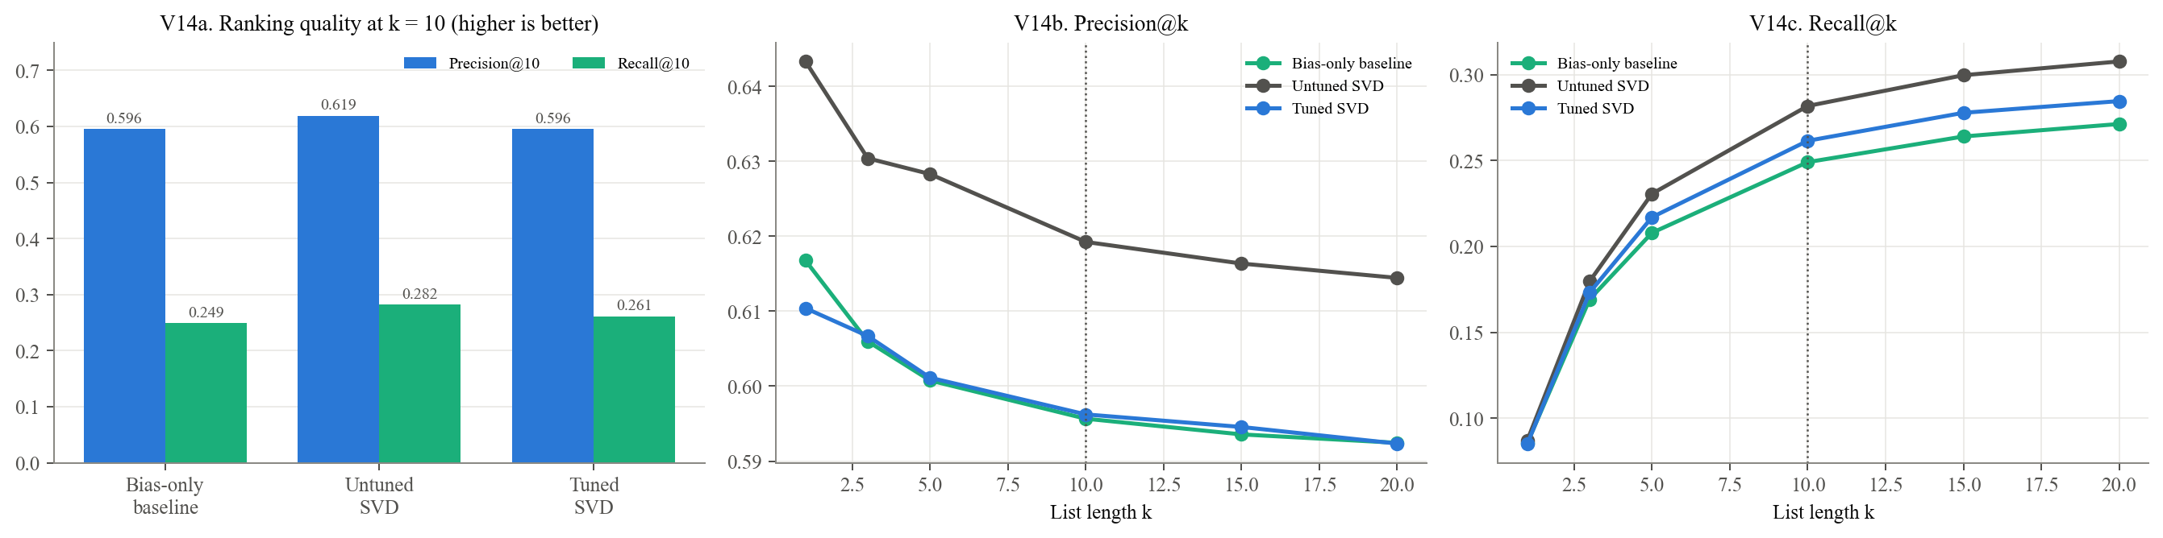
V15a. Distribution of per-user precision@10; V15b. Per-user change in precision@10 from tuning
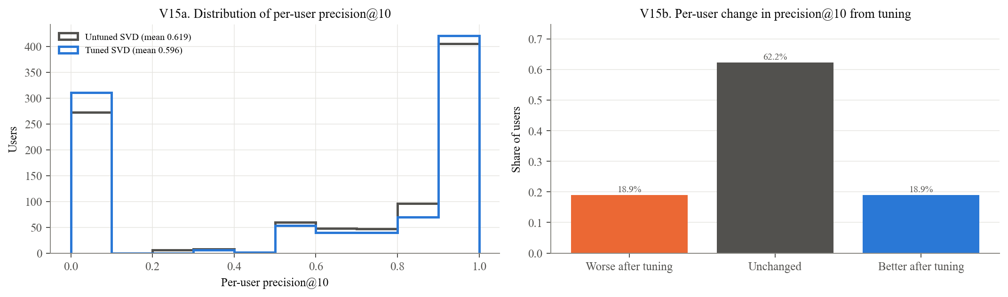
*V14 and V15.* Lower RMSE did not produce better rankings. Precision@10 fell from .619 to .596 and recall@10 from .282 to .261 after tuning. V14b and V14c show whether the tuned SVD trails across list lengths or only near k = 10, and V15 shows how the change is spread across users. Cremonesi et al. (2010) reported the same disconnect between rating error and top-N quality across algorithms; here it appears within one algorithm under tuning.
These are not the lists a user would see. Every candidate above is a movie the user already chose to watch and rate. The next step ranks movies present in training that the user has not rated in training. These lists exclude training-unknown movies, may include held-out rated movies, and do not apply the predicted-rating cutoff of 4.
Selection optimized CV RMSE, not precision or recall. Compressed predictions can leave relevant items below the predicted-rating cutoff of 4 and lower recall. Precision depends on which items cross the cutoff, and users with no qualifying recommendations receive zero precision. These are possible contributors; their separate effects were not isolated experimentally. Both metrics are averaged over 942 users, with zero recall assigned when a user has no relevant test items.

2.7 Catalog-wide top-10 lists over training-known movies

Catalog exposure summaries
index | recs to thin-evidence movies | distinct movies recommended | catalog coverage | most-recommended movie | its share of users' lists
Untuned SVD | 0.00148462 | 249 | 0.148038 | Wrong Trousers, The (1993) | 0.707317
Tuned SVD | 0.565005 | 139 | 0.0826397 | Pather Panchali (1955) | 0.973489
V16a. Evidence behind each recommendation; V16b. Recommendations to thin-evidence movies; V16c. Tuned SVD's most-recommended movies (orange = fewer than 10 training ratings)
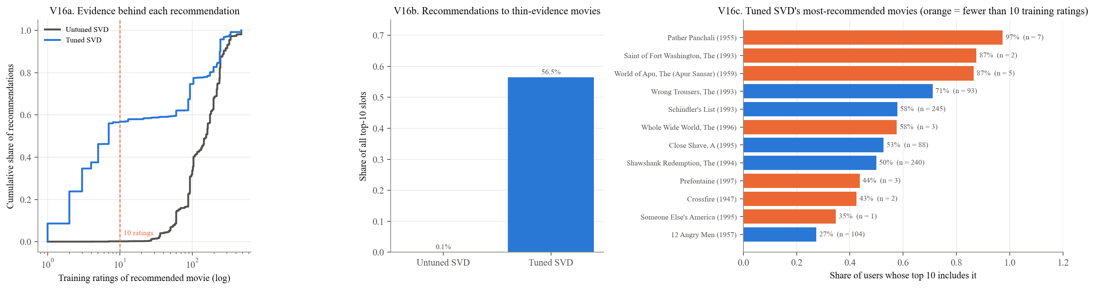
*V16.* The held-out candidate set evaluates only movies each user rated in the test partition; the catalog-wide analysis examines exposure across all training-known candidate movies. The tuned SVD sends 56.5% of its top-10 slots to thin-evidence movies, against 0.1% for the untuned SVD (committed run). *Pather Panchali* (7 training ratings) reaches about 97% of users and *The Saint of Fort Washington* (2 ratings) about 87%. This is why the report keeps the held-out ranking metrics separate from the full-catalog lists. The likely mechanism and the ethical implications are covered in Ethical Considerations.

2.8 Evaluation validity: random vs. chronological splits
A random split lets the model train on ratings made *after* the ones it is tested on. Two chronological splits test how much that flatters the model, and each has its own limitation:
- Per-user chronological: each user's latest 20% of ratings are held out, but other users' later ratings of the same movie can still be in training.
- Global chronological: everything after one cutoff date is test. There's no future information, but most test ratings come from users unseen in training, so this split mostly measures cold start.

Chronological split comparison
split | future info share | Bias-only baseline RMSE | Tuned SVD RMSE | new-user share | Tuned RMSE returning users | Tuned RMSE new users
random | 0.97995 | 0.950046 | 0.921334 | 0 | 0.921334
user_chrono | 0.94436 | 0.998163 | 0.971509 | 0 | 0.971509
global_chrono | 0 | 1.02999 | 1.02081 | 0.8524 | 0.978807 | 1.02791
V17a. Test RMSE by split; V17b. What each split leaks or withholds; V17c. Global split: returning vs new users
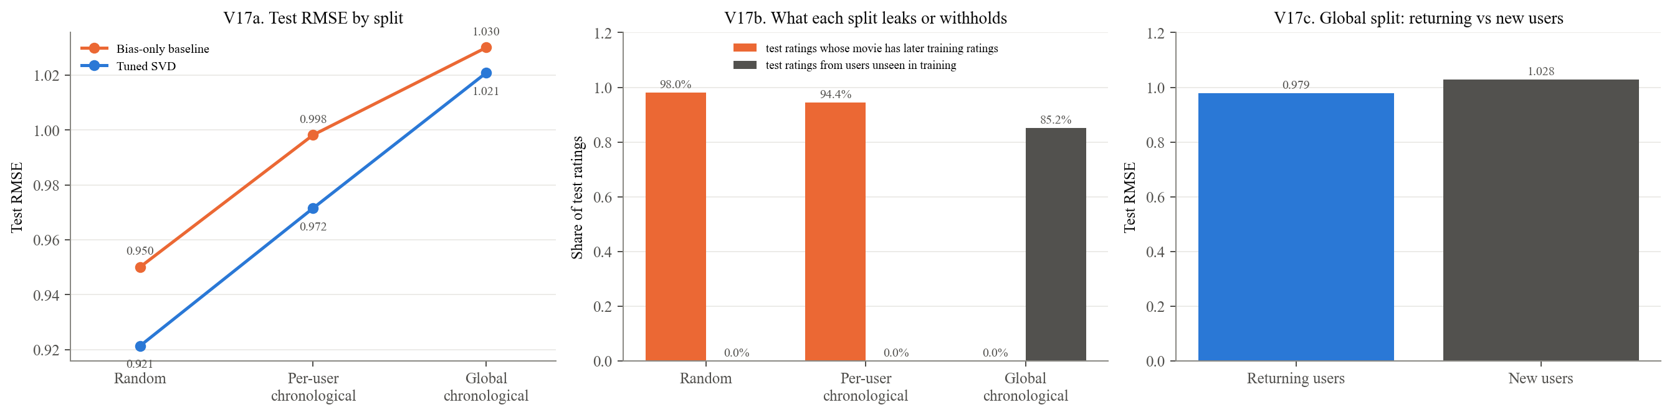
*V17.* Tuned SVD RMSE rises from 0.921 (random) to 0.972 (per-user chronological) and 1.021 (global cutoff), 10.8% above the random split.
- On the random split, 98.0% of test ratings involve a movie that also has later-dated training ratings.
- The per-user split still keeps future information for 94.4% of its test ratings, because other users' later ratings stay in training.
- The global split removes that information, but 85.2% of its test ratings come from users unseen in training (RMSE 1.028, against 0.979 for returning users). It mostly measures cold start, not leakage, and SVD's advantage over the bias-only baseline shrinks there.
Random-split results are therefore best read as an optimistic estimate of deployed accuracy (Campos et al., 2014).

Report tables and saved-result checks
index | RMSE | MAE | Precision@10 | Recall@10
Bias-only baseline | 0.95 | 0.752 | 0.596 | 0.249
Untuned SVD | 0.941 | 0.741 | 0.619 | 0.282
Tuned SVD | 0.921 | 0.729 | 0.596 | 0.261
split | Test RMSE | Test ratings with later training ratings of the same movie | Test ratings from users unseen in training
random | 0.921 | 0.98 | 0
user_chrono | 0.972 | 0.944 | 0
global_chrono | 1.021 | 0 | 0.852

3.1 Claim audit: every number quoted in the two report sections
Each row pairs a statement in the report with the value recomputed in this notebook, rounded the way the report prints it. `OK` means the report's text matches this run; `DIFF` means it doesn't, so check library versions and the committed results before submitting.

Numerical claim audit
[Complete numerical claim audit](notebook_figures/cell_66_table_18.csv)
All 64 numerical claim checks passed. All saved-result comparisons passed the notebook’s stated tolerances. The tuning searches were loaded from saved surfaces; evaluation models were refit. CV error bars describe fold variability and are not significance tests.

