LSTM Implementation Project
Image Classification with Convolutional Neural Networks and LSTM

Albert Kabore
PhD student
University of the Cumberlands

Abstract
A convolutional neural network with bidirectional Long Short-Term Memory was evaluated for eight-class classification using the Natural Images dataset. Exact-duplicate indexing reduced 6,899 photographs to 6,897 images, allocated to training (4,827), validation (1,035) and testing (1,035). Inputs were resized to 64x64 and normalized using training statistics. Ten experiments compared four architectures and six training or parameter variations. Validation macro F1 selected a configuration without augmentation, dropout or weight decay; batch normalization was retained. The epoch-17 checkpoint correctly classified 997 test images, achieving 96.33% accuracy, 96.04% macro precision, 96.01% macro recall and 0.9602 macro F1. Cat-dog confusion accounted for 27 of 38 errors. Possible related-image overlap, unequal model capacity and a single seed restrict generalization. Further evaluation requires verified image groups, repeated seeds and comparable tuning budgets.

1. Introduction

1.1 CNN and LSTM concepts
A convolutional neural network applies learned filters to local image regions. Successive layers combine edges, colours and textures into classification features, with weights shared across locations (LeCun et al., 1998). Pooling reduces spatial resolution and the amount of computation.
Long Short-Term Memory networks process ordered sequences using a memory cell and hidden state (Hochreiter & Schmidhuber, 1997). The modern formulation uses input, forget and output gates to control updates and information flow; the adaptive forget gate was introduced by Gers et al. (2000). A bidirectional network reads the sequence in both directions and combines the states (Schuster & Paliwal, 1997).
The input gate controls new content, the forget gate scales retained memory, and the output gate controls the exposed hidden representation. The additive cell-state update provides a path for information and gradients across sequence steps, helping an LSTM learn dependencies that a simple recurrent network may struggle to retain (Hochreiter & Schmidhuber, 1997; Gers et al., 2000).

1.2 Spatial sequence hypothesis
Here, each row of a CNN feature map becomes one sequence step. Row order may help represent layouts such as wheels below a vehicle body or a head above a torso. Global average pooling removes the final spatial indices, although earlier convolutions can encode spatial context. Recurrence over images was investigated in ReNet, which uses horizontal and vertical recurrent sweeps (Visin et al., 2015). CNN and LSTM combinations also appear in scene text recognition (Shi et al., 2017) and video recognition (Donahue et al., 2015). These studies motivate the design; the present comparison evaluates its performance on Natural Images.
This project classifies individual still images. Its sequence steps represent spatial rows within one image; they do not represent video frames or separate photographs. The hypothesis is that gated integration of ordered local features can help distinguish object layouts. The eight-step sequence tests that spatial design without establishing an advantage on long temporal sequences.

1.3 Objectives and dataset choice
- Inspect and preprocess labelled photographs using resizing, normalization and training augmentation.
- Implement a CNN with LSTM in PyTorch, including batch normalization and dropout in baseline experiments.
- Compare architectures and training settings using validation metrics, then report test accuracy, precision, recall and F1.
- Document errors, uncertainty, limitations and specific follow-up experiments.
The analysis used Natural Images (Roy, 2018), the dataset linked in the assignment. CIFAR-10 (Krizhevsky, 2009) was provided as an alternative example.

2. Methodology

2.1 Dataset and split
Natural Images contains 6,899 photographs in eight classes: airplane, car, cat, dog, flower, fruit, motorbike, person. The downloaded archive stores two copies. The pipeline reads only natural_images and indexes two exact duplicate pairs once, leaving 6,897 images. A saved publisher-manifest comparison matches all 13,798 downloaded filenames and sizes, totalling 359,403,192 bytes. Publisher cryptographic hashes were unavailable.
Folder names provide one label per image, encoded as integers 0 through 7 in alphabetical class order. After exact-duplicate indexing, the split first reserves 15% for testing, then takes 15/85 of the remainder for validation. Both stratified operations use seed 42. This preserves class representation while reserving separate data for fitting, configuration selection and reporting.
Table 1. Class counts after exact-duplicate indexing; stratified 70/15/15 allocation with seed 42.
Class | Training | Validation | Test | Total
airplane | 509 | 109 | 109 | 727
car | 677 | 145 | 145 | 967
cat | 619 | 133 | 133 | 885
dog | 491 | 106 | 105 | 702
flower | 589 | 126 | 127 | 842
fruit | 700 | 150 | 150 | 1000
motorbike | 552 | 118 | 118 | 788
person | 690 | 148 | 148 | 986
Total | 4,827 | 1,035 | 1,035 | 6,897

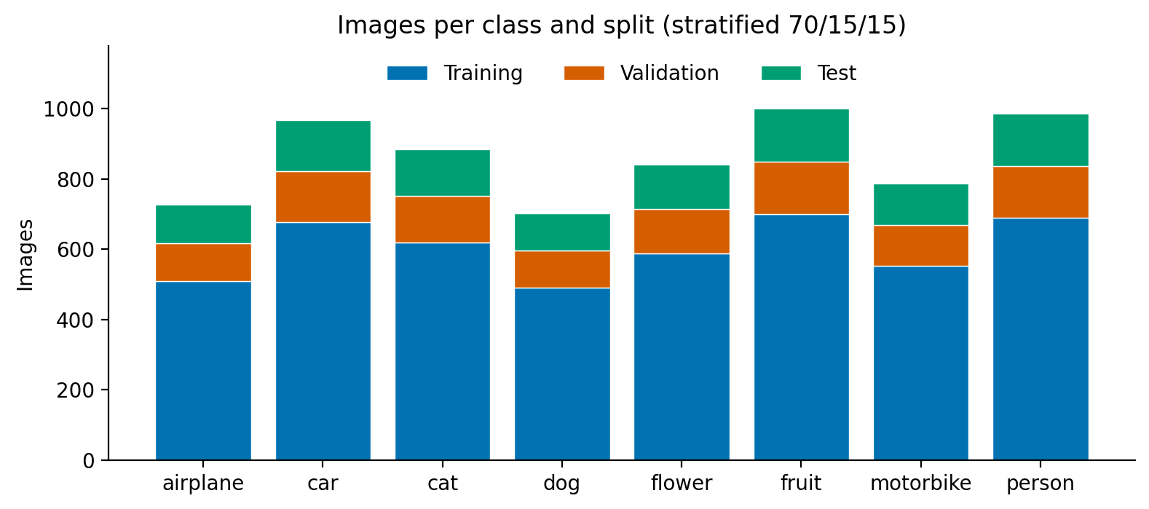
Figure 1. Class counts within the fixed split: training in blue, validation in orange and test in green.

2.2 Image quality and cleaning
- All 6,899 photographs decode and use RGB color. None are empty; one file with a JPEG extension contains PNG data.
- Two pairs contain identical bytes within the car and flower classes. Indexing each pair once leaves 6,897 images for modelling.
- A total of 38 images have a side shorter than 64 pixels. Upscaling cannot recover detail absent from the originals.
- Aspect ratios range from 0.20 to 5.89, with 920 images outside 0.5 to 2.0. Square resizing changes their object proportions.
- Average hashes identify 276 candidates, including 257 fruit images. Hash matches indicate possible similarity and require visual checks before grouping.
In the original dataset, fruit has 1,000 images and dog has 702, a class-count ratio of 1.42. Car and fruit photographs are consistently 100x100 pixels. Fruit's average brightness is 0.617, compared with 0.408 to 0.487 for other classes. Dimensions, illumination and source annotations may provide acquisition cues; model dependence on these features was not tested.

2.3 Preprocessing and augmentation
- Resize RGB images to 64x64 using bicubic interpolation. This limits computation at the cost of detail and aspect-ratio distortion; aspect-preserving padding is a proposed comparison.
- Use training-only channel means 0.510, 0.464, 0.419 and standard deviations 0.287, 0.279, 0.292 for RGB normalization after scaling pixels to [0, 1].
- When enabled, augment training batches using horizontal flips with probability 0.5, reflection-padded shifts of up to six pixels, and brightness/contrast multipliers from 0.8 to 1.2. Exclude vertical flips to preserve typical object orientation.
- Apply deterministic resizing and normalization to validation and test inputs. Augmentation settings for the baseline and selected models are reported in Section 3.2.
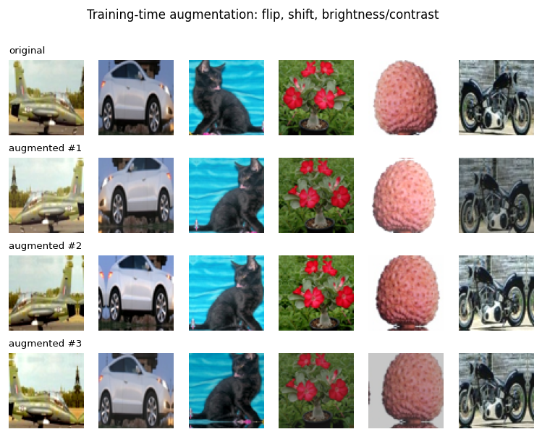
Figure 2. Training photographs before augmentation (top) and three sampled transformations.

2.4 Evaluation independence
No byte-identical or decoded-pixel-identical images cross the split boundaries in the saved audit. However, 39 test images share an 8x8 grayscale average hash with training images; including validation increases this to 41, comprising 38 fruit and three motorbike images. Visual inspection of candidate pairs identified closely related views and false positives. Hash matches therefore require visual confirmation. Potential related-image overlap limits inference about independent photographs.

2.5 Study design and rationale
The experiment uses a compact CNN followed by an LSTM, trained end to end from random initialization. No pretrained feature extractor or external training images are used. Three pooling stages balance local feature extraction against the CPU budget, and a single recurrent layer with 128 units per direction provides the reference hybrid configuration. Section 3 specifies its tensor dimensions and the alternatives used to evaluate these choices.
Stratification addresses representation in each split, while training-only normalization prevents validation or test intensities from influencing preprocessing parameters. Unweighted cross-entropy retains the observed training class frequencies; no oversampling or class weighting is used. Validation macro F1 gives all eight classes equal influence in ranking, which is useful given the unequal class counts. Accuracy and support-weighted F1 complement that view.

3. Model Implementation and Training

3.1 Architecture and design choices
The CNN uses three blocks, each with two 3x3 convolutions, batch normalization, ReLU and 2x2 max pooling. Channel counts are 32, 64 and 128. The resulting 8x8x128 map is rearranged into eight rows of 1,024 values. A single bidirectional LSTM layer has 128 units per direction. Its final states form a 256-value vector, passed through a 128-unit classification head to eight logits. Softmax is applied for reporting probabilities; training uses cross-entropy on logits.
Convolutions use stride 1 and padding 1, preserving resolution until each pooling operation. In PyTorch's channel-first format, a batch follows [B, 3, 64, 64] to [B, 128, 8, 8], then [B, 8, 1,024]. Concatenating the final forward and backward hidden states yields [B, 256]. The head applies a bias-free linear layer, batch normalization, ReLU and a final linear layer with eight outputs. B denotes batch size; every prediction concerns one image.
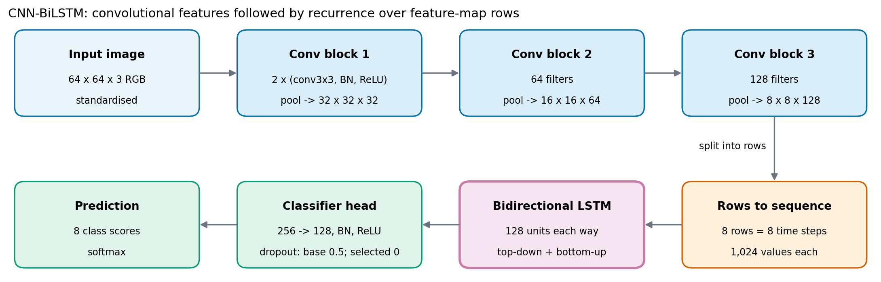
Figure 3. CNN with bidirectional LSTM; dropout differs between the baseline and selected configurations.
Table 2. Selected model summary; feature-map dimensions are channels x height x width. The CNN blocks total 287,456 parameters. Dropout has no trainable parameters.
Stage | Output per image | Parameters
CNN block 1: 3 to 32 channels | 32 x 32 x 32 | 10,208
CNN block 2: 32 to 64 channels | 64 x 16 x 16 | 55,552
CNN block 3: 64 to 128 channels | 128 x 8 x 8 | 221,696
Rows to sequence | 8 x 1,024 | 0
Bidirectional LSTM | 256 final-state values | 1,181,696
Classification head | 8 logits | 34,056
Total |  | 1,503,208

- Convolutions provide local feature extraction before recurrence; eight sequence steps reduce the recurrent sequence length compared with 64 raw-pixel rows.
- Bidirectional reading makes both row orders available. The learned weights determine their influence.
- The pixel LSTM has 315,016 parameters and the CNN control has 305,128, compared with 1,503,208 in the bidirectional hybrid. Unequal capacity prevents attributing performance differences solely to recurrence.
The pixel LSTM control reads 64 rows of 192 RGB values, applies layer normalization, and uses two unidirectional recurrent layers with 128 hidden units. The CNN control uses the same convolutional backbone followed by global average pooling and a classification head. The unidirectional hybrid reads the same eight feature-map rows as the bidirectional model but supplies a 128-value final state to the head. These controls compare raw-pixel recurrence, convolutional features and spatial recurrence under the recorded training budget.

3.2 Training and model selection
Implementation uses PyTorch (Paszke et al., 2019), with scikit-learn metrics (Pedregosa et al., 2011). Original metadata records Python 3.11.0, PyTorch 2.14.0+cpu, and 8 CPU threads. No GPU was used.
Table 3. Training settings read from the saved configurations, with architecture-derived spatial dropout.
Setting | Bidirectional baseline | Selected configuration
Optimizer | AdamW | AdamW
Peak learning rate | 0.001 | 0.001
Weight decay | 0.0001 | 0
Training augmentation | True | False
Sequence/head dropout | 0.5 | 0.0
Spatial dropout | 0.1 | 0.0
Batch size / epoch limit | 64 / 20 | 64 / 20
Loss / label smoothing | Cross-entropy / 0 | Cross-entropy / 0
Split / training seed | 42 / 42 | 42 / 42
Retained epoch | 20 | 17

Batch normalization follows each convolution and the first head linear layer (Ioffe & Szegedy, 2015). Baseline spatial and sequence/head dropout follow Tompson et al. (2015) and Srivastava et al. (2014), respectively. AdamW applies decoupled weight decay when enabled (Loshchilov & Hutter, 2019). The one-cycle schedule (Smith & Topin, 2018) warms up for 15% of steps, then uses cosine annealing toward a small final rate. The loop clips gradient norm at 1.0. Validation loss must decrease by more than 1e-4 to reset the six-epoch patience counter and retain new weights. Runs are ranked by validation macro F1 after their checkpoints are restored. Test predictions were recorded after each experiment, before the full search concluded.
Each epoch shuffles the training indices using the seeded generator and performs 76 mini-batch updates, including the final 27 images. A batch passes through augmentation when enabled, normalization, the model and mean cross-entropy loss. Backpropagation updates the CNN, LSTM and head jointly; clipping precedes the optimizer step, and the learning-rate scheduler advances once per update. Validation runs with gradients disabled and batch normalization in evaluation mode.
Dropout placement is explicit: baseline spatial dropout removes feature channels after pooling with probability 0.1, and probability 0.5 is used on the row sequence and twice in the classifier head. A one-layer LSTM has no internal inter-layer dropout; the two-layer variant also applies dropout between its recurrent layers. All dropout probabilities are zero in the selected model. The name tune_no_reg refers to removal of augmentation, dropout and weight decay; batch normalization and other training controls remain active.

3.3 Training observations
- Ten experiments ran for 20 epochs. The selected configuration retained epoch 17, when its validation loss reached the minimum.
- The selected run disabled augmentation, dropout, and weight decay while retaining batch normalization, gradient clipping, and the checkpoint selection rule.
- At the retained epoch, training accuracy was 100% and validation accuracy was 95.17%. This difference warrants evaluation on independent images.
- Training loss was 0.00118 and validation loss was 0.16317. Training and evaluation settings differ, which affects comparisons between these values.
- Runs are ranked by validation macro F1. Test scores are logged per experiment; evaluation was not deferred until all experiments finished.
All ten runs reached the 20-epoch limit; the six-epoch early-stopping threshold was never reached. The selected weights were restored from epoch 17, rather than taken from epoch 20. Figure 4 shows training loss continuing toward zero while validation loss levels off around 0.16, with a 4.83-percentage-point training-to-validation accuracy gap at the retained epoch. This pattern shows a generalization gap and supports checkpoint restoration; it does not demonstrate that additional training or removing regularization would improve independent-image performance.

3.4 Computational constraints
- Recorded elapsed durations totalled 26.15 hours, including unexplained intervals. These records do not measure active CPU time. The selected run recorded 25.37 minutes.
- Historical metadata retained Python, PyTorch, processor and thread information. Other package versions were not recorded comprehensively; the reviewed environment cannot establish the full historical dependency set.

4. Results and Evaluation
Validation macro F1 selected tune_no_reg. Reloading its retained checkpoint reproduces the saved test probabilities exactly in the local audit. Metrics use the highest-probability class. For each class, precision is TP/(TP+FP), recall is TP/(TP+FN), and F1 is their harmonic mean. Macro F1 averages class F1 without weighting; weighted F1 weights by class support.
Accuracy is the fraction of correctly classified images. Top-2 accuracy checks whether the true class appears among the two highest-scoring classes and is reported only as a supplementary measure. The main decision still uses one class per image, with no threshold tuning or test-time augmentation.
Table 4. Performance of the selected epoch-17 checkpoint.
Metric | Validation | Test
Accuracy | 95.17% | 96.33%
Macro precision | 94.75% | 96.04%
Macro recall | 94.70% | 96.01%
Macro F1 | 0.9471 | 0.9602
Weighted F1 | 0.9513 | 0.9634
Top-2 accuracy | 98.94% | 99.42%

Table 5. Test metrics by class, ordered by F1.
Class | Precision | Recall | F1 | Support
dog | 84.62% | 83.81% | 0.8421 | 105
cat | 87.50% | 89.47% | 0.8848 | 133
flower | 98.43% | 98.43% | 0.9843 | 127
car | 100.00% | 97.93% | 0.9895 | 145
airplane | 99.08% | 99.08% | 0.9908 | 109
person | 99.32% | 99.32% | 0.9932 | 148
fruit | 99.34% | 100.00% | 0.9967 | 150
motorbike | 100.00% | 100.00% | 1.0000 | 118

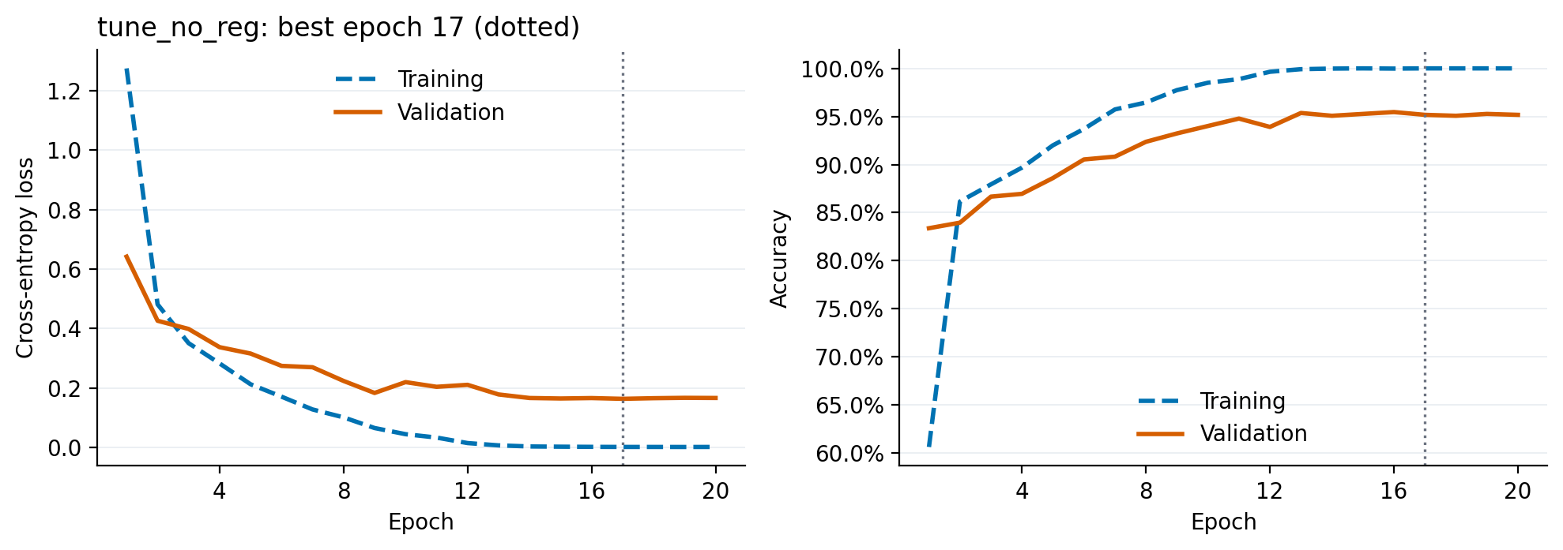
Figure 4. Selected-run histories: training in blue dashed lines and validation in orange solid lines. Training metrics are recorded during optimization; validation uses evaluation mode.
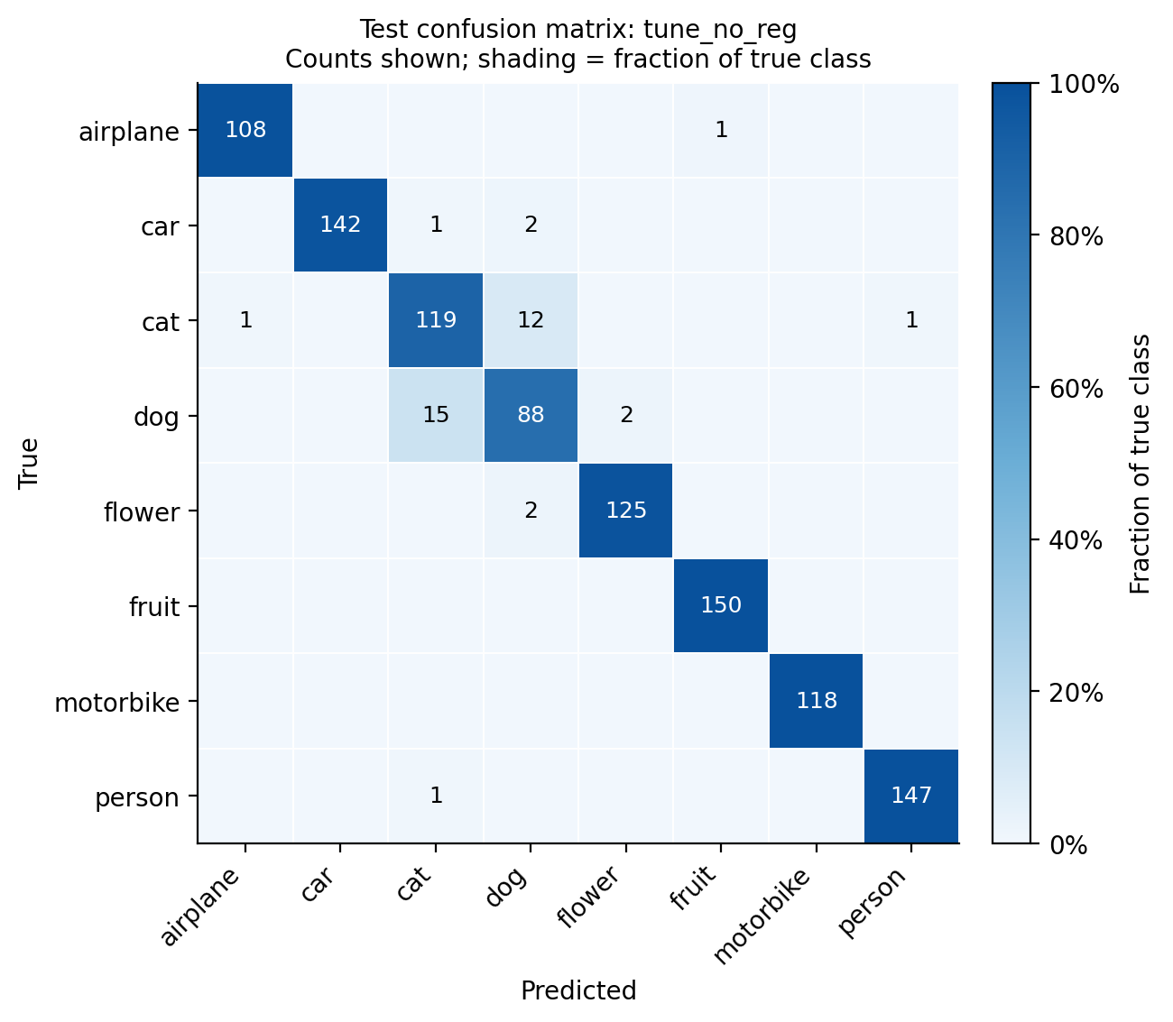
Figure 5. Test confusion matrix. Labels show counts; darker blue indicates a larger fraction of each true class.
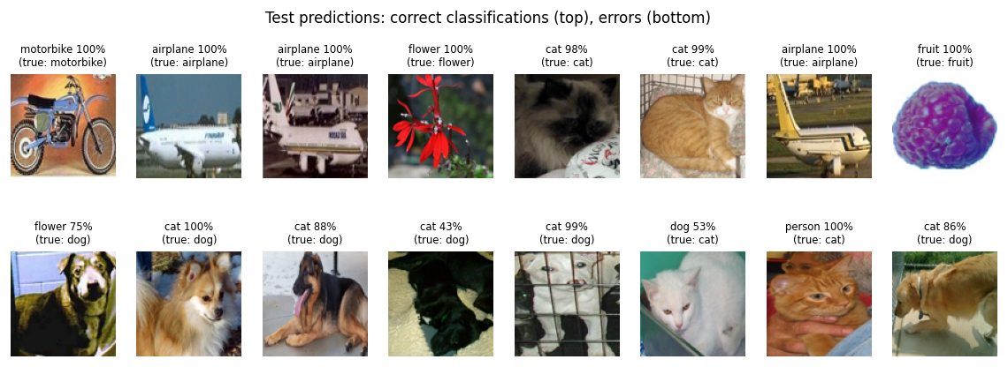
Figure 6. Examples of correct predictions and errors. Displayed softmax values have not been calibrated.

4.1 Observations
- The model correctly classified 997 of 1,035 test images, producing 96.33% accuracy and macro F1 of 0.9602 on this split.
- Macro precision was 96.04% and macro recall was 96.01%. The checkpoint audit reproduced the test probabilities, with no changed predictions.
- Dogs had F1 of 0.8421 and cats had 0.8848. Confusion between these classes accounted for 27 of the 38 errors.
- 118 motorbike images were classified correctly. Fruit recall was 100%, although similar images across splits limit interpretation of those scores.
- Measurements describe one split and seed. Similarity between images across splits limits conclusions about reported classification performance on independent photographs.
The confusion matrix identifies 12 cats predicted as dogs and 15 dogs predicted as cats: 71.1% of all test errors. Shared appearance or difficult backgrounds are plausible explanations to investigate; the confusion matrix alone cannot identify their cause. Prediction examples illustrate individual outcomes, while the complete per-class table supports the aggregate conclusions.
Test accuracy exceeds validation accuracy by 1.16 percentage points. These are different image samples, so the difference does not establish improved generalization. High softmax confidence also does not establish calibration. The perfect motorbike recall concerns 118 images on this split, with potential related-image overlap considered in the sensitivity analysis.

4.2 Uncertainty and descriptive sensitivity
Table 6. Conditional uncertainty from the existing test predictions.
Estimate | Value | 95% interval
Accuracy (Wilson) | 96.33% | 95.00% to 97.31%
Macro F1 (bootstrap) | 0.9602 | 0.9481 to 0.9718

Accuracy uses a Wilson score interval (Wilson, 1927). Macro F1 uses 2,000 class-stratified bootstrap resamples with replacement, seed 42, retaining each class's observed count and taking the 2.5th and 97.5th percentiles (Efron, 1979). Both calculations condition on the fitted model and assume independent sampled images. They exclude seed, retraining, model-selection and distribution-shift uncertainty. Related images can violate independence and make these intervals too narrow.
Table 7. Post hoc subset analysis using candidate flags from training or validation hash matches.
Descriptive subset | Images | Correct | Accuracy
All test images | 1035 | 997 | 96.33%
Average-hash candidates | 41 | 41 | 100.00%
Remaining test images | 994 | 956 | 96.18%

The subset analysis is post hoc. Candidate removal does not establish an independent holdout: the hash detector can miss related images and flag unrelated ones. The complete test set is the primary evaluation.

4.3 Further improvements
- Use validation examples to investigate animal-class errors by annotation ambiguity, object scale, occlusion and background. Compare targeted sampling and higher input resolution under a fixed protocol.
- Compare square resizing with aspect-preserving padding while holding the split, architecture and training budget constant. Evaluate animal-class F1 alongside aggregate metrics.
- Test potential acquisition shortcuts using a color-statistic baseline and prespecified illumination perturbations. Class brightness differences alone do not establish model dependence.
- Construct visually verified image groups before another split and reserve an external holdout for final evaluation.

5. Optimization and Insights

5.1 Architecture and tuning experiments
The architecture comparison included a pixel LSTM, a CNN with global average pooling, and CNNs with unidirectional or bidirectional LSTM. All experiments used the original split and seed 42.
Five tuning runs separately changed hidden units (128 to 256), recurrent depth (one to two layers), dropout (0.5 to 0.3), peak learning rate (0.001 to 0.0003), or augmentation. A sixth run disabled augmentation, dropout and weight decay jointly. The lower learning rate was evaluated under the same 20-epoch cap, which may limit that comparison.
Table 8. Complete experiment settings from saved configurations. Hidden units are per direction; dropout denotes sequence/head probability (head only for the CNN). Aug. means training augmentation; Bi/Uni mean bidirectional/unidirectional, and decay means AdamW weight decay. All runs use seed 42, batch size 64 and a 20-epoch limit. N/A means not applicable.
Run | Hidden | Layers | Dir. | Dropout | Aug. | Peak LR | Decay
pixel_lstm | 128 | 2 | Uni | 0.3 | Yes | 0.001 | 0.0001
cnn_only | N/A | N/A | N/A | 0.5 | Yes | 0.001 | 0.0001
cnn_lstm | 128 | 1 | Uni | 0.5 | Yes | 0.001 | 0.0001
cnn_bilstm | 128 | 1 | Bi | 0.5 | Yes | 0.001 | 0.0001
tune_hidden256 | 256 | 1 | Bi | 0.5 | Yes | 0.001 | 0.0001
tune_layers2 | 128 | 2 | Bi | 0.5 | Yes | 0.001 | 0.0001
tune_dropout03 | 128 | 1 | Bi | 0.3 | Yes | 0.001 | 0.0001
tune_lr3e4 | 128 | 1 | Bi | 0.5 | Yes | 0.0003 | 0.0001
tune_no_aug | 128 | 1 | Bi | 0.5 | No | 0.001 | 0.0001
tune_no_reg | 128 | 1 | Bi | 0 | No | 0.001 | 0

Table 9. All ten runs ranked by validation macro F1. F1 values are fractions; accuracy is a percentage.
Run | Parameters | Epoch | Val F1 | Test accuracy | Test F1
tune_no_reg | 1,503,208 | 17 | 0.9471 | 96.33% | 0.9602
tune_no_aug | 1,503,208 | 20 | 0.9342 | 94.40% | 0.9397
tune_dropout03 | 1,503,208 | 20 | 0.9314 | 94.11% | 0.9360
tune_hidden256 | 2,979,816 | 20 | 0.9217 | 93.82% | 0.9322
tune_layers2 | 1,898,472 | 20 | 0.9190 | 93.53% | 0.9296
cnn_bilstm | 1,503,208 | 20 | 0.9040 | 92.17% | 0.9126
cnn_lstm | 895,976 | 20 | 0.8754 | 89.86% | 0.8755
tune_lr3e4 | 1,503,208 | 20 | 0.8618 | 88.89% | 0.8709
cnn_only | 305,128 | 20 | 0.8582 | 87.63% | 0.8448
pixel_lstm | 315,016 | 19 | 0.8239 | 82.61% | 0.8101

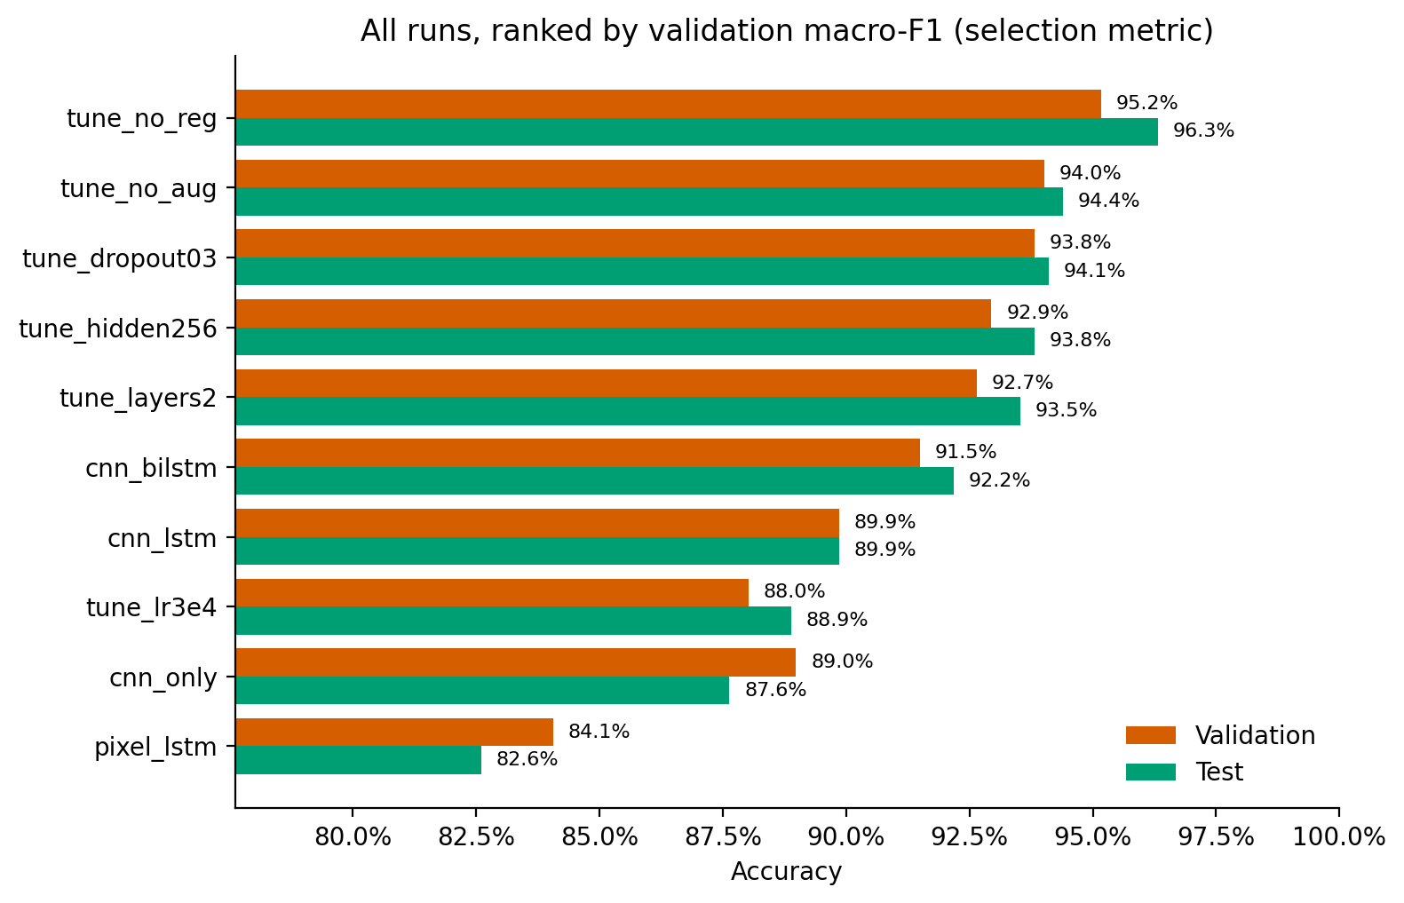
Figure 7. Validation accuracy in orange and test accuracy in green; ordering uses validation macro F1.
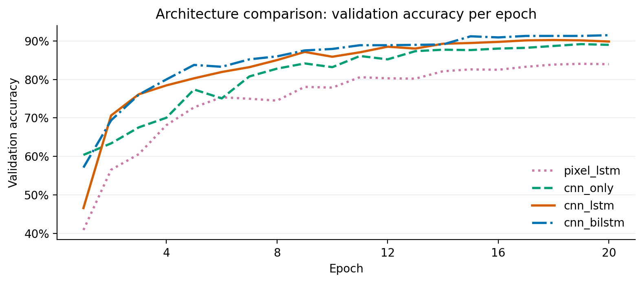
Figure 8. Validation histories of the four architecture configurations.
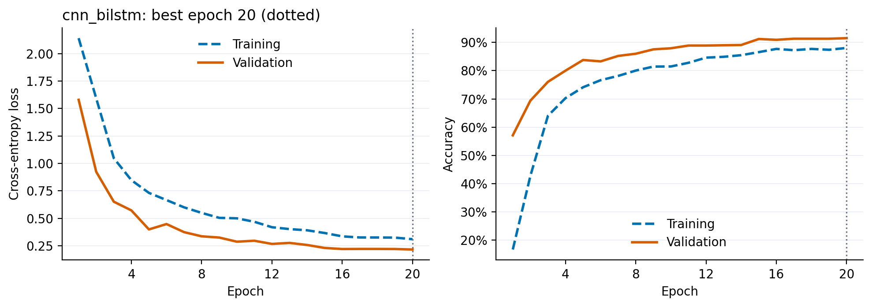
Figure 9. Bidirectional baseline histories for comparison with the selected run: training in blue dashed lines and validation in orange solid lines.
The selected configuration improves test accuracy by 4.15 percentage points over the bidirectional baseline. On the same images, it corrects 58 baseline errors and introduces 15 errors where the baseline was correct. A paired class-stratified bootstrap gives a conditional 95% difference interval of 2.61 to 5.70 percentage points. This post hoc contrast is unadjusted for the search and does not isolate a causal effect of any single setting.

5.2 Observations
- Baseline test accuracies were 82.61% for pixel LSTM, 87.63% for CNN, 89.86% for CNN with LSTM, and 92.17% for bidirectional recurrence.
- The configuration reached validation macro F1 of 0.9471, compared with 0.9040 for the baseline. Selection used validation scores throughout.
- Disabling augmentation alone produced validation macro F1 of 0.9342. Disabling augmentation, dropout, and weight decay together produced the highest validation score.
- The combined change does not isolate dropout or weight decay effects. Controlled runs are needed before attributing improvement to either.
- Increasing size or depth did not exceed the selected score. Unequal capacity and tuning coverage restrict claims about superiority.
The search was a manually specified set of ten runs, rather than a grid search or a repeated-seed optimization. Increasing hidden size or depth tests extra recurrent capacity; reducing dropout tests a weaker masking setting; the lower learning rate tests slower updates within the same epoch budget. Disabling augmentation tests whether those transformations help on this split. The combined run tests a joint change and cannot identify the separate contribution of dropout or weight decay. The tied dropout parameter also changes multiple masking locations together.
The configuration without augmentation achieved validation macro F1 of 0.9342 versus 0.9040 for the bidirectional baseline; the combined run reached 0.9471. These observations suggest that the original regularization and augmentation settings may be too strong for this training budget, but they do not establish a general benefit from removing regularization. A follow-up factorial comparison should vary augmentation, dropout and weight decay independently, use comparable search budgets for each architecture, and select models before evaluating a new holdout.

6. Conclusion

6.1 Final insights
- The validation-selected CNN with bidirectional LSTM classified 997 of 1,035 test images correctly, achieving 96.33% accuracy and 0.9602 macro F1. These estimates characterize the original split and seed. Conditional uncertainty intervals quantify sampling variation, while independent-image performance requires evaluation on photographs separated by object identity or acquisition source.
- Cat and dog discrimination should receive priority in subsequent experiments. Confusion between these classes produced 27 of 38 errors; their F1 scores were 0.8848 and 0.8421, respectively. Validation-based review should examine annotation ambiguity, occlusion, object scale and background composition before evaluating targeted sampling or resolution changes under a fixed protocol.
- Similarity screening identified 41 test images with average hashes also present in training or validation data. Candidate matches require visual confirmation because hash equality does not establish duplication. Confirmed image families should remain together during splitting. Performance on the remaining images is descriptive and cannot substitute for an independent holdout.

6.2 Recommendations
- The selected configuration disabled augmentation, dropout and weight decay while retaining batch normalization. Its validation macro F1 exceeded the baseline, but the combined ablation cannot identify individual contributions. Separate controlled experiments should vary these settings independently, with equal training budgets and repeated seeds used to estimate variability across fitted models.
- Model complexity should be assessed alongside classification performance. The selected model contains 1,503,208 parameters, versus 305,128 in the CNN baseline. Comparable tuning searches are needed before attributing gains to recurrence. Deployment comparisons should report inference latency, memory use and class-specific accuracy under the same hardware conditions and representative image distributions.
- Reproducibility requires retained split assignments, complete configurations, package version inventories, predictions and model checkpoints. Historical elapsed durations include unexplained intervals and do not measure active computation. Future studies should record computational conditions, freeze validation-based selection before test evaluation, and report uncertainty across seeds. Aspect-preserving resizing and acquisition-related shortcuts warrant prespecified validation comparisons.

References
Donahue, J., Hendricks, L. A., Guadarrama, S., Rohrbach, M., Venugopalan, S., Saenko, K., & Darrell, T. (2015). Long-term recurrent convolutional networks for visual recognition and description. In Proceedings of the IEEE Conference on Computer Vision and Pattern Recognition (pp. 2625–2634). IEEE. https://doi.org/10.1109/CVPR.2015.7298878
Efron, B. (1979). Bootstrap methods: Another look at the jackknife. The Annals of Statistics, 7(1), 1–26. https://doi.org/10.1214/aos/1176344552
Gers, F. A., Schmidhuber, J., & Cummins, F. (2000). Learning to forget: Continual prediction with LSTM. Neural Computation, 12(10), 2451–2471. https://doi.org/10.1162/089976600300015015
Hochreiter, S., & Schmidhuber, J. (1997). Long short-term memory. Neural Computation, 9(8), 1735–1780. https://doi.org/10.1162/neco.1997.9.8.1735
Ioffe, S., & Szegedy, C. (2015). Batch normalization: Accelerating deep network training by reducing internal covariate shift. In F. Bach & D. Blei (Eds.), Proceedings of the 32nd International Conference on Machine Learning (Vol. 37, pp. 448–456). PMLR. https://proceedings.mlr.press/v37/ioffe15.html
Krizhevsky, A. (2009). Learning multiple layers of features from tiny images [Technical report]. University of Toronto. https://www.cs.toronto.edu/~kriz/learning-features-2009-TR.pdf
LeCun, Y., Bottou, L., Bengio, Y., & Haffner, P. (1998). Gradient-based learning applied to document recognition. Proceedings of the IEEE, 86(11), 2278–2324. https://doi.org/10.1109/5.726791
Loshchilov, I., & Hutter, F. (2019). Decoupled weight decay regularization. In International Conference on Learning Representations. https://openreview.net/forum?id=Bkg6RiCqY7
Paszke, A., Gross, S., Massa, F., Lerer, A., Bradbury, J., Chanan, G., Killeen, T., Lin, Z., Gimelshein, N., Antiga, L., Desmaison, A., Köpf, A., Yang, E., DeVito, Z., Raison, M., Tejani, A., Chilamkurthy, S., Steiner, B., Fang, L., … Chintala, S. (2019). PyTorch: An imperative style, high-performance deep learning library. In H. Wallach, H. Larochelle, A. Beygelzimer, F. d'Alché-Buc, E. Fox, & R. Garnett (Eds.), Advances in neural information processing systems (Vol. 32, pp. 8024–8035). Curran Associates. https://proceedings.neurips.cc/paper/2019/hash/bdbca288fee7f92f2bfa9f7012727740-Abstract.html
Pedregosa, F., Varoquaux, G., Gramfort, A., Michel, V., Thirion, B., Grisel, O., Blondel, M., Prettenhofer, P., Weiss, R., Dubourg, V., Vanderplas, J., Passos, A., Cournapeau, D., Brucher, M., Perrot, M., & Duchesnay, É. (2011). Scikit-learn: Machine learning in Python. Journal of Machine Learning Research, 12, 2825–2830. https://jmlr.org/papers/v12/pedregosa11a.html
Roy, P. (2018). Natural images [Data set]. Kaggle. https://www.kaggle.com/datasets/prasunroy/natural-images
Schuster, M., & Paliwal, K. K. (1997). Bidirectional recurrent neural networks. IEEE Transactions on Signal Processing, 45(11), 2673–2681. https://doi.org/10.1109/78.650093
Shi, B., Bai, X., & Yao, C. (2017). An end-to-end trainable neural network for image-based sequence recognition and its application to scene text recognition. IEEE Transactions on Pattern Analysis and Machine Intelligence, 39(11), 2298–2304. https://doi.org/10.1109/TPAMI.2016.2646371
Smith, L. N., & Topin, N. (2018). Super-convergence: Very fast training of neural networks using large learning rates (arXiv:1708.07120v3) [Preprint]. arXiv. https://arxiv.org/abs/1708.07120v3
Srivastava, N., Hinton, G., Krizhevsky, A., Sutskever, I., & Salakhutdinov, R. (2014). Dropout: A simple way to prevent neural networks from overfitting. Journal of Machine Learning Research, 15(56), 1929–1958. https://jmlr.org/papers/v15/srivastava14a.html
Tompson, J., Goroshin, R., Jain, A., LeCun, Y., & Bregler, C. (2015). Efficient object localization using convolutional networks. In Proceedings of the IEEE Conference on Computer Vision and Pattern Recognition (pp. 648–656). IEEE. https://doi.org/10.1109/CVPR.2015.7298664
Visin, F., Kastner, K., Cho, K., Matteucci, M., Courville, A., & Bengio, Y. (2015). ReNet: A recurrent neural network based alternative to convolutional networks [Preprint]. arXiv. https://doi.org/10.48550/arXiv.1505.00393
Wilson, E. B. (1927). Probable inference, the law of succession, and statistical inference. Journal of the American Statistical Association, 22(158), 209–212. https://doi.org/10.1080/01621459.1927.10502953

