Image Classification with Convolutional Neural Networks
Neural Networks Implementation Project Report

Introduction
This project classifies photographs into eight object categories using a convolutional neural network (CNN). The Natural Images dataset contains 6899 labeled images of airplanes, cars, cats, dogs, flowers, fruit, motorbikes, and people. The objective is to compare a simple CNN with a version using batch normalization and dropout, then evaluate the selected model on unseen images.
Class | Images
airplane | 727
car | 968
cat | 885
dog | 702
flower | 843
fruit | 1000
motorbike | 788
person | 986

Methodology

Preprocessing steps
Images were divided with stratified random sampling (seed 42) into 4829 training, 1035 validation, and 1035 test examples (70/15/15). The test set was held out until model selection was complete. All images were converted to RGB, resized to 48 x 48 pixels, and scaled from 0-255 to 0-1. Training images alone received random horizontal flips and brightness changes (factor 0.85-1.15).

CNN architecture design
Both networks use three 3x3 convolution blocks with 16, 32, and 64 output channels. Each block has ReLU and 2x2 max pooling. Global average pooling maps each channel to one value, followed by a linear eight-class classifier. The regularized variant adds batch normalization after every convolution and 30% dropout before the classifier. The baseline omits both. This comparison isolates the effect of regularization while keeping network width and depth fixed.
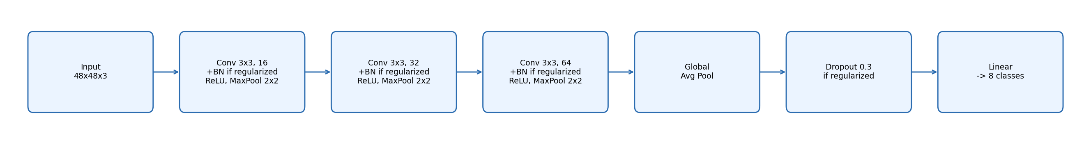
Figure 1. Shared CNN architecture. The regularized variant additionally applies batch normalization and dropout as noted in each block.

Training setup and hyperparameters
Both variants were trained for 3 epochs using cross entropy loss, Adam with learning rate 0.001, and batch size 64. The checkpoint with the highest validation accuracy for each variant was saved; the variant with the higher validation accuracy was selected. Ties favor the baseline. Training ran on cpu. No test labels were used for optimization. These starting hyperparameters were then tuned by a grid search over learning rate and dropout rate, reported and justified in the Discussion section.

Results

Performance metrics
Baseline best validation accuracy: 54.686%
Regularized best validation accuracy: 75.556%
Selected model: regularized. Test accuracy: 74.589%; macro precision: 0.737; macro recall: 0.727; macro F1: 0.712; test cross entropy: 0.732.
Macro metrics average the eight classes equally. The test accuracy uses all held-out examples. Per-class precision, recall, and F1-score are shown below.
Class | Precision | Recall | F1-score | Support
airplane | 0.759 | 0.807 | 0.782 | 109
car | 0.831 | 0.745 | 0.785 | 145
cat | 0.608 | 0.466 | 0.528 | 133
dog | 0.500 | 0.171 | 0.255 | 105
flower | 0.959 | 0.732 | 0.830 | 127
fruit | 0.872 | 1.000 | 0.932 | 150
motorbike | 0.768 | 0.924 | 0.838 | 118
person | 0.600 | 0.973 | 0.742 | 148

Confusion matrix and classification report
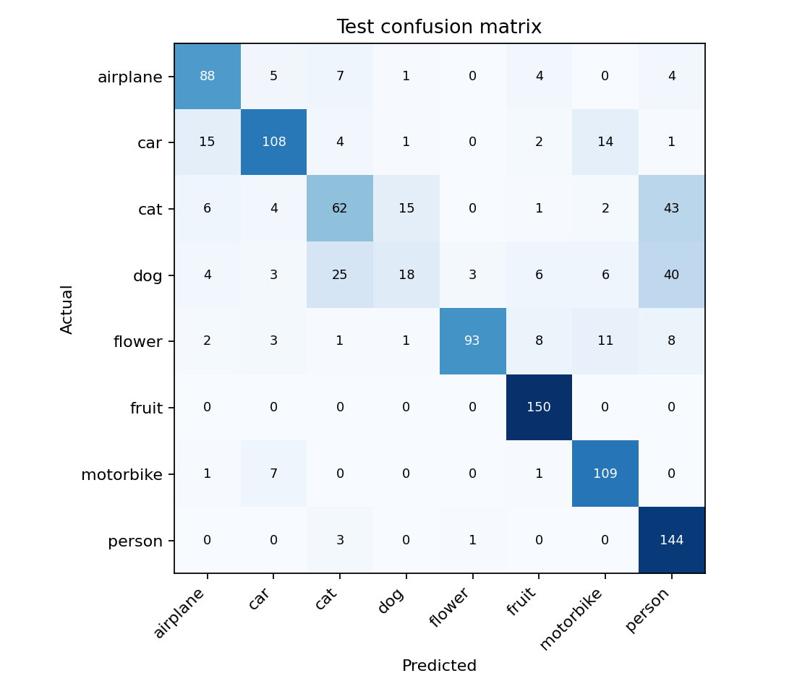
Figure 2. Confusion matrix for the selected model on the held-out test set. Rows are true labels; columns are predictions.

Training/validation loss and accuracy curves
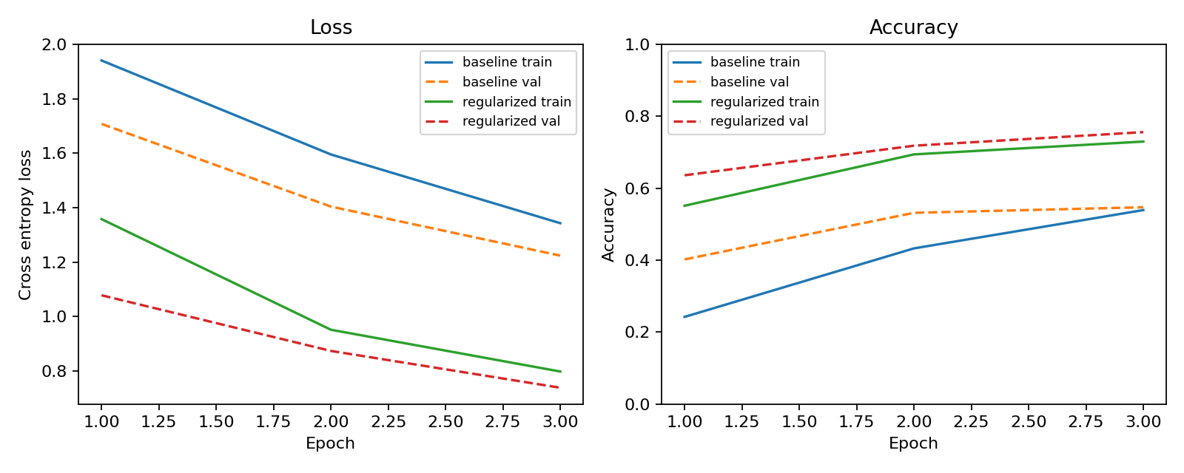
Figure 3. Training and validation loss and accuracy for both CNN variants. Each dashed line is validation performance.

Discussion

Observations, challenges, and insights
On the test set, recall was highest for fruit (1.000) and lowest for dog (0.171). Per the confusion matrix, the largest confusion errors on the test set were 43 true 'cat' images predicted as 'person'; 40 true 'dog' images predicted as 'person'; 25 true 'dog' images predicted as 'cat'. This shows that aggregate accuracy alone does not describe performance across all categories, and that per-class recall is a more informative diagnostic than a single accuracy number.
The main practical challenge was keeping training time reasonable on a CPU-only machine: images were downsized to 48x48 and the network kept to three convolution blocks so that a full architecture comparison plus a hyperparameter search could still complete in well under an hour. A second challenge was noise in short training runs — with only 3 epochs per configuration and a 1035-image validation set, a single run's best-epoch accuracy can swing several points between otherwise identical settings (see the hyperparameter search below), which complicates picking a clear winner from a small number of runs.

Justification for design and optimization decisions
The regularized architecture (batch normalization + 30% dropout) was selected over the baseline because it reached 75.556% best validation accuracy versus 54.686% for the baseline under identical data, epochs, and optimizer settings. Batch normalization stabilizes the input distribution to each layer, and dropout reduces overfitting on a training set of under 5,000 images; the gap between the two variants' training curves (below) shows the baseline both learning more slowly and generalizing worse. Global average pooling was used instead of a flattened dense layer to keep the parameter count small and the network size-invariant to any input resolution.
Starting from the winning architecture, learning rate and dropout were tuned by a two-stage grid search, each run for 3 epochs and scored by validation accuracy. First, the learning rate was swept with dropout fixed at its original value; then dropout was swept at the best learning rate found. This keeps the search small (six total configurations) while still probing both an optimization hyperparameter and a regularization hyperparameter.
Learning rate | Best validation accuracy
0.0003 | 69.469%
0.001 | 75.556%
0.003 | 68.986%
Best learning rate: 0.001.
Dropout rate | Best validation accuracy
0.1 | 72.174%
0.3 | 74.300%
0.5 | 72.560%
Best dropout rate at learning rate 0.001: 0.3.
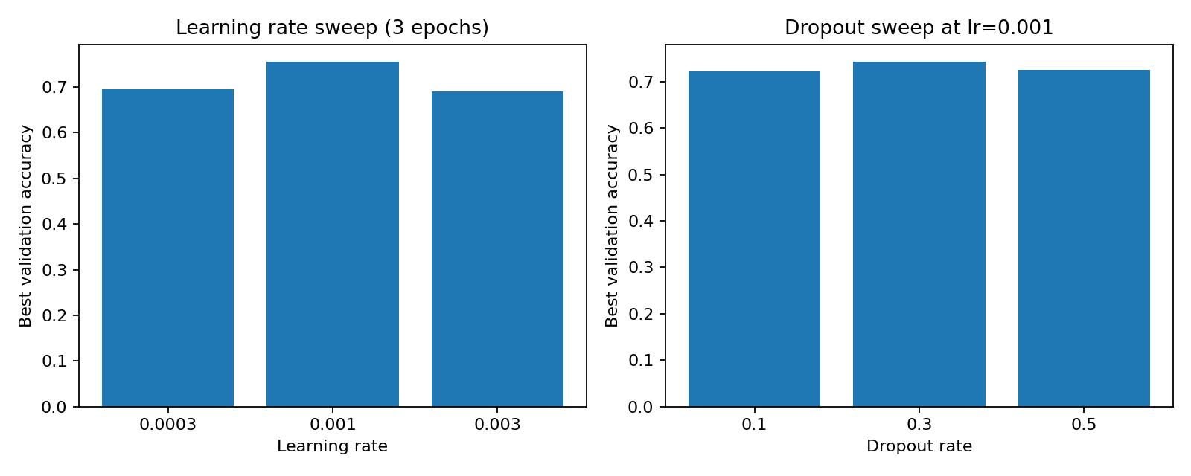
Figure 4. Best validation accuracy across the learning rate sweep (left) and the dropout sweep at the best learning rate (right).
The best tuned configuration reached 74.300% validation accuracy, which did not exceed the original 75.556% achieved with learning rate 0.001 and dropout 0.3. The original regularized model was therefore kept as the final model, and its test results above are unchanged.

Potential improvements and future work
Future work could compare larger input sizes, more training epochs with early stopping, class-weighted loss to offset the uneven class counts, additional augmentation such as rotation and cropping, and pretrained feature extractors (transfer learning) rather than a network trained from scratch. Any of these changes would need a new validation comparison and a fresh held-out test set for a fair final estimate. Averaging several random seeds per hyperparameter configuration would also make the tuning results above more reliable, since single three-epoch runs showed noticeable run-to-run variance.

Final Insight and Recommendations
The single biggest driver of accuracy in this project was regularization, not hyperparameter tuning: adding batch normalization and dropout raised best validation accuracy by 20.9% (from 54.686% to 75.556%), a larger gain than any single learning-rate or dropout value found in the grid search.
The hyperparameter search did not improve on the original settings (best alternative 74.300% versus 75.556% original), so within the ranges tested no further gain was available from learning rate or dropout alone.
Dog is the model's weakest category (recall 0.171, F1 0.255); the largest confusion errors on the test set were 43 true 'cat' images predicted as 'person'; 40 true 'dog' images predicted as 'person'; 25 true 'dog' images predicted as 'cat'. Recommendation: prioritize more or better-augmented dog training images, or a class-weighted loss, before any further architecture or hyperparameter changes, since that is where most of the remaining error is concentrated.
Recommendation for deployment: the regularized model (test accuracy 74.589%, macro F1 0.712) is the checkpoint to use from this project. It is adequate for a coarse eight-class screen but not yet reliable for use cases where confusing dog with a visually similar class is costly; for those, address the observation above and revisit the future-work items before deploying.

Reproducibility and source
Dataset: Prasun Roy, Natural Images, Kaggle, https://www.kaggle.com/datasets/prasunroy/natural-images . Source code and measured results are included with this submission. Run python train.py --epochs 3, then python tune.py, then python make_report.py with the required packages installed.

Conclusion
A reproducible CNN pipeline was implemented for eight-class Natural Images classification. The regularized CNN was selected from a controlled architecture comparison and a follow-up hyperparameter search and achieved 74.589% accuracy and 0.712 macro F1 on 1035 held-out images. The saved metrics, curves, confusion matrix, and model checkpoints support reproduction and further tuning.

