Evaluating the Impact of Policy Changes on Economic Outcomes
A Counterfactual Analysis of the Federal Reserve's 2022 Monetary Tightening Cycle
Project 2: Counterfactual Analysis Project
Albert Kabore, PhD Student in AI
GitHub: github.com/albertokabore/Project-2---Evaluating-the-Impact-of-Policy-Changes-on-Economic-Outcomes
September 2026

1. Introduction

1.1 The Policy Change and Research Question
In March 2022 the Federal Open Market Committee started raising the federal funds rate from near zero, about 0.00 to 0.25 percent, up to a peak of 5.25 to 5.50 percent by mid 2023. It was the fastest pace of rate hikes in roughly four decades. The Fed's stated goal was simple: bring inflation, which had hit a 40 year high, back down toward its 2 percent target.
Research question: what effect did this rate hiking cycle have on U.S. inflation and output, compared with the path those indicators would have followed if the Fed had left rates alone?
A quick note on scope. The policy change studied here already happened, the Fed did raise rates. The hypothetical part of this project is the counterfactual alternative: what inflation and output would look like if the Fed had not raised rates. That hypothetical scenario is exactly what Sections 3 and 4 simulate and compare against what actually happened.

1.2 Motivation
Monetary policy applies to the whole economy at once, so there is no control group sitting around somewhere as “the same U.S. economy that didn't get a rate hike.” A simple before and after comparison would mix the policy's effect together with everything else happening in the economy over the same stretch of time: supply chains normalizing, energy prices swinging, pandemic era fiscal stimulus fading out. Figuring out what the policy actually did means building a counterfactual instead, a model based estimate of what inflation and output would have done without the hikes, with those other global forces stripped out as much as the data allows.
Observations: The research question concerns the difference between observed U.S. outcomes and an unobserved path without the tightening cycle. The figures can describe what changed after March 2022, but attributing those changes to policy requires additional assumptions about that alternative path. March 2022 provides a reproducible boundary for the analysis. It represents the start of a sequence of policy decisions, however, rather than an isolated treatment; anticipation and subsequent decisions complicate interpretation of a single intervention date.

2. Data Description

2.1 Source and Nature of the Dataset
Every series in this project comes from FRED, the Federal Reserve Economic Data service run by the Federal Reserve Bank of St. Louis, a public source for U.S. and international macroeconomic data. Data were pulled using the pandas-datareader library, which reads each series' public CSV file directly. No API key is needed, and every raw pull is cached locally, so rerunning the analysis later produces the same numbers.
The cleaned analysis frame spans January 2006-August 2026 and contains 248 monthly rows. Model estimation uses January 2006-February 2022 (194 months), and evaluation uses March 2022-February 2025 (36 months), for 230 modeled observations. The final 18 months in the full frame are outside this evaluation window.

2.2 Key Variables and Economic Indicators
Variable | FRED Code | Frequency | Role
Federal funds rate | FEDFUNDS | Monthly | Policy variable (the treatment)
CPI, all items | CPIAUCSL | Monthly | → YoY inflation (primary outcome)
PCE price index | PCEPI | Monthly | → YoY inflation (robustness outcome)
Industrial production | INDPRO | Monthly | → YoY growth (output outcome)
Unemployment rate | UNRATE | Monthly | Secondary outcome
Real GDP | GDPC1 | Quarterly | → YoY growth, secondary outcome
Euro area HICP | CP0000EZ19M086NEST | Monthly | Control covariate
UK CPI | GBRCPIALLMINMEI | Monthly | Control covariate
Global commodity price index | PALLFNFINDEXM | Monthly | Control covariate
The foreign inflation and commodity-price series proxy shared global conditions. Their use as controls requires assumptions about exposure to U.S. policy and other central banks' responses; being outside the United States does not establish that a series is untreated.
Observations: The raw-data output contains 260 monthly index entries and nine series, spanning January 2005 to August 2026. The final rows contain missing observations, so the requested retrieval range should not be interpreted as complete coverage for every variable. CPI and PCE measure inflation, industrial production and real GDP capture different aspects of activity, and unemployment adds a labor-market outcome. GDP is quarterly even though it appears on a monthly index; the alignment does not create new monthly measurements. Euro area inflation, UK inflation, and commodity prices provide information about shared global conditions. Their usefulness as predictors does not establish that they are unaffected by U.S. policy or other countries' policy responses. The cached files preserve the inputs used here. Reproducibility depends on retaining that data snapshot, because a later download can contain revised values and different coverage.

2.3 Preprocessing Steps
- Index level series, CPI, PCE, industrial production, GDP, both foreign CPI controls, and commodity prices, are converted to year over year percent change. That puts every outcome on a comparable, roughly stationary scale instead of a raw, trending index level.
- All series are aligned to a common month start index. The quarterly GDP series is forward filled, up to two months, so it lines up with the monthly index.
- Short, isolated reporting gaps are forward filled, again up to two months. Rows still missing the treatment variable or the primary outcome after that get dropped. In practice this only removes the first twelve months of history, which the year over year transform consumes anyway.
- Normalizing the control covariates. Right before the model is fit, the three control covariates are z-scored, mean centered and scaled to unit variance, using statistics from the pre-intervention period only, and that same transform is then applied to the post-intervention covariates. This matters because the controls sit on very different scales (global commodity price swings are much bigger than UK CPI swings), and normalizing keeps the regression numerically stable without letting any post-intervention information leak backward into the transform.
- The train and test split is done by date, not at random. The pre-intervention period is the training set, and the post-intervention period is held out and compared against the model's counterfactual. A random shuffle would leak post-intervention information into training and break the whole counterfactual design.
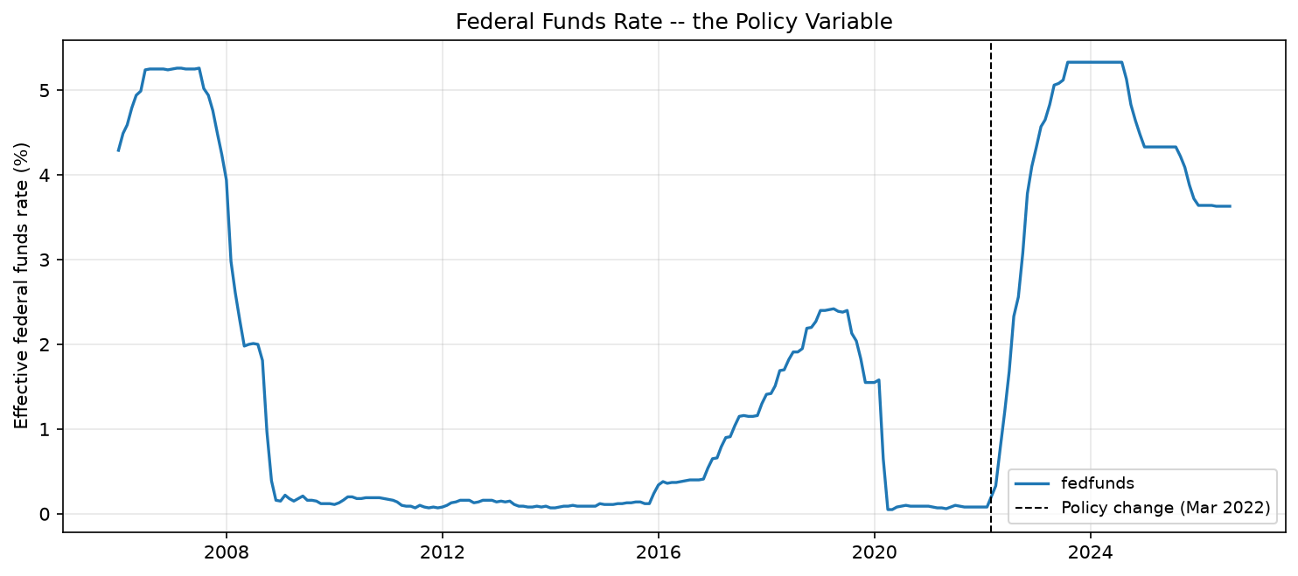
Figure 1. The federal funds rate, the policy variable in this study, rising from near zero to a peak above 5 percent starting March 2022.
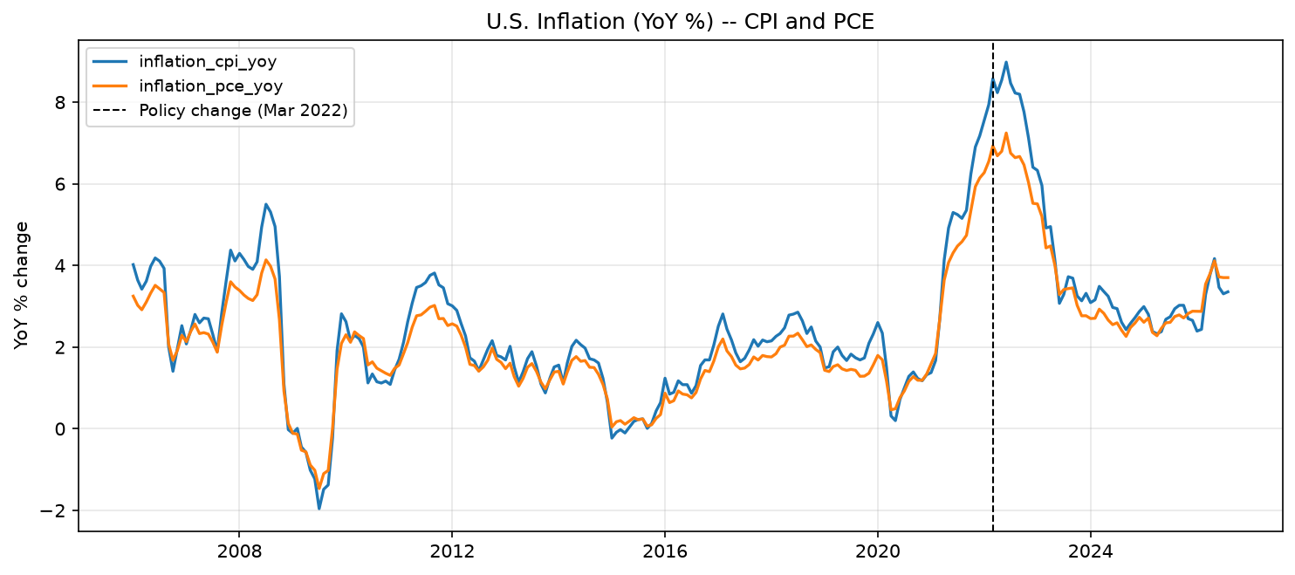
Figure 2. U.S. CPI and PCE inflation (YoY %) across the full sample, with the intervention date marked.
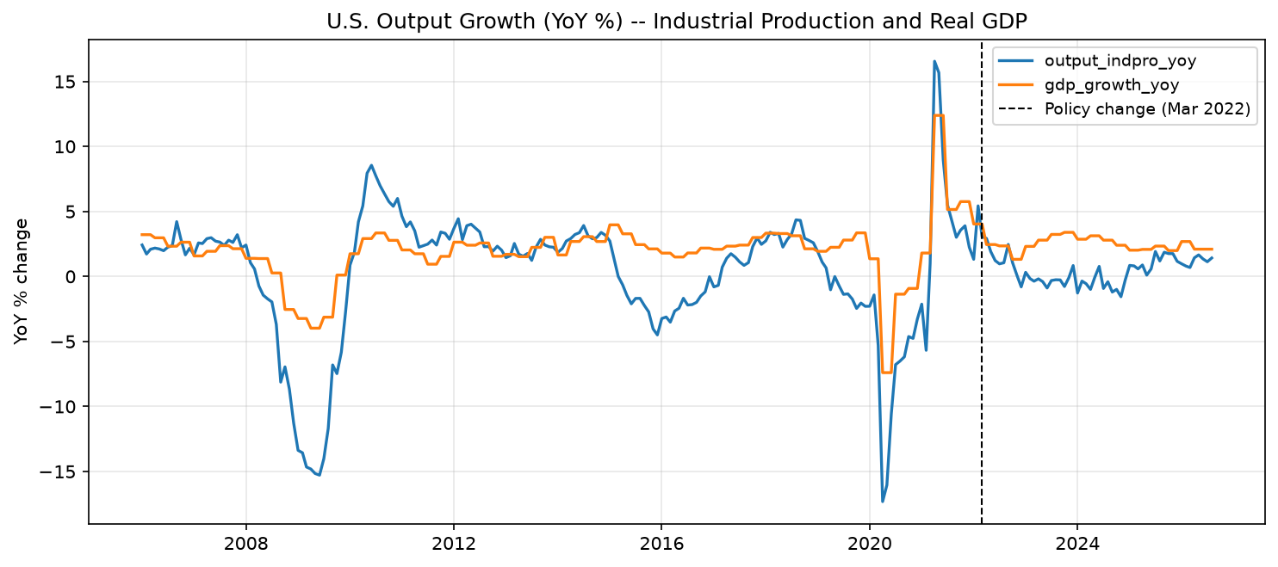
Figure 3. U.S. output growth (YoY %), industrial production and real GDP, across the full sample.
Observations: Preprocessing produces 248 monthly rows from January 2006 to August 2026. The estimation and evaluation windows use 194 and 36 months respectively, for 230 modeled observations; the remaining 18 months are outside the selected evaluation window. Year-over-year transformations express index movements as growth rates, while the policy and unemployment rates remain in levels. Adjacent annual growth observations share much of the same underlying history, so serial dependence remains and stationarity is not guaranteed. The diagnostic reports 15 missing UK CPI values in the full analysis frame. Missingness therefore remains relevant when extending the evaluation period, even though the reported models use the earlier window ending in February 2025. The chronological split and training-only scaling protect the fitted model from direct use of post-intervention outcomes. Forward-filled observations, especially GDP, still require care: a denser index should not be mistaken for additional independent information.

3. Methodology

3.1 Counterfactual Model
This analysis uses a regression based structural time series counterfactual, an approach known as intervention analysis going back to Box and Tiao (1975) and conceptually close to Google's CausalImpact method (Brodersen et al., 2015). The model itself is a local level state space model with exogenous regression covariates, fit with the Kalman filter and maximum likelihood:
yₜ = μₜ + βᵀxₜ + εₜ , μₜ = μₜ₋₁ + ηₜ
Here yₜ is the outcome (for example, CPI inflation YoY), μₜ is a stochastic local level that captures the outcome's own slow moving trend, and xₜ is the vector of control covariates: Euro area inflation, UK inflation, and global commodity prices.
The control covariates xₜ are z-scored using pre-intervention statistics only before they enter the regression. The outcome yₜ stays in its native year over year percent unit, since the transform in Section 2.3 already put it on a comparable, stationary scale.

3.2 Justification for Model Choice
The pre-intervention model is projected forward using observed post-intervention controls. This is a conditional forecast of the historical relationship. Interpreting it as a no-tightening counterfactual additionally requires stable relationships, credible controls, and no omitted concurrent shocks that explain the gap.
- Difference-in-differences and synthetic control would require defensible comparison units. Synchronized policy responses complicate their selection, but the same exposure concerns also apply to this model's control series.
- A plain before and after comparison would mix the policy's effect together with the global inflation shock that was already fading for reasons that had nothing to do with the Fed, supply chains normalizing being the obvious example.
- The structural time-series model supplies a transparent baseline and conditional forecast intervals. Its residual gaps may reflect policy, forecast error, and unmodeled shocks; the specification alone does not separate these explanations.

3.3 Simulation Setup
The intervention date is March 2022. The model is estimated on the pre-intervention window and forecast for 36 months using statsmodels get_forecast. The resulting intervals reflect state and observation uncertainty conditional on fitted parameters and supplied controls; they should not be treated as a complete account of parameter or causal uncertainty.

3.4 Model Validation
The CPI backtest has an RMSE of 1.24 percentage points and an MAE of 1.10. Actual inflation exceeds the projection in 11 of 12 months, showing that the model lags the acceleration. This pre-hike holdout is informative about forecast error; it is not a period without other economic shocks, and it cannot validate the unobserved post-policy counterfactual.
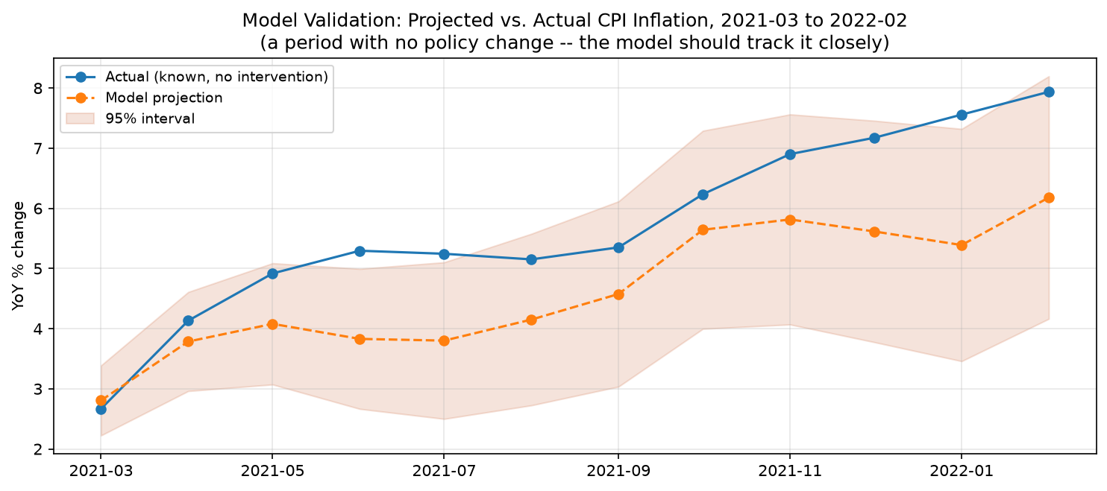
Figure 4. CPI inflation forecast validation over the pre-intervention holdout, March 2021-February 2022.

4. Results

4.1 Primary Outcome: CPI Inflation
Observed CPI inflation is 8.57 percent against a 9.60 percent counterfactual in March 2022, and 2.80 percent against 4.46 percent in February 2025. The mean observed-minus-counterfactual gap is -1.65 percentage points across 36 months. Its sum is -59.35 percentage-point months, an accumulation of annual inflation-rate gaps rather than a price-level effect.
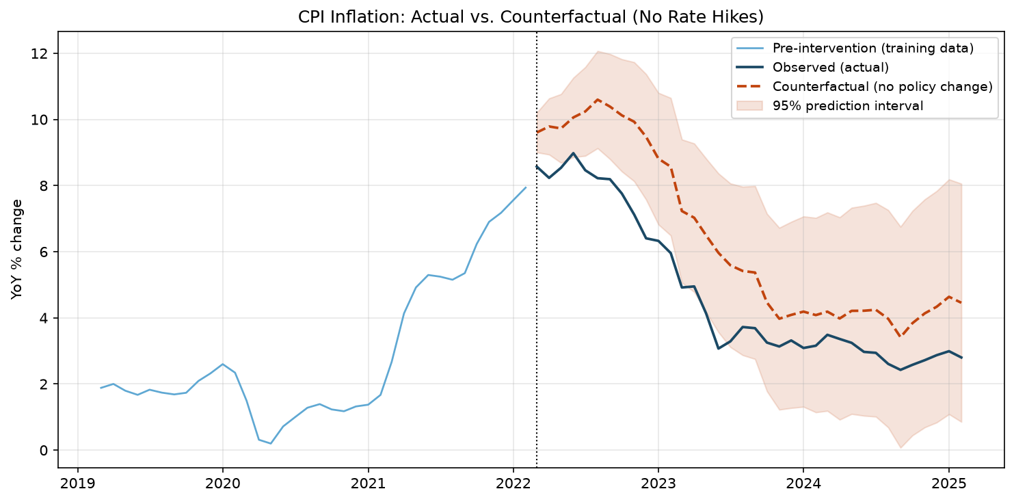
Figure 5. CPI inflation: observed vs. counterfactual (no rate hikes), with 95% prediction interval.
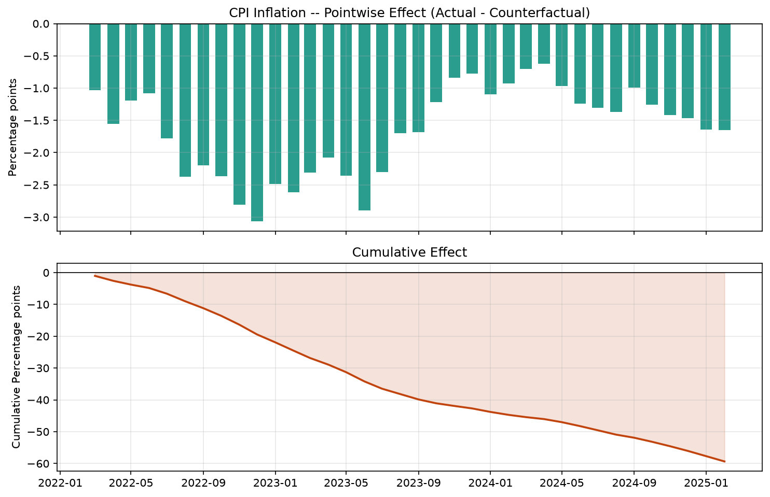
Figure 6. Pointwise and cumulative estimated effect of the policy on CPI inflation.

4.2 Output Outcome: Industrial Production Growth
Industrial production supplies a monthly activity measure, while GDP provides a broader quarterly comparison. The industrial-production growth gap averages -2.04 percentage points and sums to -73.57 percentage-point months. The gap is already -4.54 points in March 2022 and narrows to -0.61 points by February 2025 (0.81 percent observed versus 1.42 percent projected). The large initial discrepancy warrants checking model error and concurrent shocks before assigning it to the first rate increase.
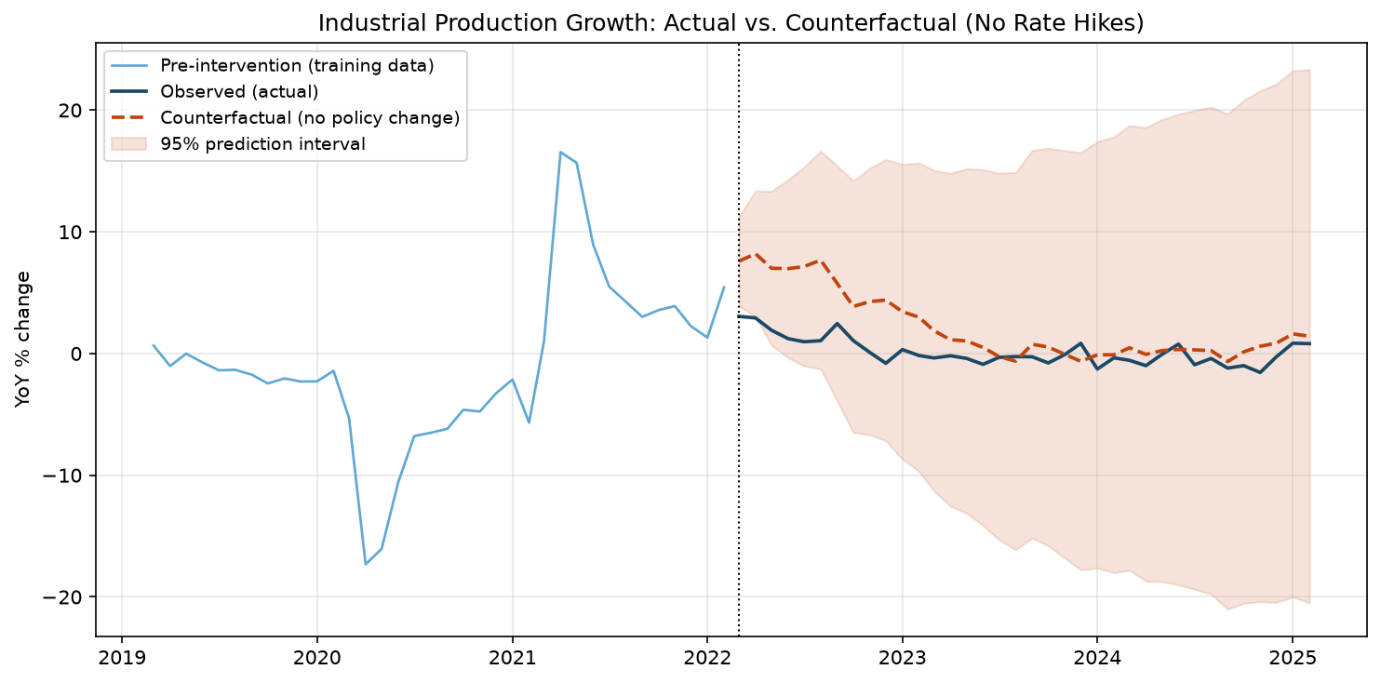
Figure 7. Industrial production growth: observed vs. counterfactual, with 95% prediction interval.
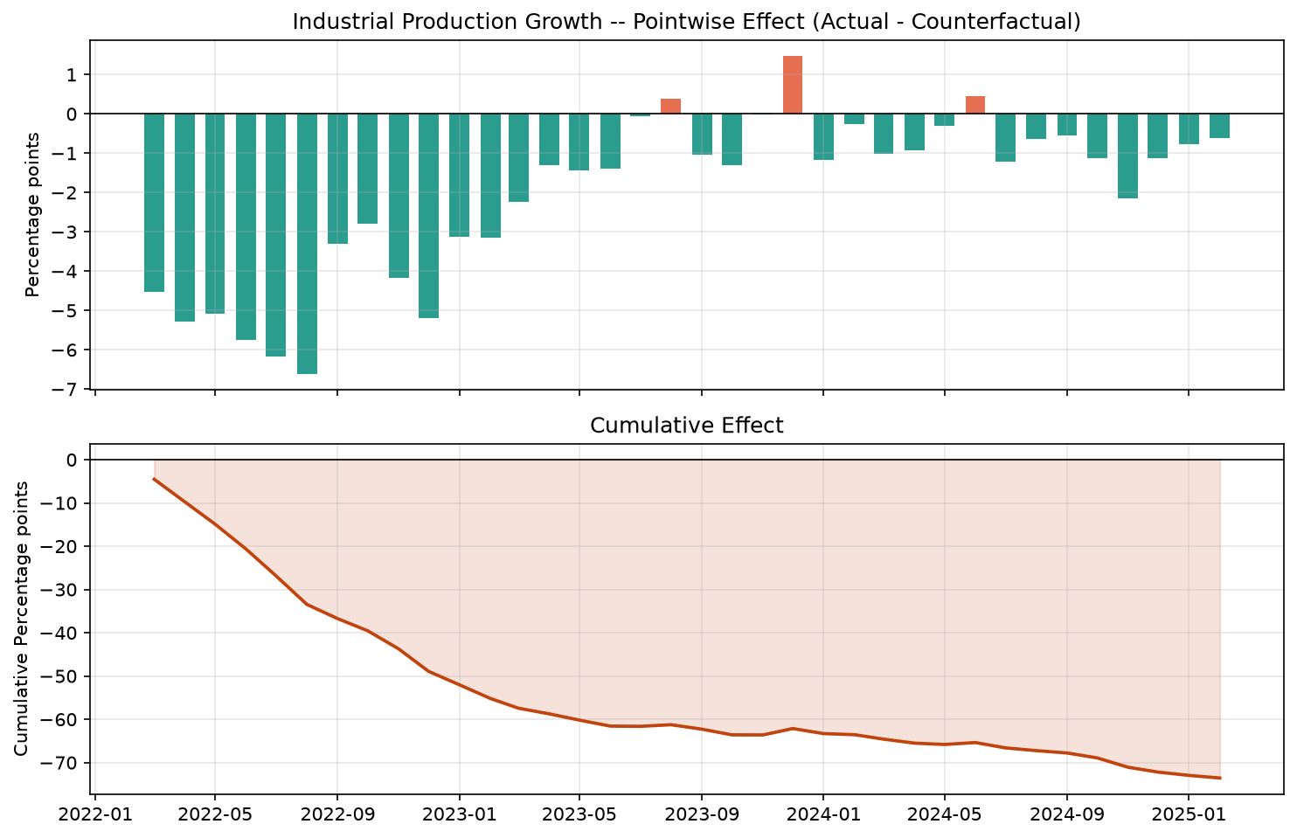
Figure 8. Pointwise and cumulative estimated effect of the policy on industrial production growth.

4.3 Robustness Checks
Three checks look at whether the headline result depends too heavily on modeling choices: swapping in an alternative outcome measure, dropping each control one at a time, and looking at two secondary outcomes.
Specification | Avg. monthly effect (pp) | Cumulative effect (pp-months)
CPI inflation (primary) | -1.65 | -59.35
PCE inflation (alt. outcome) | -1.35 | -48.53
Drop Euro area control | -1.7 | -61.31
Drop UK control | -1.36 | -48.82
Drop commodity-price control | -2.79 | -100.54
Unemployment rate | -0.5 | -17.97
Real GDP growth (YoY) | -0.06 | -2.25
The leave-one-control-out CPI estimates range from -1.36 to -2.79 percentage points, compared with the -1.65 baseline. The negative sign persists, but the magnitude is sensitive to control selection, particularly omission of commodity prices. The negative PCE estimate provides agreement across inflation measures under shared assumptions. Unemployment and GDP are secondary outcomes, rather than independent validation of the CPI result.
Methodological observations: The 12-month CPI backtest yields an RMSE of 1.24 percentage points and an MAE of 1.10. The model underpredicts inflation in 11 of the 12 months, indicating directional error during the 2021 acceleration. This is a material limitation of the baseline rather than evidence that the counterfactual has been validated causally. The model estimates average observed-minus-counterfactual gaps of -1.65 percentage points for CPI inflation and -2.04 for industrial production growth. The industrial-production gap is already -4.54 points in March 2022, which warrants checking anticipation, initial forecast error, and concurrent shocks before interpreting it as a response to the first hike. Dropping individual controls leaves the CPI estimate negative but moves it from -1.36 to -2.79 percentage points. Removing commodity prices produces the largest change from the -1.65 baseline. The sign is stable within these specifications; the magnitude is meaningfully sensitive to the control set. The prediction bands describe uncertainty within the fitted forecasting model. They do not account for every source of causal uncertainty, including contaminated controls and omitted shocks, and the single CPI backtest does not establish predictive reliability for the other outcomes.
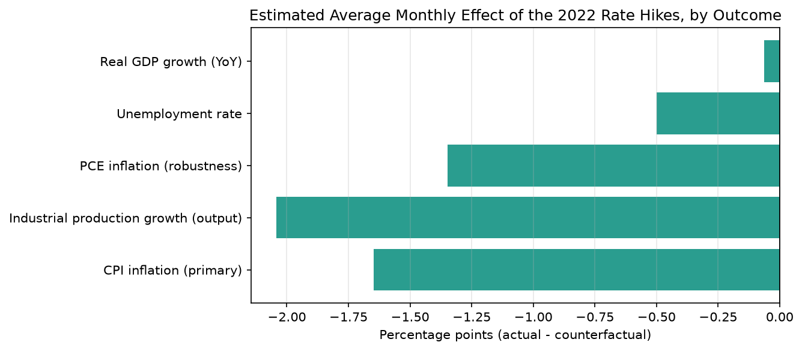
Figure 9. Estimated average monthly effect of the 2022 rate hikes, by outcome.
Observations: Across March 2022-February 2025, the average gaps are -1.65 percentage points for CPI inflation, -1.35 for PCE inflation, and -2.04 for industrial production growth. Both inflation measures support the same direction of departure from their projected paths, although they share the same modeling assumptions. The unemployment gap is -0.50 percentage points and the real GDP growth gap is -0.06. These estimates do not support a uniform deterioration across activity and labor-market outcomes. They also do not establish that tightening reduced unemployment or caused a soft landing. The summary chart displays point estimates without their uncertainty. Differences in bar length should therefore not be read as differences in statistical significance or as directly comparable welfare costs. The cumulative CPI gap of -59.35 percentage-point months sums monthly differences in annual inflation rates. It is neither a 59.35 percent reduction in the price level nor evidence of a compounding policy mechanism; recovering a price-level effect would require a separate calculation.

5. Analysis & Interpretation

5.1 Short-Term vs. Long-Term Implications
During the first 12 evaluation months, March 2022-February 2023, the CPI gap moves from -1.03 to -2.61 percentage points. This pattern is consistent with a delayed response, but the gap already present at intervention and the backtest's directional errors prevent the timing alone from identifying monetary transmission.
By February 2025, CPI inflation is 2.80 percent against a 4.46 percent counterfactual. The cumulative gap records accumulated differences over the window; it does not establish that the effect compounds or persists beyond the evaluation horizon. The industrial-production result suggests weaker activity relative to its baseline, while the near-zero average GDP gap and negative unemployment gap complicate a simple output-employment tradeoff.

5.2 Uncertainty, Limitations, and Assumptions
- The controls may be affected by U.S. spillovers and synchronized foreign tightening. Their resulting bias need not have a known direction; it should be assessed through sensitivity analysis rather than assumed to understate the policy effect.
- There is no random assignment here. As with any single country policy evaluation, it is impossible to fully rule out that some other shock the model does not capture happened to line up almost exactly with the intervention date.
- The local-level specification permits a changing latent level but retains fixed regression relationships. The directional errors in the CPI holdout indicate vulnerability during rapid changes. Predictive checks for the other outcomes are also needed.
- Aligning quarterly GDP to a monthly index repeats lower-frequency information. The near-zero average GDP gap cannot be attributed to smoothing alone without a separate comparison at the native quarterly frequency.
- The plotted intervals are conditional on the fitted state-space specification and observed controls. Observations inside a pointwise prediction band are compatible with that forecast at its stated nominal level; observations outside it indicate a discrepancy, not proof of a policy effect. Cumulative inference additionally requires the dependence between forecast errors. Model misspecification and uncertainty about identification remain outside these bands.

5.3 Final Insights and Recommendations from an AI Research Perspective
The empirical results motivate the following research conclusions and priorities. These recommendations distinguish what the current experiment demonstrates from extensions that remain to be tested.
- The central finding is a consistent negative inflation gap within the specifications examined: CPI inflation averages 1.65 percentage points below its counterfactual, and PCE inflation averages 1.35 points below. I interpret this as evidence consistent with a disinflationary contribution from tightening, conditional on the model's assumptions. The analysis does not independently identify how much of the decline was caused by the Federal Reserve.
- For an AI researcher, the main lesson is that predictive performance and causal identification require separate scrutiny. The local-level model is a transparent baseline for 194 training observations, but the 2021 backtest exposes persistent underprediction. Greater model capacity is worth considering only if it improves temporally held-out performance and calibration; no comparison in this project establishes that neural models would necessarily overfit or that the present model is optimal.
- Validation should be the first extension. I would use several rolling pre-intervention holdouts, report signed forecast error and interval coverage alongside RMSE, and repeat these checks for industrial production and the secondary outcomes. Placebo intervention dates would help reveal whether the procedure generates sustained gaps in other periods; their interpretation must account for serial dependence and other economic shocks.
- The next priority is sensitivity of the identifying assumptions. The CPI estimate changes from -1.36 to -2.79 percentage points when controls are removed, so donor selection deserves as much attention as the forecasting algorithm. A larger donor panel or regularized factor model could provide alternative baselines, but each donor still needs a defensible exposure assessment. Financial conditions may transmit monetary policy and should not be added mechanically as controls when estimating its total effect.
- Uncertainty should be assessed over complete forecast paths, including the dependence between monthly errors, before drawing conclusions about average or cumulative effects. Time-series conformal methods could be evaluated as a calibration extension, but standard conformal coverage does not automatically survive serial dependence or distribution shift. Likewise, double machine learning can address aspects of nuisance-function estimation under an appropriate causal design; it does not remove the need to justify identification or repair policy-affected controls by itself.
- For policy interpretation, the inflation results should be considered alongside the industrial-production, GDP, and unemployment estimates, which tell a less uniform story. This exercise does not estimate an optimal rate path or a welfare tradeoff. My recommendation is to use the counterfactual as one conditional diagnostic, strengthen validation and control sensitivity before extending the horizon, and preserve the raw-data snapshot and software environment so that revisions can be distinguished from methodological changes.

6. Conclusion

6.1 Summary of Findings
Over the 36-month evaluation window, observed CPI and PCE inflation lie below their model-based counterfactuals on average, alongside a negative industrial-production growth gap. The GDP and unemployment results show that the estimated pattern is not a uniform contraction across outcomes. The findings are consistent with disinflation following tightening, but their causal interpretation remains conditional on stable pre-policy relationships, credible controls, and the absence of unmodeled concurrent shocks.

6.2 Policy Relevance and Recommendations
The immediate research priority is to test the reliability of this interpretation through repeated temporal validation, placebo dates, and alternative control sets. Any policy discussion should retain the uncertainty around the estimates and distinguish an accumulated forecast gap from evidence of a lasting causal mechanism. The present design cannot determine how long interest rates should remain restrictive or isolate the effect of each decision within the tightening cycle.
Future work should prioritize repeated temporal validation and sensitivity to control exposure, then compare alternative counterfactual models under the same evaluation protocol. Extending the window requires checking missing control observations and data revisions. Preserve the input snapshot and software environment, and report changes in estimates alongside changes in data and specification.

References
Box, G. E. P., & Tiao, G. C. (1975). Intervention Analysis with Applications to Economic and Environmental Problems. Journal of the American Statistical Association, 70(349), 70-79.
Brodersen, K. H., Gallusser, F., Koehler, J., Remy, N., & Scott, S. L. (2015). Inferring causal impact using Bayesian structural time-series models. Annals of Applied Statistics, 9(1), 247-274.
Federal Reserve Economic Data (FRED), Federal Reserve Bank of St. Louis. https://fred.stlouisfed.org/
Chernozhukov et al. (2018). Double/debiased machine learning for treatment and structural parameters. The Econometrics Journal, 21(1), C1-C68. https://academic.oup.com/ectj/article/21/1/C1/5056401
Barber, Candes, Ramdas, and Tibshirani. Conformal prediction beyond exchangeability. https://arxiv.org/abs/2202.13415

