Predictive Modeling in Marketing Analytics
Predicting Campaign Conversion with Regularized Logistic Regression
Albert Kabore
PhD student in AI
October 1, 2026
Analysis of the assignment's example Marketing A/B Testing dataset: conversion prediction, regularization, and the trade-off between predictive performance and coefficient sparsity.

1. Introduction
Predicting conversion is a useful marketing problem, but a model can appear accurate simply by predicting that nobody will buy. This is a particular concern here: only about 2.52% of the supplied records have a positive conversion outcome. The analysis therefore examines both the models' ability to rank likely converters and the precision-recall trade-off at a chosen decision threshold.
The project compares logistic regression with L1 and L2 regularization against an unregularized model and a constant-probability baseline. The central research question is whether regularization produces a simpler model while retaining useful predictive performance. This question is assessed through cross-validation, test-set metrics, and the fitted coefficients, rather than assuming that a penalty must improve the results.
The analysis uses marketing_AB.csv from the Kaggle *Marketing A/B Testing* dataset explicitly listed as the assignment's example. Campaign exposure, timing, and group membership provide the predictors for a binary conversion outcome. This setting supports the assignment's central objective: assessing how regularization affects predictive performance and model interpretability.
Research questions. The analysis examines whether L1 or L2 improves discrimination and probability prediction relative to unregularized logistic regression, how much coefficient sparsity can be obtained, and how threshold choice changes precision and recall. These questions separate the predictive objective from the question of whether advertising causes purchases.

2. Data Collection
Source (faviovaz, n.d.). The file marketing_AB.csv was obtained from the *Marketing A/B Testing* dataset published by *faviovaz* on Kaggle: https://www.kaggle.com/datasets/faviovaz/marketing-ab-testing. This is the dataset used in this project. The publisher describes user-level advertising/PSA records. The local audit verifies unique user identifiers.
Column | Type | Description
user id | int | Unique user identifier
test group | categorical | ad = saw product advertisements; psa = saw a public-service announcement (control)
converted | bool | Target — whether the user bought the product
total ads | int | Number of ads the user saw (purchase-funnel exposure / engagement history)
most ads day | categorical | Day of week on which the user saw the most ads
most ads hour | int 0–23 | Hour of day at which the user saw the most ads

Dataset selection. This is the example dataset named in the assignment, and Albert Kabore confirmed obtaining the file from the cited Kaggle page. Its predictors describe campaign exposure and timing rather than demographics or purchase history. The analysis therefore focuses on predicting campaign conversion using the available fields. The local file contains 588,101 records, each with a unique user identifier, and its SHA-256 hash is retained for reproducibility.
The local file contains 588,101 records and seven columns. The additional column Unnamed: 0 is a saved row index, not a customer attribute.
Data-quality findings. The audit finds no missing values, duplicate rows, or duplicate user identifiers. Unnamed: 0 matches the saved row index. Both index and user ID are excluded from the predictors because they are identifiers rather than substantive customer characteristics. The exposure count is highly skewed, with a median of 13 and a maximum of 2,065. This motivates considering a logarithmic term alongside the raw count.
Recorded group | Records | Conversions | Conversion rate
ad | 564,577 | 14,423 | 2.555%
psa | 23,524 | 420 | 1.785%

Data profile. Counts and conversion rates computed directly from the supplied CSV.
Each record represents a uniquely identified user. The target records conversion, while the predictors describe exposure volume, most-active day and hour, and ad-versus-PSA group membership. These variables support analysis of class balance, exposure patterns, timing differences, and conditional conversion prediction.
Exposure statistic | Total ads
Minimum | 1
25th percentile | 4.0
Median | 13.0
Mean | 24.82
75th percentile | 27.0
Maximum | 2,065

Mean exposure is 24.82 ads compared with a median of 13. Together with the large maximum, this indicates a right-skewed distribution. The log transform reduces the numerical influence of the upper tail while the retained raw term allows the fitted curve to change shape.

Observations from the supplied data
- Conversion is uncommon. The file contains 14,843 conversions among 588,101 records, a rate of 2.52%. A classifier that predicts no conversions would be about 97.5% accurate, so accuracy alone would give an incomplete account of performance.
- Exposure and conversion are associated. The observed conversion rate increases from about 0.19% in the lowest exposure group (1-2 ads) to 14.3% in the highest (58 or more ads). These quantile-based groups are not necessarily equal in size because many records share the same exposure count.
- Timing groups differ. Monday and Tuesday have conversion rates of about 3.28% and 2.98%, compared with 2.11% on Saturday. The rate at 2 a.m. is approximately 0.73%. These differences motivate including day and hour as categorical predictors.
- The ad group has a higher observed rate. Conversion is approximately 2.55% in the ad group and 1.79% in the PSA group. The difference is about 0.769 percentage points, or 43.1% relative to the PSA rate. Group membership is therefore included alongside exposure and timing in the predictive model.
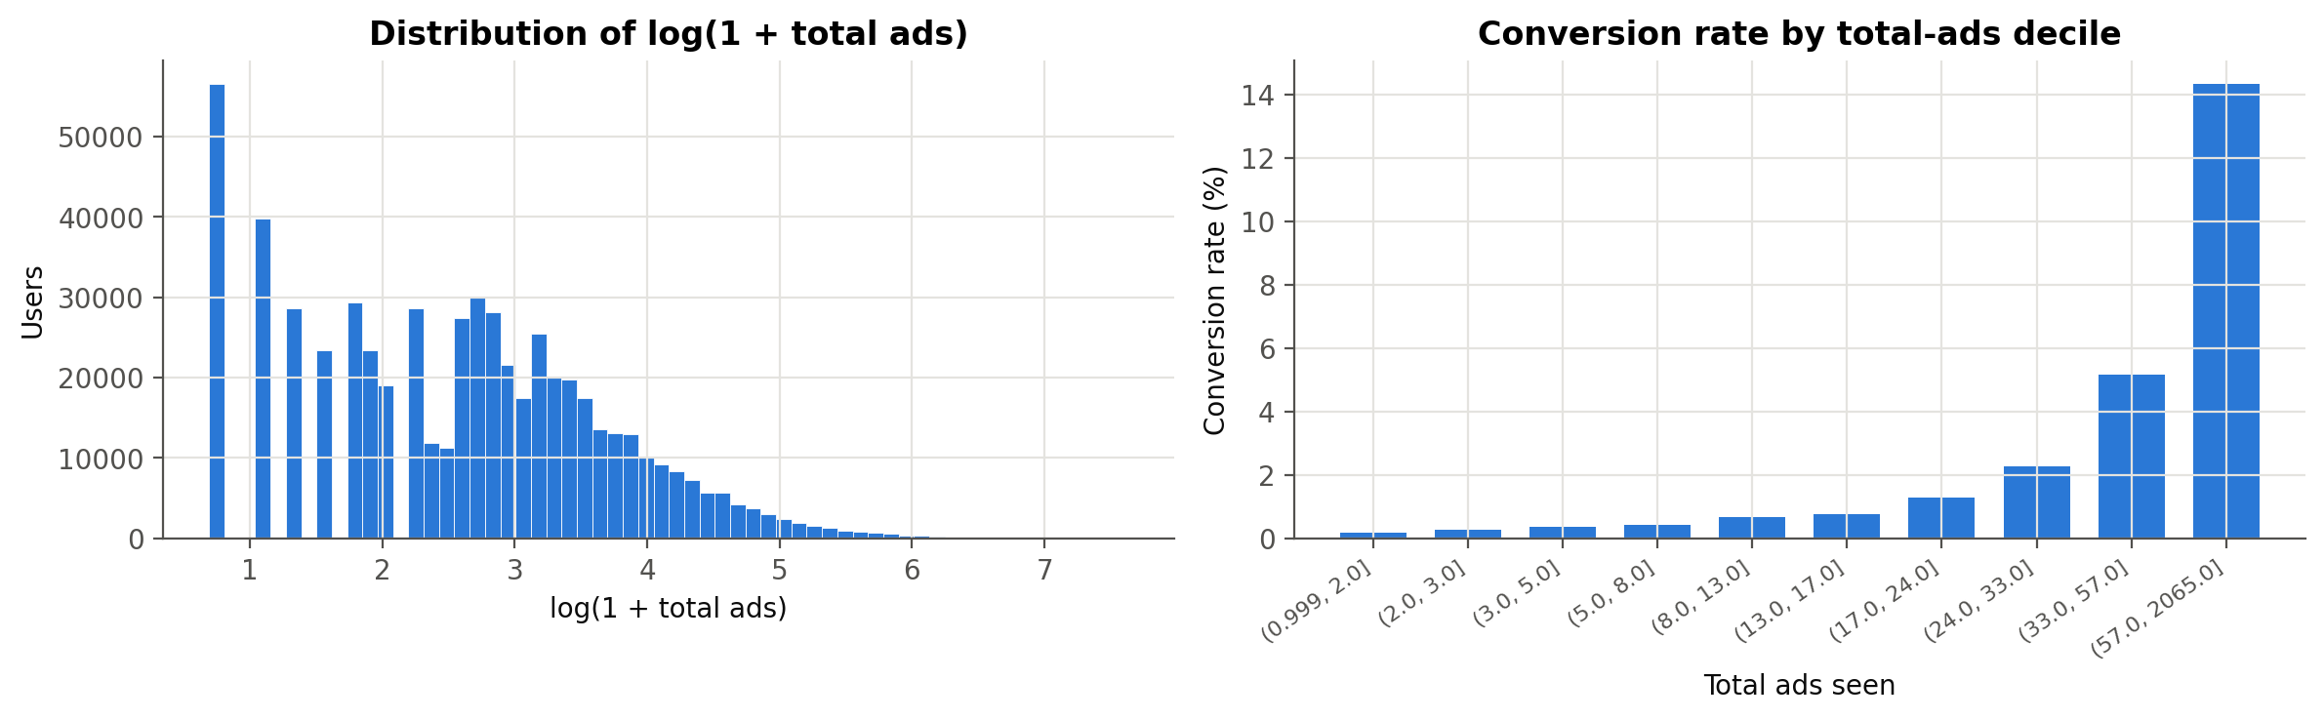
Figure 1. Exposure distribution and observed conversion rates by quantile-based exposure group.
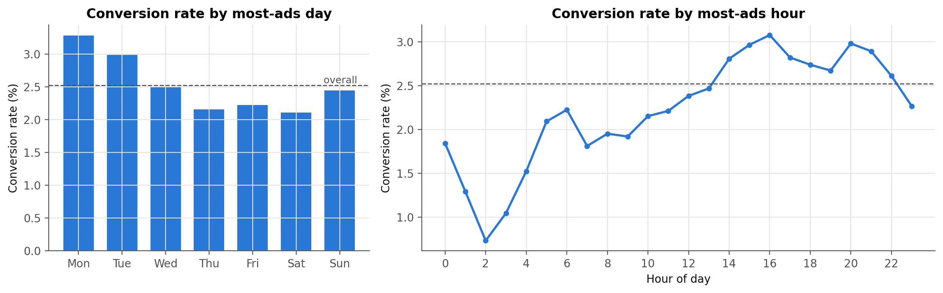
Figure 2. Observed conversion rates by most-ads day and hour.
Day | Records | Conversions | Conversion rate
Monday | 87,073 | 2,857 | 3.28%
Tuesday | 77,479 | 2,312 | 2.98%
Wednesday | 80,908 | 2,018 | 2.49%
Thursday | 82,982 | 1,790 | 2.16%
Friday | 92,608 | 2,057 | 2.22%
Saturday | 81,660 | 1,719 | 2.11%
Sunday | 85,391 | 2,090 | 2.45%

Day-level rates summarize variation across timing groups. Categorical encoding preserves this flexibility without imposing an ordered Monday-to-Sunday effect. The same reasoning applies to hour, for which a single linear coefficient would assume a constant change between successive clock hours.

3. Data Preprocessing
Step | Treatment | Rationale
Identifiers | Drop Unnamed: 0, user id | Exclude identifiers to reduce spurious fitting
Missing values | SimpleImputer — median (numeric), most-frequent (categorical) inside the pipeline | The supplied file has no missing values. Imputers are fitted inside CV using each training fold
Skew | log_total_ads = log1p(total_ads) | Compresses a 1–2,065 range; permits a nonlinear association with exposure
Treatment flag | is_ad = 1 if test_group == "ad" | Binary encoding of the A/B arm
Raw total_ads | Kept alongside its log | Deliberately correlated pair → shows how Lasso vs Ridge handle redundant features
Categoricals | One-hot encode most_ads_day (7 levels) and most_ads_hour (24 levels, treated as categorical because the hour effect is non-monotonic). Regularized models keep all levels (full one-hot); the unregularized baseline drops the first level (reference coding) | A linear model needs numeric inputs. Without a penalty, a full set of dummies is perfectly collinear with the intercept, so reference coding is used here. Full encoding avoids choosing a reference category for the penalty. L2 can yield unique penalized coefficients; L1 coefficient uniqueness is not guaranteed with redundant columns. Interpret category contrasts rather than individual dummy coefficients.
Scaling | StandardScaler on the numeric features and, for the regularized models, on the one-hot dummies too | Penalty scaling. The L1/L2 penalty acts on raw coefficient size, so standardization is used here to define the relative penalty weighting. Standardizing the dummies also centres them, which changes the penalty weighting across category frequencies. This permits coefficient comparison on standardized input scales.

Order of operations. Identifiers are removed before fitting. The log exposure term and binary ad-group flag are deterministic row-wise transformations; they do not estimate population parameters. Fitted preprocessing is then carried out separately within each training fold. A scaler estimates the training mean and standard deviation and applies those same values to the validation fold. The same principle applies to imputation statistics and one-hot categories. This prevents fitted preprocessing from using validation records, although it does not undo the earlier use of the full dataset for exploratory feature decisions.
Missing values. The audit found no missing entries, so no observed values required imputation. Median imputation for numeric inputs and most-frequent imputation for categorical inputs remain part of the fitted pipeline. handle_unknown="ignore" allows the encoder to process unfamiliar category labels. Raw-input validation would still be required when scoring new data.
The regularized design matrix contains 34 encoded predictors: three numeric terms, seven day indicators, and 24 hour indicators. Reference coding gives 32 predictors for unregularized logistic regression. This difference follows from retaining all categorical levels in penalized models and dropping one level per categorical variable in the unregularized comparison.

4. Model Selection & Regularization
Logistic regression is used because the target is binary and the fitted model provides both probability estimates and a coefficient-based representation of its predictions. These probabilities are not assumed to be calibrated; that would require a separate assessment.
Regularization adds a coefficient penalty to the logistic loss. An L1 penalty uses the sum of absolute coefficient values and can set coefficients exactly to zero. An L2 penalty uses squared coefficient values and generally shrinks coefficients without producing a sparse solution. In the scikit-learn implementation used here, smaller C means stronger regularization (scikit-learn, n.d.-b).
Model | Purpose
Constant-probability baseline | Predict the training conversion rate for every record; at 0.50, predict the majority class
Unregularized logistic regression | Provide a comparison without a coefficient penalty
L2-regularized logistic regression (Ridge) | Tune the amount of shrinkage by cross-validation
L1-regularized logistic regression (Lasso) | Evaluate shrinkage and selection of encoded predictors
L1 with the one-standard-error rule | Select the smallest eligible C for a sparser candidate

Lasso and Ridge refer here to penalties within logistic regression, not to least-squares regression estimators. The L1 models use liblinear; L2 and unregularized models use lbfgs. liblinear also penalizes its synthetic intercept feature. Setting intercept_scaling=100 reduces that penalty but does not remove it (scikit-learn, n.d.-b). Because solver, intercept treatment, and categorical encoding differ, this comparison does not isolate the penalty as the only implementation difference.
Statistical formulation. If z is the intercept plus the weighted sum of the transformed inputs, logistic regression estimates conversion probability as 1 / (1 + exp(-z)). Training minimizes binary cross-entropy with an optional coefficient penalty. L1 penalizes the sum of absolute weights; L2 penalizes half the sum of squared weights in the summed-loss convention used to describe this comparison. A penalty can reduce sensitivity to the training sample, but it also introduces shrinkage bias. Its usefulness must therefore be judged using validation results rather than presumed from the model name.
Implementation choices. The analysis uses scikit-learn (Pedregosa et al., 2011). No oversampling, synthetic examples, or class weights are used. Instead, stratification preserves the rare positive class in the splits, and training-only threshold selection addresses the all-negative predictions at 0.50. The L1 iteration limit is 3,000, the L2 limit is 2,000, and the unregularized limit is 5,000. These are solver limits, not the number of iterations necessarily taken.

5. Training & Hyperparameter Tuning
An 80/20 stratified split is used with random_state=42, giving 470,480 training records and 117,621 test records. Hyperparameters are selected using five shuffled, stratified folds within the training set. Each fold refits the imputer, encoder, and scaler as part of the model pipeline.
The search evaluates 11 logarithmically spaced C values from 0.0001 to 10 for each penalty. Mean validation ROC-AUC determines the selected model; validation log-loss is also recorded. After selection, each candidate is fitted on the full training set.
For the sparse L1 candidate, the selected value is the smallest C whose mean validation AUC is no more than one estimated standard error below the best mean. The estimate is the best candidate's fold standard deviation divided by the square root of five. This is a selection heuristic, not a test that the candidates are statistically equivalent.
Selection and reproducibility. Each penalty's search evaluates 11 candidates over five folds, or 55 candidate-fold fits, followed by refitting the selected candidate. ROC-AUC is the refit criterion; log-loss does not determine which C wins. Threshold tuning subsequently generates out-of-fold probabilities for each fixed logistic candidate, computes precision and recall over candidate thresholds, and selects the threshold with the largest training F1. Test labels are used only for reported test metrics at this stage.
The same random seed is used for the stratified split, shuffled folds, and L1 solver. Package versions and the dataset hash are recorded with the results. These records support reproduction of the present run; they do not guarantee identical floating-point coefficients across every operating system or software version.
C | L1 CV AUC | L2 CV AUC | L1 log-loss | L2 log-loss
0.0001 | 0.85339 | 0.85607 | 0.11046 | 0.10134
0.00031623 | 0.85339 | 0.85621 | 0.09775 | 0.09739
0.001 | 0.85366 | 0.85664 | 0.09579 | 0.09495
0.0031623 | 0.85589 | 0.85693 | 0.09434 | 0.09410
0.01 | 0.85695 | 0.85702 | 0.09393 | 0.09391
0.031623 | 0.85704 | 0.85702 | 0.09388 | 0.09388
0.1 | 0.85703 | 0.85702 | 0.09387 | 0.09387
0.31623 | 0.85702 | 0.85701 | 0.09387 | 0.09387
1 | 0.85701 | 0.85701 | 0.09387 | 0.09387
3.1623 | 0.85701 | 0.85701 | 0.09387 | 0.09387
10 | 0.85701 | 0.85701 | 0.09387 | 0.09387

Observations from cross-validation
- Both penalties select C of approximately 0.0316, with mean validation ROC-AUC near 0.857.
- The one-standard-error rule selects approximately 0.00316 for L1, giving a stronger penalty than the best-score candidate.
- The plotted scores vary little across the weaker penalties. This supports examining a simpler candidate, but it does not establish that regularization has no effect or that the models will perform equally on new data.
- The shaded bands show fold standard deviations. They are not confidence intervals for differences between models.
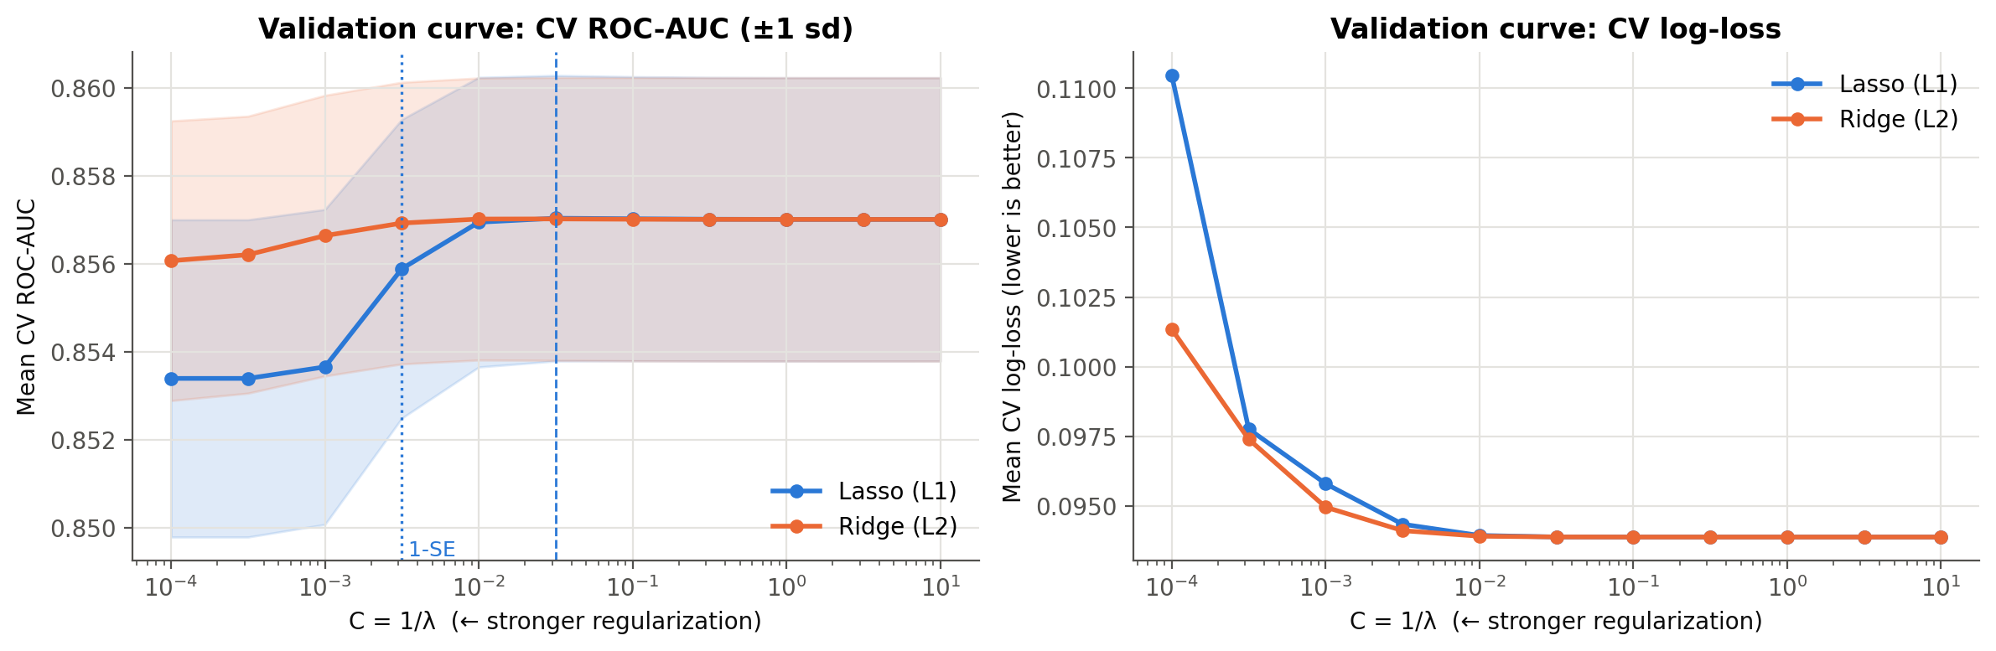
Figure 3. Cross-validation results; shaded bands represent fold standard deviations.

6. Evaluation
Several metrics are reported because no single score captures both ranking quality and the consequences of a classification threshold.
- ROC-AUC measures discrimination across thresholds.
- Average precision (AP) summarizes precision-recall performance. It differs from trapezoidal precision-recall area (scikit-learn, n.d.-a). The saved field pr_auc contains AP, and a constant-score model has AP equal to test prevalence.
- Accuracy, precision, recall, and F1 describe predictions at a specified threshold.
- Log-loss and Brier score assess probability predictions; neither alone establishes calibration.
- Top-decile capture measures the share of recorded converters among the highest-scored approximately 10% of test records. It measures retrospective ranking, not additional conversions caused by targeting.
For each logistic model, the threshold that maximizes F1 on out-of-fold training predictions is selected and compared with 0.50. The baseline is reported at 0.50 only. F1 is useful for this comparison, but a deployment threshold would need to reflect campaign costs, conversion value, and operational capacity.
Why these metrics are complementary. Precision is TP / (TP + FP), recall is TP / (TP + FN), and F1 is their harmonic mean. ROC-AUC measures ranking across positive-negative pairs, whereas precision-recall analysis makes the false-positive burden more visible when positive outcomes are uncommon (Saito & Rehmsmeier, 2015). AP is reported alongside ROC-AUC for that reason. Lower log-loss and Brier scores indicate better probability predictions under those scoring rules. A calibration plot would still be needed to examine whether stated probabilities match observed frequencies across risk groups.
Model | Threshold | Accuracy | Precision | Recall | F1
Majority baseline | 0.5000 | 0.9748 | 0.0000 | 0.0000 | 0.0000
Unregularized LR | 0.1105 | 0.9378 | 0.1726 | 0.3860 | 0.2385
Ridge (L2) | 0.1069 | 0.9359 | 0.1714 | 0.4015 | 0.2403
Lasso (L1) | 0.1064 | 0.9355 | 0.1709 | 0.4042 | 0.2402
Lasso (L1, 1-SE) | 0.0956 | 0.9311 | 0.1640 | 0.4217 | 0.2361

Table 1. Test classification metrics at training-selected F1 thresholds for logistic models; the baseline uses 0.50. Scores apply to 117,621 test records.
Model | ROC-AUC | AP | Log-loss | Brier | Top 10% capture
Majority baseline | 0.5000 | 0.0252 | 0.11779 | 0.02460 | 10.00%
Unregularized LR | 0.8600 | 0.1420 | 0.09351 | 0.02274 | 57.83%
Ridge (L2) | 0.8600 | 0.1422 | 0.09350 | 0.02274 | 57.97%
Lasso (L1) | 0.8601 | 0.1420 | 0.09349 | 0.02274 | 58.00%
Lasso (L1, 1-SE) | 0.8601 | 0.1378 | 0.09375 | 0.02281 | 57.66%

Table 2. Ranking and probability metrics. Baseline top-decile capture is the expectation under random tie-breaking.

Observations from model evaluation
- The models rank converters better than the constant baseline. Tuned L1 achieves test ROC-AUC 0.8601 and AP 0.1420, compared with 0.5000 and approximately 0.0252 for the baseline.
- Threshold choice changes the practical result. At its training-selected threshold of 0.1064, tuned L1 has precision 17.09%, recall 40.42%, and F1 0.2402. It identifies more converters than at 0.50, but most positive predictions still correspond to non-conversions.
- High accuracy is not sufficient here. At 0.50, all fitted models have zero recall on the test set despite accuracy of about 97.48%.
- The sparse model involves a measurable trade-off. The 1-SE L1 fit retains 22 of 34 encoded coefficients. Its ROC-AUC rounds to 0.8601, while AP falls to 0.1378 from 0.1420 for tuned L1. Similar AUC therefore does not mean identical performance.
- The ranking is concentrated. The highest-scored approximately 10% of records contain 58.00% of observed test conversions for tuned L1. This corresponds to about 5.8 times the converter concentration expected from random selection.

6.1 Classification errors and practical meaning
Outcome at tuned L1 threshold | Count
True positives | 1,200
False positives | 5,823
False negatives | 1,769
True negatives | 108,829

Among 2,969 test converters, the tuned L1 rule identifies 1,200 and misses 1,769. It also assigns a positive prediction to 5,823 non-converters. These counts explain why an AUC near 0.86 does not imply high precision at a particular operating point. Whether this error balance is acceptable depends on the intended use; no campaign cost or profit data are available to answer that question.

6.2 Comparing predictive scores
Relative to unregularized logistic regression, tuned L1 changes ROC-AUC by +0.000125, AP by +0.000015, and log-loss by -0.000022. The predictive change is small on this split. The main contrast is therefore how the penalties alter coefficient selection while retaining similar ranking scores.
The sparse 1-SE model changes AP by -0.004195, log-loss by +0.000258, and Brier score by +0.000074 relative to tuned L1. Its simpler coefficient representation therefore accompanies worse point estimates for these metrics, even though its ROC-AUC is slightly higher. The preferred candidate depends on the metric that matches the task.
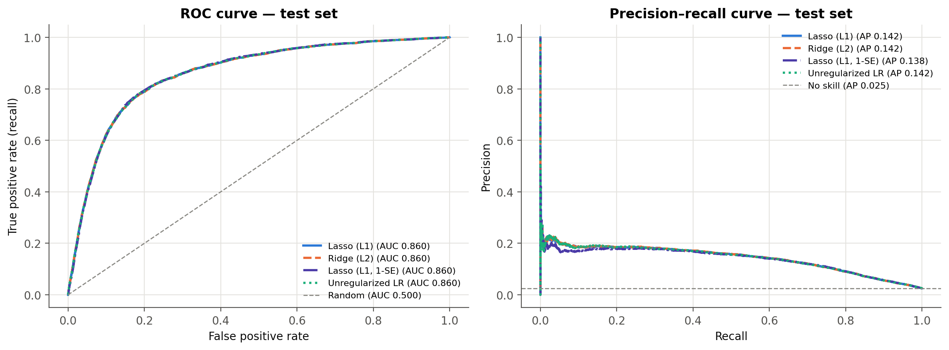
Figure 4. ROC and precision-recall curves for the test split.
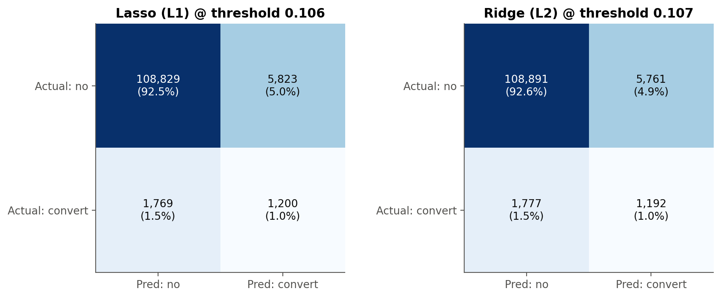
Figure 5. Confusion matrices at the training-selected thresholds.
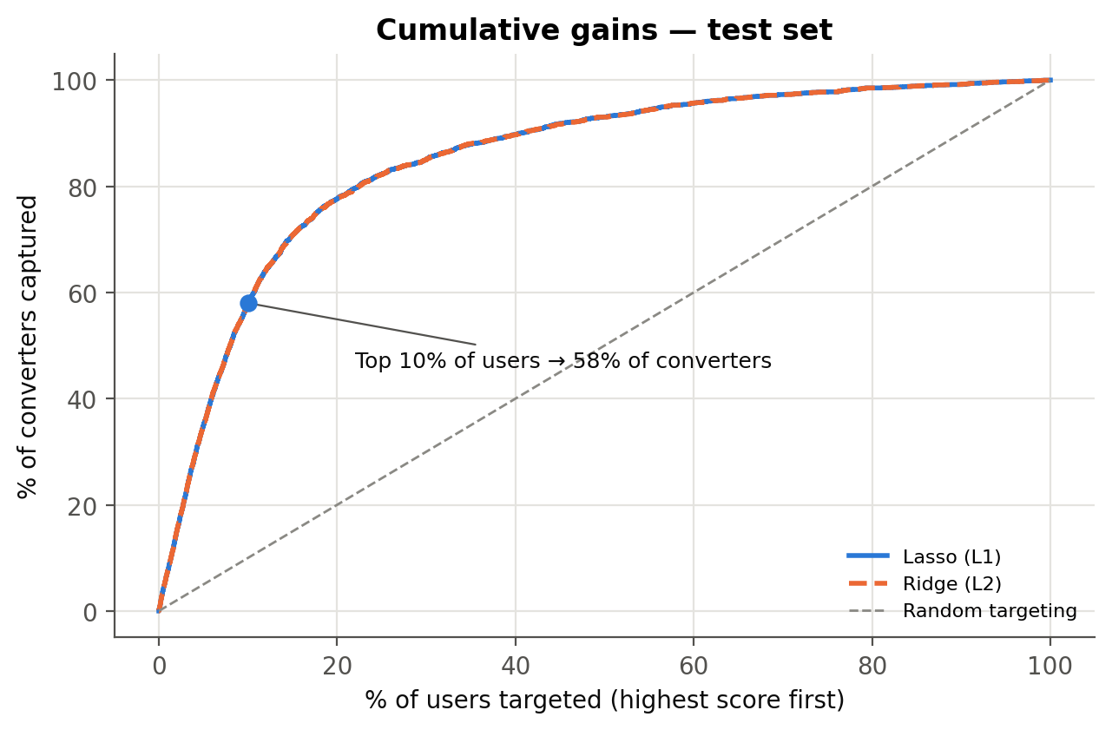
Figure 6. Cumulative share of test converters captured by the score ranking.

7. Interpretation
Encoded predictor | Ridge | Lasso | Lasso 1-SE
log_total_ads | 1.9597 | 1.9582 | 1.7823
total_ads | -0.2707 | -0.2709 | -0.2049
most_ads_hour_02 | -0.1263 | -0.1215 | -0.0575
most_ads_day_Monday | 0.1014 | 0.1163 | 0.0950
most_ads_hour_16 | 0.0870 | 0.0729 | 0.0578
is_ad | 0.0815 | 0.0781 | 0.0452
most_ads_day_Tuesday | 0.0792 | 0.0917 | 0.0682
most_ads_hour_01 | -0.0754 | -0.0744 | -0.0307
most_ads_day_Saturday | -0.0749 | -0.0569 | -0.0338
most_ads_day_Friday | -0.0693 | -0.0504 | -0.0282
most_ads_hour_07 | -0.0609 | -0.0624 | -0.0285
most_ads_hour_09 | -0.0549 | -0.0624 | -0.0244

Table 3. Twelve largest absolute Ridge coefficients, with corresponding L1 coefficients. This ordering describes coefficient magnitude, not validated feature importance. The full table is in results/coefficients.csv.
Observations from the coefficient comparison
- Exposure contributes the largest standardized coefficients. Tuned L1 assigns approximately +1.9582 to log exposure and -0.2709 to raw exposure. Retaining both terms permits a nonlinear fitted relationship between the exposure count and conversion.
- Timing contributes additional terms. For tuned L1, the standardized Monday coefficient is approximately +0.1163, hour 16 is +0.0729, and hour 02 is -0.1215. These describe the encoded model; comparisons between two categories require adjustment for the corresponding scaling factors.
- L1 creates a simpler representation. Ridge retains 34 nonzero coefficients, tuned L1 retains 32, and the 1-SE L1 model retains 22. Relative to Ridge, the sparse candidate removes 12 encoded terms, a 35.3% reduction.
- The trade-off is visible in the scores. The sparse candidate retains a ROC-AUC near 0.860 but has AP 0.1378, compared with 0.1420 for tuned L1. Coefficient sparsity and prediction quality should therefore be evaluated together.
- Interpretability depends on the encoding. Zero coefficients identify terms excluded by the fitted penalty, not statistically insignificant variables. The retained day and hour indicators still represent the original timing variables.
The main interpretive benefit is a smaller set of nonzero terms that can be inspected alongside the model's predictions. The exposure terms, selected timing categories, and ad-group indicator remain explicit, making the model's structure easier to examine than an undifferentiated performance score.

7.1 Worked coefficient contrasts
For tuned L1, the standardized is_ad coefficient is 0.0781. Dividing by its training standard deviation gives a fitted ad-versus-PSA log-odds contrast of 0.3993, or an odds ratio of 1.491, with the modeled exposure and timing inputs held fixed. This is an adjusted model association; it is not an estimated causal effect of assignment.
For an illustrative comparison of 10 versus 20 recorded ads, changing the raw and log inputs together gives a fitted log-odds difference of 1.0353, or an odds ratio of 2.816, with the remaining inputs fixed. This algebraic contrast combines both exposure coefficients and illustrates how to interpret the fitted curve. It compares odds rather than conversion probabilities.

7.2 What the sparse model removes
The encoded terms set to zero by the 1-SE L1 fit are: most_ads_hour_22, most_ads_day_Thursday, most_ads_hour_04, most_ads_hour_20, most_ads_hour_00, most_ads_hour_21, most_ads_hour_23, most_ads_hour_18, most_ads_day_Sunday, most_ads_day_Wednesday, most_ads_hour_19, most_ads_hour_13.
Its coefficient L1 norm is 0.690 times that of the least-penalized L1 fit at C = 10 on the same encoded design. This quantifies the shrinkage in total absolute coefficient size within the same parameterization, complementing the count of retained terms.

7. Regularization Paths
The following plots show how the fitted coefficients change across the specified penalty grid. They make L1's sparsity visible and allow comparison with L2 shrinkage. The order in which a coefficient becomes nonzero depends on scaling, correlated predictors, and the fitted sample; it is not treated as an independent ranking of feature importance.
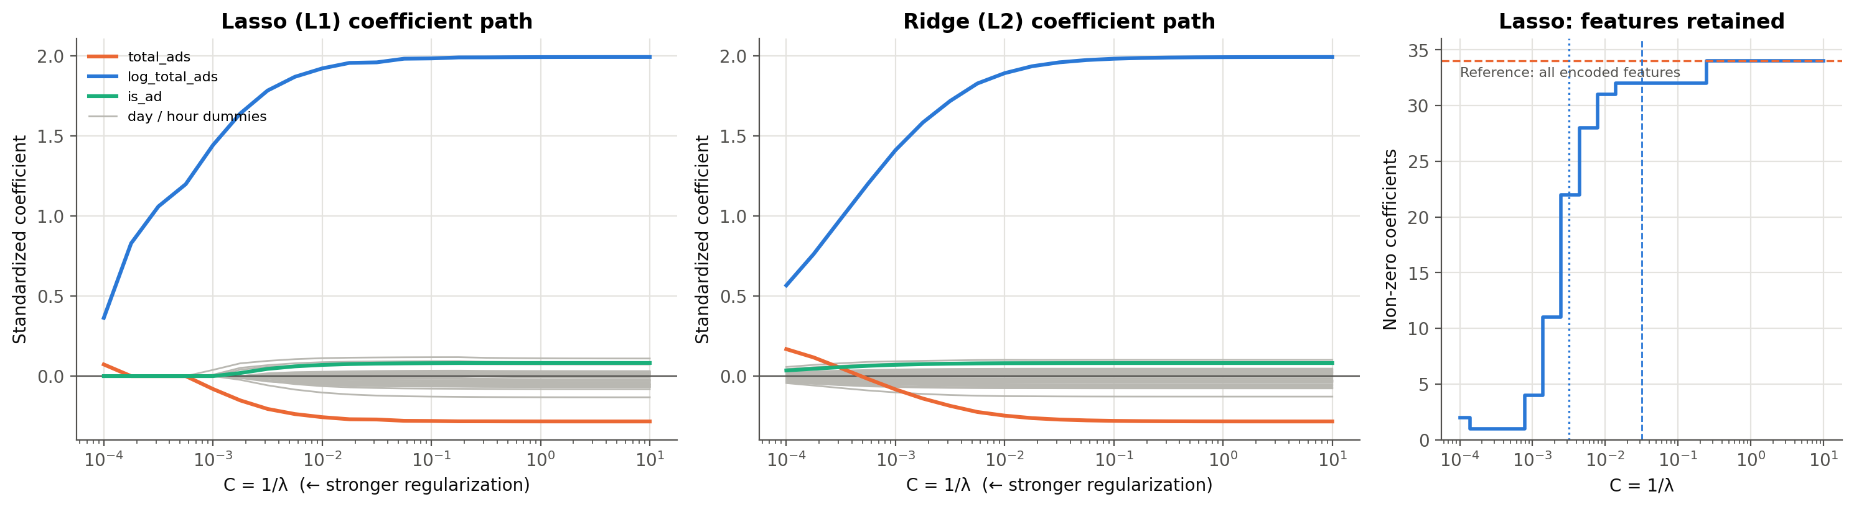
Figure 7. Coefficient paths and the number of nonzero L1 terms across the penalty grid.

8. Conclusion

Final Insight
- Regularized logistic regression separates likely converters from non-converters in this dataset: tuned L1 achieves ROC-AUC 0.8601 and AP 0.1420.
- Threshold selection has a substantial practical effect. At 0.1064, tuned L1 identifies 40.42% of test converters with precision of 17.09%, whereas the 0.50 threshold identifies none.
- The clearest contribution of stronger L1 regularization is sparsity. The 1-SE candidate retains 22 of 34 terms, with similar ROC-AUC but lower AP. Regularization therefore offers a choice between a shorter coefficient representation and stronger precision-recall performance.

Recommendations
- Retain tuned L1 and Ridge as predictive benchmarks. Ridge has the highest AP among the tested candidates, while tuned L1 removes two coefficients and produces very similar classification performance.
- Use the 1-SE L1 candidate when fewer nonzero terms are valuable, with explicit acceptance of its lower AP and slightly worse probability scores in this evaluation.
- Select the operating threshold according to the desired precision-recall balance, contact capacity, and measured campaign economics. The F1-selected threshold provides a documented starting point for comparison.
- Assess the score ranking at several contact-budget levels. The top approximately 10% already contain 58% of observed test converters for tuned L1.
- Extend the comparison with Elastic Net or nonlinear exposure terms, and assess probability calibration and performance on a new campaign before operational use. These are proposed next steps, not completed experiments.

Concluding Discussion
The project applies the full modeling workflow to the assignment's example marketing dataset: data inspection, preprocessing, logistic-regression model selection, regularization tuning, evaluation, and coefficient interpretation. Five-fold cross-validation selects C of approximately 0.0316 for both L1 and L2. Both produce test ROC-AUC near 0.860, with small score differences relative to unregularized logistic regression.
Stronger L1 regularization reduces the number of nonzero coefficients from 34 to 22 while preserving a similar ROC-AUC point estimate. Its lower AP shows that simplification still has a measurable cost. The main finding is therefore a concrete sparsity-performance trade-off, accompanied by a clear demonstration of why threshold selection matters for an imbalanced marketing outcome.
Scope of inference. These results describe predictive associations within the supplied campaign records. Exposure timing and the original assignment protocol were not independently verified; full-data exploration informed feature choices, and hyperparameter and threshold selection reused training folds. The evaluation is therefore exploratory internal validation, with no formal uncertainty intervals or external campaign test. These qualifications concern interpretation and future use, not the suitability of the explicitly provided example dataset for this modeling exercise.

9. References
faviovaz. (n.d.). Marketing A/B testing [Data set]. Kaggle. https://www.kaggle.com/datasets/faviovaz/marketing-ab-testing
Joblib. (n.d.). Joblib documentation. Retrieved October 1, 2026, from https://joblib.readthedocs.io/en/stable/
Matplotlib. (n.d.). Matplotlib documentation. Retrieved October 1, 2026, from https://matplotlib.org/stable/
NumPy. (n.d.). NumPy documentation. Retrieved October 1, 2026, from https://numpy.org/doc/
pandas. (n.d.). pandas documentation. Retrieved October 1, 2026, from https://pandas.pydata.org/docs/
Pedregosa, F., Varoquaux, G., Gramfort, A., Michel, V., Thirion, B., Grisel, O., Blondel, M., Prettenhofer, P., Weiss, R., Dubourg, V., Vanderplas, J., Passos, A., Cournapeau, D., Brucher, M., Perrot, M., & Duchesnay, E. (2011). Scikit-learn: Machine learning in Python. Journal of Machine Learning Research, 12, 2825–2830. https://www.jmlr.org/papers/v12/pedregosa11a.html
Project Jupyter. (n.d.). Project Jupyter documentation. Retrieved October 1, 2026, from https://docs.jupyter.org/en/latest/
python-docx. (n.d.). python-docx documentation. Retrieved October 1, 2026, from https://python-docx.readthedocs.io/en/latest/
Python Software Foundation. (n.d.). Python 3.11 documentation. Retrieved October 1, 2026, from https://docs.python.org/3.11/index.html
Saito, T., & Rehmsmeier, M. (2015). The precision-recall plot is more informative than the ROC plot when evaluating binary classifiers on imbalanced datasets. PLOS ONE, 10(3), Article e0118432. https://doi.org/10.1371/journal.pone.0118432
scikit-learn. (n.d.-a). average_precision_score. In Scikit-learn 1.7 documentation. https://scikit-learn.org/1.7/modules/generated/sklearn.metrics.average_precision_score.html
scikit-learn. (n.d.-b). LogisticRegression. In Scikit-learn 1.7 documentation. https://scikit-learn.org/1.7/modules/generated/sklearn.linear_model.LogisticRegression.html
Source note. Peer-reviewed articles support the software and evaluation discussion; official documentation supports implementation details. The dataset reference identifies the Kaggle example specified in the assignment. Undated documentation is cited as n.d.; release years have not been inferred from copyright notices.

Reproducibility record
The computational workflow uses Python (Python Software Foundation, n.d.), pandas (pandas, n.d.), NumPy (NumPy, n.d.), scikit-learn (Pedregosa et al., 2011), Matplotlib (Matplotlib, n.d.), Jupyter (Project Jupyter, n.d.), and Joblib (Joblib, n.d.). The written document is generated with python-docx (python-docx, n.d.).
Recorded analysis versions: pandas 2.3.2; numpy 2.3.2; scikit-learn 1.7.2; matplotlib 3.9.2; joblib 1.5.2; nbformat 5.10.4; nbclient 0.10.2; ipykernel 7.0.1.
Dataset SHA-256: de6ce8def1a6559e9e5ab364fce07cfe2e84f02dd407c3586eea55743c7e17f2

