Predictive Modeling in Marketing Analytics
Predicting Campaign Conversion with Regularized Logistic Regression
Albert Kabore
PhD student in AI
October 1, 2026
Scope: computational analysis of the supplied marketing records. The data-collection requirement is only partially met because demographics and purchase history are absent. Original empirical provenance and the separate grading rubric remain unverified.

1. Introduction
Predicting conversion is a useful marketing problem, but a model can appear accurate simply by predicting that nobody will buy. This is a particular concern here: only about 2.52% of the supplied records have a positive conversion outcome. I therefore examine both the models' ability to rank likely converters and the precision-recall trade-off at a chosen decision threshold.
The project compares logistic regression with L1 and L2 regularization against an unregularized model and a constant-probability baseline. My main question is whether regularization produces a simpler model while retaining useful predictive performance. I assess that question through cross-validation, test-set metrics, and the fitted coefficients, rather than assuming that a penalty must improve the results.
The analysis uses the supplied marketing_AB.csv; no observations or customer attributes have been invented. It addresses the marketing-prediction objective in the assignment. However, the file contains campaign exposure rather than demographics or prior purchases, so it does not fully meet the stated data-collection requirement. Section 2 explains this limitation and what remains unknown about the source.
Research questions. I ask whether L1 or L2 improves discrimination and probability prediction relative to unregularized logistic regression, how much coefficient sparsity can be obtained, and how threshold choice changes precision and recall. These questions separate the predictive objective from the question of whether advertising causes purchases.

2. Data Collection
Source (faviovaz, n.d.). *Marketing A/B Testing* dataset, published on Kaggle by user *faviovaz* (https://www.kaggle.com/datasets/faviovaz/marketing-ab-testing), file marketing_AB.csv (the file in this repository). The publisher describes user-level advertising/PSA records. The local audit verifies unique user identifiers.
Column | Type | Description
user id | int | Unique user identifier
test group | categorical | ad = saw product advertisements; psa = saw a public-service announcement (control)
converted | bool | Target — whether the user bought the product
total ads | int | Number of ads the user saw (purchase-funnel exposure / engagement history)
most ads day | categorical | Day of week on which the user saw the most ads
most ads hour | int 0–23 | Hour of day at which the user saw the most ads

Fit to the assignment. The instructions ask for customer demographics, purchase history, and other relevant features. This file has neither demographics nor a history of purchases. The converted outcome is not purchase history, and total ads measures advertising exposure. I have not inferred or fabricated the missing attributes. Completing this requirement would require a suitable documented dataset, or the instructor's explicit acceptance of this narrower scope.
Source limitations. The Kaggle listing can be located, but I have not independently established the original organization, collection dates, assignment protocol, or whether the records are empirical or synthetic. The local file has not been matched byte-for-byte to a hosted version. I therefore treat it as a supplied dataset for a modeling exercise, not as independently verified evidence from a real experiment. The setup cell records its SHA-256 hash so the analyzed file can be identified.
The local file contains 588,101 records and seven columns. The additional column Unnamed: 0 is a saved row index, not a customer attribute.
Data-quality findings. The audit finds no missing values, duplicate rows, or duplicate user identifiers. Unnamed: 0 matches the saved row index. I exclude both index and user ID from the predictors because they are identifiers rather than substantive customer characteristics. The exposure count is highly skewed, with a median of 13 and a maximum of 2,065. This motivates considering a logarithmic term alongside the raw count.
Recorded group | Records | Conversions | Conversion rate
ad | 564,577 | 14,423 | 2.555%
psa | 23,524 | 420 | 1.785%

Data profile. Counts and rates are computed directly from the supplied CSV; group labels do not independently verify random assignment.
The unit of analysis is a record with a unique user identifier. The binary target indicates recorded conversion. There are no dated transactions, monetary outcomes, demographic attributes, or verified pre-campaign histories. Consequently, this file supports a conversion-classification exercise but cannot quantify customer lifetime value or establish which predictors were available before the outcome. No external customer records were joined.

Observations from the supplied data
- Conversion is uncommon. The file contains 14,843 conversions among 588,101 records, a rate of 2.52%. A classifier that predicts no conversions would be about 97.5% accurate, so accuracy alone would give an incomplete account of performance.
- Exposure and conversion are associated. The observed conversion rate increases from about 0.19% in the lowest exposure group (1-2 ads) to 14.3% in the highest (58 or more ads). These quantile-based groups are not necessarily equal in size because many records share the same exposure count.
- Timing groups differ. Monday and Tuesday have conversion rates of about 3.28% and 2.98%, compared with 2.11% on Saturday. The rate at 2 a.m. is approximately 0.73%. These comparisons describe the recorded groups; they do not show that rescheduling ads would change conversion.
- The ad group has a higher observed rate. Conversion is approximately 2.55% in the ad group and 1.79% in the PSA group. The difference is about 0.769 percentage points, or 43.1% relative to the PSA rate. A causal interpretation would require evidence about how users were assigned and how outcomes were measured.
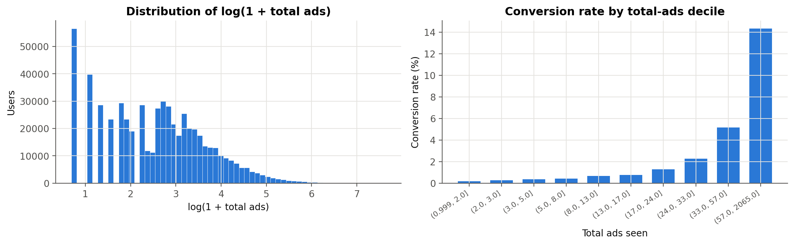
Figure 1. Exposure distribution and observed conversion rates by quantile-based exposure group.

3. Data Preprocessing
Step | Treatment | Rationale
Identifiers | Drop Unnamed: 0, user id | Exclude identifiers to reduce spurious fitting
Missing values | SimpleImputer — median (numeric), most-frequent (categorical) inside the pipeline | The supplied file has no missing values. Imputers are fitted inside CV; future raw inputs still require schema and missing-category validation before feature engineering
Skew | log_total_ads = log1p(total_ads) | Compresses a 1–2,065 range; permits a nonlinear association with exposure
Treatment flag | is_ad = 1 if test_group == "ad" | Binary encoding of the A/B arm
Raw total_ads | Kept alongside its log | Deliberately correlated pair → shows how Lasso vs Ridge handle redundant features
Categoricals | One-hot encode most_ads_day (7 levels) and most_ads_hour (24 levels, treated as categorical because the hour effect is non-monotonic). Regularized models keep all levels (full one-hot); the unregularized baseline drops the first level (reference coding) | A linear model needs numeric inputs. Without a penalty, a full set of dummies is perfectly collinear with the intercept, so reference coding is used here. Full encoding avoids choosing a reference category for the penalty. L2 can yield unique penalized coefficients; L1 coefficient uniqueness is not guaranteed with redundant columns. Interpret category contrasts rather than individual dummy coefficients.
Scaling | StandardScaler on the numeric features and, for the regularized models, on the one-hot dummies too | Penalty scaling. The L1/L2 penalty acts on raw coefficient size, so standardization is used here to define the relative penalty weighting. Standardizing the dummies also centres them, which changes the penalty weighting across category frequencies. Standardization does not make coefficients causal or establish variable importance.

Order of operations. Identifiers are removed before fitting. The log exposure term and binary ad-group flag are deterministic row-wise transformations; they do not estimate population parameters. Fitted preprocessing is then carried out separately within each training fold. A scaler estimates the training mean and standard deviation and applies those same values to the validation fold. The same principle applies to imputation statistics and one-hot categories. This prevents fitted preprocessing from using validation records, although it does not undo the earlier use of the full dataset for exploratory feature decisions.
Missing and unfamiliar inputs. No values required imputation in the supplied CSV. Median and most-frequent imputers specify what would happen to missing transformed inputs, rather than implying that missing observations were found. The encoder ignores unfamiliar categories, which maps them to an all-zero indicator vector before scaling. That is a computational fallback, not evidence that predictions for new categories are reliable. In particular, raw missing hours must be handled before conversion to strings, and missing group labels must not silently become PSA assignments.
The regularized design matrix contains 34 encoded predictors: three numeric terms, seven day indicators, and 24 hour indicators. Reference coding gives 32 predictors for unregularized logistic regression. Missing raw categories would still need validation before feature engineering; imputers alone do not establish readiness for arbitrary future inputs.

4. Model Selection & Regularization
I use logistic regression because the target is binary and the fitted model provides both probability estimates and a coefficient-based representation of its predictions. These probabilities are not assumed to be calibrated; that would require a separate assessment.
Regularization adds a coefficient penalty to the logistic loss. An L1 penalty uses the sum of absolute coefficient values and can set coefficients exactly to zero. An L2 penalty uses squared coefficient values and generally shrinks coefficients without producing a sparse solution. In the scikit-learn implementation used here, smaller C means stronger regularization (scikit-learn, n.d.-b).
Model | Purpose
Constant-probability baseline | Predict the training conversion rate for every record; at 0.50, predict the majority class
Unregularized logistic regression | Provide a comparison without a coefficient penalty
L2-regularized logistic regression (Ridge) | Tune the amount of shrinkage by cross-validation
L1-regularized logistic regression (Lasso) | Evaluate shrinkage and selection of encoded predictors
L1 with the one-standard-error rule | Select the smallest eligible C for a sparser candidate

Lasso and Ridge refer here to penalties within logistic regression, not to least-squares regression estimators. The L1 models use liblinear; L2 and unregularized models use lbfgs. liblinear also penalizes its synthetic intercept feature. Setting intercept_scaling=100 reduces that penalty but does not remove it (scikit-learn, n.d.-b). Because solver, intercept treatment, and categorical encoding differ, this comparison does not isolate the penalty as the only implementation difference.
Statistical formulation. If z is the intercept plus the weighted sum of the transformed inputs, logistic regression estimates conversion probability as 1 / (1 + exp(-z)). Training minimizes binary cross-entropy with an optional coefficient penalty. L1 penalizes the sum of absolute weights; L2 penalizes half the sum of squared weights in the summed-loss convention used to describe this comparison. A penalty can reduce sensitivity to the training sample, but it also introduces shrinkage bias. Its usefulness must therefore be judged using validation results rather than presumed from the model name.
Implementation choices. The analysis uses scikit-learn (Pedregosa et al., 2011). No oversampling, synthetic examples, or class weights are used. Instead, stratification preserves the rare positive class in the splits, and training-only threshold selection addresses the all-negative predictions at 0.50. The L1 iteration limit is 3,000, the L2 limit is 2,000, and the unregularized limit is 5,000. These are solver limits, not the number of iterations necessarily taken.

5. Training & Hyperparameter Tuning
I use an 80/20 stratified split with random_state=42, giving 470,480 training records and 117,621 test records. Hyperparameters are selected using five shuffled, stratified folds within the training set. Each fold refits the imputer, encoder, and scaler as part of the model pipeline.
The search evaluates 11 logarithmically spaced C values from 0.0001 to 10 for each penalty. Mean validation ROC-AUC determines the selected model; validation log-loss is also recorded. After selection, each candidate is fitted on the full training set.
For the sparse L1 candidate, I use the smallest C whose mean validation AUC is no more than one estimated standard error below the best mean. The estimate is the best candidate's fold standard deviation divided by the square root of five. This is a selection heuristic, not a test that the candidates are statistically equivalent.
Limits of the validation design. The exploratory plots use the full dataset and informed feature choices. Although test labels are excluded from model fitting and threshold selection, the test set was not isolated from all analytical decisions. In addition, hyperparameter selection and out-of-fold threshold tuning reuse the same training folds rather than using nested cross-validation. I therefore interpret the reported scores as exploratory internal validation. Performance on a future campaign, uncertainty in score differences, and feature-selection stability remain to be assessed.
Selection and reproducibility. Each penalty's search evaluates 11 candidates over five folds, or 55 candidate-fold fits, followed by refitting the selected candidate. ROC-AUC is the refit criterion; log-loss does not determine which C wins. Threshold tuning subsequently generates out-of-fold probabilities for each fixed logistic candidate, computes precision and recall over candidate thresholds, and selects the threshold with the largest training F1. Test labels are used only for reported test metrics at this stage. The earlier full-data exploration and reuse of folds remain the qualifications discussed above.
The same random seed is used for the stratified split, shuffled folds, and L1 solver. Package versions and the dataset hash are recorded with the results. These records support reproduction of the present run; they do not guarantee identical floating-point coefficients across every operating system or software version.
C | L1 CV AUC | L2 CV AUC | L1 log-loss | L2 log-loss
0.0001 | 0.85339 | 0.85607 | 0.11046 | 0.10134
0.00031623 | 0.85339 | 0.85621 | 0.09775 | 0.09739
0.001 | 0.85366 | 0.85664 | 0.09579 | 0.09495
0.0031623 | 0.85589 | 0.85693 | 0.09434 | 0.09410
0.01 | 0.85695 | 0.85702 | 0.09393 | 0.09391
0.031623 | 0.85704 | 0.85702 | 0.09388 | 0.09388
0.1 | 0.85703 | 0.85702 | 0.09387 | 0.09387
0.31623 | 0.85702 | 0.85701 | 0.09387 | 0.09387
1 | 0.85701 | 0.85701 | 0.09387 | 0.09387
3.1623 | 0.85701 | 0.85701 | 0.09387 | 0.09387
10 | 0.85701 | 0.85701 | 0.09387 | 0.09387

Observations from cross-validation
- Both penalties select C of approximately 0.0316, with mean validation ROC-AUC near 0.857.
- The one-standard-error rule selects approximately 0.00316 for L1, giving a stronger penalty than the best-score candidate.
- The plotted scores vary little across the weaker penalties. This supports examining a simpler candidate, but it does not establish that regularization has no effect or that the models will perform equally on new data.
- The shaded bands show fold standard deviations. They are not confidence intervals for differences between models.
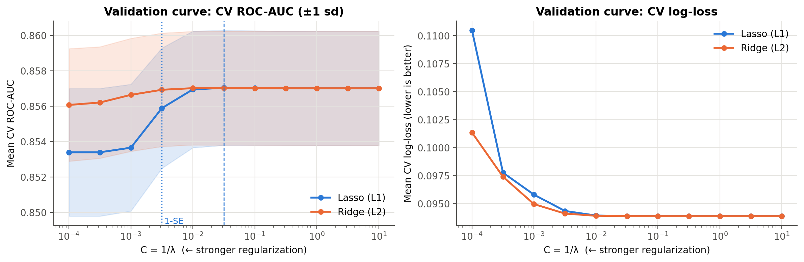
Figure 2. Cross-validation results; shaded bands represent fold standard deviations.

6. Evaluation
I report several metrics because no single score captures both ranking quality and the consequences of a classification threshold.
- ROC-AUC measures discrimination across thresholds.
- Average precision (AP) summarizes precision-recall performance. It differs from trapezoidal precision-recall area (scikit-learn, n.d.-a). The saved field pr_auc contains AP, and a constant-score model has AP equal to test prevalence.
- Accuracy, precision, recall, and F1 describe predictions at a specified threshold.
- Log-loss and Brier score assess probability predictions; neither alone establishes calibration.
- Top-decile capture measures the share of recorded converters among the highest-scored approximately 10% of test records. It measures retrospective ranking, not additional conversions caused by targeting.
For each logistic model, I select a threshold that maximizes F1 on out-of-fold training predictions and compare it with 0.50. The baseline is reported at 0.50 only. F1 is useful for this comparison, but a deployment threshold would need to reflect campaign costs, conversion value, and operational capacity.
Why these metrics are complementary. Precision is TP / (TP + FP), recall is TP / (TP + FN), and F1 is their harmonic mean. ROC-AUC measures ranking across positive-negative pairs, whereas precision-recall analysis makes the false-positive burden more visible when positive outcomes are uncommon (Saito & Rehmsmeier, 2015). AP is reported alongside ROC-AUC for that reason. Lower log-loss and Brier scores indicate better probability predictions under those scoring rules. A calibration plot would still be needed to examine whether stated probabilities match observed frequencies across risk groups.
Model | Threshold | Accuracy | Precision | Recall | F1
Majority baseline | 0.5000 | 0.9748 | 0.0000 | 0.0000 | 0.0000
Unregularized LR | 0.1105 | 0.9378 | 0.1726 | 0.3860 | 0.2385
Ridge (L2) | 0.1069 | 0.9359 | 0.1714 | 0.4015 | 0.2403
Lasso (L1) | 0.1064 | 0.9355 | 0.1709 | 0.4042 | 0.2402
Lasso (L1, 1-SE) | 0.0956 | 0.9311 | 0.1640 | 0.4217 | 0.2361

Table 1. Test classification metrics at training-selected F1 thresholds for logistic models; the baseline uses 0.50. Scores apply to 117,621 test records.
Model | ROC-AUC | AP | Log-loss | Brier | Top 10% capture
Majority baseline | 0.5000 | 0.0252 | 0.11779 | 0.02460 | 10.00%
Unregularized LR | 0.8600 | 0.1420 | 0.09351 | 0.02274 | 57.83%
Ridge (L2) | 0.8600 | 0.1422 | 0.09350 | 0.02274 | 57.97%
Lasso (L1) | 0.8601 | 0.1420 | 0.09349 | 0.02274 | 58.00%
Lasso (L1, 1-SE) | 0.8601 | 0.1378 | 0.09375 | 0.02281 | 57.66%

Table 2. Ranking and probability metrics. Baseline top-decile capture is the expectation under random tie-breaking.

Observations from model evaluation
- The models rank converters better than the constant baseline. Tuned L1 achieves test ROC-AUC 0.8601 and AP 0.1420, compared with 0.5000 and approximately 0.0252 for the baseline.
- Threshold choice changes the practical result. At its training-selected threshold of 0.1064, tuned L1 has precision 17.09%, recall 40.42%, and F1 0.2402. It identifies more converters than at 0.50, but most positive predictions still correspond to non-conversions.
- High accuracy is not sufficient here. At 0.50, all fitted models have zero recall on the test set despite accuracy of about 97.48%.
- The sparse model involves a measurable trade-off. The 1-SE L1 fit retains 22 of 34 encoded coefficients. Its ROC-AUC rounds to 0.8601, while AP falls to 0.1378 from 0.1420 for tuned L1. Similar AUC therefore does not mean identical performance.
- The ranking is concentrated. The highest-scored approximately 10% of records contain 58.00% of observed test conversions for tuned L1. This does not establish profit or incremental advertising benefit.
- The comparison remains exploratory. The table gives point estimates for this split. No formal equivalence test, paired uncertainty interval, or external validation has been carried out.

6.1 Classification errors and practical meaning
Outcome at tuned L1 threshold | Count
True positives | 1,200
False positives | 5,823
False negatives | 1,769
True negatives | 108,829

Among 2,969 test converters, the tuned L1 rule identifies 1,200 and misses 1,769. It also assigns a positive prediction to 5,823 non-converters. These counts explain why an AUC near 0.86 does not imply high precision at a particular operating point. Whether this error balance is acceptable depends on the intended use; no campaign cost or profit data are available to answer that question.

6.2 Comparing predictive scores
Relative to unregularized logistic regression, tuned L1 changes ROC-AUC by +0.000125, AP by +0.000015, and log-loss by -0.000022. These small numerical changes do not support claiming a substantial predictive gain. No uncertainty interval for the paired differences was computed, so neither superiority nor equivalence is established.
The sparse 1-SE model changes AP by -0.004195, log-loss by +0.000258, and Brier score by +0.000074 relative to tuned L1. Its simpler coefficient representation therefore accompanies worse point estimates for these metrics, even though its ROC-AUC is slightly higher. The preferred candidate depends on the metric that matches the task.
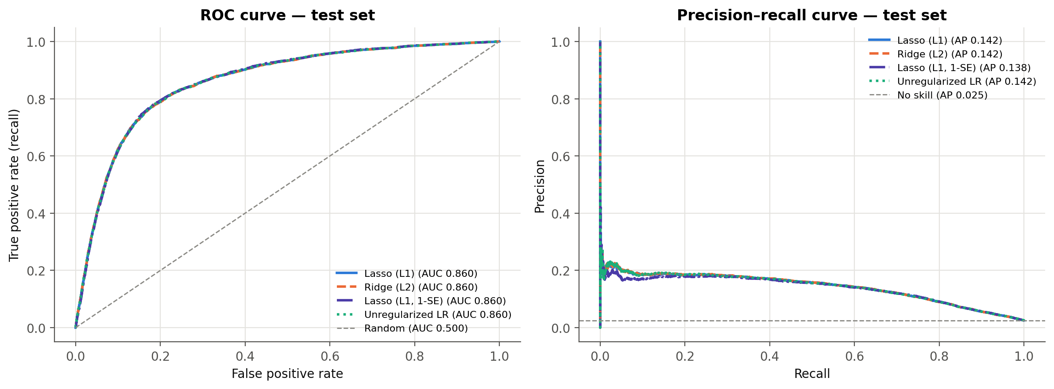
Figure 3. ROC and precision-recall curves for the test split.
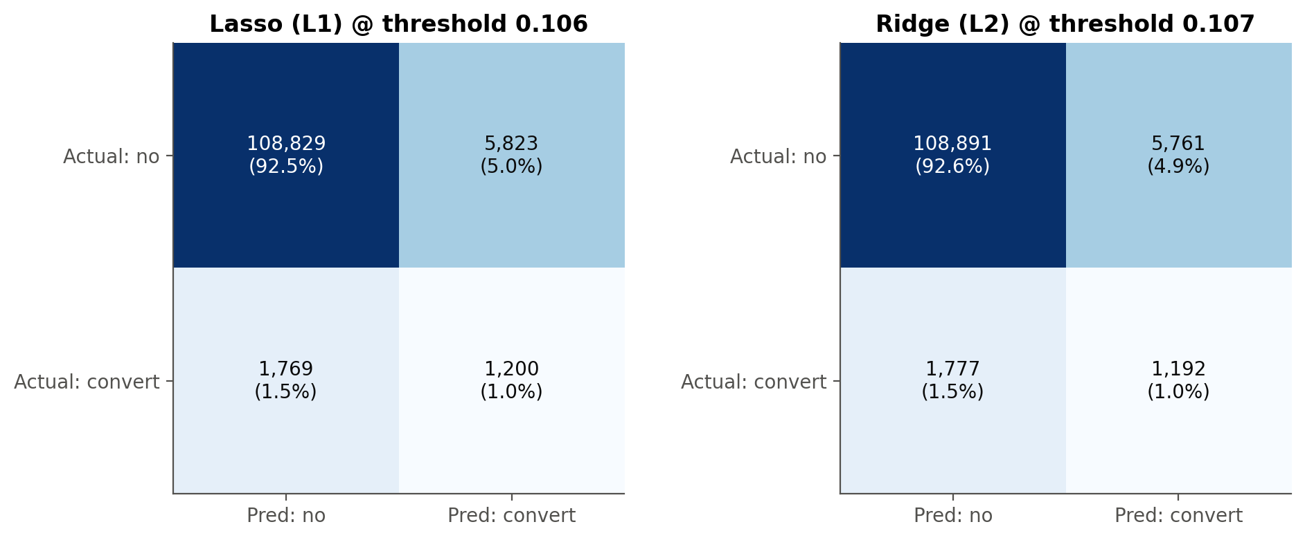
Figure 4. Confusion matrices at the training-selected thresholds.

7. Interpretation
The coefficients describe the fitted model's conditional associations. Numeric inputs are standardized, so their coefficients are expressed per training-set standard deviation. For the binary is_ad input, the fitted 0-to-1 log-odds contrast is its coefficient divided by the training standard deviation.
Day and hour require more care because the regularized models retain and standardize every one-hot column. Comparing categories a and b requires the contrast beta_a / scale_a - beta_b / scale_b. A single dummy coefficient is not a difference from a reference category. Likewise, a zero L1 coefficient reflects the penalized solution; it is not a significance test or evidence that the category has no association with conversion.
The raw exposure count and its logarithm also need to be interpreted together. A feasible change from x ads to x' ads changes both inputs. Its fitted log-odds contrast is beta_raw*(x'-x)/scale_raw + beta_log*(log1p(x')-log1p(x))/scale_log. Exponentiating the log-term coefficient alone would not describe that exposure change.
The unregularized model uses reference coding, so its dummy coefficients are excluded from the direct coefficient table. Even among models with the same encoding, coefficient magnitude is only one description of the fitted representation; it is not a validated measure of causal importance.
Encoded predictor | Ridge | Lasso | Lasso 1-SE
log_total_ads | 1.9597 | 1.9582 | 1.7823
total_ads | -0.2707 | -0.2709 | -0.2049
most_ads_hour_02 | -0.1263 | -0.1215 | -0.0575
most_ads_day_Monday | 0.1014 | 0.1163 | 0.0950
most_ads_hour_16 | 0.0870 | 0.0729 | 0.0578
is_ad | 0.0815 | 0.0781 | 0.0452
most_ads_day_Tuesday | 0.0792 | 0.0917 | 0.0682
most_ads_hour_01 | -0.0754 | -0.0744 | -0.0307
most_ads_day_Saturday | -0.0749 | -0.0569 | -0.0338
most_ads_day_Friday | -0.0693 | -0.0504 | -0.0282
most_ads_hour_07 | -0.0609 | -0.0624 | -0.0285
most_ads_hour_09 | -0.0549 | -0.0624 | -0.0244

Table 3. Twelve largest absolute Ridge coefficients, with corresponding L1 coefficients. This ordering describes coefficient magnitude, not validated feature importance. The full table is in results/coefficients.csv.
Observations from the coefficient comparison
- The tuned L1 and L2 fits both include the raw and logarithmic exposure terms. Their joint contribution permits a nonlinear relationship with conversion. The signs do not establish diminishing economic returns or an optimal number of ads.
- In this fit, Ridge retains all 34 encoded coefficients, tuned L1 retains 32, and the 1-SE L1 candidate retains 22. The sparse candidate therefore requires fewer nonzero terms, although it still relies on the same original predictor types.
- Selection depends on the penalty and encoding. A discarded day or hour indicator should not be interpreted as statistically unimportant; correlated and redundant columns can affect which coefficients L1 retains.
- I do not give the adjusted ad-group coefficient a causal interpretation. Even with randomized assignment, controlling for exposure or timing measured after assignment could bias an estimate of the total treatment effect.
- The useful interpretation is a sparsity-performance comparison for this dataset. Establishing stable feature importance would require further work, such as repeated resampling or a suitable held-out importance analysis.
What interpretability means here. A shorter coefficient list makes the fitted rule easier to inspect, but the sparse model still includes day and hour information through its remaining indicators. Dropping individual encoded columns is not equivalent to removing the original variable. Nor does a large standardized coefficient prove that a predictor would remain important under a different encoding or correlated feature set. I therefore report selection counts and coefficient values as properties of the fitted models, while reserving stronger importance claims for a stability or held-out importance study.

7.1 Worked coefficient contrasts
For tuned L1, the standardized is_ad coefficient is 0.0781. Dividing by its training standard deviation gives a fitted ad-versus-PSA log-odds contrast of 0.3993, or an odds ratio of 1.491, with the modeled exposure and timing inputs held fixed. This is an adjusted model association; it is not an estimated causal effect of assignment.
For an illustrative comparison of 10 versus 20 recorded ads, changing the raw and log inputs together gives a fitted log-odds difference of 1.0353, or an odds ratio of 2.816, with the remaining inputs fixed. This is an algebraic contrast from the fitted model, not a new observation, simulated data, or a recommendation to double exposure. An odds ratio is also not a probability ratio.

7.2 What the sparse model removes
The encoded terms set to zero by the 1-SE L1 fit are: most_ads_hour_22, most_ads_day_Thursday, most_ads_hour_04, most_ads_hour_20, most_ads_hour_00, most_ads_hour_21, most_ads_hour_23, most_ads_hour_18, most_ads_day_Sunday, most_ads_day_Wednesday, most_ads_hour_19, most_ads_hour_13.
Its coefficient L1 norm is 0.690 times that of the least-penalized L1 fit at C = 10 on the same encoded design. This compares total absolute coefficient size within this parameterization; it is not a percentage reduction in prediction error or proof of causal irrelevance.

7. Regularization Paths
The following plots show how the fitted coefficients change across the specified penalty grid. They make L1's sparsity visible and allow comparison with L2 shrinkage. The order in which a coefficient becomes nonzero depends on scaling, correlated predictors, and the fitted sample; I do not treat it as an independent ranking of feature importance.
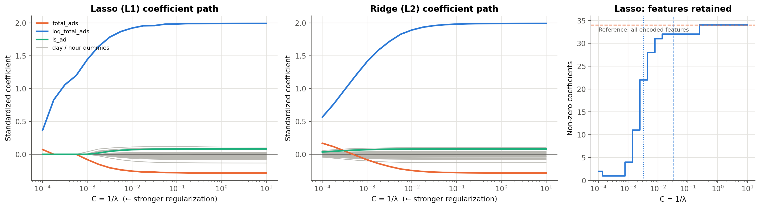
Figure 5. Coefficient paths and the number of nonzero L1 terms across the penalty grid.

8. Conclusion

Final Insight
- The clearest contribution of regularization in this analysis is the option to simplify the coefficient representation. The 1-SE L1 candidate uses 22 nonzero terms instead of 34, while retaining a similar ROC-AUC point estimate.
- That simplification is not free: average precision is lower for the sparse candidate. I would therefore choose between the models using the intended decision task rather than ROC-AUC alone.
- The results describe prediction within the supplied records. They do not establish that changing advertising exposure will cause additional purchases, or that the model is ready for a future campaign.

Recommendations
- Resolve the data-collection requirement before submission: obtain a documented dataset with demographics and purchase history, or secure the instructor's acceptance of the present exposure-only scope. Do not invent missing customer attributes or join unrelated customers across datasets.
- Obtain documentation of the source, collection process, and outcome window before presenting the records as verified empirical data.
- Define when a prediction would be made and use only information available at that time. Campaign-total exposure may not be available before a conversion decision.
- Evaluate a fixed modeling procedure on a new campaign or an untouched holdout, then assess calibration, uncertainty in performance differences, and selection stability.
- Choose a deployment threshold using measured costs, conversion value, and capacity. The F1-selected threshold in this project is an analytical comparison, not an established business optimum.

Concluding Discussion
This project demonstrates a complete computational workflow for comparing regularized logistic regression models on the supplied marketing records. Tuned L1 achieves a test ROC-AUC of 0.8601 and AP of 0.1420. A stronger L1 penalty yields a sparser model with similar ROC-AUC but lower AP, illustrating why interpretability and performance should be considered together.
The conclusions remain limited by the data and validation design. The source's original empirical authenticity is unverified, exposure timing is unclear, and the full-data exploratory analysis limits the independence of the test evaluation. The dataset also lacks the demographics and purchase history specified in the assignment. These limitations do not erase the modeling results, but they prevent a claim that every assignment requirement has been satisfied.

9. References
faviovaz. (n.d.). Marketing A/B testing [Data set]. Kaggle. https://www.kaggle.com/datasets/faviovaz/marketing-ab-testing
Joblib. (n.d.). Joblib documentation. Retrieved October 1, 2026, from https://joblib.readthedocs.io/en/stable/
Matplotlib. (n.d.). Matplotlib documentation. Retrieved October 1, 2026, from https://matplotlib.org/stable/
NumPy. (n.d.). NumPy documentation. Retrieved October 1, 2026, from https://numpy.org/doc/
pandas. (n.d.). pandas documentation. Retrieved October 1, 2026, from https://pandas.pydata.org/docs/
Pedregosa, F., Varoquaux, G., Gramfort, A., Michel, V., Thirion, B., Grisel, O., Blondel, M., Prettenhofer, P., Weiss, R., Dubourg, V., Vanderplas, J., Passos, A., Cournapeau, D., Brucher, M., Perrot, M., & Duchesnay, E. (2011). Scikit-learn: Machine learning in Python. Journal of Machine Learning Research, 12, 2825–2830. https://www.jmlr.org/papers/v12/pedregosa11a.html
Project Jupyter. (n.d.). Project Jupyter documentation. Retrieved October 1, 2026, from https://docs.jupyter.org/en/latest/
python-docx. (n.d.). python-docx documentation. Retrieved October 1, 2026, from https://python-docx.readthedocs.io/en/latest/
Python Software Foundation. (n.d.). Python 3.11 documentation. Retrieved October 1, 2026, from https://docs.python.org/3.11/index.html
Saito, T., & Rehmsmeier, M. (2015). The precision-recall plot is more informative than the ROC plot when evaluating binary classifiers on imbalanced datasets. PLOS ONE, 10(3), Article e0118432. https://doi.org/10.1371/journal.pone.0118432
scikit-learn. (n.d.-a). average_precision_score. In Scikit-learn 1.7 documentation. https://scikit-learn.org/1.7/modules/generated/sklearn.metrics.average_precision_score.html
scikit-learn. (n.d.-b). LogisticRegression. In Scikit-learn 1.7 documentation. https://scikit-learn.org/1.7/modules/generated/sklearn.linear_model.LogisticRegression.html
Source note. Peer-reviewed articles support the software and evaluation discussion; official documentation supports implementation details. Kaggle is the dataset listing, not independent verification of its collection. Undated documentation is cited as n.d.; release years have not been inferred from copyright notices.

Reproducibility record
The computational workflow uses Python (Python Software Foundation, n.d.), pandas (pandas, n.d.), NumPy (NumPy, n.d.), scikit-learn (Pedregosa et al., 2011), Matplotlib (Matplotlib, n.d.), Jupyter (Project Jupyter, n.d.), and Joblib (Joblib, n.d.). The written document is generated with python-docx (python-docx, n.d.).
Recorded analysis versions: pandas 2.3.2; numpy 2.3.2; scikit-learn 1.7.2; matplotlib 3.9.2; joblib 1.5.2; nbformat 5.10.4; nbclient 0.10.2; ipykernel 7.0.1.
Dataset SHA-256: de6ce8def1a6559e9e5ab364fce07cfe2e84f02dd407c3586eea55743c7e17f2

Appendix: Assignment Requirements Review
Requirement | Evidence in this project | Status
Marketing prediction objective | Binary campaign-conversion prediction | Addressed
Demographics, purchase history, and relevant features | Only campaign exposure and a conversion outcome are available | Not fully met; demographics and purchase history are absent
Missing values, encoding, scaling | Data audit, pipeline imputers, one-hot encoding, StandardScaler | Addressed for the supplied dataset
Model selection and regularization | Unregularized, L1, L2, and sparse L1 logistic regression | Addressed
Cross-validation and tuning | Five stratified folds; 11 C values per penalty | Addressed, with validation limitations disclosed
Performance evaluation | Classification, ranking, and probability metrics | Addressed
Coefficient interpretation | Encoding-aware interpretation and sparsity comparison | Addressed; no causal or significance claims
Written report in Word or PDF | report/Project3_Regularization_Report_APA_Expanded.docx, with the nine requested sections | Word report provided
Separate Regularization Methods Project Rubric | Not supplied with the assignment text | Cannot verify rubric-specific criteria

This review is based on the instructions supplied in the conversation. It does not imply instructor approval of the dataset substitution or certify a grade.

