Assignment 3
Name: Albert Kabore
Academic status: PhD student in Advanced and Equitable Computing

Basis, notation, and simulation setup
Use the ordered basis |00⟩, |01⟩, |10⟩, |11⟩, with kets written |q1 q0⟩ as in Qiskit. A gate on q0 is the right tensor factor; a gate on q1 is the left tensor factor. Later gates multiply on the left. For two 2×2 matrices, the Kronecker product replaces each entry of the first matrix by that entry times the second matrix, producing four 2×2 blocks in a 4×4 operator.
For input |ψ_i⟩, the output is |ψ_f⟩ = U|ψ_i⟩. A basis input selects its corresponding matrix column. The Born rule gives $P(b)=|⟨b|ψ_{f}⟩|^{2}$; the four probabilities sum to 1. The assignment writes the conjugate overlap ${\left|ψ_{f}|b⟩\right|}^{2}$, which has the same squared magnitude.
The Question 1 circuits start in Qiskit's default input |00⟩. Each histogram is generated by running the assigned circuit for 1024 shots on an ideal AerSimulator with seed 2026. The displayed counts are simulator measurements, not IBM hardware measurements. Expected counts are 1024 times the predicted probability; finite sampling can make observed counts differ from that expectation.
Run this notebook with the project's Python 3.11 (.venv) kernel. Define the gates and check each assigned operator and its four basis actions against Qiskit before sampling its measurements.
In [1]
import numpy as np
import matplotlib.pyplot as plt
from qiskit import QuantumCircuit, transpile
from qiskit.quantum_info import Operator, Statevector
from qiskit.visualization import plot_histogram, array_to_latex
from qiskit_aer import AerSimulator
from IPython.display import display, Markdown
SHOTS, SEED = 1024, 2026
BASIS = ["00", "01", "10", "11"] # |q1 q0>
sim = AerSimulator(seed_simulator=SEED)
I2 = np.eye(2)
X = np.array([[0, 1], [1, 0]])
Y = np.array([[0, -1j], [1j, 0]])
Z = np.array([[1, 0], [0, -1]])
H = np.array([[1, 1], [1, -1]]) / np.sqrt(2)
def analyze(qc, U_hand, label):
assert np.allclose(Operator(qc).data, U_hand)
assert np.allclose(U_hand.conj().T @ U_hand, np.eye(4))
for k, bits in enumerate(BASIS):
actual = Statevector.from_label(bits).evolve(qc).data
assert np.allclose(actual, U_hand[:, k])
print(f"{label}: operator and all four basis actions verified against Qiskit.")
display(Markdown(f"### Circuit Diagram: {label}"))
with plt.rc_context():
circuit_figure = qc.draw("mpl", initial_state=True, idle_wires=True, fold=-1)
display(circuit_figure)
plt.close(circuit_figure)
display(Markdown("Wire order: q0 above q1; basis kets use |q1 q0⟩."))
psi = Statevector.from_label("00").evolve(qc).data
probabilities = {b: float(abs(psi[k]) ** 2) for k, b in enumerate(BASIS)}
assert np.isclose(sum(probabilities.values()), 1)
display(Markdown("**State vector at the circuit output:**"))
display(array_to_latex(psi.reshape(-1, 1), prefix=r"|\psi_f\rangle = "))
measured = qc.copy()
measured.measure_all()
sampled = sim.run(transpile(measured, sim), shots=SHOTS).result().get_counts()
counts = {b: sampled.get(b, 0) for b in BASIS}
assert sum(counts.values()) == SHOTS
assert all(counts[b] == 0 for b in BASIS if np.isclose(probabilities[b], 0))
rows = ["| Outcome | Exact probability | Expected count | Observed count |",
"|---|---:|---:|---:|"]
for b in BASIS:
rows.append(
f"| {b} | {probabilities[b]:.2f} | "
f"{SHOTS * probabilities[b]:.0f} | {counts[b]} |"
)
display(Markdown("\n".join(rows)))
return counts
print("Setup ready: NumPy, Matplotlib, Qiskit, and AerSimulator loaded.")
Setup ready: NumPy, Matplotlib, Qiskit, and AerSimulator loaded.

Question 1(a)

4×4 Operator Using the Kronecker Product Formulation
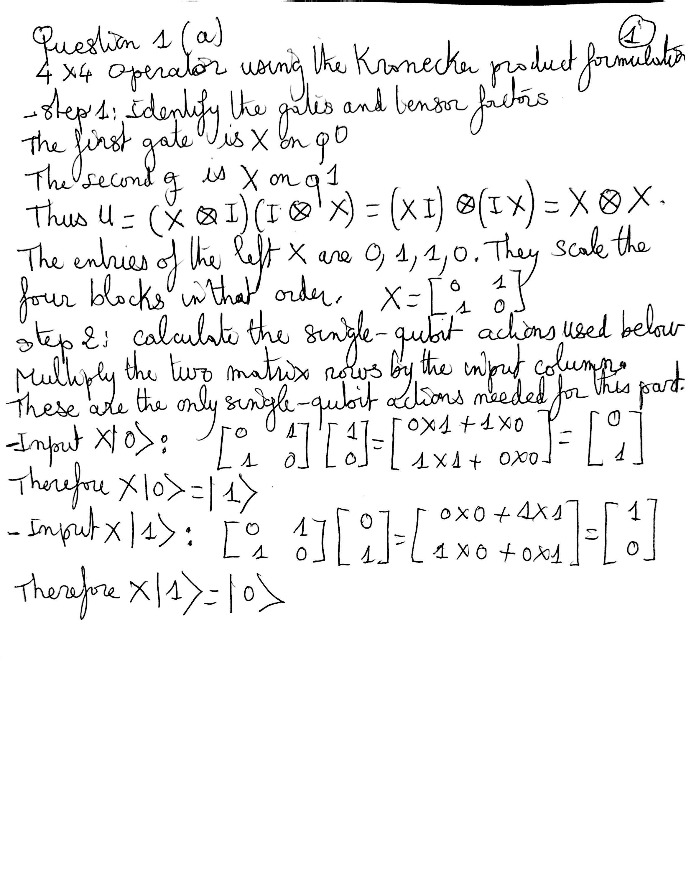

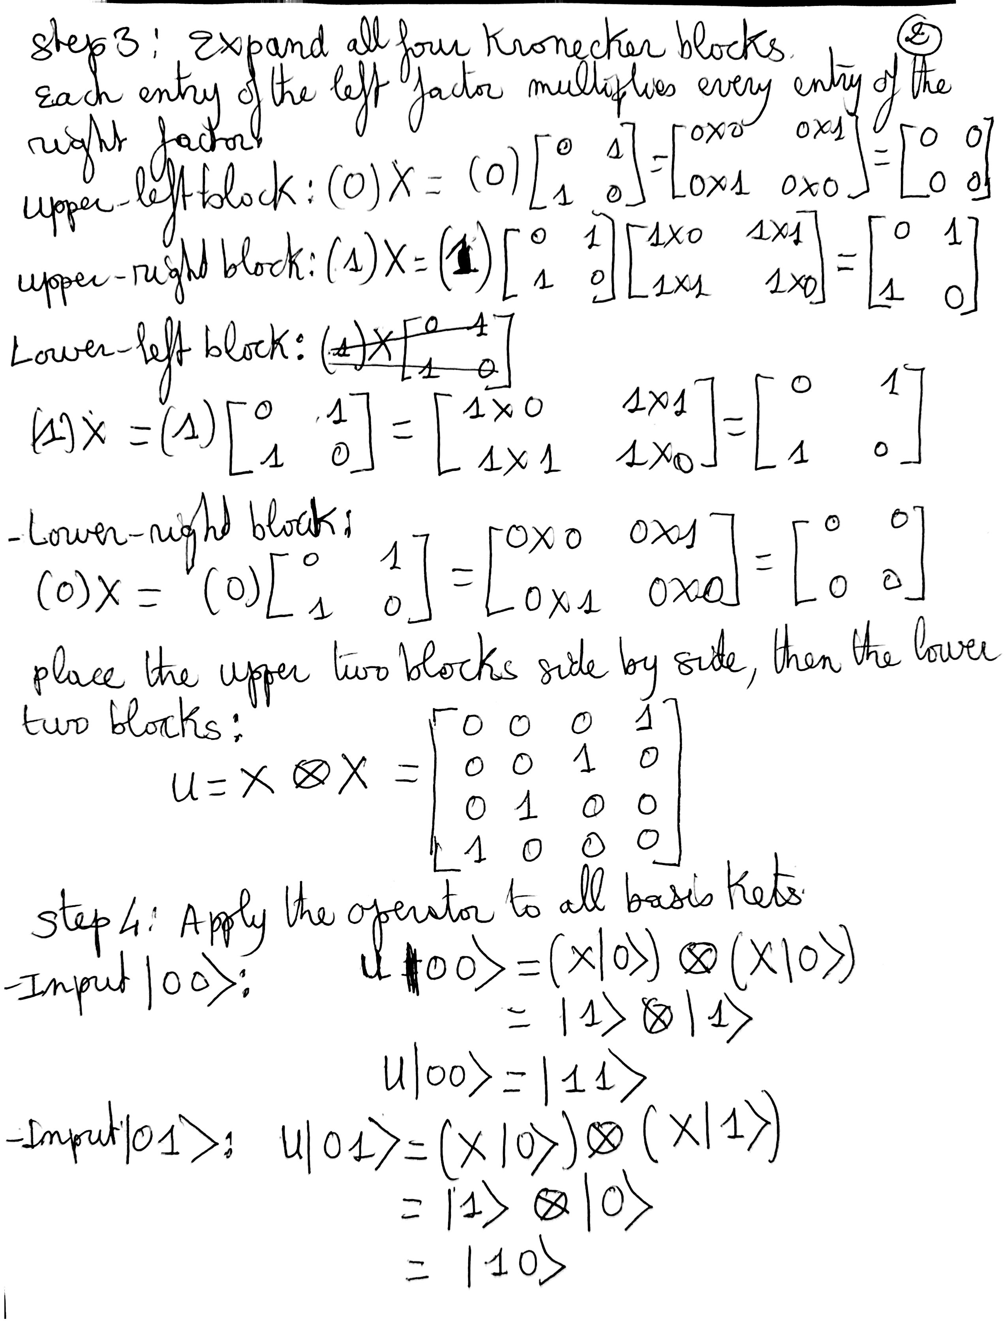

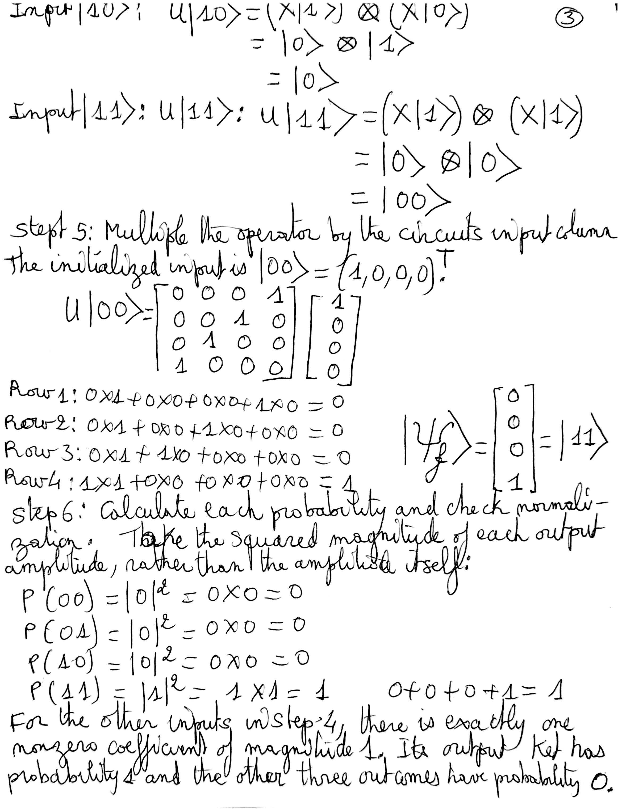
For clarity, the Step 4 result for input |10⟩ is the two-qubit ket |01⟩:
$$U|10⟩=|0⟩⊗|1⟩=|01⟩.$$

Verify the operator and all four basis actions, then compare the predicted probabilities with actual simulator counts.
In [2]
qc = QuantumCircuit(2)
qc.x(0)
qc.x(1)
counts_q1a = analyze(qc, np.kron(X, X), 'Question 1(a)')
Question 1(a): operator and all four basis actions verified against Qiskit.

Circuit Diagram: Question 1(a)
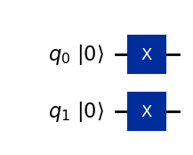
Wire order: q0 above q1; basis kets use |q1 q0⟩.
State vector at the circuit output:
$$|ψ_{f}⟩=\left[\begin{aligned}0 \\ 0 \\ 0 \\ 1\end{aligned}\right]$$
Outcome | Exact probability | Expected count | Observed count
00 | 0.00 | 0 | 0
01 | 0.00 | 0 | 0
10 | 0.00 | 0 | 0
11 | 1.00 | 1024 | 1024

Qiskit Histograms Verifying the Measurement Predictions
Qiskit measurement snapshot for input |00⟩. The horizontal axis shows q1q0 outcomes; the vertical axis shows counts.
In [3]
figure = plot_histogram(counts_q1a, title="Question 1(a)")
display(figure)
plt.close(figure)
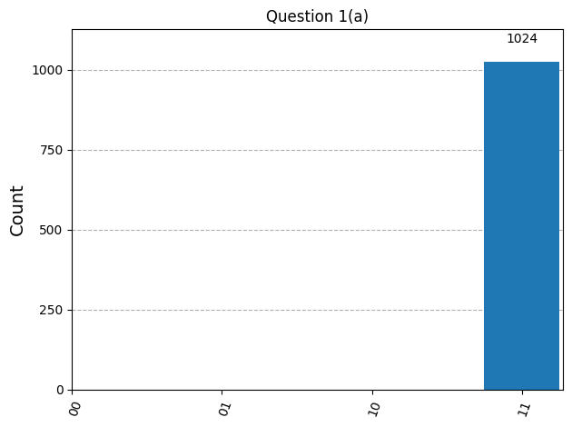
Actual simulator counts: 00: 0; 01: 0; 10: 0; 11: 1024. All 1024 shots give 11, matching P(11) = 1 and probability 0 for the other outcomes.

Question 1(b)

4×4 Operator Using the Kronecker Product Formulation
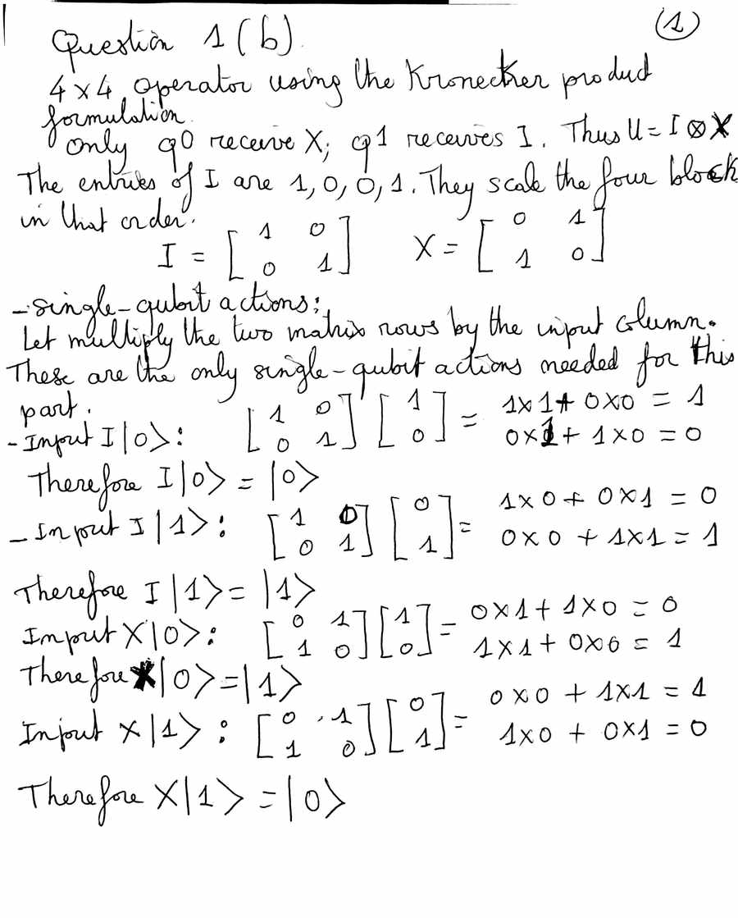

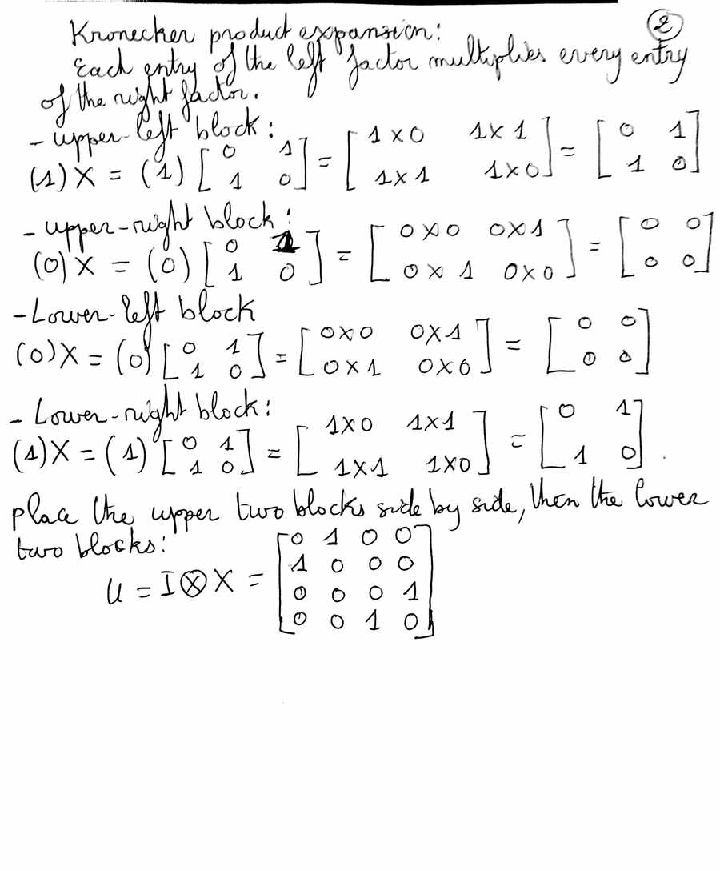

Action of the Operator on the Kets: |00⟩, |01⟩, |10⟩, |11⟩
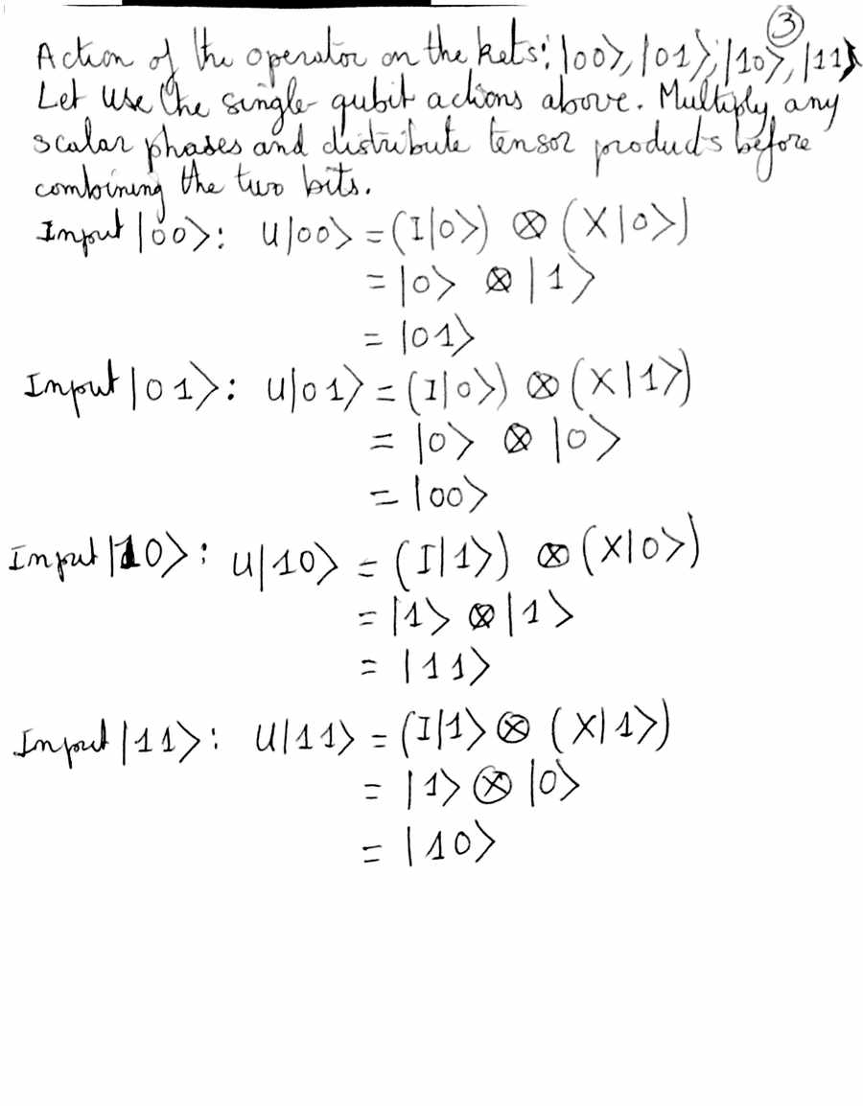

Probability Measurements
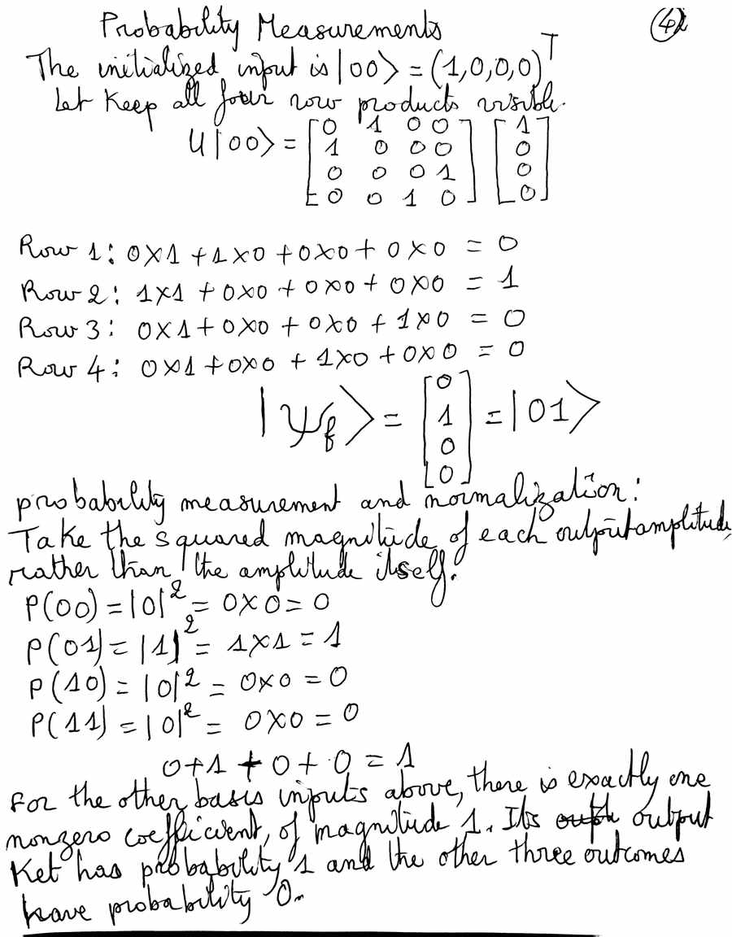

Verify the operator and all four basis actions, then compare the predicted probabilities with actual simulator counts.
In [4]
qc = QuantumCircuit(2)
qc.x(0)
counts_q1b = analyze(qc, np.kron(I2, X), 'Question 1(b)')
Question 1(b): operator and all four basis actions verified against Qiskit.

Circuit Diagram: Question 1(b)
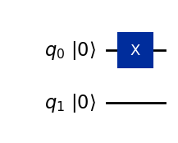
Wire order: q0 above q1; basis kets use |q1 q0⟩.
State vector at the circuit output:
$$|ψ_{f}⟩=\left[\begin{aligned}0 \\ 1 \\ 0 \\ 0\end{aligned}\right]$$
Outcome | Exact probability | Expected count | Observed count
00 | 0.00 | 0 | 0
01 | 1.00 | 1024 | 1024
10 | 0.00 | 0 | 0
11 | 0.00 | 0 | 0

Qiskit Histograms Verifying the Measurement Predictions
Qiskit measurement snapshot for input |00⟩. The horizontal axis shows q1q0 outcomes; the vertical axis shows counts.
In [5]
figure = plot_histogram(counts_q1b, title="Question 1(b)")
display(figure)
plt.close(figure)
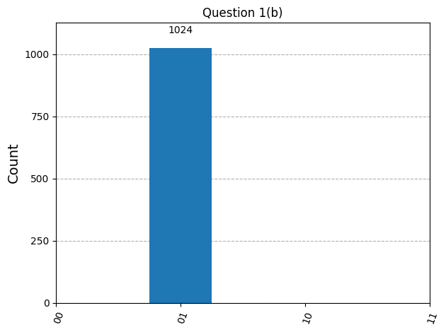
Actual simulator counts: 00: 0; 01: 1024; 10: 0; 11: 0. All 1024 shots give 01, matching P(01) = 1 and probability 0 for the other outcomes.

Question 1(c)

4×4 Operator Using the Kronecker Product Formulation
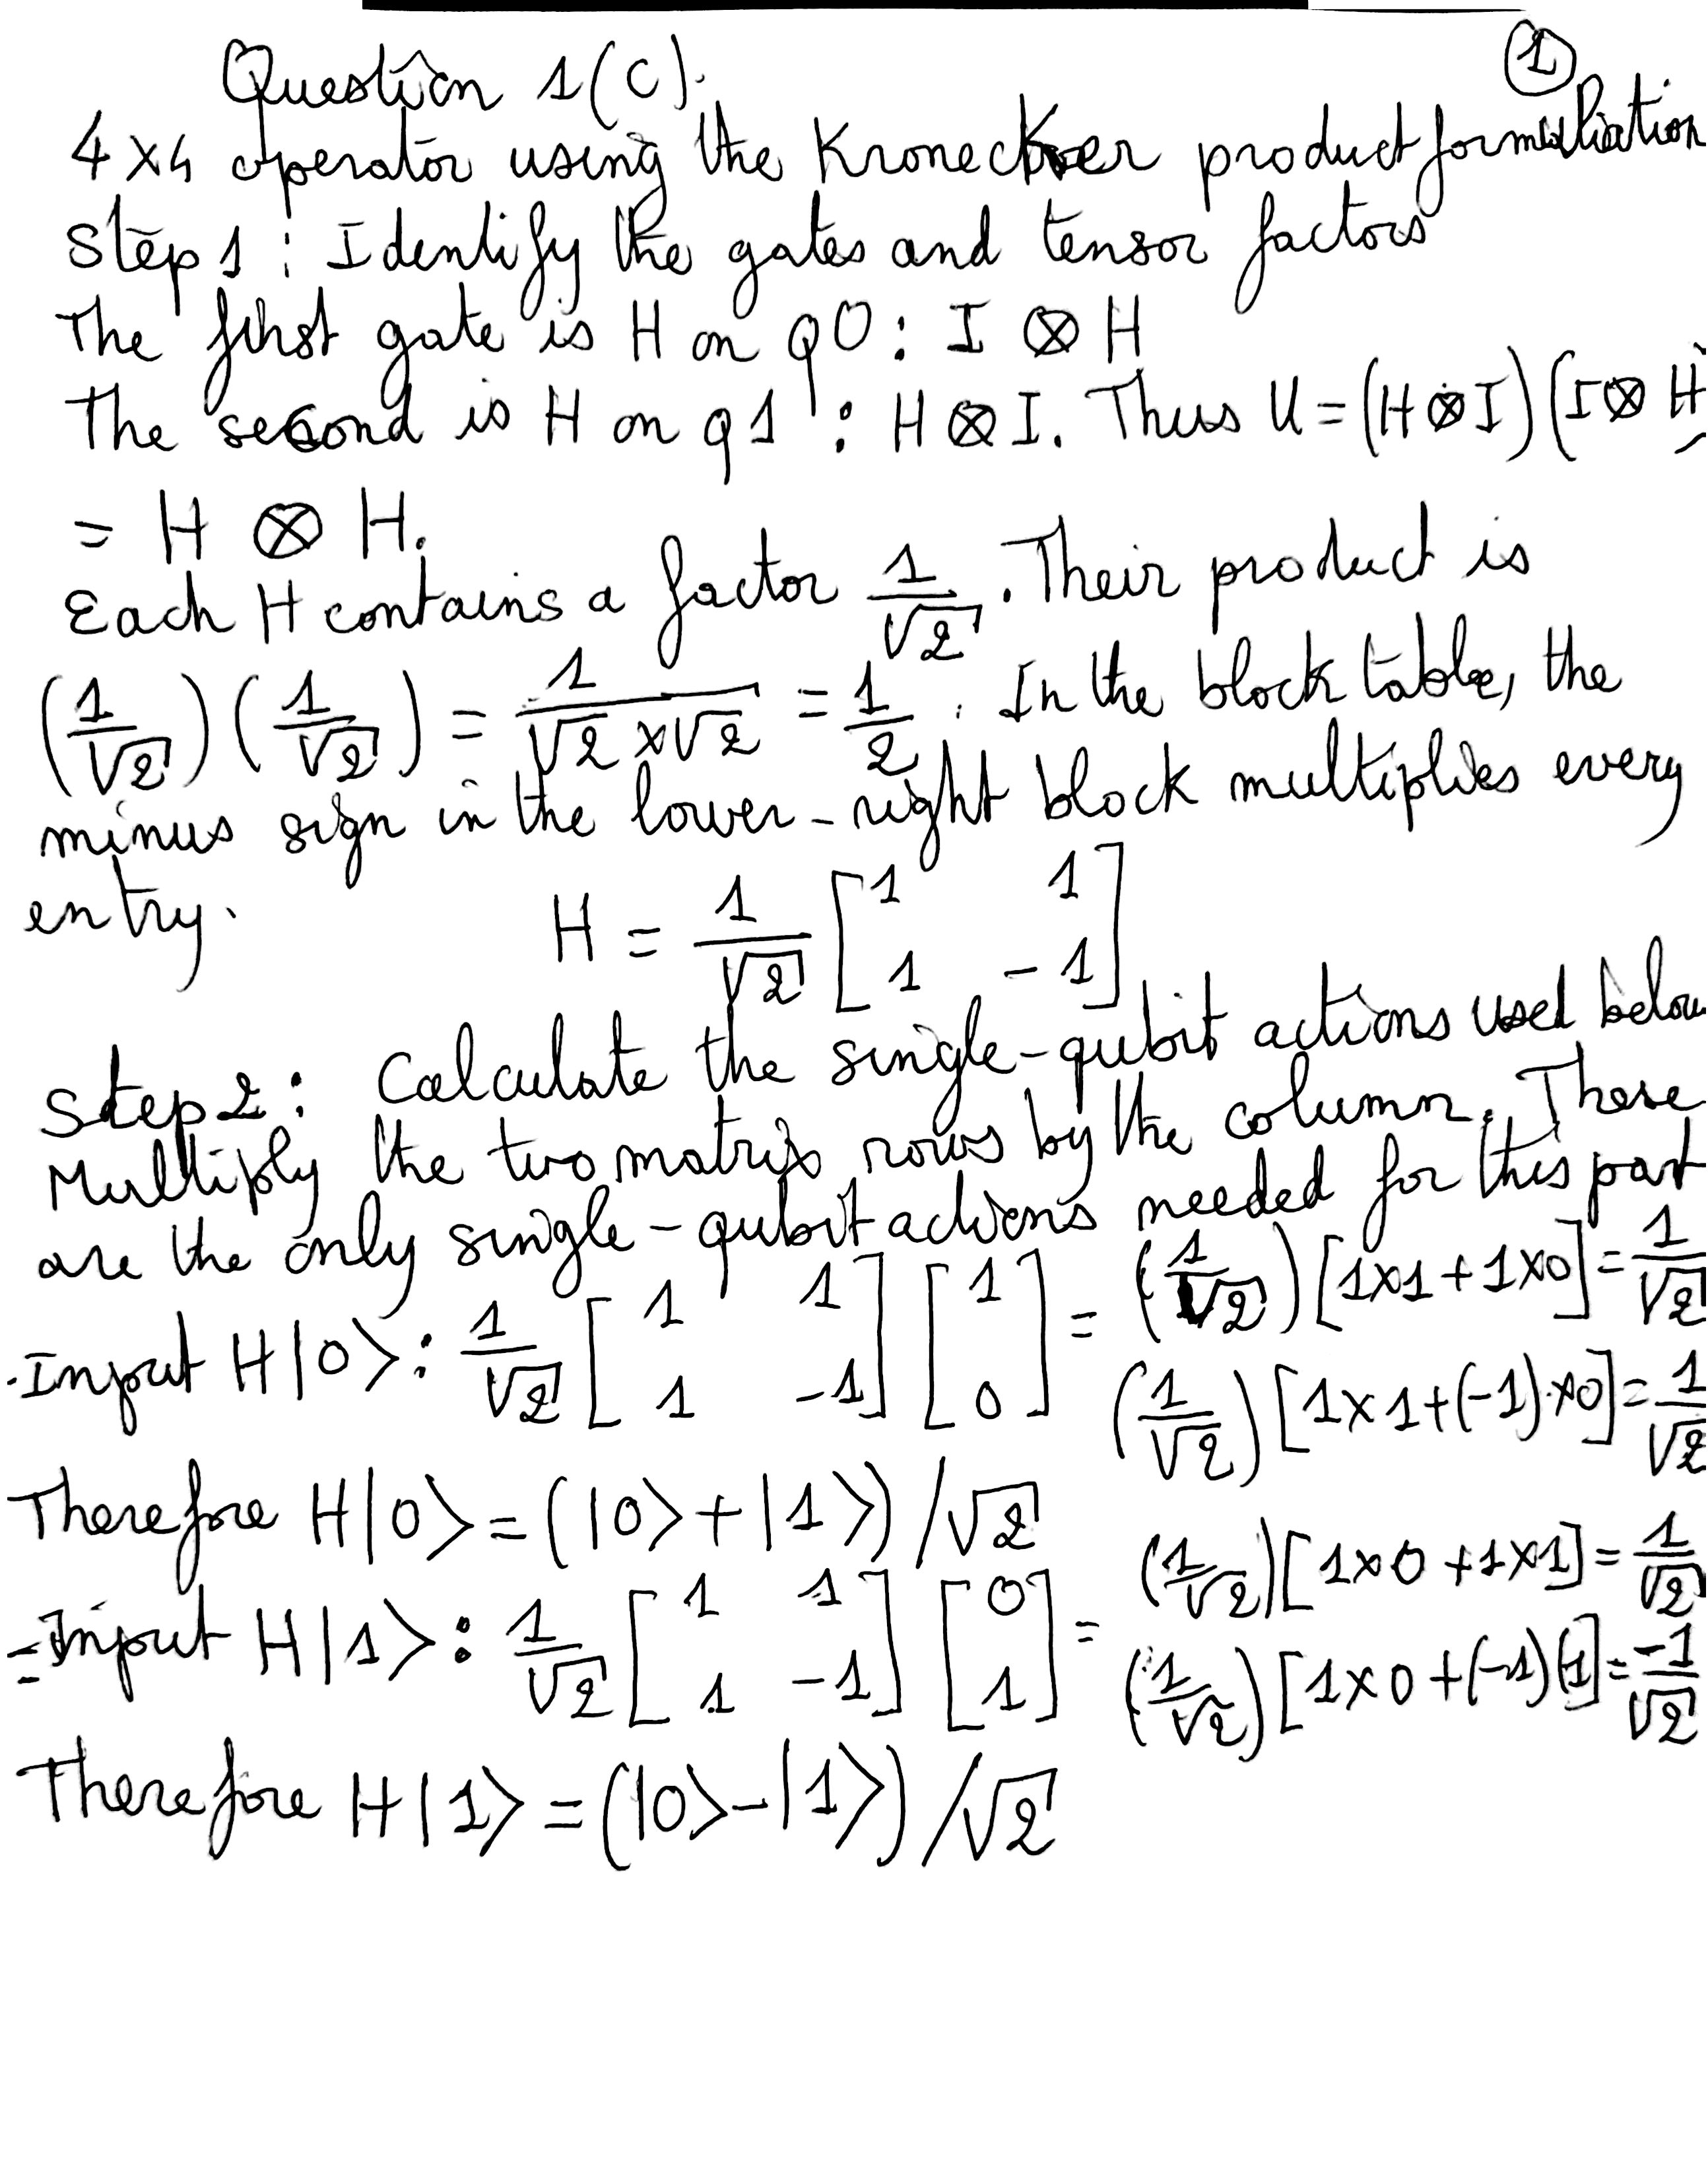

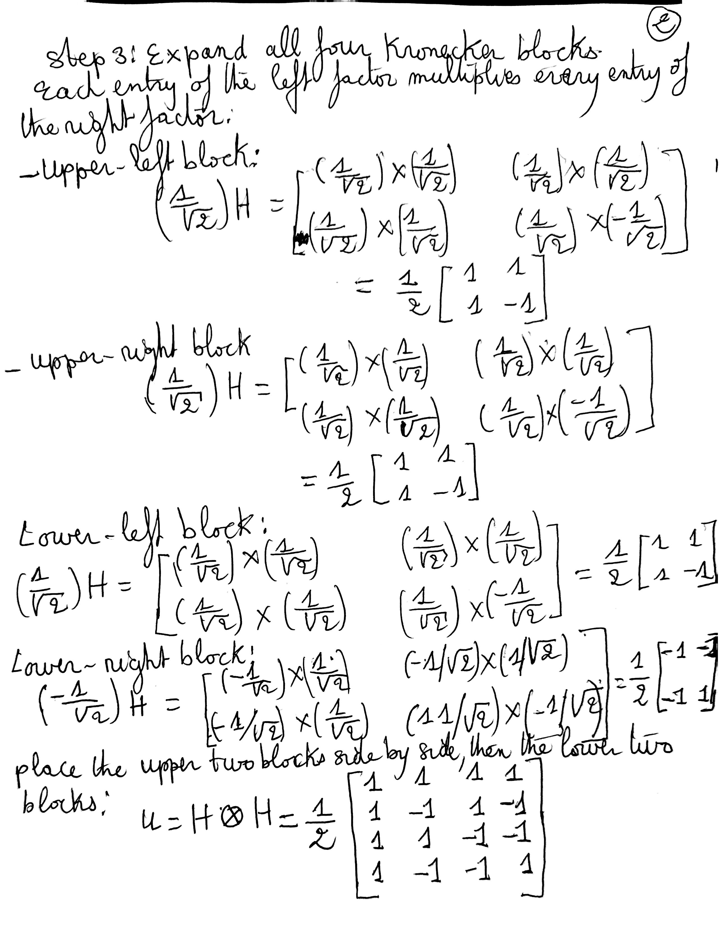
For clarity, the bottom-right entry of the lower-right block uses two negative factors:
$$\left( − \frac{1}{\sqrt{2}}\right)\left( − \frac{1}{\sqrt{2}}\right)=\frac{1}{2}.$$

Action of the Operator on the Kets: |00⟩, |01⟩, |10⟩, |11⟩
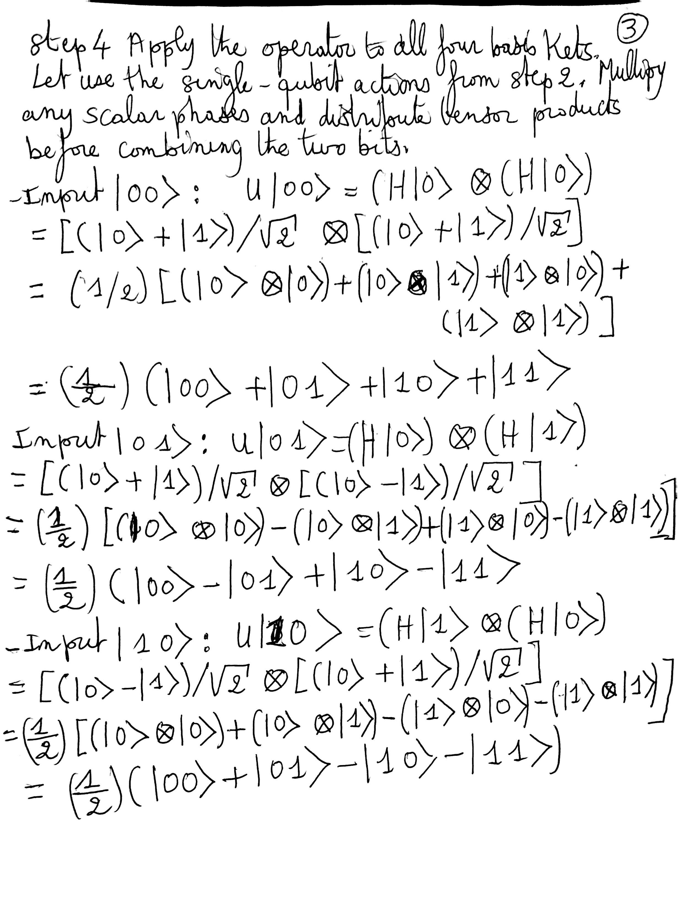

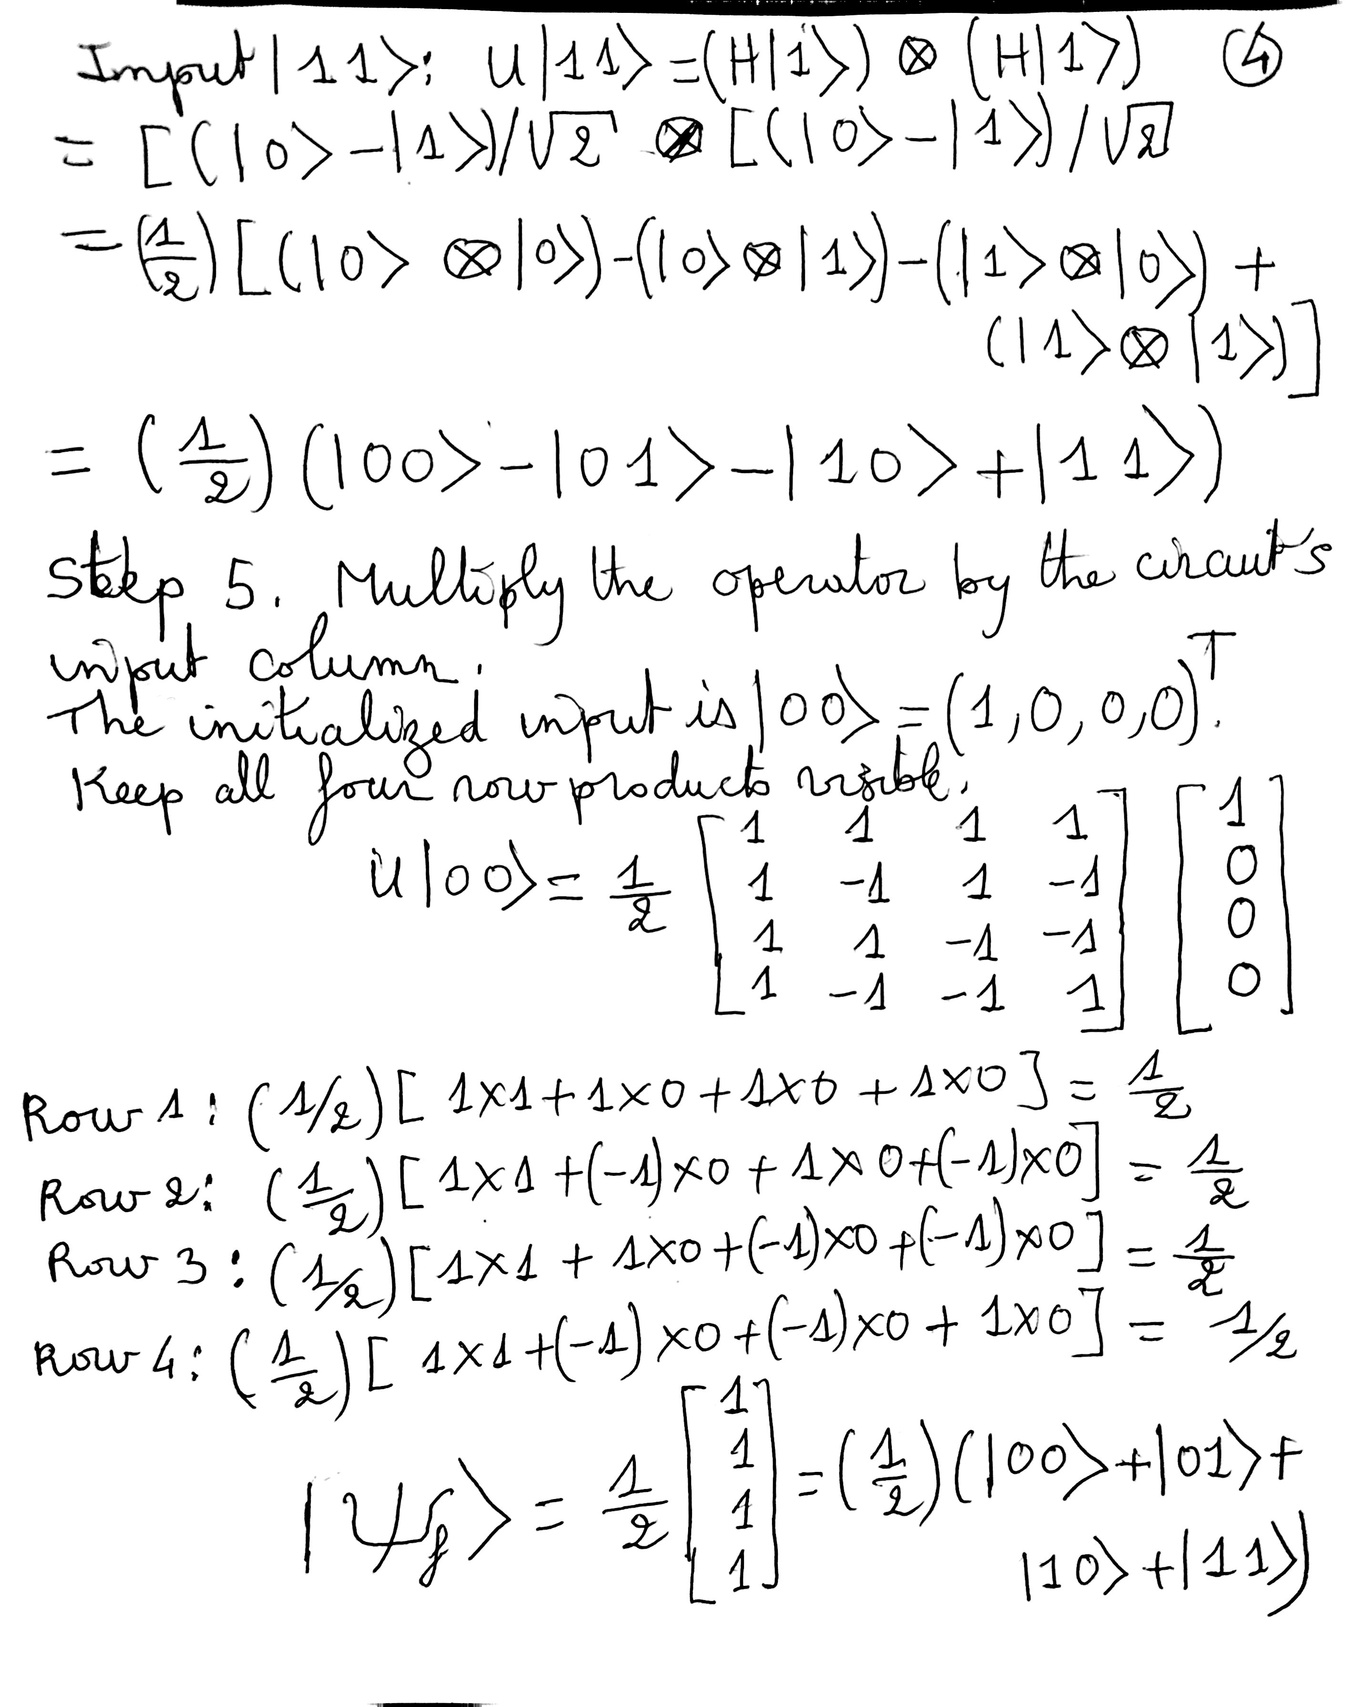

Probability Measurements
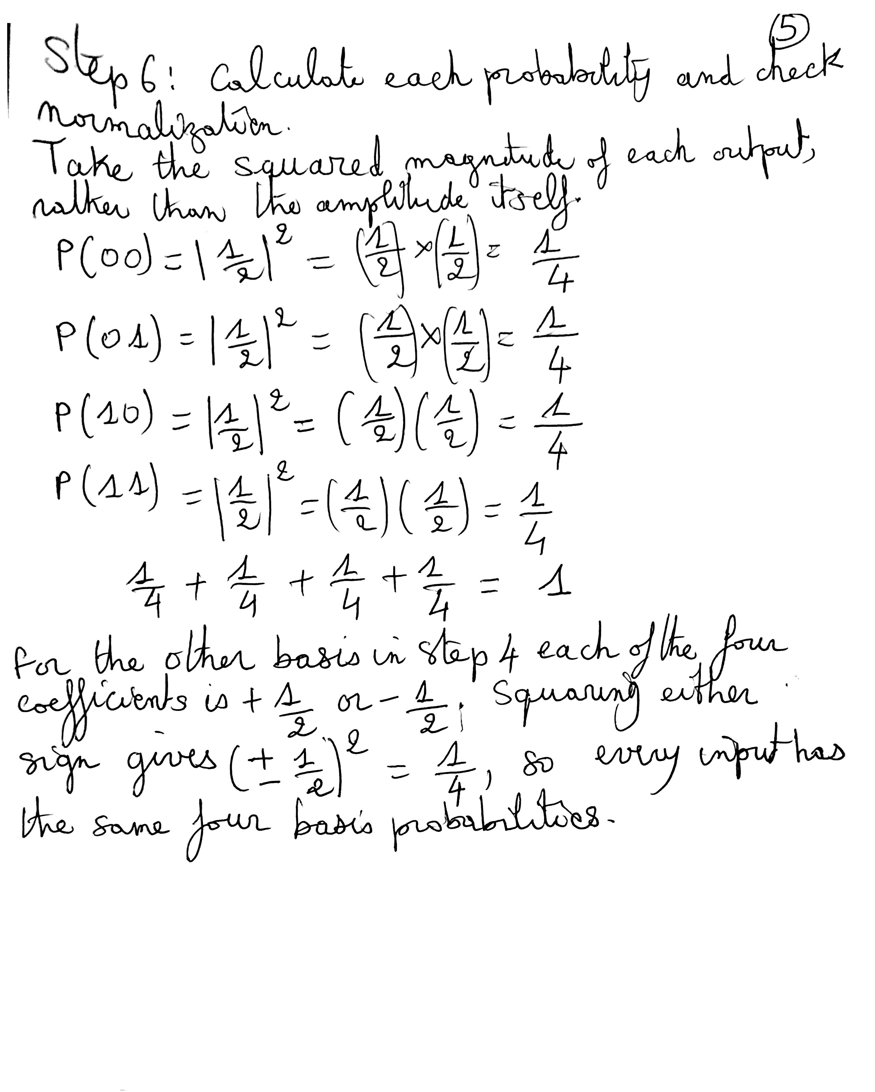

Verify the operator and all four basis actions, then compare the predicted probabilities with actual simulator counts.
In [6]
qc = QuantumCircuit(2)
qc.h(0)
qc.h(1)
counts_q1c = analyze(qc, np.kron(H, H), 'Question 1(c)')
Question 1(c): operator and all four basis actions verified against Qiskit.

Circuit Diagram: Question 1(c)
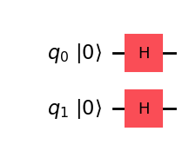
Wire order: q0 above q1; basis kets use |q1 q0⟩.
State vector at the circuit output:
$$|ψ_{f}⟩=\left[\begin{aligned}\frac{1}{2} \\ \frac{1}{2} \\ \frac{1}{2} \\ \frac{1}{2}\end{aligned}\right]$$
Outcome | Exact probability | Expected count | Observed count
00 | 0.25 | 256 | 264
01 | 0.25 | 256 | 275
10 | 0.25 | 256 | 252
11 | 0.25 | 256 | 233

Qiskit Histograms Verifying the Measurement Predictions
Qiskit measurement snapshot for input |00⟩. The horizontal axis shows q1q0 outcomes; the vertical axis shows counts.
In [7]
figure = plot_histogram(counts_q1c, title="Question 1(c)")
display(figure)
plt.close(figure)
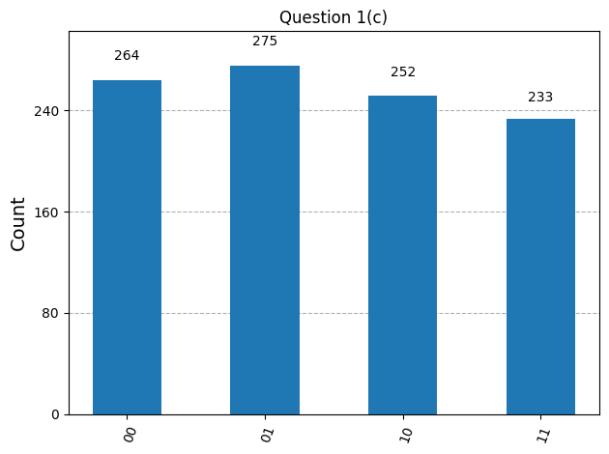
Actual simulator counts: 00: 264; 01: 275; 10: 252; 11: 233. The prediction is probability 1/4 for every outcome, or 256 counts per outcome on average. The observed bars are approximately equal; their small differences arise from finite-shot sampling in the ideal simulator. For one outcome, the count standard deviation is $σ=\sqrt{Np(1−p)}=\sqrt{1024(1/4)(3/4)}≈13.9$ counts. This gives the typical scale of variation across repeated runs; differences larger than one standard deviation can occur.

Question 1(d)

4×4 Operator Using the Kronecker Product Formulation
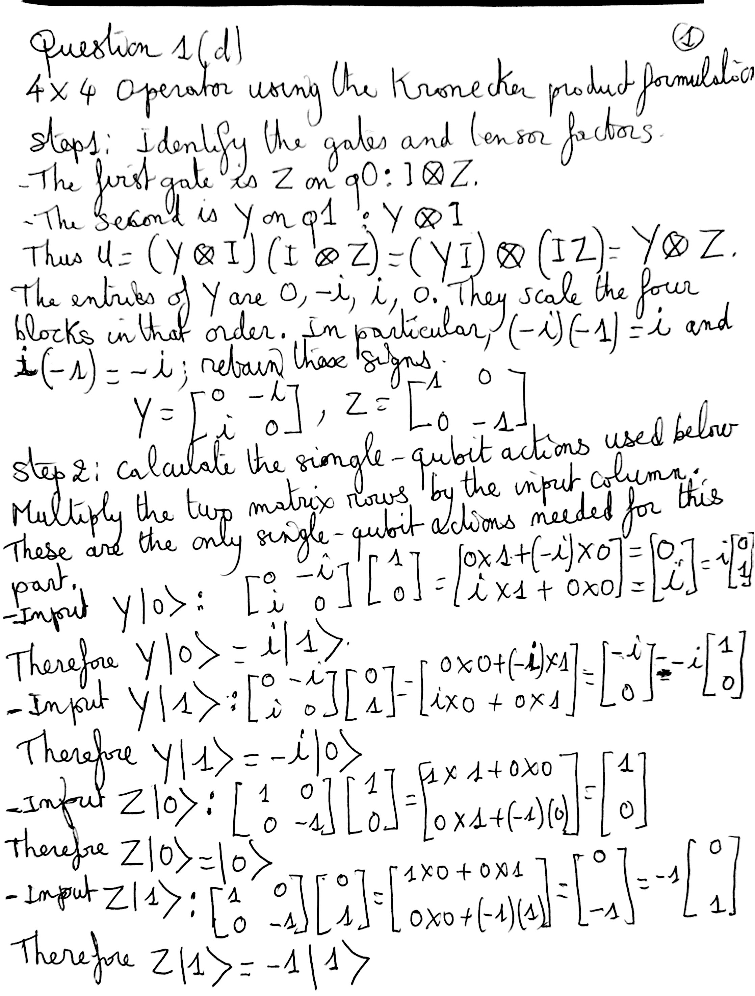

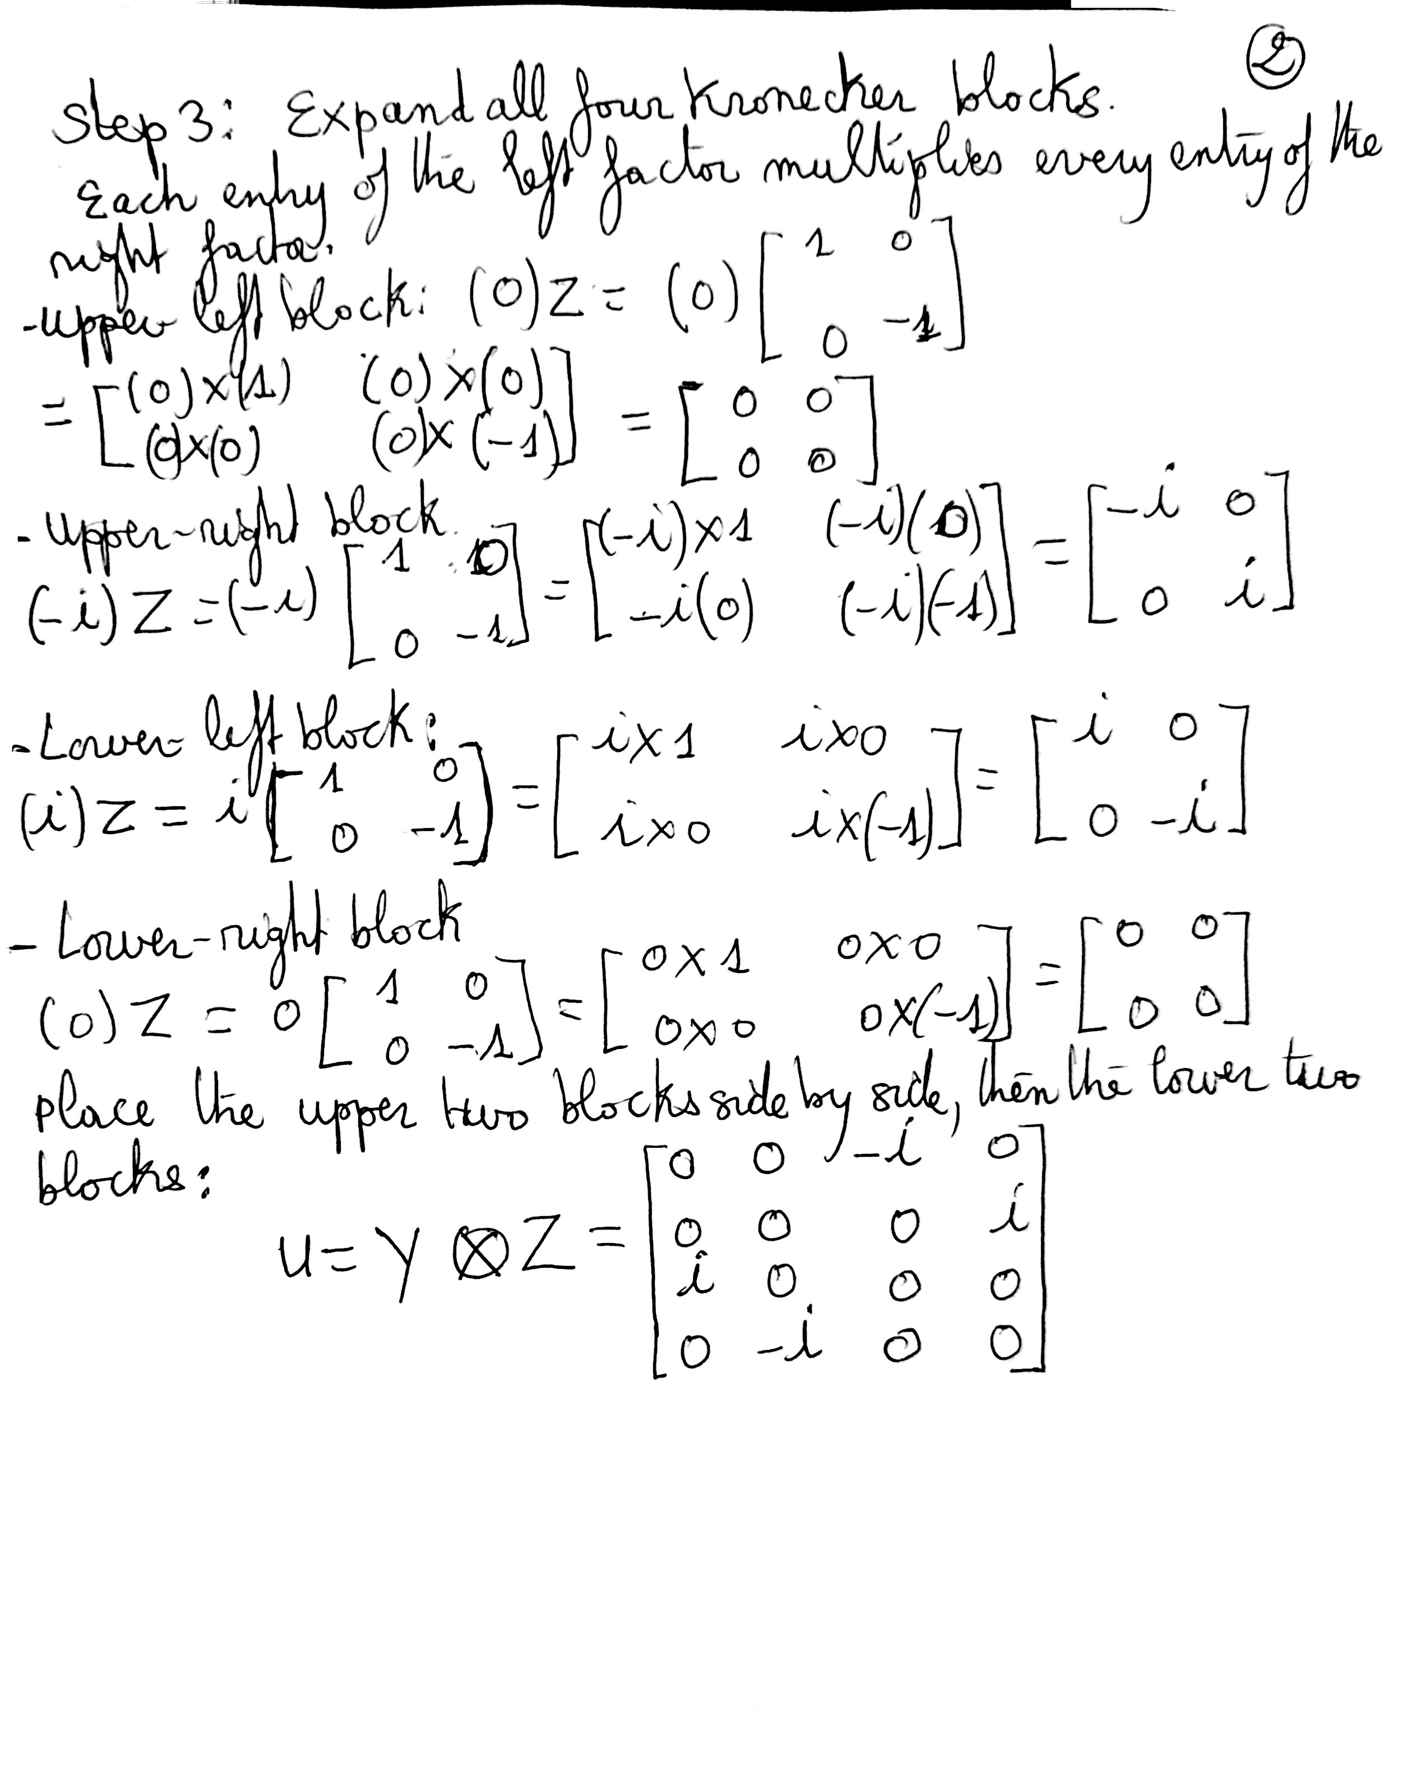

Action of the Operator on the Kets: |00⟩, |01⟩, |10⟩, |11⟩
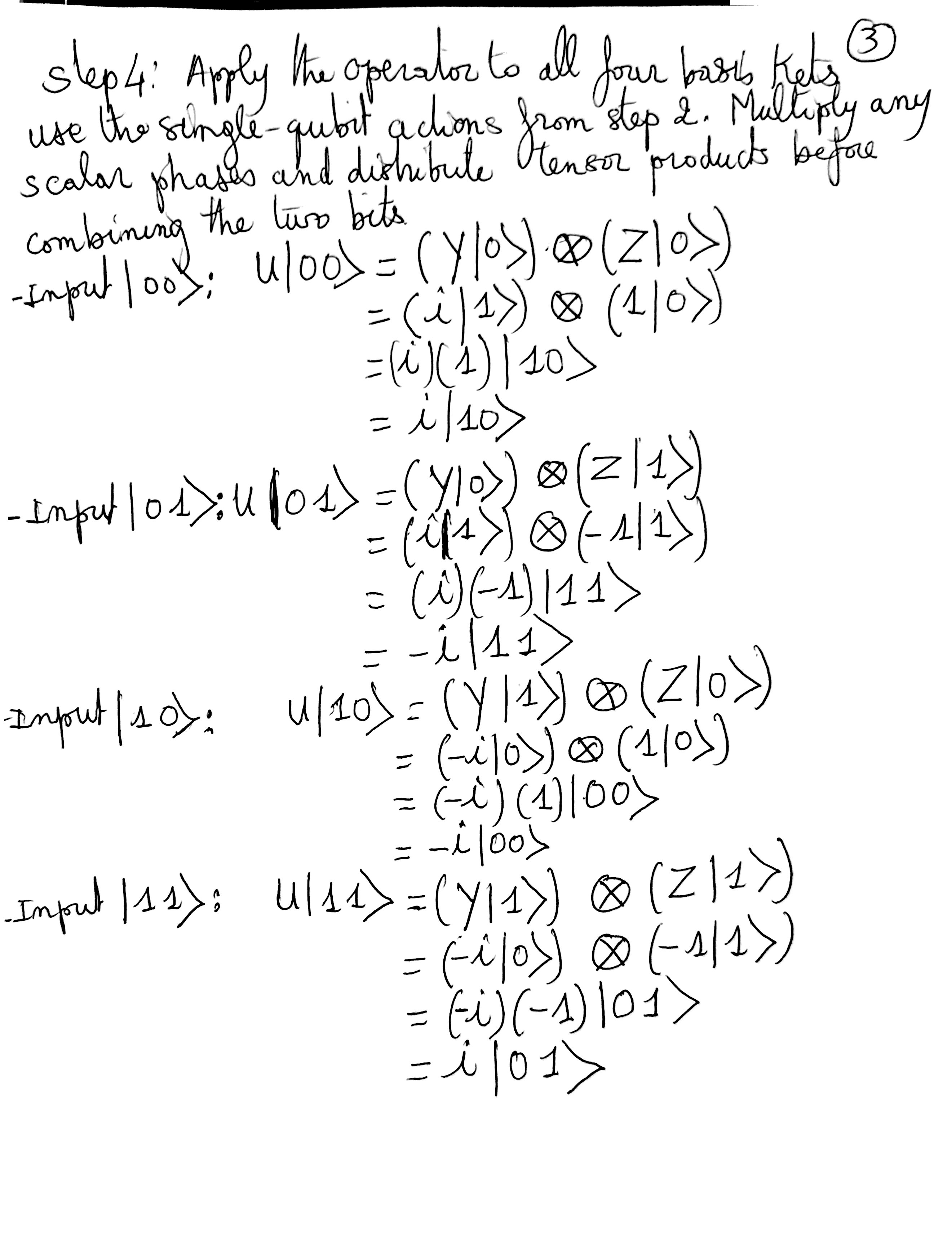

Probability Measurements
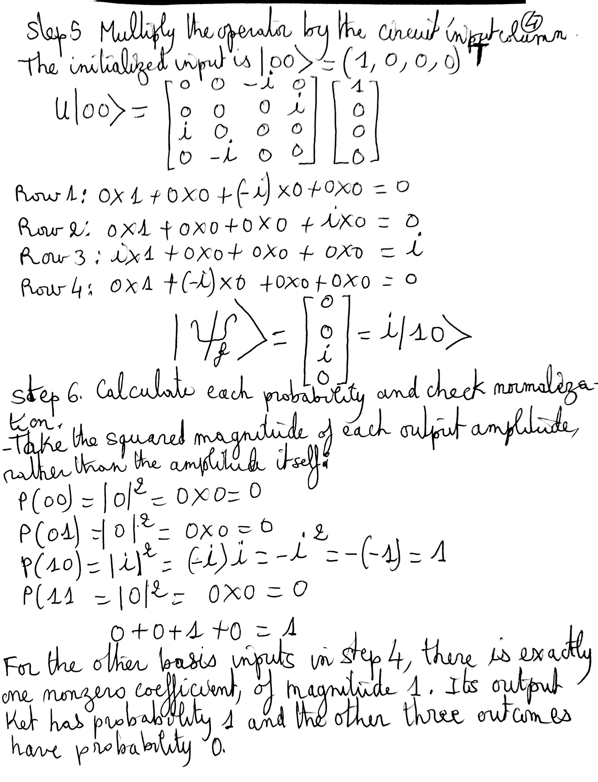

Verify the operator and all four basis actions, then compare the predicted probabilities with actual simulator counts.
In [8]
qc = QuantumCircuit(2)
qc.z(0)
qc.y(1)
counts_q1d = analyze(qc, np.kron(Y, Z), 'Question 1(d)')
Question 1(d): operator and all four basis actions verified against Qiskit.

Circuit Diagram: Question 1(d)
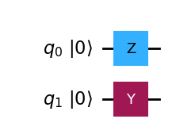
Wire order: q0 above q1; basis kets use |q1 q0⟩.
State vector at the circuit output:
$$|ψ_{f}⟩=\left[\begin{aligned}0 \\ 0 \\ i \\ 0\end{aligned}\right]$$
Outcome | Exact probability | Expected count | Observed count
00 | 0.00 | 0 | 0
01 | 0.00 | 0 | 0
10 | 1.00 | 1024 | 1024
11 | 0.00 | 0 | 0

Qiskit Histograms Verifying the Measurement Predictions
Qiskit measurement snapshot for input |00⟩. The horizontal axis shows q1q0 outcomes; the vertical axis shows counts.
In [9]
figure = plot_histogram(counts_q1d, title="Question 1(d)")
display(figure)
plt.close(figure)
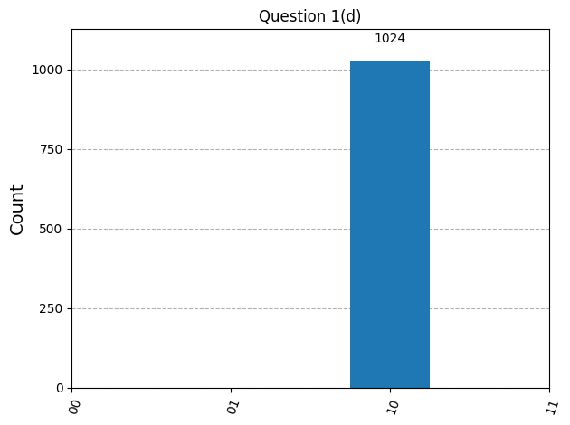
Actual simulator counts: 00: 0; 01: 0; 10: 1024; 11: 0. All 1024 shots give 10, matching P(10) = 1 and probability 0 for the other outcomes. The global phase i in i|10⟩ does not change measurement probabilities.

Question 2: Output State Vector
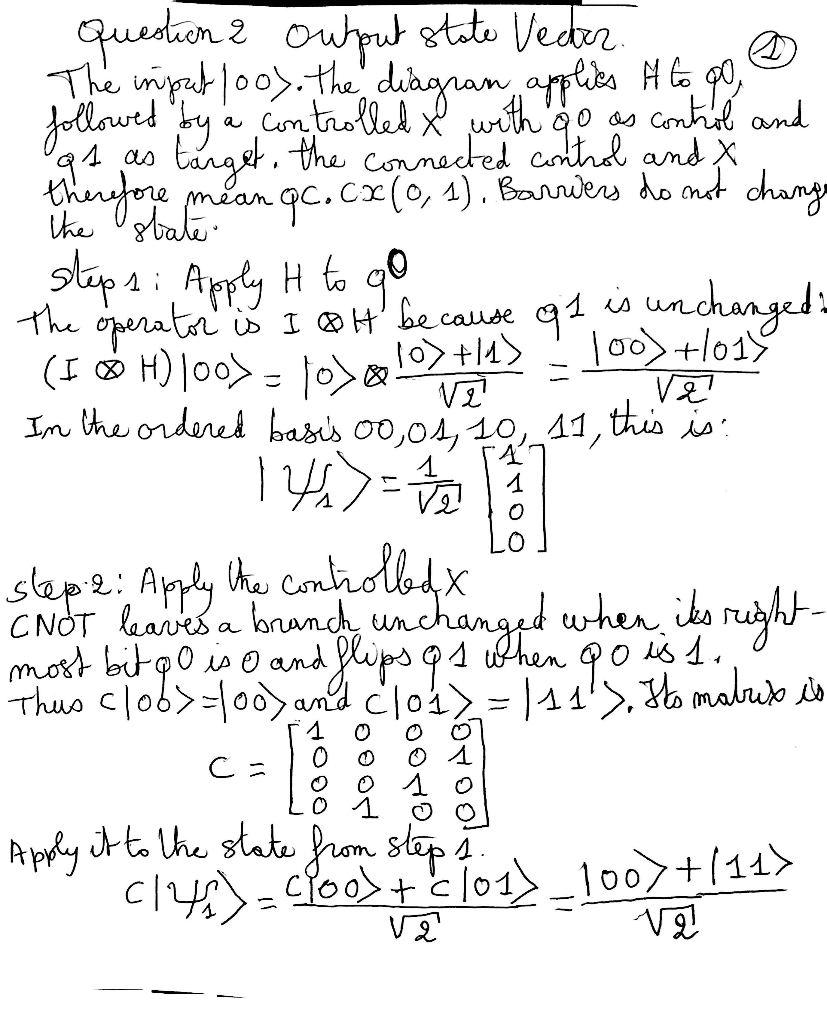

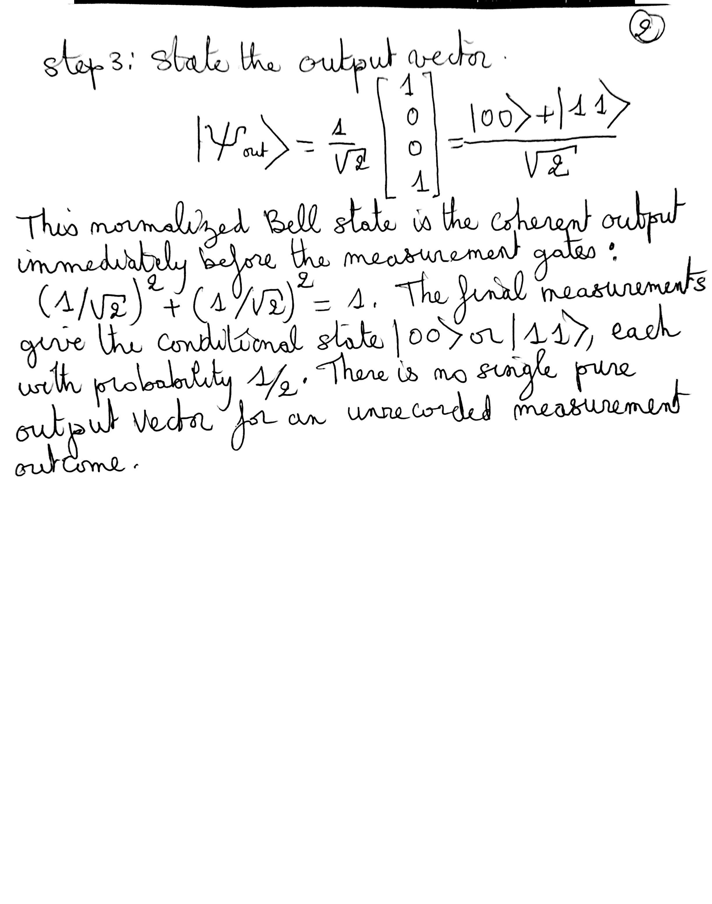

The Bell state above is entangled: it cannot be written as two independent single-qubit states. To see why, expand a possible product:
$$\left(a|0⟩+b|1⟩)⊗(c|0⟩+d|1⟩\right)$$
$$=ac|00⟩+ad|01⟩+bc|10⟩+bd|11⟩.$$
Matching the Bell state would require both ac and bd to equal 1/√2, so a, b, c, and d must all be nonzero. Then ad and bc would also be nonzero, contradicting the zero coefficients of |01⟩ and |10⟩. Therefore the output cannot be factored into separate qubit states.
The two qubits give matching measurement outcomes, 00 or 11, each with probability 1/2. A classical mixture of these two outcomes gives the same computational-basis probabilities. The ideal statevector calculation establishes the coherent Bell state produced before measurement.
Verify the state before measurement and display the circuit with the measurement gates shown in the assignment.
In [10]
qc2 = QuantumCircuit(2, 2)
qc2.barrier()
qc2.h(0)
qc2.cx(0, 1)
qc2.barrier()
psi_out = Statevector.from_label("00").evolve(qc2)
assert np.allclose(psi_out.data, np.array([1, 0, 0, 1]) / np.sqrt(2))
display(array_to_latex(psi_out.data.reshape(-1, 1), prefix=r"|\psi_{out}\rangle = "))
qc2.measure([0, 1], [0, 1])
display(Markdown("### Circuit Diagram: Question 2"))
figure = qc2.draw("mpl")
display(figure)
plt.close(figure)
$$|ψ_{out}⟩=\left[\begin{aligned}\frac{\sqrt{2}}{2} \\ 0 \\ 0 \\ \frac{\sqrt{2}}{2}\end{aligned}\right]$$

Circuit Diagram: Question 2
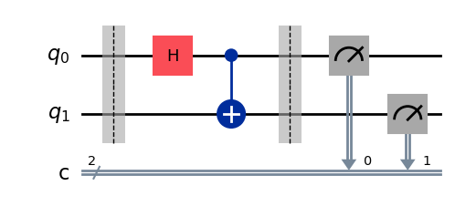

Observations for Questions 1 and 2
For the default input |00⟩, the predicted probabilities and recorded simulator counts are summarized below. Every count tuple uses the outcome order (00, 01, 10, 11), and each circuit was sampled with 1024 shots.
Circuit | Predicted probabilities | Observed counts
Question 1(a) | (0, 0, 0, 1) | (0, 0, 0, 1024)
Question 1(b) | (0, 1, 0, 0) | (0, 1024, 0, 0)
Question 1(c) | (1/4, 1/4, 1/4, 1/4) | (264, 275, 252, 233)
Question 1(d) | (0, 0, 1, 0) | (0, 0, 1024, 0)

The deterministic circuits agree exactly with their predictions: applying X to both qubits produces |11⟩, applying X only to q0 produces |01⟩, and the Y-and-Z circuit produces i|10⟩. The global phase i in this last output does not change its measurement probabilities. The four possible input kets and their phases are checked separately in the worked answers and verification code.
For Question 1(c), the Hadamard gates give probability 1/4 to each outcome. The observed counts are close to the expected 256 per outcome. Their unequal heights reflect finite-shot sampling; the previously calculated count standard deviation is about 13.9. These measurements come from an ideal simulator and do not measure physical device noise.
For Question 2, the verified output vector has equal nonzero amplitudes only for |00⟩ and |11⟩, giving the Bell state (|00⟩ + |11⟩)/√2 before measurement. The state is entangled, and the predicted measurement outcomes are 00 and 11, each with probability 1/2. The statevector calculation also retains the coherence that a measurement histogram alone cannot establish.

Question 3: Representation of Qubits on an IBM Quantum Computer
IBM implements physical qubits using superconducting transmon circuits, which contain a Josephson junction connected in parallel with a capacitor (IBM, n.d.). The junction makes the circuit an anharmonic oscillator: successive energy levels have different spacings, allowing a microwave drive to address the qubit transition selectively (Koch et al., 2007). A large shunt capacitance reduces sensitivity to charge noise (Koch et al., 2007). The ground and first excited energy states represent |0⟩ and |1⟩. Within this two-state computational subspace, a pure qubit state is |ψ⟩ = α|0⟩ + β|1⟩, where the complex amplitudes satisfy |α|² + |β|² = 1; their magnitudes and relative phase specify the state (Krantz et al., 2019). A transmon physically has higher energy levels, so pulse shaping suppresses unintended excitation outside |0⟩ and |1⟩ (Krantz et al., 2019).
The processor operates inside a dilution refrigerator at millikelvin temperatures to support superconductivity and reduce thermal excitation (Krantz et al., 2019). Calibrated microwave pulses control the qubit state and implement gates (IBM, n.d.). Measurement uses a coupled microwave resonator whose response depends on the qubit state; the amplified signal is classified as a classical 0 or 1 (Krantz et al., 2019). Ideally, measuring α|0⟩ + β|1⟩ produces 0 with probability |α|² and 1 with probability |β|². Repeated preparations estimate these probabilities; a single measurement does not reveal both complex amplitudes (Krantz et al., 2019). Energy relaxation, loss of relative phase (dephasing), and readout errors limit physical devices (Krantz et al., 2019).

References
IBM. (n.d.). Running quantum circuits. IBM Quantum Learning. https://quantum.cloud.ibm.com/learning/en/courses/quantum-computing-in-practice/running-quantum-circuits
Koch, J., Yu, T. M., Gambetta, J., Houck, A. A., Schuster, D. I., Majer, J., Blais, A., Devoret, M. H., Girvin, S. M., & Schoelkopf, R. J. (2007). Charge-insensitive qubit design derived from the Cooper pair box. Physical Review A, 76(4), Article 042319. https://doi.org/10.1103/PhysRevA.76.042319
Krantz, P., Kjaergaard, M., Yan, F., Orlando, T. P., Gustavsson, S., & Oliver, W. D. (2019). A quantum engineer's guide to superconducting qubits. Applied Physics Reviews, 6(2), Article 021318. https://doi.org/10.1063/1.5089550

