Quantum Computation
Assignment 2
Single-Qubit State Vectors, Pauli Gates and the Hadamard Gate in Qiskit

Student | Albert Kabore  PhD student in Advanced and Equitable Computing
 | ______________________
Course | Quantum Computation
Date | October 5, 2026
Software | Python 3.11 · Qiskit 2.5.2 · Qiskit Aer 0.17.2
Companion notebook | Assignment2_Quantum_Circuits.ipynb

Question 1 - Showing that |ψ⟩ is a valid state vector
The question gives |ψ⟩ = (i/2)|0⟩ + (√3 e^(iπ/6)/2)|1⟩. Use the computational basis |0⟩ = (1, 0)ᵀ and |1⟩ = (0, 1)ᵀ. These vectors are orthonormal: ⟨0|0⟩ = ⟨1|1⟩ = 1 and ⟨0|1⟩ = ⟨1|0⟩ = 0.
The conjugate transpose is ⟨ψ| = (−i/2)⟨0| + (√3 e^(−iπ/6)/2)⟨1|. Expanding ⟨ψ|ψ⟩ gives |a₀|²⟨0|0⟩ + a₀* a₁⟨0|1⟩ + a₁* a₀⟨1|0⟩ + |a₁|²⟨1|1⟩. The two cross terms vanish because the basis vectors are orthogonal.
|a₀|² = (−i/2)(i/2) = −i²/4 = 1/4. Also, |a₁|² = (√3/2)² e^(−iπ/6)e^(iπ/6) = (3/4)e⁰ = 3/4. Thus ⟨ψ|ψ⟩ = 1/4 + 3/4 = 1 and ‖ψ‖ = √1 = 1. This proves the required normalization without treating complex amplitudes as ordinary real squares.
As an independent algebra check, e^(iπ/6) = √3/2 + i/2, so a₁ = 3/4 + i√3/4. Its squared magnitude is (3/4)² + (√3/4)² = 9/16 + 3/16 = 3/4.
Question
Given the single-qubit state vector $|ψ⟩=a_{0}|0⟩+a_{1}|1⟩$, show that the following ket is a valid state vector (i.e. its magnitude is normalised to one): $|ψ⟩=\frac{i}{2}|0⟩+\frac{\sqrt{3} e^{iπ/6}}{2}|1⟩$

Step 1 – Identify the amplitudes
For |ψ⟩ = a₀|0⟩ + a₁|1⟩, the amplitudes are:
$a_{0}=\frac{i}{2}, a_{1}=\frac{\sqrt{3} e^{iπ/6}}{2}$
A valid normalized state must satisfy |a₀|² + |a₁|² = 1.

Step 2 – Squared magnitude of a₀
Multiply the amplitude by its complex conjugate:
$|a_{0}|^{2}=a_{0} a_{0}^{*}=\left(\frac{i}{2}\right)\left(\frac{-i}{2}\right)=\frac{-i^{2}}{4}=\frac{-(-1)}{4}=\frac{1}{4}$

Step 3 – Squared magnitude of a₁
The phase has magnitude one, so:
$|a_{1}|^{2}=\left(\frac{\sqrt{3} e^{iπ/6}}{2}\right)\left(\frac{\sqrt{3} e^{-iπ/6}}{2}\right)=\frac{3}{4} e^{iπ/6-iπ/6}=\frac{3}{4} e^{0}=\frac{3}{4}$

Step 4 - Normalization
$⟨ψ|ψ⟩=|a_{0}|^{2}+|a_{1}|^{2}=\frac{1}{4}+\frac{3}{4}=1$
Thus the norm is the square root of 1, which is 1. The given ket is a valid normalized state vector.
Conclusion for Question 1
Since $⟨ψ|ψ⟩=1$, the magnitude of $|ψ⟩$ is normalised to one, so it is a valid single-qubit state vector. Physically, a measurement would give 0 with probability $P(|0⟩)=\frac{1}{4}=25\%$ and 1 with probability $P(|1⟩)=\frac{3}{4}=75\%$. Note that the phases $i$ and $e^{iπ/6}$ do not change these probabilities; only the magnitudes matter.

Question 2 - H|0⟩, Y|0⟩ and Z|0⟩ in Qiskit
The three requested inputs are |0⟩, independently of the state in Question 1. H is the Hadamard gate; Y and Z are Pauli gates. Although the instructions recall X, they request implementations only of H|0⟩, Y|0⟩ and Z|0⟩.
For an output b₀|0⟩ + b₁|1⟩, computational-basis measurement obeys the Born rule: P(|0⟩) = |b₀|² and P(|1⟩) = |b₁|². Derive these amplitudes by matrix multiplication before comparing them with simulator output. State vectors are computed before measurement; the measured circuit then produces classical counts.
Question
Using qc = QuantumCircuit(1,1) and the gate syntax qc.x(0), qc.y(0), qc.z(0) (and qc.h(0)), implement (a) $H|0⟩$, (b) $Y|0⟩$, (c) $Z|0⟩$. For each: (i) measure and show the histogram, (ii) show the circuit drawn with draw(), (iii) derive the output state and $P(|0⟩)$, $P(|1⟩)$ and verify them against the histogram, (iv) put everything in one document.

Gate | Qiskit call | Action on |0⟩ | Action on |1⟩ | Intuition
$$X$$ | qc.x(0) | $$|1⟩$$ | $$|0⟩$$ | Bit flip (quantum NOT)
$$Y$$ | qc.y(0) | $$i|1⟩$$ | $$-i|0⟩$$ | Bit flip + phase flip
$$Z$$ | qc.z(0) | $$|0⟩$$ | $$-|1⟩$$ | Phase flip
$$H$$ | qc.h(0) | $$\frac{|0⟩+|1⟩}{\sqrt{2}}$$ | $$\frac{|0⟩-|1⟩}{\sqrt{2}}$$ | Creates equal superposition

Implementation
Each circuit uses one qubit initialized in |0⟩ and one classical bit. The notebook implements the following steps:
1. qc = QuantumCircuit(1, 1) creates 1 qubit and 1 classical bit. These ideal simulations start the qubit in $|0⟩$.
2. The gate is applied, e.g. qc.h(0) acts on qubit 0.
3. Statevector.from_instruction(qc) gives the exact output state, used to double-check the hand-derived prediction.
4. qc.measure(0, 0) stores the measurement result in the classical bit. The circuit is drawn with qc.draw() and run 1024 times (shots) on the AerSimulator (seed 42 for reproducibility). plot_histogram then shows how often each outcome occurred.
Each shot starts from a fresh |0⟩ state. The histograms show counts; dividing by 1024 gives the observed frequencies. These simulations use no noise model.

(a) H|0⟩
Detailed hand calculation: H = (1/√2)[[1, 1], [1, −1]]. Multiplying by (1, 0)ᵀ gives (1/√2)(1·1 + 1·0, 1·1 + (−1)·0)ᵀ = (1/√2, 1/√2)ᵀ. Hence H|0⟩ = (|0⟩ + |1⟩)/√2.
Both amplitudes are 1/√2, so P(|0⟩) = (1/√2)*(1/√2) = 1/2 and P(|1⟩) = 1/2. Their sum is 1. For 1024 shots the expected counts are 512 and 512; expected counts are averages over repeated experiments, not a requirement that every run gives exactly these counts.

Qiskit code
qc = QuantumCircuit(1, 1)
qc.h(0)
state = Statevector.from_instruction(qc)
qc.measure(0, 0)
print(qc.draw())
sim = AerSimulator()
raw = sim.run(transpile(qc, sim, seed_transpiler=42), shots=1024, seed_simulator=42).result().get_counts()
counts = {k: raw.get(k, 0) for k in ("0", "1")}
print("Statevector:", np.round(state.data, 4))
print("Counts:", counts)
print("Observed frequencies:", {k: v / 1024 for k, v in counts.items()})
display(plot_histogram(counts))
Output (the generated histogram appears below with its mathematical verification):
┌───┐┌─┐
q: ┤ H ├┤M├
└───┘└╥┘
c: 1/══════╩═
0
Statevector: [0.7071+0.j 0.7071+0.j]
Counts: {'0': 526, '1': 498}
Observed frequencies: {'0': 0.513671875, '1': 0.486328125}
Figure(640x480)

(ii) Circuit after running draw()

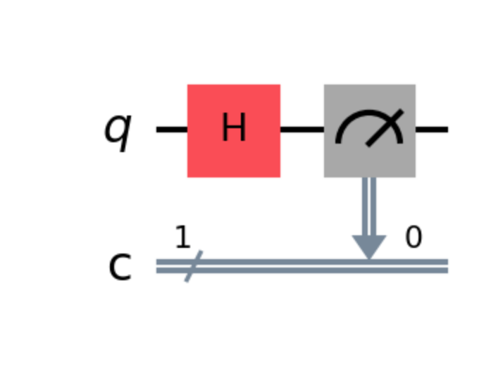

Figure 1a - Screenshot of the executed notebook circuit output for H|0>, drawn with qc.draw("mpl"), including measurement into classical bit 0.

(iii) Mathematical prediction
Using |0⟩ = (1, 0)ᵀ, multiply by the Hadamard matrix:
$H|0⟩=\frac{1}{\sqrt{2}}\left(\begin{matrix}1 & 1 \\ 1 & -1\end{matrix}\right)\left(\begin{aligned}1 \\ 0\end{aligned}\right)=\frac{1}{\sqrt{2}}\left(\begin{aligned}1·1+1·0 \\ 1·1+(-1)·0\end{aligned}\right)=\frac{1}{\sqrt{2}}\left(\begin{aligned}1 \\ 1\end{aligned}\right)$
Writing the column vector back in ket form:
$H|0⟩=\frac{1}{\sqrt{2}}|0⟩+\frac{1}{\sqrt{2}}|1⟩=|+⟩$
This is the equal superposition state, often called $|+⟩$. Qiskit’s Statevector gives [0.7071+0.j, 0.7071+0.j], and $\frac{1}{\sqrt{2}}≈0.7071$ ✔.

Predicted probabilities
$P(|0⟩)={\left|\frac{1}{\sqrt{2}}\right|}^{2}=\frac{1}{2}=0.5, P(|1⟩)={\left|\frac{1}{\sqrt{2}}\right|}^{2}=\frac{1}{2}=0.5$
Check: $0.5+0.5=1$ ✔. Expected counts for 1024 shots: $1024×0.5=512$ for each outcome.

(i) Measurement histogram
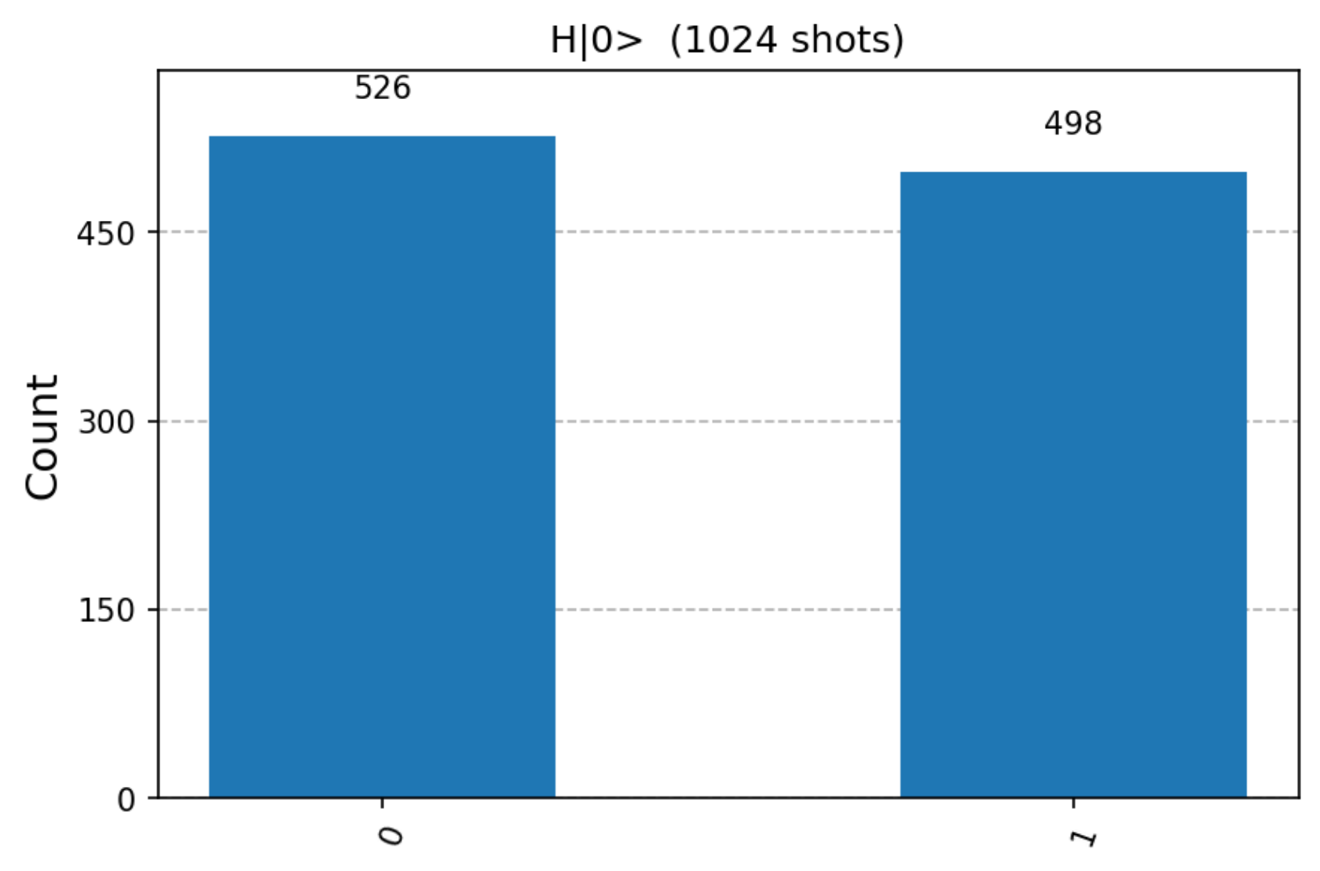

Figure 1b - Screenshot of the executed notebook measurement histogram for H|0>, 1024 shots: 526 zeros and 498 ones.

Verification
The histogram shows 526 zeros and 498 ones, i.e. relative frequencies
$\hat{P}(|0⟩)=\frac{526}{1024}≈0.514, \hat{P}(|1⟩)=\frac{498}{1024}≈0.486$
The observed frequencies 526/1024 - 0.5137 and 498/1024 - 0.4863 are close to the predicted 0.5 and 0.5. The small difference is consistent with finite sampling.

(b) Y|0⟩
Detailed hand calculation: Y = [[0, −i], [i, 0]]. Therefore Y(1, 0)ᵀ = (0·1 + (−i)·0, i·1 + 0·0)ᵀ = (0, i)ᵀ = i|1⟩.
The output amplitudes are b₀ = 0 and b₁ = i. Thus P(|0⟩) = 0 and P(|1⟩) = i* i = (−i)i = 1. The factor i multiplies the entire state by a global phase, so it does not change the outcome probabilities. Every ideal shot yields 1.

Qiskit code
qc = QuantumCircuit(1, 1)
qc.y(0)
state = Statevector.from_instruction(qc)
qc.measure(0, 0)
print(qc.draw())
sim = AerSimulator()
raw = sim.run(transpile(qc, sim, seed_transpiler=42), shots=1024, seed_simulator=42).result().get_counts()
counts = {k: raw.get(k, 0) for k in ("0", "1")}
print("Statevector:", np.round(state.data, 4))
print("Counts:", counts)
print("Observed frequencies:", {k: v / 1024 for k, v in counts.items()})
display(plot_histogram(counts))
Output (the generated histogram appears below with its mathematical verification):
┌───┐┌─┐
q: ┤ Y ├┤M├
└───┘└╥┘
c: 1/══════╩═
0
Statevector: [0.+0.j 0.+1.j]
Counts: {'0': 0, '1': 1024}
Observed frequencies: {'0': 0.0, '1': 1.0}
Figure(640x480)

(ii) Circuit after running draw()

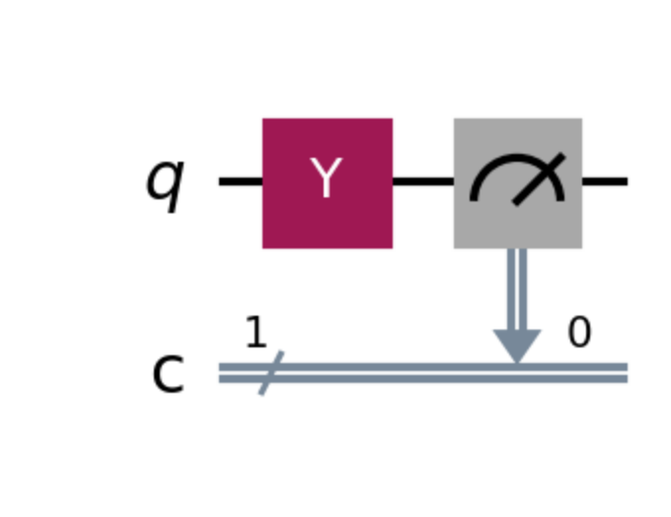

Figure 2a - Screenshot of the executed notebook circuit output for Y|0>, drawn with qc.draw("mpl"), including measurement into classical bit 0.

(iii) Mathematical prediction
Multiply $|0⟩$ by the Pauli-Y matrix:
$Y|0⟩=\left(\begin{matrix}0 & -i \\ i & 0\end{matrix}\right)\left(\begin{aligned}1 \\ 0\end{aligned}\right)=\left(\begin{aligned}0·1+(-i)·0 \\ i·1+0·0\end{aligned}\right)=\left(\begin{aligned}0 \\ i\end{aligned}\right)$
In ket form:
$Y|0⟩=0 |0⟩+i |1⟩=i|1⟩$
Qiskit gives the state vector (0, i)ᵀ, agreeing with the derivation. The factor i is a global phase and does not change the measurement probabilities.

Predicted probabilities
$P(|0⟩)=|0|^{2}=0, P(|1⟩)=|i|^{2}=i·(-i)=-i^{2}=1$
Check: $0+1=1$ ✔. Expected counts: 0 for '0' and all 1024 for '1'.

(i) Measurement histogram
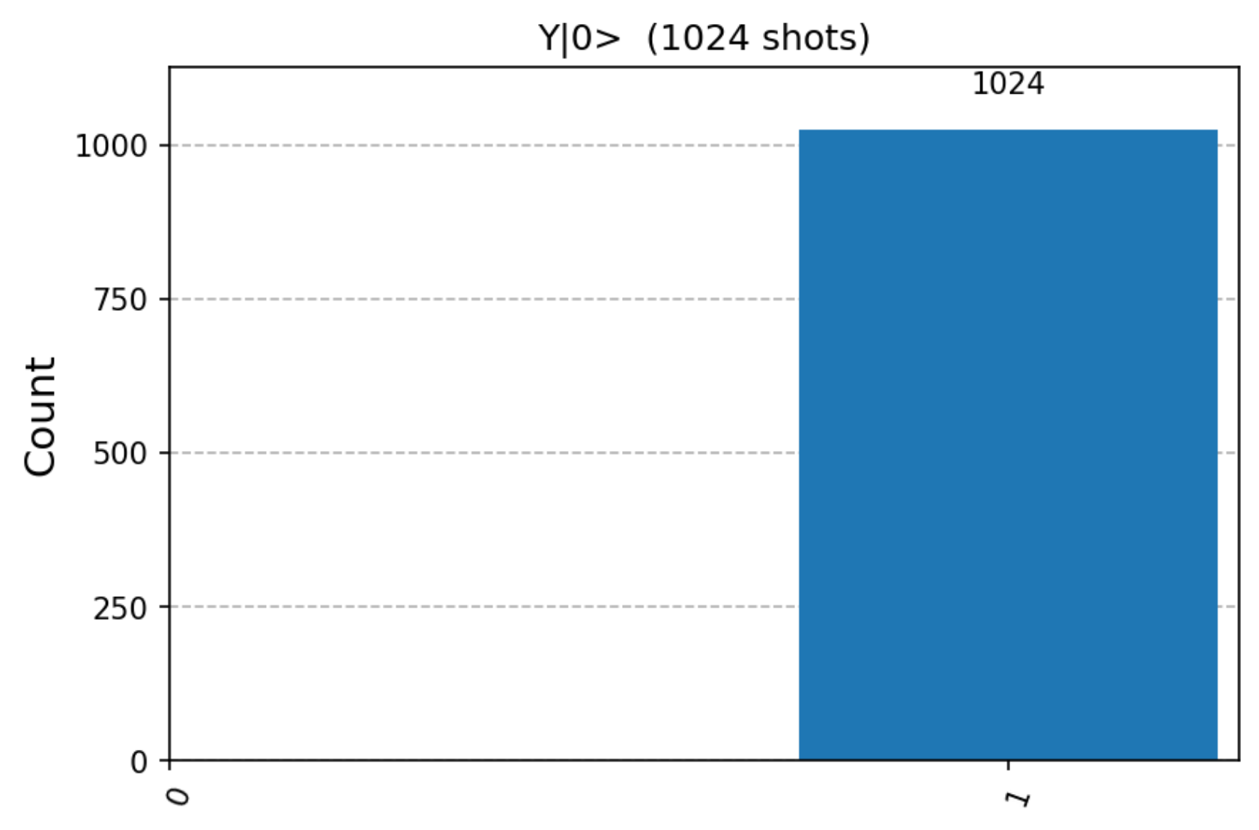

Figure 2b - Screenshot of the executed notebook measurement histogram for Y|0>, 1024 shots: 0 zeros and 1024 ones.

Verification
The histogram shows 1024 counts of '1' and 0 counts of '0', so $\hat{P}(|1⟩)=1024/1024=1$ and $\hat{P}(|0⟩)=0$. This matches the prediction exactly. In this ideal noiseless simulation, a probability of 1 is deterministic, so there is no statistical spread.
Why does the factor i not show up in the histogram?
Y|0⟩ = i|1⟩ differs from |1⟩ by a global phase. The squared magnitude is |i|² = (−i)i = 1, so computational-basis measurement gives outcome 1 with certainty.

(c) Z|0⟩
Detailed hand calculation: Z = [[1, 0], [0, −1]]. Therefore Z(1, 0)ᵀ = (1·1 + 0·0, 0·1 + (−1)·0)ᵀ = (1, 0)ᵀ = |0⟩.
The output amplitudes are b₀ = 1 and b₁ = 0, so P(|0⟩) = |1|² = 1 and P(|1⟩) = |0|² = 0. Z changes the sign of a |1⟩ component, but the requested input has no such component. Every ideal shot yields 0.

Qiskit code
qc = QuantumCircuit(1, 1)
qc.z(0)
state = Statevector.from_instruction(qc)
qc.measure(0, 0)
print(qc.draw())
sim = AerSimulator()
raw = sim.run(transpile(qc, sim, seed_transpiler=42), shots=1024, seed_simulator=42).result().get_counts()
counts = {k: raw.get(k, 0) for k in ("0", "1")}
print("Statevector:", np.round(state.data, 4))
print("Counts:", counts)
print("Observed frequencies:", {k: v / 1024 for k, v in counts.items()})
display(plot_histogram(counts))
Output (the generated histogram appears below with its mathematical verification):
┌───┐┌─┐
q: ┤ Z ├┤M├
└───┘└╥┘
c: 1/══════╩═
0
Statevector: [1.+0.j 0.+0.j]
Counts: {'0': 1024, '1': 0}
Observed frequencies: {'0': 1.0, '1': 0.0}
Figure(640x480)

(ii) Circuit after running draw()

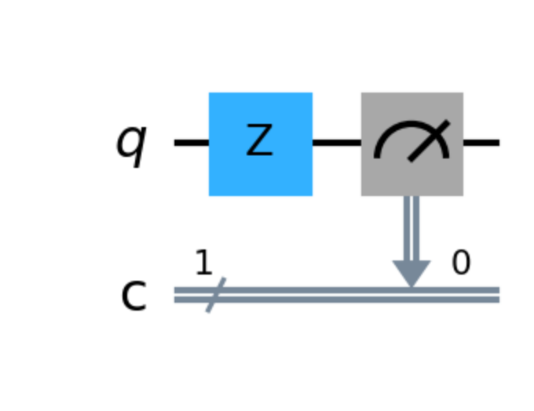

Figure 3a - Screenshot of the executed notebook circuit output for Z|0>, drawn with qc.draw("mpl"), including measurement into classical bit 0.

(iii) Mathematical prediction
Multiply $|0⟩$ by the Pauli-Z matrix:
$Z|0⟩=\left(\begin{matrix}1 & 0 \\ 0 & -1\end{matrix}\right)\left(\begin{aligned}1 \\ 0\end{aligned}\right)=\left(\begin{aligned}1·1+0·0 \\ 0·1+(-1)·0\end{aligned}\right)=\left(\begin{aligned}1 \\ 0\end{aligned}\right)$
In ket form:
$Z|0⟩=|0⟩$
Qiskit gives the state vector (1, 0)ᵀ, agreeing with the derivation.

Predicted probabilities
$P(|0⟩)=|1|^{2}=1, P(|1⟩)=|0|^{2}=0$
Check: $1+0=1$ ✔. Expected counts: all 1024 for '0' and 0 for '1'.

(i) Measurement histogram
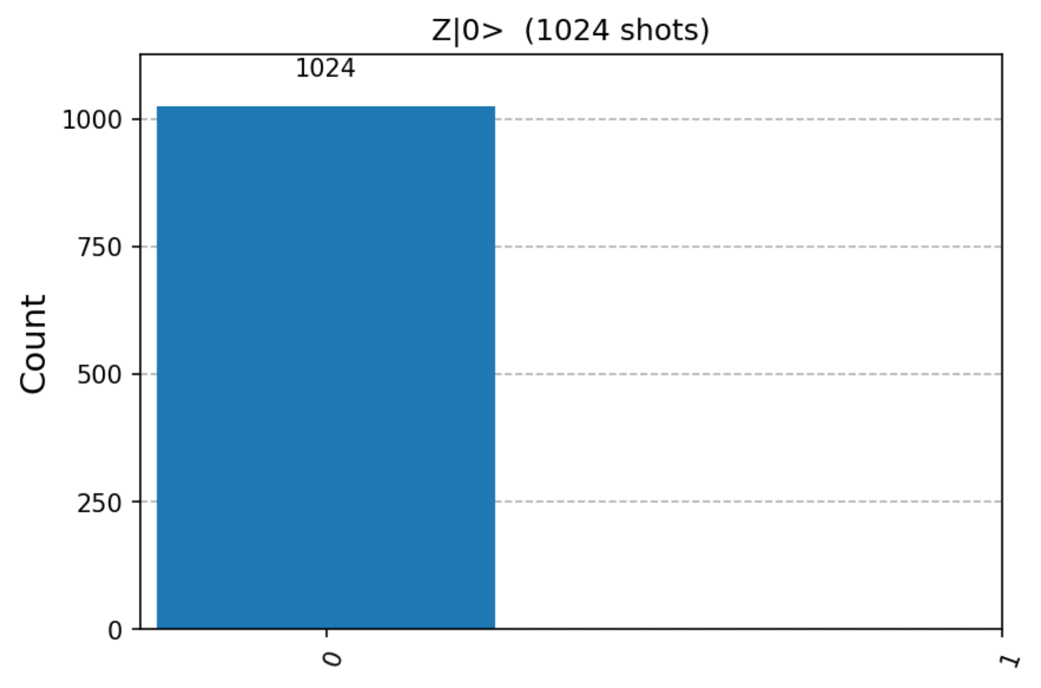

Figure 3b - Screenshot of the executed notebook measurement histogram for Z|0>, 1024 shots: 1024 zeros and 0 ones.

Verification
The histogram shows 1024 counts of '0' and 0 counts of '1', so $\hat{P}(|0⟩)=1$ and $\hat{P}(|1⟩)=0$, in exact agreement with the prediction.
What does Z actually do?
$Z$ is a phase flip: it multiplies the $|1⟩$ amplitude by −1 and leaves the $|0⟩$ amplitude alone, $Z(a_{0}|0⟩+a_{1}|1⟩)=a_{0}|0⟩-a_{1}|1⟩$. Starting from $|0⟩$ there is no $|1⟩$ component to flip, so nothing changes. Its effect is visible only on superpositions, e.g. $Z|+⟩=|-⟩$, and even then only after a change of measurement basis.

Comparison of predictions and measurements
The H run gives frequencies 526/1024 = 0.513671875 and 498/1024 = 0.486328125. Their deviations from 0.5 are +0.013671875 and −0.013671875. For independent shots with p = 0.5, the standard deviation of the count of zeros is √(1024 × 0.5 × 0.5) = 16. The observed difference of 14 counts from 512 is 0.875 standard deviations, consistent with finite sampling. This comparison supports the prediction; the exact state-vector check independently verifies the amplitudes.
Y gives 0/1024 = 0 for outcome 0 and 1024/1024 = 1 for outcome 1. Z gives 1024/1024 = 1 for outcome 0 and 0/1024 = 0 for outcome 1. Both match the predictions exactly. These are ideal AerSimulator results, not measurements from a physical quantum processor.
The table collects the hand-derived predictions and the measured results (1024 shots each).
Circuit | Predicted output state | Predicted P(0), P(1) | Measured counts '0' / '1' | Observed f(0), f(1) | Agree?
$$H|0⟩$$ | $$\frac{1}{\sqrt{2}}(|0⟩+|1⟩)$$ | 0.5, 0.5 | 526 / 498 | 0.514, 0.486 | Yes (within 1σ)
$$Y|0⟩$$ | $$i|1⟩$$ | 0, 1 | 0 / 1024 | 0, 1 | Yes (exact)
$$Z|0⟩$$ | $$|0⟩$$ | 1, 0 | 1024 / 0 | 1, 0 | Yes (exact)

References
- IBM Quantum Learning – Basics of Quantum Information, “Single systems”. https://learning.quantum.ibm.com/course/basics-of-quantum-information/single-systems

