Quantum Computation
Assignment 2
Single-Qubit State Vectors, Pauli Gates and the Hadamard Gate in Qiskit

Student | Albert Kabore  PhD student in Advanced and Equitable Computing
 | ______________________
Course | Quantum Computation
Date | October 5, 2026
Software | Python 3.11 · Qiskit 2.5.2 · Qiskit Aer 0.17.2
Companion notebook | Assignment2_Quantum_Circuits.ipynb

Contents
1. Background: the key ideas for a new learner
2. Question 1 – Showing that |ψ⟩ is a valid (normalised) state
3. Question 2 – Implementing H|0⟩, Y|0⟩ and Z|0⟩ in Qiskit
3.1 The gate matrices
3.2 How each circuit is built and measured in Qiskit
3.3 Circuit (a): H|0⟩
3.4 Circuit (b): Y|0⟩
3.5 Circuit (c): Z|0⟩
3.6 Verification: predictions vs. Qiskit histograms
4. Conclusion
Appendix A – Complete Qiskit code
Appendix B – How to reproduce the results
References

1. Background: the key ideas for a new learner
Before answering the questions it helps to collect the handful of rules that are used throughout. Every result in this report follows from these five ideas.

1.1 A qubit and Dirac (ket) notation
A classical bit is either 0 or 1. A qubit has two basis states, written as kets $|0⟩$ and $|1⟩$, that we represent as column vectors:
$|0⟩=\left(\begin{aligned}1 \\ 0\end{aligned}\right), |1⟩=\left(\begin{aligned}0 \\ 1\end{aligned}\right)$ (1)
A general qubit state is a superposition (a weighted combination) of the two:
$|ψ⟩=a_{0}|0⟩+a_{1}|1⟩=\left(\begin{aligned}a_{0} \\ a_{1}\end{aligned}\right)$ (2)
The weights $a_{0}$ and $a_{1}$ are called amplitudes. Unlike ordinary probabilities they are complex numbers.

1.2 A short complex-number refresher
A complex number has a real part and an imaginary part, with $i^{2}=-1$:
$z=x+iy, z^{*}=x-iy (complex conjugate)$ (3)
Its squared magnitude (squared length) is always a real, non-negative number:
$|z|^{2}=z z^{*}=(x+iy)(x-iy)=x^{2}+y^{2}$ (4)
Complex numbers can also be written in polar form using Euler’s formula:
$e^{iθ}=cosθ+isinθ, |e^{iθ}|^{2}=\cos^{2}θ+\sin^{2}θ=1$ (5)
Equation (5) is very useful: a factor $e^{iθ}$ is called a phase. It rotates a complex number but never changes its length.

1.3 Measurement and the Born rule
When we measure a qubit in the computational basis we never see the amplitudes directly. We get the outcome 0 or 1, with probabilities given by the Born rule:
$P(|0⟩)=|a_{0}|^{2}, P(|1⟩)=|a_{1}|^{2}$ (6)
Because one of the two outcomes must happen, the probabilities have to add up to 1. This is the normalisation condition that every valid state vector must satisfy:
$⟨ψ|ψ⟩=|a_{0}|^{2}+|a_{1}|^{2}=1$ (7)
Here $⟨ψ|$ (a bra) is the conjugate-transpose of $|ψ⟩$, that is, the row vector $\left(a_{0}^{*} , a_{1}^{*}\right)$.

1.4 Gates are matrices
A single-qubit gate is a 2 × 2 unitary matrix $U$. Applying a gate means multiplying the state vector by that matrix:
$|ψ_{\text{out}}⟩=U |ψ_{\text{in}}⟩, \left(\begin{matrix}u_{00} & u_{01} \\ u_{10} & u_{11}\end{matrix}\right)\left(\begin{aligned}a_{0} \\ a_{1}\end{aligned}\right)=\left(\begin{aligned}u_{00}a_{0}+u_{01}a_{1} \\ u_{10}a_{0}+u_{11}a_{1}\end{aligned}\right)$ (8)
Unitary means $U^{†}U=I$. Because of this, a gate always maps a normalised state to another normalised state, so probabilities still add up to 1 after every gate.

1.5 Global phase cannot be measured
If two states differ only by an overall factor $e^{iφ}$, for example $|1⟩$ and $i|1⟩$, then by equation (5) every probability $|e^{iφ} aₖ|² = |aₖ|²$ is identical. Such an overall factor is called a global phase. It has no observable effect, and we will see this in circuit (b).

2. Question 1 – Showing that |ψ⟩ is a valid state vector
Question
Given the single-qubit state vector $|ψ⟩=a_{0}|0⟩+a_{1}|1⟩$, show that the following ket is a valid state vector (i.e. its magnitude is normalised to one): $|ψ⟩=\frac{i}{2}|0⟩+\frac{\sqrt{3} e^{iπ/6}}{2}|1⟩$

Step 1 – Identify the amplitudes
Comparing with equation (2):
$a_{0}=\frac{i}{2}, a_{1}=\frac{\sqrt{3} e^{iπ/6}}{2}$ (9)
We must show that $|a_{0}|^{2}+|a_{1}|^{2}=1$ (equation 7).

Step 2 – Squared magnitude of a₀
The conjugate of $\frac{i}{2}$ is $-\frac{i}{2}$ (flip the sign of $i$). Using equation (4):
$|a_{0}|^{2}=a_{0} a_{0}^{*}=\left(\frac{i}{2}\right)\left(\frac{-i}{2}\right)=\frac{-i^{2}}{4}=\frac{-(-1)}{4}=\frac{1}{4}$ (10)

Step 3 – Squared magnitude of a₁
Method A (polar form). The conjugate of $e^{iπ/6}$ is $e^{-iπ/6}$, and the product of the two is $e^{0}=1$:
$|a_{1}|^{2}=\left(\frac{\sqrt{3} e^{iπ/6}}{2}\right)\left(\frac{\sqrt{3} e^{-iπ/6}}{2}\right)=\frac{3}{4} e^{iπ/6-iπ/6}=\frac{3}{4} e^{0}=\frac{3}{4}$ (11)
Method B (Cartesian form, as a cross-check). With Euler’s formula, $cos\frac{π}{6}=\frac{\sqrt{3}}{2}$ and $sin\frac{π}{6}=\frac{1}{2}$:
$e^{iπ/6}=\frac{\sqrt{3}}{2}+\frac{1}{2}i ⇒ a_{1}=\frac{\sqrt{3}}{2}\left(\frac{\sqrt{3}}{2} + \frac{1}{2}i\right)=\frac{3}{4}+\frac{\sqrt{3}}{4}i$ (12)
$|a_{1}|^{2}={\left(\frac{3}{4}\right)}^{2}+{\left(\frac{\sqrt{3}}{4}\right)}^{2}=\frac{9}{16}+\frac{3}{16}=\frac{12}{16}=\frac{3}{4}$ (13)
Both methods give the same answer.

Step 4 – Add the probabilities
$⟨ψ|ψ⟩=|a_{0}|^{2}+|a_{1}|^{2}=\frac{1}{4}+\frac{3}{4}=1$ (14)
The same result written as a bra–ket (row × column) product:
$⟨ψ|ψ⟩=\left(\begin{matrix}-\frac{i}{2} & \frac{\sqrt{3} e^{-iπ/6}}{2}\end{matrix}\right)\left(\begin{aligned}\frac{i}{2} \\ \frac{\sqrt{3} e^{iπ/6}}{2}\end{aligned}\right)=\frac{1}{4}+\frac{3}{4}=1$ (15)
Conclusion for Question 1
Since $⟨ψ|ψ⟩=1$, the magnitude of $|ψ⟩$ is normalised to one, so it is a valid single-qubit state vector. Physically, a measurement would give 0 with probability $P(|0⟩)=\frac{1}{4}=25\%$ and 1 with probability $P(|1⟩)=\frac{3}{4}=75\%$. Note that the phases $i$ and $e^{iπ/6}$ do not change these probabilities; only the magnitudes matter.

Numerical check in Python
The companion notebook confirms the hand calculation (Section “Question 1”):
import numpy as np
from qiskit.quantum_info import Statevector
a0 = 1j / 2
a1 = np.sqrt(3) * np.exp(1j * np.pi / 6) / 2
print(f"a0 = {a0:.4f}")
print(f"a1 = {a1:.4f} (= 3/4 + i*sqrt(3)/4 in Cartesian form)")
print(f"|a0|^2 = {abs(a0)**2:.4f}")
print(f"|a1|^2 = {abs(a1)**2:.4f}")
norm_sq = abs(a0)**2 + abs(a1)**2
print(f"|a0|^2 + |a1|^2 = {norm_sq:.4f}")
psi = Statevector([a0, a1])
print("Qiskit Statevector.is_valid():", psi.is_valid())
assert np.isclose(norm_sq, 1.0)

Output:
a0 = 0.0000+0.5000j
a1 = 0.7500+0.4330j (= 3/4 + i*sqrt(3)/4 in Cartesian form)
|a0|^2 = 0.2500
|a1|^2 = 0.7500
|a0|^2 + |a1|^2 = 1.0000
Qiskit Statevector.is_valid(): True

Note that $0.4330≈\frac{\sqrt{3}}{4}$, exactly as derived in equation (12).

3. Question 2 – Implementing H|0⟩, Y|0⟩ and Z|0⟩ in Qiskit
Question
Using qc = QuantumCircuit(1,1) and the gate syntax qc.x(0), qc.y(0), qc.z(0) (and qc.h(0)), implement (a) $H|0⟩$, (b) $Y|0⟩$, (c) $Z|0⟩$. For each: (i) measure and show the histogram, (ii) show the circuit drawn with draw(), (iii) derive the output state and $P(|0⟩)$, $P(|1⟩)$ and verify them against the histogram, (iv) put everything in one document.

3.1 The gate matrices
The Pauli operators (IBM Quantum Learning, “Single systems”) and the Hadamard gate are:
$X=\left(\begin{matrix}0 & 1 \\ 1 & 0\end{matrix}\right), Y=\left(\begin{matrix}0 & -i \\ i & 0\end{matrix}\right), Z=\left(\begin{matrix}1 & 0 \\ 0 & -1\end{matrix}\right), H=\frac{1}{\sqrt{2}}\left(\begin{matrix}1 & 1 \\ 1 & -1\end{matrix}\right)$ (16)
Gate | Qiskit call | Action on |0⟩ | Action on |1⟩ | Intuition
$$X$$ | qc.x(0) | $$|1⟩$$ | $$|0⟩$$ | Bit flip (quantum NOT)
$$Y$$ | qc.y(0) | $$i|1⟩$$ | $$-i|0⟩$$ | Bit flip + phase flip
$$Z$$ | qc.z(0) | $$|0⟩$$ | $$-|1⟩$$ | Phase flip
$$H$$ | qc.h(0) | $$\frac{|0⟩+|1⟩}{\sqrt{2}}$$ | $$\frac{|0⟩-|1⟩}{\sqrt{2}}$$ | Creates equal superposition

3.2 How each circuit is built and measured in Qiskit
Every circuit follows the same four steps, so a single helper function is used for all three (the full code is in Appendix A and in the notebook):
1. qc = QuantumCircuit(1, 1) creates 1 qubit and 1 classical bit. These ideal simulations start the qubit in $|0⟩$.
2. The gate is applied, e.g. qc.h(0) acts on qubit 0.
3. Statevector.from_instruction(qc) gives the exact output state, used to double-check the hand-derived prediction.
4. qc.measure(0, 0) stores the measurement result in the classical bit. The circuit is drawn with qc.draw() and run 1024 times (shots) on the AerSimulator (seed 42 for reproducibility). plot_histogram then shows how often each outcome occurred.
Each shot prepares |0> again and runs the entire circuit once. Measurement records a classical 0 or 1. The histograms show counts on the histogram vertical axis; dividing each count by 1024 gives the observed relative frequency, an estimate of the theoretical probability. The simulator has no noise model. Transpilation translates the circuit for the simulator.
For $N=1024$ shots the expected counts are simply $N·P(|0⟩)$ and $N·P(|1⟩)$.
import os
import numpy as np
import matplotlib.pyplot as plt
from IPython.display import display
from qiskit import QuantumCircuit, transpile
from qiskit.quantum_info import Statevector
from qiskit.visualization import plot_histogram
from qiskit_aer import AerSimulator
os.makedirs("figures", exist_ok=True)
SHOTS, SEED = 1024, 42
qc = QuantumCircuit(1, 1)
qc.h(0)
state = Statevector.from_instruction(qc)
qc.measure(0, 0)
print(qc.draw())
sim = AerSimulator()
counts = sim.run(transpile(qc, sim, seed_transpiler=42), shots=1024, seed_simulator=42).result().get_counts()
print("Statevector:", np.round(state.data, 4))
print("Counts:", counts)
display(plot_histogram(counts))
Output (the H histogram is reproduced in Figure 1b):
┌───┐┌─┐
q: ┤ H ├┤M├
└───┘└╥┘
c: 1/══════╩═
0
Statevector: [0.7071+0.j 0.7071+0.j]
Counts: {'1': 498, '0': 526}
Figure(640x480)

3.3 Circuit (a): H|0⟩

Qiskit code
qc = QuantumCircuit(1, 1)
qc.h(0)
state = Statevector.from_instruction(qc)
qc.measure(0, 0)
print(qc.draw())
sim = AerSimulator()
raw = sim.run(transpile(qc, sim, seed_transpiler=42), shots=1024, seed_simulator=42).result().get_counts()
counts = {k: raw.get(k, 0) for k in ("0", "1")}
print("Statevector:", np.round(state.data, 4))
print("Counts:", counts)
print("Observed frequencies:", {k: v / 1024 for k, v in counts.items()})
display(plot_histogram(counts))
Output (the generated histogram appears below with its mathematical verification):
┌───┐┌─┐
q: ┤ H ├┤M├
└───┘└╥┘
c: 1/══════╩═
0
Statevector: [0.7071+0.j 0.7071+0.j]
Counts: {'0': 526, '1': 498}
Observed frequencies: {'0': 0.513671875, '1': 0.486328125}
Figure(640x480)

(ii) Circuit after running draw()
Text output of qc.draw():
┌───┐┌─┐
q: ┤ H ├┤M├
└───┘└╥┘
c: 1/══════╩═
0

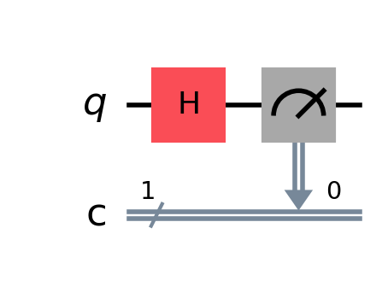

Figure 1a - Qiskit circuit diagram for H|0>, drawn with qc.draw("mpl"), including measurement into classical bit 0.

(iii) Mathematical prediction
Start from $|0⟩$ and multiply by the Hadamard matrix (equation 8):
$H|0⟩=\frac{1}{\sqrt{2}}\left(\begin{matrix}1 & 1 \\ 1 & -1\end{matrix}\right)\left(\begin{aligned}1 \\ 0\end{aligned}\right)=\frac{1}{\sqrt{2}}\left(\begin{aligned}1·1+1·0 \\ 1·1+(-1)·0\end{aligned}\right)=\frac{1}{\sqrt{2}}\left(\begin{aligned}1 \\ 1\end{aligned}\right)$ (17)
Writing the column vector back in ket form:
$H|0⟩=\frac{1}{\sqrt{2}}|0⟩+\frac{1}{\sqrt{2}}|1⟩=|+⟩$ (18)
This is the equal superposition state, often called $|+⟩$. Qiskit’s Statevector gives [0.7071+0.j, 0.7071+0.j], and $\frac{1}{\sqrt{2}}≈0.7071$ ✔.

Predicted probabilities
$P(|0⟩)={\left|\frac{1}{\sqrt{2}}\right|}^{2}=\frac{1}{2}=0.5, P(|1⟩)={\left|\frac{1}{\sqrt{2}}\right|}^{2}=\frac{1}{2}=0.5$ (19)
Check: $0.5+0.5=1$ ✔. Expected counts for 1024 shots: $1024×0.5=512$ for each outcome.

(i) Measurement histogram
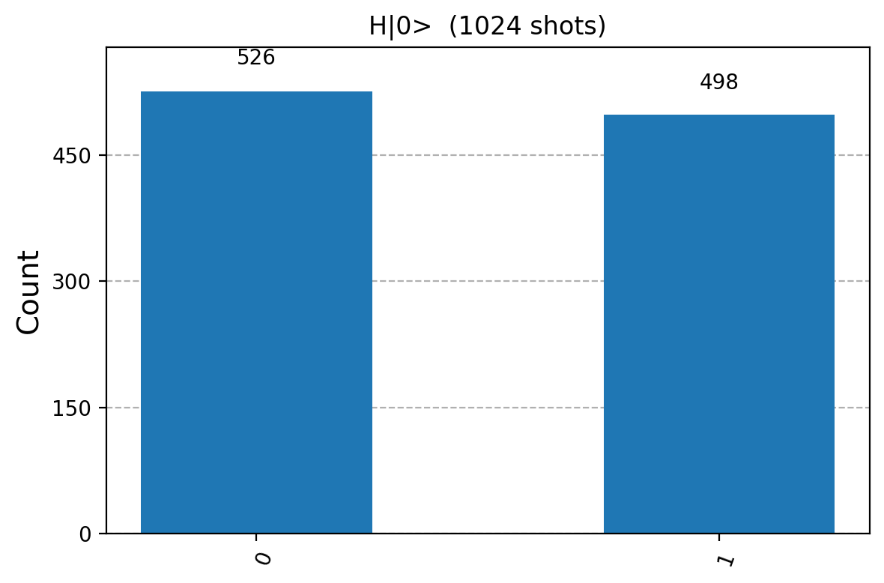

Figure 1b - Simulated measurement histogram for H|0>, 1024 shots: 526 zeros and 498 ones.

Verification
The histogram shows 526 zeros and 498 ones, i.e. relative frequencies
$\hat{P}(|0⟩)=\frac{526}{1024}≈0.514, \hat{P}(|1⟩)=\frac{498}{1024}≈0.486$ (20)
These are not exactly 0.5 because each shot is a random event, like tossing a fair coin 1024 times. The expected spread is given by the binomial standard deviation:
$σ=\sqrt{N p (1-p)}=\sqrt{1024×0.5×0.5}=16 counts$ (21)
The observed deviation is $|526-512|=14$ counts, which is less than one standard deviation ($14<16$). The histogram therefore agrees with the prediction $P(|0⟩)=P(|1⟩)=0.5$. Increasing the number of shots reduces the typical uncertainty in these relative frequencies; an individual larger run is not guaranteed to be closer to 50 % / 50 %.

3.4 Circuit (b): Y|0⟩

Qiskit code
qc = QuantumCircuit(1, 1)
qc.y(0)
state = Statevector.from_instruction(qc)
qc.measure(0, 0)
print(qc.draw())
sim = AerSimulator()
raw = sim.run(transpile(qc, sim, seed_transpiler=42), shots=1024, seed_simulator=42).result().get_counts()
counts = {k: raw.get(k, 0) for k in ("0", "1")}
print("Statevector:", np.round(state.data, 4))
print("Counts:", counts)
print("Observed frequencies:", {k: v / 1024 for k, v in counts.items()})
display(plot_histogram(counts))
Output (the generated histogram appears below with its mathematical verification):
┌───┐┌─┐
q: ┤ Y ├┤M├
└───┘└╥┘
c: 1/══════╩═
0
Statevector: [0.+0.j 0.+1.j]
Counts: {'0': 0, '1': 1024}
Observed frequencies: {'0': 0.0, '1': 1.0}
Figure(640x480)

(ii) Circuit after running draw()
Text output of qc.draw():
┌───┐┌─┐
q: ┤ Y ├┤M├
└───┘└╥┘
c: 1/══════╩═
0

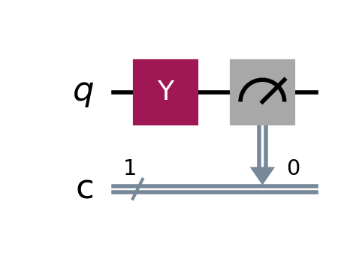

Figure 2a - Qiskit circuit diagram for Y|0>, drawn with qc.draw("mpl"), including measurement into classical bit 0.

(iii) Mathematical prediction
Multiply $|0⟩$ by the Pauli-Y matrix:
$Y|0⟩=\left(\begin{matrix}0 & -i \\ i & 0\end{matrix}\right)\left(\begin{aligned}1 \\ 0\end{aligned}\right)=\left(\begin{aligned}0·1+(-i)·0 \\ i·1+0·0\end{aligned}\right)=\left(\begin{aligned}0 \\ i\end{aligned}\right)$ (22)
In ket form:
$Y|0⟩=0 |0⟩+i |1⟩=i|1⟩$ (23)
Qiskit’s Statevector gives [0.+0.j, 0.+1.j], which is exactly ${\left(0, i\right)}^{T}$ ✔.

Predicted probabilities
$P(|0⟩)=|0|^{2}=0, P(|1⟩)=|i|^{2}=i·(-i)=-i^{2}=1$ (24)
Check: $0+1=1$ ✔. Expected counts: 0 for '0' and all 1024 for '1'.

(i) Measurement histogram
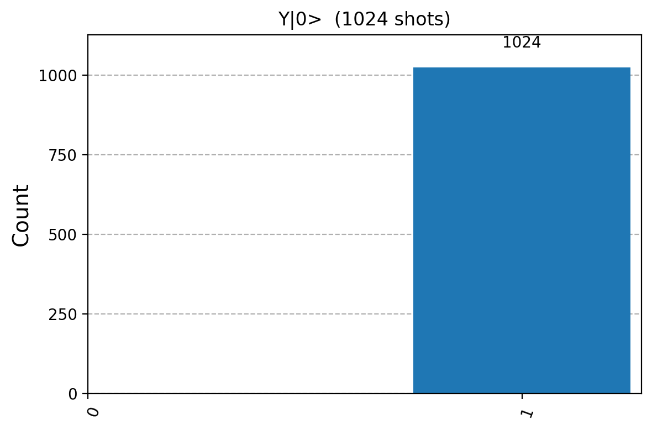

Figure 2b - Simulated measurement histogram for Y|0>, 1024 shots: 0 zeros and 1024 ones.

Verification
The histogram shows 1024 counts of '1' and 0 counts of '0', so $\hat{P}(|1⟩)=1024/1024=1$ and $\hat{P}(|0⟩)=0$. This matches the prediction exactly. In this ideal noiseless simulation, a probability of 1 is deterministic, so there is no statistical spread.
Why does the factor i not show up in the histogram?
The output $i|1⟩$ differs from $|1⟩$ only by the global phase $i=e^{iπ/2}$. As explained in Section 1.5, $|i|^{2}=1$, so every measurement probability is unchanged. On the measurement level, $Y|0⟩$ is indistinguishable from $X|0⟩=|1⟩$, which the notebook also confirms (bonus X circuit).

3.5 Circuit (c): Z|0⟩

Qiskit code
qc = QuantumCircuit(1, 1)
qc.z(0)
state = Statevector.from_instruction(qc)
qc.measure(0, 0)
print(qc.draw())
sim = AerSimulator()
raw = sim.run(transpile(qc, sim, seed_transpiler=42), shots=1024, seed_simulator=42).result().get_counts()
counts = {k: raw.get(k, 0) for k in ("0", "1")}
print("Statevector:", np.round(state.data, 4))
print("Counts:", counts)
print("Observed frequencies:", {k: v / 1024 for k, v in counts.items()})
display(plot_histogram(counts))
Output (the generated histogram appears below with its mathematical verification):
┌───┐┌─┐
q: ┤ Z ├┤M├
└───┘└╥┘
c: 1/══════╩═
0
Statevector: [1.+0.j 0.+0.j]
Counts: {'0': 1024, '1': 0}
Observed frequencies: {'0': 1.0, '1': 0.0}
Figure(640x480)

(ii) Circuit after running draw()
Text output of qc.draw():
┌───┐┌─┐
q: ┤ Z ├┤M├
└───┘└╥┘
c: 1/══════╩═
0

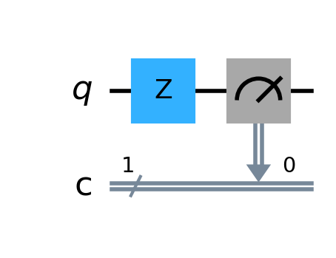

Figure 3a - Qiskit circuit diagram for Z|0>, drawn with qc.draw("mpl"), including measurement into classical bit 0.

(iii) Mathematical prediction
Multiply $|0⟩$ by the Pauli-Z matrix:
$Z|0⟩=\left(\begin{matrix}1 & 0 \\ 0 & -1\end{matrix}\right)\left(\begin{aligned}1 \\ 0\end{aligned}\right)=\left(\begin{aligned}1·1+0·0 \\ 0·1+(-1)·0\end{aligned}\right)=\left(\begin{aligned}1 \\ 0\end{aligned}\right)$ (25)
In ket form:
$Z|0⟩=|0⟩$ (26)
Qiskit’s Statevector gives [1.+0.j, 0.+0.j] ✔. $|0⟩$ is an eigenvector of $Z$ with eigenvalue $+1$, so the gate leaves it unchanged.

Predicted probabilities
$P(|0⟩)=|1|^{2}=1, P(|1⟩)=|0|^{2}=0$ (27)
Check: $1+0=1$ ✔. Expected counts: all 1024 for '0' and 0 for '1'.

(i) Measurement histogram
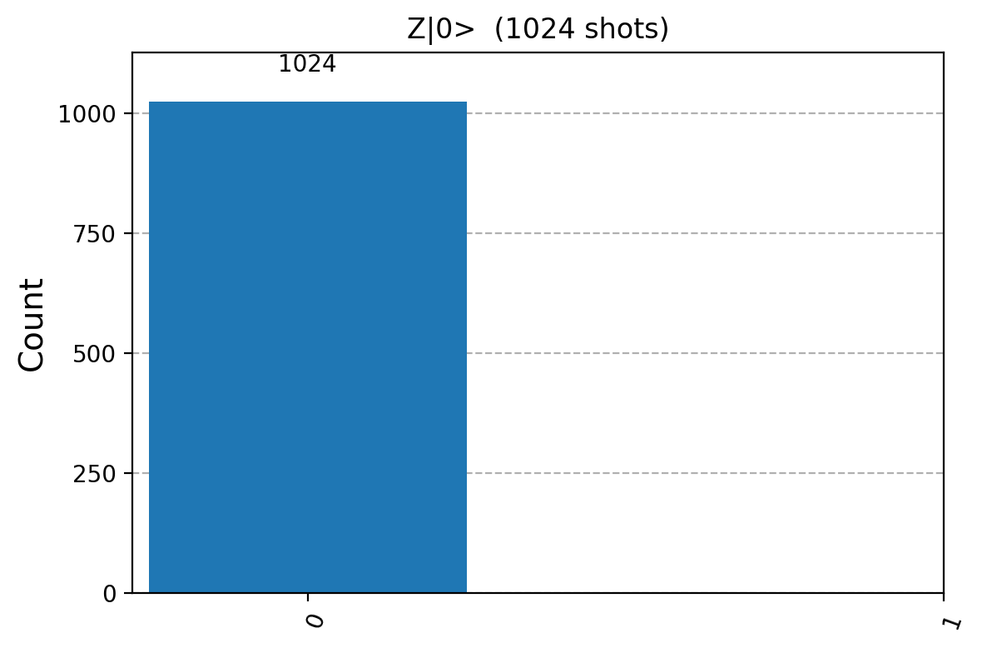

Figure 3b - Simulated measurement histogram for Z|0>, 1024 shots: 1024 zeros and 0 ones.

Verification
The histogram shows 1024 counts of '0' and 0 counts of '1', so $\hat{P}(|0⟩)=1$ and $\hat{P}(|1⟩)=0$, in exact agreement with the prediction.
What does Z actually do?
$Z$ is a phase flip: it multiplies the $|1⟩$ amplitude by −1 and leaves the $|0⟩$ amplitude alone, $Z(a_{0}|0⟩+a_{1}|1⟩)=a_{0}|0⟩-a_{1}|1⟩$. Starting from $|0⟩$ there is no $|1⟩$ component to flip, so nothing changes. Its effect is visible only on superpositions, e.g. $Z|+⟩=|-⟩$, and even then only after a change of measurement basis.

3.6 Verification: predictions vs. Qiskit histograms
The table collects the hand-derived predictions and the measured results (1024 shots each).
Circuit | Predicted output state | Predicted P(0), P(1) | Measured counts '0' / '1' | Measured P(0), P(1) | Agree?
$$H|0⟩$$ | $$\frac{1}{\sqrt{2}}(|0⟩+|1⟩)$$ | 0.5, 0.5 | 526 / 498 | 0.514, 0.486 | Yes (within 1σ)
$$Y|0⟩$$ | $$i|1⟩$$ | 0, 1 | 0 / 1024 | 0, 1 | Yes (exact)
$$Z|0⟩$$ | $$|0⟩$$ | 1, 0 | 1024 / 0 | 1, 0 | Yes (exact)
$X|0⟩$ (bonus) | $$|1⟩$$ | 0, 1 | 0 / 1024 | 0, 1 | Yes (exact)

The notebook separately checks the exact state amplitudes and probabilities against the hand derivations, verifies that counts total 1024, and checks the deterministic Y and Z results. H passes a three-standard-deviation statistical consistency check. This is not a proof: even a correct random sample can occasionally fall outside that range.

Key observations
- Superposition gives randomness. $H$ creates equal amplitudes, so each shot is a fair coin toss. The histogram is close to, but not exactly, 50/50.
- Basis states give certainty. $Y$ and $Z$ map $|0⟩$ to a single basis state (up to a phase), so every one of the 1024 shots gives the same answer.
- Computational-basis measurements do not directly reveal phase. The i in Y|0⟩ = i|1⟩ is a global phase and has no observable effect. Z leaves |0⟩ unchanged in this assignment. On a superposition, Z changes a relative phase, which can affect interference in a later circuit: HZH|0⟩ = |1⟩, whereas HH|0⟩ = |0⟩.
- The exact Statevector checks the hand-derived amplitudes, including phase. The sampled histograms are consistent with the predicted computational-basis probabilities, but cannot by themselves verify the phases or uniquely determine the state vector.

4. Conclusion
In Question 1 the state $|ψ⟩=\frac{i}{2}|0⟩+\frac{\sqrt{3}e^{iπ/6}}{2}|1⟩$ was shown to satisfy $|a_{0}|^{2}+|a_{1}|^{2}=\frac{1}{4}+\frac{3}{4}=1$ in two independent ways, so it is a valid state vector. A numerical check in Python agrees.
In Question 2 the circuits $H|0⟩$, $Y|0⟩$ and $Z|0⟩$ were implemented in Qiskit, drawn, and measured 1024 times each. Matrix multiplication predicted the output states $|+⟩$, $i|1⟩$ and $|0⟩$ with probabilities (0.5, 0.5), (0, 1) and (1, 0). The Qiskit histograms (526/498, 0/1024, 1024/0) confirm every prediction. The only deviation, for $H$, is well within the statistical shot noise expected from 1024 samples.

Appendix A – Complete Qiskit code
This is the helper function used for every circuit in the companion notebook Assignment2_Quantum_Circuits.ipynb.
import os
import numpy as np
import matplotlib.pyplot as plt
from IPython.display import display
from qiskit import QuantumCircuit, transpile
from qiskit.quantum_info import Statevector
from qiskit.visualization import plot_histogram
from qiskit_aer import AerSimulator
os.makedirs("figures", exist_ok=True)
SHOTS, SEED = 1024, 42
simulator = AerSimulator()
def run_single_qubit_circuit(gate_name):
# 1) circuit with 1 qubit and 1 classical bit, qubit initialised to |0>
qc = QuantumCircuit(1, 1)
# 2) apply the requested gate using Qiskit's syntax
getattr(qc, gate_name)(0) # qc.h(0), qc.x(0), qc.y(0) or qc.z(0)
# 3) exact state vector before measurement (theory)
state = Statevector.from_instruction(qc)
probs = state.probabilities_dict()
# 4) measure qubit 0 into classical bit 0
qc.measure(0, 0)
# draw the circuit (text in the notebook + image for the report)
print(qc.draw())
fig_c = qc.draw("mpl")
fig_c.savefig(f"figures/circuit_{gate_name}.png", dpi=200, bbox_inches="tight")
display(fig_c)
plt.close(fig_c)
# simulate
job = simulator.run(transpile(qc, simulator, seed_transpiler=SEED), shots=SHOTS, seed_simulator=SEED)
counts = job.result().get_counts()
counts = {k: counts.get(k, 0) for k in ("0", "1")} # show both outcomes
fig_h = plot_histogram(counts, title=f"{gate_name.upper()}|0> ({SHOTS} shots)",
figsize=(6, 4))
fig_h.savefig(f"figures/histogram_{gate_name}.png", dpi=200, bbox_inches="tight")
display(fig_h)
plt.close(fig_h)
print("Statevector:", np.round(state.data, 4))
print("Predicted P(0) = %.4f P(1) = %.4f" % (probs.get("0", 0), probs.get("1", 0)))
print("Observed f(0) = %.4f f(1) = %.4f counts = %s"
% (counts["0"] / SHOTS, counts["1"] / SHOTS, counts))
return qc, state, counts
qc_h, state_h, counts_h = run_single_qubit_circuit("h")
qc_y, state_y, counts_y = run_single_qubit_circuit("y")
qc_z, state_z, counts_z = run_single_qubit_circuit("z")
Output of Appendix A (the circuit diagrams and histograms are also included in Sections 3.3–3.5):
┌───┐┌─┐
q: ┤ H ├┤M├
└───┘└╥┘
c: 1/══════╩═
0
Figure(269.064x200.667)
Figure(600x400)
Statevector: [0.7071+0.j 0.7071+0.j]
Predicted P(0) = 0.5000 P(1) = 0.5000
Observed f(0) = 0.5137 f(1) = 0.4863 counts = {'0': 526, '1': 498}
┌───┐┌─┐
q: ┤ Y ├┤M├
└───┘└╥┘
c: 1/══════╩═
0
Figure(269.064x200.667)
Figure(600x400)
Statevector: [0.+0.j 0.+1.j]
Predicted P(0) = 0.0000 P(1) = 1.0000
Observed f(0) = 0.0000 f(1) = 1.0000 counts = {'0': 0, '1': 1024}
┌───┐┌─┐
q: ┤ Z ├┤M├
└───┘└╥┘
c: 1/══════╩═
0
Figure(269.064x200.667)
Figure(600x400)
Statevector: [1.+0.j 0.+0.j]
Predicted P(0) = 1.0000 P(1) = 0.0000
Observed f(0) = 1.0000 f(1) = 0.0000 counts = {'0': 1024, '1': 0}

Appendix B – How to reproduce the results
1. Install the packages: pip install qiskit qiskit-aer matplotlib pylatexenc jupyter.
2. Open the notebook: jupyter notebook Assignment2_Quantum_Circuits.ipynb.
3. Choose Kernel → Restart & Run All. Circuit diagrams and histograms are shown inline and saved to the figures/ folder.
With the tested environment (Python 3.11, Qiskit 2.5.2 and Qiskit Aer 0.17.2), seed_simulator=42 gives the recorded counts. The seed supports reproducibility within the same configuration; exact counts can change across versions. Different seeds give H frequencies fluctuating around 0.5. Real hardware can also produce unexpected Y and Z outcomes because of noise.

References
- IBM Quantum Learning – Basics of Quantum Information, “Single systems”. https://learning.quantum.ibm.com/course/basics-of-quantum-information/single-systems
- Qiskit documentation – QuantumCircuit, Statevector and plot_histogram. https://docs.quantum.ibm.com/
- Qiskit Aer documentation – AerSimulator. https://qiskit.github.io/qiskit-aer/
- M. A. Nielsen and I. L. Chuang, Quantum Computation and Quantum Information, 10th Anniversary Ed., Cambridge University Press, 2010.

