Quantum Computation
Module 2 Assignment
Single-Qubit State Vectors, Pauli Gates and the Hadamard Gate in Qiskit
Albert Kabore
October 5, 2026
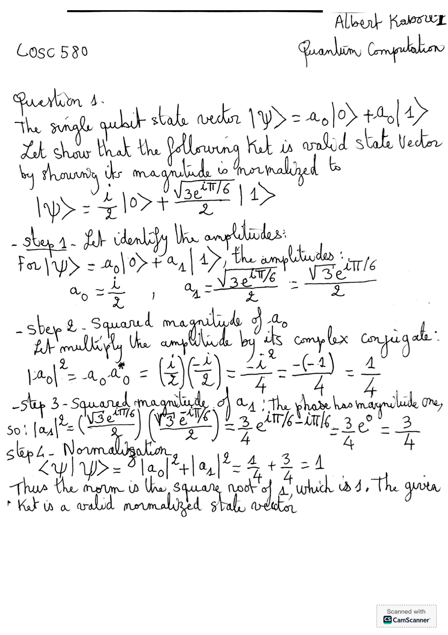

Question 2
Implement (a) H|0⟩, (b) Y|0⟩, and (c) Z|0⟩ using qc = QuantumCircuit(1, 1). Each circuit below follows the assignment order:
(i) Measure the output and show the histogram screenshot.
(ii) Show the circuit screenshot produced by draw().
(iii) Derive the output state and P(|0⟩), P(|1⟩), then compare with the histogram.
(iv) Collect all answers in this report, alongside the supplied Question 1 answer.
The computational basis is |0⟩ = (1, 0)ᵀ and |1⟩ = (0, 1)ᵀ. X, Y, and Z are the Pauli operators; H is the Hadamard gate. The imaginary unit satisfies i² = −1.
X = [[0, 1], [1, 0]]
Y = [[0, −i], [i, 0]]
Z = [[1, 0], [0, −1]]

Gate actions and Qiskit syntax
Gate | Qiskit call | Action on |0⟩ | Action on |1⟩ | Intuition
$$X$$ | qc.x(0) | $$|1⟩$$ | $$|0⟩$$ | Bit flip (quantum NOT)
$$Y$$ | qc.y(0) | $$i|1⟩$$ | $$-i|0⟩$$ | Bit flip + phase flip
$$Z$$ | qc.z(0) | $$|0⟩$$ | $$-|1⟩$$ | Phase flip
$$H$$ | qc.h(0) | $$\frac{|0⟩+|1⟩}{\sqrt{2}}$$ | $$\frac{|0⟩-|1⟩}{\sqrt{2}}$$ | Creates equal superposition

Qiskit implementation
Each circuit starts in |0⟩ and has one classical bit. The output state vector is computed before measurement. Measurement in the computational basis stores the result in classical bit 0. All reported runs use an ideal AerSimulator with 1024 shots and seed 42.
For b₀|0⟩ + b₁|1⟩, the Born rule gives P(|0⟩) = |b₀|² and P(|1⟩) = |b₁|². Observed frequencies are counts divided by 1024.
import numpy as np
from IPython.display import display
from qiskit import QuantumCircuit, transpile
from qiskit.quantum_info import Statevector
from qiskit.visualization import plot_histogram
from qiskit_aer import AerSimulator
def run_circuit(gate):
qc = QuantumCircuit(1, 1)
getattr(qc, gate)(0)
state = Statevector.from_instruction(qc)
qc.measure(0, 0)
sim = AerSimulator()
compiled = transpile(qc, sim, seed_transpiler=42)
raw = sim.run(compiled, shots=1024,
seed_simulator=42).result().get_counts()
counts = {k: raw.get(k, 0) for k in ("0", "1")}
print("Statevector:", np.round(state.data, 4))
print("Counts:", counts)
print("Observed frequencies:",
{k: v / 1024 for k, v in counts.items()})
display(plot_histogram(counts))
display(qc.draw("mpl"))
return qc, state, counts

(a) H|0⟩ — Hadamard gate applied to |0⟩

(i) Measurement histogram for H|0⟩
Apply qc.h(0) to QuantumCircuit(1, 1). Run qc_h, state_h, counts_h = run_circuit("h") using the shared setup. Measure with qc.measure(0, 0).
1024-shot output: {'0': 526, '1': 498}
State vector before measurement: [0.7071+0.j, 0.7071+0.j]
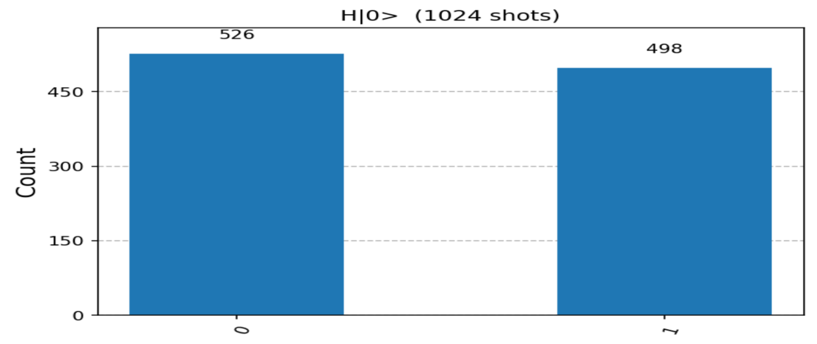
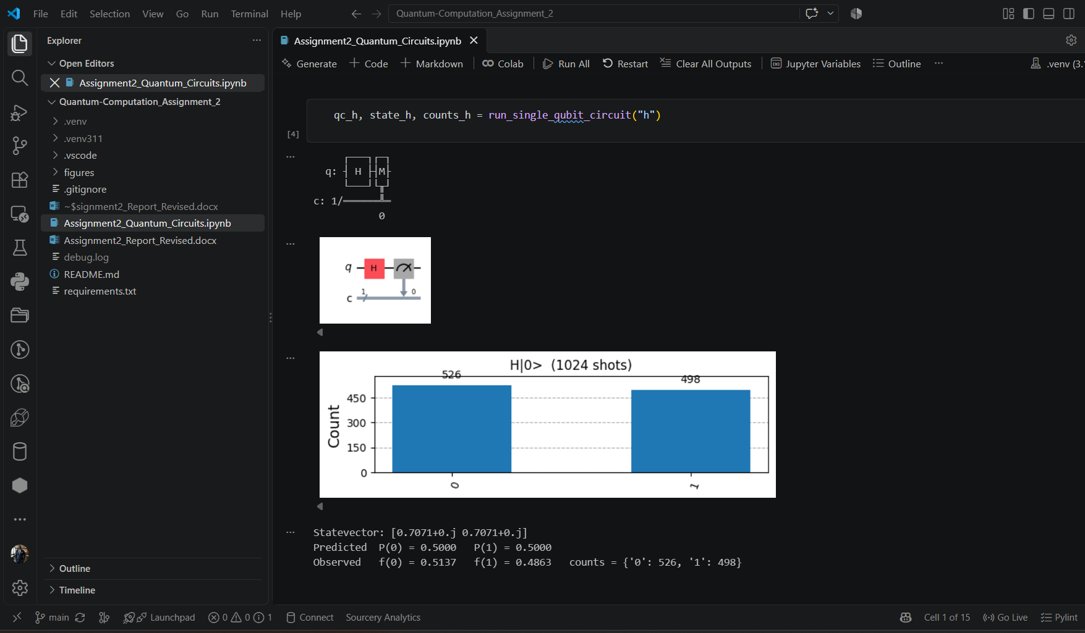
H|0⟩: measurement histogram and executed-notebook screenshot.

(ii) Circuit screenshot for H|0⟩ after running draw()
The measured circuit is drawn with qc.draw("mpl"). It contains one H gate on qubit 0 followed by measurement into classical bit 0.
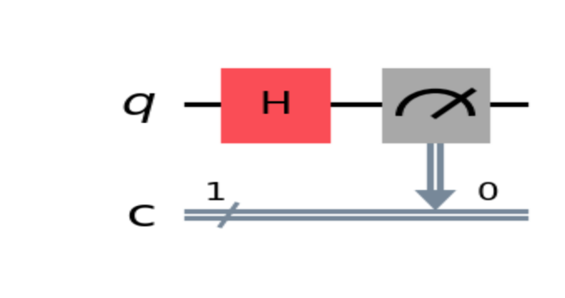
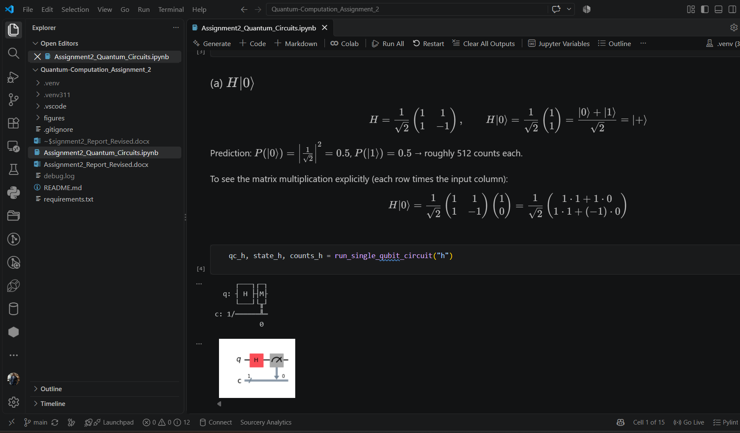
H|0⟩: circuit diagram and executed-notebook screenshot.
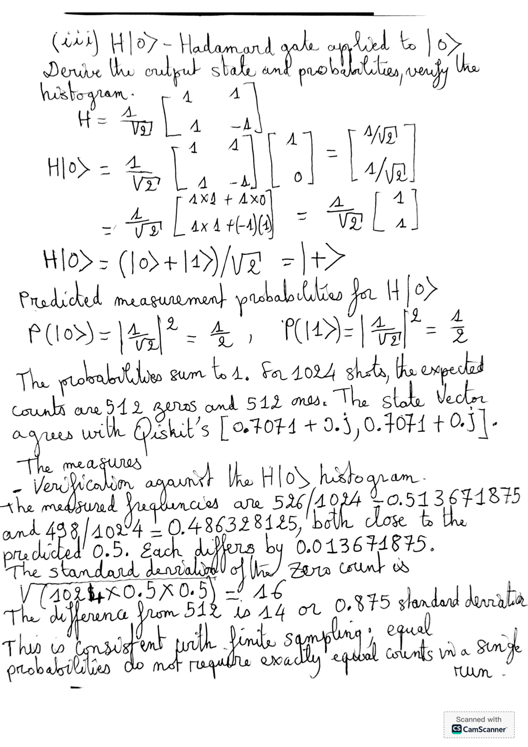

(b) Y|0⟩ — Pauli Y gate applied to |0⟩

(i) Measurement histogram for Y|0⟩
Apply qc.y(0) to QuantumCircuit(1, 1). Run qc_y, state_y, counts_y = run_circuit("y") using the shared setup. Measure with qc.measure(0, 0).
1024-shot output: {'0': 0, '1': 1024}
State vector before measurement: [0.+0.j, 0.+1.j]
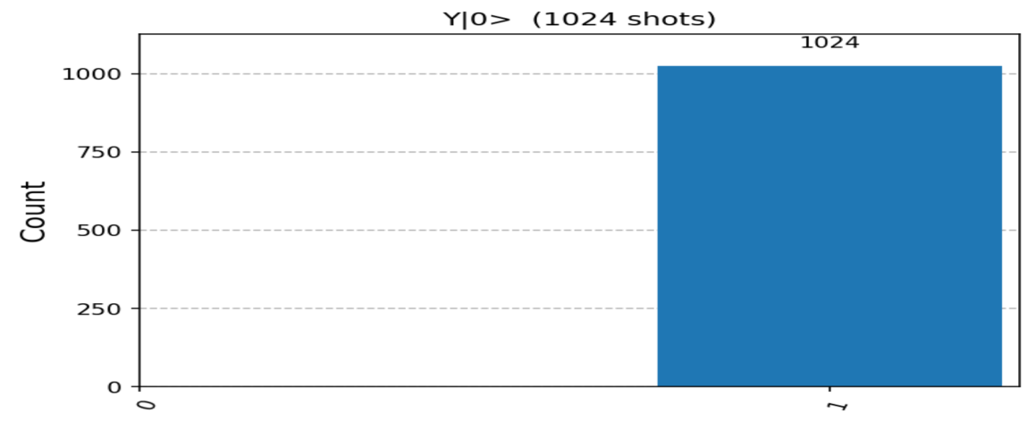
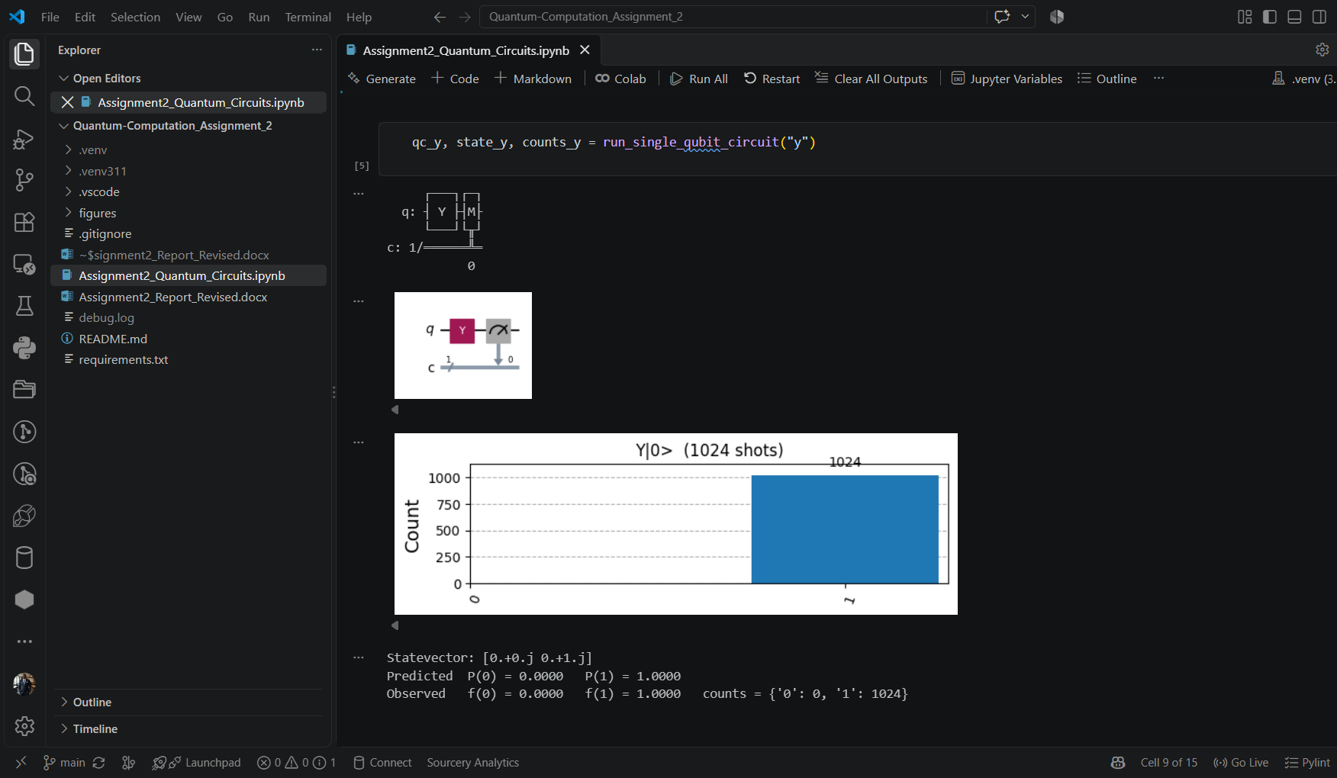
Y|0⟩: measurement histogram and executed-notebook screenshot.

(ii) Circuit screenshot for Y|0⟩ after running draw()
The measured circuit is drawn with qc.draw("mpl"). It contains one Y gate on qubit 0 followed by measurement into classical bit 0.
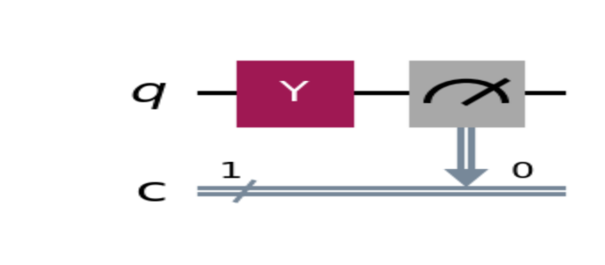
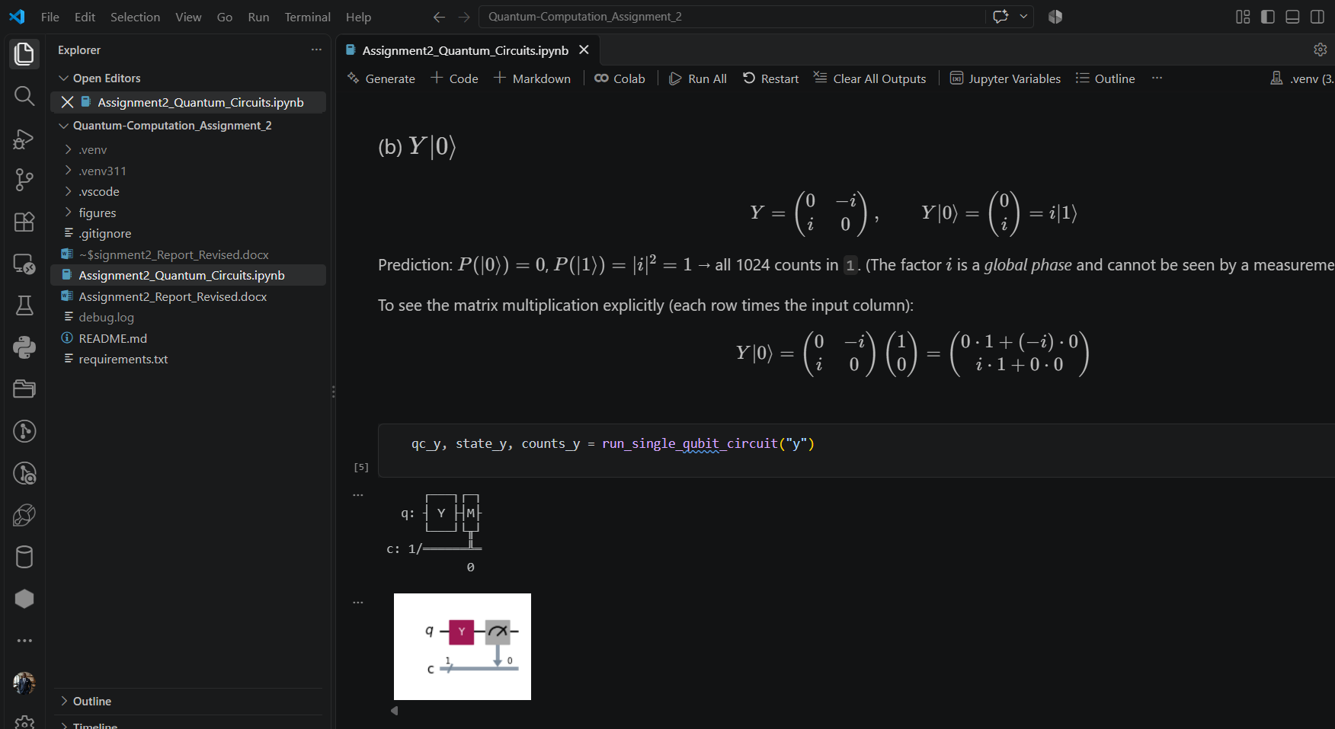
Y|0⟩: circuit diagram and executed-notebook screenshot.
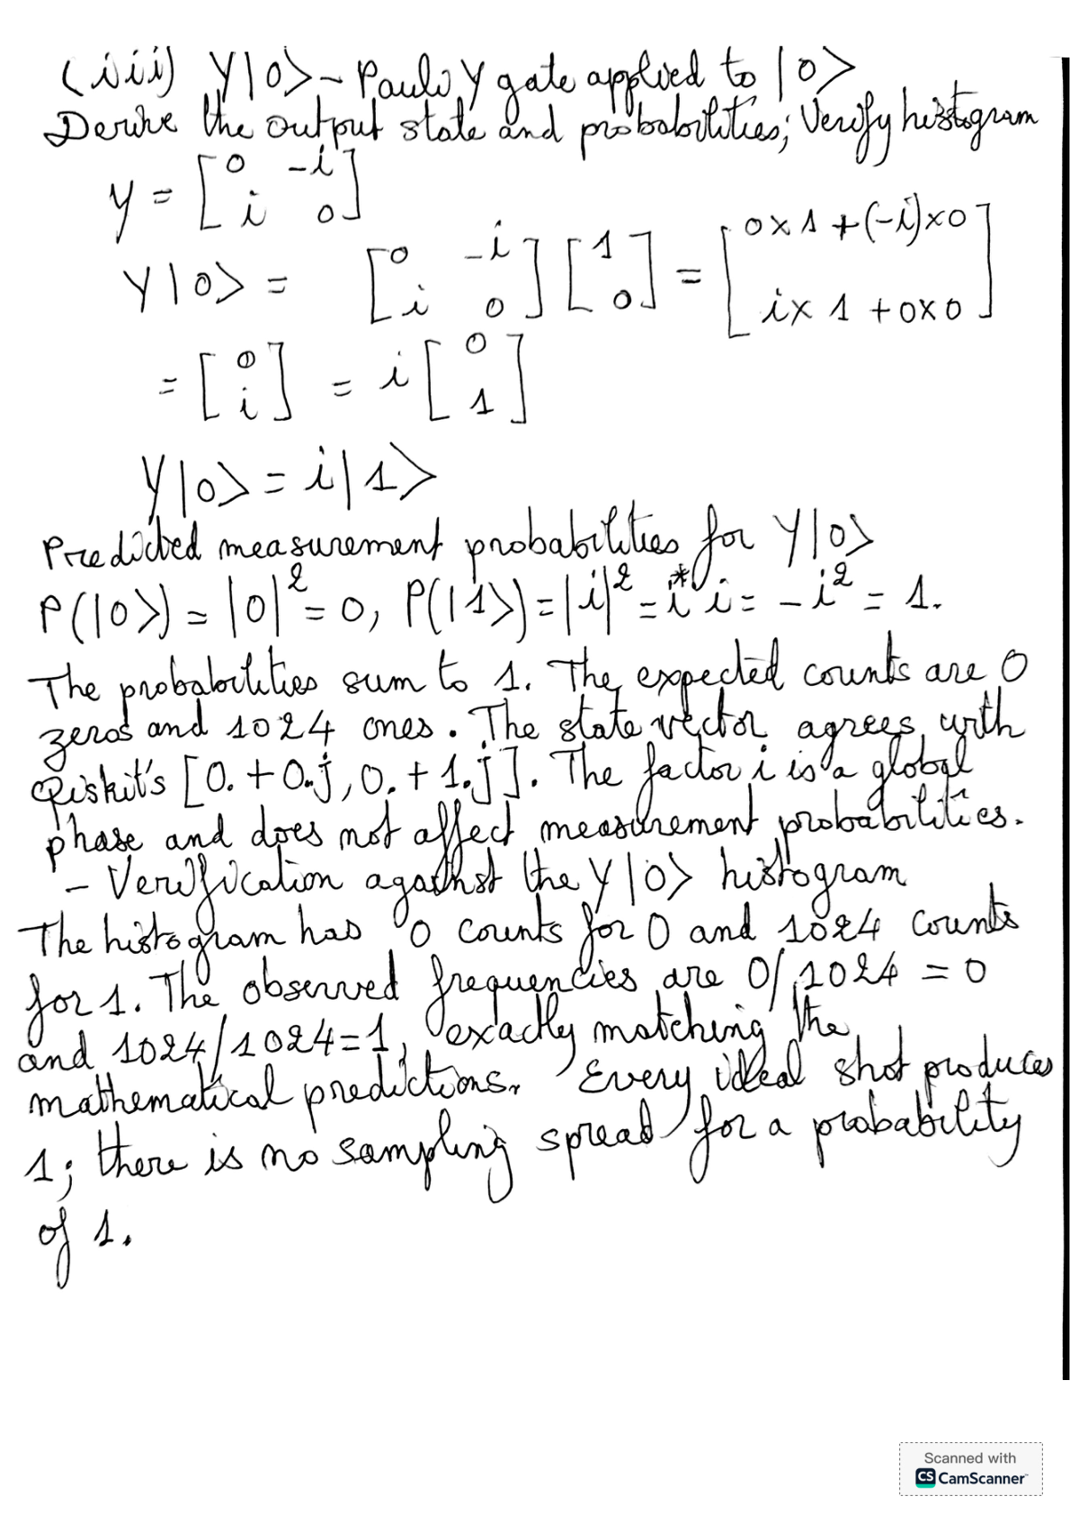

(c) Z|0⟩ — Pauli Z gate applied to |0⟩

(i) Measurement histogram for Z|0⟩
Apply qc.z(0) to QuantumCircuit(1, 1). Run qc_z, state_z, counts_z = run_circuit("z") using the shared setup. Measure with qc.measure(0, 0).
1024-shot output: {'0': 1024, '1': 0}
State vector before measurement: [1.+0.j, 0.+0.j]
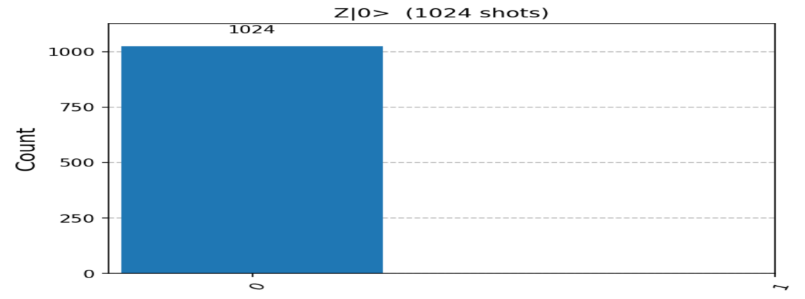
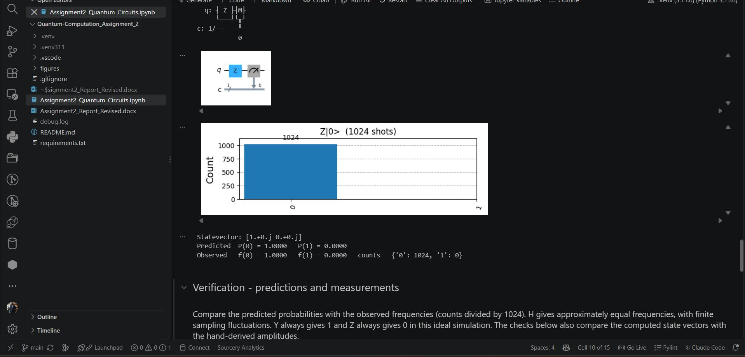
Z|0⟩: measurement histogram and executed-notebook screenshot.

(ii) Circuit screenshot for Z|0⟩ after running draw()
The measured circuit is drawn with qc.draw("mpl"). It contains one Z gate on qubit 0 followed by measurement into classical bit 0.
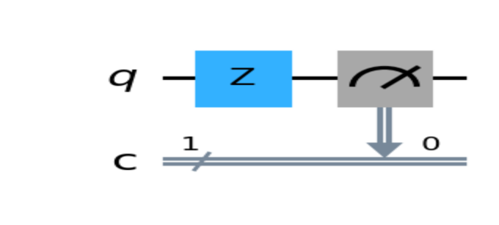
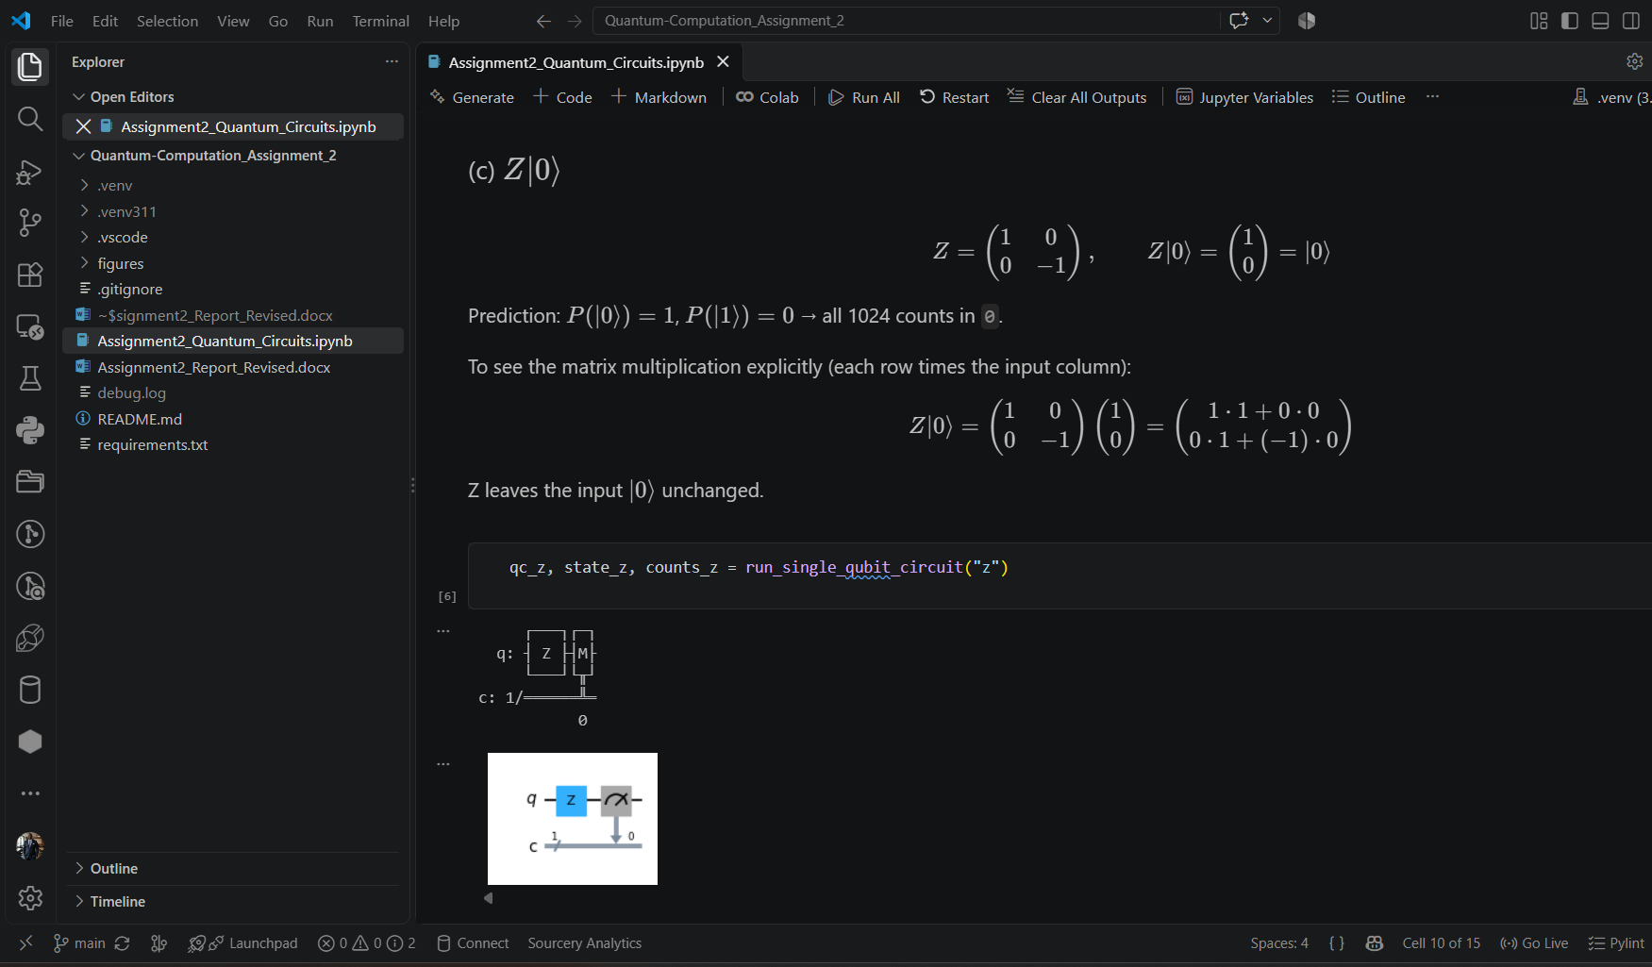
Z|0⟩: circuit diagram and executed-notebook screenshot.
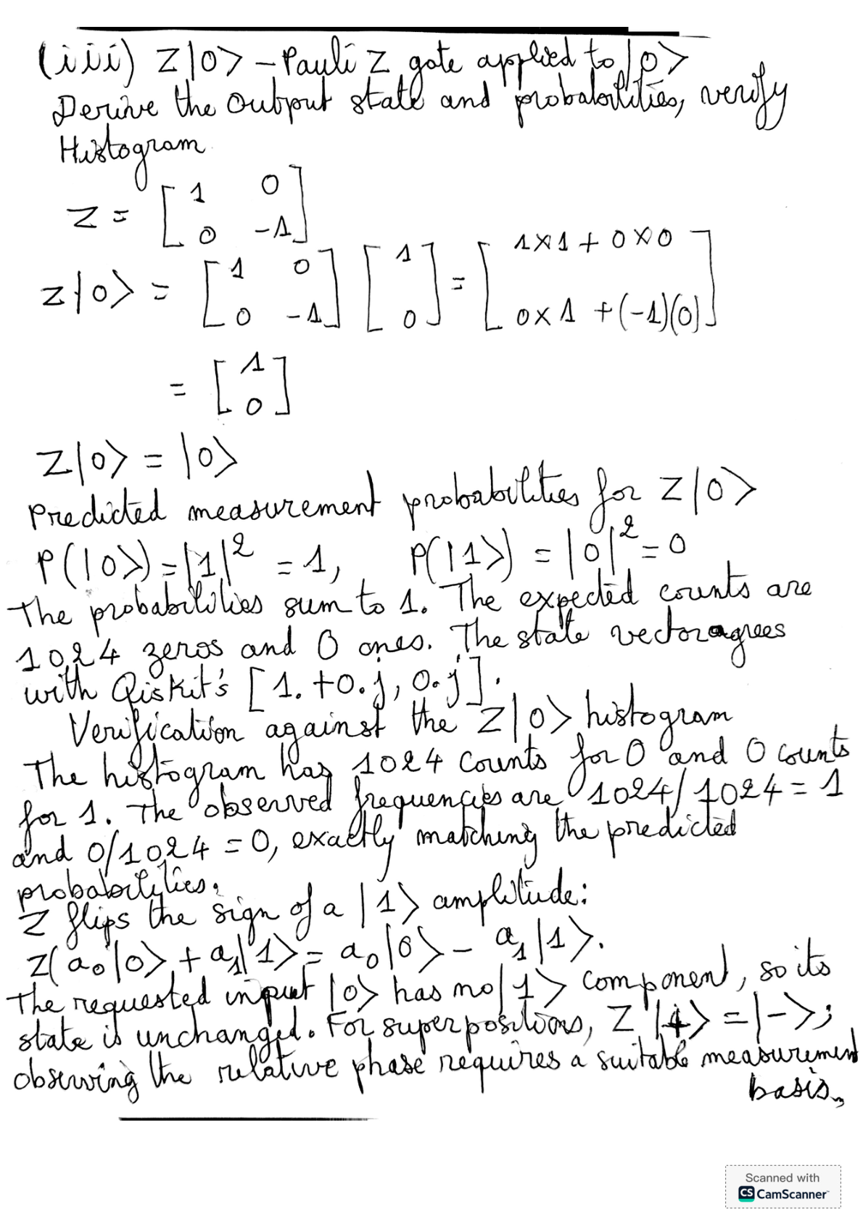

(iv) One document containing all answers
This report contains the supplied Question 1 answer and the answers to (a), (b), and (c), including code, histogram and circuit screenshots, mathematical predictions, and verification. The table summarizes the results for 1024 shots per circuit.
Circuit | Predicted output state | Predicted P(0), P(1) | Measured counts '0' / '1' | Observed f(0), f(1) | Agree?
$$H|0⟩$$ | $$\frac{1}{\sqrt{2}}(|0⟩+|1⟩)$$ | 0.5, 0.5 | 526 / 498 | 0.514, 0.486 | Yes (within 1σ)
$$Y|0⟩$$ | $$i|1⟩$$ | 0, 1 | 0 / 1024 | 0, 1 | Yes (exact)
$$Z|0⟩$$ | $$|0⟩$$ | 1, 0 | 1024 / 0 | 1, 0 | Yes (exact)

H agrees within finite-shot variation; Y and Z agree exactly with the ideal predictions. These are ideal AerSimulator results, not measurements from a physical quantum processor.

Reference
IBM Quantum Learning, Basics of Quantum Information — Single systems.
https://learning.quantum.ibm.com/course/basics-of-quantum-information/single-systems

