Time-Series Forecasting with Gaussian Processes
Probabilistic Forecasting of Daily Mean Temperature in Delhi, India

1. Dataset Choice and Characteristics
This report uses the Daily Delhi Climate dataset, a publicly available time series of daily weather observations for Delhi, India, spanning January 1, 2013 through April 24, 2017. Each record contains four variables: mean temperature, humidity, wind speed, and mean pressure. The dataset is distributed in chronological training and test files. The common date at the boundary was removed from the test file so every test observation occurs after the final training observation.
Training set: 1462 daily observations (2013-01-01 to 2017-01-01). Test set: 113 daily observations (2017-01-02 to 2017-04-24).
The files were obtained from Kaggle (sumanthvrao, n.d.).
The target is meantemp (daily mean temperature). The training series shows an annual cycle and shorter changes from day to day. The model uses a periodic kernel for the annual cycle and two RBF kernels for slower and shorter changes.

2. Preprocessing
The raw data required only light preprocessing, since it is already a clean, regularly sampled daily series with no missing timestamps or missing values:
- Missing values: none were present in either file; no imputation was necessary.
- Duplicate date: the training and test files share one overlapping date (2017-01-01). The duplicate row was removed from the test set to avoid double-counting an observation the model had already seen during training.
- Only date and meantemp enter this time-only model. Other recorded variables, including pressure, are not modified or used as predictors.
- Time axis encoding: calendar dates were converted to a continuous numeric axis, measured in years elapsed since the first training date. This scaling keeps the periodic kernel's learned period directly interpretable (a value near 1.0 corresponds to the expected ~365-day annual cycle).
- Target standardization: meantemp was standardized (zero mean, unit variance) using training-set statistics only. Standardization improves the numerical stability of GP hyperparameter optimization; all reported metrics and plots are unscaled back to the original °C units.
- Train/test split: the supplied chronological split was retained after removal of the shared boundary date; no observations were shuffled.

3. Model Design
The model is an exact Gaussian Process regressor implemented with GPyTorch (gpytorch.models.ExactGP), using a constant mean function and a composite covariance function built as the sum of three components, each with its own learned output scale (ScaleKernel):
Component | Kernel | Role / Constraint
Trend | RBF (squared exponential) | Long-term smooth drift; lengthscale constrained > 0.5 years
Seasonal | Periodic | Annual seasonal cycle; period constrained to [0.8, 1.2] years
Local | RBF (squared exponential) | Short-range, day-to-day correlation; lengthscale constrained < 0.15 years
Noise | Gaussian likelihood | I.i.d. observation noise

The trend and local lengthscales have disjoint constraints to encourage interpretable long- and short-range components. The effect of these constraints on forecast accuracy was not assessed against an unconstrained fit.
This kernel structure follows the treatment of trend and periodic components in Rasmussen and Williams (2006), adapted here to daily temperature.
The ExactGP model, Gaussian likelihood, and training procedure follow the GPyTorch regression tutorial (GPyTorch, n.d.).

4. Training Process
All kernel hyperparameters (lengthscales, output scales, seasonal period) and the Gaussian likelihood's observation noise were optimized jointly by maximizing the exact marginal log likelihood (MLL) of the training data, using the Adam optimizer (learning rate 0.02, cosine-annealed over 500 iterations). No mini-batching was needed: with 1,462 training points, exact GP inference (which scales cubically in the number of points) remains computationally tractable on CPU.
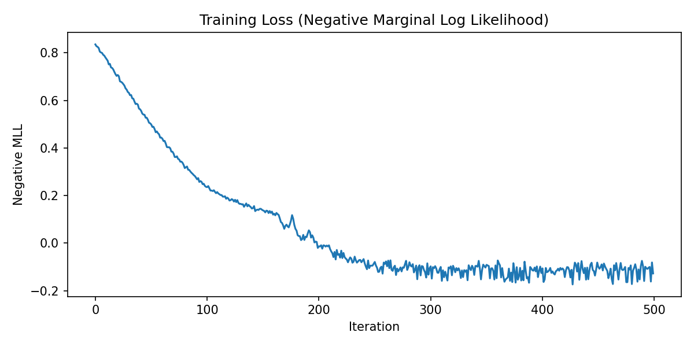
Figure 1. Training loss (negative marginal log likelihood) vs. iteration. The loss falls during training and changes less in later iterations.
Learned hyperparameters after training:
Hyperparameter | Learned Value
Trend RBF lengthscale | 2.680 years
Seasonal period | 0.998 years (≈ 364 days)
Seasonal kernel lengthscale | 0.318
Local RBF lengthscale | 1.9 days
Observation noise (std, standardized units) | 0.1381
Trend kernel output scale | 0.169
Seasonal kernel output scale | 0.985
Local kernel output scale | 0.079

The seasonal period converged to approximately one year, consistent with the annual temperature cycle. The period was initialized near one year and constrained to the range 0.8–1.2 years, so this result is not independent evidence that an unconstrained model would find the same period.

5. Forecasting Method
After training, the model was switched to evaluation mode and used to compute the exact GP posterior predictive distribution at each test-set time point. Passing the latent posterior through the Gaussian likelihood adds the learned observation noise variance, yielding a predictive mean and variance for the observed temperature (not just the noise-free latent function) at every forecast date. The forecast mean rises through the test period, following the usual seasonal warming pattern. The reported variance describes uncertainty in a future daily temperature observation at each date.
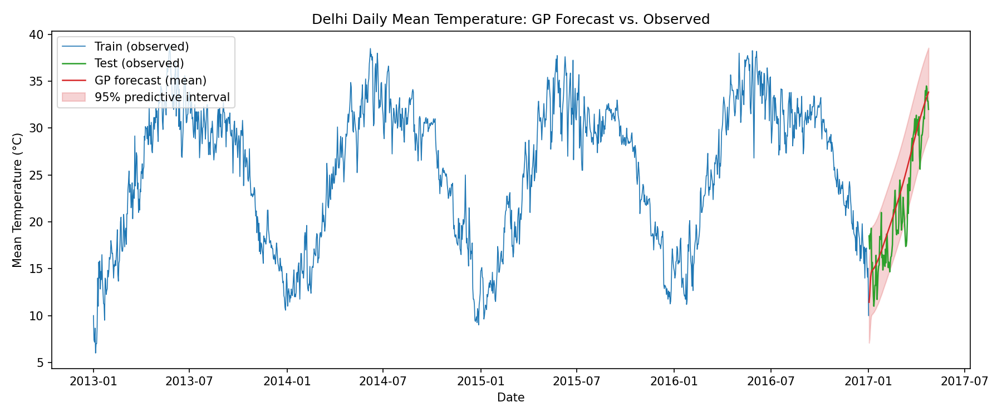
Figure 2. Full series: training data, held-out test data, and the GP forecast mean with 95% predictive interval over the test period.
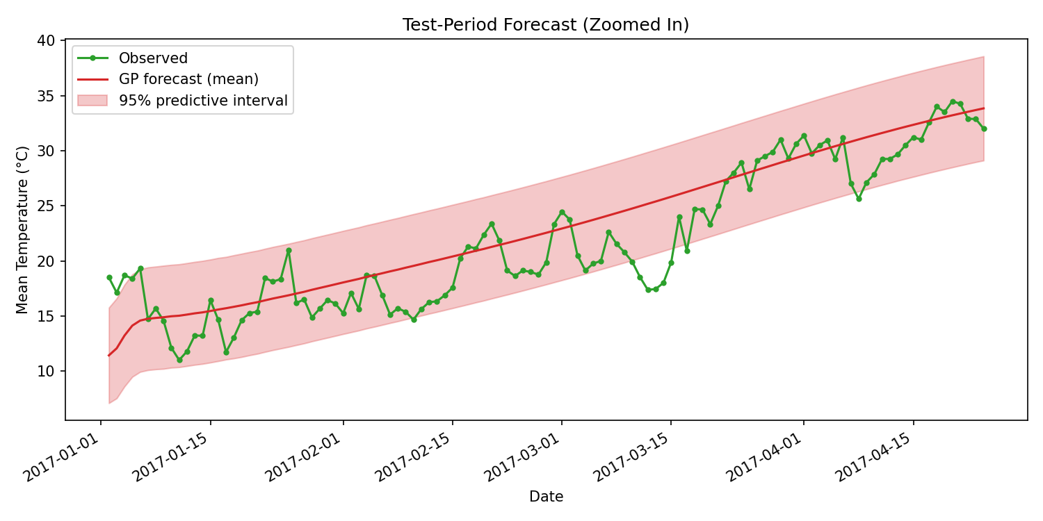
Figure 3. Zoomed view of the test period, comparing the GP forecast (mean and 95% predictive interval) against the actual observed daily temperatures.

6. Evaluation Results
Forecast quality was assessed with both point-forecast and probabilistic metrics, computed on the original (°C) scale:
The executed gp_forecasting.ipynb notebook uses the same data, model, training, and evaluation functions as main.py; its printed test metrics match the values in this report.
Metric | Value
MSE | 9.0546
RMSE | 3.0091
MAE | 2.4019
Mean predictive log likelihood (nats) | -2.5894
Mean NLPD | 2.5894
95% predictive interval coverage | 0.8850

MSE, RMSE, and MAE quantify the accuracy of the predictive mean. Mean predictive log likelihood is the average per-point log density of the observed value under the model's predictive Gaussian; higher is better. Mean NLPD is its negative, so lower is better. These metrics assess uncertainty quality in addition to accuracy, penalizing both large errors and over/under-confident intervals. Predictive interval coverage is the fraction of true test values that fall within the model's own 95% predictive interval; a well-calibrated model should show coverage near 0.95 over many comparable forecasts.
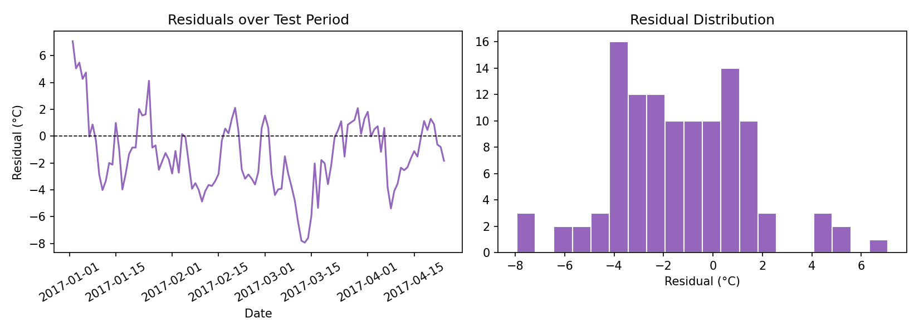
Figure 4. Residuals (observed minus predicted mean) over the test period and their distribution. This plot can reveal systematic errors that aggregate metrics may hide.

7. Interpretation of Uncertainty and Predictive Intervals
The shaded bands in Figures 2 and 3 are 95% predictive intervals for future observed temperatures. They include uncertainty in the fitted temperature curve and observation noise; they are not confidence intervals for the mean alone.
- The interval width changes modestly over the test period rather than widening steadily with forecast horizon (Figures 2 and 3).
- The empirical 95% predictive interval coverage on the test set was 88.5%, below the nominal 95% target. The model therefore undercovers this held-out period; its intervals should not be treated as calibrated 95% ranges without further validation.
- The local kernel models correlated day-to-day variation, while the Gaussian likelihood models independent observation noise. The long-range and seasonal kernels also contribute to uncertainty beyond the training dates.
- The 95% label describes the model's probability for an individual observation under its assumptions; the observed 88.5% coverage shows those assumptions do not give 95% coverage on this test period.

8. Conclusion
A Gaussian Process with a trend + seasonal + local composite kernel was able to learn the annual temperature cycle of Delhi directly from the training data and produce probabilistic forecasts for the following months that tracked the observed seasonal warming trend. Its 95% predictive intervals covered 88.5% of held-out observations, showing undercoverage. The main limitation is that the model is purely temporal (a function of date only). A later study could test additional weather variables, provided their values are available at the time each forecast is made.

References
GPyTorch. (n.d.). GPyTorch regression tutorial. Retrieved September 16, 2026, from https://docs.gpytorch.ai/en/stable/examples/01_Exact_GPs/Simple_GP_Regression.html
Rasmussen, C. E., & Williams, C. K. I. (2006). Gaussian processes for machine learning. MIT Press. https://gaussianprocess.org/gpml/
sumanthvrao. (n.d.). Daily climate time series data [Data set]. Kaggle. https://www.kaggle.com/datasets/sumanthvrao/daily-climate-time-series-data

