# Create the ipv6 tunnel using www.tunnelbroker.net:
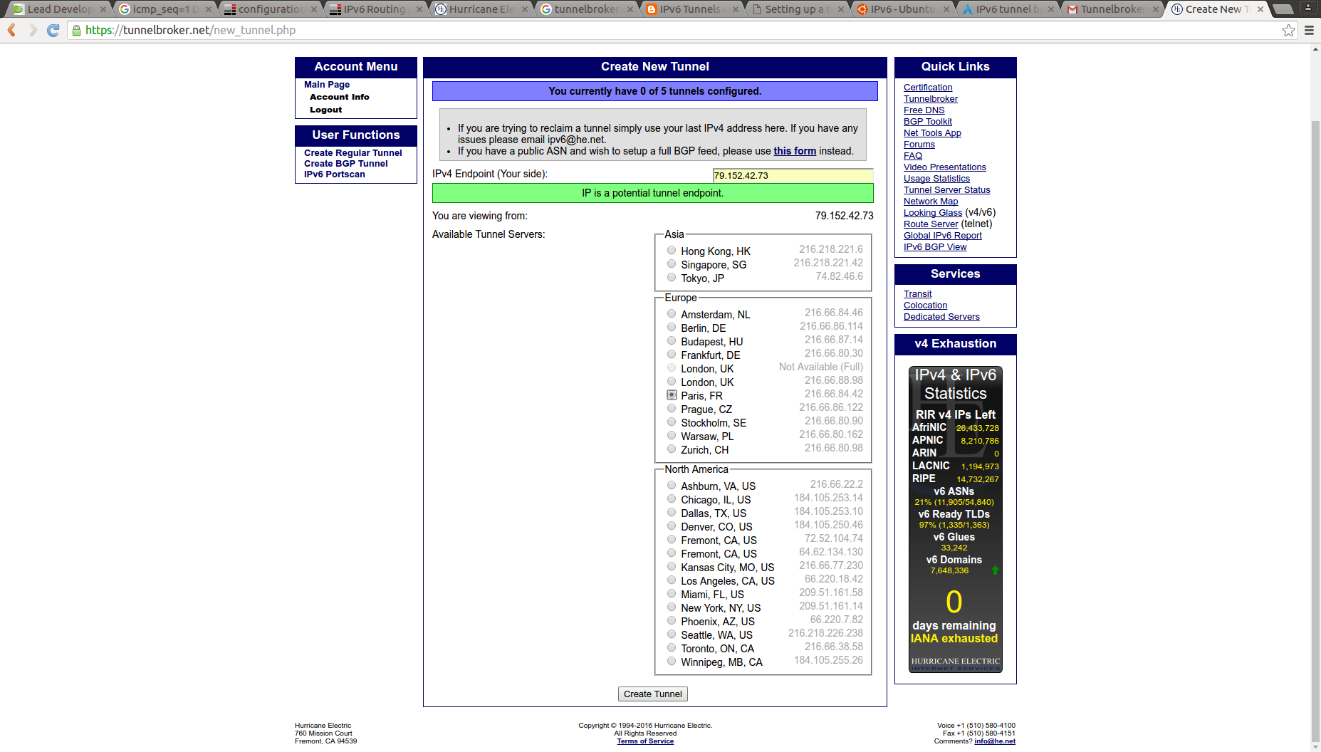
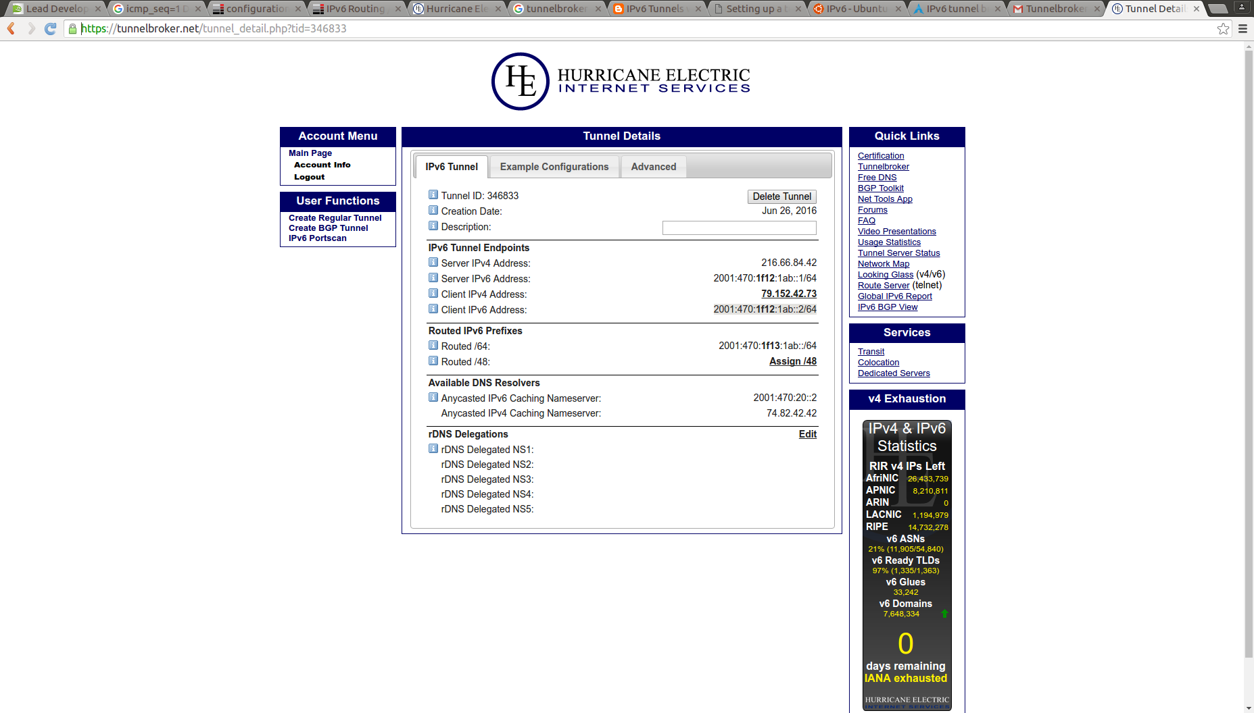

# Create the tunnel ipv6 in my host which is connect to internet using ipv4

/usr/sbin/ip tunnel add he-ipv6 mode sit remote 216.66.84.42 local 192.168.1.38 ttl 255
/usr/sbin/ip link set he-ipv6 up mtu 1480
/usr/sbin/ip addr add 2001:470:1f12:1ab::2/64 dev he-ipv6
/usr/sbin/ip -6 route add ::/0 dev he-ipv6

# I send a ping to google and monitor it with tcpdump
ping6 www.google.es
PING www.google.es(mad01s25-in-x03.1e100.net) 56 data bytes
64 bytes from mad01s25-in-x03.1e100.net: icmp_seq=1 ttl=53 time=109 ms
64 bytes from mad01s25-in-x03.1e100.net: icmp_seq=2 ttl=53 time=157 ms
64 bytes from mad01s25-in-x03.1e100.net: icmp_seq=3 ttl=53 time=204 ms
64 bytes from mad01s25-in-x03.1e100.net: icmp_seq=4 ttl=53 time=45.7 ms
64 bytes from mad01s25-in-x03.1e100.net: icmp_seq=5 ttl=53 time=45.5 ms

tcpdump -i he-ipv6 -w /tmp/ping6google.tcpdump

