Lab 7 – Image Stitching Morselli Alberto (2102413)

***-short report-***

This lab was really well guided and i liked it very much and I didn’t spaced too much from the guidelines offered. The report will so focus only on results obtained. The code starts by loading the images contained in the name of the folder passed by command line and applying the cylindrical projection on all of them, noticeable in the example below especially looking onto the window lines.

*cylindrical projection (on the right) of image i0.png (on the left) of data folder*

After this, continues by extracting SIFT features and matches them with a BFmatcher. Right after, a “selector” of the good matches is realized, trashing all the matches whose distance is greater than 3 times the minimum match distance (in the feature space). Below is reported the application on the 1st and 2nd image of each of the three provided datasets: data, dolomites and kitchen.

*SIFT feature extraction and matching with a BFmatcher with a ratio treshold=3 on the first and second images of kitchen dataset.*

The last step is the computation of dx, dy of each image with the next one and the forming of the final stitched image. The code iterates two times on ds=(dx,dy) array:

1. The first time to compute the dimensions of the final image (looking for the extrema ymin (negative) and ymax(positive) to add (in absolute value) on the final image to the initial image height. The same is done for computing the width.
2. The second time to actually copy the image in the right position.

The results on the 3 datasets provided are reported below and commented right after.

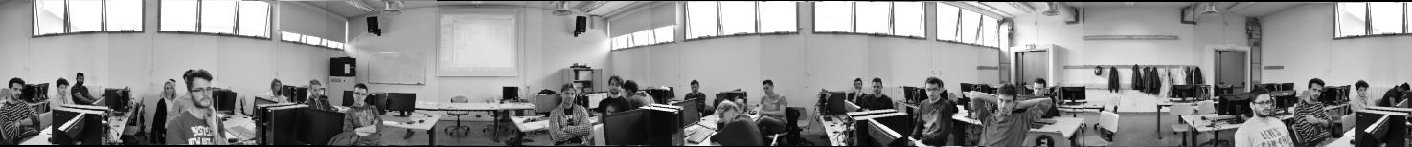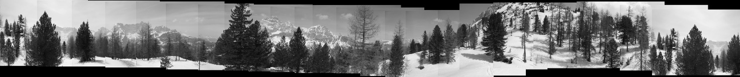

In this dolomites dataset is clearly visible the human displacement error in the y-direction, and the needing for a detection of extremas ymin and ymax, not that visible in the other two datasets. The final image can be obtained by just keeping the central band.



Below the entire application process visible by command line executing the script on the data dataset.

