SOMIOD: Service Oriented Middleware for Interoperability and Open Data

Project Report

Alberto Pingo  
2202145@my.ipleiria.pt

Francisco Marques

2211059@my.ipleiria.pt

Diogo Moreira

2211051@my.ipleiria.pt

Rodrigo Sousa  
*2191243@my.ipleiria.pt*

*Abstract*—This document consists of a report about the SOMIOD: Service Oriented Middleware for Interoperability and Open Data project, developed by a group of 4 students enrolled in the “Integração de Sistemas” course of the Computer Engineering Bachelor of the Polytechnic Institute of Leiria.

Keywords—component, formatting, style, styling, insert

# Introduction

The Internet of Things (IoT) concept emerges as a potential and distinctive contribution to innumerable societal issues. These include the contemporary challenges surrounding climate changes, energy prodution and consumption, and broad sustainability concerns, among others. From our smart homes and workspaces to the landscape of smart cities, the effortlessly gathered data holds promise for societal benefits, impacting not only the general population but also the business sector and local as well as state governments. This surge in data availability fosters the creation of new applications and pioneering services designed to propel social harmony, environmental betterment, and economic prosperity, thereby contributing to the realization of a more developed society.

As nowadays, a significant part of the proposed and already developed IoT solutions leans heavily on proprietary protocols and secluded cloud services, the focal point of this project is to create a service-oriented middleware proficient in standardizing the approach to data access, writing, and notification, irrespective of the application domain. The overarching aim is to champion interoperability and the practice of open data, ensuring uniformity in how data is accessed and written, and how applications are crafted. This standardized paradigm empowers individuals to tap into data, broaden capabilities, and create new applications and services, always following the same approach. To materialize this vision, we adopted Web Services and a Web-based resource structure, firmly grounded in established web standards.

To achieve our goals, the following resources were created: applications, containers, data, and subscriptions, all organized in a hierarchy. Each resource type has his unique properties.In the following sections of this document the System Architecture will be presented, with all of included components being explained in detail.

This document will also include an Evaluation section where the operation of the testing application will be described, a Conclusion section and an Appendix including the cRUD commands for crud operations for all supported resources and a section including the work done by each group member.

# System Architecture

In this section we present a diagram of the system architecture, followed by the description of each of his components, all represented by a different letter.

(This section must introduce the system architecture diagram, present the diagram and then detail every component of the diagram. Delete this.)

1. 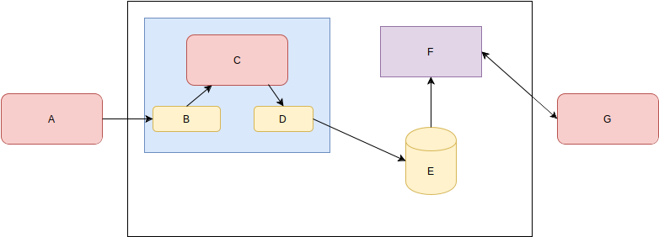Example of a figure caption. (*figure caption*)

## Component A

xxxxxxxxxxx

## Component B

xxxxxxxxx

## Component C

xxxxxxxxxx

## Component D

xxxxxxxxx

## Component E

xxxxxxxxx

1. Table Type Styles

| Table Head | Table Column Head | | |
| --- | --- | --- | --- |
| Table column subhead | Subhead | Subhead |
| copy | More table copya |  |  |

1. Sample of a Table footnote. (*Table footnote*)
2. Example of a figure caption. (*figure caption*)

# Evaluation

This is example text. Blá, blá, blá introducing this main section...

# Integration/App Development

This section exists only if any other applications were developed that used the exposed public API by this system. If so, presented the applications and the performance, capabilities, advantages to the community, etc.

## Application X

Blá, blá, Blá, blá,Blá, blá,Blá, blá,Blá, blá,Blá, blá,Blá, blá,Blá, blá,.

## Application Y

Blá, blá, Blá, blá,Blá, blá,Blá, blá,Blá, blá,Blá, blá,Blá, blá,Blá, blá,.

# Conclusions and Future Work

In summary, the primary goal of this project was to create SOMIOD, a middleware for standardized data access, writing, and notification in the Internet of Things (IoT). We successfully structured resources like applications, containers, data, and subscriptions, each with unique properties. The system supports CRUD operations through a RESTful API, ensuring a consistent approach to data management. By minimizing reliance on private protocols, SOMIOD addresses interoperability challenges, fostering open data practices.

For users and the community, SOMIOD brings standardization, ensuring a consistent approach to IoT data access. It enhances interoperability, promoting collaboration in diverse IoT environments. Additionally, it simplifies application development through a unified structure and RESTful API.

Looking ahead, potential improvements include enhanced security measures to protect sensitive IoT data, extended support for additional communication protocols, optimization for scalability, a user-friendly interface for easy resource management, and exploration of advanced notification mechanisms. Addressing these aspects will contribute to SOMIOD's evolution into a more robust and versatile solution, further advancing standardized practices in the IoT landscape.

# Appendix

*Appendix A*

Include the cRUD commands for crud operations for all supported resources.

*Appendix B*

Alberto Pingo –

Diogo Moreira –

Francisco Marques –

Rodrigo Sousa –