# Differentiability in higher order dimensions

Today we are going to see how to differentiate higher order functions and give a definition of when any function is differentiable at a point a.

Before all that, however, we need to know the formula for finding hyperplanes and linear lines in higher dimensions.

## Line equation in 3 dimensions

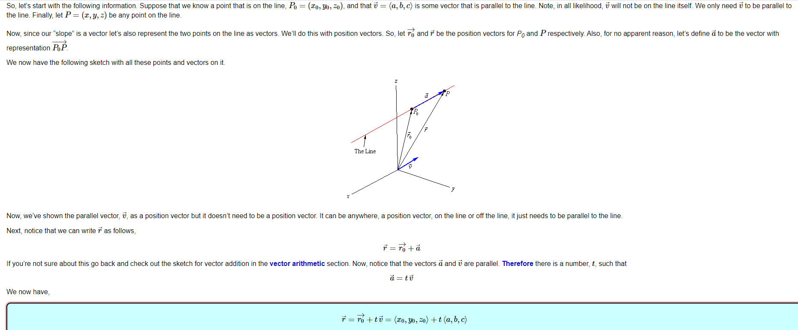In other words, given that we know a point P0 = (x0,y0,z0) which is on the line, we create a vector r0=(x0,y0,z0) and we know a vector v which is parallel to the line then we can create a vector function which we call r(t) such that

r(t) = r0 + tv

However, there are other two ways we can express the equation of a line in a 3 dimensional space which are derived from the above formula.

These two ways are called:

1. Parametric form of the equation of a line
2. Symmetric equation of the line

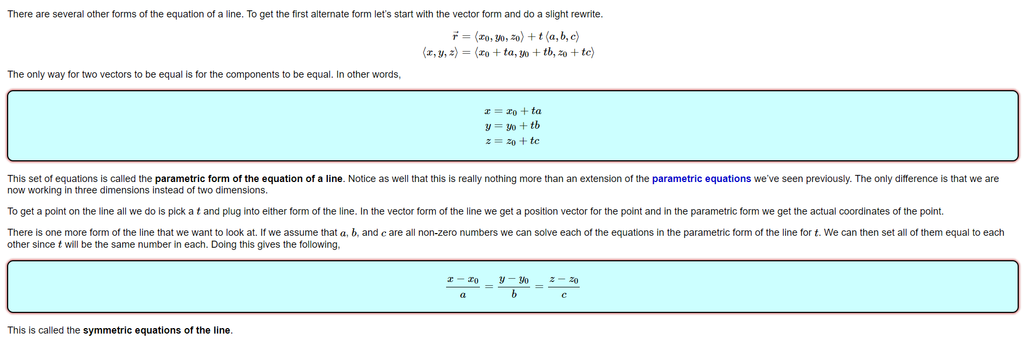The definitions above refer to the equation of a line in a 3D space. Nonetheless, we can use the first derived equation which is actually a vector function to derive the equation of a line in any n-dimensional space given we know a point in the line and a vector which is parallel to the line.

The formula is simply:

r(t) = r0 + tv

where r0 is the point in the line and v is the vector parallel to the line

## Equation of a plane in a 2D space

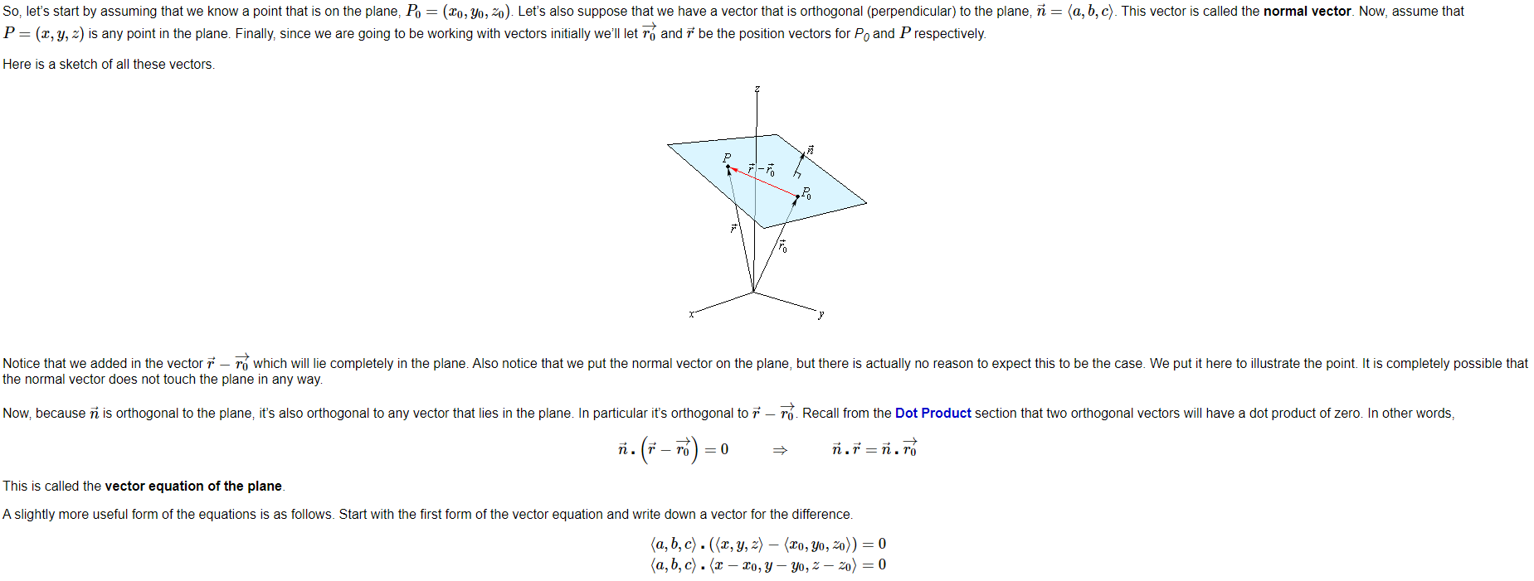

By computing the above dot product we produce the scalar equation of the plane which is the following:

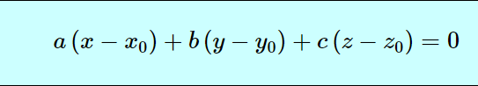where $\vec{n}=(a,b,c) and P_{0}=(x_{0},y_{0},z_{0})$

It is important to notice that we can use the same concepts to derive hyperplanes in higher dimensions. In fact, all we need to have is just a vector that is perpendicular to the hyperplane and a point inside the hyperplane. Then everything that has been said above follows.

## Definition of hyperplane

In geometry, a hyperplane is a subspace whose dimension is one less than that of its ambient space. If a space is 3-dimensional then its hyperplanes are the 2-dimensional planes, while if the space is 2-dimensional, its hyperplanes are the 1-dimensional lines.

An important property of any hyperplane is that the partial derivatives with respect to any variable are always constants. This must follow because if we have a function of an hyperplane z = f(x0,x1,…,xn) then if we keep n-1 variables fixed we get the equation of a line.

Proof(the proof will consider a 2D plane in a 3D dimension without loss of generality):

## Derivative Intuition for higher dimensional functions

The intuition of derivatives for higher dimensional functions can be inferred by the same intuition that we have for derivatives of functions in 2D spaces that is functions of the form y=f(x).

We know that given a function y=f(x) then f’(x0) gives us the slope of the tangent line at the point x0 of the function f(x).

Given the slope f’(x0) we can effectively find the equation of the tangent line at the point x0 of the function f(x) by using the following formula:

y-f(x0) = f’(x0)(x-x0)

y = f’(x0)(x-x0) + f(x0)

By rethinking about the interpolation lecture, we can state that the above equation gives us a **LINEAR APPROXIMATION** of the function f(x). Naturally, the closer a point is to x0, the closer the result that we get from the linear equation reflects the real function value.

We can derive the fact that the closer a point is to x0, the closer the result that we get from the linear equation is closer to the real function value in the following way:

Thus, we gain an understanding that derivatives in 2D space are important to find a linear approximation of the function itself by finding the tangent line.

What about the higher dimensional functions?

It turns out that we find derivatives to higher dimensional functions to find **LINEAR APPROXIMATIONS** as well but while in the 2D functions we find tangent lines in 3 and more dimensional spaces we need to find tangent hyperplanes to a point of the function.

We already know the equation of hyperplanes but how do we find the equation of the hyperplane which is tangent to a point?

## How to find tangent plane to a 3D function

The explanation of why the following formula holds can be found in the following link <https://tutorial.math.lamar.edu/Classes/CalcIII/TangentPlanes.aspx>

The formula for finding a linear approximation of the function z=f(x,y) at a point (x0,y0,z0) is the following:



As we can see the formula for finding the linear approximation of a 3D function is very similar to the one that we use to find a linear approximation of a function in a 2D space. The formula works also for higher dimensional functions as all we have to do is to compute more partial derivatives with respect to the other variables.

As an example, given a function z=f(x,y,w) then a linear approximation of the function f(x,y,w) at point (x0,y0,w0) (the linear approximation is an hyperplane tanget to the point) is computed by the following formula:



## Gradient of a function

The gradient of a function denoted as Df is just a matrix which contains in order all partial derivatives of the function.

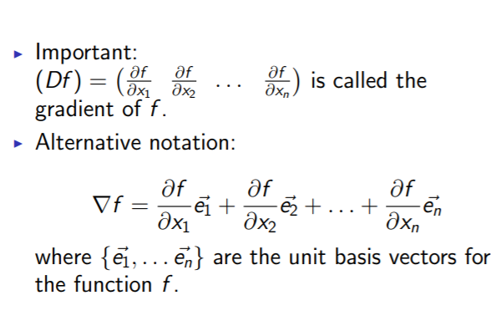Thus the gradient of a function f denoted as Df is just a matrix containing the partial derivatives of the function f. Naturally if f is a 2D function then Df will contain just the first derivative.

Given the gradient of a function Df then we can shorten the formula to find the tangent hyperplane to a point by using the following dot product:

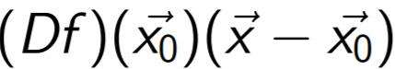

Which means that we multiply every partial derivative to its corresponding factor as we do in the formula that we have explained and then sum everything up (dot product definition) and this is equivalent to what we do in the formula we have explained.

Finally, now we can give a definition of differentiability which is the following:

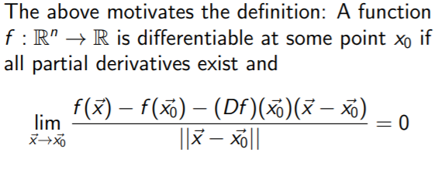Thus, if a function is differentiable to a point $\vec{x_{0}}$ then all its partial derivatives must exist. However, the converse does not hold true thus if all partial derivatives of a function exist at a point $\vec{x_{0}}$ it is not guaranteed that the function will be differentiable.

## The Jacobian Matrix

The Jacobian Matrix is an mxn matrix of a function f : Rn→Rm.

A function f : Rn→Rm is just a function that takes a vector of length n as input and outputs a vector of length m. In other words, the function outputs m functions which are stored in an m-length vector.

An example will clarify this concept:

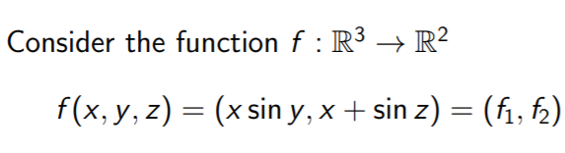The Jacobian Matrix in other words contains m rows which are the number of functions that f outputs and each row has n columns as the number of partial derivatives.

## Final definition of differentiability

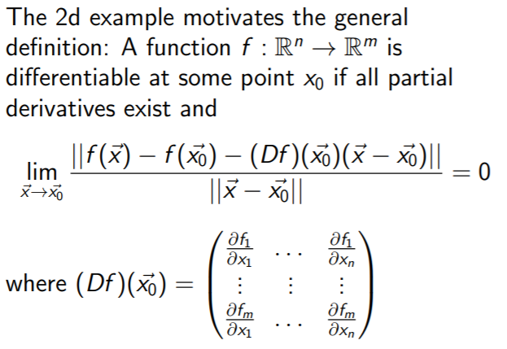as we can see it uses the Jacobian Matrix