# The extrema of a function

The extrema of a function are its maximum and minimum values.

It is possible to categorize maximum and minimum points into the following:

* Global maximum and minimum points
* Relative (local) maximum and minimum points

An open interval around x =c is an interval (a,b) such that a < c < b and a and b are not included in that interval. By the definition of relative extrema then it follows that a relative extrema c cannot occur at the boundary of a function domain because it is not possible to construct an interval (a,b) where a < c < b.

## Text Description automatically generatedCritical points of a function

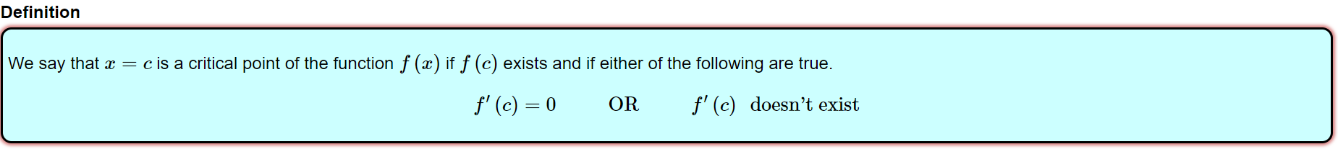

In other words, the critical points of a function f(x) are all those points c where the function f(x) exists and either f’(c)=0 or f’(c) does not exist. The points of the function f(x) where the derivative is 0 at those points are called STATIONARY POINTS.

## Extreme value Theorem

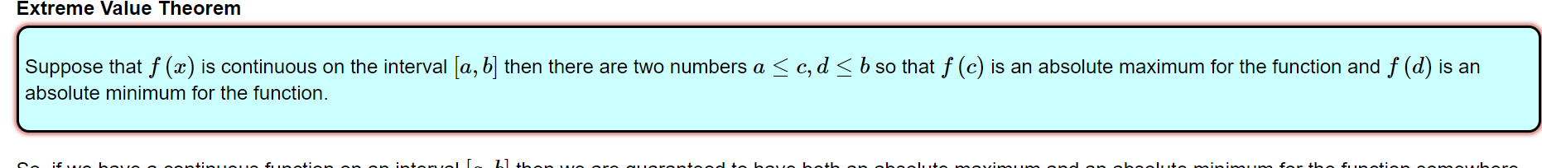

In other words, given that a function f(x) is continuous on an interval [a,b] where a and b are included then we are guaranteed to find a global maximum and global minimum.

## Fermat’s Theorem

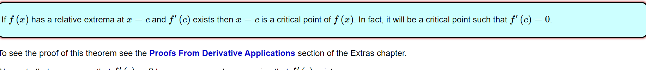

In other words, given that c is a relative extrema of a function f(x) and f’(c) exists then f’(c) = 0

From the previous 2 theorems we can infer how to look for the global minimum and the global maximum of a function f(x) in the interval [a,b].

Given that f(x) is continuous in the interval [a,b] then we are guaranteed to find a global maximum and a global minimum.

We can find them:

1. At the boundaries of the interval. That is either a or b may be global maximum or minimum
2. At local extrema

Thanks to the Fermat’s Theorem we know how to find local extrema:

1. Look where f’(x)=0
2. Look where f’(x) does not exist

In other words, we can find the local extrema of a function f(x) at the critical points of the function f(x).

Therefore, we can further outline the process of finding global extrema of a function f(x) in an interval [a,b] as the following:

1. Look for the boundaries of the interval
2. Look for the critical points of the function

Thus, we have explained how to find global extrema of a function f(x) in an interval [a,b].

## Proof Fermat’s Theorem

Without loss of generality let’s assume that x0 is a local maximum of the function f(x). Let’s assume that f’(x0) exists. Given that f’(x0) exists then both the left and right limit exists and have the same value. Let’s prove that f’(x0)=0.

* f(x0 + h)≤ f(x0) //local maximum definition
* f(x0 + h)-f(x0) ≤ 0



Thus, we have proved Fermat’s Theorem.

## From stationary point to local extrema

How is it possible to know given that f’(c)=0 whether or not c is a local extrema?

The following properties must hold:

Given that c is a local extrema then c can be either a local maximum or a local minimum

* If c is a local minimum then f’(c - h) < 0 and f’(c + h) > 0 for a small value h
* If c is a local maximum then f’(c - h) > 0 and f’(c + h) < 0 for a small value h

There is another way to check whether c is a local extrema and this way involves the use of higher order derivatives.

Let’s suppose that f’(c)=0 then:

* If f’’(c) < 0 then c is a LOCAL MAXIMUM
* If f’’(c) > 0 then c is a LOCAL MINIMUM
* If f’’(c) = 0 then it is inconclusive and we need to check higher order derivatives

Now, we are going to prove that the three statement above hold. Specifically, we are going to prove the first one. The second statement proof is analogous. Given that the first statement and second statement hold then the third statement must hold as well.

### First statement proof

Let’s suppose that c is a stationary point of the function f(x) and that f’’(c) < 0. Then c is a local maxima.

Proof:

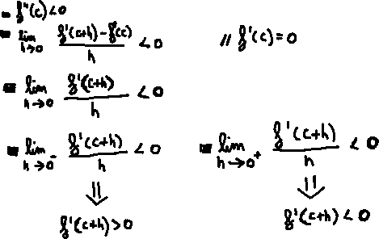

In other words, given that f’’(c) < 0 then f’’(x) is greater than 0 for values shortly before c and f’’(x) is less than 0 for values shortly after c. Therefore, c is a LOCAL MAXIMA.

Similar proof can be obtained with the second statement above.