# Interpolation Techniques

Interpolation is the process of using known data values to estimate unknown data values.

For example, sometimes we would like to know when f(x) = a but it is not easy to find a solution. While we know how to easily compute roots of linear and quadratic function, we still do not know yet how to effectively find higher order roots.

Thus, in this cases we need to find an approximation using interpolation techniques.

## Linear Interpolation

Let’s suppose that we need to know f(x) at some point x but we only know exactly f(x0) where x0 is a close point to x. For example, we may not exactly compute f(x) because it would require too much time.

In these cases we can use Linear Interpolation which consists of approximating a function with the line which is tangent to the known point x0.

We can easily compute such a line by using the following formula:

y = f(x0) + f’(x0)(x-x0)

In order to know the approximate value for some x, all we need to do is to plug x into the formula and we obtain y.

Naturally, given high order functions, a linear approximation cannot be a good approximation unless the known point x0 is very close to the point x we need an approximation of.

## Taylor Serie

Another way to approximate a function f(x) is to use the Taylor Serie whose formula is the following knowing the value of a point x0:

However, we need to be wary that the Taylor Serie does not always converge and that given that we know x0, x0 must be a close point to the x point we want its value of.

## Newton Raphson Method

The Newton Method is a method to find the approximate roots of a function.

For example, we may need to find g(x) =a. In this case, we transform the previous equation into

f(x)=0 where f(x) = g(x) – a and all we have to do is to find the roots of the function f(x). For some functions, finding the roots may be complicated and so we can use the Newton Method to find approximate roots.

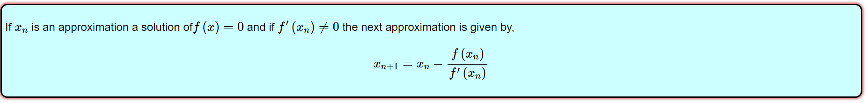For more info about the Newton Method look on <https://tutorial.math.lamar.edu/Classes/CalcI/NewtonsMethod.aspx>

### When the Newton Method does not work

* The first approximation we know should be as close as possible to the real root of the function
* If between the approximation root and the real root there is a critical point then we may not find the real root if such a critical point appears as an approximation thereafter
* If we firstly choose a critical point then we will never find the real root
* If our guesses oscillate back and forth then Newton's method will not work.
* If there are no roots, then Newton's method will fail to find it
* If there are two roots, we must have a first guess near the root that we are interested in, otherwise Newton's method will find the wrong root