# Linear Algebra

## The cross product

The cross product between two vectors a and b is a function called × which is defined in the following way:

× : (a,b) → c where a,b,c ∈ R3

In other words the cross product is defined only if the two vectors that it takes as arguments are three dimensional vectors (they not necessarily must be in R3) and it returns a vector as output.

Given two three dimensional vectors a and b a×b will be a vector that is orthogonal to both and whose magnitude is equal to the area of the parallelogram enclosed within the vectors a and b.

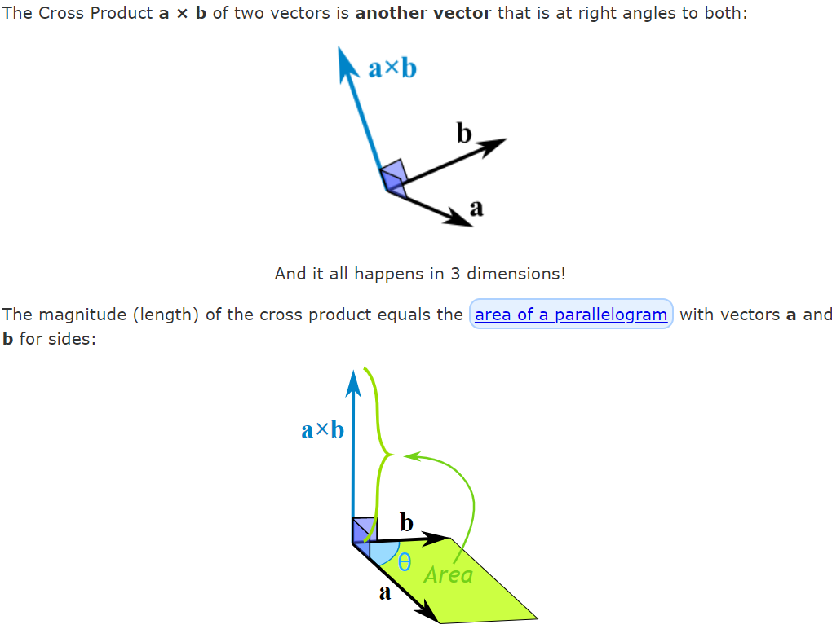

In other to understand why the cross product between two three dimensional vectors a and b is orthogonal to them and its magnitude is equal to the parallelogram enclosed within a and b, we need to look at the geometric definition of the cross product.

## Geometric definition cross product

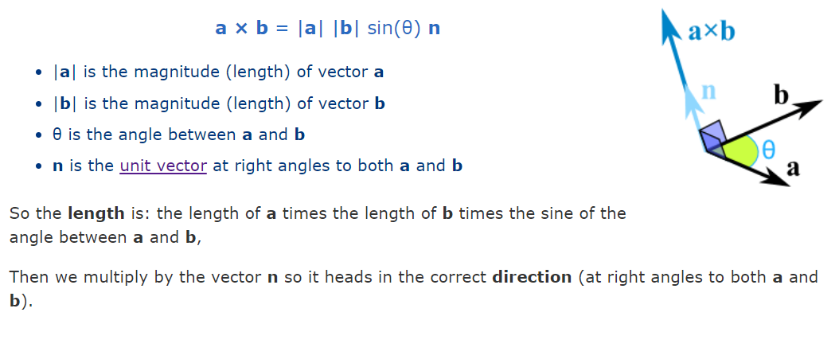In other words, the cross product between two three dimensional vectors a and b is equal to the length of a times the length of b times the sine of the angle enclosed within a and b. Then the previous scalar is multiplied to the unit vector which is orthogonal to both.

Given that the unit vector has length 1 and the resulting vector from the cross product must have length equal to the parallelogram area then how is |a| |b| sin(Θab) = area of parallelogram ?

**PROOF:**

However, how can we find the unit normal vector n (parallel) to the two vector a and b?

Given what we have studied in vector calculus we know that n·a=0 and n·b=0 as the dot product between two perpendicular vectors is equal to 0.

Then it is easy to make n a unit vector by dividing the vector by the scalar |n|.

It goes without saying that the **0** vector will be produced by the cross product of a and b if a and b are parallel as the parallelogram will have an area equal to 0.

We can arrive at the above conclusion also by watching the geometric formula of the cross product as sin(Θab) = 0 when Θab = 0° or Θab = 180°.

## Algebraic definition of cross product

Given vectors a = (a1,a2,a3) and b = (b1,b2,b3) then the cross product is defined in the following way:

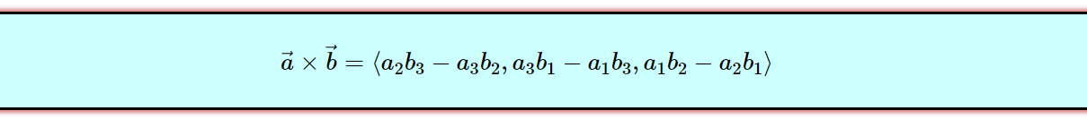

## Direction cross product between a and b

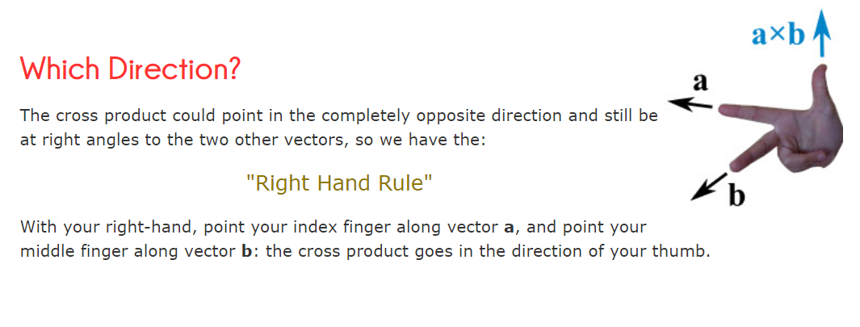

## Linear Map (Linear Transformation)

A linear map or linear transformation is just a fancy name for a function that is defined in the following way:

T : V → W where V and W are vector spaces

In other words, T is a function that transforms vectors in the sense that given that receives a vector a in V as input then it outputs a vector b in W.

However, a linear transformation must satisfy the following properties:

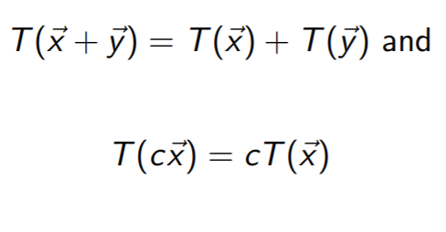

Which implies that:

This properties are very nice and ensure linearity in the transformation function because every vector that comes out of the linear transformation function is just a linear combination of its orthonormal basis.



In other words, given that we have a linear map from V to W then all vectors in V are expressed as linear combinations of their orthonormal basis. Due to the above property that linear combinations must satisfy then given any vector v in V we can know T(v) by just knowing the transformations of the orthonormal basis and then multiply those by the scalar contained in v. In other words T(v) is just a linear combination of the new transformed basis.

Matrices act as linear transformations as we know that the definition of matrix vector multiplication is the following:



Thus, given that we have a linear transformation described by a matrix A then column 1 describes the linear transformation of the first orthogonal basis vector, column 2 describes the linear transformation of the second orthogonal basis vector and so on.



**Proof in 2D standard orthogonal basis:**

## Scalar field

A scalar field is just a function f which is defined in the following way:

f : Rn → R

In other words a scalar field is just a function f that maps a specific point in a n-dimensional space (n-dimensional vector) to a scalar number.

## Vector field

A vector field is just a function f defined in the following way:

f : Rn → Rn

In other words, a vector field is a function f which maps a specific point x in a n-dimensional space to a vector in the same n-dimensional space which will have the tail attached to the point x.

