# Vector Calculus

## Scalar vs Vector

* A scalar is a quantity which can be described by a single number which is called magnitude
* A vector is an element which has both a magnitude and a direction

A vector can be distinguished into:

* Column vector
* Row vector

The difference between a row and column vector is only the way it is graphically represented but apart from that they are identical. For example, the row vector u and column vector u above are identical.

## Vector space

A vector space is a set of vectors V over a field F which must adhere to some axioms and must support two functions:

1. Vector addition
2. Scalar multiplication => a scalar times a vector

Usually a vector space is defined over the set of real numbers R.

If V = Rn then V contains all possible n-tuples of real numbers.

Each tuples represents a vector (row vector).

The field F is a set of the scalar quantities that the vector space V uses to define its scalar multiplication function.

The axioms that the vector space V must adhere to are the following:

However, due to some linear algebra requirements, vector spaces can be given an additional structure which comprises the following concepts:

* Vector norm => vector length
* Angles => can be derived from the dot product (scalar product) between 2 vectors

## Vector norm

The vector norm is the length (magnitude) of a vector and in Eulerian vector spaces is measured in the following way (uses the Pythagoras Theorem):

Given that $\vec{x} = (x_{1},x_{2},...,x_{n})$ then the norm of $\vec{x}$ denoted as | | or |||| is the following:

## The Dot product (scalar product)

The dot product is a function with the following definition · : V × V → F

In other words, the dot product, denoted as · , is a function that takes as arguments two vectors and returns a scalar over the field F of the vector space V.

There are two definitions of the dot product which are equivalent and we are going to start from the geometrid definition.

### Geometric definition Dot product

The dot product between two vectors a and b is the product of the length of b times the length of the projection of a onto b. In other words, a·b = |a|×|projection a onto b|

The question that may arise is how to compute the length of the projection of a onto b. Thankfully, trigonometry gives us a hand in this case.

The length of the projection of a onto b is given by the following formula:

|projection of a onto b| = |a|× cos(Θab) where Θab is the angle between a and b

The formula above holds by the definition: cos(Θab) =

Thus, in conclusion the geometric formula to compute the dot product between two vectors a and b is the following:

$$a·b = |a|×|b|× cos(Θ_{ab})$$

### Algebraic definition dot product

The algebraic definition of the dot product is the following:

Given that the dot product between two vectors a and b is defined in the following way:

$$a·b = |a|×|b|× cos(Θ_{ab})$$

Then:

* If $Θ_{ab}$ = 90°, that is the vectors are perpendicular then their dot product will be equal to 0 because $cos(90°)=0$.
* If $Θ_{ab}$ = 0°, that is the vectors are parallel then their dot product will be equal to $|a|×|b|$ because $cos(0°)=1$.

## Equality between vectors

Two vectors a and b are equal are equal when they have the same magnitude and the same direction.

That is a=b when a=(x1,y1) and b=(x1,y1).

## Parallel vectors

On the other hand, two vectors are parallel when they have either the same direction or inverse direction.

Given that a and b are parallel then $a·b = |a|×|b|$.

Additionally, if a and b are parallel then it is possible to express them as a scalar multiplication of the other that is:

b=ca where c is a scalar and a is the vector parallel to b

## Definition of scalar multiplication and addition in the Euclidean vector space

In the Euclidean vector space the addition and scalar multiplication are defined in the following way:

Given that a and b are two vectors such that a =(x1,y1) and a =(x2,y2) then:

* a+b = (x1+x2, y1 +y2)
* ca =(cx1,cy1) where c is a scalar

The inverse of a vector a is defined by the following scalar multiplication: (-1)a

## Diagram Description automatically generatedLinear combination

A vector v is a linear combination of a set of other vectors G iff v can be expressed as the sum of all vectors in G multiplied by a certain scalar.

Mathematically, if v is a linear combination of of a set of other vectors G of size n then:

$\vec{v}={c_{1}\vec{g}}_{1}$ + ${c_{2}\vec{g}}_{2}+{...+{ c}_{n}\vec{g}}_{n}$

## Linear independence

A set of vectors G is linear independent iff none of the vectors in G is a linear combination of the other vectors in G.

## Definition of a vector space by means of the basis

Given the notion of linear combination and linear independence, it is possible to formally describe an n-dimensions vector space V through a set G of n vectors which are linearly independent.

Such a set G is called the basis of the vector space V.

Thus, it follows that given that the basis of V is G then all vectors in v are a linear combination of the vectors in G.

## Orthonormal basis

A basis G of a vector space V is orthonormal iff all vectors in G are unit-length vectors and are orthogonal to each other. In other words, the dot product between any pair of vectors in G must be equal to 0 and all vectors must have a length equal to 1.

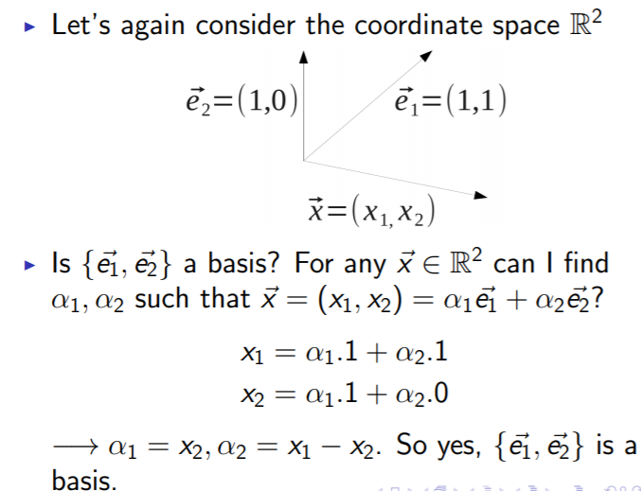Usually when describing a vector space V such that V = Rn the standard basis is used which is the following:

As regards the equation of a plane given a vector on the plane and a norm vector (orthogonal vector to the plane) visit <https://tutorial.math.lamar.edu/classes/calcii/eqnsofplanes.aspx>

## Proof Equivalence Geometric and Algebraic Definition of Dot Product

