Lab 1: AI-Assisted Software Delivery
This lab implements an AI-assisted software delivery workflow for the BankAssist AI project. Claude Code was used to create and follow repository-level engineering instructions, generate the application foundation, develop and execute automated tests, perform an AI self-review, and prepare the change for delivery through GitHub.
Approach: Spec-first AI SDLC with explicit human approval gates before implementation and before Git publication.
Services/Tools used: Claude Code, Git, GitHub, Python, FastAPI, pytest, Ruff, OpenAI SDK.

Step 1: Setup GitHub repository for the BankAssist application
A dedicated BankAssist AI repository was initialized for the individual lab project. The repository contains the application source, tests, project documentation, Claude Code instructions, reusable skills, and Git metadata. Lab 1 changes were later published from a dedicated feature branch rather than directly to main.

Screenshot 1: GitHub pull request from feature/lab-01-foundation to main, confirming the repository and feature-branch delivery flow.

Step 2: Setup Claude project instructions and reusable skills
A root-level CLAUDE.md file was created as persistent project context for Claude Code. It defines the BankAssist project scope, seven-lab progression, architecture principles, security expectations, scope discipline, and the required AI-assisted development workflow.
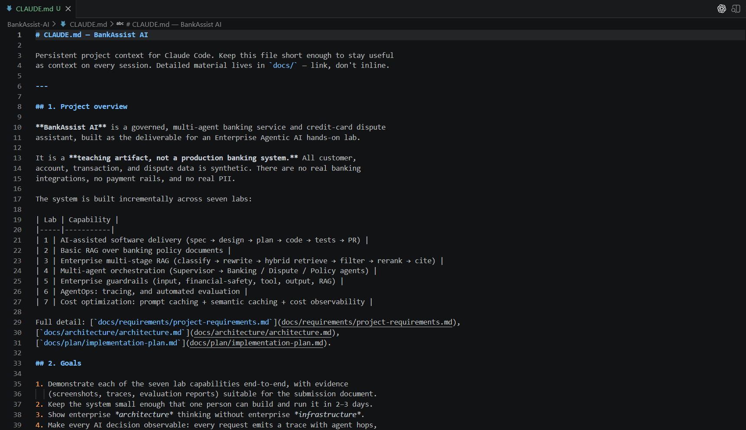
Screenshot 2: CLAUDE.md showing the BankAssist project overview and seven-lab implementation roadmap.
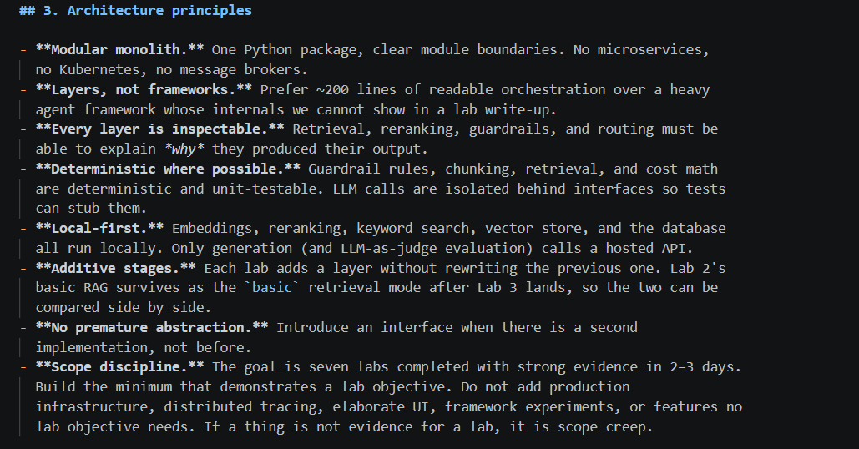
Screenshot 3: CLAUDE.md architecture principles used to keep the implementation modular, inspectable, local-first, and within lab scope.
Three reusable skills were added under .claude/skills so that the same delivery controls can be reused for subsequent labs.
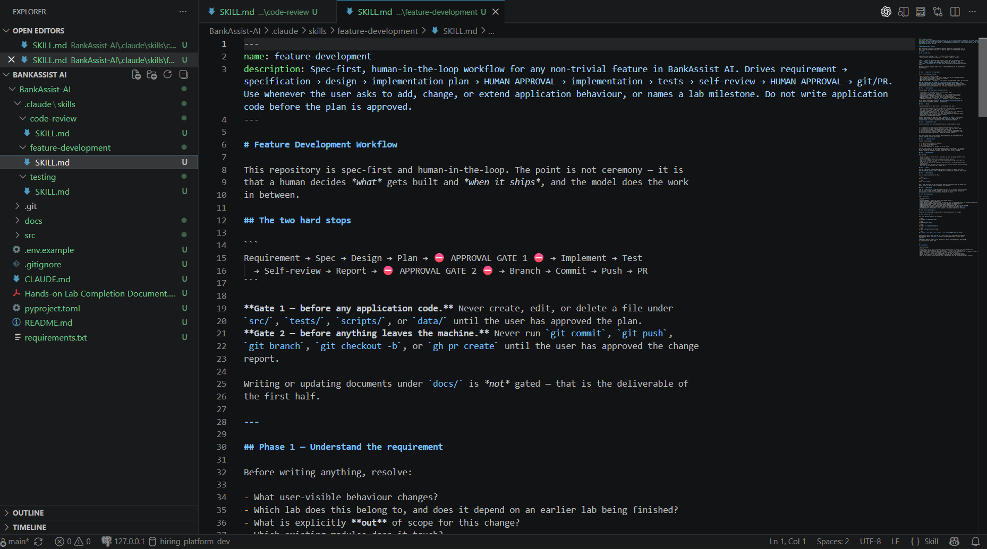
Screenshot 4: feature-development skill defining Requirement → Spec → Design → Plan → Human Approval → Implementation → Test → Self-review → Human Approval → Git/PR.
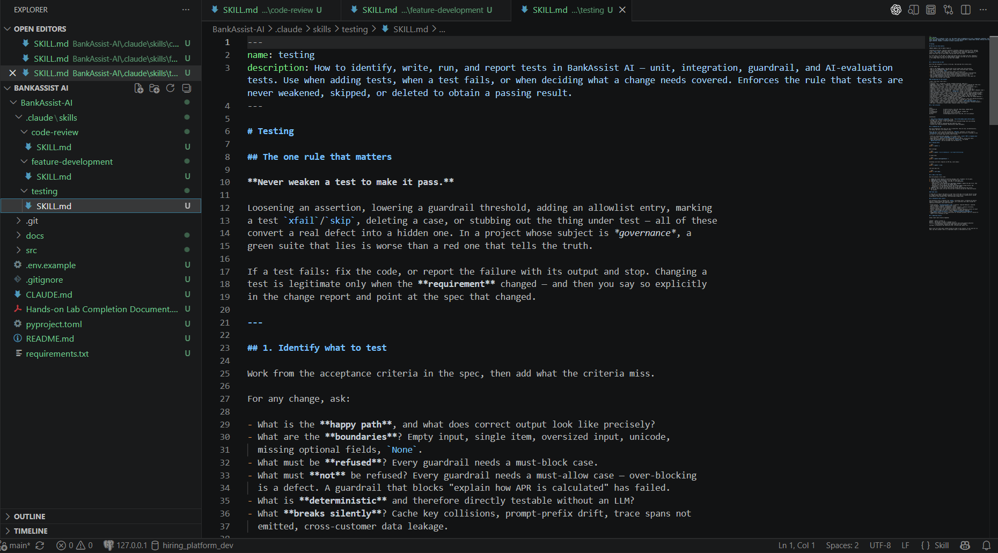
Screenshot 5: testing skill defining test selection and the rule that tests must not be weakened merely to obtain a passing result.
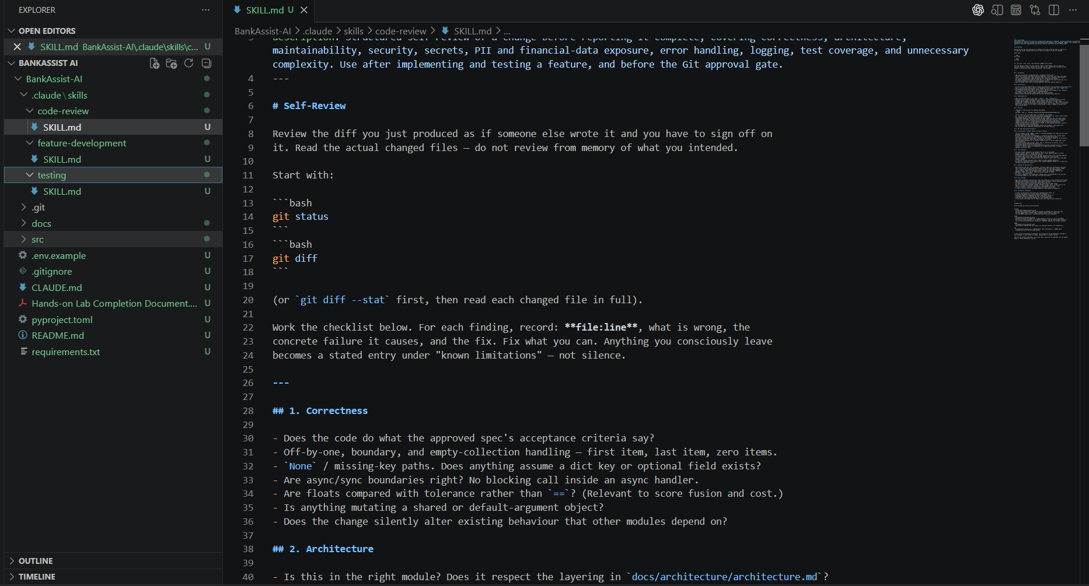
Screenshot 6: code-review skill used to review the actual changed files for correctness, architecture, maintainability, security, secrets, PII exposure, error handling, logging, and test coverage.

Step 3: Configure integrations required for the delivery workflow
Git and GitHub were used as the source-control and delivery integrations for this lab. The project was configured so Claude Code could prepare changes locally, while publication remained behind a human approval gate. No Jira requirement was used because BankAssist is a new greenfield individual project; the approved repository specification served as the source requirement.
The LLM provider was kept behind an application abstraction and configured through environment variables. API credentials were not hard-coded, logged, or included in tests. Tests use mocks/fakes rather than real paid LLM calls.

Step 4: AI-SDLC execution
4.1 Select and detail the requirement
The selected Lab 1 requirement was to establish the minimum BankAssist application foundation and prove the complete AI-assisted delivery cycle. The requirement was documented before application implementation, including functional requirements, acceptance criteria, module design, test plan, out-of-scope items, and the later-lab boundaries.
4.2 Create feature design and obtain human approval
Claude Code first generated the planning artifacts and stopped before application code. The design was reviewed and approved with amendments covering the initial OpenAI provider, economical model usage, layered guardrails for later labs, safe semantic-cache eligibility, Lab 3 retrieval stages, Lab 6 evaluation scope, and strict scope discipline. Only after this approval was Lab 1 implementation authorized.

Screenshot 7: The feature-development skill contains two hard stops, ensuring application code is not written before plan approval and Git publication does not occur before final approval.
4.3 Initiate creation of code and tests
After approval, Claude Code implemented the minimum application foundation: configuration, request context, structured logging, application errors, FastAPI API/health route, an LLM client abstraction with OpenAI adapter/stub/factory, and a lightweight tracer foundation. RAG, agents, guardrails, evaluation, caching, and Streamlit were deliberately excluded from Lab 1.
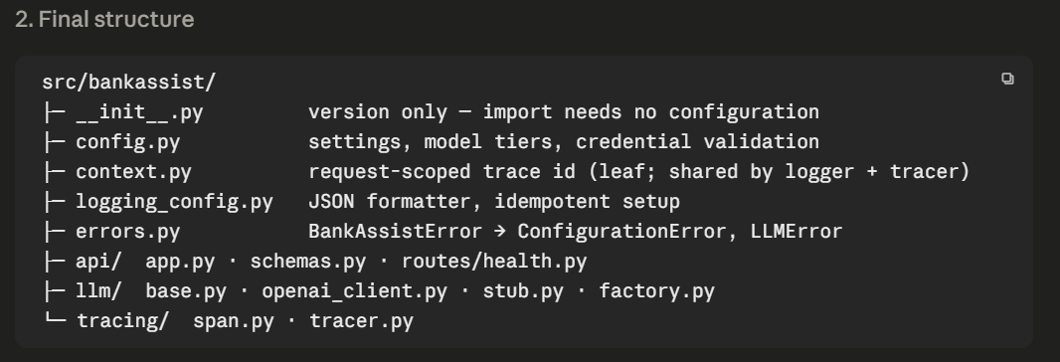
Screenshot 8: Final Lab 1 source structure generated after approval.
Automated tests were then created and executed. The supplied terminal evidence shows 67 tests passing with one dependency deprecation warning. The warning originates from the FastAPI/Starlette test-client dependency path rather than a failing BankAssist test.
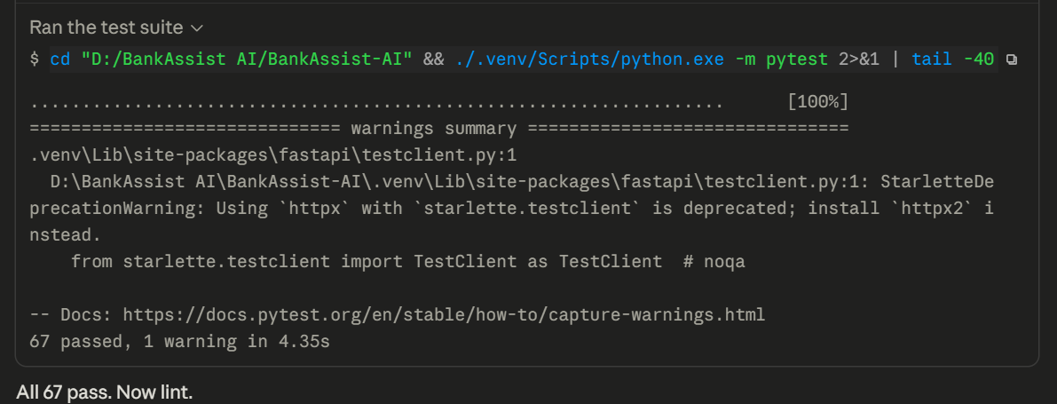
Screenshot 9: pytest execution showing 67 passed and 1 warning.
4.4 AI self-review and correction
Before publication, Claude Code followed the code-review skill and inspected the changed files rather than reviewing only from memory. The review covered correctness, architecture, security, secrets, PII/financial-data exposure, logging, error handling, test quality, and unnecessary complexity. A trace-ID issue on the HTTP 500 path was identified during review, corrected, and protected with regression tests.
4.5 Confirm push changes and create pull request
After implementation, testing, lint/static validation, startup verification, and AI self-review, Claude Code stopped again and requested explicit human approval before commit, push, and pull-request creation.
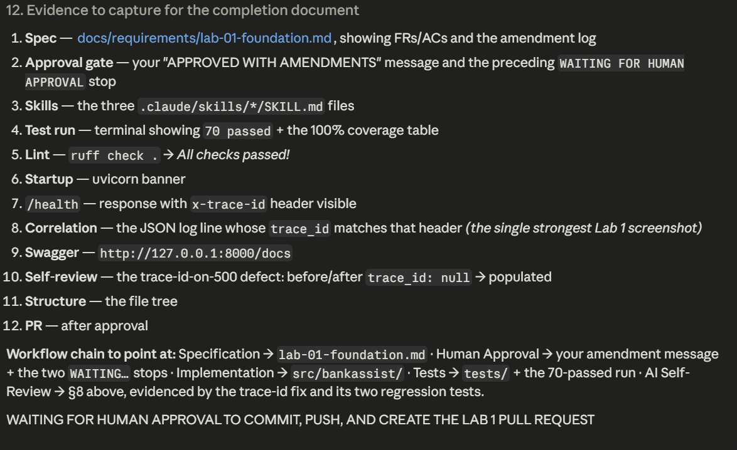
Screenshot 10: Second human approval gate after implementation and validation, before commit, push, and pull-request creation.
Following approval, the implementation was committed to feature/lab-01-foundation, pushed to GitHub, and a pull request was created against main. The pull request records the engineering workflow and planning artifacts, providing the final delivery artifact for Lab 1.
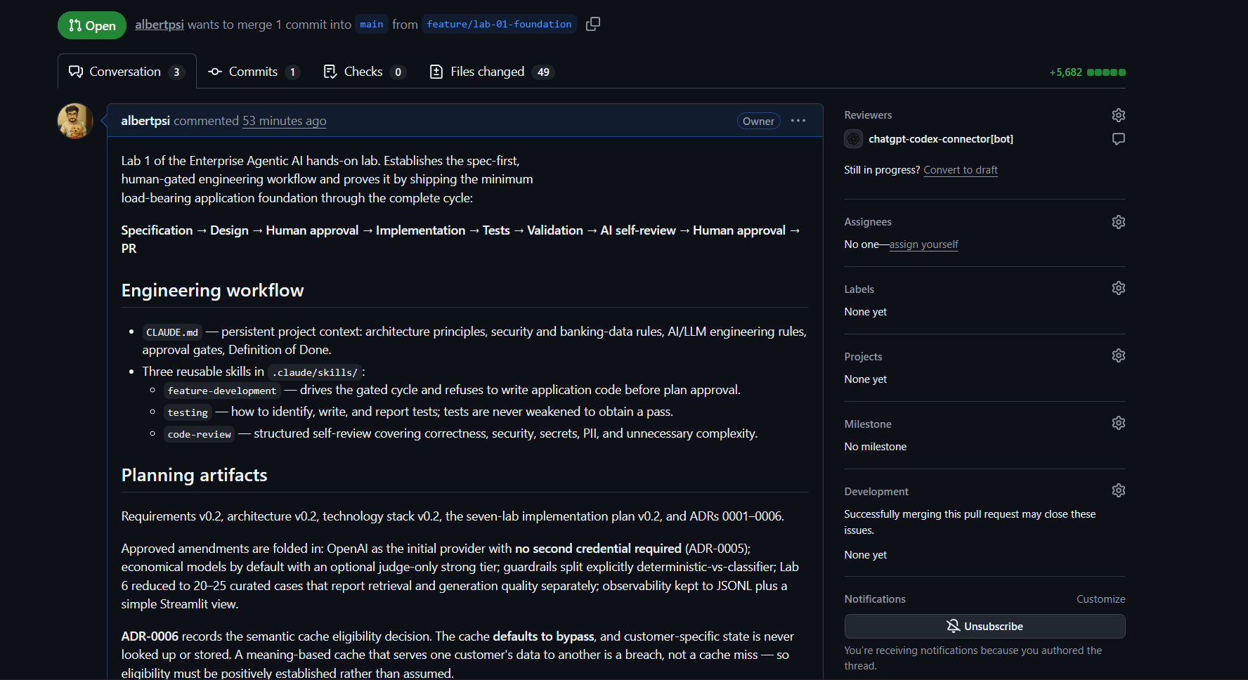
Screenshot 11: GitHub pull request documenting the Lab 1 AI-SDLC workflow and feature-branch delivery.

Implementation Result
Area | Implemented evidence
AI project governance | CLAUDE.md with project context, architecture principles, scope rules, and lab roadmap.
Reusable AI workflow | feature-development, testing, and code-review skills.
Human-in-the-loop control | Approval before implementation and separate approval before Git publication.
Application foundation | FastAPI health API, configuration, logging, errors, request context, LLM abstraction, tracing.
Automated validation | pytest test suite; supplied evidence shows 67 passing tests.
AI quality review | Structured self-review with a defect found and regression-tested.
Software delivery | Dedicated feature branch and GitHub pull request to main.

Learnings
- Spec-first development makes AI-generated code more controlled: defining acceptance criteria, design, test expectations, and out-of-scope items before implementation reduced ambiguity and prevented Claude from moving directly into feature coding.
- Repository-level AI instructions are useful for consistency. CLAUDE.md provides persistent project context, while focused skills keep feature development, testing, and code review reusable across future labs.
- Human approval gates are important when AI participates in the SDLC. Separating approval to implement from approval to publish kept architecture/scope decisions and source-control actions under human control.
- Tests should be treated as quality controls rather than obstacles. The explicit 'never weaken a test to make it pass' rule encourages fixing the implementation or requirement instead of hiding defects.
- AI self-review can provide additional value after code generation. In this lab, the review identified a trace-ID issue on an error path and led to a code correction plus regression tests.
- Keeping the Lab 1 scope small was important. Implementing only the application foundation preserved time and left RAG, multi-agent orchestration, guardrails, AgentOps/evaluation, and caching for the labs where those capabilities are actually evaluated.
- GitHub feature-branch and pull-request delivery provides a clear auditable artifact for the Spec → Code → Tests → PR workflow.

