1. Register the Container generated by the DockerFile with Cloud Build / Artifacts.
First of all we are going to create the docker repository on google artifact registry. So we enable the service, and then create a new repo, format: Docker, model: standard.

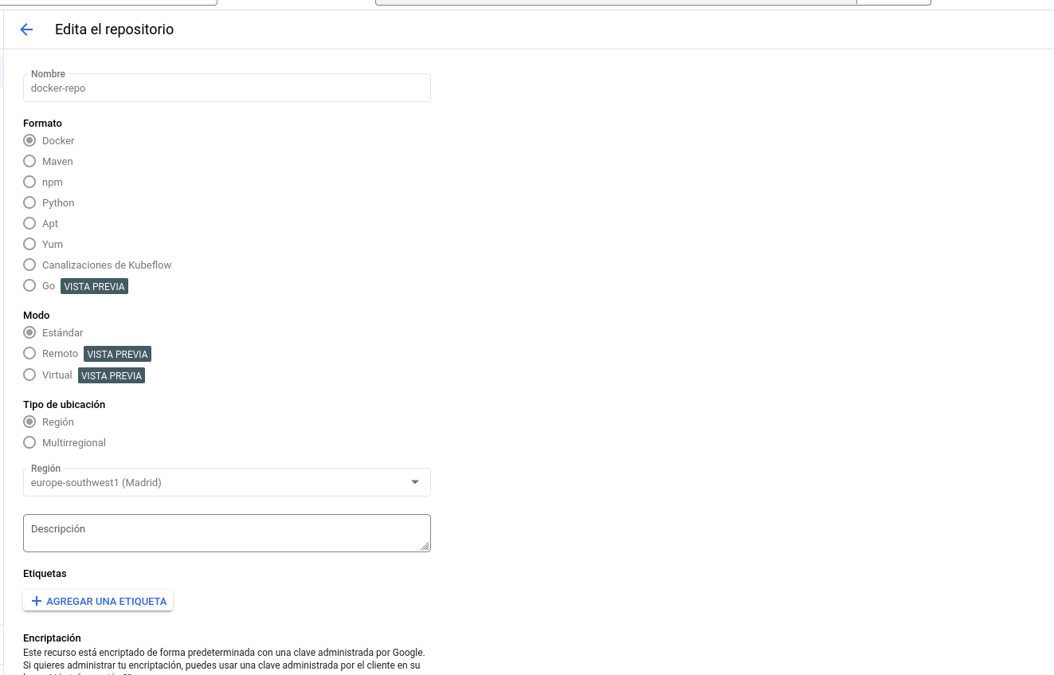

The first approach consist on using Cloud Build to connect to a GitHUb repo which contains all the files needed to build the image with the vue app.
But this plan fails as we do not have sufficient permisions to configure the GitHub repo with the Cloud Build service.

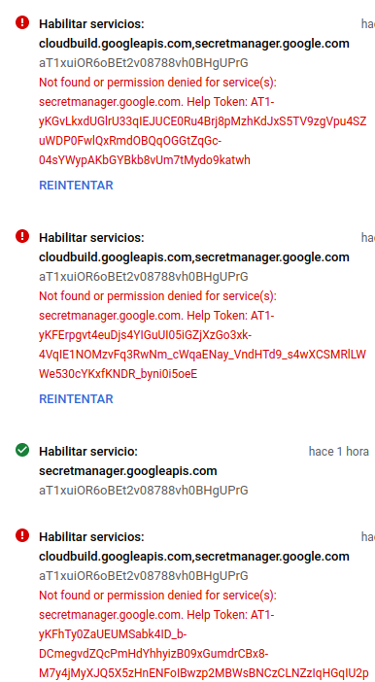

So a second approach has been applied. This one consists on cloning the github repo in our local machine, build the image from the Dockerfile provided and push the image to the already docker repository created in Google Artifatcs.

Firstly we have to login and enable permisions to push images from our local repo to the Google repository.
Configure gcloud with registry:

gcloud auth configure-docker \
europe-southwest1-docker.pkg.dev
Then login to the gcloud:

gcloud auth login

Finally we build locally our image with the following command:

docker build -t europe-southwest1-docker.pkg.dev/at1xuior6obet2v08788vh0bhguprg/docker-repo/vue-app:1.0.0 .

And push the generated image to our google artifact registry:
docker push europe-southwest1-docker.pkg.dev/at1xuior6obet2v08788vh0bhguprg/docker-repo/vue-app:1.0.0

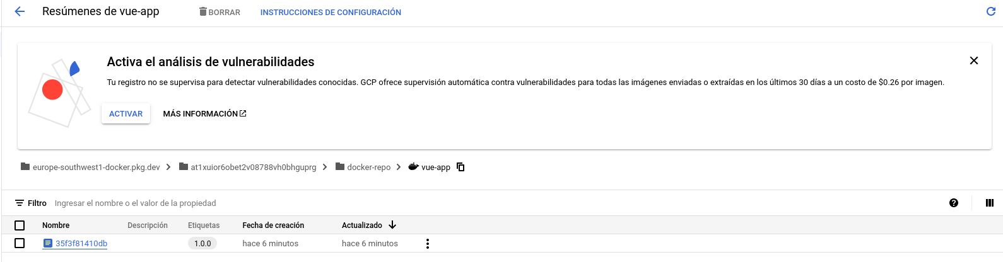

Another option is to configure our project in the gcloud cli client and use Cloud Build service to build the image and push it to the artifactory. This way we do not have to use docker locally, instead we use Cloud Build.

gcloud config set project at1xuior6obet2v08788vh0bhguprg

gcloud builds submit --region=global --tag europe-southwest1-docker.pkg.dev/at1xuior6obet2v08788vh0bhguprg/docker-repo/vue-app:1.0.0
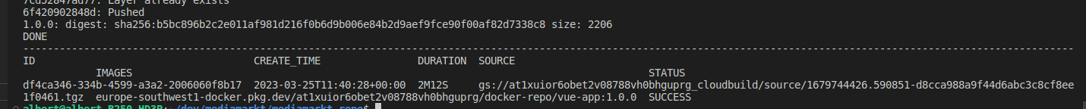

2. Generating a YAML file for Docker Composer.
Now it’s time to create our compose file in order to run the application:

version: "3"
services:
web:
container_name: vue-app
image: vue-app:1.0.0
ports:
- “3000:3000”

From this yaml file using kompose we can create the yaml deployment files, for the service and the deployment objects.

We are using version 3 of docker-compose, as we are going to run only 1 container we instance 1 service called web, the container created will have the name vue-app, the image which creates the container is the one in the registry, vue-app:1.0.0.

3. Generate the Terraform files in order to have the infrastructure as code and be able to deploy with Kubernetes.
Now it’s time to provision the infrastructure required to deploy our app. First of all we are going to create a VPC and then a Kubernetes cluster all of that using Terraform.
By creating a VPC, we create an envirnment where our cluster will reside, so it is isolated from other resources.

Before creating all this infra, we have to configure some things: enable Compute engine API and install gcloud auth plugin.

gcloud services enable servicemanagement.googleapis.com servicecontrol.googleapis.com cloudresourcemanager.googleapis.com compute.googleapis.com container.googleapis.com containerregistry.googleapis.com cloudbuild.googleapis.com

sudo apt-get install google-cloud-sdk-gke-gcloud-auth-plugin

Now we can start provisioning our infrastructure. In our terraform configuration file we define a resource VPC and a GKE resource, define all required variables and providers.
Then we initialize the environment with terraform init and follow the workflow , terraform plan and terraform apply. So our infra is created:
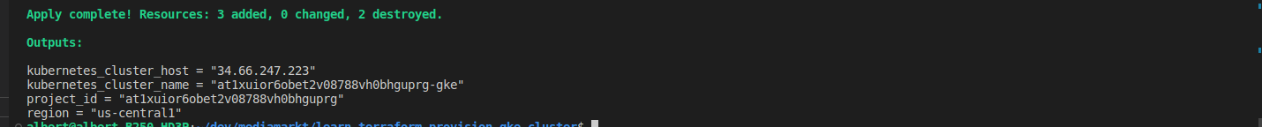

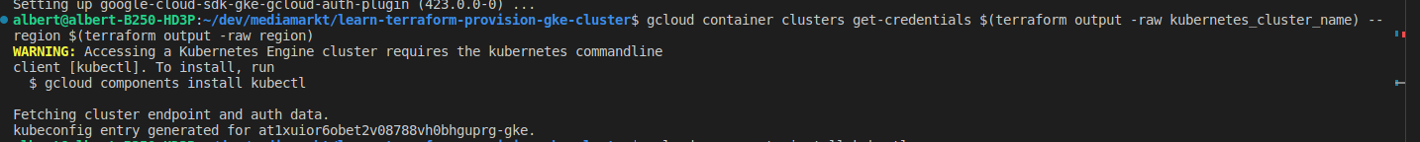
To connect to our cluster we must configure kubectl client

Then confirm that we have access to the cluster:
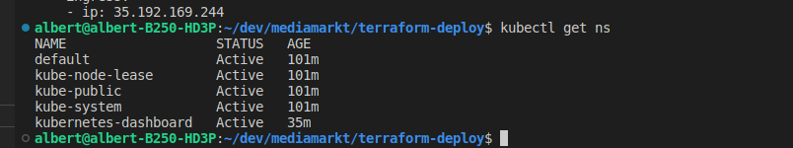

Now that we have created our cluster inside a VPC its time to deploy the application as a pod in our kubernetes cluster.

This could be done with a simple kubectl apply -f <file_name.yaml> but we are going to use terraform to deploy the deployment. We are going to deploy a deployment instead of a pod to give robustness to the app, as our deployment will have 2 replicas. Then it supports more traffic and in case one replica falls, we will continue giving service.

So we need another terraform configuration file for our deployment, inside it we are going to define a new resource of type kubernetes_deployment.
Also we need to define the providers used, in this case gcloud and kubernetes.

**Note: it is important to mark that, at the time of deploying the app, the kubelet could not pull the image from the registry, so we had to add in our gke terraform conf file the following lines in order to kubelet have permissions to pull the image:

oauth_scopes = [
"https://www.googleapis.com/auth/cloud-platform"
]

(All Terraform files are provided in the solution)

Then we have to make our app accesible to the internet, so we have 2 options here:

1- Provision a service of type ClusterIP and an ingress in order to expose our pod.
2- Provision a service of type LoadBalancer

We opt for the second one, as we only need to provision one resource. So we proceed to deploy our LoadBalancer service type with terraform.
As done before, we add the code to instanciate our service in the same conf file where we defined our deployment.

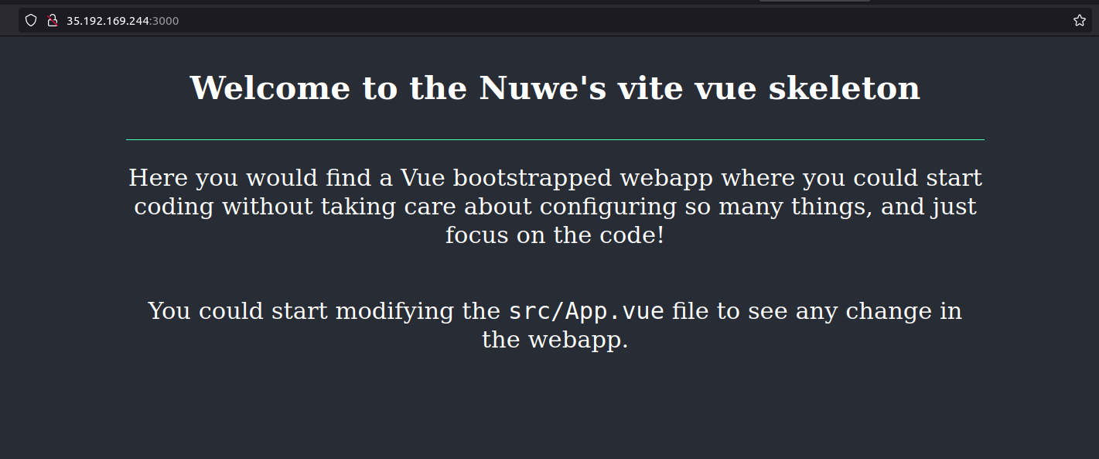
Finally accesing our LoadBalancer external IP providing the port of the app, we can connect to our application:

4. Answer the question to check the understanding of the Minimum Least Priviledge in the Roles assignment.

For a Devops role, it is a must to have permissions of all services used along the CI/CD process. This includes having permissions to the secret manager. As the process followed in this documentation is nice, but it would be better if we can connect from our GitHub repository , which is a common practice in companies, instead of having to clone locally the repo and then use Cloud Build to build and push the image. In other words, if we want our GitHub repo to be the SCM, we need to configure it with our CI tool , in this case Cloud Build.
Focusing on the cuestion, the roles for a devops in order to create clusters in kubernetes should be: roles/container as this role enables permissions to administer clusters and acces to all API objects.

For a Finance workers, the correct role should be roles/
billing. As it brings full access to the billing accounts and administer them.

DOCUMENTATION
Terraform GKE module: https://registry.terraform.io/providers/hashicorp/google/latest/docs/resources/container_cluster#argument-reference
https://registry.terraform.io/providers/hashicorp/google/latest/docs/resources/container_node_pool

