**TRIP ADVISOR**

**TUSCANY NETWORK**

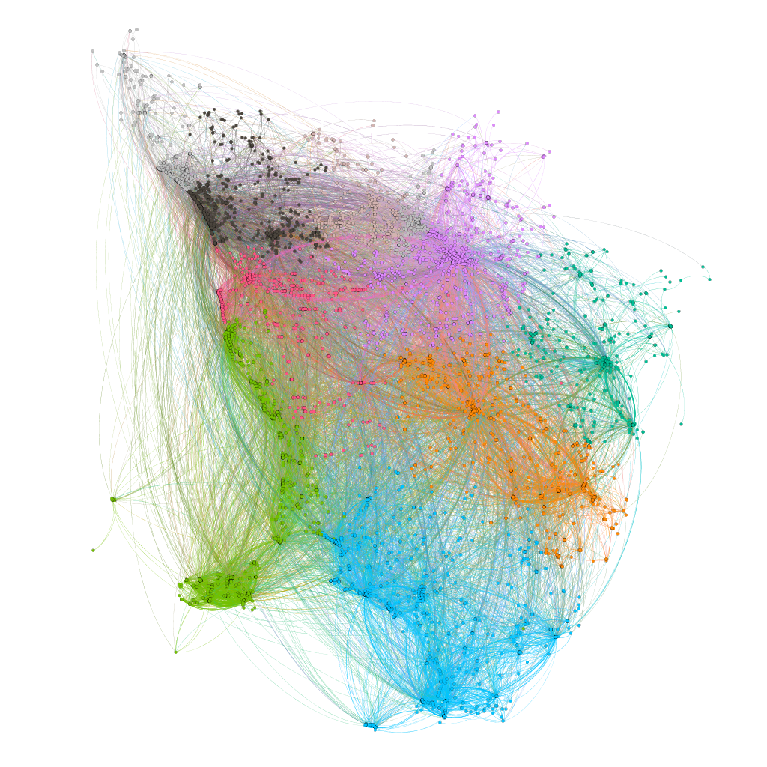Restaurants & Reviews

Final Report in

Social Newtork Analysis

Year 2020-2021

