PHPMYADMIN

WEBSITE PETSHOP TABLE

Tables and Views List

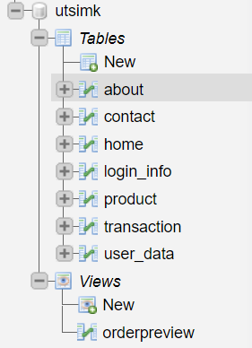

About

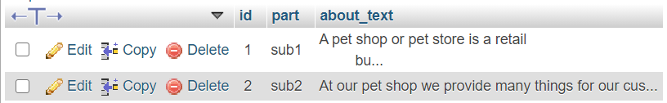

Contact

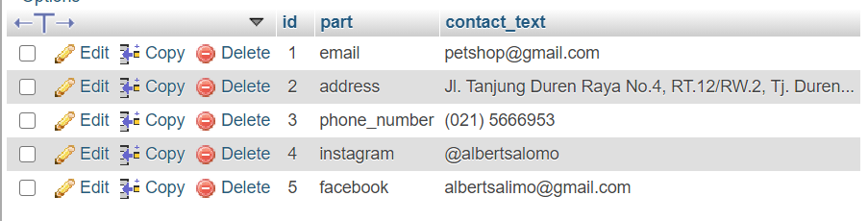

Home

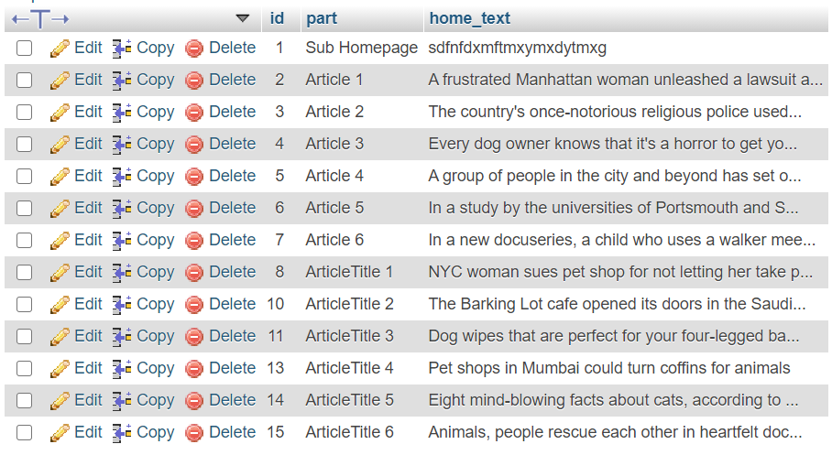

Login_info

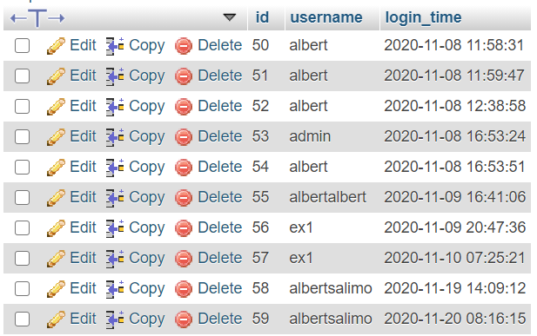

Product

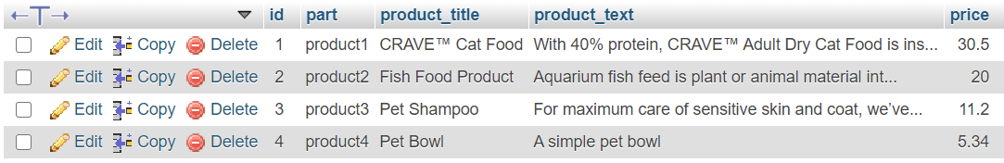

Transaction

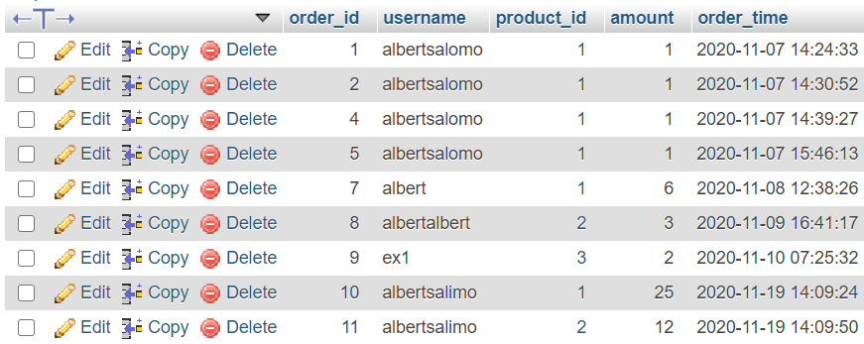

User data

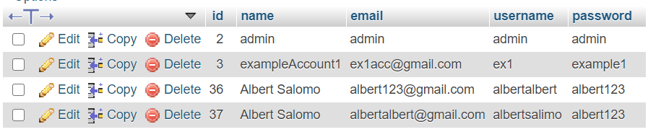

Orderpreview (JOINED TABLE)

