A reproducible, test-driven workflow for reducing and gridding legacy gravity compilations with calibrated uncertainty, verified on a synthetic benchmark
Flujo reproducible y verificado por pruebas para reducir e interpolar compilaciones gravimétricas heredadas con incertidumbre calibrada, validado con una campaña sintética
Albert Johan Herreraª
a Programa de Ingeniería Topográfica y Geomática, Universidad del Quindío, Armenia, Colombia. alberthj.herreras@uqvirtual.edu.co. ORCID: 0009-0009-1490-9075
Abstract
Bouguer anomaly maps are often built from legacy gravity compilations whose reduction choices and gridding methods are undocumented and lack uncertainty. We present an open, test-driven workflow that produces free-air, simple and complete Bouguer anomalies of known quality, and verify it on a synthetic survey with known truth. A term-by-term reconciliation recovers the defects injected into two simulated legacy spreadsheets: a 2300 kg m⁻³ reduction density (up to 4.1 mGal) and a sign-inverted curvature term (bias up to 0.75 mGal). Nettleton and Parasnis estimators recover a known density in high relief but fail, and are flagged, when the anomaly follows a low-relief topography. Under nested spatial block cross-validation, kriging, equivalent sources and a spline reduce the error of inverse-distance weighting by 62–72%, whereas random cross-validation understates errors by factors of 1.7–5.1. Only kriging provides uncertainty, which reaches nominal coverage on held-out blocks (0.956) and against the truth (0.953).
Keywords: Bouguer anomaly; gravity reduction; spatial cross-validation; kriging; equivalent sources; uncertainty; synthetic benchmark; reproducibility.
Resumen
Los mapas de anomalía de Bouguer suelen construirse con compilaciones heredadas cuyas decisiones de reducción e interpolación no están documentadas. Se presenta un flujo abierto que produce anomalías de aire libre y de Bouguer de calidad conocida, validado con una campaña sintética de verdad conocida. La conciliación término a término recupera los defectos de dos hojas de cálculo heredadas simuladas: una densidad de 2300 kg m⁻³ (hasta 4,1 mGal) y una curvatura con signo invertido (sesgo de hasta 0,75 mGal). Los estimadores de Nettleton y Parasnis recuperan la densidad con alto relieve, pero fallan, y se marcan, cuando la anomalía sigue una topografía de bajo relieve. Con validación cruzada espacial anidada, el kriging, las fuentes equivalentes y un spline reducen el error de IDW entre 62 y 72 %; la validación aleatoria lo subestima entre 1,7 y 5,1 veces. Solo el kriging entrega incertidumbre con cobertura nominal (0,956 y 0,953).
Palabras clave: anomalía de Bouguer; reducción gravimétrica; validación cruzada espacial; kriging; fuentes equivalentes; incertidumbre; campaña sintética; reproducibilidad.

1 Introduction
Complete Bouguer anomalies (CBA) are the standard input to regional studies of crustal structure and sedimentary basins. Turning observed gravity into a CBA map nevertheless involves a chain of choices: the reference ellipsoid and normal-gravity formula, the treatment of the atmosphere and of the permanent tide, the height correction, the reduction density, the curvature (Bullard B) term, the terrain correction and, finally, the method used to interpolate scattered stations onto a grid. Each choice is well studied individually [2-5], and Hinze et al. [1] consolidated them into a reduction standard. In practice, however, regional compilations are often assembled from heterogeneous legacy subsets whose reductions differ, whose intermediate quantities are supplied without documentation and whose maps are interpolated over areas with no data.
Interpolation adds its own, frequently ignored, uncertainty. Gravity stations in poorly accessible regions are usually acquired along roads and rivers, producing strongly clustered, line-based sampling. Geostatistical prediction then depends on an admissible covariance model fitted in metric coordinates [6,7]; the Gaussian model, still common in desktop GIS, leads to ill-conditioned systems [8]. Alternatives such as minimum-curvature splines [9-11] and equivalent sources [12-14] are physically or numerically attractive but lack a native error model. Moreover, the usual leave-one-out or random cross-validation is optimistic for autocorrelated, clustered data, and spatially blocked designs are recommended [15]. Few gravity studies report calibrated prediction uncertainty or the share of a map that is actually supported by data.
This paper presents a reproducible workflow that addresses these issues and verifies it where the answer is known: on a deterministic synthetic survey with line-based sampling, a known true anomaly, injected data defects and two simulated legacy subsets with undocumented reduction errors. We ask four methodological questions. (Q1) Can a term-by-term reconciliation between legacy and standard reductions detect and attribute undocumented reduction defects? (Q2) When can the reduction density be estimated from the data themselves? (Q3) Which gridding method minimizes the predictive error for line-sampled stations, and can its uncertainty be calibrated on held-out data and against the truth? (Q4) How optimistic is random cross-validation compared with a spatial block design?
Our contributions are: (i) a legacy mode that reproduces spreadsheet formulas exactly and a term-by-term reconciliation that attributes every difference to an individual reduction term; (ii) a nested spatial block cross-validation protocol that selects hyper-parameters and calibrates uncertainty on inner folds and evaluates both on outer folds; (iii) a deterministic synthetic benchmark with known truth, injected defects, simulated legacy subsets and two density scenarios; and (iv) open software with a web interface in which every product carries its provenance.
2 Methods
2.1 Harmonization and quality control
Records from several subsets are merged by identifier when all principal facts agree within tolerances (10⁻⁶ deg, 0.01 m, 0.01 mGal, 10⁻⁴ mGal for TC) and flagged otherwise. Stations closer than 1 m are merged into one position (mean g, H and TC), and the spread of g within merged groups is kept as evidence of repeatability. Quality control never deletes a record; it assigns flags from a controlled vocabulary: schema and range errors, shared-identifier conflicts, duplicate positions, suspect TC (zero at H>20 m, or a robust outlier relative to the 10 nearest neighbours, $|z_{MAD}|>3.5$; [16]), non-positive heights, offshore coordinates, outliers of the free-air–height relation and spatial outliers of the cross-validation residuals. Only error flags remove a station from the grids; suspect TC values are treated as missing, so the affected stations contribute to free-air and simple Bouguer products but not to the CBA grid. The other flags are advisory.
2.2 Reduction chain
All corrections are written as values added to the observed gravity, so that every anomaly is $g+∑δg−γ_{0}$. Normal gravity on the GRS80 ellipsoid [17] uses Somigliana's closed form,
$γ_{0}(φ)=γ_{e}\frac{1+k\sin^{2}φ}{\sqrt{1−e^{2}\sin^{2}φ}},$ (1)
with $γ_{e}=978032.67715mGal$, k=0.001 931 851 353 and $e^{2}=0.00669438002290$. Following Hinze et al. [1], the free-air, simple Bouguer and complete Bouguer anomalies are
$FAA=g+g_{H}−γ_{0}+δg_{h}+δg_{atm},$ (2)
$SBA=FAA−2πGρH,$ (3)
$CBA=FAA−BC_{cap}(H,ρ)+TCρ/ρ_{TC},$ (4)
where $g_{H}=0.0371(1−3\sin^{2}φ)$ is the Honkasalo term that removes the permanent-tide correction of IGSN71 data, $δg_{atm}=0.874−9.9×{10}^{−5}H+3.56×{10}^{−9}H^{2}$, $δg_{h}=(0.3087691−0.0004398\sin^{2}φ)H−7.2125×{10}^{−8}H^{2}$ (all in mGal with H in metres), $G=6.67430×{10}^{−11}m^{3}kg^{−1}s^{−2}$ [19], and $BC_{cap}$ is the attraction of a spherical cap of radius 166.735 km in the closed form of LaFehr [18]. The curvature term is $BB=BC_{cap}−2πGρH$; it is positive below about 4.15 km, so it reduces the anomaly. The reference density is 2670 kg m⁻³ [3].
The implementation was verified against analytical golden values (normal gravity to 10⁻⁴ mGal; other terms to 10⁻⁵ mGal), against the GRS80 implementation of the Boule library [20] to better than 10⁻³ mGal from pole to pole, and against the cubic approximation of the curvature term [21], which it matches to 5×10⁻⁴ mGal below 300 m. Property-based tests check the identity $CBA=SBA−BB+{TC}_{ρ}$ to 10⁻⁹ mGal.
2.3 Legacy mode and term-by-term reconciliation
Legacy spreadsheets typically combine a hard-coded slab density, a first-order height correction (0.3086H), their own normal-gravity coefficients and a curvature value supplied per station without documentation of its sign convention. The legacy mode reproduces such formulas exactly, so that the cached legacy anomalies can be verified before they are compared with the standard ones. The reconciliation then computes both reductions with all intermediate terms and decomposes the difference into normal gravity, Honkasalo, atmospheric, height, slab-density, curvature and terrain-scaling contributions; the sum of the contributions must close the total difference to numerical precision. The supplied curvature values are also compared with the recomputed BB: a correct “value to add” has a ratio close to −1, whereas a ratio close to +1 reveals an inverted sign.
2.4 Station uncertainty
Station uncertainty is propagated to first order from independent errors in g ($σ_{g}=0.1mGal$ by default), H (1 m), TC (10 %) and horizontal position (50 m), using central-difference derivatives of the full reduction (e.g. $∂CBA/∂H=0.195mGalm^{−1}$ for 2670 kg m⁻³). A Monte Carlo propagation (2 000 draws) with common random numbers and moment matching verifies the linear values. The density is treated as a scenario, not as a random error.
2.5 Density diagnostics
The Nettleton estimate minimizes $|corr(CBA(ρ),H)|$ over 1800–3000 kg m⁻³, and the Parasnis estimate is the least-squares slope of FAA on the unit-density Bouguer-plus-terrain term $X=BC_{cap}(H;1kgm^{−3})−TC/ρ_{TC}$ [22,23]. Both are computed on residuals of a degree-2 polynomial trend to suppress regional correlation, with 95 % intervals from a spatial block bootstrap (15 km blocks, 1 000 replicates). An estimate is considered reliable only if both interval half-widths are below 300 kg m⁻³, the estimate is physically plausible and the two intervals overlap.
2.6 Spatial model and gridding
All spatial computations use projected metric coordinates (EPSG:9377; [24]). The gridded anomaly is modelled as
$Z(s)=m(s)+Y(s)+ε(s),$ (5)
where m is a polynomial drift of degree $p∈\{0,1,2\}$, Y a zero-mean Gaussian process with Matérn covariance
$C(r)=σ^{2}\frac{2^{1−ν}}{Γ(ν)}{(\frac{\sqrt{2ν}r}{ℓ})}^{ν}K_{ν}(\frac{\sqrt{2ν}r}{ℓ}),ν∈\{0.5,1.5,2.5\},$ (6)
and $ε$ a nugget of variance $τ^{2}$. The Gaussian covariance is excluded [8]. Covariance parameters are fitted by weighted least squares to the experimental semivariogram of the drift residuals [6] (bins of 1.5 km, lags up to 30 km), with a fixed fallback sequence. Prediction is by regression kriging (OLS drift and simple kriging of the residuals); its variance is reported raw and multiplied by a calibration factor c=sd(z) obtained from block cross-validation, where $z=(Z_{obs}−\hat{Z})/\hat{σ}$. Geometric anisotropy is modelled only if the minor/major ratio of directional length scales is below 0.7 in at least four of five folds. The gridding methods compared are inverse-distance weighting (IDW, power 2, 12 neighbours, a common legacy choice), a linear trend plus a biharmonic spline [11], equivalent sources at relative depths of 7–20 km with damping 0.01–1 [14,25], and regression kriging. Grids have 500 m cells [26]; cells farther than 5 km from a station or outside the convex hull are masked as unsupported.
2.7 Validation design
Hyper-parameters (drift degree and $ν$ for kriging; depth and damping for equivalent sources) and the calibration factor are selected on inner five-fold spatial block cross-validation within each training set of an outer five-fold block cross-validation (15 km blocks). The outer folds therefore provide honest estimates of predictive error (RMSE) and of calibration (sd(z) and the share of |z|<1.96). The sensitivity of the conclusions to the fold layout and block size is assessed with two further random seeds and with 10- and 25-km blocks. For comparison, the same nested protocol is repeated with 250 m blocks, which contain at most one station each and are therefore equivalent to random five-fold cross-validation.
2.8 Software and reproducibility
The workflow is implemented as a typed Python package (gravanom) built on NumPy, xarray, pyproj, Verde [11], Harmonica [25], Boule [20] and GSTools [27], with a FastAPI service and a MapLibre web interface. About 170 automated tests cover formulas, quality-control rules, the pipeline, the API and eight end-to-end acceptance scenarios. Every run writes a manifest with input and output hashes, the resolved configuration, package versions and seeds; repeated runs produce byte-identical tables and grids.
3 Synthetic benchmark
The benchmark is generated deterministically from a fixed seed (Fig. 1). A topography with heights of 5–269 m (mean 142 m) and a terrain-correction field of 0.1–1.0 mGal are drawn as Matérn random fields over a 160×160 km square. The true CBA, from −68 to −10 mGal, is the sum of a quadratic regional field and the attraction of four buried prisms with density contrasts of −300, −200, +150 and +250 kg m⁻³, tops at 5.5–7.9 km depth and widths of 10–25 km, computed with Harmonica at the topographic surface. Two thousand stations are placed on 20 meandering traverses with a spacing of 1.0–1.6 km, leaving gaps of tens of kilometres between lines. Observed gravity is obtained by inverting the standard reduction exactly with $ρ_{true}=2670kgm^{−3}$, so that the noise-free observations reduce to the true CBA; Gaussian noise of 0.3 mGal is added to gravity and of 1 m to the reported heights. Five duplicate positions (two with a 0.5 mGal offset), three terrain corrections set to zero above 50 m and one gross gravity error are injected, giving 2 005 records.
Two legacy subsets, A and B, are simulated from the 1 996 clean stations by splitting them into even and odd traverses (997 and 999 stations). Both are reduced with typical legacy spreadsheet formulas: slab density 2300 kg m⁻³, first-order height correction and legacy normal-gravity coefficients. Subset A supplies the cubic approximation of the curvature term with the correct “value to add” sign; subset B supplies it with the opposite sign and 8 % too large. Two further variants test the density estimators: a high-relief survey (0–1500 m, $ρ_{true}=2400kgm^{−3}$) and a low-relief survey in which the true anomaly contains a term of 0.08 mGal m⁻¹ proportional to the topography, mimicking lowlands that coincide with thick, light sedimentary fill.
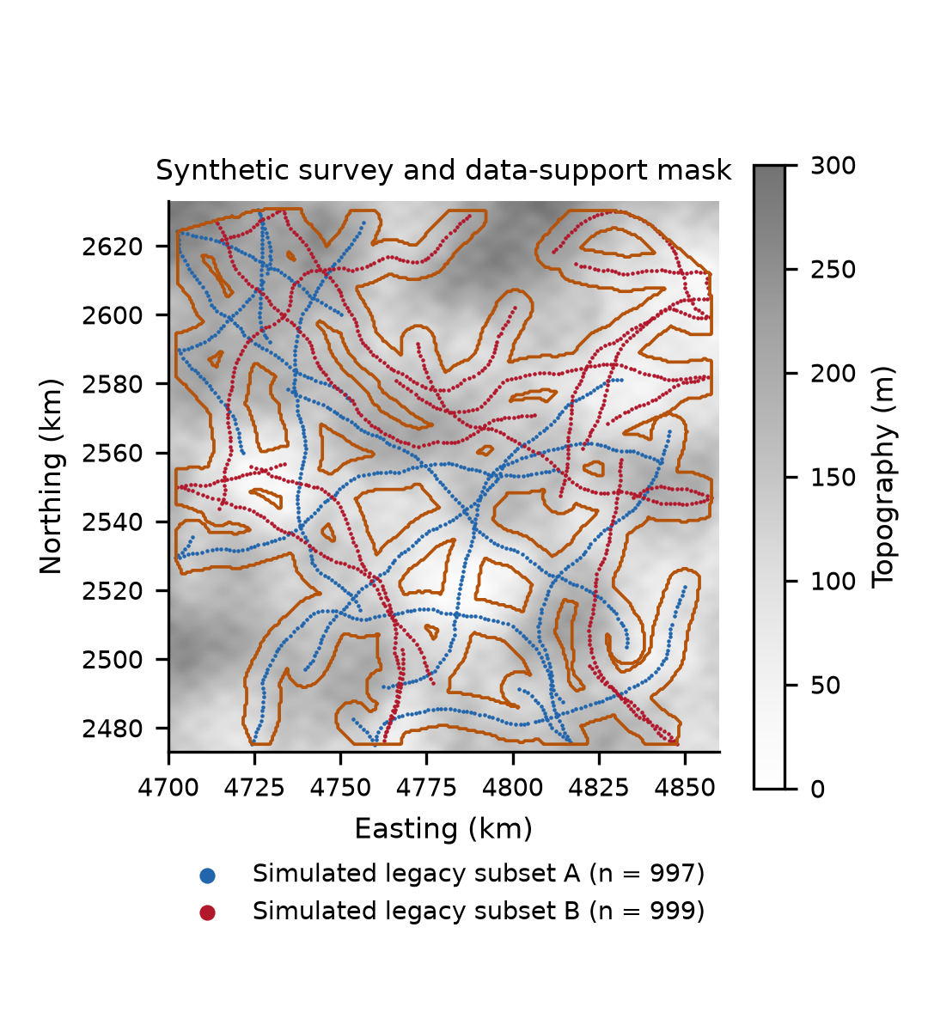
Figure 1. Synthetic survey: topography, stations of the two simulated legacy subsets (even and odd traverses) and the data-support mask (orange: cells within 5 km of a station and inside the convex hull). All values are fictitious.
Source: The author.
4 Results
4.1 Quality control and station uncertainty
Quality control flags all nine injected defects: the five duplicate positions are merged (the two offset pairs imply a repeatability of $σ_{g}≈0.22mGal$), the three zero terrain corrections are flagged as suspect and the gross error is flagged as out of range. The remaining 1 996 stations enter the CBA grid. Advisory flags mark 38 stations whose fictitious coordinates fall offshore, 31 spatial outliers of the cross-validation residuals and seven outliers of the free-air–height relation; none of them is removed. With the default error budget, the median station uncertainty is 0.32 mGal for the FAA and 0.23 mGal for the CBA, dominated by the height error, and the Monte Carlo and linear values agree to better than 10⁻⁶ (relative).
4.2 Reconciling legacy and standard reductions (Q1)
The legacy mode reproduces the simulated spreadsheets exactly, and the term-by-term decomposition closes the difference between the standard CBA ($ρ=2670kgm^{−3}$) and the legacy CBA to 2.3×10⁻¹⁰ mGal (Table 1). The reduction density dominates: replacing 2300 by 2670 kg m⁻³ changes the CBA by −2.15 mGal on average and by up to −4.08 mGal at the highest stations (Fig. 2a). The curvature contribution separates the two subsets. For subset A it is zero within 3 imes10⁻⁴ mGal, and the ratio of supplied to recomputed curvature is −0.999, the correct convention. For subset B the ratio is +1.079, which reveals both the inverted sign and the 8 % excess (Fig. 2b), and the curvature term contributes −0.40 mGal on average and up to −0.71 mGal. Consequently, even with the density fixed at the legacy 2300 kg m⁻³, the standard CBA differs from legacy A by only −0.04 mGal on average (range −0.10 to +0.03), whereas it differs from legacy B by −0.42 mGal on average and by up to −0.75 mGal. The height correction contributes about +0.02 mGal, and the legacy normal-gravity coefficients reproduce GRS80 to 10⁻⁵ mGal.

Table 1.
Term-by-term decomposition of the difference between the standard CBA ($ρ=2670kgm^{−3}$) and the CBA of the two simulated legacy subsets (mGal). Injected defects: density 2300 kg m⁻³ in both subsets; curvature with inverted sign and 8 % excess in subset B.
 | Subset A |  | Subset B
Term | Mean | Min | Mean | Min
Slab density (2670 vs 2300) | −2.31 | −4.16 | −2.10 | −3.87
Curvature (supplied vs recomputed) | 0.00 | 0.00 | −0.40 | −0.71
Height correction | +0.02 | 0.00 | +0.02 | 0.00
Total difference | −2.29 | −4.12 | −2.47 | −4.54
Standard ($ρ=2300$) minus legacy | −0.04 | −0.10 | −0.42 | −0.75
Ratio supplied/recomputed BB | −0.999 |  | +1.079
Source: The author.

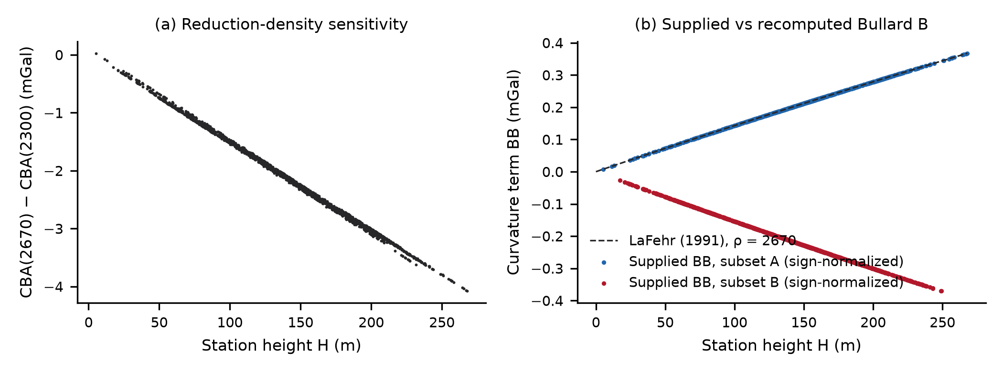
Figure 2. (a) Change of the CBA when the reduction density is raised from 2300 to 2670 kg m⁻³, as a function of station height. (b) Curvature term recomputed with the LaFehr closed form compared with the values supplied with the two simulated legacy subsets (sign-normalized to the “value subtracted” convention): subset A coincides with the recomputed term, subset B has the opposite sign and is 8 % too large.
Source: The author.

4.3 Density diagnostics (Q2)
On the high-relief survey (height sd 285 m), Nettleton gives 2440 kg m⁻³ (95 % interval 2340–2570) and Parasnis 2437 kg m⁻³ (2342–2570), both containing the true 2400 kg m⁻³, and the reliability criterion is met (Fig. 3). On the low-relief survey whose anomaly follows the topography (height sd 46 m), the Nettleton criterion reaches the upper bound of the search range and Parasnis gives a physically implausible 4 110 kg m⁻³ (3 394–4 839), although the true density is 2670 kg m⁻³. Removing a quadratic trend does not help, because the correlation between anomaly and topography is local. The reliability criterion correctly rejects both estimates, so the workflow falls back to the conventional density and reports the alternative as a scenario.

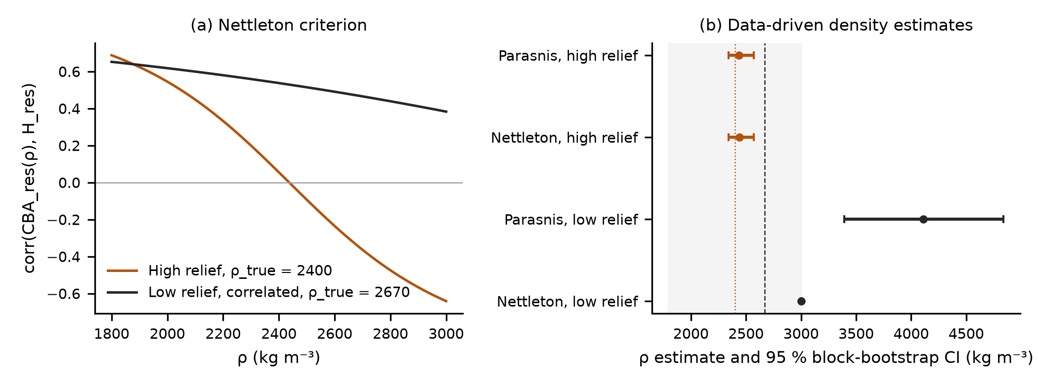
Figure 3. (a) Nettleton criterion for the high-relief survey ($ρ_{true}=2400kgm^{−3}$) and for the low-relief survey whose anomaly follows the topography ($ρ_{true}=2670kgm^{−3}$). (b) Nettleton and Parasnis estimates with 95 % block-bootstrap intervals; the shaded band marks physically plausible densities.
Source: The author.

4.4 Variography and gridding performance (Q3, Q4)
The experimental semivariogram of the drift residuals is well described by a Matérn model with $ν=1.5$, a length scale of 46 km, a partial sill of 137 mGal² and a nugget of 0.10 mGal² on a degree-2 drift (Fig. 4). Directional length scales differ: the minor/major ratio is below 0.7 in four of the five outer folds (0.55–0.77), so the anisotropy test is positive (major axis N45°E, ratio 0.64) and the anisotropic model competes with isotropic ones in the inner selection; it was chosen in one fold.
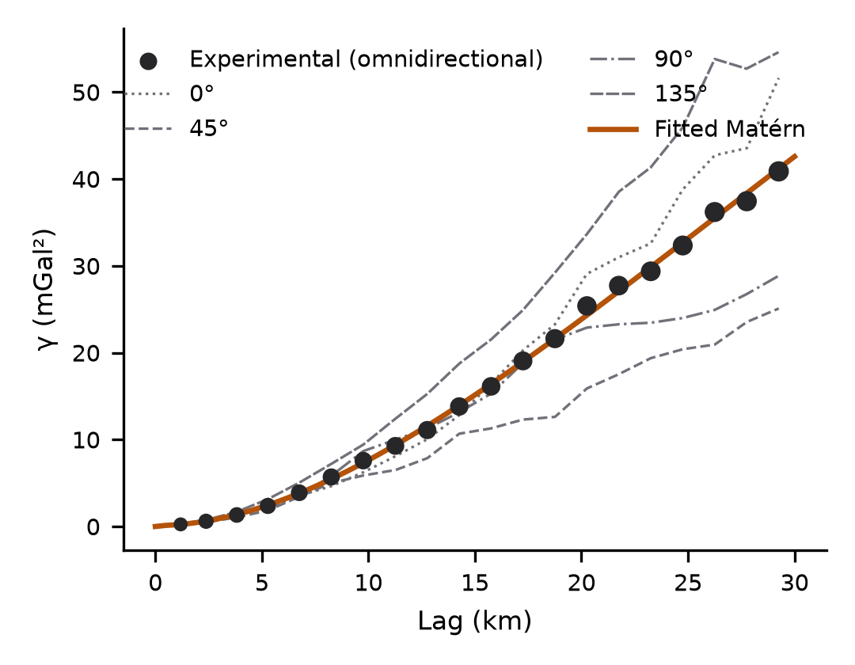
Figure 4. Experimental semivariogram of the CBA drift residuals (marker size proportional to the number of pairs), directional semivariograms and the fitted Matérn model ($ν=1.5$).
Source: The author.
Under outer spatial block cross-validation (Table 2, Fig. 5), the trend-plus-spline has the lowest error (0.69 mGal), followed by regression kriging (0.74 mGal) and equivalent sources (0.94 mGal); IDW is clearly worst (2.49 mGal). The three model-based methods therefore reduce the IDW error by 62–72 %, and their differences are comparable to the spread between folds. The ratio of kriging to IDW error is stable across fold layouts (0.27–0.36 for three seeds) and block sizes (0.31 and 0.34 for 10- and 25-km blocks). Only kriging delivers an uncertainty estimate. Its raw variance is conservative (sd(z)=0.84), and after scaling with the inner-fold factor (c=0.73) the outer-fold calibration is close to nominal (sd(z)=0.90, 95 % coverage 0.956); it remains so for all seeds and block sizes (coverage 0.956–0.972). Random cross-validation is markedly optimistic: it understates the error of IDW by a factor of 5.1, of equivalent sources by 2.5, of kriging by 2.0 and of the spline by 1.7, and it would rank the methods differently.

Table 2.
Outer five-fold cross-validation of the CBA on the synthetic survey (1 996 stations): spatial blocks of 15 km and the random-equivalent design. Hyper-parameters and calibration were selected on inner folds.
Method | Block RMSE | Fold RMSE | Random RMSE | sd(z) | 95 % cov.
IDW (p=2, k=12) | 2.49 | 2.42±0.63 | 0.49 | – | –
Linear trend + biharmonic spline | 0.69 | 0.69±0.11 | 0.40 | – | –
Equivalent sources | 0.94 | 0.89±0.32 | 0.38 | – | –
Regression kriging (Matérn) | 0.74 | 0.72±0.15 | 0.38 | 0.90 | 0.956
Source: The author.

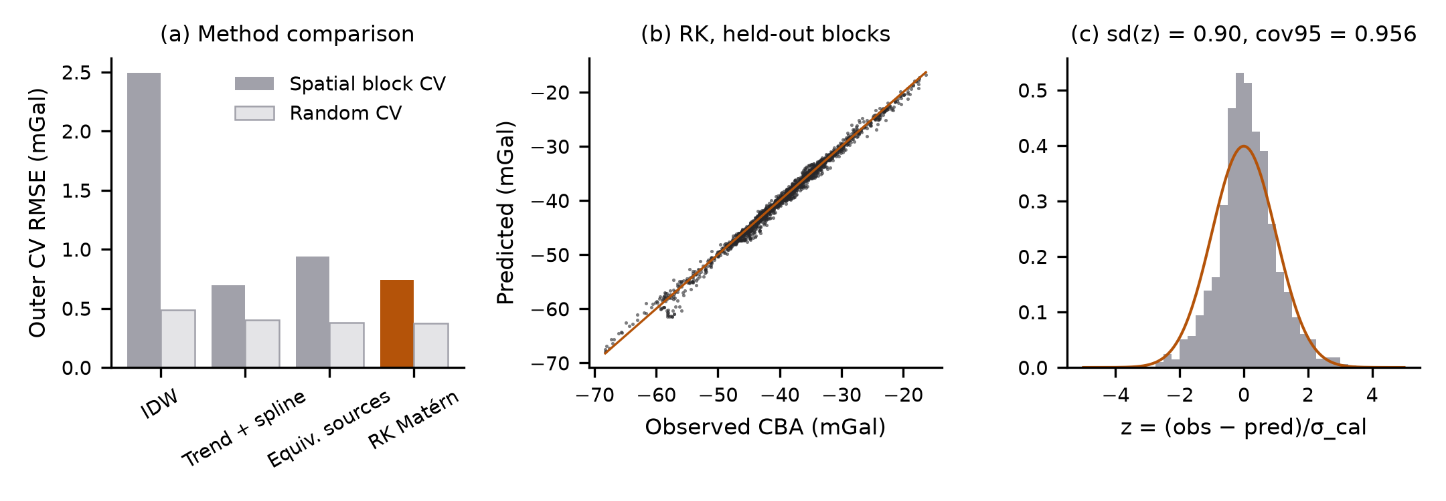
Figure 5. (a) Outer cross-validation RMSE of the four methods with spatial blocks and with the random-equivalent design. (b) Predicted versus observed CBA at held-out stations for regression kriging. (c) Standardized errors with calibrated uncertainty and the standard normal density.
Source: The author.

4.5 Truth recovery and data support
Inside the support mask, the kriging grid differs from the true field by 0.27 mGal RMS, well below the cross-validation estimate, because most supported cells lie close to a traverse, whereas the outer folds predict whole blocks (Fig. 6). The calibrated uncertainty covers the true field at the nominal rate (95 % coverage 0.953); it has a median of 0.24 mGal and grows to 1.0 mGal towards the gaps between traverses and the edges of the mask. The support mask retains 65 % of the square; the remaining area is extrapolation and is not published. The cell size has a negligible effect: the RMS difference between a 250 m grid and the bilinearly resampled 500 m grid is 0.002 mGal.

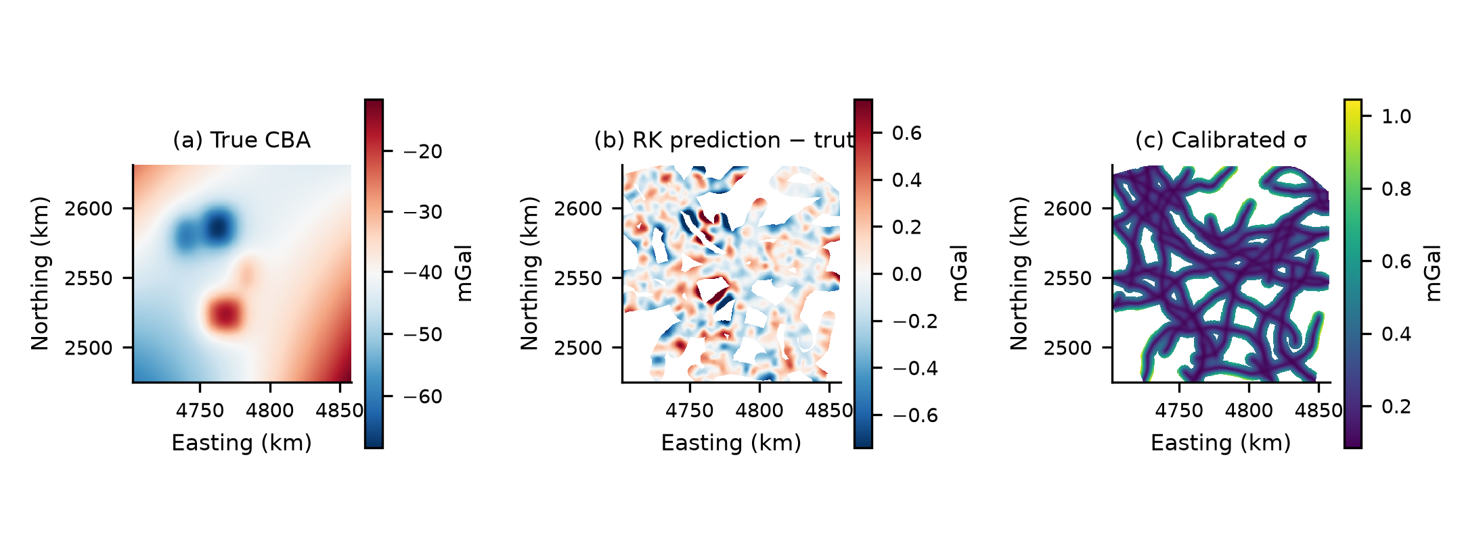
Figure 6. Synthetic benchmark: (a) true CBA at the topographic surface; (b) kriging prediction minus truth inside the support mask (RMSE 0.27 mGal); (c) calibrated prediction uncertainty.
Source: The author.

5 Discussion
5.1 What legacy reductions hide
The reconciliation shows that two maps computed from the same observations can differ by several mGal for reasons unrelated to geology: the reduction density and a curvature term whose sign and magnitude depend on how it was supplied. Each of these choices is small compared with the amplitude of regional anomalies, but together they exceed the station uncertainty by an order of magnitude and are spatially structured, since they scale with height. A single comparison of the final anomalies would mix both effects; the term-by-term decomposition, which closes to numerical precision, separates them and identifies the defective subset, and the ratio of supplied to recomputed curvature exposes a sign convention that is otherwise invisible. Reproducing the legacy numbers exactly, rather than only recomputing “correct” anomalies, is therefore a prerequisite for merging compilations.
5.2 When the density cannot be estimated
Data-driven density estimates assume that the anomaly is uncorrelated with the topography after the regional trend is removed. The low-relief variant shows that this assumption fails precisely in sedimentary basins, where lowlands coincide with thick, light fill: both estimators then return biased values with narrow or implausible intervals. A reliability rule that combines interval width, physical plausibility and agreement between methods prevents such estimates from being used silently.
5.3 Validation of gridded products
The comparison of gridding methods depends strongly on the validation design. Random cross-validation of line-sampled data mostly tests interpolation between neighbouring stations of the same traverse and understates the error of predicting across the gaps, most severely for IDW. With a spatial block design, the three model-based methods perform similarly and their ranking should not be over-interpreted. The decisive difference is uncertainty: equivalent sources and splines provide no error model, whereas kriging, once its variance is calibrated by an inner-fold factor, produces prediction intervals with nominal coverage both on unseen blocks and against the true field. Following Stein [8], the Gaussian covariance was excluded; together with weighted least-squares fitting in metric coordinates, this prevents the ill-conditioning and the non-admissible variogram curves that occur when variograms are fitted by polynomials in geographic degrees.
5.4 Limitations
The benchmark tests the workflow where the truth is known, but it cannot reproduce every difficulty of real compilations: undocumented gravity datums and height systems, terrain corrections computed with unknown methods, drift and tares of individual surveys, and correlated errors between stations of the same campaign. The simulated legacy defects are representative but not exhaustive. Ellipsoidal heights would allow gravity disturbances [5,28]; terrain corrections could be verified with a digital elevation model and prism modelling [29]; and global models such as EGM2008 [30] or XGM2019e [31], distributed by ICGEM [32], would allow a consistency check of long wavelengths when the workflow is applied to real data. Regional–residual separation by upward continuation [33], edge detection [34] and spectral depth estimates [35] are natural extensions.
6 Conclusions
A reproducible, test-driven workflow turns heterogeneous legacy gravity subsets into anomalies and grids of known quality, and a synthetic benchmark with known truth verifies each step. (1) A legacy mode and a term-by-term reconciliation recover undocumented reduction defects exactly: the effect of a 2300 kg m⁻³ slab density (up to 4.1 mGal) and a supplied curvature term with inverted sign (bias up to 0.75 mGal) are attributed to the correct term and subset. (2) Nettleton and Parasnis estimators recover a known density on a high-relief survey but fail when the anomaly follows a low-relief topography; a reliability rule flags these cases. (3) Under spatial block cross-validation, kriging, equivalent sources and splines reduce the IDW error by 62–72 %, and only kriging provides uncertainty that is calibrated both on held-out blocks and against the truth. (4) Random cross-validation understates gridding errors by factors of 1.7–5.1 for line-sampled stations. Spatially blocked validation, calibrated uncertainty and data-support masks should therefore accompany every published Bouguer anomaly grid.
Data and code availability
The software (gravanom, API and web interface), the synthetic benchmark, the validation protocol and the scripts that generate the figures are openly available at https://github.com/alberttkd/static-gravity-anomalies-colombia under the BSD-3-Clause licence (documentation and synthetic data: CC BY 4.0). All data used in this article are synthetic and can be regenerated from the published seeds.
Declaration of generative AI use
During the preparation of this work the author used Claude (Anthropic), an AI assistant, to support software development and testing and the drafting and editing of the text. The author reviewed and edited all content and takes full responsibility for the publication.
Funding and competing interests
This research did not receive any specific grant from funding agencies in the public, commercial or not-for-profit sectors. The author declares no competing interests.
References
[1] Hinze, W.J., Aiken, C., Brozena, J., Coakley, B., Dater, D., Flanagan, G., et al., New standards for reducing gravity data: The North American gravity database. Geophysics, 70(4), pp. J25-J32, 2005. DOI: https://doi.org/10.1190/1.1988183
[2] LaFehr, T.R., Standardization in gravity reduction. Geophysics, 56(8), pp. 1170-1178, 1991. DOI: https://doi.org/10.1190/1.1443137
[3] Hinze, W.J., Bouguer reduction density, why 2.67?. Geophysics, 68(5), pp. 1559-1560, 2003. DOI: https://doi.org/10.1190/1.1620629
[4] Nowell, D.A.G., Gravity terrain corrections – an overview. Journal of Applied Geophysics, 42(2), pp. 117-134, 1999. DOI: https://doi.org/10.1016/S0926-9851(99)00028-2
[5] Hackney, R.I., and Featherstone, W.E., Geodetic versus geophysical perspectives of the ‘gravity anomaly’. Geophysical Journal International, 154(1), pp. 35-43, 2003. DOI: https://doi.org/10.1046/j.1365-246X.2003.01941.x
[6] Cressie, N., Fitting variogram models by weighted least squares. Mathematical Geology, 17(5), pp. 563-586, 1985. DOI: https://doi.org/10.1007/BF01032109
[7] Chilès, J.-P., and Delfiner, P., Geostatistics: Modeling Spatial Uncertainty, 2nd ed., Wiley, 2012. DOI: https://doi.org/10.1002/9781118136188
[8] Stein, M.L., Interpolation of Spatial Data: Some Theory for Kriging, Springer, 1999. DOI: https://doi.org/10.1007/978-1-4612-1494-6
[9] Briggs, I.C., Machine contouring using minimum curvature. Geophysics, 39(1), pp. 39-48, 1974. DOI: https://doi.org/10.1190/1.1440410
[10] Smith, W.H.F., and Wessel, P., Gridding with continuous curvature splines in tension. Geophysics, 55(3), pp. 293-305, 1990. DOI: https://doi.org/10.1190/1.1442837
[11] Uieda, L., Verde: Processing and gridding spatial data using Green’s functions. Journal of Open Source Software, 3(30), 957, 2018. DOI: https://doi.org/10.21105/joss.00957
[12] Dampney, C.N.G., The equivalent source technique. Geophysics, 34(1), pp. 39-53, 1969. DOI: https://doi.org/10.1190/1.1439996
[13] Cordell, L., A scattered equivalent-source method for interpolation and gridding of potential-field data in three dimensions. Geophysics, 57(4), pp. 629-636, 1992. DOI: https://doi.org/10.1190/1.1443275
[14] Soler, S.R., and Uieda, L., Gradient-boosted equivalent sources. Geophysical Journal International, 227(3), pp. 1768-1783, 2021. DOI: https://doi.org/10.1093/gji/ggab297
[15] Roberts, D.R., Bahn, V., Ciuti, S., Boyce, M.S., Elith, J., Guillera-Arroita, G., et al., Cross-validation strategies for data with temporal, spatial, hierarchical, or phylogenetic structure. Ecography, 40(8), pp. 913-929, 2017. DOI: https://doi.org/10.1111/ecog.02881
[16] Rousseeuw, P.J., and Hubert, M., Robust statistics for outlier detection. WIREs Data Mining and Knowledge Discovery, 1(1), pp. 73-79, 2011. DOI: https://doi.org/10.1002/widm.2
[17] Moritz, H., Geodetic Reference System 1980. Journal of Geodesy, 74(1), pp. 128-133, 2000. DOI: https://doi.org/10.1007/s001900050278
[18] LaFehr, T.R., An exact solution for the gravity curvature (Bullard B) correction. Geophysics, 56(8), pp. 1179-1184, 1991. DOI: https://doi.org/10.1190/1.1443138
[19] Tiesinga, E., Mohr, P.J., Newell, D.B., and Taylor, B.N., CODATA recommended values of the fundamental physical constants: 2018. Reviews of Modern Physics, 93(2), 025010, 2021. DOI: https://doi.org/10.1103/RevModPhys.93.025010
[20] Fatiando a Terra Project, Boule v0.6.0: Reference ellipsoids for geodesy and geophysics, Zenodo, 2026. DOI: https://doi.org/10.5281/zenodo.3530749
[21] Whitman, W.W., A microgal approximation for the Bullard B – Earth’s curvature – gravity correction. Geophysics, 56(12), pp. 1980-1985, 1991. DOI: https://doi.org/10.1190/1.1443009
[22] Nettleton, L.L., Determination of density for reduction of gravimeter observations. Geophysics, 4(3), pp. 176-183, 1939. DOI: https://doi.org/10.1190/1.1437088
[23] Parasnis, D.S., A study of rock densities in the English Midlands. Geophysical Supplements to the Monthly Notices of the Royal Astronomical Society, 6(5), pp. 252-271, 1952. DOI: https://doi.org/10.1111/j.1365-246X.1952.tb03013.x
[24] Instituto Geográfico Agustín Codazzi, Resolución 471 de 2020, Bogotá, Colombia, 2020. Modified by Resolución 529 de 2020.
[25] Fatiando a Terra Project, Harmonica v0.7.0: Forward modeling, inversion, and processing gravity and magnetic data, Zenodo, 2024. DOI: https://doi.org/10.5281/zenodo.3628741
[26] Hengl, T., Finding the right pixel size. Computers & Geosciences, 32(9), pp. 1283-1298, 2006. DOI: https://doi.org/10.1016/j.cageo.2005.11.008
[27] Müller, S., Schüler, L., Zech, A., and Heße, F., GSTools v1.3: a toolbox for geostatistical modelling in Python. Geoscientific Model Development, 15(7), pp. 3161-3182, 2022. DOI: https://doi.org/10.5194/gmd-15-3161-2022
[28] Li, X., and Götze, H.-J., Ellipsoid, geoid, gravity, geodesy, and geophysics. Geophysics, 66(6), pp. 1660-1668, 2001. DOI: https://doi.org/10.1190/1.1487109
[29] Nagy, D., Papp, G., and Benedek, J., The gravitational potential and its derivatives for the prism. Journal of Geodesy, 74(7–8), pp. 552-560, 2000. DOI: https://doi.org/10.1007/s001900000116
[30] Pavlis, N.K., Holmes, S.A., Kenyon, S.C., and Factor, J.K., The development and evaluation of the Earth Gravitational Model 2008 (EGM2008). Journal of Geophysical Research: Solid Earth, 117(B4), 2012. DOI: https://doi.org/10.1029/2011JB008916
[31] Zingerle, P., Pail, R., Gruber, T., and Oikonomidou, X., The combined global gravity field model XGM2019e. Journal of Geodesy, 94(7), 66, 2020. DOI: https://doi.org/10.1007/s00190-020-01398-0
[32] Ince, E.S., Barthelmes, F., Reißland, S., Elger, K., Förste, C., Flechtner, F., and Schuh, H., ICGEM – 15 years of successful collection and distribution of global gravitational models, associated services, and future plans. Earth System Science Data, 11(2), pp. 647-674, 2019. DOI: https://doi.org/10.5194/essd-11-647-2019
[33] Jacobsen, B.H., A case for upward continuation as a standard separation filter for potential-field maps. Geophysics, 52(8), pp. 1138-1148, 1987. DOI: https://doi.org/10.1190/1.1442378
[34] Blakely, R.J., and Simpson, R.W., Approximating edges of source bodies from magnetic or gravity anomalies. Geophysics, 51(7), pp. 1494-1498, 1986. DOI: https://doi.org/10.1190/1.1442197
[35] Spector, A., and Grant, F.S., Statistical models for interpreting aeromagnetic data. Geophysics, 35(2), pp. 293-302, 1970. DOI: https://doi.org/10.1190/1.1440092
A.J. Herrera, is affiliated with the Topographic and Geomatics Engineering programme of the Universidad del Quindío, Armenia, Colombia. Research interests include physical geodesy, the processing of gravity data, geostatistics and reproducible open-source geospatial software.
ORCID: 0009-0009-1490-9075

