LPL
Redis Cloud
Load Testing Report
Consolidated findings from the AWS + Redis Cloud benchmark campaign
Report scope
Atomic writes, immediately-current reads, cluster-aware routing, 12 query patterns, a 244.2 million-document seed, the retained 2 TB-class full-load environment, the optimized gzip staircase, the valid 180K-read/sec + 30K-write/sec stress run, and the complete experiment history.
Updated 23 July 2026 (UTC)
Latest sequence: optimized clean-capacity validation followed by a valid 180K-read/sec + 30K-write/sec full-load stress run
Benchmark evidence—not a production readiness certification

Contents
1. Executive summary | 3
2. Goals of the load testing | 5
3. Test Architecture | 7
4. Physical Architecture | 11
5. Architectural Decisions | 13
6. Data Model, Seed data, Key Queries | 18
The 12 read queries and current results | 20
Queries in detail | 26
7. Why Redis | 29

How to read this report
The clean optimized staircase remains the capacity baseline: 2,556 reads/sec meets the strict SLO and 3,400 reads/sec meets rate but misses three p95 objectives. The newest 180K-read/sec run is an overload characterization: it produced more successful reads, but also heavy admission rejection, generator drops, and timeouts.

1. Executive summary
The optimized sequence sustains 2,556 reads/sec within the strict latency SLO and 3,400 reads/sec at the throughput objective while preserving 30K atomic writes/sec. The subsequent valid full-load stress run achieved 10,136.75 successful reads/sec of 180,000 and 29,847.15 writes/sec of 30,000.
2,555.09/s  highest clean mixed reads | 3,398.99/s  clean max mixed reads | 10,136.75/s  full-load successful reads | 29,847.15/s  full-load writes

The optimization sequence implemented the two highest-priority changes from the prior report. positionsByAccount and transactionsByAccount now read the synchronously maintained account snapshot instead of running broad searches. transactionsBySecurity retains its indexed semantics but uses sortable date ordering, DIALECT 4, and WITHOUTCOUNT. The API also performs real gzip negotiation and returns compressed bodies for clients that request it.
The optimized 75% step achieved 2,555.09 of 2,556 reads/sec and 29,995.34 of 30,000 writes/sec. All 12 read patterns had zero drops and zero errors; the worst query p95 was 95 ms. The 100% gzip step achieved 3,398.99 of 3,400 reads/sec and 29,995.71 writes/sec with zero query drops or errors, but securityByNo (103 ms), transactionsBySecurity (112 ms), and transactionsByAccountSecurity (102 ms) exceeded the 100 ms p95 objective.
The two snapshot-backed lists removed the largest prior latency failures: positionsByAccount improved from 136 ms to 15 ms p95 and transactionsByAccount from 102 ms to 12 ms. Gzip reduced successful response traffic from 454.24 MB/sec to 53.72 MB/sec—88.2%—without reducing achieved throughput. A matched identity control shows that compression adds API CPU latency to large responses, including portfolio p95 increasing from 16 ms to 34 ms and snapshot p95 from 17 ms to 41 ms.
Primary conclusion
Use 2,556 mixed reads/sec plus 30,000 writes/sec as the strict-SLO capacity of the tested topology. The newest full-load stress run achieved 10,136.75 successful reads/sec of 180,000 and 29,847.15 writes/sec of 30,000, but its 7.54 million HTTP 429 responses, 2.30 million scheduler drops, and 345,915 timeouts make it an overload result—not a new clean capacity claim.

The 60-second full-load window produced 608,206 successful reads, 7,544,659 HTTP 429 responses, 2,296,563 generator drops, and 345,915 30-second request timeouts. The two write shards inserted 1,795,797 unique transactions with zero write errors; write p50/p95/p99 was 33/356/635 ms.

What has been proven
- The write path can sustain essentially 30K writes/sec on the retained dataset while atomically updating the transaction row, current position, and materialized account snapshot.
- Cluster hash tags plus a single Redis Function keep one account's write set on one shard and prevent readers from observing a partial update.
- Primary reads use one JSON.GET or one projected FT.SEARCH, and materialized portfolio/activity/snapshot reads return immediately-current data after the Function commits.
- Snapshot-backed positions and recent-transaction lists preserve immediate freshness while reducing their 100% p95 values to 15 ms and 12 ms.
- The 25%, 50%, and 75% optimized gzip levels met every query target with zero drops/errors while 30K writes/sec continued concurrently.
- Real gzip reduced wire response throughput by 88.2%. Dedicated workload pools kept the 294 KB portfolio and 431 KB snapshot gzip reads at p95 values of 34 ms and 41 ms.
- The newest full-load run demonstrated that writes can remain at 99.49% of target while the read tier is heavily overloaded; Redis still reported zero blocked clients and zero rejected connections.

What has not been proven
- No run met the 180K/sec mixed read target with unchanged payload sizes. The newest run reached 10,136.75 successful reads/sec—5.63% attainment—and cannot be treated as a latency-SLO result because most offered work was rejected, dropped, or timed out.
- The campaign did not run a formal linearizability checker; atomicity is supported by Redis execution semantics, same-slot validation, source code, and smoke/unit coverage.
- The current benchmark database disables replication and continuous persistence. Its retained RDB export supports benchmark reproducibility, not a production RPO/RTO claim.
- The final run did not measure API CPU utilization per worker, so the exact compression headroom and the best gzip-versus-Brotli placement remain open.
- The 4 TB case remains untested. The latest run supports the hypothesis that payload delivery is the nearer limit; it does not prove data volume has zero performance effect.

Recommended next benchmark
1. Run a stepped admission-capacity sweep between 3,400 and 15,000 reads/sec to locate the first 429, drop, timeout, and connection-pressure thresholds by pool.
2. Optimize securityByNo, transactionsBySecurity, and transactionsByAccountSecurity, the three remaining indexed paths above 100 ms p95 in the clean 100% run.
3. Capture per-worker API CPU, event-loop utilization, active sockets, ALB target metrics, and Redis connections throughout the sweep.
4. Recompute pool-specific admission and horizontal scale requirements from the last clean step rather than offering 180K immediately.
5. Repeat capacity with production replication/persistence and add a controlled data-scale sweep at approximately 100 GB, 1 TB, 2 TB, and 4 TB.

2. Goals of the load testing
Measure the real end-to-end limit while preserving correctness, full response shapes, randomized keys, and immediately-current account reads.

2.1 Target workload
The current objective is 210,000 client-visible Redis operations/sec at the application boundary: 180,000 successful HTTP read requests/sec across 12 query patterns plus 30,000 FCALL-based trade writes/sec. Every measured read issues one top-level Redis command, and every write issues one top-level FCALL.
Segment | Per-pattern rate | Aggregate target | Role
Nine standard patterns | 9 × 9,000/s | 81,000/s | 45% of reads
accountPortfolioJoin | 45,000/s | 45,000/s | 25% of reads
accountActivityJoin | 45,000/s | 45,000/s | 25% of reads
accountSnapshot | 9,000/s | 9,000/s | 5% of reads
Read total | — | 180,000/s | 100%
Atomic trade writes | — | 30,000/s | separate write target

The Workbench exposes a thirteenth convenience pattern, transactionsByComposite. It was not assigned a rate in the final 12-pattern mix because its four-filter transaction search overlaps the measured account/security transaction searches.

2.2 Correctness goals
- Atomicity: a new transaction must not be visible without its corresponding position and account-snapshot update.
- Immediate freshness: the next portfolio, activity, or snapshot read must see the committed write; no asynchronous projection lag is acceptable.
- Idempotency: replaying the same transaction key must not double-apply quantity or advance the snapshot revision.
- Isolation under concurrency: concurrent readers must observe the state before or after a Redis Function, never a partially applied sequence.
- Cluster correctness: every multi-key write must stay within one Redis Cluster hash slot, and the client must route commands with the OSS Cluster API.

2.3 Performance and operational goals
- Report target/sec, achieved/sec, p50, p95, and p99 for every read pattern and the write pattern.
- Randomize valid query keys across independent sample dimensions and report distinct keys to avoid hot-key or index-order bias.
- Keep generators separate from API workers so generator CPU, sockets, and network do not inflate or cap application performance.
- Identify whether the limiting resource is offered-load generation, API admission, API CPU/serialization, network egress, Redis connections, Redis command capacity, Redis CPU, or data volume.
- Seed a representative large dataset once, export shard RDB files, and restore that baseline before later tests so every run starts from the same state.

2.4 Acceptance gates
Test | Achievement | Errors | Latency | Other
Isolated query step | ≥98% of target | ≤0.1% | p95 ≤250 ms | 0 drops; payload within ±5%
Mixed target run | target achieved per pattern | 0 unexpected errors | report p50/p95/p99 | 429s/timeouts/drops = 0 at final SLO
Atomic writes | ≥99% of 30K/s | 0 write errors | tail recorded | 0 duplicate effects

Latency interpretation
The retained mixed run was intentionally overloaded. A recorded 30,001 ms p95/p99 is a client wall-clock timeout sentinel, not a Redis command latency measurement. Service-time conclusions must come from non-overloaded or isolated steps.

3. Test Architecture
A distributed, closed-loop benchmark with synchronized generators, randomized keys, explicit admission, and artifact-based result aggregation.
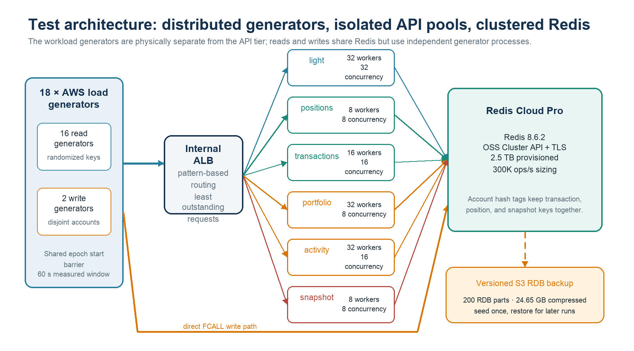
Figure 1. Final tested distributed benchmark topology.

3.1 Workload generation
- Eighteen dedicated c7i.large generator hosts: sixteen query generators and two trade-write generators.
- The query hosts repeat seven workload groups—two light groups plus positions, transactions, portfolio, activity, and snapshot—while splitting each pattern's aggregate target across its group replicas.
- The two write hosts use deterministic, disjoint account partitions across a 1,000-account pool, avoiding accidental duplicate transaction keys.
- Every process uses a shared epoch barrier; a warm-up primes HTTP keep-alive and Redis clients before the 60-second measured window.
- Query parameters are selected from Redis-backed samples rather than FT.SEARCH * LIMIT N, preventing the earlier single-account sampling bias.

3.2 Application and Redis command accounting
The Next.js query API returns content-length, payload bytes, Redis command count, workload pool, concurrency state, and timing metadata. The runner records offered/started/completed/successful/dropped requests, status codes, timeouts, socket-queue time, latency percentiles, bytes/sec, and distinct keys.
Each successful read issues exactly one JSON.GET or projected FT.SEARCH. Each trade write issues exactly one FCALL. Internal JSON.SET, JSON.NUMINCRBY, JSON.ARRINSERT, JSON.ARRTRIM, and validation calls executed inside the Function consume shard work but are not additional client requests.

3.3 Final optimized sequence and newest full-load stress run
Dimension | Configuration / result
Dataset | 6,600 accounts; 3,960 securities; 3.3M positions; 240.9M transactions; 6,600 snapshots
Provisioned Redis | Redis Cloud Pro 8.6.2; 2.5 TB; 300K ops/s sizing; TLS; OSS Cluster API
API tier | 128 × c7i.large across six dedicated pools; pool-specific Redis clients and concurrency
Generators | 18 × c7i.large: 16 read + 2 write
Strict-SLO result | 2,556/s target; 2,555.09/s achieved; worst read p95 95 ms; 0 drops/errors
100% capacity step | 3,400/s target; 3,398.99/s achieved; three indexed-search p95 values >100 ms
Write result | 29,995.34/s at strict-SLO read step; p95 9 ms; 0 errors
Response traffic | 53.72 MB/s gzip versus 454.24 MB/s identity at matched 100% load
Artifacts | concurrent-18-hosts-optimized-{gzip,identity}-*; concurrent-18-hosts-20260723T163243Z
Newest full-load reads | 180,000/s target; 10,136.75/s achieved (5.63%); 7,544,659 HTTP 429s; 2,296,563 drops; 345,915 timeouts
Newest full-load writes | 30,000/s target; 29,847.15/s achieved; p50/p95/p99 33/356/635 ms; 4,203 drops; 0 errors

3.4 Experiment history and what changed
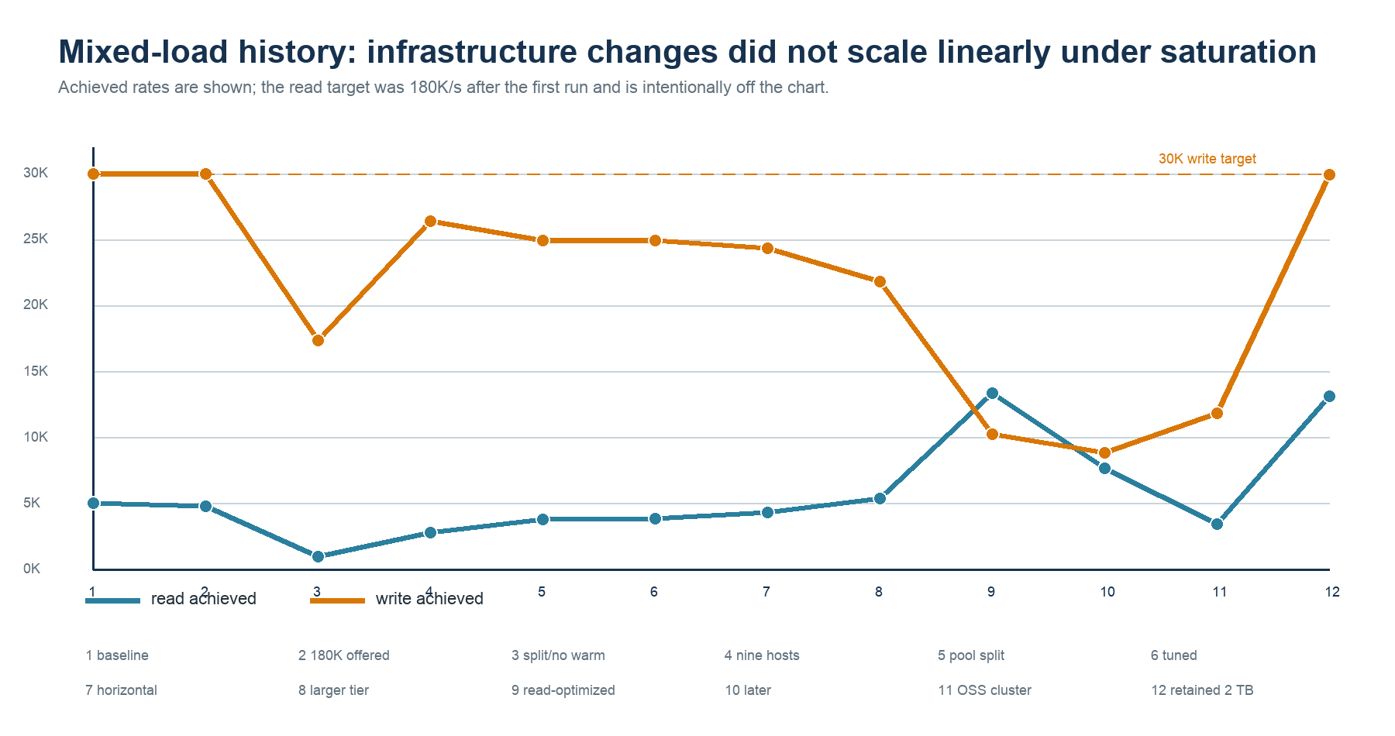
Figure 2. Historical 180K overload experiments preceding the controlled recommended sequence.

Run | Read target/s | Read achieved/s | Write achieved/s | Write p95 | Interpretation
15 Jul baseline | 5,000 | 4,997.57 | 29,988.63 | 18 ms | 5K target met
15 Jul 180K offered | 180,000 | 4,799.56 | 29,989.60 | 123 ms | API admission ceiling
16 Jul split/no warmup | 180,000 | 976.37 | 17,379.68 | 1,255 ms | cold + contention
17 Jul nine hosts | 180,000 | 2,817.85 | 26,403.11 | 1,786 ms | connection/HOL pressure
17 Jul pool split | 180,000 | 3,805.08 | 24,934.83 | 1,282 ms | isolation improved reads
18 Jul tuned pools | 180,000 | 3,871.04 | 24,932.20 | 1,269 ms | incremental gain
19 Jul horizontal | 180,000 | 4,300.20 | 24,308.92 | 1,179 ms | more API capacity
20 Jul larger tier | 180,000 | 5,392.12 | 21,823.74 | 1,407 ms | read/write tradeoff
20 Jul read-optimized | 180,000 | 13,336.26 | 10,226.12 | 2,313 ms | highest earlier reads
20 Jul later run | 180,000 | 7,685.15 | 8,823.30 | 4,396 ms | saturation instability
21 Jul OSS cluster | 180,000 | 3,440.43 | 11,820.23 | 3,517 ms | pre-normalization mix
23 Jul retained 2 TB | 180,000 | 13,142.82 | 29,912.05 | 169 ms | best balanced run
23 Jul optimized full load | 180,000 | 10,136.75 | 29,847.15 | 356 ms | valid stress; API admission saturated

Earlier 15 July tests used API-side joins that issued roughly 302 Redis commands for a portfolio and 102 for activity. Replacing them with materialized one-command reads removed that command amplification. Later runs show that adding infrastructure under saturation was not linear: read tuning often reduced write throughput, and a cluster API change by itself did not remove admission or payload constraints.
Current sequence correction
The retained-seed payload baselines were recalibrated before finalizing the isolated results: positions averaged 119 KB, account+security transactions 3.1 KB, portfolio 294 KB, and snapshot 431 KB. This prevented valid current-seed responses from being misclassified as payload failures.

4. Physical Architecture
Dedicated AWS compute drives a managed Redis Cloud clustered database over TLS; durable seed exports are retained in a separate S3 bucket.
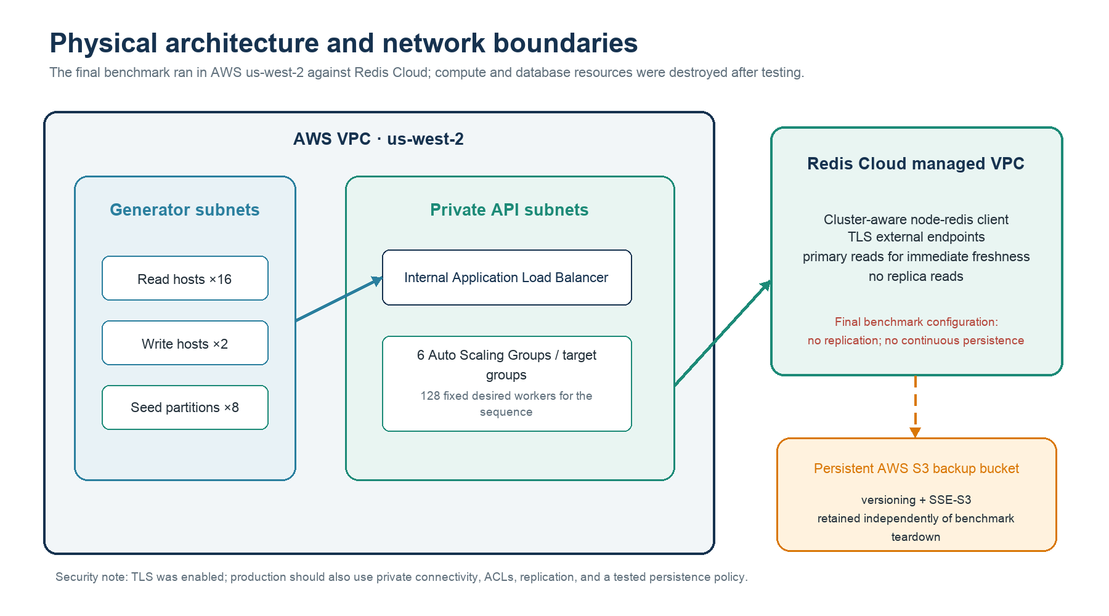
Figure 3. Final tested AWS and Redis Cloud deployment boundaries. The same 146-instance AWS fleet and seven-primary Redis Cloud database remain provisioned after the newest full-load test.

4.1 API pool sizing
Pool | Patterns | Workers | Concurrency / worker | Cluster clients / worker | Read target
light | 6 measured light patterns | 32 | 32 | 16 | 1,020/s at 100%
positions | positionsByAccount | 8 | 8 | 8 | 170/s
transactions | transactionsByAccount + bySecurity | 16 | 16 | 16 | 340/s
portfolio | accountPortfolioJoin | 32 | 8 | 8 | 850/s
activity | accountActivityJoin | 32 | 16 | 16 | 850/s
snapshot | accountSnapshot | 8 | 8 | 8 | 170/s
Total | 12 measured patterns | 128 | — | 1,664 logical | 3,400/s

The Redis client is node-redis 4.7 createCluster, with explicit routing keys and useReplicas=false. Pool-specific client counts reduced the configured logical total to 1,664 even as worker count doubled. A logical cluster client maintains connections to discovered primaries, so physical sockets can exceed the logical count; Redis nevertheless reported zero rejected connections throughout the combined sequence.

4.2 Redis Cloud configuration
Property | Final tested configuration
Version / API | Redis 8.6.2; OSS Cluster API enabled; cluster-aware client
Capacity | 2.5 TB dataset size; 300,000 operations/sec sizing
Transport | TLS external endpoints
Read consistency | Primary reads only; replica reads disabled
Eviction | noeviction
Replication | disabled in benchmark
Continuous persistence | none in benchmark
Retained baseline | 200 RDB parts + 2 manifests; 24,647,985,412 bytes; versioned SSE-S3 bucket

Current resource state
After the newest full-load test, all 146 c7i.large instances (128 API workers and 18 generators) and the seven-primary Redis Cloud database remain provisioned and billable. Redis 8.6.2 health and all five indexes passed validation. Terraform state contains 64 AWS and 4 Redis Cloud resources; the separate versioned S3 backup remains retained.

4.3 Backup topology
The one-time seed completed before an on-demand Redis Cloud export, and a later scheduled export captured the prior post-benchmark state. The newest full-load run restored the retained RDB set and then inserted 1,795,797 unique runtime transactions. No new post-run backup was created, so the retained S3 manifest remains the repeatable pre-run baseline rather than a copy of the current live database.
The retained S3 inventory totals 24,647,985,412 compressed bytes across two 100-part exports. Each export is far smaller than the in-memory dataset because the synthetic 8 KB padding is highly repetitive and compressible. Production backup size, transfer time, and restore time must be measured with production-like entropy; these artifacts are a reproducibility baseline, not a storage forecast.

5. Architectural Decisions
The current design deliberately trades write-side server work and snapshot memory for immediately-current, one-command account reads.

5.1 How to get atomic writes?
All runtime trade writes call one Redis Function: FCALL apply_transaction 3 <transaction-key> <position-key> <snapshot-key> .... The three keys contain the identical {acct:<account_id>} hash tag. The Function validates the tag, rejects a missing/malformed snapshot, checks duplicate transaction keys, writes the source transaction, updates or creates the position, patches the materialized snapshot, trims recent activity to 200, and increments revision before returning.
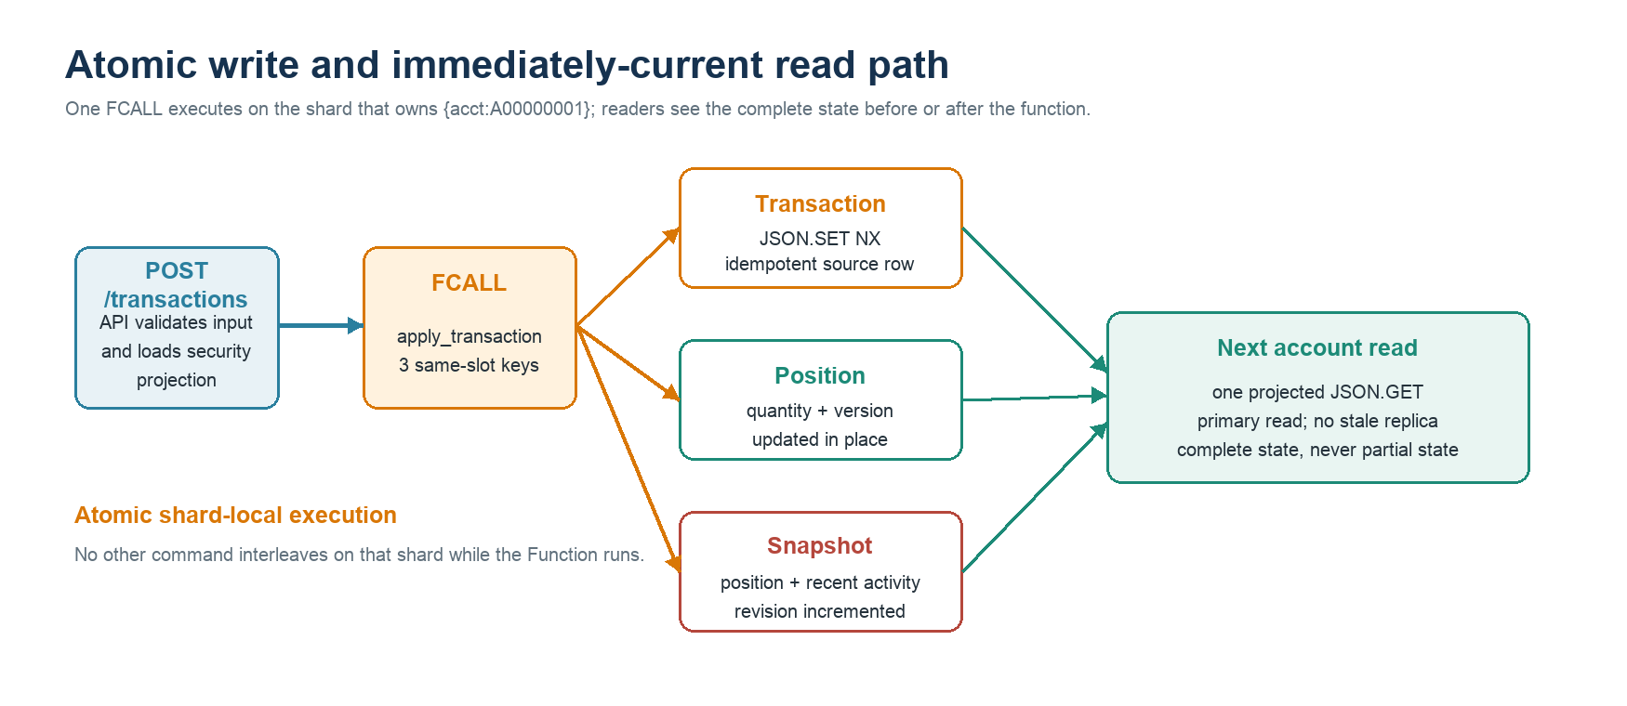
Figure 4. One same-slot Redis Function commits source and projection state atomically.

5.2 How to get consistency?
Redis guarantees atomic Function execution on the shard. A reader cannot interleave with the Function on that shard; it sees the account state before the invocation or after the complete invocation. The query client sets useReplicas=false, so an immediately-following account read goes to the primary rather than an eventually consistent replica.
The snapshot stores a revision and each position projection stores projection_version. Duplicate transactions return without advancing either. The source position and embedded snapshot position are patched from the same invocation, so the read model does not have an asynchronous freshness window.
Precision about “single-threading”
Redis Cluster processes different shards in parallel. The guarantee needed here is shard-local serialization plus atomic Function execution—not a claim that the whole cluster is single-threaded. If the application used several separate commands, other clients could interleave between them; the single FCALL prevents that.

5.3 How to get isolation with concurrent reads and writes?
Data isolation has two layers. Redis provides command/Function isolation for one account slot. The API tier separately isolates workload costs: light, positions, transaction collections, portfolio, activity, and full snapshot requests each have an independent Auto Scaling Group, target group, Redis-client budget, and hard concurrency limit. A large 431 KB snapshot therefore cannot consume the same process admission slots as a 196-byte account lookup.
This design prevents partial account state and reduces head-of-line blocking, but it is not a general cross-account transaction system. Multi-account workflows span hash slots and would need a different consistency design.

5.4 How does Redis handle durability?
Redis supports RDB snapshots, AOF, or both. Redis Cloud exposes persistence policies and remote backups. In this benchmark, data_persistence=none and replication=false were chosen to focus on load behavior and shorten provisioning. An on-demand RDB export was taken before the write load so the seed is repeatable.
For production, enable replication and choose AOF every second, AOF every write, or periodic snapshots based on the required RPO/RTO. Keep remote backups and run restore drills. Persistence and replication add CPU, network, and storage work, so the final capacity test must be repeated with the production durability configuration.

5.5 Multiple schemas or a single schema?
Use one logical Redis database with separate document families and key prefixes: accounts, securities, positions, transactions, and account snapshots. The normalized source rows remain independently addressable and searchable; the account snapshot is a purpose-built read schema. This avoids rewriting a multi-megabyte account aggregate for every historical transaction while still serving the hot join as one key.

5.6 Pipeline, projections, materialized reads, Lua script?
Mechanism | Use | Reason
Pipelining | Bulk seed only | Groups slot-aware JSON.SET batches; not used to assemble runtime reads
Projected FT.SEARCH | Selective secondary reads | Returns only fields needed by the API; avoids hydrating 8 KB padded source rows
Materialized JSON read model | Position/activity lists + joins + snapshot | One key, immediate account view; 500 positions + 200 recent transactions
Redis Function (Lua) | Runtime writes | Atomically maintains transaction, position, and snapshot in one account slot

This is a synchronous materialization pattern. It avoids stale account reads but moves projection maintenance onto the write path. The clean 100% gzip run achieved 29,995.71 writes/sec at p95 12 ms. Under the newest 180K-read/sec stress, writes still achieved 29,847.15/sec with zero errors, but p95 rose to 356 ms; Function CPU/runtime and durability overhead must therefore be monitored.

5.7 Indexing strategy
Index | Prefix | Indexed fields
idx:accounts | acct: | account_id TAG
idx:securities | sec: | security_id TAG; security_no TAG
idx:positions | pos: | _id TAG; account_id TAG; security_no TAG; acct_type_code TAG
idx:transactions | txn: | _id TAG; account_id TAG; security_id TAG; trade_date_epoch NUMERIC SORTABLE; acct_type_code TAG
idx:account_snapshots | acct-snapshot: | account_id TAG; position_count NUMERIC; transaction_count NUMERIC

Only fields used for lookup, filtering, or sorting are indexed. Secondary queries use specific TAG filters, projected RETURN fields, and bounded LIMIT values. The final transactionsBySecurity path uses the SORTABLE trade_date_epoch field with DIALECT 4 and WITHOUTCOUNT so Redis can stop after the requested ordered limit. The bulk loader drops indexes before the 240.9 million-row load, recreates them afterward, and waits for backfill before snapshot generation.

5.8 JSON vs Hash?
Concern | RedisJSON | Hash
Nested arrays / objects | Natural fit | Requires flattening or multiple hashes
Partial nested updates | JSON.SET / NUMINCRBY paths | Flat HSET only
Query Engine indexing | Supported | Supported
Memory efficiency | More overhead | Usually lower overhead for flat rows
Current snapshot | Strong fit: positions + activity arrays | Poor fit without redesign

RedisJSON is the correct current choice for nested account snapshots and atomic JSON-path updates. Flat account/security source rows could be stored as hashes to reduce memory, but the benchmark does not show those small records as the throughput bottleneck. A mixed storage migration would add operational complexity without addressing the 202 Gbit/sec target response shape.

5.9 Limits: IOPS, CPU, command cost, and bandwidth
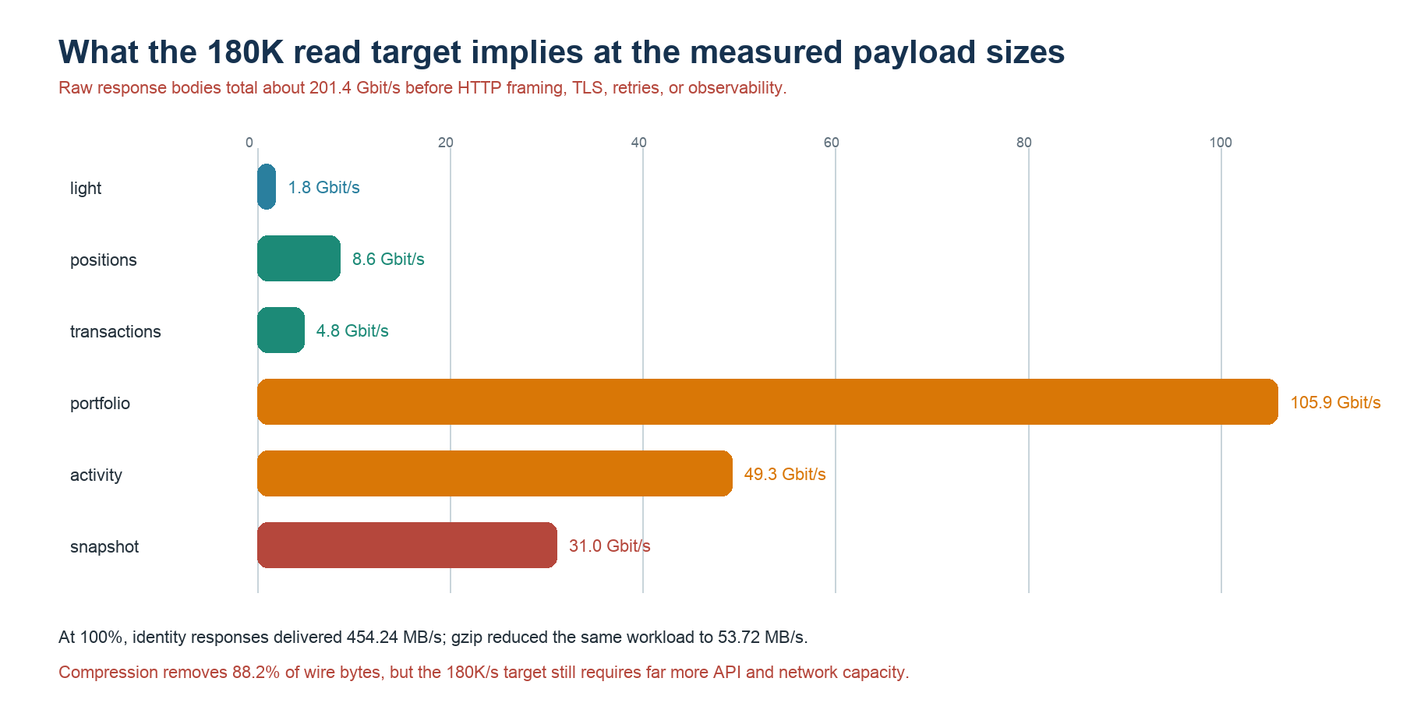
Figure 5. Target response-body bandwidth by API pool using the retained run's measured payloads.
- Client commands: the desired mix is about 210K top-level commands/sec. The clean composite point is 2,555 reads/sec plus 29,995 writes/sec; the newest stress run completed about 39,983.90 successful top-level commands/sec. Do not equate client request count with Redis shard CPU capacity.
- Internal write work: one FCALL performs multiple validation and RedisJSON operations. Equal client command counts can consume very different shard CPU.
- API admission: the newest valid 180K stress run produced 7,544,659 HTTP 429 responses, 2,296,563 scheduler drops, and 345,915 request timeouts. The clean 25%–100% sequence had zero read drops/errors, so the overload is an admission and connection-capacity result rather than a regression in the clean baseline.
- Query execution: snapshot materialization fixed the two account-list bottlenecks, while securityByNo, transactionsBySecurity, and transactionsByAccountSecurity remain above 100 ms p95 at 100%.
- Payload bandwidth: the full target requires ~25.2 GB/sec of data before protocol overhead. Portfolio alone implies ~106 Gbit/sec; activity ~49 Gbit/sec; full snapshots ~31 Gbit/sec.
- Compression: real gzip reduced matched clean-load response traffic from 454.24 MB/sec to 53.72 MB/sec (88.2%). During the newest stress run, successful gzip responses used 150.99 MB/sec of wire traffic for 1,280.56 MB/sec of uncompressed API payload, but compression did not remove admission saturation.
- Dataset scale: the retained large dataset did not prevent 30K writes/sec or low-latency materialized reads, but 4 TB still requires a controlled data-scale test.

5.10 Should Redis Cloud OSS Cluster API be enabled?
Decision. Enable Redis Cloud OSS Cluster API for this workload when the dataset or aggregate command capacity requires multiple primaries. Treat it as the horizontal scaling and routing topology—not as an automatic optimization for every query.
- Why it fits. The tested design uses seven primaries and a cluster-aware node-redis client. Slot discovery and direct shard routing distribute memory and independent account workloads, while useReplicas=false preserves immediately-current primary reads.
- How atomicity is preserved. Account, position, transaction, and snapshot keys use the same {acct:<account_id>} hash tag. The apply_transaction Function therefore runs inside one slot and one primary; unrelated accounts can execute on other primaries in parallel.
- What it does not solve. A hot account remains a single-shard workload, cross-slot multi-account transactions are not atomic, and global Query Engine searches can still coordinate across shards. OSS Cluster API also does not remove API admission, serialization, compression CPU, or response-bandwidth limits. The benchmark did not include a controlled single-endpoint-versus-OSS-cluster A/B, so no per-query latency gain should be attributed to the feature alone.
- Operational guardrails. Use a cluster-aware client, budget connections across all API workers, monitor shard and slot skew, retain hash tags for atomic account writes, and test resharding/failover with the production replication and persistence policy.

5.11 Does gzip compression improve query performance?
Decision. Enable gzip for the large account responses because it materially lowers wire bandwidth and egress cost. Do not count gzip as a Redis query-speed optimization; it leaves Redis command execution unchanged and consumes API CPU.
- Throughput result. In the matched 3,400-read/sec control, identity achieved 3,398.85 reads/sec and gzip achieved 3,398.99 reads/sec. The 0.14 read/sec difference is measurement noise, so gzip did not increase achieved query throughput.
- Bandwidth result. Successful response traffic fell from 454.24 MB/sec to 53.72 MB/sec—an 88.2% reduction. This is a large capacity benefit when HTTP egress is the constraint and is especially important for the 294 KB portfolio and 431 KB snapshot responses.
- Latency trade-off. Overall worst p95 was effectively unchanged (114 ms identity versus 112 ms gzip), but compression increased p95 for the largest responses: accountPortfolioJoin rose from 16 ms to 34 ms and accountSnapshot from 17 ms to 41 ms. Gzip exchanges API CPU and some response latency for much lower wire volume.
- Implementation guardrails. Negotiate compression only for clients that request it, use a minimum body-size threshold so tiny point reads are not compressed unnecessarily, keep compression work inside the correct isolated API pool, and compare CPU, p95/p99, and wire bytes whenever compression level or codec changes.
- Full-load confirmation. Gzip remained enabled during the newest 180K-read/sec stress run, yet read attainment was 5.63%. This confirms that compression is a bandwidth optimization, not a substitute for API admission and connection capacity. The stress run was not a matched identity-versus-gzip A/B.

6. Data Model, Seed data, Key Queries
The retained seed expands each account to 500 positions and 36,500 historical transactions while keeping hot account reads bounded to 500 positions and 200 recent transactions.

6.1 ERD of the data model
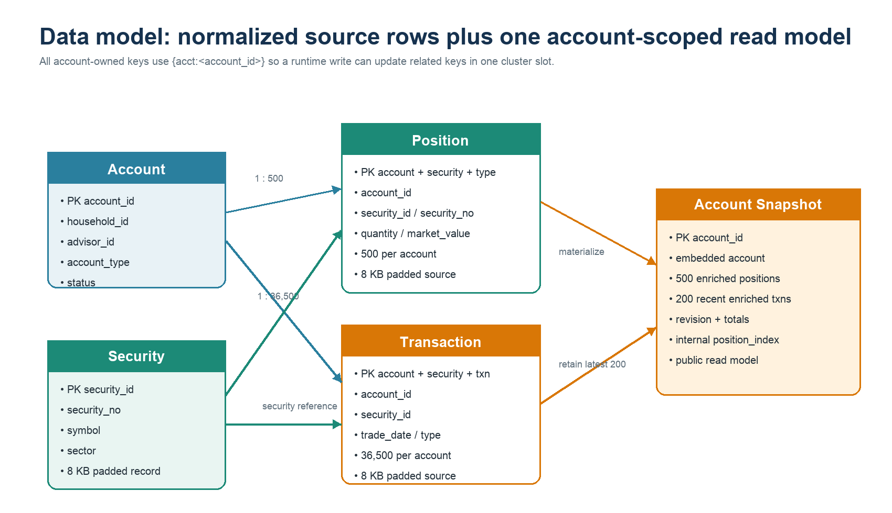
Figure 6. Normalized record families and the materialized account read model.

6.2 Details of the retained seed
Record family | Count | Shape
Accounts | 6,600 | compact metadata; exact live A00000001 payload 191 B
Securities | 3,960 | 8,192 B each; S&P 500-derived synthetic records
Positions | 3,300,000 | 500/account; 8,192 B full source rows
Transactions | 240,900,000 | 36,500/account; 8,192 B full source rows
Account snapshots | 6,600 | 500 enriched positions + 200 recent enriched transactions
Base RedisJSON documents | 244,217,160 | before runtime trade inserts and index overhead

The 8 KB values are deliberate synthetic padding. Unpadded position and transaction documents are much smaller; the padding tests dataset size, read bandwidth for direct full-row lookups, write amplification, and backup compressibility. Secondary searches return compact projections and therefore do not transmit the padding.

6.2.1 Seed and backup process
1. Seed shared securities once.
2. Run eight deterministic account-owned partitions in parallel; each host writes 825 accounts, 412,500 positions, and 30,112,500 transactions with slot-aware pipelines.
3. Drop indexes before the base load, then create and backfill five narrow Query Engine indexes.
4. Build 6,600 materialized snapshots with bounded concurrency after the indexes are ready.
5. Export one RDB per Redis Cloud internal shard to the versioned S3 bucket and write a stable latest.json manifest.
6. Restore that RDB set for subsequent benchmark cycles instead of reseeding.
Observed completion: the slowest of eight transaction partitions finished in about 25.3 minutes; index backfill completed in 374.7 seconds; all 6,600 snapshots were written. The initial export contained 100 RDB files totaling 12,273,734,940 compressed bytes. After the final run, the retained bucket held two 100-part exports plus two manifests: 202 objects totaling 24,647,985,412 bytes.

6.2.2 Example JSON record: account A00000001
{
"_id": "A00000001",
"account_id": "A00000001",
"household_id": "HH0000001",
"advisor_id": "ADV03302",
"account_type": "TRUST",
"registration_type": "TRUST",
"status": "ACTIVE",
"opened_date": "2020-02-12"
}

Live verification before the earlier teardown: JSON.GET acct:{acct:A00000001}:info $ returned this object with a 191-byte data payload. The newest valid full-load average for accountById was 196.30 bytes across randomized accounts.

6.3 The 12 read queries: access pattern, size, and contents
Group | Pattern | Workbench label | Main inputs | Redis access pattern | Avg size | What it contains
Primary | accountById | Account by ID | account_id | JSON.GET account key | 196 B | one compact account metadata document
Primary | securityById | Security by ID | security_id | JSON.GET security key | 8,192 B | one full 8 KB padded security document
Secondary | securityByNo | Security by No | security_no | FT.SEARCH; projected fields; LIMIT 20 | 333 B | normally one compact security projection
Primary | positionByComposite | Position composite | account_id + security_no + acct_type_code | JSON.GET composite position key | 8,192 B | one full 8 KB padded position document
Secondary | positionsByAccount | Positions by account | account_id | JSON.GET snapshot position_count + positions | 119,170 B | 500 compact position projections
Primary | transactionById | Transaction by ID | account + security + type + transaction_id | JSON.GET composite transaction key | 8,192 B | one full 8 KB padded transaction document
Secondary | transactionsByAccount | Transactions by account | account_id + limit=100 | JSON.GET snapshot recent_transactions; slice 100 | 33,404 B | 100 compact transaction projections
Secondary | transactionsBySecurity | Transactions by security | security_id + limit=100 | FT.SEARCH security filter; LIMIT 100 | 35,304 B | 100 compact transaction projections
Secondary | transactionsByAccountSecurity | Account + security transactions | account_id + security_id + limit=100 | FT.SEARCH two TAG filters; LIMIT 100 | 717 B | typically one compact row in the final randomized sample
Join | accountPortfolioJoin | Account portfolio join | account_id | JSON.GET snapshot account + positions | 294,024 B | account + 500 security-enriched positions
Join | accountActivityJoin | Account activity join | account_id | JSON.GET snapshot account + recent txns | 136,901 B | account + 200 security-enriched recent transactions
Read model | accountSnapshot | Materialized account snapshot | account_id | JSON.GET public snapshot projection | 430,898 B | account + 500 positions + 200 recent transactions + totals

Every measured pattern issues one top-level Redis command. Full source-row lookups return the padded 8 KB JSON; searches return projected fields; materialized joins return the complete embedded read model fields requested.

6.4 Final optimized gzip combined-load staircase
Level | Read target/s | Read achieved/s | Worst read p95 | Write achieved/s | Write p95 | Result
25% | 856 | 855.32 | 69 | 29,994.84 | 10 | Pass
50% | 1,700 | 1,699.16 | 80 | 29,994.57 | 10 | Pass
75% | 2,556 | 2,555.09 | 95 | 29,995.34 | 9 | Highest clean SLO
100% | 3,400 | 3,398.99 | 112 | 29,995.71 | 12 | Throughput pass; latency fail

Current strict-SLO baseline
Use 2,556 mixed reads/sec plus 30,000 writes/sec for this tested topology. The optimized 75% gzip step achieved every target with zero read drops/errors and a worst-query p95 of 95 ms. The later 180K stress result does not replace this clean baseline.

6.4.1 Current 100% result by query
Pattern | Target/s | Achieved/s | Attainment | p50 ms | p95 ms | p99 ms | Avg payload B | Avg wire B
accountById | 170 | 169.96 | 99.98% | 4 | 8 | 15 | 196.31 | 403.07
securityById | 170 | 169.96 | 99.98% | 5 | 9 | 21 | 8,192.00 | 469.64
securityByNo | 170 | 169.94 | 99.96% | 16 | 103 | 137 | 332.35 | 607.38
positionByComposite | 170 | 169.96 | 99.98% | 5 | 8 | 24 | 8,192.00 | 429.37
positionsByAccount | 170 | 169.94 | 99.96% | 10 | 15 | 25 | 119,175.61 | 13,413.24
transactionById | 170 | 169.96 | 99.98% | 4 | 8 | 20 | 8,192.00 | 464.90
transactionsByAccount | 170 | 169.96 | 99.98% | 8 | 12 | 27 | 33,406.37 | 3,998.16
transactionsBySecurity | 170 | 169.90 | 99.94% | 29 | 112 | 145 | 33,643.11 | 1,670.13
transactionsByAccountSecurity | 170 | 169.95 | 99.97% | 16 | 102 | 133 | 366.62 | 696.77
accountPortfolioJoin | 850 | 849.77 | 99.97% | 11 | 34 | 45 | 294,035.06 | 35,656.83
accountActivityJoin | 850 | 849.77 | 99.97% | 8 | 14 | 38 | 136,899.55 | 15,948.18
accountSnapshot | 170 | 169.92 | 99.95% | 13 | 41 | 51 | 430,886.94 | 51,350.30
READ TOTAL | 3,400 | 3,398.99 | 99.97% | — | — | — | — | —
tradeWrites | 30,000 | 29,995.71 | 99.99% | 5 | 12 | 54 | — | —

Every query pattern met at least 99.9% of its offered rate with zero drops and zero errors. The 100% step fails only the strict latency objective: securityByNo, transactionsBySecurity, and transactionsByAccountSecurity exceeded 100 ms p95.
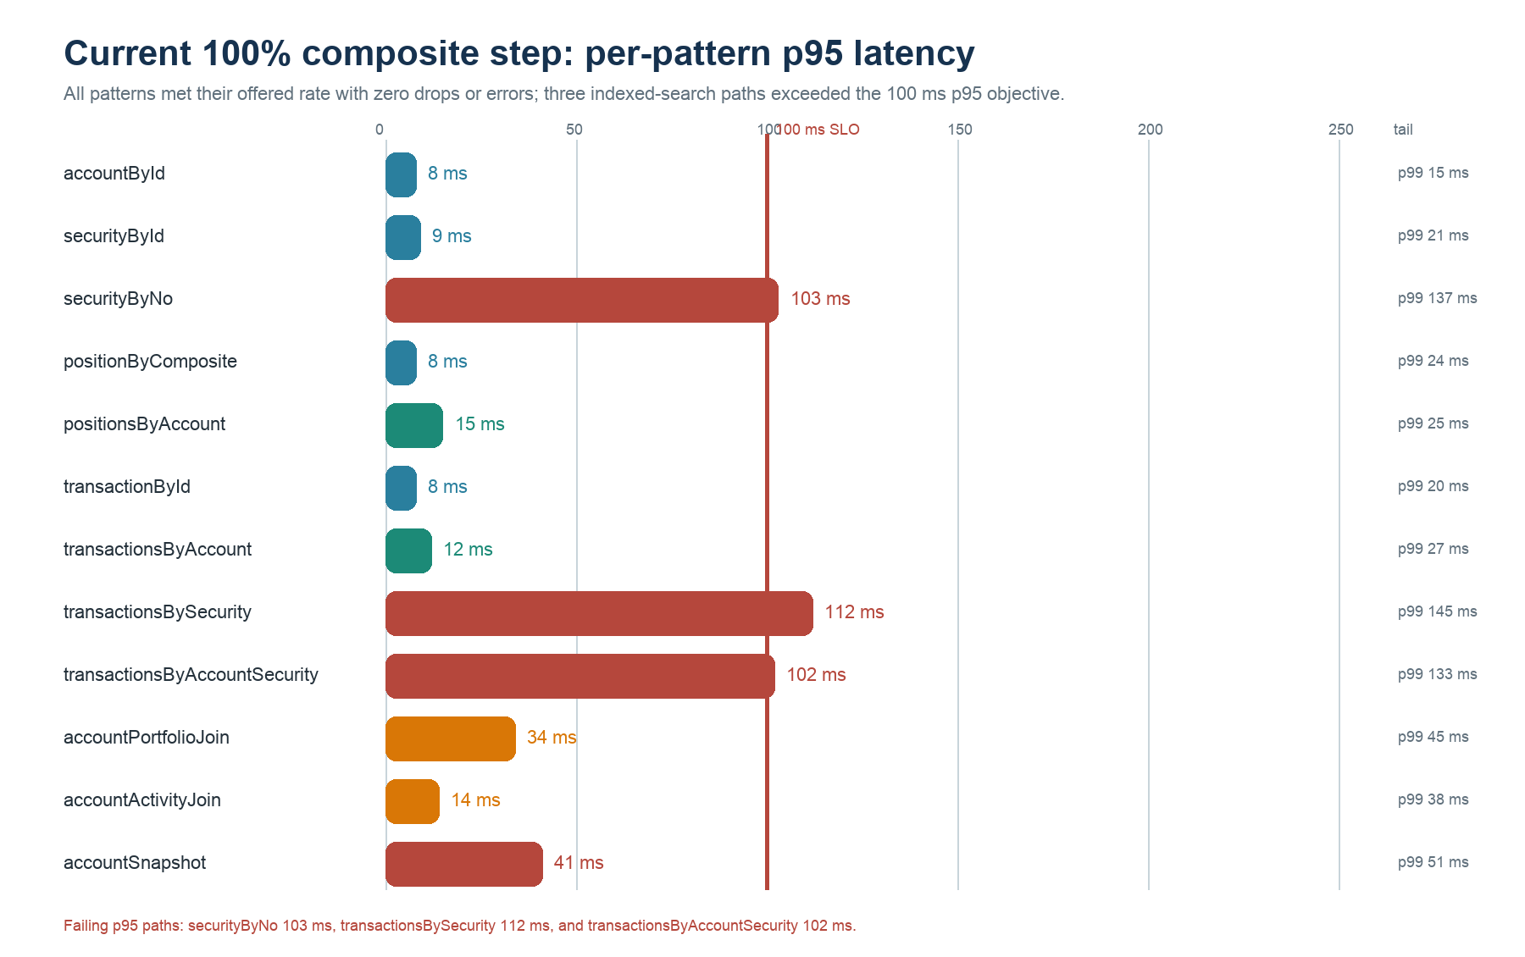
Figure 7. Per-pattern p95 latency at the current 100% composite step.

6.4.2 Matched identity-versus-gzip control
Mode | Read achieved/s | Worst read p95 | Reported body rate | Write achieved/s | Write p95
Identity | 3,398.85 | 114 ms | 454.24 MB/s | 29,991.71 | 13 ms
gzip | 3,398.99 | 112 ms | 53.72 MB/s | 29,995.71 | 12 ms

Compression is now active
The API returned Content-Encoding: gzip and reduced successful response traffic by 88.2% at the same 3,400-read/sec offer. Total throughput was unchanged. Per-pattern results show the expected API CPU cost for compressing the largest documents.

Raw snapshot request | Wire bytes | Content-Encoding
Accept-Encoding: identity | 427,520 | not present
Accept-Encoding: gzip | 54,820 | gzip

The aggregate worst-p95 difference between identity and gzip is normal run-to-run variation, not evidence that compression reduced latency. The pattern-level comparison is more diagnostic: accountPortfolioJoin increased from 16 ms to 34 ms p95 and accountSnapshot from 17 ms to 41 ms while wire traffic fell sharply. The newest 180K stress run used gzip but was not a matched compression control; its 5.63% read attainment reinforces that gzip does not remove API admission limits.

6.4.3 Full 180K read/sec + 30K write/sec stress run
The valid 60-second run offered the full production-ratio target through 16 read generators while two dedicated write generators shared 30K writes/sec. Reads achieved 10,136.75/sec (5.63%); writes achieved 29,847.15/sec (99.49%) with zero write errors.
Pattern | Target/s | Achieved/s | Attainment | p50 ms | p95 ms | p99 ms | Avg payload B | Avg wire B
accountById | 9,000 | 359.23 | 3.99% | 130 | 30,001 | 30,001 | 196.30 | 406.59
securityById | 9,000 | 351.48 | 3.91% | 130 | 30,001 | 30,001 | 8,192.00 | 471.67
securityByNo | 9,000 | 314.91 | 3.50% | 129 | 30,001 | 30,001 | 332.63 | 611.32
positionByComposite | 9,000 | 401.27 | 4.46% | 124 | 30,001 | 30,001 | 8,192.01 | 431.66
positionsByAccount | 9,000 | 283.85 | 3.15% | 54 | 116 | 266 | 119,169.90 | 13,341.01
transactionById | 9,000 | 464.31 | 5.16% | 120 | 30,001 | 30,001 | 8,192.00 | 466.37
transactionsByAccount | 9,000 | 383.65 | 4.26% | 6 | 31 | 136 | 33,404.32 | 3,989.80
transactionsBySecurity | 9,000 | 253.24 | 2.81% | 6 | 35 | 759 | 35,303.52 | 3,498.31
transactionsByAccountSecurity | 9,000 | 422.00 | 4.69% | 119 | 30,001 | 30,001 | 716.62 | 479.56
accountPortfolioJoin | 45,000 | 1,827.00 | 4.06% | 33 | 188 | 30,001 | 294,023.99 | 35,472.53
accountActivityJoin | 45,000 | 4,923.80 | 10.94% | 28 | 185 | 30,001 | 136,900.88 | 15,932.16
accountSnapshot | 9,000 | 152.01 | 1.69% | 67 | 118 | 466 | 430,898.05 | 51,153.89
READ TOTAL | 180,000 | 10,136.75 | 5.63% | — | — | — | — | —
tradeWrites | 30,000 | 29,847.15 | 99.49% | 33 | 356 | 635 | — | —
Read latency histograms include successful responses, fast HTTP 429 responses, and request failures; they are not success-only service latencies at this overload level. A 30,001 ms value is the 30-second wall-clock timeout sentinel.
The query generators recorded 608,206 successful reads during the measurement window, 7,544,659 HTTP 429 responses, 2,296,563 unscheduled drops, and 345,915 timeouts. The write generators inserted 1,795,797 unique transactions, dropped 4,203 write slots, and reported zero errors. The immediately preceding attempt is excluded because its write generators started before restored account samples were visible; this recorded rerun verified all 6,600 accounts and complete 1,000-account sample pools.

6.5 Highest passing isolated staircase step before final query optimization
Pattern | API targets | Target/s | Achieved/s | p50 | p95 | p99 | Payload B
accountById | 16 | 8,000 | 7,998.02 | 6 | 13 | 22 | 196
securityById | 16 | 8,000 | 7,998.00 | 7 | 17 | 25 | 8,192
securityByNo | 16 | 8,000 | 7,997.73 | 12 | 17 | 24 | 333
positionByComposite | 16 | 8,000 | 7,996.55 | 8 | 24 | 35 | 8,192
positionsByAccount | 4 | 150 | 149.85 | 46 | 65 | 82 | 119,170
transactionById | 16 | 4,000 | 3,999.22 | 4 | 7 | 9 | 8,192
transactionsByAccount | 8 | 1,000 | 999.48 | 26 | 39 | 51 | 33,845
transactionsBySecurity | 8 | 250 | 249.82 | 38 | 46 | 63 | 33,843
transactionsByAccountSecurity | 16 | 4,000 | 3,998.98 | 9 | 12 | 16 | 3,126
accountPortfolioJoin | 16 | 2,000 | 1,999.47 | 9 | 15 | 19 | 294,034
accountActivityJoin | 16 | 4,000 | 3,999.05 | 9 | 18 | 23 | 136,858
accountSnapshot | 4 | 500 | 499.87 | 10 | 16 | 23 | 430,865

Pass gate: ≥98% achievement, ≤0.1% errors, p95 ≤250 ms, zero scheduler drops, and payload within 5% of the current-seed baseline. These isolation results preceded the final snapshot-backed positionsByAccount and transactionsByAccount paths and are retained as the optimization baseline.

6.6 Queries in detail
The following four patterns match the attached report outline. Samples were verified live against the retained database on 22 July 2026 PDT. Large responses are abridged; exact live payload sizes and benchmark averages are stated separately.

6.6.1 Primary — accountById
Request
GET /api/query?pattern=accountById&account_id=A00000001

Redis command
JSON.GET acct:{acct:A00000001}:info $

Live response data (191 bytes; newest full-load average 196.30 bytes)
{
"_id": "A00000001",
"account_id": "A00000001",
"household_id": "HH0000001",
"advisor_id": "ADV03302",
"account_type": "TRUST",
"registration_type": "TRUST",
"status": "ACTIVE",
"opened_date": "2020-02-12"
}

This is the smallest direct read and returns one compact metadata document. On the retained seed it passed 7,998.02/s in isolation at p95 13 ms and achieved 169.96 of 170/s at p95 8 ms in the final 100% gzip step.

6.6.2 Secondary — securityByNo
Request
GET /api/query?pattern=securityByNo&security_no=SPX000001

Redis command
FT.SEARCH idx:securities "@security_no:{SPX000001}"
RETURN <projected-fields> LIMIT 0 20 DIALECT 2

Abridged live response data (308 bytes exact; newest full-load average 332.63 bytes)
[
{
"_id": "SEC00000001",
"security_id": "SEC00000001",
"security_no": "SPX000001",
"symbol": "AAPL",
"asset_class": "EQUITY",
"sector": "Information Technology",
"exchange": "NASDAQ",
"issuer_name": "Apple Inc.",
"status": "ACTIVE"
}
]

The 8 KB padding is not returned because FT.SEARCH projects compact fields. The path passed 7,997.73/s at p95 17 ms in isolation and achieved 169.94 of 170/s at p95 103 ms in the final 100% gzip step. It is now one of the three remaining indexed-search latency targets.

6.6.3 Join — accountPortfolioJoin
Request
GET /api/query?pattern=accountPortfolioJoin&account_id=A00000001

Redis command
JSON.GET acct-snapshot:{acct:A00000001}
$.account $.position_count $.positions

Abridged live response data (289,700 bytes exact; newest full-load average 294,023.99 bytes)
{
"account": {
"_id": "A00000001",
"account_id": "A00000001",
"household_id": "HH0000001",
"advisor_id": "ADV03302",
"account_type": "TRUST",
"registration_type": "TRUST",
"status": "ACTIVE",
"opened_date": "2020-02-12"
},
"positions": [
{
"_id": "A00000001|SPX000001|ADVISORY",
"security_id": "SEC00000001",
"security_no": "SPX000001",
"acct_type_code": "ADVISORY",
"quantity": 2329.6166,
"market_value": 724292.84,
"as_of_date": "2026-07-22",
"projection_version": 0,
"security": {
"symbol": "AAPL",
"sector": "Information Technology",
"exchange": "NASDAQ"
}
},
"... 499 more enriched positions ..."
]
}

The join is already materialized: the API does not perform 500 follow-up GETs. One projected JSON.GET returns the account plus 500 security-enriched positions. It achieved 849.77 of 850/s at p95 34 ms in the final 100% gzip step. The matched identity control was p95 16 ms, exposing the API CPU cost of compressing this 294 KB response. At the ultimate 45K/s target this pattern still implies about 13.23 GB/s (~106 Gbit/s) before compression.

6.6.4 Read model — accountSnapshot
Request
GET /api/query?pattern=accountSnapshot&account_id=A00000001

Redis command
JSON.GET acct-snapshot:{acct:A00000001} <public-projection-fields>

Abridged live response data (427,278 bytes exact; newest full-load average 430,898.05 bytes)
{
"_id": "A00000001",
"account_id": "A00000001",
"generated_at": "2026-07-23T00:46:43.200Z",
"revision": 0,
"position_count": 500,
"transaction_count": 200,
"total_market_value": 193972750.89,
"account": {
"_id": "A00000001",
"account_id": "A00000001",
"household_id": "HH0000001",
"advisor_id": "ADV03302",
"account_type": "TRUST",
"registration_type": "TRUST",
"status": "ACTIVE",
"opened_date": "2020-02-12"
},
"positions": [
"500 enriched position objects; first matches portfolio sample"
],
"recent_transactions": [
{
"transaction_id": "SEED-A00000001-000000023764",
"security_id": "SEC00000005",
"trade_date": "2025-12-26",
"transaction_type": "TRANSFER",
"quantity": 1957.9558,
"amount": 73478.14,
"security": {
"symbol": "META",
"exchange": "NASDAQ"
}
},
"... 199 more recent enriched transactions ..."
]
}

The public response omits the internal SHA-1 position_index map used for O(1)-style embedded-position lookup inside the Function. The seeded transaction_count starts at the retained 200-row activity window rather than the full 36,500-row historical account count; complete history remains in normalized transaction documents and Query Engine indexes. The final 100% gzip step achieved 169.92 of 170/s at p95 41 ms for this 431 KB read; the matched identity control was p95 17 ms.

7. Why Redis
Redis is a strong fit for this workload when its atomicity, data locality, JSON/search capabilities, and cluster routing are combined with a correctly sized API and network tier.

7.1 Evidence-backed fit
Requirement | Redis capability / observed evidence
Immediate reads after writes | Same-slot Redis Function updates source + snapshot; primary JSON.GET reads the committed projection
Atomic multi-record account update | Hash tags colocate transaction, position, and snapshot; FCALL executes atomically
Direct and secondary access | JSON.GET for keys; Query Engine TAG/NUMERIC indexes for filtered lookup
Nested account read model | RedisJSON stores account, 500 enriched positions, 200 enriched recent transactions, totals, and revision
Horizontal data distribution | OSS Cluster API lets a cluster-aware client route commands to the owning primary
High write rate | 29,995.34 FCALL writes/sec, p95 9 ms, zero errors alongside the highest clean read step
Repeatable benchmark state | Two retained Redis Cloud RDB exports, 200 parts + two S3 manifests

7.2 What Redis does not solve automatically
- An in-memory database does not remove API serialization, JSON encoding, ALB, TLS, socket, NIC, or load-generator constraints.
- Clustering cannot make a 431 KB response cheap. The full target's body bandwidth is a system-architecture requirement.
- Read replicas can increase read capacity but are not suitable for this immediate-freshness requirement unless the consistency contract changes.
- A large Function blocks its shard while running. The write projection must remain bounded and monitored.
- No-persistence, no-replication benchmark settings are not a production durability design.
- Command counts are not interchangeable: an 8 KB GET, a 431 KB JSON projection, an indexed search, and a Function each consume different CPU and network resources.

7.3 Prioritized path to the target
Priority | Action | Success evidence
Done | 12 isolated staircases on retained seed | Current per-target RPS, p50/p95/p99, payload, and safe headroom recorded
Done | Scale generators and API pools together | 18 generators and 128 API workers validated; pool-specific limits retained
Done | Run optimized combined staircase | 25%, 50%, and 75% pass; 100% meets rate but fails three indexed-search p95 objectives
Done | Materialize account list reads | positionsByAccount p95 136→15 ms; transactionsByAccount 102→12 ms
Done | Enable and validate gzip | Content-Encoding verified; 454.24→53.72 MB/s at matched 100% load
Done | Run valid full 180K + 30K stress | 10,136.75 reads/s; 29,847.15 writes/s; complete per-pattern p50/p95/p99 and admission-failure counts recorded
P0 | Locate per-pool admission threshold | Step from 3.4K toward 15K; record first 429/drop/timeout plus sockets, connections, CPU, and ALB target metrics
P0 | Optimize remaining indexed searches | securityByNo, transactionsBySecurity, and account+security transactions ≤100 ms p95
P0 | Measure compression CPU placement | Record per-worker CPU/event loop; compare application versus proxy compression
P1 | Recompute per-pool headroom | Repeat isolated and combined staircases before increasing offer
P1 | Enable production durability | Replication + persistence + backups, then repeat capacity and restore tests
P2 | Formal consistency checker | Assert monotonic revision, no missing/duplicate txn IDs, and exact position deltas
P2 | Data-scale sweep | Repeat identical topology at ~100 GB, 1 TB, 2 TB, and 4 TB

Final assessment
Keep Redis, the same-slot Function, the materialized account snapshot, pool-specific admission, and negotiated compression. The clean sequence proves 2,556 reads/sec within SLO and 3,400 reads/sec at rate; the newest full-load stress reaches 10,136.75 successful reads/sec while preserving 29,847.15 writes/sec, but with overwhelming admission failures. Invest next in per-pool admission/connection capacity, the three remaining indexed searches, and compression CPU placement.

7.4 Evidence and references
ID | Source | Used for
[R1] | memtier-output/aws-load-runner/concurrent-9-hosts-20260723T010534Z/retained-run-report.md | retained dataset, results, backup, resources
[R2] | …/concurrent-query-summary.json | 12 read targets, achieved rates, latencies, drops, status, payload and bytes/sec
[R3] | …/trade-writes-aggregate.json | write rate, errors, drops, p50/p95/p99
[R4] | memtier-output/aws-load-runner/query-staircase-sequence-20260723T034500Z/ | current retained-seed isolated staircases
[R5] | memtier-output/aws-load-runner/query-staircase-corrected-20260723T044500Z/ | corrected current-seed payload baselines
[R6] | memtier-output/aws-load-runner/heavy-staircase-scaled-20260723T052000Z/ | controlled 2x heavyweight validation
[R7] | memtier-output/aws-load-runner/concurrent-18-hosts-sequence-{25,50,75,100}pct-*/ | combined sequence and writes
[R8] | memtier-output/aws-load-runner/concurrent-18-hosts-optimized-gzip-{25,50,75,100}pct-*/ | optimized gzip staircase
[R9] | memtier-output/aws-load-runner/concurrent-18-hosts-optimized-identity-100pct-*/ | matched identity control
[R10] | docs/optimized-query-compression-results-2026-07-23.md | durable optimized result summary
[R11] | GitHub pull request #12; commit 74c31f2 | implementation and review record
[H1] | Earlier Terraform teardown outputs + S3 inventory | historical cleanup evidence before the current environment was reprovisioned
[R12] | memtier-output/aws-load-runner/concurrent-18-hosts-20260723T163243Z/ | newest valid 180K-read/sec + 30K-write/sec stress artifacts
[R13] | docs/full-load-180k-results-2026-07-23.md | durable newest-run result summary
[R14] | Terraform state + live AWS/Redis health verification, 23 July | 146 live AWS instances, Redis health, retained S3 backup
[C1] | src/lib/queries.ts; src/app/api/query/route.ts; src/lib/query-response.ts | query commands, API shape, payload accounting
[C2] | src/lib/redis.ts; src/lib/query-workloads.ts | cluster-aware routing, primary reads, workload pools
[C3] | redis/functions/financial-transactions.lua; src/lib/transaction-writes.ts | same-slot atomic write implementation
[C4] | src/lib/indexes.ts; scripts/seed.ts; .env.initial-load.example | index schema and retained seed
[D1] | https://redis.io/docs/latest/develop/programmability/functions-intro/ | Redis Function atomic execution
[D2] | https://redis.io/docs/latest/operate/oss_and_stack/reference/cluster-spec/ | hash tags and slot-local operations
[D3] | https://redis.io/docs/latest/operate/rc/databases/configuration/clustering/ | Redis Cloud OSS Cluster API
[D4] | https://redis.io/docs/latest/operate/rc/databases/configuration/data-persistence/ | Redis Cloud persistence choices
[D5] | https://redis.io/docs/latest/operate/rc/databases/back-up-data/ | Redis Cloud RDB backup behavior
[D6] | https://redis.io/docs/latest/develop/data-types/json/ | RedisJSON and Query Engine integration

Method note: all benchmark metrics in this report come from runner artifacts preserved in the local workspace. The four JSON examples were verified with read-only live queries before the earlier teardown. After the newest full-load run, the 146-instance AWS benchmark fleet and Redis Cloud database remain provisioned and billable; only the separate versioned S3 backup is intended as the reusable seed baseline.

