  CONTACT  Jakarta, Indonesia  albertus.freddi@yahoo.com  linkedin.com/in/albertusfreddi  WHAT I DO BEST  ▪ Negotiation and deal support  ▪ Government and military account relationships  ▪ Client strategy and advisory  ▪ Competitive and market positioning  ▪ Cross border export coordination  ▪ Public speaking and team training  ▪ Technical proposal scoping  INSTITUTIONS WORKED WITH  Ministry of Defence · Indonesian National Armed Forces (TNI) · Indonesian National Police (Polri) · Attorney General's Office  SECTORS  Defense and armored vehicles · Government IT · Aerospace and security systems · Financial services  EDUCATION  Registered Financial Planner (RFP)  University of Indonesia / FPSB Indonesia, 2017  Data Scientist Program  Purwadhika Digital Technology School, 2020  S.Ars, Architecture  Tarumanagara University, 2010–2014  CERTIFICATIONS  ▪ Certified AppSec Practitioner (CAP)  ▪ Agile and Waterfall Project Management (PMI)  ▪ Ethical Hacking and Web Penetration Testing  ▪ Data Science and Machine Learning, DataCamp (15+)  TECHNICAL  Python · SQL · Data analysis and visualisation · Project management tooling ·  LANGUAGES  English — professional working proficiency  Indonesian — native | ALBERTUS FREDDI  Business Development Manager  Defense · Aerospace · Government and Institutional Relations · Indonesia and APAC  PROFILE  Business development professional in Indonesia's defense sector, working the part of the job that decides whether a deal happens at all: getting into the room with the right people at government and military institutions, understanding what they actually need, and keeping that relationship alive through procurement cycles that run for months. Six years delivering projects for institutional clients before this, including work for the Attorney General's Office, means proposals put on the table are ones the delivery team can stand behind. Comfortable across the technical, commercial, and institutional sides of a deal, and used to being the person who translates between them.  SALES ACHIEVEMENTS  ▪ 2022 · Rp 90 billion. Rp 89 billion project with the Attorney General's Office (Kejaksaan) and Rp 1 billion with the Indonesian National Police (Polri).  ▪ 2023 · Rp 2 billion. Project with the Indonesian National Police (Polri).  ▪ 2024 · Rp 24 billion. Project with the Jakarta Regional Revenue Agency (Bapenda DKI Jakarta).  ▪ 2025 · Rp 22.5 billion. Rp 19 billion and Rp 3.5 billion across the Ministry of Defence (Kemhan) and the Indonesian Army Headquarters (Mabes TNI AD).  ▪ Cumulative 2022–2025: Rp 138.5 billion closed across four consecutive years with government and military institutions.  GOVERNMENT ACCOUNTS  ▪ Attorney General's Office (Kejaksaan RI). 2022, largest single project at Rp 89 billion.  ▪ Indonesian National Police (Polri). 2022 and 2023, repeat client across two years.  ▪ Jakarta Regional Revenue Agency (Bapenda DKI Jakarta). 2024, regional government account.  ▪ Ministry of Defence (Kemhan). 2025, defense procurement account.  ▪ Indonesian Army Headquarters (Mabes TNI AD). 2025, military account.  WHAT I BRING  ▪ Negotiation and relationship management. Runs day-to-day commercial negotiation on agreements with international defense contractors, coordinating with the legal team on terms, and maintains the client relationships that keep long procurement cycles moving.  ▪ Government and military account access. Builds and sustains working relationships with the Ministry of Defence, the Indonesian National Armed Forces (TNI), and the Indonesian National Police (Polri) across the full procurement cycle.  ▪ Client advisory and strategy. Shapes the pitch, pricing, and technical positioning around what a specific institutional client is trying to solve, rather than running a standard sales script.  ▪ Market and competitive intelligence. Builds internal analysis of the Indonesian defense manufacturing landscape used to position products and set pricing strategy.  ▪ Cross border operations. Handles export documentation and loan agreements for defense equipment sent abroad for foreign military evaluation.  ▪ Technical fluency. Background in software engineering and data science means technical requirements from a client get scoped accurately, not guessed at.  EXPERIENCE  Business Development Manager  SSE Defence (PT Sentra Surya Ekajaya) · Apr 2025 – Present · Indonesia  ▪ Manage the day-to-day business development cycle with government and military institutional clients, covering prospecting, technical positioning, and commercial negotiation for armored vehicles and defense equipment.  ▪ Lead commercial negotiation with international defense contractors on NDAs and framework agreements, coordinating with legal on contract terms.  ▪ Handle cross border export documentation and loan agreements for defense equipment sent abroad for foreign military evaluation.  ▪ Build internal competitive intelligence comparing the company's armored vehicles against other Indonesian defense manufacturers, used to sharpen product positioning and pricing strategy.  ▪ Produce market landscape analysis of Indonesia's domestic defense industry (INHAN) to position the company within the private sector armored vehicle segment.  ▪ Represent the company at industry forums including Defence Technology Forum 2025, where institutional relationships begin ahead of formal procurement.  ▪ Work with engineering and legal teams so proposals match what can actually be delivered, on the client's procurement timeline and rules.  Business Development Representative  SSE Defence · Jan 2025 – Mar 2025 · Indonesia  ▪ Built the client outreach and pipeline process later scaled into the Business Development Manager role, establishing first contact with government and military institutional accounts.  Project Manager  PT. Arvitech Mega Solusi · May 2019 – Dec 2024 · Jakarta, Indonesia  ▪ Delivered projects for government institutions, including data gathering and analysis work for the Attorney General's Office of the Republic of Indonesia.  ▪ Negotiated proposals, scope, and change requests directly with client stakeholders, balancing client requests against what the team could realistically deliver.  ▪ Ran projects end to end: scope definition, budget, timeline, risk assessment, and stakeholder communication.  ▪ Applied Agile and Waterfall methods depending on client and project requirements.  ▪ Mentored junior project managers and led cross-functional coordination between technical and client-facing teams.  Junior Software Engineer  PT. Arvitech Mega Solusi · Jan 2018 – May 2019 · Jakarta, Indonesia  ▪ Software development and quality assurance across client projects, building the technical foundation that now informs how technical proposals get scoped and priced.  Data Scientist (Remote)  ProfitOath · Jan 2017 – Jan 2018 · Singapore  ▪ Defined project objectives, scope, and deliverables directly with clients across finance, healthcare, and e-commerce.  ▪ Translated statistical analysis into recommendations that shaped client strategic decisions.  Associate Agency Director  Prudential Indonesia (PT Prudential Life Assurance) · Jul 2016 – Jan 2017 · Greater Jakarta, Indonesia  ▪ Recruited, trained, and mentored a team of financial advisors, with responsibility for team performance and capability building.  ▪ Taught agency training classes on objection handling and closing large cases, and ran sharing sessions for agents moving into leadership roles.  ▪ Mentored the team to a top three placing in the agency leader ranking by case volume.  ▪ Established performance metrics and KPIs for the agency, and delivered individual coaching through regular performance reviews.  Financial Advisor  Prudential Indonesia (PT Prudential Life Assurance) · Apr 2015 – Jul 2016 · Greater Jakarta, Indonesia  ▪ Built and managed a personal client portfolio from the ground up, consistently meeting and exceeding individual sales targets.  ▪ Presented New Business Opportunity sessions to rooms of prospective recruits, the entry point of the agency's recruitment pipeline.  ▪ Structured customized financial and insurance plans around each client's goals, an early training ground for consultative selling and objection handling.  IN THE FIELD
  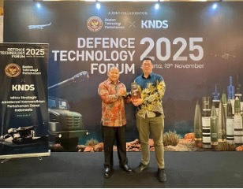  Defence Technology Forum 2025  Representing SSE Defence at Indonesia's main defense industry forum. | 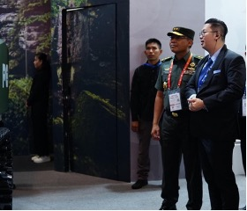  Institutional Engagement  Direct engagement with military and government officials at industry events. | 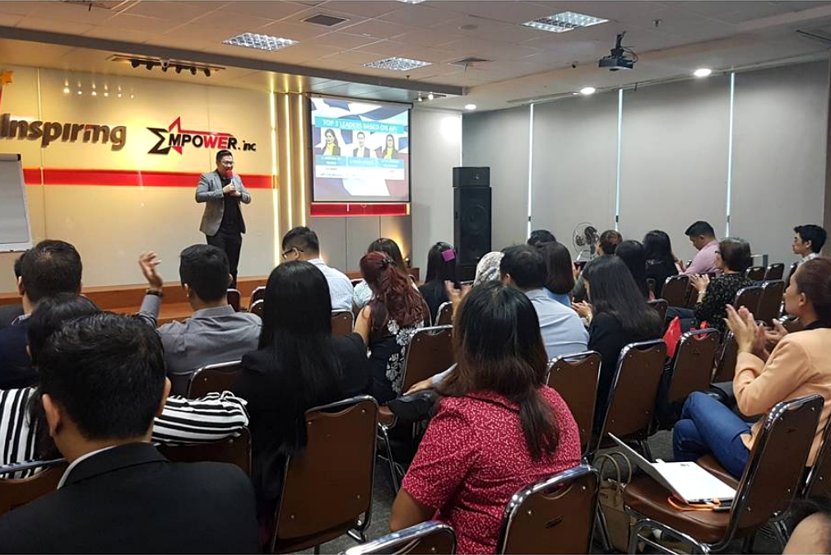  Agency Leadership Session  Presenting team results at a Prudential agency leadership session.
  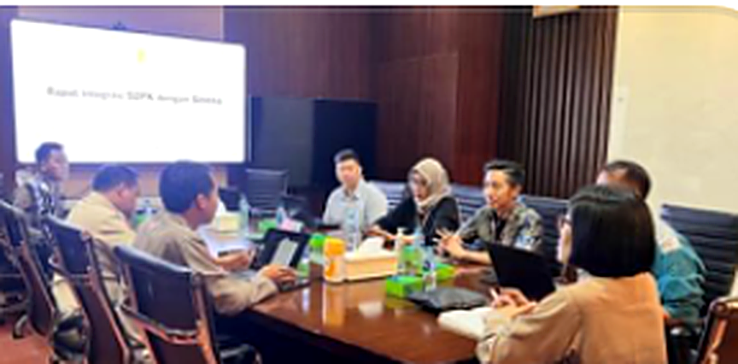  Client Working Session  Leading stakeholder alignment during the project management years. | 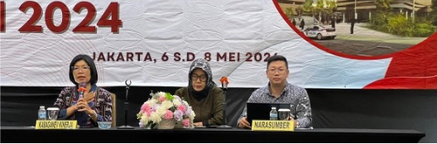  National Industry Conference  Ongoing presence at national events with institutional stakeholders. | 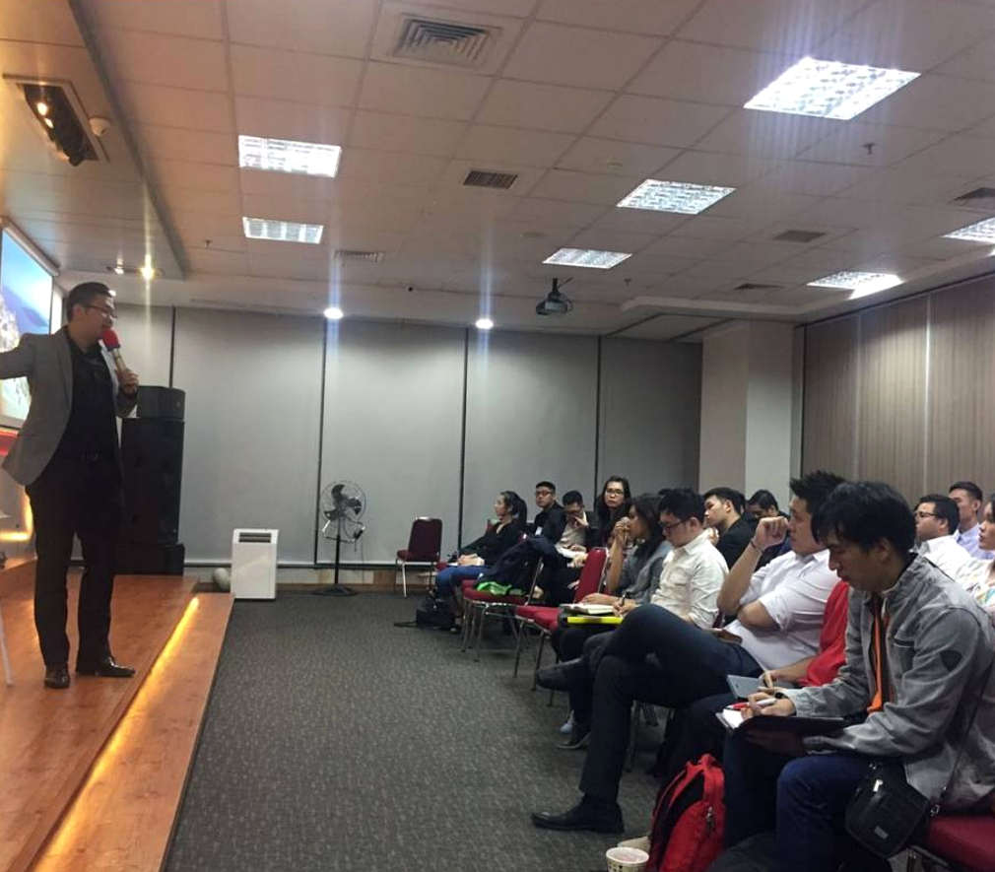  Leadership Sharing Session  Running a sharing session for agents stepping into leadership roles.

