
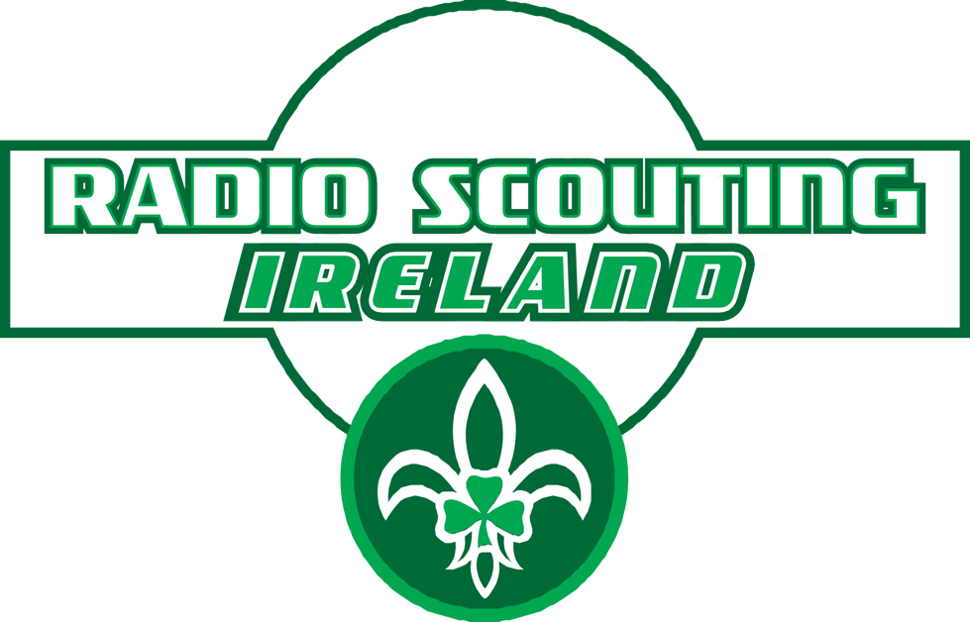
Morse Whistle/Torch Game:

This is a fun game to develop morse code listening skills.

AGE RANGE: Cub Scouts through Venturer Scouts

Game works a lot like the familiar Ship to Shore (port, starboard, swab the deck, etc.) but with directions and actions indicated by their initial letter, sent via Morse code and a whistle or morse code sounder or flashing torch.

Run a few practice runs, then start eliminating the last person to correctly follow each direction or action, until you have one player left (the winner). T

The various letters in morse and directions and actions are:

E . East - run to east wall
G - -. Gully - lie down on the ground
H . . . . Hill - stand still with hands up in the air
N -. North - run to north wall
S . . . South - run to south wall
T - Tree - stand with arms extended out to the side
V . . . - Valley - crouch down
W . - - West - run to west wall

The letters indicated are tweeted on a whistle or morse code sounder in Morse code.

Each player needs a simplified Morse code card (shown below) with the 8 letters shown on it.

To make it easier to learn, it helps if you make the dashes very long and the dots very short. If working with younger participants, stick to introducing only four or five codes the first time you play the game.

Once they get good at it using the reference card, take the card away and see if they can remember the directions without reading the letters on the card (using sounds alone).

The goal is to learn to associate the sound with the word or action just by hearing it.

Morse code game card

E . East - run to east wall
G - -. Gully - lie down on the ground
H . . . . Hill - stand still with hands up in the air
N -. North - run to north wall
S . . . South - run to south wall
T - Tree - stand with arms extended out to the side
V . . . - Valley - crouch down
W . - - West - run to west wall

Morse code game card

E . East - run to east wall
G - -. Gully - lie down on the ground
H . . . . Hill - stand still with hands up in the air
N -. North - run to north wall
S . . . South - run to south wall
T - Tree - stand with arms extended out to the side
V . . . - Valley - crouch down
W . - - West - run to west wall

Morse code game card

E . East - run to east wall
G - -. Gully - lie down on the ground
H . . . . Hill - stand still with hands up in the air
N -. North - run to north wall
S . . . South - run to south wall
T - Tree - stand with arms extended out to the side
V . . . - Valley - crouch down
W . - - West - run to west wall

Morse code game card

E . East - run to east wall
G - -. Gully - lie down on the ground
H . . . . Hill - stand still with hands up in the air
N -. North - run to north wall
S . . . South - run to south wall
T - Tree - stand with arms extended out to the side
V . . . - Valley - crouch down
W . - - West - run to west wall

Morse code game card

E . East - run to east wall
G - -. Gully - lie down on the ground
H . . . . Hill - stand still with hands up in the air
N -. North - run to north wall
S . . . South - run to south wall
T - Tree - stand with arms extended out to the side
V . . . - Valley - crouch down
W . - - West - run to west wall

